

**Public Summary Document**

***Application No. 1377 – Optical coherence tomography (OCT) for retinal assessment in the presence of diabetic macular oedema (DMO) for access to treatment with dexamethasone posterior segment drug delivery system***

**Applicant: Allergan Australia Pty Ltd**

**Date of MSAC consideration: MSAC 63rd Meeting, 1-2 April 2015**

Context for decision: MSAC makes its advice in accordance with its Terms of Reference, see at [www.msac.gov.au](http://www.msac.gov.au/)

# Purpose of application and links to other applications

A submission based assessment (SBA) requesting MBS listing of optical coherence tomography (OCT) for the purpose of assessing the retina to determine eligibility for a dexamethasone implant was received from Allergan by the Department of Health in October 2014. This submission was coordinated with a concurrent submission to the Pharmaceutical Benefits Advisory Committee (PBAC) from the same applicant (Allergan) for a PBS listing of dexamethasone implant, for the treatment of adults with pseudophakia who have centre-involving macular oedema associated with diabetic retinopathy.

# MSAC’s advice to the Minister

After considering the available evidence presented in relation to safety, clinical effectiveness and cost-effectiveness of optical coherence tomography (OCT), MSAC deferred the application for the requested MBS item until such time as PBAC makes a positive recommendation regarding the corresponding PBS listing of dexamethasone implant. MSAC advised that, if PBAC subsequently decides to recommend to the Minister that dexamethasone implant be listed on the PBS for diabetic macular oedema (DMO), then MSAC would support an expedited process of reconsideration. This process would be undertaken to ensure that MSAC support for public funding of OCT is aligned with the circumstances recommended by PBAC.

MSAC foreshadowed that the MBS item descriptor should allow for the use of OCT before the initial implant of dexamethasone and before each subsequent implant, in each case to confirm the presence of oedema and thus the suitability of proceeding to inject the implant. MSAC stated that the MBS item descriptor not allow for the use of OCT to assess the post-treatment response as this can best be determined by a visual acuity test using a Snellen chart. MSAC also foreshadowed that the MBS fee should be approximately $50 as suggested by ESC.

# Summary of consideration and rationale for MSAC’s advice

MSAC agreed that this submission was co-dependent with the submission for PBS funding of dexamethasone implant being considered by PBAC. This was primarily established by the use of OCT before each injection of dexamethasone implant in the randomised trials of dexamethasone implant. Therefore, to ensure that the requested MBS funding of OCT remains closely linked to the use of dexamethasone implant via the PBS and thus to prevent any leakage of OCT to other purposes, any MBS item descriptor in this context would need to be altered to maintain this link.

MSAC noted that the patient population in this submission was restricted to people with central DMO who have pseudophakia (an artificial lens) following cataract surgery. Restriction to a pseudophakic population was requested because dexamethasone increases the risk of developing cataracts. To align with the proposed PBS population, eligible patients would also need to be limited to those with a visual acuity of ≤ 6/12 Snellen fraction.

MSAC agreed that the appropriate comparator for OCT was assessment without OCT using other tools and procedures such as clinical examinations and visual acuity.

The safety of OCT was not assessed in this submission as it is already established that OCT is a non-invasive and safe imaging tool.

MSAC noted that the reference standards for OCT for DMO were defined as fundus stereophotography or biomicroscopy in the Cochrane review by Virgili et al, 2011. However, MSAC considered these reference standards to be imperfect and noted that they also incur costs. MSAC considered that the pooled sensitivity (79%) and specificity (85%) of CRT measured by OCT against these standards represented reasonable accuracy. MSAC considered that it is difficult to obtain analytical validity results that are 100% using imperfect reference standards, and noted that the 2015 update to the Cochrane review (Virgili et al, 2015) had concluded that OCT would become the new reference standard and therefore the review would not be updated further. MSAC accepted that use of OCT, which returns a quantitative measure, in addition to or in place of fundus stereophotography or biomicroscopy, would be reasonable to confirm the presence of macular oedema for initial treatment with dexamethasone as reflected in the pre-MSAC response. However, MSAC was concerned about the lack of evidence to support a CRT threshold to affect clinical management and therefore using OCT to assess for the presence of oedema would be subjective and would likely extend beyond simple CRT measurement.

MSAC also noted the reasonably tight reproducibility of CRT measurements by OCT indicating that changes of approximately 10% or greater in CRT would be detectable, particularly when using the same OCT instrument. MSAC was concerned, however, with the reproducibility of OCT results between instruments having implications for the quality and consistency of patient care if comparing results from different instruments over time.

MSAC considered that the moderate correlations reported between baseline visual acuity and baseline CRT measured by OCT and between change in visual acuity and change in CRT were to be expected given that other factors beyond CRT are also likely to affect visual acuity. MSAC concluded that this evidence supported the validity of CRT measured by OCT. However, MSAC considered that OCT would not be appropriate for monitoring. MSAC was concerned that the submission did not address the value of adding OCT to monitoring more patient-relevant outcomes such as visual acuity. If OCT were to be used to monitor post-treatment response, treatment might be guided by OCT measurements rather than by visual function. Instead, MSAC considered that, once a decision has been made to inject a subsequent dexamethasone implant, it would support re-use of OCT to confirm the continued presence of macular oedema. Again, this support reflected the pre-MSAC response.

In summary, MSAC supported the use of OCT to confirm the presence of macular oedema once a decision has been made to inject dexamethasone implant based on other criteria, but not the repeated use of OCT to monitor response to dexamethasone. Consistent with this, MSAC foreshadowed that it would consider simplifying the wording of any single MBS item descriptor along the following lines:

*Optical coherence tomography (OCT) for assessment of macular oedema prior to intraocular injection of PBS-subsidised dexamethasone implant in adults with pseudophakia who have centre-involving macular oedema associated with diabetic retinopathy and a visual acuity of ≤ 6/12 Snellen fraction.*

Without any basis to establish a threshold OCT result to distinguish between presence and absence of macular oedema, MSAC agreed that any MBS item would not need to distinguish between types of OCT instrument, eg time domain OCT or spectral domain OCT, even though OCT results are known to vary systematically across the type of OCT instrument.

MSAC noted that the clinical utility of OCT arose from how it would be used to influence the decision to inject dexamethasone implant as outlined above. MSAC also noted that the associated economic evaluation of the co-dependent package of OCT and dexamethasone implant and the injection of dexamethasone implant had been submitted for PBAC consideration. As OCT had a comparatively small effect on the results of the economic evaluation, MSAC considered that this was a reasonable approach.

MSAC noted that the submission estimated that the number of eligible patients who would be scanned and treated, accounting for market share, would be less than 10,000 by year 5. MSAC noted that inconsistencies between the MSAC and PBAC submissions regarding the uptake rate of dexamethasone implant had been acknowledged in the pre-ESC report as being underestimates in the MSAC submission.

MBS funding of OCT with PBS listing of dexamethasone implant was projected by the submission to result in overall cost saving to the MBS of less than $10 million in the first year of funding. MSAC noted that this cost saving was based on the assumption that the dexamethasone implant would reduce the frequency of injections compared with anti-VEGF therapies (presented in the concurrent submission to PBAC) which have yet to be listed in the PBS, rather than due to the use of OCT. Apparent net cost savings were also associated with uncertainties in the frequency of combined use of corticosteroid and anti-VEGF therapies, unless this is explicitly excluded by the PBS restriction as suggested in the pre-MSAC response, and therefore the number of associated OCTs that would be performed.

# Background

MSAC has previously considered OCT. In November 2008, it rejected OCT for general macular conditions (MSAC Application 1116). In August 2013, it rejected OCT for the diagnosis and monitoring of treatment effectiveness with aflibercept in patients with central retinal vein occlusion (MSAC Application 1310). In April 2013, it also noted that the issues considered in relation to aflibercept would also apply to ranibizumab (MSAC Application 1350). MSAC did not support these applications due to insufficient evidence in relation to OCT’s role in assessing oedema prior to treatment and during the monitoring of treatment.

# Prerequisites to implementation of any funding advice

OCT for retinal and macular imaging is listed on the Australian Register of Therapeutic Goods (ARTG) and classified as a Class IIa device, indicating a low to medium level of risk. The Protocol noted that OCT is listed on the ARTG for retinal and macular imaging. The Therapeutic Goods Administration (TGA) approved OCT for these indications in February 2012.

# Proposal for public funding

OCT is a non-invasive ophthalmic imaging technique, which provides high-resolution cross-sectional images of the macula, allowing identification of changes due to ophthalmologic conditions. OCT is based on the light reflectance properties of the tissue and provides tissue morphology imagery at higher resolution (better than 10 µm) than other imaging modalities such as MRI or ultrasound.

OCT is intended to be used for diagnosis and monitoring of retinal diseases in a specialist ophthalmologic setting. It is used in conjunction with visual acuity assessments, clinical examination and fluorescein angiography.

MSAC noted that spectral domain (SD) OCT instruments have largely superseded the earlier time domain (TD) OCT instruments in current practice.

There are currently no specific MBS item numbers that cover OCT for the diagnosis and/or monitoring of macular diseases. No subsidies from private health insurers are currently available.

Diabetic retinopathy is defined as the presence of typical retinal microvascular lesions in persons with diabetes mellitus. DMO, a specific form of diabetic retinopathy, is usually defined as a retinal thickening within two disc diameters of the macula.

DMO is associated with damage to the microvasculature, including retinal haemorrhages, exudates, micro-aneurysms, microvascular abnormalities and areas of capillary closure; leading to the accumulation of fluid and serum macromolecules in the intercellular space. As a result, thickening of the retina and fovea can occur, leading to disturbances in visual acuity.

The applicant proposed a subset of patients, those with DMO and pseudophakia (ie the presence of an implanted intraocular lens). The rationale for the proposed restriction was to ensure alignment between the requested MBS population and the population likely to be approved by the TGA for dexamethasone implant.

The submission noted that the precise wording of the proposed MBS listing may need modification depending on the outcomes of PBAC’s consideration of dexamethasone implant (Table 1).

MSAC noted that the narrower eligibility in the proposed MBS listing than in the Protocol reflected the expected narrower approved indication for dexamethasone to adults with pseudophakia and who’s DMO involves the centre of the macula. Although indicating that use would be limited to patients with some loss of vision consistent with the Protocol, no threshold visual acuity was proposed for the item descriptor. ESC suggested that the two proposed descriptors be reduced to a single “Optical coherence tomography (OCT) to determine central retinal thickness prior to injection with PBS-subsidised dexamethasone implant in adults with pseudophakia who have centre-involving macular oedema associated with diabetic retinopathy.”

Table 1 Applicant-proposed MBS item descriptors for OCT for retinal assessment in patients with DMO and pseudophakia for access to treatment with dexamethasone implant

| **CATEGORY 2: DIAGNOSTIC PROCEDURES AND INVESTIGATIONS** |
| --- |
| MBS item number  Optical coherence tomography (OCT) for retinal assessment to determine the eligibility for PBS‑subsidised dexamethasone implant in adults with pseudophakia who have centre-involving macular oedema associated with diabetic retinopathy.  Fee: 91.75 75% benefit: $68.81 85% benefit: $77.99 |
| MBS item number  Optical coherence tomography (OCT) for retinal assessment to determine whether to continue PBS‑subsidised dexamethasone implant in adults with pseudophakia who have centre-involving macular oedema associated with diabetic retinopathy.  Fee: $91.75 75% benefit: $68.81 85% benefit: $77.99 |
| Explanatory notes:  Diagnosis of diabetic macular oedema by professional attendance of an ophthalmologist is required. Diagnosis will involve the use of standard assessments. |

# Summary of Public Consultation Feedback/Consumer Issues

Consumer input indicated that patients need subsidy support for OCT, but that they also understand the need for evidence. The assumption that there would be equitable access to OCT either before or after MBS listing was questioned. The additional benefit of monitoring with OCT beyond assessing visual acuity was not clear. Without a clear link between OCT results and changing management with dexamethasone, it was difficult to determine how using OCT could improve health outcomes or affect the use of other health care resources.

# Proposed intervention’s place in clinical management

Reflecting the two requested MBS items, OCT was proposed to augment the diagnosis of centre-involving DMO (Figure 1), and to then provide additional information regarding the recurrence of DMO or the presence of residual DMO to inform the decision to re-inject with dexamethasone implant (compare Figures 2 and 3).

Figure 1 Current and proposed clinical management algorithm: Diagnosis of centre-involving diabetic macular oedema (DMO) with vision impairment

Patients presents with diabetes or vision loss (VA ≤ 6/12)
They undergo clinical assessment (medical history, visual acuity), and then ophthalmic assessment (fluorescien angiography, slit-lamp biomicroscopy, retinal photography, ophthalmoscopy, optical coherence tomography)
Patinets with centre-involving DMO are excluded and those with centre-involving DMO are confirmed.

Source: Figure A.7, p26 of the MSAC submission

Figure 2 Current clinical management algorithm: Treatment, repeat assessment and re-treatment of centre-involving diabetic macular oedema (DMO) with vision impairment

Laser is typically performed in non-centre involving DMO. Laser may be performed when there is leakage from microvascular capillaries situated outside the macula, but the macula is impacted by the ‘leakage’.
Patients with centre-involving DMO and vision loss (VA < 6/12) receive anti-VEGF therapy and are monitored for effects such as: visual acuity; safety; quality of life. 
Patients are monitored by non-reimbursed OCT and those with centre-involving DMO and vision loss (VA < 6/12) receive anti-VEGF therapy and are monitored for effects such as: visual acuity; safety; quality of life, and the cycle continues…

Source: Figure A.7, p26 of the MSAC submission

Figure 3 Proposed clinical management algorithm: Treatment, repeat assessment/re-treatment of centre-involving diabetic macular oedema (DMO)

Laser is typically performed in non-centre involving DMO. Laser may be performed when there is leakage from microvascular capillaries situated outside the macula, but the macula is impacted by the ‘leakage’.
Patients that have not had previous cataract surgery and have centre-involving DMO with vision loss (VA < 6/12) receive anti-VEGF therapy and are monitored for effects such as: visual acuity; safety; quality of life, with reimbursed OCT 
Patients that have had previous cataract surgery and have centre-involving DMO with vision loss (VA < 6/12) receive either anti-VEGF therapy or a dexamethasone implant and are monitored for effects such as: visual acuity; safety; quality of life, with reimbursed OCT.
Those with centre-involving DMO and vision loss (VA < 6/12) receive treatment and are monitored for effects such as: visual acuity; safety; quality of life, and the cycle continues…

# Comparator

The proposed comparator for the use of OCT as a diagnostic tool was standard ophthalmic diagnostic evaluation without OCT.

The proposed comparator for the use of OCT to monitor central retinal thickness after insertion of a dexamethasone implant was the standard monitoring evaluation, without OCT, following standard care for DMO.

The nominated reference standards for determining the accuracy of OCT at determining central retinal thickness to diagnose and monitor centrally occurring DMO were performance and stereoscopic fundus photography and contact lens or non-contact lens biomicroscopy of the fundus.

# Comparative safety

The safety of OCT was not assessed in the current MSAC submission. The submission argued that OCT has already been established as a non-invasive imaging tool and is a safe procedure. In the MSAC Application 1116 Assessment Report, no studies were identified which reported any adverse events (AEs) with the use of OCT. MSAC accepted that the safety of OCT had already been established in previous submissions

# Comparative effectiveness

The submission addressed the four information requests related to monitoring technologies outlined in the Protocol and in the PSD for 1310. The study populations included in the analyses were patients with DMO, with or without pseudophakia. MSAC noted that the 024 randomised trial of dexamethasone implant and ranibizumab was the only source of data using spectral domain (SD) OCT, the most widely used type of OCT instrument in Australia, rather than the now largely superseded time domain (TD) OCT. SD-OCT instruments produce larger values for retinal thickness, ranging from 30 µm to 55 µm, compared to TD-OCT instruments due to different reference points (SD-OCT: retinal pigment epithelium; TD-OCT: inner/outer segment junction).

The diagnostic accuracy of OCT in diagnosing DMO

The submission included ten publications assessing the accuracy of OCT at detecting macular oedema in patients with diabetic retinopathy, and focussed on a Cochrane review of eight studies (Virgili et al, 2011). Reference standards considered in the review were stereoscopic fundus photography and contact lens or non-contact lens biomicroscopy of the fundus. The macular thickness cut-off extracted from studies included in the review ranged between 230 μm and 300 μm. Pooled summary estimates obtained from the full-text publication were:

* sensitivity = 79% (95% CI: 74% to 84%)
* specificity = 85% (95% CI: 74% to 92%)
* positive likelihood ratio = 5.4 (95% CI: 3.1 to 9.4)
* negative likelihood ratio = 0.25 (95% CI: 0.20 to 0.30)
* diagnostic odds ratio = 22.0 (95% CI: 12.5 to 38.6).

MSAC noted that sensitivity and specificity did not vary substantially across the two reference standards. MSAC also noted the following similar pooled summary estimates from the updated Cochrane review of nine studies (Virgili et al, 2015):

* sensitivity = 81% (95% CI: 74% to 86%)
* specificity = 85% (95% CI: 75% to 91%)
* positive likelihood ratio = 5.3 (95% CI: 3.2 to 8.7)
* negative likelihood ratio = 0.23 (95% CI: 0.18 to 0.30)
* diagnostic odds ratio = 23 (95% CI: 13 to 40).

Reliability/repeatability/reproducibility of central retinal thickness (CRT) measurement with the use of OCT instruments

The submission presented the results of 9 studies from the literature to indicate that OCT instruments have adequate reproducibility/reliability, but the research tended to relate to reliability of measurement with a particular OCT instrument. There were concerns regarding the observed variability between different OCT instruments. Any differences in measurements from using different OCT instruments interchangeably could be problematic when monitoring the therapeutic effect of the dexamethasone implant for a patient over time. There is also evidence of non-statistically significant diurnal variation in patients with clinically significant DMO. ESC advised that these concerns may not be clinically relevant if re-treatment decisions are not based on particular thresholds of retinal thickness.

Krzystolik (Ophthalmology 2007;114:1520-5) reported the reproducibility across a total of 1205 paired CRT measurements using OCT with a median absolute difference of 7 µm, a median relative absolute difference of 2%, and 92% measurements within 10% of each other:

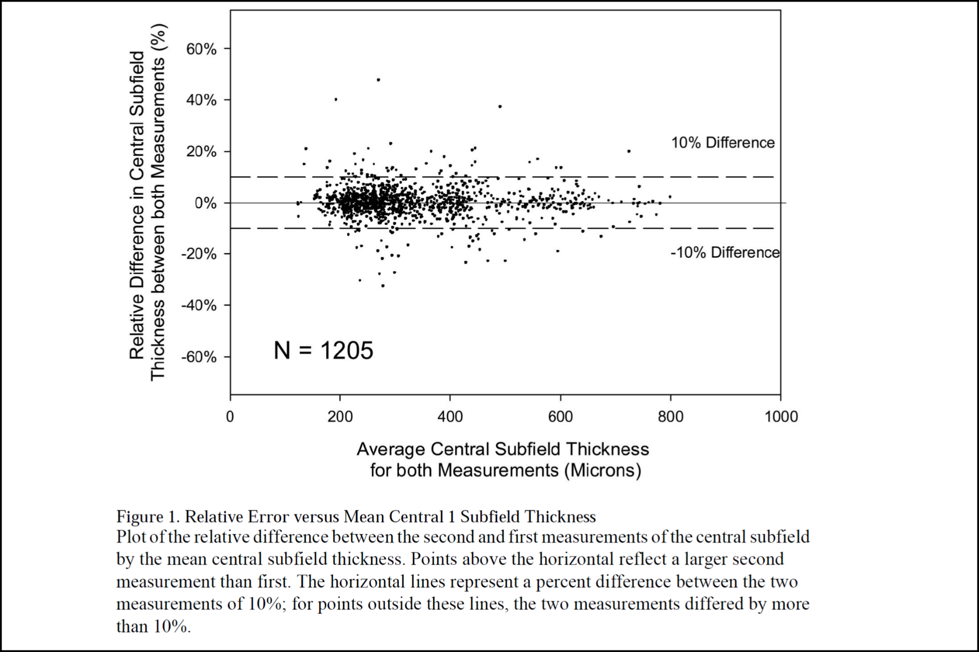

Clinical validity of CRT in terms of visual acuity

Browning et al (Ophthalmology 2007;114:525-36) reported a moderate correlation of r=0.52 comparing baseline visual acuity with baseline CRT measured by OCT in 251 eyes:

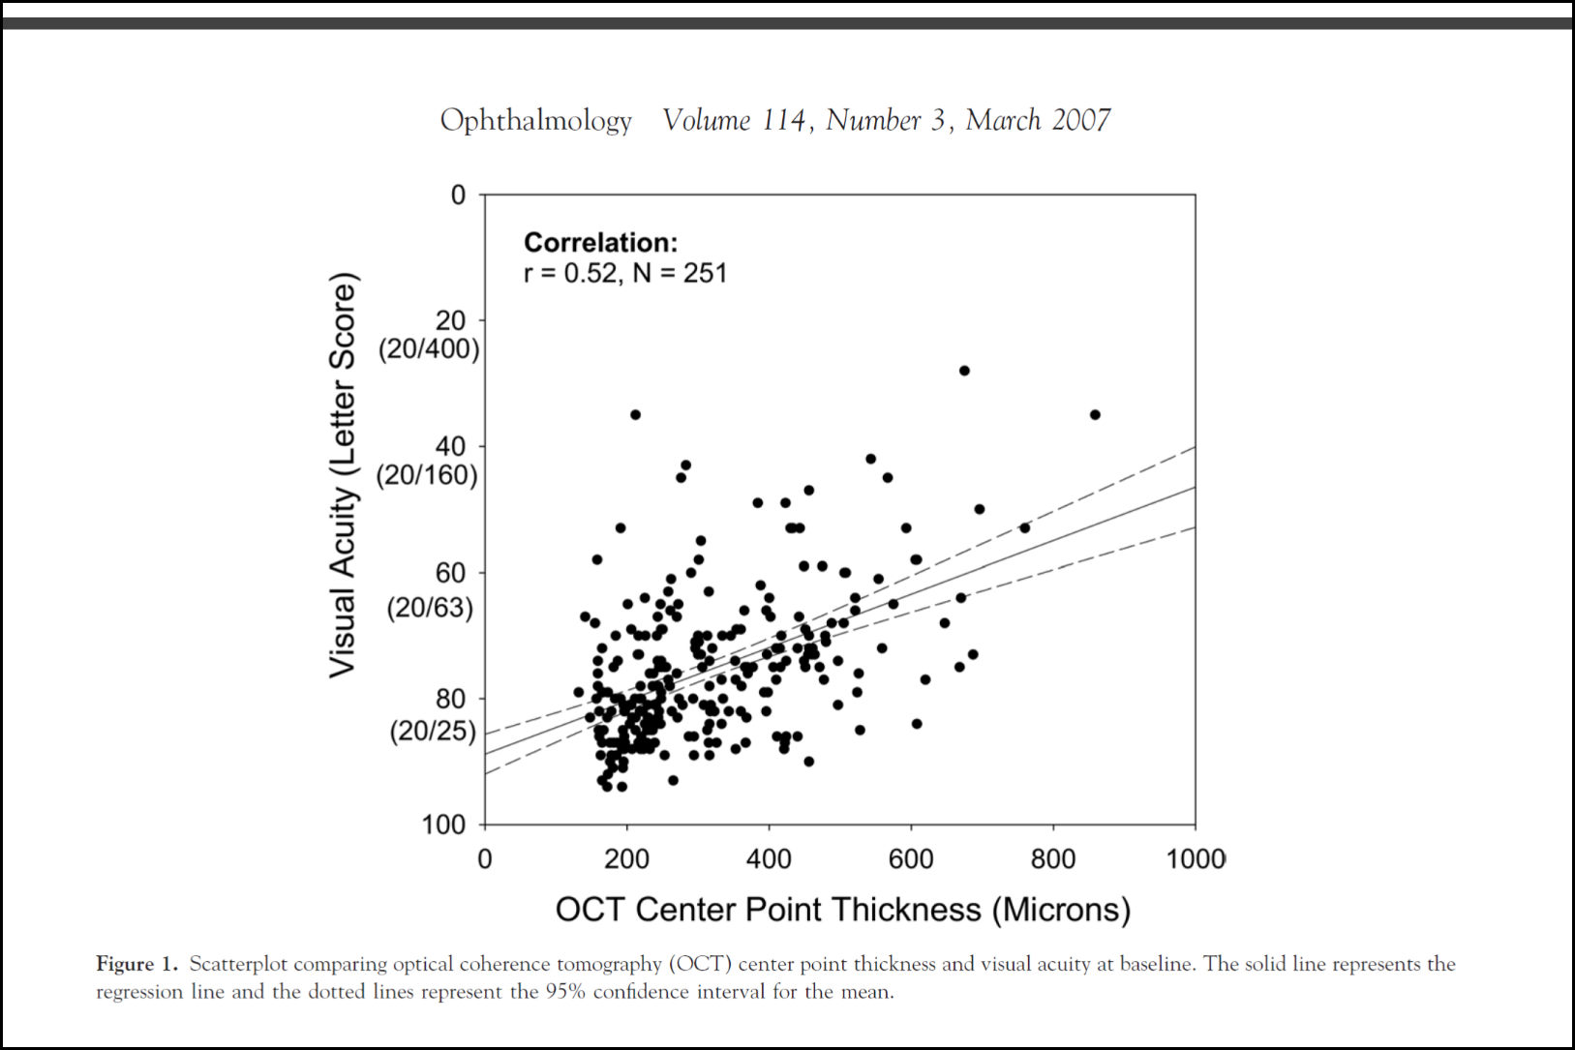

Similar results were reported from Trial 024, which used SD-OCT (R2=**redacted**):

**Figure redacted**

Whether baseline CRT predicts a material variation in dexamethasone implant treatment effect on visual acuity

The submission stated that the inclusion criterion based on a CRT ≥ 300 µm (threshold for a ‘normal’ macula) in the dexamethasone implant trials (included as the evidence base for the submission to PBAC) was not to predict response to therapy, but to ensure that trial patients had macular oedema. ESC noted that, as a consequence of this, there were few data points below this threshold in any trial-based assessment of correlation between CRT and change in visual acuity.

The submission presented: 1) a review of trials in DMO (ranibizumab, bevacizumab, fluocinolone, triamcinolone and dexamethasone implant) to enable a comparison of baseline CRT thresholds applied as eligibility criteria, and 2) a *post hoc* analysis of individual patient data (IPD) from randomised trials of dexamethasone implant (MEAD trials: Trials 010 and 011 (versus sham) and Trial 024 (versus ranibizumab)[1]. A review of the literature was also presented to determine the CRT of a normal, healthy fovea as measured by OCT.

From the literature search and analyses conducted, the submission concluded that:

* Evidence from the literature shows that a healthy macula measured using TD-OCT ranges between 144 µm and 212 µm, whilst a healthy macula measured using SD-OCT ranges between 201 µm 290 µm. The inclusion criterion of a CRT threshold of ≥ 300 µm, used in the dexamethasone implant trials, is therefore an appropriate threshold to diagnose oedema;
* The majority of studies found no predictive value of baseline CRT on the treatment effect of existing therapies on BCVA outcome and there was apparently no consensus in identifying a CRT threshold that would predict treatment response; and
* From the *post hoc* analysis, there was a weak correlation between baseline CRT versus change in BCVA (MEAD trials R2= **redacted**; Trial 024 R2= **redacted**). Other factors, such as the extent of tissue preservation in the oedematous area, may be better predictors of response to treatment.

The association between change in CRT and change in visual acuity

In line with the Protocol, the submission conducted a literature search for evidence of change in CRT as a surrogate for change in visual acuity. Additional *post hoc* exploratory analyses of the dexamethasone implant trials (MEAD and Trial 024) were presented to assess the association between BCVA change and CRT change (categorised by intervals of 50 µm). The submission concluded from the studies identified in the literature search that there is evidence for a “modest, but significant correlation between change in CRT and change in visual acuity”.

The study by Browning et al (2007) reported a moderate correlation of r=0.44 comparing change in visual acuity with absolute change in CRT measured by OCT after 3.5 months (correlations of r=030 after 8 months and r=0.43 after 12 months were also reported):

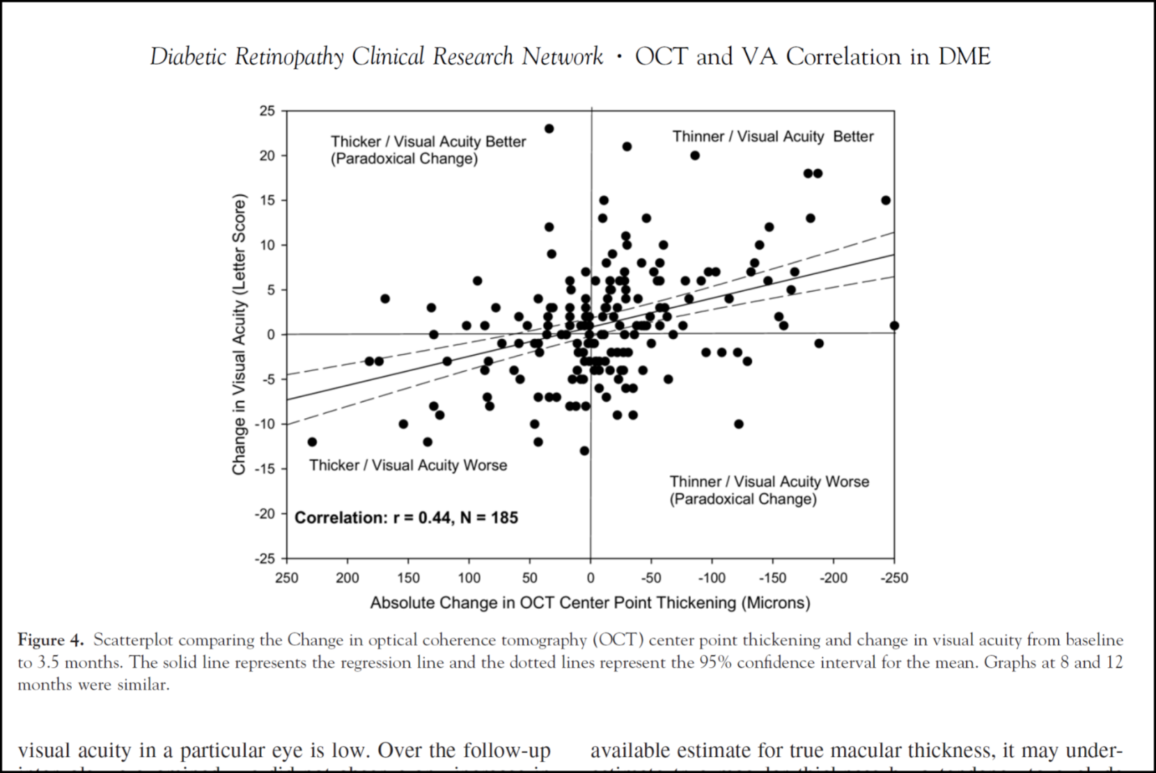

This analysis also showed substantial paradoxical variation across these outcomes. Some eyes with maculas that became thicker had paradoxically increased visual acuity (7%-17% across the three time points assessed), and some eyes with maculas that became thinner had paradoxically decreased visual acuity (18%-26%).

The *post hoc* analyses of the dexamethasone implant trials also showed that there was a moderate correlation between change in CRT and change in visual acuity in both the MEAD (R2= **redacted**) and 024 (R2= **redacted**) trials. The plot for 024, which used SD-OCT, is shown below:

**Figure redacted**

ESC provided advice to MSAC that the utility of adding CRT assessed by OCT as a surrogate measure to the more directly patient-relevant and easily assessed measure of visual acuity was not clear. It was also not clear what other quantitative and qualitative variables are being measured with OCT beyond CRT to influence re-treatment decisions and, if so, whether evidence would be available to support monitoring of these variables.

Whether response criteria can predict true inter-subject variation in treatment effect in order to evaluate the effectiveness of OCT

The submission provided:

* a summary of re-treatment criteria in DMO trials (ranibizumab, bevacizumab, fluocinolone, triamcinolone and dexamethasone implant trials)
* a literature review to determine the CRT of a normal (healthy) fovea as measured by OCT and any inter-individual variation in treatment effect regarding a defined CRT response criterion in DMO and any minimal clinically important difference (MCID) in CRT. Re-treatment data from the MEAD trials were also analysed to determine the proportion of patients re-treated.

The MEAD and BEVORDEX trials had OCT thresholds for re-treatment which varied across the two trials. The MEAD trials used a re-treatment threshold of > 225 μm, and 75% of its participants were re-treated. In the key Trial 024 comparing dexamethasone implant with ranibizumab, there appeared to be no CRT or visual acuity threshold for re-treatment with dexamethasone. Re-treatment was administered at Months 5 and 10 when a patient was judged to have residual oedema[2]. The submission noted that, in the dexamethasone implant trials, CRT measurement by OCT was used to confirm the presence of residual macular oedema (and thus the potential to benefit from treatment) rather than to assess the extent of response to treatment.

The submission offered the following observations:

* The literature suggests that a CRT of 175 µm to 225 µm is considered a flat retina and thus any macula with a CRT of ≤ 225 µm as assessed by OCT indicates an absence of oedema.
* In clinical practice, the assessment of oedema is considered a binary assessment (present or absent).
* Expert advice provided to the applicant is that re-injection with dexamethasone implant (expected to be about six months after the previous injection) would be considered only if there is evidence of oedema via OCT and other monitored aspects of the disease support re-injection.

Translation issues

This was not addressed in the submission as the economic considerations were addressed in the concurrent submission to PBAC. No direct evidence of the consequence of using OCT or not on patient health outcomes was identified. ESC noted that the dexamethasone studies were not designed to answer the questions posed in the Protocol. ESC also noted that no analyses were presented to examine whether there is any variation in OCT performance between the pseudophakic and non-pseudophakic subgroups. The pre-MSAC response indicated that no variation should be expected.

# Economic evaluation

This was not addressed in the submission. A cost-minimisation comparing dexamethasone implant and anti-VEGF therapy was presented in the concurrent submission to PBAC.

# Financial/budgetary impacts

The submission proposed a schedule fee of $91.75 for each OCT scan. The submission assumed two OCT scans per injection of dexamethasone implant with an average of 2.7 injections in the first year declining to 1.9 and 1.8 in the subsequent years.

Discussion with the Department established that a fee of $50 would be more appropriate as it correctly reflects current clinical practice. ESC advised that $50 was a more appropriate fee and noted that the lower fee would impact on the cost calculations in the economic model. MSAC agreed that $50 is a more appropriate fee.

The cost of an intravitreal injection to insert the dexamethasone implant was estimated to be $300.75 with an average of 2.7 treatments in the first year, declining to 1.9 and 1.8 in the subsequent years. Additional costs included consultation fees.

Using an epidemiological approach, the number of pseudophakia patients with centre-involving DMO (eligible population) was estimated to be between 10,000 – 50,000 by Year 5.

The estimated number of patients who would be scanned and treated, accounting for market share, was less than 10,000 by Year 5. The estimated number of scans was between 10,000 – 50,000 by Year 5.

The Pre-ESC response provided a sound rationale for why the number of initial OCT scans should be similar to the number of initial dexamethasone injections, and had acknowledged the discrepancy between uptake rates between the submissions to MSAC and PBAC. The uptake rates should reflect the estimates provided to PBAC.

The submission did not present net costs to the MBS. The concurrent submission to PBAC presented the net costs to the MBS. These included the administration costs of dexamethasone implant + OCT versus administration costs of ranibizumab (no OCT). The revised net cost saving to the MBS was approximately less than $10 million in Year 1. MSAC considered that the main source of cost offset arose from the claim that treatment with dexamethasone would reduce the frequency of injections compared with anti-VEGF therapy. MSAC noted that the frequency of re-treatment with dexamethasone would be expected to be less than that for anti-VEGF re-treatment because it would likely to be also influenced by the delivery of the medicine from its implant formulation. As a consequence, a claim that not using OCT would mean that ophthalmologists would err of the side of caution and give more frequent injections would apply less obviously to dexamethasone.

MSAC noted that the assumptions in the submission were based on current MBS utilisation in the absence of any PBS-listed treatment for DMO (ranibizumab and aflibercept have been recommended for listing but were not yet listed). The current use of MBS eye injection items is likely limited due to the unaffordability of treatment without PBS subsidy. It is possible that the availability of any PBS-listed treatment would drive an overall increase in utilisation. Such unmet clinical need was not accounted for in the budgetary forecasts. The pre-MSAC response argued against this, suggesting that current MBS utilisation reflects “administration of off-label intravitreal bevacizumab to treat DMO”.

# Key issues from ESC for MSAC

ESC considered that OCT was being proposed as an additional objective measurement to provide an absolute measure prior to initial treatment (diagnostic tool) and subsequent re-treatment (monitoring).

In relation to the proposed use of OCT for diagnosis prior to treatment, ESC advised that there was inadequate evidence to determine a CRT threshold which is predictive of treatment response.

In relation to the proposed use of OCT for monitoring, ESC advised that:

* the utility of adding CRT assessed by OCT as a surrogate measure to the more directly patient-relevant and easily assessed measure of visual acuity was not clear
* although OCT instruments have adequate intra-instrument reproducibility/reliability, greater inter-instrument variability might be of concern if re-treatment decisions are based on particular thresholds of retinal thickness
* it was not clear what other quantitative and qualitative variables are being measured with OCT beyond CRT to influence re-treatment decisions and, if so, whether evidence would be available to support monitoring of these variables.

Despite the widespread dissemination of OCT, the evidence supporting a co-dependency between OCT and dexamethasone implant is weak. Without a clear link between OCT results and changing management with dexamethasone, it was difficult to determine how using OCT could improve health outcomes.

The dexamethasone studies were not designed to answer the questions posed in the Protocol. No analyses were presented to examine whether there is any variation in OCT performance between the pseudophakic and non-pseudophakic subgroups.

Without a clear link between OCT results and changing management with dexamethasone, it was difficult to determine how using OCT could affect the use of other health care resources.

# Other significant factors

Nil.

# Applicant’s comments on MSAC’s Public Summary Document

Allergan are pleased that the MSAC support an expedited process for MBS listing of OCT to

ensure public funding of OCT is aligned with the circumstances recommended by the PBAC

for dexamethasone implant. Allergan will continue to work with the PBAC to ensure dexamethasone implant is made available on the PBS for eligible Australian patients.

# Further information on MSAC

MSAC Terms of Reference and other information are available on the MSAC Website at: [www.msac.gov.au](http://www.msac.gov.au/).

1. The BEVORDEX trial of dexamethasone versus bevacizumab was not included because the applicant had no access to IPD data from this trial).
2. The 024 trial protocol noted that patients could receive deferred laser treatment any time during the study after month 2 if they had a VA of ≥ 10 letters worse than baseline/an OCT central subfield > 320 μm or 300 μm depending on instrument type (p23 of the 024 Protocol, Volume 3 of the MSAC submission).