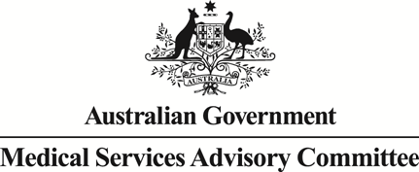
Public Summary Document

Report to the Medical Services Advisory Committee on real world outcomes of Application 1221: Intravesical injection of Botox® (botulinum toxin type A) for the treatment of urinary incontinence due to neurogenic detrusor overactivity (NDO)
Medicare Benefits Schedule (MBS) items considered: 18375 and 36851
Date of MSAC consideration: 24-25 November 2016
Context for decision: MSAC makes its advice in accordance with its Terms of Reference, see the MSAC Website

Purpose
The purpose of the report presented to the Medical Services Advisory Committee (MSAC) was to inform MSAC of the real world impacts on the outcomes of application 1221. The MSAC then uses this information to ensure that the new item/s resulting from this application/s is being used as intended.
The report is not intended to be a review of the clinical information covered during the application process.

MSAC’s advice
After considering the real world impacts of the outcomes of application 1221 for the intravesical injection of botulinum toxin type A (Botox®) for the treatment of urinary incontinence due to neurogenic detrusor overactivity (NDO) (MBS item number 18375), MSAC recommended that that the potential issue of inappropriate co-claiming of cystoscopy with this item be referred to the department to investigate if the intention was to include cystoscopy as part of this service.

Summary of consideration and rationale for MSAC’s advice
MSAC considered the real world impacts of the outcome of application 1221 for the intravesical injection of botulinum toxin type A (Botox®) for the treatment of urinary incontinence due to neurogenic detrusor overactivity (NDO) (MBS item number 18375) by examining the available data for this item number.
In considering the utilisation data MSAC noted that actual utilisation of the item number was significantly below the total services expected. MSAC noted that the number of patients receiving the service was also much lower than estimated. MSAC considered that the lower than expected utilisation of this service is most likely a reflection of low patient acceptability regarding the procedure. MSAC noted that this is a relatively invasive procedure that requires hospitalisation and anaesthesia. MSAC considered that a large proportion of patients would have lived with NDO for many years and may not consider the quality of life gains of intravesical injection of Botox® substantial enough to undergo treatment.
In considering the co-claiming data MSAC noted that item 18375 was predominantly claimed alone. MSAC noted that in some cases item 18375 was co-claimed with other cystoscopy items, despite cystoscopy being included in the item descriptor. MSAC noted that there may be situations in which co-claiming with cystoscopy items may be appropriate. MSAC recommended that the potential issue of inappropriate co-claiming of cystoscopy with this item be referred to the department to investigate if the intention was to include cystoscopy as part of this service.

Methodology
An application is selected for consideration if the resulting new item(s) or item amendment(s) have been on the MBS for approximately 24 months or longer or if there were particular concerns about utilisation such that MSAC requested to consider it earlier. The specific applications for each MSAC meeting are selected by the MSAC Executive which is composed of the Chairs of MSAC and its sub-committees.
A report on the utilisation is developed by the Department of Health (the department) with information on a number of metrics including state variation, patient demographics, services per patient, practitioner’s providing the service, data on fees and co-claiming of services. The number of metrics included in a report is dependent on the annual service volume for the MBS item(s) under consideration i.e. an item with very low utilisation will have less data to analyse. Where service volumes are too low, information is suppressed to protect patient privacy.
Where possible the report compares data on real world utilisation to the assumptions made during the MSAC assessment. Most of these assumptions are drawn from the assessment report.
Relevant stakeholders are provided an opportunity to comment on the findings in the report before it is presented to the MSAC. It is intended that stakeholders are given at least three weeks to consider the reports.
The stakeholder version of the report does not contain information on assumptions from the MSAC consideration if this information is not already publicly available. This is to protect the commercial in confidence of the original applicants. The same principle is applied to this document.
Once MSAC has considered the report its advice is made available online at the MSAC Website.

Results

Utilisation
Item 18375 has been growing steadily since listing. However, overall utilisation is low at 299 services in 2014-15 and 456 services in 2015-16 (Table 1).
It was expected that there would be a decrease in utilisation of item 36851 due to the restriction for injecting botulinum toxin under this item. Item 36851 does not appear to have been affected by the listing of 18375, growing by 36% from 2012-13 to 2013-14 and by 14% from 2013-14 to 2014-15 (Table 1).

Table 1: Services, growth and benefits paid per state for MBS item 18375 and 36851 from 2010-2011 to 2015-16
 |  | 2010-11 | 2011-12 | 2012-13 | 2013-14 | 2014-15 | 2015-16
18375 | Services |  |  |  | 70 | 299 | 456
 | Growth |  |  |  |  | +327% | +53%
 | Benefits |  |  |  | $12,068 | $51,548 | $78,614
36851 | Services | 661 | 745 | 861 | 1,168 | 1,324 | 1,242
 | Growth |  | +13% | +16% | +36% | +14% | -6%
 | Benefits | $82,760 | $96,346 | $117,600 | $162,869 | $183,971 | $158,951
Source: Medicare statistics online and Department of Health

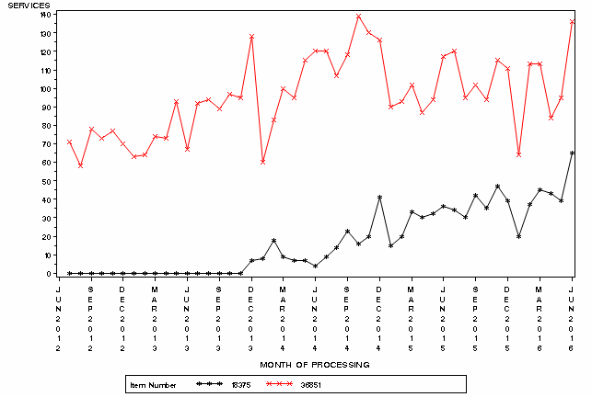

Figure 1: Month by month comparison of service volume for MBS items 36851 and 18375
Source: Medicare statistics online

Patient breakdown
There were 381 patients who claimed item 18375 in 2015-16. Of these, 272 were new patients and 109 continuing from the previous financial year (Table 2).
The maximum number of treatments per year is two, with no less than six months to elapse between treatments, as stated in the PBS restrictions for botulinum toxin. In 2015-16, 19% of patients received two or more treatments under item 18375 (Table 3). The number receiving more than two is very small and may be a data error given that it is specifically prohibited.
At least 12% of patients who have received treatment in the first year have remained on treatment (Table 4).
The service is predominantly used by females aged 45-74 (Figure 2).

Table 2: Number of new and continuing patients who received MBS item 18375 in 2013-14, 2014-15 or 2015-16
Financial Year | New Patients | Continuing Patients | Total Patients
2013-14 | 65 |  | 65
2014-15 | 222 | 39 | 261
2015-16 | 272 | 109 | 381

Table 3: Number of services per patient in 2014-15 and 2015-16
Financial year | Number of services per patient | Count | Percentage
2014-15 | 1 | 226 | 87%
 | 2+ | 35 | 13%
 | Total | 261 | 100%
2015-16 | 1 | 310 | 81%
 | 2+ | 71 | 19%
 | Total | 381 | 100%

Table 4: Number of services per patient since service listed 1 October 2014 to June 2016
Number of services per patient | Count | Percentage
1 | 382 | 68%
2 | 114 | 20%
3 | 46 | 8%
4+ | 17 | 4%
Total | 559 | 100%
Source for tables 2-4: Department of Health

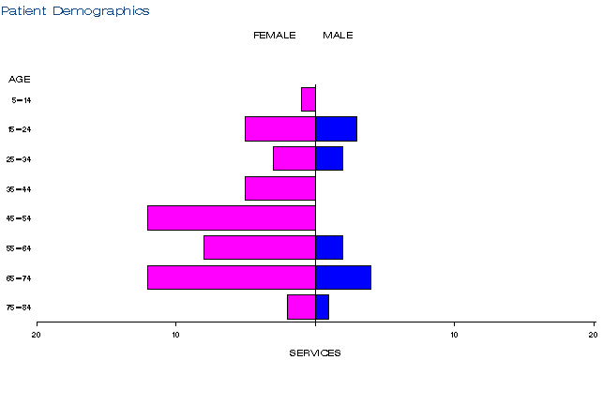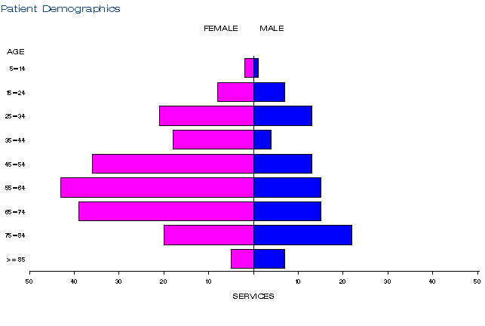
a)
b)

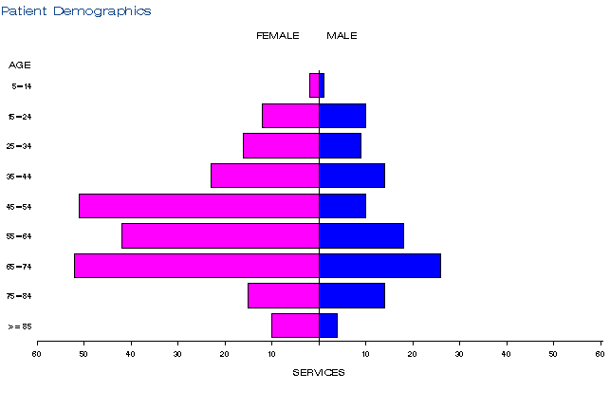
c)

Figure 2: Demographic profile for MBS item 18375 for 2013-14 (a), 2014-15 (b) and 2015-16 (c)
Source: Medicare statistics online

Practitioner breakdown
The number of practitioners providing this service has been increasing steadily each year (Table 5). The service is predominantly provided by general surgeons and specialists in urology (Table 6). Provision of the service is not very concentrated with 40% of practitioners providing around 80% of services (Table 7).

Table 5: Number of practitioners providing this service in 2013-14 to 2015-16
Financial year | Australia
2013-14 | 17
2014-15 | 49
2015-16 | 64

Table 6: Practitioner specialties providing item 18375 from 2013-14 to 2015-16
Practitioner specialty | 2013-14 | 2014-15 | 2015-16
Surgery - General Surgery | 12 | 19 | 14
Surgery - Urology | 58 | 275 | 428
Other | np | np | np

NP = not printed

Table 7: Cumulative percentage of medical practitioners providing item 18375 and how many services each percentile accounts for in 2013-14 to 2015-16
 | 2013-14 | 2014-15 | 2015-16
10% | 39% | 53% | 53%
20% | 63% | 72% | 66%
30% | 69% | 83% | 78%
40% | 80% | 88% | 84%
50% | 87% | 91% | 90%
60% | 91% | 94% | 93%
70% | 93% | 96% | 96%
80% | 96% | 97% | 98%
90% | 99% | 99% | 99%
100% | 100% | 100% | 100%
Source for tables 5-7: Department of Health

Co-claiming
The service is predominantly claimed by itself (Tables 8-10). The most common items claimed with the service are those for cystoscopy (MBS items 36811, 36812, 36815, 36818, 36827, 36840, 36851 or 36854). In 2015-16 the service is co-claimed with a subsequent consult (MBS item 105). This claiming is specifically prohibited in the item descriptor of item 18375.

Table 8: Top 10 instances of co-claiming with MBS item 18375 in 2013-14
# | Items | Episodes | Number of Services | Schedule Fee for Combination | % of total episodes | Cumulative %
1 | 18375 | 60 | 60 | $13,791 | 86% | 86%
2 | 18375, 36840. | np | np | np | np
3 | 18375, 00105, 36863. | np | np | np | np
4 | 18375, 00105. | np | np | np | np
5 | 18375, 11903. | np | np | np | np
6 | 18375, 35599. | np | np | np | np
7 | 18375, 36811, 55085. | np | np | np | np
8 | 18375, 36812. | np | np | np | np
9 | 18375, 36854. | np | np | np | np
10 | 18375, 36860. | np | np | np | np

Table 9: Top 10 instances of co-claiming with MBS item 18375 in 2014-15
# | Items | Episodes | Number of Services | Schedule Fee for Combination | % of total episodes | Cumulative %
1 | 18375 | 242 | 242 | $55,624 | 81% | 81%
2 | 18375, 36827. | 16 | 32 | $7,355 | 5% | 86%
3 | 18375, 37011. | np | np | np | np
4 | 18375, 36840. | np | np | np | np
5 | 18375, 36854. | np | np | np | np
6 | 18375, 00105, 36827. | np | np | np | np
7 | 18375, 00105. | np | np | np | np
8 | 18375, 36811. | np | np | np | np
9 | 18375, 36812. | np | np | np | np
10 | 18375, 36818, 36827. | np | np | np | np

Table 10: Top 10 instances of co-claiming with MBS item 18375 in 2015-16
# | Items | Episodes | Number of Services | Schedule Fee for Combination | % of total episodes | Cumulative %
1 | 18375 | 388 | 388 | $89,182 | 80% | 80%
2 | 18375, 00105 | 13 | 26 | $3,547 | 3% | 83%
3 | 18375, 36812. | 12 | 24 | $4,759 | 2% | 85%
4 | 18375, 36840. | 11 | 22 | $6,084 | 2% | 87%
5 | 18375, 36827. | 10 | 20 | $4,597 | 2% | 89%
6 | 18375, 36818, 36827. | np | np | np | np
7 | 18375, 36836. | np | np | np | np
8 | 18375, 37011. | np | np | np | np
9 | 18375, 36863. | np | np | np | np
10 | 18375, 00105, 36827. | np | np | np | np
NP = not published due to low volumes
Source for tables 8-10: Department of Health

Data on fee charged
The average fee charged in 2015-16 ranged from $339 in WA to $552 in SA (Table 11). The median fee charged in SA in 2015-16 is $657 and is only $1 below the 95th percentile fee charged, indicating that the higher fee is the most common fee charged for that state.
This service has only been bulk billed in NSW.

Table 11: Statistics on fees charged for MBS item 18375 for 2014-15 to 2015-16 by date of service
 |  | Provider State/Territory
 |  | NSW | VIC | QLD | SA | WA | TAS | NT | ACT | Australia
2014-15 | Average Fee Charged | $401 | $357 | $435 | $477 | $302 | np | np | np | $391
 | Std Deviation | $88 | $86 | $128 | $127 | $119 | np | np | np | $111
 | Median Fee Charged | $383 | $383 | $392 | $406 | np | np | np | np | $240
 | 75th Percentile | $408 | $408 | $447 | $614 | np | np | np | np | $350
 | 95th Percentile | $600 | $530 | $622 | $656 | np | np | np | np | $500
 | Bulk-billing Rate | 6% | 0% | 0% | 0% | 0% | np | np | np | 0%
2015-16 | Average Fee Charged | $398 | $365 | $446 | $552 | $339 | np | np | np | $402
 | Std Deviation | $73 | $50 | $112 | $189 | $142 | np | np | np | $114
 | Median Fee Charged | $365 | $362 | $394 | $657 | $282 | np | np | np | $358
 | 75th Percentile | $394 | $410 | $545 | $658 | $363 | np | np | np | $365
 | 95th Percentile | $600 | $532 | $622 | $658 | $650 | np | np | np | $410
 | Bulk-billing Rate | 10% | 0% | 0% | 0% | 0% | np | np | np | 0%
NP = not published due to low volumes
Source: Department of Health

Background
In August 2011, an application to the MSAC was received from Allergan Australia Pty Ltd, requesting MBS listing of intravesical injection of Botox® for the treatment of urinary incontinence due to neurogenic detrusor overactivity (NDO). This MSAC application is co-dependent on an application to the Pharmaceutical Benefits Advisory Committee (PBAC) for Pharmaceutical Benefits Scheme (PBS) listing of the drug component of the service.
Prior to the procedure, the patient is usually given a local anaesthetic, with light sedation administered by an anaesthetist, or may occasionally be provided under general anaesthesia. A rigid or flexible cystoscope is inserted through the urethra and into the bladder to allow visualisation of the bladder wall. Reconstituted Botox® (200 U in 30 mL) is injected into the inner muscular layer of the bladder wall (detrusor). Clinical improvement generally occurs within 2 weeks. Time to re-treatment is approximately nine months.
Injecting Botox® into the bladder wall was not formally approved for funding via the MBS prior to MSAC’s consideration in April 2013. Expert clinical opinion confirmed that the service was being performed under MBS item 36851 (cystoscopy with injection into the bladder wall) and that patients were paying for the drug in the absence of PBS subsidy. Item 36851 was not originally listed for such use; it was mainly intended for bulking agent injections into the bladder.
A re-application for PBS listing of Botox® for this indication was considered at the March 2013 PBAC meeting. MSAC was advised that, as a subsequent out-of-session decision, PBAC recommended the listing of botulinum toxin type A (Botox®) for this indication. The MSAC supported the listing of a new item onto the MBS for this service at its April 2013 meeting where it also recommended that the existing item 36851 should be amended to exclude its use for the injection of any botulinum toxin product.

Item descriptor
18375 | Botulinum Toxin Type A Purified Neurotoxin Complex (Botox®), intravesical injection of, with cystoscopy, for the treatment of urinary incontinence, including all such injections on any one day, if:  (a) the urinary incontinence is due to neurogenic detrusor overactivity as demonstrated by urodynamic study of a patient with:  (i) multiple sclerosis; or  (ii) spinal cord injury; or  (iii) spina bifida and who is at least 18 years of age; and  (b) the patient has urinary incontinence that is inadequately controlled by anti-cholinergic therapy, as manifested by having experienced at least 14 episodes of urinary incontinence per week before commencement of treatment with botulinum toxin type A; and  (c) the patient is willing and able to self-catheterise; and  (d) the requirements relating to botulinum toxin type A under the Pharmaceutical Benefits Scheme are complied with; and  (e) treatment is not provided on the same occasion as a service described in item 104, 105, 110, 116, 119, 11900 or 11919  For each patient - applicable not more than once except if the patient achieves at least a 50% reduction in urinary incontinence episodes from baseline at any time during the period of 6 to 12 weeks after first treatment (Anaes.)  (See para T11.1 of explanatory notes to this Category)  Fee: $229.85 Benefit: 75% = $172.40
36851 | Cystoscopy, with injection into bladder wall, other than a service associated with a service to which item 18375  or 18379 applies (H) (Anaes.)  (See para T8.2 of explanatory notes to this Category)  Fee: $229.85 Benefit: 75% = $172.40

Applicant’s comments on MSAC’s public summary document
Nil response

Further information on MSAC
MSAC Terms of Reference and other information are available on the MSAC Website.

The 95th percentile fee charged represents that 95% of the time the fee is below this amount but in 5% of cases, the fee is higher than this.

