Public Summary Document

Application 1221 – Intravesical injection of BOTOX® (botulinum toxin type A) for the treatment of urinary incontinence due to neurogenic detrusor overactivity (NDO)

Sponsor/Applicant/s: Allergan Australia Pty Ltd

Date of MSAC consideration: 29 – 30 November 2012

1. Purpose of application
In August 2011, an application to the Medical Services Advisory Committee (MSAC) was received from Allergan Australia Pty Ltd, requesting Medicare Benefits Schedule (MBS) listing of intravesical* injection of BOTOX® for the treatment of urinary incontinence due to neurogenic detrusor overactivity (NDO). This MSAC application was co-dependent on an application to the Pharmaceutical Benefits Advisory Committee (PBAC) for Pharmaceutical Benefits Scheme (PBS) listing of the drug component of the service.

At its July 2012 meeting, PBAC deferred the application based on uncertain cost- effectiveness, utilisation and financial estimates. PBAC sought information from MSAC about the MBS cost of the service to deliver the drug, including subsequent patient monitoring, as well as additional information from the sponsor about the economic model and drug utilisation.

* Please note: Terminology used in the original title of this application was ‘transurethral injection of BOTOX®’, but expert clinical opinion recommended changing it to ‘intravesical injection’.

Urinary incontinence due to NDO, is described as incontinence resulting from an underlying neurologic disorder, such as multiple sclerosis (MS) or spinal cord injury (SCI). In patients with NDO, spontaneous detrusor contractions lead to increased bladder pressure, reduced storage volume and incontinence.

Prior to the procedure, the patient would usually be given local anaesthetic, with light sedation administered by an anaesthetist, or may occasionally be provided general anaesthesia. A rigid or flexible cystoscope is inserted through the urethra and into the bladder to allow visualisation of the bladder wall. Reconstituted BOTOX® (200 U in 30 mL) is injected into the inner muscular layer of the bladder wall (detrusor). Clinical improvement generally occurs within 2 weeks. Time to re-treatment is approximately nine months.
Injecting BOTOX® into the bladder wall has never been approved for use on the MBS. MSAC noted expert clinical opinion which confirmed that the service was currently being performed under MBS item 36851 (cystoscopy with injection into the bladder wall) and patients self-pay for the drug. Item 36851 was not originally listed for such use, the intended use being for bulking agent injections into the bladder. Injecting BOTOX® under item 36851 has been allowed to continue, pending the outcome of MSAC’s assessment.

2. Background
This is the first time MSAC has considered the MBS listing of intravesical injection of
BOTOX® for the treatment of ‘urinary incontinence due to NDO.

In May 2012, Allergan submitted a separate application (Application 1272) requesting MBS- listing of intravesical injection of BOTOX® for the treatment of urinary incontinence due to idiopathic detrusor overactivity (IDO).

3. Prerequisites to implementation of any funding advice
BOTOX® was TGA approved for the treatment of urinary incontinence due to NDO in March 2012. The TGA approved indication is “Treatment of urinary incontinence due to neurogenic detrusor overactivity resulting from a defined neurological illness (such as spinal cord injury or multiple sclerosis) and not controlled adequately by anticholinergic agents. This does not include idiopathic overactive bladder.”

Proposed PBS Section 100 listing for BOTOX® in NDO
An application for PBS listing of the drug has progressed through PBAC. The proposed PBS
Section 100 listing is provided below:

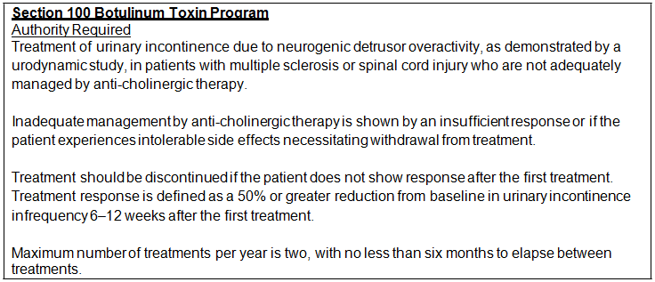

4. Proposal for public funding

Applicant’s proposed MBS item descriptor
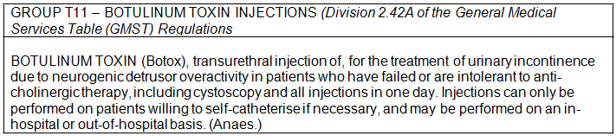The applicant proposed that injections be funded for both in and out-of-hospital settings. MSAC noted expert clinical opinion which recommended the funded service be restricted to hospital settings, where patients are day-admitted to hospital (i.e. as admitted ‘inpatients’) or are occasionally overnight-admitted (in cases of significant co-morbidities), which is consistent with the MBS item already being billed for the service (item 36851).

The applicant also proposed that a urine flow study (MBS item 11900) be billed on the same day as the procedure. MSAC noted expert clinical opinion that this simple test, if needed on the day of procedure, would already form part of the BOTOX® service fee and should not be billed separately. Item 11900 could be billed during a subsequent (follow-up) visit to the specialist if urinary retention needed to be assessed.

The proposed MBS listing is consistent with the TGA-approved indication; however the proposed PBS listing limits access to MS and SCI patients (i.e. it excludes patients with stroke and Parkinson’s disease). PBAC determined that the final patient population may be wider than MS and SCI. MSAC may wish to consider whether patient restrictions (e.g. MS and SCI) should be explicitly stated in the MBS item descriptor.

The proposed MBS item restricted injections to patients with urinary incontinence due to NDO (a distinct subset of overactive bladder syndrome (urge incontinence) that arises either as a direct result of a primary neurologic disorder (such as MS or SCI), or secondary to a non-neurologic disease impacting the bladder’s neural pathway).

The proposed MBS item would require patients to have failed or be intolerant to anti- cholinergic medications.

The Final DAP stated that delivery of the injection could be restricted to certain specialties, including urologists and potentially also gynaecologists or subspecialties of gynaecology (e.g. urogynaecologists). The Critique of the SBA stated that the TGA product information specifies that intra-detrusor administration of BOTOX® is only to be conducted by a urologist/urogynaecologist who has been trained in this highly specialised technique, or by a urologist/urogynaecologist under direct supervision of a urologist/urogynaecologist who has been trained.

5. Consumer Impact Statement
There is concern that restricting the service to particular specialties and ‘in-hospital’ settings may disadvantage some consumers, particularly those with access issues, such as patients living in rural and remote areas. Also there may be inequality in access between patients with and without private health insurance. However, it was noted that safety concerns associated with using BOTOX® means the service must be restricted to adequately trained and approved practitioners, and restricted to hospital/admitted day patient settings because of the
cystoscopy component.

Adverse events associated with this therapy include retention, requiring intermittent self- catheterisation, which can result in urinary tract infection. Concerns were expressed regarding the place of the treatment in the algorithm/flowchart (i.e. that sacral nerve stimulation (SNS) should be considered before injection of BOTOX®, citing international guidelines when suggesting SNS and BOTOX® should both be second line therapies (i.e. BOTOX® should not be chosen ahead of SNS, because of adverse events).

Concerns were also expressed that the effect of BOTOX® for this indication only lasts
6 months, and the concept of injections by cystoscopy every 6 months for the remainder of a person's life is questionable, as well as possible long term damage from repeated BOTOX® injections (where longer term safety has not been established).

BOTOX® is already used in Australia for the treatment of urinary incontinence due to NDO. Practitioners currently bill MBS item 36851 (cystoscopy, with injection into bladder wall) and patients self-pay for the drug.

6. Proposed intervention’s place in clinical management
BOTOX® injections are proposed as a second-line conservative treatment for patients who are unsuitable for, or fail, first-line conservative management or best supportive care (BSC) e.g. lifestyle modifications including: pad use, portable urinals, clean intermittent catheterisation (CIC) or the use of anti-cholinergic drugs. MSAC noted expert clinical opinion that the use of anticholinergics is normally temporarily suspended, in order to assess
the effectiveness of BOTOX®; however, anticholinergics may be reintroduced approximately
3-4 months following the BOTOX® injection.

Prior to the service, the presence of NDO needs to be confirmed by urodynamic studies (i.e. MBS item 11919), and the patient must be both ‘willing and able’ to self-catheterise.

Sacral nerve stimulation (SNS), a more invasive treatment option (which requires implantation of a system that delivers the electrical stimulation to the sacral nerve), may be utilised less frequently as a result of listing BOTOX® injections on the PBS and MBS (insofar as the drug may displace SNS as a second-line treatment option). However, this is difficult to predict.

BOTOX® therapy is proposed as a second-line approach [i.e. BOTOX® is more invasive than first-line conservative approaches (i.e. lifestyle modifications and/or anti-cholinergic drugs), but less invasive than SNS].

BOTOX® is ‘reversible’ in the sense that the patient may elect not to undergo re-injection at the end of the 6 month effectiveness period.

If the BOTOX® therapy fails, SNS or (return to) first-line conservative therapies are possible treatment options.

7. Other options for MSAC consideration
Not applicable.

8. Comparator to the proposed intervention
The comparator in the Final Decision Analytic Protocol (DAP) was MBS item 36851 (cystoscopy, with injection into the bladder wall), which is the item currently being billed for administering the drug. However, the comparator in the SBA report was ‘best supportive care’. This aligns with PBAC’s assessment of the drug. The main argument in the SBA report was for using proposed best supportive care as the comparator (for assessment of safety and efficacy) based on the assumption that BOTOX® would not substitute for any other therapy
in conservative management. Patients conservatively managed may go on to receive further treatment options, such as SNS.

There is a discrepancy between the comparator proposed in the DAP (MBS item 36851) and the comparator proposed in the SBA report (best supportive care).

Injecting BOTOX® into the bladder wall has never been approved for use on the MBS. MSAC noted expert clinical opinion which confirmed that the service was currently being performed under existing MBS item 36851 (cystoscopy with injection into the bladder wall) and patients self-pay for the drug.
Based on expert clinical opinion, it was determined that the service is currently being provided privately (i.e. billed under the MBS) around 60% of the time, while being provided in public sector settings around 40% of the time.

MSAC agreed that item 36851 should be amended to prevent delivering BOTOX® injections if a new BOTOX® specific item is recommended (and subsequently MBS listed), and also amended if a new BOTOX® specific item is not recommended by MSAC, based on evidence.

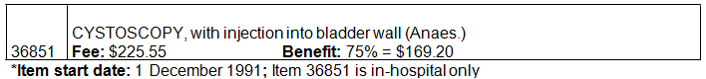
MBS item 36851* - Total services and average practitioner fee per service

Financial year  (Date of processing) | Total services | Average practitioner fee per service  (all services - i.e. patient and bulk-billed services^)
2011/2012 | 745 | $302
2010/2011 | 661 | $288
2009/2010 | 495 | $303

*Item 36851 is currently billed for the procedure (injection of BOTOX® into the bladder wall), without Government approval for such use. As such, data on the item is masked by appropriate usage for which the item was originally approved (i.e. injections other than BOTOX®, such as bulking agents). ^99.06% of services were patient-billed in 2011-12, with private health insurers or patients paying for some or all costs in excess of the MBS rebate.

9. Comparative safety
The literature review identified 21 relevant publications, corresponding to 6 randomised controlled trials (RCTs). Designated Study IDs are used throughout the SBA report to refer to the respective studies (including primary or subsequent publications). The Six randomised controlled trials were presented in the SBA comprised:

• two pivotal Phase III RCTs (Studies 515 and 516) examining the efficacy and safety of BOTOX® in NDO patients;
• a long-term follow-up trial of the two pivotal trials (Study 094); and
• three supportive studies, consisting of two small exploratory Phase II trials (Studies 511 and 518) and one RCT in a selected population (Study 082 – NDO patients with neurological respiratory impairment).

The literature search identified eight published systematic reviews or meta-analyses examining the use of BOTOX® for the treatment of detrusor overactivity were also presented. The SBA report noted that detailed evaluation of the systematic reviews did not identify any additional relevant trials.

MSAC determines the safety of the delivery method (i.e. cystoscopy, with injection into the bladder wall) and PBAC determines safety of the drug. Some evidence in the SBA report (and evaluated in the Critique) related to safety of the injection method.
The main results presented in relation to the procedure to deliver BOTOX® for NDO were: Pain at injection site: No significant differences in incidence of injection site pain were reported by the pivotal studies; the remaining studies (516, 518, 082 and 094) reported no
cases of injection site pain for either the BOTOX® or placebo groups. It was not clear whether this is because no cases occurred or because cases were not recorded.

Urinary tract infection (UTI): The incidence of UTI was higher among the BOTOX® treated patients compared to placebo. No significant differences in rates of UTI related to the procedure itself were identified (rates ranged from 0-23.5% in the BOTOX® group and 0-25.0% in the placebo group).

Haematuria: Differences in incidence of haematuria were not significant (incidence ranged from 0-9.7% for the BOTOX® group and 0-10.0% for the placebo group). No significant differences in incidence of haematuria related to the procedure were observed (the incidence rate for the BOTOX® group ranged from 0-7.7% and for the placebo group from 0-3.3%).

Asthenia: No significant differences were observed between the BOTOX® and placebo group in the incidence of asthenia (incidence ranged from 0.0-8.3% for the BOTOX® group and 0.7-10.0% for the placebo group). Most studies reported zero cases of asthenia due to procedure (one case of asthenia was reported in study 094 in the third treatment cycle with BOTOX®).

Bladder infection: There were no significant differences in bladder infection rates between the BOTOX® group and placebo group (incidence ranged from 0-5.3% in the BOTOX® group and 0-2.1% in the placebo group). No significant differences in rates of bladder infection due to the procedure were observed between the two groups (incidence ranged from 0-1.5% in the BOTOX® group and 0-0.7% in the placebo group).

Additional safety data reported: Additional safety data on adverse events by system organ class (occurring in ≥3% of patients) was provided. It is reproduced in tables AttB.6.3 and AttB.6.4 in Attachment B of the Critique.

MSAC considered that the injection method to deliver BOTOX® for NDO is no more or less safe than services already being provided under MBS item 36851.

Extended assessment of comparative harms
In relation to the use of BOTOX® for NDO:

Long term clinical data: Study 094 (n=91), a follow-up study to pivotal studies 515 and 516, began in April 2009, with a planned duration of 3 years; the results presented in the SBA report are from the most recent interim analysis carried out in May 2010. The patients remained on the same doses as in the pivotal studies (i.e. either 200U or 300U of BOTOX®). The study reported safety data across 4 reinjections. The number of all adverse effects ranged from 2 (first injection) to 56 (second reinjection). The number of injection procedure-related adverse effects ranged from 0 to 7, whilst the number of BOTOX®-related adverse events (AEs) ranged from 1 to 11. The number of serious adverse effects ranged from 0 to 2. There were no (0) deaths or discontinuations due to AEs.

Periodic safety update reports (PSUR): Long-term safety data for BOTOX® is available from the most recent PSUR which covers for the period 1st January to 31st December 2010. The SBA report states that “a comparison of adverse events reported with unlicensed and licensed indications did not suggest any significant differences in the safety profile [...], there were no unexpected AEs associated with the treatment of NDO.
The safety profile was noted to be mostly comparable between BOTOX® and placebo, with the exception of urinary retention, UTI and initiation of de-novo catheterisation in the pivotal trials. Pooled data from the pivotal and supportive studies showed that the majority of adverse event categories were higher among BOTOX® patients than among placebo patients, including the categories of: study drug-related adverse events, injection procedure-related adverse events, and discontinuation due to adverse events. Pooled data from pivotal studies shows higher rates of all adverse events for the BOTOX® group, whilst pooled data from supportive studies shows higher rate of all adverse events for the placebo group. BOTOX® treatment was not associated with disease exacerbation or progression in MS patients. Overall, the adverse events were consistent with the known pharmacology for BOTOX®, with no unexpected safety issues identified.

10. Comparative effectiveness
The majority of evidence on comparative effectiveness of the treatment was focused on the drug component which is subject to assessment by PBAC. In the SBA report and Critique, no comparison was made between the current methods of delivery (cystoscopy, with injection
into bladder wall) and any other delivery method. No further details were given on issues which may be of concern to MSAC.

11. Economic evaluation
The SBA report did not present an economic evaluation of the cost effectiveness of BOTOX® treatment for urinary incontinence due to NDO, as MSAC PASC and PBAC both agreed this issue was to be considered by PBAC.

However, PBAC asked MSAC for feedback on four specific issues associated with listing an
MBS item for BOTOX® for NDO:

(1) the MBS item descriptor;

(2) the patient population and utilisation; (3) the MBS fee; and
(4) patient out-of-pocket costs and Extended Medicare Safety Net risk. These issues will be discussed in Section 13.

The SBA report nominated a fee of $225.55, based on an estimate of the fee for 30 minutes of a urologist’s or urogynaecologist’s time. This estimate was derived from the recommended rate for specialists published by the Workers’ Compensation Regulatory Authority, which was estimated at $241.00 per 30 minutes. The applicant slightly adjusted the fee downwards to align with the fee for MBS item 36851 ($225.55), the item currently being billed for this procedure.

Based on 2011-12 financial year data on MBS item 36851 (currently being billed for the service), practitioners are charging an average fee of $302 for the service, with patients paying an additional amount for the drug. (Please note: Average practitioner fee information includes all services, patient and bulk-billed). The item currently being billed for the service
(MBS item 36851) has a 75% rebate of $169.20. Therefore, an average out-of-pocket cost for patients is $132.80, which would be covered by private health insurance (if patients are insured).

Given item 36851 is also billed for other types of injections (i.e. not just BOTOX®), expert clinical opinion suggested a more common fee being charged for BOTOX® injections is $490, which is consistent with the Australian Medical Association’s recommended fee for the service. Therefore, patient out-of-pocket costs would be $320.80 per service. The drug component of the service must be separately itemised on the account (i.e. not billed to Medicare).

The service would only be provided 'in-hospital', with no Extended Medicare Safety Net (EMSN) financial implications.

12. Financial/budgetary impacts
The estimated number of services, (Table E.2.3 of the Critique was based on the projected number of treatments patients are likely to receive in a single year

The Critique noted that, based on a number of assumptions, the number of services per year estimated in the SBA report is uncertain. The number of services per year could be further under-estimated if patient populations other than MS and SCI are included.

The applicant estimated (redacted) injections per patient per year (base case) over 5 years. This was based on the average length of time to re-treatment in the pivotal studies, and adjusted for the proportion of patients continuing onto re-treatments.
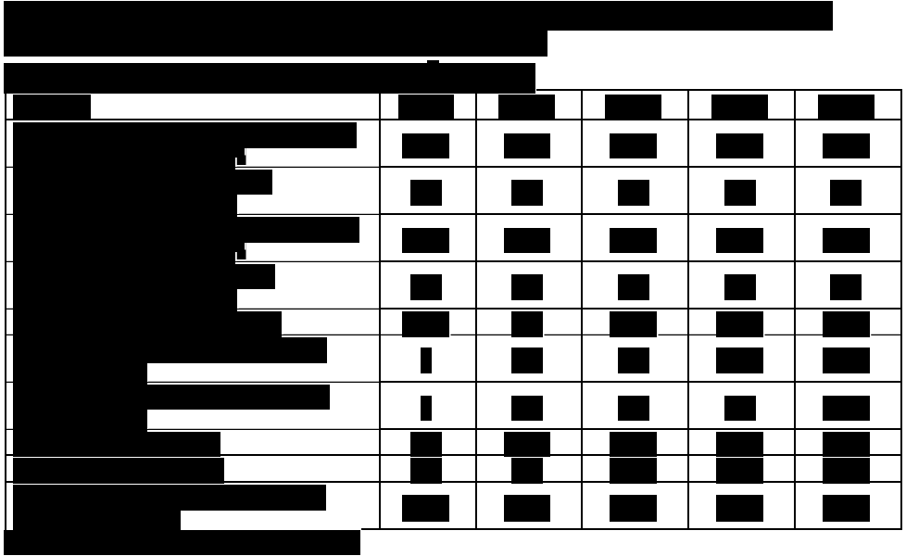
The Critique noted that the estimated number of patients likely to access the proposed therapy did not take into account patients who may currently be receiving it through self-pay arrangements (this was described in Section A of the Critique).
The total projected cost to the MBS, incurred as a result of providing this service over five years, was estimated by the submission to be less than $10 million.

The costs projected above are exclusive of hospital costs, such as admission costs, as well as the cost of antibiotics administered and the cost of BOTOX® needles.

Additional MBS costs to be considered
In terms of additional costs to the MBS, the Final DAP stated that a urine flow test may be required on the same day as the procedure (MBS item 11900). Expert clinical opinion in relation to BOTOX® for IDO (Application 1272) advised that a urine flow test is not necessary (on the same day), and if it was, it should form part of the service. Expert clinical opinion also advised that urodynamic testing (MBS item 11919) is needed to confirm detrusor muscle involvement prior to injecting BOTOX®, usually on a separate occasion of service.
Estimates (from Table E.3.3 of the Critique) demonstrate the additional costs flowing from MBS item 11919 costs. Other pre and post-treatment testing and consultation costs were not included, as these would be occurring with or without the MBS listing of this new intervention.
The total cost of the service to the public is unknown; this would be determined by a number of factors including: service volume, MBS rebate, practitioner fees, and if the patient had private health insurance.
The item currently being billed for the service (MBS item 36851) has a 75% rebate of $169.20. Expert clinical opinion (in relation to Application 1272, BOTOX® for IDO) is that a common fee charged for injecting BOTOX® is $490 (consistent with the Australian Medical Association's recommended fee for the service).
As the proposed service is 'in-hospital only', it would not attract Extended Medicare Safety Net (EMSN) benefits.

13. Key issues for MSAC from ESC

In its deferral of decision on PBS funding for BOTOX® for NDO, PBAC sought information from MSAC on the:

1. MBS item descriptor;

2. Patient population and utilisation;

3. MBS fee; and

4. Patient out-of-pocket costs and Extended Medicare Safety Net risk

MBS Item Descriptor

Based on expert clinical opinion, MSAC ESC determined that the applicant's proposed descriptor needed refinement. An amended descriptor is:
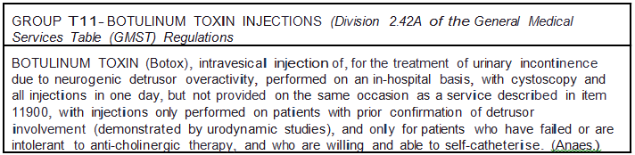

Main issues around the proposed eligible population for public funding and/or the proposed main comparator?

Patient Population and Utilisation

MSAC ESC agreed that the population needs to be resolved (i.e. will the MBS item be specifically limited to patients with MS and SCI, or widened to include other conditions with neurogenic origins, such as patients with spina bifida, stroke or Parkinson's disease). The term 'neurogenic' may be enough to limit the patient population, but if PBAC decided to limit the drug to MS and SCI, the MBS descriptor should align with this and specifically state the population.
MSAC ESC did not resolve whether the 'neurogenic' reference, together with demonstration of 'detrusor ' muscle involvement was enough to prevent future over-use of the item, or whether specific reference to populations is needed in the item descriptor (e.g. limited to patients with MS or SCI, or also limited to patients with stroke or Parkinson's disease). It was agreed that the MBS and PBS listings should align.
MSAC ESC discussed issues associated with re-treatment rates including catheterisation and delay in treatment due to UTI's requiring patients to rebook for the service.
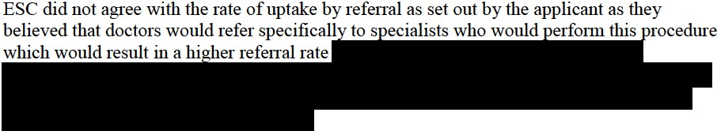

Comparator
The applicant initially proposed MBS item 36851 as the comparator (and MSAC PASC agreed). However, MSAC ESC determined that the comparator is 'best supportive care', in line with PBAC's assessment.
Main issues around evidence and conclusions for safety?
PBAC is assessing the evidence on safety of the drug in treating NDO. Based on evidence, MSAC ESC determined that the procedure to inject BOTOX® for NDO was no more or less inferior to the existing cystoscopy (with injection) procedure funded on the MBS.
Main issues around the evidence and conclusions for clinical effectiveness?
ESC noted that the SF36 and EQ-5D were used in Study 515 and Study 516 (See Appendix 7), but that these were not used to by the applicant to produce utility weights. ESC agreed that it was possible to create SF-D utilities from the SF-36 data at the applicant's disposal (which in tum would enable them to estimate, e.g. QALYs saved by the intervention). ESC agreed that the instrument the applicant used instead, the IQOL, cannot be used to generate QALY-type measures of the intervention's consequences.
PBAC is assessing the evidence for clinical effectiveness of the drug for NDO. These conclusions will determine if an MBS item is listed to administer the drug.
Other important clinical issues and areas of clinical uncertainty?
Most of these issues will be determined and resolved by PBAC, in relation to the use of BOTOX® for NDO. However, MSAC ESC discussed the evidence of increased UTI’s in patients who receive the treatment. MSAC ESC discussed the unce1iainty about whether this would be caused by the procedure or by patient self-catheterisation.
Main economic issues and areas of uncertainty?
MSAC was not expected to reach conclusions on economic issues. This is PBAC's role, and PBAC will use information from MSAC on the appropriate MBS fee for the service (and associated MBS costs) to inform PBAC's economic assessment. However, ESC agreed that the economic modelling should take into account the costs of self-catheterisation and the consequential effect on a patient's utility. ESC also noted that missing data in the two pivotal studies had been replaced by using the last observation carried forward (LOCF) approach. It noted that this approach can introduce bias and frequently gives rise to confidence intervals that are narrower than is justified.

MBS Fee
MSAC ESC agreed the most appropriate MBS fee was $225.55, in line with the existing item being billed for the procedure (MBS item 36851).
Patient Out-of-Pocket Costs and Extended Medicare Safety Net Risk
Based on 2011-12 financial year data, practitioners are currently charging an average fee of $302 for the service under MBS item 36851(with patients self-paying for the drug). This means the average out-of-pocket cost for patients is $132.80, part or all of which may be covered by private health insurance (if patients are insured).
Given item 36851 is also billed for other types of injections (i.e. not just BOTOX®), expert clinical opinion suggested a more common fee being charged for BOTOX® injections is $490, which is consistent with the Australian Medical Association’s recommended fee for the service. This would mean patient out-of-pocket costs of $320.80 per service. The drug component of the service must be separately itemised on the account (i.e. not billed to Medicare).

The service will only be provided ‘in-hospital’, with no Extended Medicare Safety Net (EMSN) financial implications.

MSAC ESC determined that other MBS costs associated with the procedure are unclear. There are various reasons for this, including:

• lack of information in the SBA report and Critique on anaesthetic costs on the same day as the procedure;

• uncertainty about whether a new (specific) MBS listing of BOTOX® for NDO will increase demand for the service (or would current rates of utilisation simply transfer from existing item 36851 to the new item); and

• whether the cost of UTI diagnosis and treatment should be factored into cost estimates.

To assist MSAC, the following information is provided: Anaesthetic costs on the day of procedure
MBS item 17610 – Pre-anaesthesia consultation
(MBS fee $42.20, with patient rebate of $31.65)

MBS item 20910 – Initiation of management of anaesthesia
(MBS fee $77.80, with patient rebate of $58.35)

MBS item 23022 – Monitoring of anaesthesia
(MBS fee $38.90, with patient rebate of $29.20) Possible other MBS costs to be considered
The following data will be provided to MSAC:

1. Average fee charged for an initial specialist consultation item 104 (to determine appropriateness for Botox injection by cystoscopy - not on same day as cystoscopy);

2. Average fee charged for follow-up specialist item 105 (to review patient after cystoscopy - not on same day as cystoscopy);

3. Average fee charged for GP referral to specialist, or treatment of UTIs post procedure, under GP item 23; and

4. Average fee charged for GP referral to specialist, or treatment of UTIs post procedure, under GP item 36.

Average fee data on specialist consultations 104 and 105 is specific to the 'urology' sub- specialty.

14. Other significant factors
MSAC agreed that if a new BOTOX® specific item was listed on the MBS, existing item
36851 should be amended to prevent use with BOTOX®. Similarly, if the proposed service for funding was not recommended, item 36851 should be amended to prevent use with BOTOX®.

15. Summary of consideration and rationale for MSAC’s advice
MSAC noted that the application from Allergan in June 2012 preceded PBAC consideration of the associated request to extend the PBS listing of botulinum toxin to include urinary incontinence due to neurogenic detrusor overactivity in July 2012. PBAC decided to defer the requested listing and referred questions to MSAC for advice to be included in a minor resubmission from the applicant to PBAC. MSAC first considered the requests from PBAC because they helped focus on the matters to be addressed and then any other matters which were relevant.

Responses to PBAC requests for MSAC advice
MSAC advised that it would support $229.85 as the MBS fee for injecting botulinum toxin in urinary incontinence, with reference to the 1 November 2012 MBS fee for MBS item 36851 (for cystoscopy with injection into the bladder wall) as the benchmark. MSAC further advised that, consistent with MBS item 36851, this should be rendered as a hospital inpatient service (noting that this includes same day hospital admission), and should always be accompanied by anaesthesia. These associated costs are also identified in the tables below.

MSAC advised that the consultation item(s) likely to be required to assess and reassess each patient would be MBS item 104 (noting that urologists, who are nominated to inject botulinum toxin for urinary incontinence, are specialists) for an initial assessment if referred for this purpose and MBS item 105 for an initial assessment for this purpose (if part of the ongoing management by the urologist, having been referred earlier) and also for subsequent reassessments. In addition, if general practitioners are to be included in the overall economic evaluation for any reason, such as for increased referral rates or for ongoing assessments, then the GP attendance item(s) likely to be required are MBS items 23 and 36.

MSAC advised that the implications for out-of-pocket (or private health insurance) payments are as set out for each identified MBS item (proposed and existing) in the tables below. Each amount is calculated as the difference between the relevant average fees charged for the most recent financial year and, except as noted below, the relevant rebate in the current Schedule of Medicare Benefits. For the proposed MBS item, the average fee charged was calculated as the average fee charged for MBS item 36851. For the two specialist items (104 and 105), the average fee charged was calculated for the urology specialty only (for greater accuracy). For the pre-anaesthesia consultation MBS items (17610 to 17625), the weighting to determine the average fee charged was determined by the proportion use of these items in association with MBS item 36851. Similarly, for the duration of anaesthesia MBS items (23020 to 24136), the weighting to determine the average fee charged was determined by the proportion use of these items in association with the initiation of anaesthesia for transurethral procedure MBS item (20910) and in association with MBS item 36851. These weightings were also used to determine the weighted average rebate paid for the most recent financial year.

MSAC further advised that, in the context of proposed MBS items to inject proposed PBS items, the relative influence of MBS costs on the overall economic evaluation for the PBS proposal is greater than usual. For this reason, MSAC advised PBAC and the applicant that the average fee charged in these tables should be included in the economic evaluation to reflect its opportunity cost from the health care system perspective (rather than the MBS fee as is recommended in PBAC’s Manual of Resource Items and their Unit Costs). Similarly, the relevant costs to the MBS for inclusion in the financial analyses are also provided in the table, based on the most applicable rebate.

MSAC advised against including any consequences for the Extended Medicare Safety Net
(EMSN) in the economic evaluation or the financial analysis because the EMSN does not apply to hospital inpatient services and the other attendance items (104, 105, 23, and 36) already have EMSN caps applied.

Item number | Proposed  item | 17610 to  17625 | 20910 | 23020 to 24136 | Total
Brief  description | Inject  botulinum toxin for urinary incontinence | Pre-  anaesthesia consultation | Initiation of  anaesthesia for transurethral procedure | Management of  anaesthesia associated with 20910 for varying durations of anaesthesia
Fee | $229.85 | $43.00 | $79.20 | $19.80 (<15min) to  $2772 (24hr)
Government  pays (rebate) | $172.40  (75%) | $32.49 | $110.71 |  | $315.60
Patient/PHI  pays | $129.60 | $44.96 | $157.07 |  | $331.63
Total (average  fee charged) | $302 | $77.45 | $267.78 |  | $647.23

Item number | 104 | 105 | 23 | 36
Brief description | Initial specialist  attendance | Subsequent  specialist attendance | GP  attendance  < 20 minutes | GP attendance  > 20 minutes
Fee | $85.55 | $43.00 | $36.30 | $70.30
Government pays  (rebate) | $72.75 (85%) | $36.55 (85%) | $36.30  (100%) | $70.30 (100%)
Patient pays (OOP) | $57.23 | $29.93 | $5.04 | $4.67
Total (average fee  charged) | $129.98 | $66.48 | $41.34 | $74.97

Additional MSAC considerations and rationale
MSAC advised that there was no evidence to suggest that any variation in injecting performance across trained and experienced urologists (or other subspecialists such as urogynaecologists) would be likely to have important consequences for patient safety or for the effectiveness and safety of botulinum toxin in the proposed indication. MSAC also noted PBAC’s comments that the proposed PBS restriction for botulinum toxin did not restrict treatment to patients with multiple sclerosis or spinal cord injury and that use in other patients was likely. The latter group potentially includes the large group of patients with idiopathic neurogenic detrusor overactivity. MSAC decided that the overall comparative effectiveness and safety of botulinum toxin were matters for PBAC to consider.

MSAC advised that, in the event of a PBAC recommendation to list botulinum toxin for urinary incontinence due to neurogenic detrusor overactivity, it would revisit the wording of the proposed MBS item descriptor. Specifically, the Committee foreshadowed its intention to exclude out-of-hospital injection and to advise that the definition of eligible patients should be aligned with any PBAC-recommended PBS restriction, preferring to include the ability to self-catheterise as a prerequisite to botulinum toxin therapy and the term “intravesical injection” rather than “transurethral injection”. MSAC also foreshadowed its intention to exclude the billing of attendance items to assess or reassess the patient on the same occasion of service, in the context of an in-hospital procedure, or of a urine flow or urodynamic study (e.g., MBS items 11900 or 11919) on the same occasion of service, given a urine flow study is a simple procedure that (if necessary) would form part of the MBS-funded botulinum toxin service, and urodynamic studies would have been billed separately (and prior) to the injection service to confirm detrusor involvement . MSAC agreed that assessment and reassessment were necessary aspects of managing therapy with botulinum toxin, and the frequency of these might change should botulinum toxin be funded for this purpose, but did not consider that this should form part of the process of injection, which would need to be arranged as a separate procedure on another day following assessment. If these proposed exclusions raise any concerns, MSAC requested that data for the most recent financial year be presented on the extent of co-claiming of the proposed exclusion alongside the benchmark MBS items 36851 on the same day and 25% had a specialist attendance co-claimed on the same day. MSAC also considered the possibility of limiting the item to appropriately trained urologists and associated subspecialties like urogynaecologists, but accepted advice that this issue would be appropriately handled as part of any extension of the PBS arrangements for botulinum toxin.

MSAC noted that the proposed MBS item would exclude its use to inject any other medicine, and advised that injection of botulinum toxin should be excluded from MBS item 36851, but asked that the Department consider the timing of any implementation of this advice in relation to MBS item 36851.

MSAC noted the following advice in the ESC report and referred these to PBAC and the applicant:
• limiting the listing to individuals able to self-catheterise may reduce the extent of utilisation, and may also affect the extent of utility and resources needed for patients receiving botulinum toxin rather than best supportive care
• the retreatment interval might be six months rather than the projected nine months
• the referral rate to specialists might be greater than the projected 25%
• the key randomised trials (Study 515 and 516) handled missing data by using the last observation carried forward (LOCF) approach, which can introduce bias and frequently gives rise to confidence intervals that are narrower than is justified
• it is not clear whether the increased rate of urinary tract infections, urine retention and catheterisation with botulinum toxin is caused by the injection procedure or by patient self-catheterisation
• the SF-36 and EQ5D instruments were used in the key randomised trials and their results could be used to produce utility weights using accepted scoring algorithms
• the IQOL instrument used to produce utility weights is not directly suitable for this purpose.

16. MSAC’s advice to the Minister
After considering the strength of the available evidence in relation to the safety, clinical effectiveness and cost-effectiveness of the injection of botulinum toxin in the treatment of urinary incontinence related to neurogenic detrusor overactivity, MSAC deferred the application until its responses to PBAC’s requests, its other advice, and further information from the applicant, are considered by PBAC. If PBAC refers more matters to MSAC for advice, or the applicant has reason to disagree with the advice given above, MSAC will support an expedited process for reconsideration. If PBAC subsequently decides to recommend to the Minister that botulinum toxin be listed on the PBS for the treatment of urinary incontinence related to neurogenic detrusor overactivity, MSAC will support an expedited process for reconsideration, to align MSAC support for public funding of the injection of botulinum toxin according to the circumstances recommended by PBAC. The purpose of this reconsideration would be to align the proposed MBS item descriptor with the proposed PBS restriction; consider the exclusion of other items to be billed to the patient on the same occasion of service; and consider changes in the estimates of costs to the MBS. MSAC also advised the Minister that the current MBS item 36581 should be rewritten to exclude its use for injecting botulinum toxin at a time considered reasonable.

17. Applicant’s comments on MSAC’s Public Summary Document
Nil.

18. Context for decision
This advice was made in accordance with MSAC Terms of Reference. MSAC is to:
Advise the Minister for Health and Ageing on medical services that involve new or emerging technologies and procedures and, where relevant, amendment to existing MBS items, in relation to:
• the strength of evidence in relation to the comparative safety, effectiveness, cost- effectiveness and total cost of the medical service;
• whether public funding should be supported for the medical service and, if so, the circumstances under which public funding should be supported;
• the proposed Medicare Benefits Schedule (MBS) item descriptor and fee for the service where funding through the MBS is supported;
• the circumstances, where there is uncertainty in relation to the clinical or cost- effectiveness of a service, under which interim public funding of a service should be supported for a specified period, during which defined data collections under agreed clinical protocols would be collected to inform a re-assessment of the service by MSAC at the conclusion of that period;
• other matters related to the public funding of health services referred by the Minister.

Advise the Australian Health Ministers’ Advisory Council (AHMAC) on health technology assessments referred under AHMAC arrangements.

MSAC may also establish sub-committees to assist MSAC to effectively undertake its role. MSAC may delegate some of its functions to its Executive sub-committee.

19. Linkages to other documents

MSAC’s processes are detailed on the MSAC Website at: www.msac.gov.au.

