Ratified PICO
MSAC Application 1649:
Modification of the wording of minimally invasive glaucoma surgery (MIGS) existing item number to encompass the use of a microcatheter

Summary of PICO/PPICO criteria to define the question(s) to be addressed in an Assessment Report to the Medical Services Advisory Committee (MSAC)
Component | Description
Patients | Patients with glaucoma:  - Without concomitant cataract pathology (standalone population as per application)  - With concomitant cataract pathology.
Intervention | Ab-interno canaloplasty (ABiC) using a microcatheter device as:  - Standalone procedure (as per application to amend MBS item 42504)  - In conjunction with cataract surgery (MBS item 42705).
Comparator | Insertion of a micro-bypass stent into the trabecular meshwork as:  - Standalone procedure (MBS item 42504)  - In conjunction with cataract surgery (MBS item 42705).
Outcomes | Safety  Intraoperative complications  Post-surgical complications  Effectiveness  Mean intraocular pressure (IOP)  Changes in use of IOP lowering medications  Visual acuity  Health-related quality of life  Quality of life  Healthcare resources  Cost per course of treatment  Cost associated with the management of adverse events  Courses of treatment anticipated per patient  Number and cost of revision procedures (and/or costs of subsequent trabeculectomy, tube shunt surgery or further MIGS procedures due to treatment failure)  Costs or savings associated with offset utilisation of trabeculectomy or tube shunt surgery  Any cost implications associated with substitution of trabecular micro-bypass stent insertion  Australian government healthcare costs

PICO or PPICO rationale for therapeutic and investigative medical services only

Population

Context
PASC noted this codependent application for listing of microcatheters for patients with open angle glaucoma (OAG) on the MBS followed a referral from the Prostheses List Advisory Committee (PLAC). PLAC found the device required assessment by the Medical Services Advisory Committee (MSAC) as it is a novel technology.

Glaucoma
Glaucoma is a disease process involving progressive atrophy of the optic nerve and loss of retinal ganglion cell axons. Untreated it results in visual field loss and blindness. In Australia, glaucoma is one of the leading causes of blindness in persons aged 55 or over and literature suggests a substantial proportion of patients with glaucoma are blind at the end of life (Mokhles et al., 2016). While the pathophysiology of glaucoma is not fully understood, lowering and controlling intraocular pressure (IOP) has been shown to reduce the risk of progression (Lusthaus and Goldberg, 2019). Therefore, the mainstay of treatment involves control of intraocular pressure (IOP) using medication, laser treatment or surgical intervention (Lusthaus and Goldberg, 2019).
Glaucoma can be primary open angle glaucoma (OAG) or primary angle-closure glaucoma with primary angle-closure glaucoma accounting for a smaller proportion of all glaucoma cases in Australia (Keel et al., 2019). Secondary glaucoma refers to glaucoma caused by a known underlying pathology such as steroid use (Lusthaus and Goldberg, 2019). Patients with secondary glaucoma will often benefit from treatments directed at the underlying cause but may also benefit from IOP directed treatment. In all patients, treatment aims to slow or prevent vision loss (Lusthaus and Goldberg, 2019).
The Australian National Eye Health survey conducted between March 2015 and April 2016 estimated the prevalence of glaucoma in non-indigenous Australians (≥50 years) and Indigenous Australians (≥40 years) to be 1.5% and 0.6% respectively (Keel et al., 2019). If probable cases of glaucoma are accounted for, then these rates are 3.4% and 1.6% respectively (Keel et al., 2019). Given Australia’s ageing population profile, a significant increase in the prevalence of glaucoma is likely, and modelling estimates are forecasting 379,000 individuals with primary OAG by 2025 (Dirani et al., 2011). Further, literature estimates that there is a high burden of undetected and untreated disease in the community (Keel et al., 2019). Consequently, the number of patients who may benefit from having their glaucoma treated is likely to be substantially higher than the number accessing treatment.
Glaucoma has an insidious course and may be co-existent with other ocular pathologies such as cataract. Patients are often asymptomatic until significant damage has occurred and National Health and Medical Research Council (NHMRC) guidelines (2010) strongly support screening individuals deemed to be at high risk of developing glaucoma. Glaucoma may be detected during routine eye examination or on examination following referral by a patient’s general practitioner. Changes to the optic nerve head and the presence of visual field defects are diagnostic of glaucoma when combined with patient workup that includes a comprehensive medical history, a full eye examination and appropriate investigations (NHMRC, 2010). General practitioners, optometrists and ophthalmologists are involved in the care of patients with glaucoma with treatments directed at IOP targets specific to each patient (Lusthaus and Goldberg, 2019).

Treatment of glaucoma
Typically, an IOP ≤ 21 mmHg is considered normal. However, for patients with glaucoma disease progression may occur even at normal IOP and target IOP will vary for each individual, in some cases being in the single-digit range (Lusthaus and Goldberg, 2019). Target IOP levels for each patient will be based on the stage of the disease, the rate of progression and presence of risk factors for poor prognosis such as migraine, family history and disc haemorrhage at diagnosis (Lusthaus and Goldberg, 2019). Most patients will commence treatment with IOP lowering medications including prostaglandin analogues, beta-blockers, carbonic anhydrase inhibitors alpha-2 agonists or cholinergic medication and progress to combination therapies or laser therapy or both combined if target IOP is not achieved (Lusthaus and Goldberg, 2019). These interventions are typically considered conservative treatments. For patients who are not suitable for conservative treatments or do not achieve IOP targets with these treatments, surgical options exist, including minimally invasive glaucoma surgeries (MIGS) (Fellman et al., 2020).
Historically patients with glaucoma with inadequate control of IOP on medical or laser therapy had limited surgical options, with trabeculectomy being the gold standard. Trabeculectomy is an established and effective IOP lowering intervention; however, has known intraoperative and postoperative complications (Fellman et al., 2020). MIGS (minimally invasive glaucoma surgery), the umbrella term for a range of IOP lowering interventions, provides treatment options to individuals who could benefit from trabeculectomy but in whom the risks to benefit profile favours a trial of less invasive treatments. This decision is made on an individual basis taking into consideration the risk to vision posed by high IOP, the risk of the procedure, and a patient’s comorbidities (Fellman et al., 2020).

MIGS procedures for glaucoma
The American Glaucoma Society defines MIGS procedures as those designed to lower IOP by improving aqueous outflow with minimal disruption to the sclera or conjunctiva with or without an implanted device, or by reducing aqueous production selectively (Fellman et al., 2020). MIGS procedures can be classified on the basis of anatomical site targeted and the mechanism by which they lower IOP (Gillmann and Mansouri, 2020). Anatomical sites targeted include: Schlemm’s canal and the trabecular meshwork (site of greatest physiological aqueous humour outflow); the suprachoroidal space; the subconjunctival space; and, the ciliary body. Figure 1 below illustrates the main classes of MIGS according to the anatomical site targeted (Gillmann and Mansouri, 2020). The current application pertains to the MIGS procedure ab-interno canaloplasty (ABiC).
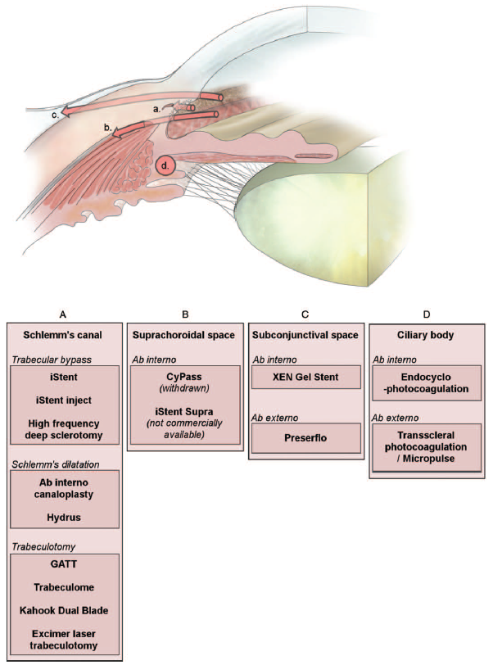
Figure 1 Anatomical and technical approaches of minimally invasive glaucoma surgeries (Gillmann and Mansouri, 2020)
Notes: GATT = gonioscopy-assisted transluminal trabeculotomy

Background to MIGS funded via the MBS
MIGS procedures funded via the MBS in Australia include trabecular micro-bypass stent insertion. Devices that were considered as part of the MSAC consideration included the Hydrus Microstent, the iStent Trabecular Micro-Bypass Stent and the iStent inject system. Suprachoroidal stent insertion with the CyPass Micro-Stent was also considered for funding via the MBS, however, following withdrawal of the device from the market this procedure was not publicly funded. Relevant prior MSAC considerations of MIGS procedures are tabulated below.

Table 1 Prior MSAC applications for MIGS procedures (Medical Services Advisory Committee, 2017b, Medical Services Advisory Committee, 2017c, Medical Services Advisory Committee, 2019a)
MSAC considerations, included populations and outcome | Associated MBS items
Application 1496 (November 2017) Suprachoroidal stent implantation in conjunction with cataract surgery or as a standalone procedure.  Population 1: Patients with OAG undergoing stent implantation in conjunction with cataract surgery. Supported for public funding.  Population 2: Patients with OAG undergoing stent implantation as a standalone procedure. Not supported for public funding. | 42705 (previously claimed under 42758).  Note: the CyPass suprachoroidal stent was withdrawn from the global market in 2018 (Medical Services Advisory Committee, 2019a)
Application 1483 (November 2017) Trabecular bypass stent insertion in conjunction with cataract surgery or as a standalone procedure.  Population 1: Patients with OAG undergoing stent implantation in conjunction with cataract surgery. Supported for public funding.  Population 2: Patients with OAG undergoing stent implantation as a standalone procedure. Not supported for public funding. | 42705 (previously claimed under 42758)
Application 1541 (August 2019) Trabecular bypass stent insertion as a standalone procedure  Population: Patients with OAG undergoing stent implantation as a standalone procedure. Supported for public funding. | 42504 (note this does not include the suprachoroidal stent implantation)
Abbreviations: MBS = medical benefits schedule; MSAC = medical services advisory committee; OAG = open angle glaucoma

Population for assessment
ABiC is intended for the same patient population as trabecular micro-bypass stent insertion, a currently funded MIGS procedure. Trabecular micro-bypass stent insertion is covered under MBS item 42504 (standalone procedure) and 42705 (in conjunction with cataract surgery). As per the current wording of these item numbers the proposed intervention is excluded from MBS item 42504 but not from MBS item 42705. The applicant is requesting a modification to the wording of MBS item 42504 which would treat those patients without concomitant cataract pathology. The applicant also indicated that ABiC is currently being used under MBS item 42705. As the MSAC has not previously considered the evidence for intervention as part of the assessment for item 42705 this PICO confirmation also considers patients with concomitant cataract pathology within the scope of the assessment phase for application 1649.
PASC noted the applicant’s proposed population is requesting a modification to the wording of MBS item 42504 which would treat OAG patients without concomitant cataract pathology (standalone population). PASC noted the proposed population is for OAG but MBS item 42504 doesn’t specify “open angle” glaucoma. The clinical expert for the applicant advised that OAG is the most common indication but the procedure is effective in both open angle and closed angle patients, and hence why wording was not prescriptive to glaucoma type.
PASC also noted that most patients will be adults, but that the procedure may benefit paediatric patients with glaucoma.
For patients receiving the intervention as a standalone procedure as per the wording of MBS item 42504 the population that would be expected to access the intervention include patients with glaucoma who:
- Have failed medical therapy and/or laser therapy; or
- Are likely to fail medical therapy and/or laser therapy; or
- Have a contraindication to medical therapy and/or laser therapy.
Consistent with the MSAC consideration of application 1541 the population includes patients considered otherwise eligible for trabeculectomy and not patients who have previously failed trabeculectomy (Medical Services Advisory Committee, 2019a).
For patients receiving the intervention in conjunction with cataract surgery as per the wording of MBS item 42705 the population that would be expected to access the intervention include patients with OAG who:
- are not adequately responsive to topical antiglaucoma medications; or
- are intolerant of antiglaucoma medication.
PASC confirmed that the PICO also needs to include OAG patients with concomitant cataract pathology (MBS item 42705), as the microcatheters are used in these patients and MSAC has not previously assessed microcatheters (as a standalone procedure or as an adjunct to cataract surgery) before.

Size of the potentially eligible population
MBS item 42504 represents the population that would be eligible for the proposed standalone intervention, however, the item was added to the MBS in May 2020 and therefore utilisation data is unlikely to accurately capture the potential size of the eligible population. Between May and September 2020 the item has been claimed 149 times (Australian Government, 2020). Before funding occurred, the Public Summary Document (PSD) for MSAC application 1541 predicted the total number of trabecular micro-bypass stent insertion claims as a standalone procedure to be 559 in 2020, increasing to 1,084 by 2025 (Medical Services Advisory Committee, 2019a). If the proposal does not change the number of services that would be offered then it may be reasonable to assume that this estimate applies to the current application. However, the applicant estimates that this item number may be utilised up to 4,056 times in 2020-21 with projected utilisation in 2022-23 and 2022-24 being 4,185 and 4,251 claims respectively. MBS item 42705 represents the population that would be eligible for the proposed intervention in combination with cataract surgery. In 2019-20 this item 42705 was claimed 6,861 times (Australian Government, 2020).
Targeted consultation feedback indicates that the proposed utilisation/population for the medical service may be underestimated. MIGS is a broad term encompassing a range of interventions aimed at improving physiological outflow with minimal disruption to normal eye anatomy. Evidence suggests that their introduction has created a novel indication for glaucoma surgery with MIGS typically trialled earlier in the glaucoma treatment pathway relative to trabeculectomy in an effort to address poor medication compliance, adverse events, and quality-of-life issues with topical medications (Fellman et al., 2020, Newman and Andrew, 2019). Local data support this with the finding that MIGS procedures have increased without a concomitant decline in traditional surgical options (Newman and Andrew, 2019). A study of Australian practice patterns in glaucoma management between 2003 and 2017 has identified strong uptake of MIGS in Australia, see Figure 2. In 2017/18 financial year the item number for insertion of a trans-trabecular drainage device or devices (MBS item 42705) combined with cataract surgery was claimed 4,271 times. The trend to growth appears to have continued in 2018-19 and 2019-20 with 6,247 and 6,861 claims respectively (Australian Government, 2020). Consequently, there is uncertainty as to how to best estimate the size of the population who may access the proposed intervention.
PASC considered there is uncertainty as to how to best estimate the size of the population who may access the proposed intervention. PASC noted that MBS item 42504 represents the standalone subpopulation, however, the item was only recently added to the MBS in May 2020. The applicant’s utilisation estimates are based on usage of MBS item 42758 prior to MBS item 42504. PASC noted that MBS item 42705 represents the cataract subpopulation. PASC also noted the high uptake of minimally invasive glaucoma surgery (MIGS) in Australia, and considered that uptake would likely to increase with microcatheter use.
The applicant considered it does not expect the uptake to increase as the population receiving the intervention and the surgeons performing the intervention would remain the same. The applicant noted the estimated utilisation numbers were based of the usage of 42,758 in 2017 and accounted for a 1.4% yearly population growth. The applicant considered the use of micro-catheters would give the option of a different type of device to perform the same procedure without leaving a stent in-situ.
Figure 2 MBS reimbursed procedures per 100,000 Medicare population (Newman and Andrew, 2019)
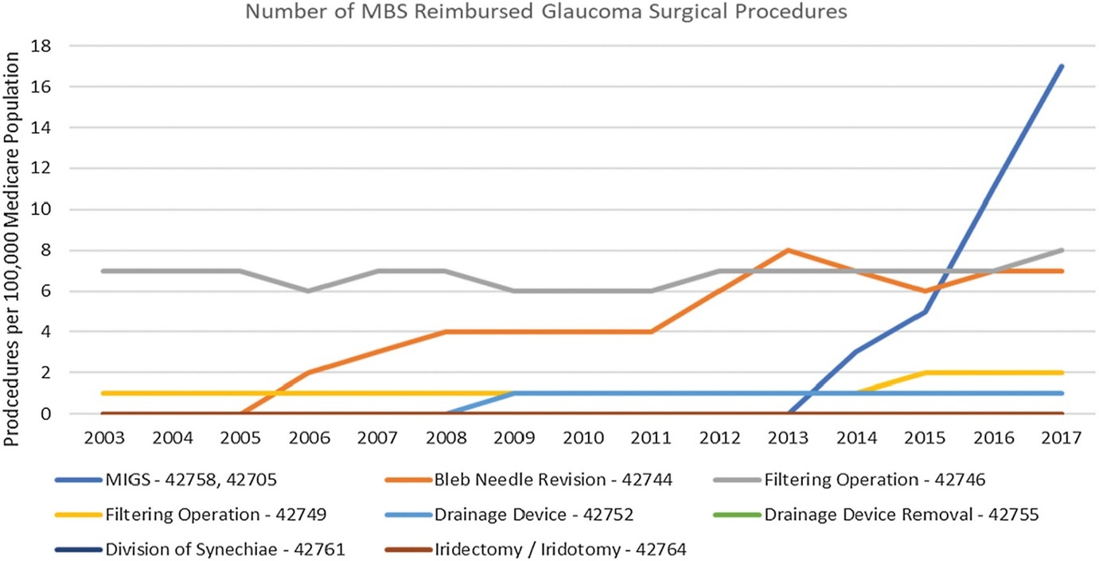

Rationale
Available literature suggests that the intervention can be performed at the time of cataract surgery or as a standalone procedure (Gallardo et al., 2018a, Gallardo et al., 2018b, Hughes and Traynor, 2020, Körber, 2018, Ondrejka and Körber, 2019, Tracer et al., 2020). The applicant does not consider the wording of item 42705 to exclude microcatheters and therefore is not requesting a modification to this item number. However, as the MSAC has not previously assessed the evidence for microcatheters in this population it may be reasonable to broaden the scope of the assessment phase to include patients undergoing concomitant cataract surgery. Further, restricting the eligible population to patients without concomitant cataract pathology would pose challenges for the assessment phase as the available literature evaluating the intervention includes a mixed population. For further details see Table 2 in the appendix.
The applicant suggests that the intervention is indicated for the same population targeted by the MBS item 42504 and that the intervention would be an alternative to trabecular micro-bypass stent insertion. However, it should be noted that the population who may benefit from MIGS appears to be broad and the extent to which one MIGS procedure is indicated in the same individual as another is uncertain due to the evolving landscape of these minimally invasive options.

Intervention
Canaloplasty aims to lower IOP by enhancing outflow through the trabecular meshwork. This is achieved by intubation and viscodilation of Schlemm’s canal using a microcatheter (iTrack™, Nova Eye Medical Pty Ltd, Adelaide, Australia). Canaloplasty may be performed via an ab-externo approach or an ab-interno approach. One retrospective paired-eye study suggests that both approaches have comparable IOP lowering and glaucoma medication reduction properties (Gallardo et al., 2018a). The ab-externo approach requires scleral incisions whilst the ABiC procedure allows access to Schlemm’s canal via a corneal incision (Gallardo et al., 2018a, Khaimi, 2015). Utilising the American Glaucoma Society definition of MIGS (Fellman et al., 2020) the ab-externo approach is not considered a MIGS procedure due to involvement of the sclera in accessing Schlemm’s canal. Therefore, only ABiC is considered within scope of the application.
ABiC is a procedure in which a microcatheter (iTrack™ 250-μm microcatheter) is used to manually dilate and viscodilate (using introduction of high molecular weight Hylaronic Acid based fluid) Schlemm’s canal (Körber, 2018). The procedure is performed under local or general anaesthesia, typically in a day surgery setting, and involves a corneal incision and opening the trabecular meshwork via goniotomy. The microcatheter is then advanced into Schlemm’s canal via the goniotomy site manually separating the meshwork and opening stenotic segments (Körber, 2018). While the microcatheter is being slowly withdrawn viscodilation of the canal and distal outflow system is performed (Körber, 2018) using sodium hyaluronate (Healon GV Intraocular Viscoelastic fluid). Intraoperatively the procedure also may involve the application of subconjunctival or intra-cameral antibiotics and dexamethasone (or similar agents) followed by post procedure topical preparations for up to one month (Gallardo et al., 2018a, Khaimi et al., 2017, Körber, 2018, Lewis et al., 2011). The aim of the procedure is to lower IOP by restoring aqueous outflow channels.
The proposed medical service involves the use of the iTrack™ Surgical System and Healon GV Intraocular Viscoelastic fluid. Healon GV Intraocular Viscoelastic fluid, listed on the Australian Register of Therapeutic Goods (ARTG) [144892], is commonly used in intraocular surgery and consists of sodium hyaluronate. The iTrack™ Surgical System is a single use device that is listed on the ARTG (244570) and comprises a microcatheter, a viscoelastic injector for introduction of the viscoelastic fluid and an illumination source. The iTrack™ Surgical System is not included on the prosthesis list. The ARTG listed purpose is ‘Fluid infusion and aspiration during surgery; catheterisation and viscodilation during surgery; placement of a tensing suture within the canal to reduce the IOP of patients with glaucoma’ (Therapeutic Goods Administration, 2015). It is understood that placement of a tensioning suture is not part of the ab-interno approach and therefore studies quoting use of a tensioning suture should be excluded at the assessment phase.
The applicant considered that any compatible high molecular weight ophthalmic viscosurgical device (OVD) is suitable for use in the procedure, and not just Healon GV®.
Alternative microcatheter devices that may be used with ABiC include the OMNI® Surgical System (Sight Sciences, Menlo Park, CA) and the VISCO360® (Sight Sciences, Menlo Park, CA) microcatheter. The OMNI® Surgical System is a single use device designed to deliver viscoelastic fluid into the anterior segment of the eye during ophthalmic surgery. It is also indicated to cut trabecular meshwork tissue during trabeculotomy procedures. The VISCO360® is a predicate device for viscodilation that forms a part of the OMNI® Surgical system which is intended to ultimately allow for the performance of multiple IOP lowering procedures in a back to back fashion via a single incision (Sight Sciences 2019). The FDA 510(k) Summary indicates that the technical features of the OMNI Surgical System are substantially equivalent to iTrack™ Surgical System (Food and Drug Administration 2017). No ARTG listing for the OMNI® Surgical System or VISCO360® was identified.
PASC noted that there are several microcatheter devices on the market, but considered that an item agnostic to the type of device would be appropriate. However, PASC considered that the assessment should sub-stratify for the type of device to assess if alternative devices may be equivalent, but noted that the current evidence base might not allow it.
The applicant noted that the Hydrus device, which is TGA approved, uses the same mechanism of action (Figure 1 -Schlemm’s Canal Dilation) as micro-catheters.
The procedure is performed by an ophthalmologist and the applicant indicates that the individual delivering the services should be recognised by the Conjoint Committee for the Recognition of Training in Micro-Bypass Glaucoma Surgery. This is consistent with the wording of the MBS item 42504. Based on minutes of the stakeholder meeting relevant to funding of the standalone stenting item there are approximately 50 ophthalmologists in Australia performing stent insertion who are glaucoma fellowship trained (Medical Services Advisory Committee, 2019b).
The applicant states that the service would be delivered only once per glaucomatous eye in a calendar year. The likelihood of a patient undergoing a repeat procedure in subsequent years is uncertain as long-term data from eyes treated by ABiC is limited. One study in which the ab externo approach was used followed patients for 3 years. Authors reported that during follow-up a total of 4 eyes were subsequently treated with trabeculectomy (2.5%) and 1 with repeat ab-externo canaloplasty (0.6%) (Lewis et al., 2011).
PASC noted that it is not clinical practice to repeat a trabecular meshwork procedure (i.e. microcatheter) on the same patient if it failed once already. The applicant clarified that trabecular meshwork procedures encompass both bypass stents and micro-catheters.

Rationale
The intervention can be performed as a standalone procedure or at the time of cataract surgery:
- The applicant is only seeking a modification to the wording item 42504 for standalone treatment as the wording of this item restricts the use of the microcatheter device.
- The applicant is not seeking a modification to the wording of item 42705 for microcatheter in conjunction with cataract surgery as the wording of the descriptor does not specifically reference stents or a particular device/intervention, and thus does not preclude the use of microcatheter for this purpose.
Further, a search of the literature identified a recently published case series in which 186 eyes from 130 consecutive patients underwent a combination of cataract extraction, trabecular micro-bypass stent insertion and ABiC or cataract extraction and trabecular micro-bypass stent insertion (Heersink and Dovich, 2019). Other combination surgeries identified included: ABiC in combination with trabeculectomy as a standalone procedure using the OMNI® Surgical System; and, ABiC in combination with trabeculectomy and cataract extraction (Al Habash et al., 2020).
PASC noted that MIGS with a microcatheter device can be done as a standalone surgery or in combination with cataract surgery. PASC noted that if safety and effectiveness data are available with regard to combination therapy it should be considered, but noted that cataract surgery does decrease intraocular pressure for a time post-surgery, which may confound the results. PASC also noted that microcatheter devices are used in combination with trabeculectomy - as a standalone procedure and in combination with cataract extraction. The applicant noted that microcatheters used via an ab-interno approach, which form the basis of this application, are not used in conjunction with trabeculectomy.
The applicant noted that its utilisation numbers encompass both patient sub-types of combined cataract surgery (42705) and stand-alone procedures (42504). This figure was calculated using 2017 utilisation of MBS 42758 and extrapolated for population growth. The applicant considered utilisation in 2020 would be impacted due to COVID-19 restrictions of elective surgery, potentially resulting in lower utilisation.
As concurrent cataract extraction provides an IOP lowering benefit over canaloplasty alone confounding should be addressed if generalising evidence from the simultaneous approach to the standalone procedure.
Comparator
The applicant proposes that ABiC would substitute for stent insertion into the trabecular meshwork, a procedure currently reimbursed via the MBS.
PASC noted that the comparator is the implantation of a micro-bypass surgery stent into the trabecular meshwork:
- as a standalone procedure (standalone subpopulation)
- in combination with cataract surgery (cataract subpopulation).
In Australia, stenting devices are available to bypass the trabecular meshwork; these include the iStent and the Hydrus Microstent. Each is associated with a slightly different surgical procedure; however, the implantation of both stents is via a corneal incision under gonioscopy (Medical Services Advisory Committee, 2017a). These stents are placed within the trabecular meshwork and Schlemm’s canal to facilitate drainage and to lower of IOP. Unlike ABiC, the procedure results in an implant remaining in the eye.
The applicant indicates that the intervention would not impact on the number of patients eligible for MIGs or services provided via the MBS but instead offers an alternative to stenting in patients undergoing MIGS. The applicant states that the cost of the ABiC is similar to that of micro-bypass stents; further, they state that the provider and setting associated with the procedure are the same.

Rationale
When considering funding trabecular micro-bypass stent insertion on the MBS as a standalone procedure (application number 1541), the MSAC considered the appropriate comparator to be trabeculectomy (Medical Services Advisory Committee, 2019a). However, stent insertion is now an accepted part of the treatment landscape in Australia and therefore may be the most relevant comparator. Further, the MSAC has previously considered comparators consisting of conservative therapy such as topical medications to be inappropriate when evaluating the effectiveness of trabecular micro-bypass stent insertion (Medical Services Advisory Committee, 2019a).
PASC considered “conservative treatment” and trabulectomy to be inappropriate comparators, as these interventions are no longer clinically relevant due to the emergence of MIGS with stent insertion in Australia.
The MSAC supported the inclusion in the MBS of Suprachoroidal stent implantation for patients with open-angle glaucoma who are also undergoing cataract surgery in November 2017 under MBS item 42705. Following this, the suprachoroidal stent CyPass was removed from the market owing to safety concerns and is not available in Australia (Medical Services Advisory Committee, 2019a). The iStent Supra (Glaukos) is a novel suprachoroidal stent. An ongoing randomised controlled trial (Trial identifier NCT01461278) comparing stent insertion in conjunction with cataract surgery to cataract surgery alone will inform FDA consideration of the device (ClinicalTrials.gov, 2020). Evidence about suprachoroidal stent implantation was not considered as part of application 1541, and therefore suprachoroidal stent insertion is not covered under item 42504. The assessment phase for item 42705 did consider this intervention.
PASC noted that there are no supra-choroidal stents available in Australia, and thus they are also not relevant as a comparator.
The applicant acknowledges the possibility that a patient failing trabecular micro-bypass stent insertion may subsequently present for ABiC or vice versa. In this scenario, the most appropriate comparator to ABiC may be trabeculectomy as these patients have previously failed a MIGS procedure. However, there is no available evidence to inform the likelihood of this occurring, and if patients fail one MIGS procedure it may be reasonable to assume that these patients would proceed to third-line therapies as opposed to re-trialling MIGS.

Outcomes

Patient relevant
PASC agreed with the outcomes presented in the draft PICO.
Clinical effectiveness outcomes
Mean IOP. Note that IOP is a surrogate endpoint to predict clinically relevant outcomes such as vision loss and quality of life (QoL). Elevated IOP is a risk factor for the development and progression of glaucoma, and predictive of future visual field loss, but is not the only risk factor and predictor (Medical Services Advisory Committee, 2019a).
PASC recalled that the minimal clinical important difference (MCID) of 1.5 mmHg decrease in intraocular pressure (IOP) has been previously accepted by the Pharmaceutical Benefits Advisory Committee for new glaucoma medicines (MSAC 1483 Public Summary Document [PSD] 2017, p14).
Changes in use of IOP lowering medications (including the mean number of IOP lowering medication, the proportion of patients on antiglaucoma medication)
Vision loss (including the time to vision impairment, the proportion with worsening vision)
Visual acuity
Success rates
Treatment failure rates (need for further glaucoma surgery including trabeculectomy, tube shunt surgery or subsequent MIGS)
Health-related quality of life
Quality of life
Safety outcomes
Any adverse events
Intraoperative adverse events such as rupture of trabeculo-descemetic membrane or descemet’s membrane detachment
Postoperative adverse events such as hyphaema/microhyphaema or IOP spike

Healthcare system
Cost per course of treatment
Cost associated with the management of adverse events
Courses of treatment anticipated per patient
Number and cost of revision procedures (plus costs of subsequent trabeculectomy, tube shunt surgery or further MIGS procedures due to treatment failure)
Costs or savings associated with offset utilisation of trabeculectomy or tube shunt surgery
Any cost implications associated with substitution of trabecular micro-bypass stent insertion
Australian government healthcare costs.

Rationale
Targeted consultation feedback suggests that there may be differences in the costs associated with the intervention relative to micro-bypass stenting as covered under MBS item 42504. Targeted consultation feedback states there needs to be greater clarity regarding the extent that these procedures are similar in terms of the time required for the procedure, the frequency with which the procedure is performed per patient and whether the proposed intervention may facilitate reduced length of hospital stay.

Current and proposed clinical management algorithms

Current clinical management algorithm for the identified population
PASC confirmed the clinical management algorithms encompassing with or without cataract surgery.
The current clinical management algorithm for patients without concomitant cataract is shown in Figure 3 and was informed by the clinical management algorithm used for the evaluation of standalone trabecular micro-bypass stent insertion implantation for MSAC application 1541. Under the current clinical management algorithm patients with primary OAG without cataract or who have previously had cataract surgery would be trialled on conservative therapies comprising of topical medication as monotherapy or in combination, systemic oral medications or laser trabeculoplasty. Patients may switch between treatments and add therapies as tolerated to reduce IOP. Patients who cannot tolerate conservative treatments, have contraindications to them or whose IOP is uncontrolled despite these therapies would be considered for surgical therapies including trabecular micro-bypass stents, filtering surgery (trabeculectomy) or further incisional surgery such as tube shunt surgery. The choice of intervention is patient-specific, and individuals can move between these options depending on their outcomes.
Figure 3 Current clinical management algorithm for patients without concomitant cataract pathology
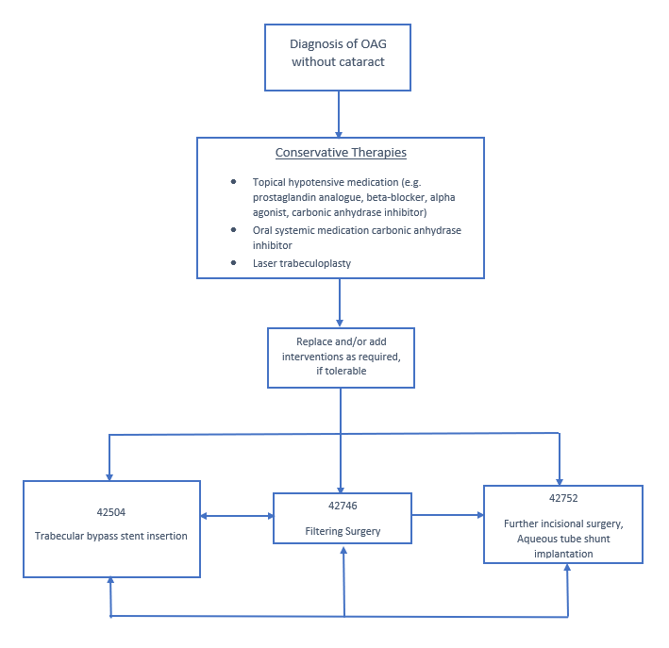
Note: Filtering surgery is understood to be trabeculectomy
Figure 4 details the current clinical management algorithm for patients with concomitant cataract pathology. The management algorithm is similar to that for patients without concomitant cataract pathology adapted from the public summary document for MSAC application 1541 and 1496 and 1483, however, in this situation patients would receive MIGS at the time of cataract extraction. Feedback from the applicant indicates that the proposed intervention can be used under the current MBS item 42705 and therefore for this population, the current and proposed management algorithm is the same.
Figure 4 Current clinical management algorithm for patients with concomitant cataract pathology
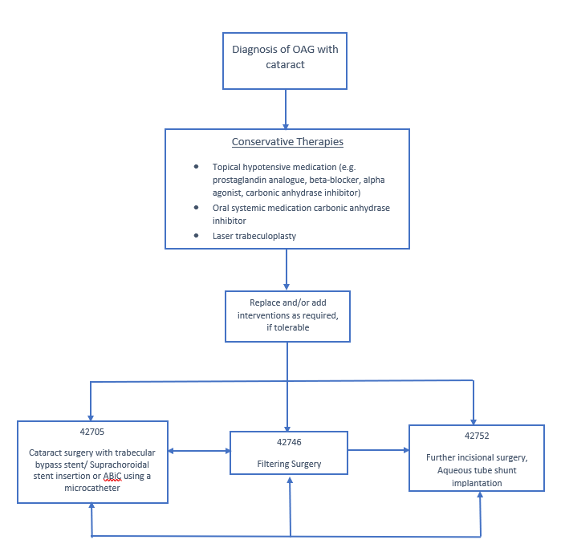
Note: Filtering surgery is understood to be trabeculectomy

Proposed clinical management algorithm for identified population
Figure 5 documents the proposed clinical management algorithm in patients without concomitant cataract. The applicant proposes that ABiC would be an alternative to trabecular micro-bypass stents. The applicant noted that the views expressed by their clinical expert at the PASC meeting, that the time, difficulty and frequency of the procedure was equivalent to stent insertion.

Figure 5 Proposed clinical management algorithm without concomitant cataract pathology
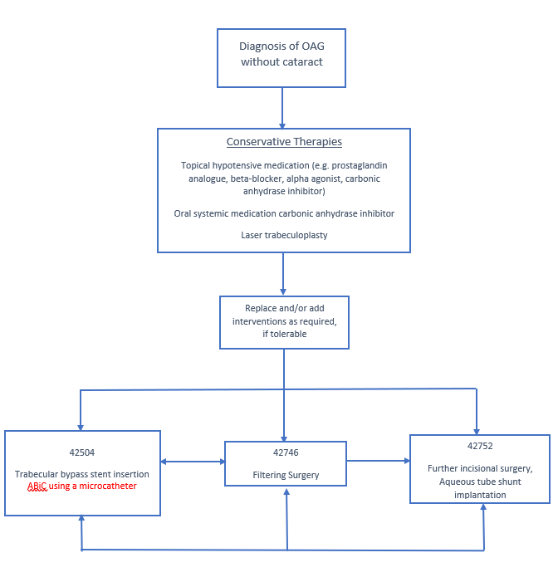
Note: Filtering surgery is understood to be trabeculectomy

Proposed economic evaluation
The clinical claim is that use of a microcatheter is non-inferior to the use of micro-bypass stents in terms of clinical effectiveness and safety. Consequently, the appropriate economic evaluation, based on the clinical claim, is cost minimisation.
PASC advised that the appropriate economic evaluation is a cost minimisation analysis.
PASC noted that there is no direct information available on the proposed product price. The applicant indicated that the microcatheter cost is similar to that of micro-bypass stents. Following the meeting, the applicant advised the requested price would match the prosthesis rebate of the comparator REDACTED.
No evidence comparing ABiC to any other MIGs procedure or other intervention for glaucoma is available. Therefore, no advice on the appropriateness of the clinical claim can be provided at this stage.

Proposed item descriptor
The proposal is for an amendment to the existing MBS item number 42504, which encompasses MIGS as a standalone procedure. The existing item number was recently added to the MBS, coming into effect from 1 May 2020. The proposed change in wording is shown in italics below. The applicant claims that comparable cost for the microcatheters and stents and therefore proposes no changes to the current fee.
The applicant is not proposing amendments to the existing MBS item number 42705 as the current wording of the item number does not exclude the intervention.
Targeted consultation feedback noted that trabecular micro-bypass stent insertion involves implantation of a device that is listed on the prostheses list. The ABiC procedure involves the use of a consumable item that is not eligible for inclusion on the prostheses list. The targeted consultation feedback also indicated that further evidence is required to support the claim that ABiC and MBGS have similar procedural time, associated hospital stay, resource use and, whether they would be performed with similar frequency per patient.
PASC noted that there is no direct information available on the proposed product price. The applicant indicated that the microcatheter cost is similar to that of micro-bypass stents.
Targeted consultation feedback indicated that PASC and MSAC might wish to consider whether it would be appropriate to have a separate MBS item for the proposed intervention.
PASC noted the proposed addition of “or insertion of a microcatheter” to the descriptor for MBS item 42504 to allow use of either a micro-bypass surgery stent or microcatheter. PASC queried whether a separate MBS item should be created for the insertion of a microcatheter in the trabecular meshwork but considered that this could be resolved during the evaluation phase. PASC also noted the Department intends to review the descriptors of items 42705, 42504, 42505 and 42758 for consistency of terminology, in parallel with the current application. The applicant supported the consistent use of terminology amongst item numbers 42705, 42504, 42505 and 42758.
PASC agreed with the inclusion of MBS item 42705 to encompass the assessment of microcatheter device used in combination with cataract surgery.
The applicant considered that the current wording, with the addition of “or insertion of a microcatheter” would be suitable and decrease confusion. The applicant’s clinical experts also supported this based on comparable surgical time, frequency and technical nature.
MBS item 42504
Category 3
Glaucoma, implantation of a micro-bypass surgery stent system or insertion of a microcatheter into the trabecular meshwork, if:

(a) conservative therapies have failed, are likely to fail, or are contraindicated; and

(b) the service is performed by a specialist with training that is recognised by the Conjoint Committee for the Recognition of Training in Micro-Bypass Glaucoma Surgery

Fee: $310.15 Benefit: 75% = $232.65 85% = $263.65

MBS item 42705
Category 3
LENS EXTRACTION AND INSERTION OF INTRAOCULAR LENS, excluding surgery performed for the correction of refractive error except for anisometropia greater than 3 dioptres following the removal of cataract in the first eye, performed in association with insertion of a trans-trabecular drainage device or devices, in a patient diagnosed with open angle glaucoma who is not adequately responsive to topical antiglaucoma medications or who is intolerant of antiglaucoma medication.

Fee: $939.60 Benefit: 75% = $704.70 85% = $854.90

Consultation feedback
Three organisations provided responses to the targeted consultation. Responses were generally supportive of the application. It was considered that the expected utilisation of intervention in the application would likely to be an underestimation. It was noted that ABiC using a microcatheter device would be especially suited for paediatric patients and patients in rural or remote locations. One response questioned the strength of evidence for the clinical effectiveness of ABiC using a microcatheter; and also considered that patients who failed the intervention should remain eligible for MIGS stent implantation.
PASC noted the supportive consultation feedback, but noted the advice that the applicant’s utilisation numbers provided in the application are likely to be underestimated.
The applicant advised it is not expecting the uptake to increase as the population receiving the intervention and the surgeons performing the intervention would remain the same. The applicant considered the use of micro-catheters will give the option of a different type of device to perform the same procedure where a stent is not left in-situ. The applicant considered that conversely their utilisation numbers were overestimated based on current utilisation data and utilisation data provided by the previous applicants for their original application (MSAC Application 1541- Table 13).

Next steps
PASC advised that, upon ratification of the post-PASC PICO, the application can proceed to the Evaluation Sub-Committee (ESC) stage of the MSAC process.
PASC noted the applicant has elected to progress its application as a DCAR (Department-contracted assessment report).

References
AL HABASH, A., ALRUSHOUD, M., AL ABDULSALAM, O., AL SOMALI, A. I., ALJINDAN, M. & AL AHMADI, A. S. 2020. Combined Gonioscopy-Assisted Transluminal Trabeculotomy (GATT) with Ab Interno Canaloplasty (ABiC) in Conjunction with Phacoemulsification: 12-Month Outcomes. Clin Ophthalmol, 14, 2491-2496.
AUSTRALIAN GOVERNMENT. 2020. MBS Item Statistics Reports [Online]. Available: http://medicarestatistics.humanservices.gov.au/statistics/mbs_item.jsp [Accessed 2 November 2020].
CLINICALTRIALS.GOV. 2020. Multicenter Investigation of the Glaukos® Suprachoroidal Stent Model G3 In Conjunction With Cataract Surgery [Online]. ClinicalTrials.gov,. Available: https://clinicaltrials.gov/ct2/show/NCT01461278?term=glaukos&rank=2 [Accessed 15 November 2020].
DAVIDS, A. M., PAHLITZSCH, M., BOEKER, A., WINTERHALTER, S., MAIER-WENZEL, A. K. & KLAMANN, M. 2019. Ab interno canaloplasty (ABiC)-12-month results of a new minimally invasive glaucoma surgery (MIGS). Graefes Arch Clin Exp Ophthalmol, 257, 1947-1953.
DIRANI, M., CROWSTON, J. G., TAYLOR, P. S., MOORE, P. T., ROGERS, S., PEZZULLO, M. L., KEEFFE, J. E. & TAYLOR, H. R. 2011. Economic impact of primary open-angle glaucoma in Australia. Clin Exp Ophthalmol, 39, 623-32.
FELLMAN, R. L., MATTOX, C., SINGH, K., FLOWERS, B., FRANCIS, B. A., ROBIN, A. L., BUTLER, M. R., SHAH, M. M., GIACONI, J. A., SHEYBANI, A., SONG, B. J. & STEIN, J. D. 2020. American Glaucoma Society Position Paper: Microinvasive Glaucoma Surgery. Ophthalmology Glaucoma, 3, 1-6.
GALLARDO, M. J., SUPNET, R. A. & AHMED, I. I. K. 2018a. Circumferential viscodilation of Schlemm's canal for open-angle glaucoma: ab-interno vs ab-externo canaloplasty with tensioning suture. Clin Ophthalmol, 12, 2493-2498.
GALLARDO, M. J., SUPNET, R. A. & AHMED, I. I. K. 2018b. Viscodilation of Schlemm's canal for the reduction of IOP via an ab-interno approach. Clin Ophthalmol, 12, 2149-2155.
GILLMANN, K. & MANSOURI, K. 2020. Minimally Invasive Glaucoma Surgery: Where Is the Evidence? Asia Pac J Ophthalmol (Phila), 9, 203-214.
HEERSINK, M. & DOVICH, J. A. 2019. Ab interno canaloplasty combined with trabecular bypass stenting in eyes with primary open-angle glaucoma. Clin Ophthalmol, 13, 1533-1542.
HUGHES, T. & TRAYNOR, M. 2020. Clinical Results of Ab Interno Canaloplasty in Patients with Open-Angle Glaucoma. Clin Ophthalmol, 14, 3641-3650.
KEEL, S., XIE, J., FOREMAN, J., LEE, P. Y., ALWAN, M., FAHY, E. T., VAN WIJNGAARDEN, P., FAN GASKIN, J. C., ANG, G. S., CROWSTON, J. G., TAYLOR, H. R. & DIRANI, M. 2019. Prevalence of glaucoma in the Australian National Eye Health Survey. Br J Ophthalmol, 103, 191-195.
KHAIMI, M. A. 2015. Canaloplasty: A Minimally Invasive and Maximally Effective Glaucoma Treatment. Journal of ophthalmology, 2015, 485065-485065.
KHAIMI, M. A., DVORAK, J. D. & DING, K. 2017. An Analysis of 3-Year Outcomes Following Canaloplasty for the Treatment of Open-Angle Glaucoma. J Ophthalmol, 2017, 2904272.
KÖRBER, N. 2018. Ab interno canaloplasty for the treatment of glaucoma: a case series study. Spektrum Augenheilkd, 32, 223-227.
LEWIS, R. A., VON WOLFF, K., TETZ, M., KOERBER, N., KEARNEY, J. R., SHINGLETON, B. J. & SAMUELSON, T. W. 2011. Canaloplasty: Three-year results of circumferential viscodilation and tensioning of Schlemm canal using a microcatheter to treat open-angle glaucoma. J Cataract Refract Surg, 37, 682-90.
LUSTHAUS, J. & GOLDBERG, I. 2019. Current management of glaucoma. Med J Aust, 210, 180-187.
MEDICAL SERVICES ADVISORY COMMITTEE. 2017a. PICO confirmation: Application No. 1483 Micro-bypass stenting for open-angle glaucoma (in trabecular meshwork) [Online]. Available: http://www.msac.gov.au/internet/msac/publishing.nsf/Content/1483-public [Accessed 2 November 2020].
MEDICAL SERVICES ADVISORY COMMITTEE. 2017b. Public Summary Document: Application No. 1483 Micro-bypass stenting for open-angle glaucoma (in trabecular meshwork) [Online]. Available: http://www.msac.gov.au/internet/msac/publishing.nsf/Content/1483-public [Accessed 2 November 2020].
MEDICAL SERVICES ADVISORY COMMITTEE. 2017c. Public Summary Document: Application No. 1496 Micro-bypass stenting for open-angle glaucoma (external to Schlemm's canal) [Online]. Available: http://www.msac.gov.au/internet/msac/publishing.nsf/Content/1496-public [Accessed 2 November 2020].
MEDICAL SERVICES ADVISORY COMMITTEE. 2019a. Public Summary Document: Application No. 1541- Micro-bypass glaucoma surgery (MBGS) device implantation as a standalone procedure in patients with open-angle glaucoma (OAG) [Online]. Available: http://www.msac.gov.au/internet/msac/publishing.nsf/Content/1541-public [Accessed 2 November 2020].
MEDICAL SERVICES ADVISORY COMMITTEE. 2019b. Stakeholder meeting final minutes application 1541- Micro-bypass glaucoma surgery (MBGS) device implantation as a standalone procedure in patients with open-angle glaucoma (OAG) [Online]. Available: http://www.msac.gov.au/internet/msac/publishing.nsf/Content/1541-public [Accessed 2 November 2020].
MOKHLES, P., SCHOUTEN, J. S., BECKERS, H. J., AZUARA-BLANCO, A., TUULONEN, A. & WEBERS, C. A. 2016. A Systematic Review of End-of-Life Visual Impairment in Open-Angle Glaucoma: An Epidemiological Autopsy. J Glaucoma, 25, 623-8.
NATIONAL HEALTH AND MEDICAL RESEARCH COUNCIL (NHMRC). 2010. NHMRC Guidelines for the screening, prognosis, diagnosis, management and prevention of glaucoma 2010. [Online]. National Health and Medical Research Council. Available: https://www.nhmrc.gov.au/about-us/publications/guidelines-screening-prognosis-diagnosis-management-and-prevention-glaucoma [Accessed 2 November 2020].
NEWMAN, A. R. & ANDREW, N. H. 2019. Changes in Australian practice patterns for glaucoma management. Clin Exp Ophthalmol, 47, 571-580.
ONDREJKA, S. & KÖRBER, N. 2019. 360° ab-interno Schlemm's canal viscodilation in primary open-angle glaucoma. Clin Ophthalmol, 13, 1235-1246.
THERAPEUTIC GOODS ADMINISTRATION. 2015. Public Summary for ARTG Entry 244570 [Online]. Available: https://www.ebs.tga.gov.au/servlet/xmlmillr6?dbid=ebs/PublicHTML/pdfStore.nsf&docid=627E685C96281411CA257E7000423801&agid=(PrintDetailsPublic)&actionid=1 [Accessed 2 November 2020].
TRACER, N., DICKERSON, J. E., JR. & RADCLIFFE, N. M. 2020. Circumferential Viscodilation Ab Interno Combined with Phacoemulsification for Treatment of Open-Angle Glaucoma: 12-Month Outcomes. Clin Ophthalmol, 14, 1357-1364.

Appendix
Table 2 Primary literature evaluating ABiC in patient with glaucoma
Study | Korber (2018)  N = 20  Eyes = 20 | Gallardo (2018b)  N=68  Eyes = 75 | Davids (2019)  N=28  Eyes = 36 | Hughes (2020)  N=64  Eyes = 89 | Ondrejka (2019)  N=71  Eyes =106 | Tracer (2020)  N=130  Eyes = 180
Type of study | Prospective single arm study | Retrospective chart review | Retrospective chart review | Retrospective case series (consecutive cases) | Retrospective case series (consecutive cases) | Retrospective case series (consecutive cases)
Intervention | ABiC using the iTrack™ microcatheter with or without cataract surgery | ABiC using the iTrack™ microcatheter with or without cataract surgery | ABiC using a microcatheter (device NR) with or without cataract surgery | ABiC using the Visco360® or Omni® System microcatheter with or without cataract surgery | ABiC using the Visco360® microcatheter with or without cataract surgery | ABiC using the Visco360® microcatheter with cataract surgery
Patients eligible | ≥ 18 years  Controlled POAG, or exfoliative glaucoma  Cataract or pseudophakia | ≥ 18 years with uncontrolled POAG | Patients who received ABiC for POAG | Patients undergoing ABiC for mild to moderate POAG | ≥ 18 years with mild-moderate  POAG who had undergone ABiC and had between 9 and 15  months of follow-up | Patients who received ABiC for POAG
IOP criteria | NA (mean pre-op IOP was 18.5 mmHg) | Baseline ≥ 18 mmHg | NA (mean pre-op IOP was 19.7 mmHg) | NA (mean pre-op IOP was 24.5 mmHg) | NA (Group 1 baseline IOP ≥18 mmHg  and Group 2 with baseline IOP <18 mmHg) | NA (Group 1 baseline IOP ≥18 mmHg  and Group 2 with baseline IOP <18 mmHg)
Exclusion criteria | Phakic patients, neovascular disease, uveitis, peripheral  anterior synechiae, as well as angle-closure, narrow angle,  neovascular, posttraumatic, and other forms of  secondary glaucomas | Patients who had laser trabeculoplasty within 1 year of surgery or other angle-based microinvasive glaucoma procedures. Neovascular disease, uveitis, peripheral anterior synechiae, goniosynechiae, angle recession, and developmental or other forms of secondary glaucoma, such as steroid-induced glaucoma | NR | Patients with pseudoexfoliative glaucoma, pigmentary glaucoma, glaucoma associated with ocular trauma, glaucoma associated with ocular inflammation, previous incisional glaucoma surgery and eyes with less than 90 degrees of viscodilation | Diagnosis of glaucoma other than POAG,  prior glaucoma surgery, terminal stage of OAG (defined as  grade 4 in the Aulhorn classification) or central retinal  vein occlusion | Advanced  glaucoma, and prior penetrating glaucoma surgery
Eyes treated with ABiC + cataract surgery | NR (reported combined) | 34 (50%) | 16 (44%) | 72 (80%) | 94 (88%) | 180 (100%)
Outcomes reported | Mean IOP  Mean glaucoma medication use  Surgical and post surgical AEs | Visual acuity  Mean IOP  Mean glaucoma medication use  Surgical and post surgical AEs  Note – comparison between groups (+/- cataract surgery reported) | Visual acuity  Mean IOP  Mean glaucoma medication use  Success  Failure  Surgical and post surgical AEs  Note – comparison between groups (+/- cataract surgery reported) | Mean IOP  Mean glaucoma medication use  Surgical and post surgical AEs  Comparison between 180 and 360-Degree treatment  Note – comparison between groups (+/- cataract surgery reported) | Mean IOP  Mean glaucoma medication use  Surgical and post surgical AEs  Secondary surgical interventions  Note – comparison between groups 1 and 2 (based on IOP) | Mean IOP  Mean glaucoma medication use  Surgical and post surgical AEs  Secondary surgical interventions  Note – comparison between groups 1 and 2 (based on IOP) reported
Abbrieviations: ABiC = Ab-interno canaloplasty; AE = adverse event; IOP= intraocular pressure; NA= not applicable; NR = not reported; OAG = open angle glaucoma; POAG = primary open angle glaucoma.

Note that canaloplasty can be performed using an ab-interno approach (avoiding a scleral incision) or an ab-externo approach. Only the ab-interno approach is within the scope of this assessment. Studies utilising the ab-externo approach should be excluded.
Note that multiple microcatheter devices exist, of which any used to perform ABiC should be included at the assessment phase.
The estimate it is based on prior claims for MBS item 42758 which would include patients who also have cataract and who now access MIGS under item MBS item 42705.
Note that prior to 2014 microbypass stenting was initially billed under MBS item number 42758 for goniotomy (Newman and Andrew, 2019). In 2017 item number 42705 was created for combined microbypass stenting and cataract surgery.
MBS item 42705: LENS EXTRACTION AND INSERTION OF INTRAOCULAR LENS, excluding surgery performed for the correction of refractive error except for anisometropia greater than 3 dioptres following the removal of cataract in the first eye, performed in association with insertion of a trans-trabecular drainage device or devices, in a patient diagnosed with open angle glaucoma who is not adequately responsive to topical anti-glaucoma medications or who is intolerant of anti-glaucoma medication.
Those designed to lower IOP by improving aqueous outflow with minimal disruption to the sclera or conjunctiva with or without an implanted device, or by reducing aqueous production selectively.
Outcomes reported in the literature may include terms such as success which is a composite outcome of achieving a specific level of IOP without the use of antiglaucoma medication. The definition of success may not be consistent across literature.
Note that this literature was identified by a search of Pubmed using the following targeted strategy: (ABiC OR (ab-interno canaloplasty) OR (ab interno canaloplasty) OR (ab interno canal*)) AND glaucoma. This is not a comprehensive search of the medical literature.
IOP ≤ 18 mmHg and ≥ 20% reduction in IOP with or without medication compared with baseline values.
defined as additional glaucoma surgery (e.g., retrabectome, trabeculectomy, aqueous shunt, cyclophotocoagulation) and if the target criteria were not reached on 2 consecutive visits.

