Title: Hyperbaric oxygen therapy (HBOT) - November 2000

Agency: Medicare Services Advisory Committee (MSAC) Commonwealth Department of Health and Ageing GPO Box 9848 Canberra ACT 2601 Australia http://www.msac.gov.au

Reference: MSAC applications 1018-1020. Assessment report ISSN 1443-7120.

Aim
To assess the safety and effectiveness of HBOT and whether public funding should be supported.

Conclusions and results
Safety HBOT carries some risk of myopia, barotrauma, claustrophobia and oxygen toxicity, but most
effects are self-limiting and life-threatening events are rare.
Effectiveness
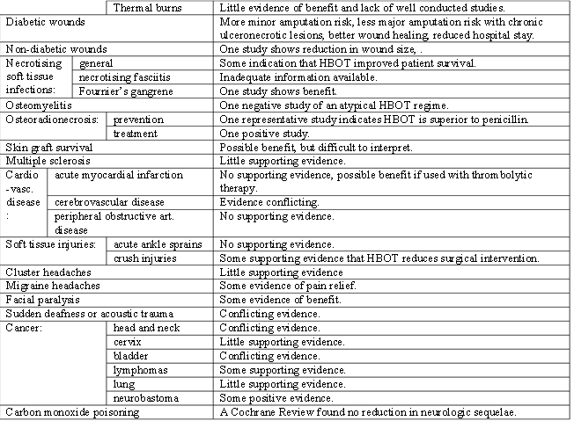

Cost-effectiveness HBOT is cost-effective for diabetic wounds and nectrotising soft-tissue infections, but may cost
$28,480 per case of osteoradionecrosis avoided.

Recommendations
Public funding for HBOT in monoplace or multiplace chambers be supported for decompression illness, gas
gangrene, air or gas embolism for which no alternative treatment exists, diabetic wounds (including gangrene and foot ulcers), necrotising soft tissue infections (including necrotising fasciitis), Fournier’s gangrene and prevention and treatment of osteoradionecrosis.

Method
MSAC conducted a systematic review of the biomedical literature from 1966 to 1999 using biomedical electronic databases, the Internet and international health technology agency websites. Reference lists of publications and
textbooks were consulted. Cost effectiveness is based on expert advice on HBOT costs and effectiveness evaluation
in this report. Prepared by the Centre for Clinical Effectiveness, Australia

