Public Summary Document

Report to the Medical Services Advisory Committee on real world outcomes of Application 1207: Testing for V600 status in patients with locally advanced or metastatic melanoma for access to appropriate therapies
Medicare Benefits Schedule (MBS) item considered: 73336
Date of MSAC consideration: 24-25 November 2016
Context for decision: MSAC makes its advice in accordance with its Terms of Reference, see the MSAC Website

Purpose
The purpose of the report presented to the Medical Services Advisory Committee (MSAC) was to inform MSAC of the real world impacts on the outcomes of Application 1207. The MSAC then uses this information to ensure that the new item/s resulting from this application/s is being used as intended.
The report is not intended to be a review of the clinical information covered during the application process.

MSAC’s advice
After considering the real world impacts of the outcome of application 1207 for testing of BRAF V600 status in patients with locally advanced or metastatic melanoma for Pharmaceutical Benefits Scheme (PBS) access to appropriate therapies (MBS item 73336), MSAC identified several potential inappropriate co-claiming issues and recommended referral to the department to investigate further.

Summary of consideration and rationale for MSAC’s advice
MSAC considered the real world impacts of the outcome of application 1207 for testing of BRAF V600 status in patients with locally advanced or metastatic melanoma for PBS access to appropriate therapies, by examining the available data for the relevant item number. This involved the review of MBS item number 73336 which specifies testing for access to dabrafenib on the PBS. In the March 2016 meeting, MSAC supported an amendment to item 73336 for the addition of access to PBS listed vemurafenib, which is yet to be implemented.
MSAC noted that utilisation of item 73336 appears to have levelled out below the estimated service volume. In comparing utilisation of item 73336 with a predicted versus actual analysis of dabrafenib undertaken by the Drug Utilisation Sub Committee, MSAC noted that the number of services for 73336 is consistent with the number of patients who go on to access dabrafenib.
MSAC noted that there was marked variation in the bulk billing rates and the fees charged for item 73336 and that the data on the fee charged may be of interest to consumers and other payers.
MSAC noted that there were more services provided in hospital than anticipated with variation evident across the states.
In considering the co-claiming data for item 73336 MSAC noted that there were instances of co-claiming with MBS item 73338 for metastatic colorectal cancer (stage IV) for RAS gene mutation status for PBS access to cetuximab or panitumumab and questioned the appropriateness of this co-claiming. MSAC also noted instances of co-claiming with MBS items 72846 and 72847 for immunohistochemical examination of biopsy material. MSAC questioned the use of a four panel test unless the initial diagnosis was in doubt.
MSAC recommended referral to the department to investigate further co-claiming of MBS items 73338, 72846 and 72847 with MBS item 73336.

Methodology
An application is selected for consideration if the resulting new item(s) or item amendment(s) have been on the MBS for approximately 24 months or longer or if there were particular concerns about utilisation such that MSAC requested to consider it earlier. The specific applications for each MSAC meeting are selected by the MSAC Executive which is composed of the Chairs of MSAC and its sub-committees.
A report on the utilisation is developed by the Department of Health (the department) with information on a number of metrics including state variation, patient demographics, services per patient, practitioner’s providing the service, data on fees and co-claiming of services. The number of metrics included in a report is dependent on the annual service volume for the MBS item(s) under consideration i.e. an item with very low utilisation will have less data to analyse. Where service volumes are too low, information is suppressed to protect patient privacy.
Where possible the report compares data on real world utilisation to the assumptions made during the MSAC assessment. Most of these assumptions are drawn from the assessment report.
Relevant stakeholders are provided an opportunity to comment on the findings in the report before it is presented to the MSAC. It is intended that stakeholders are given at least three weeks to consider the reports.
The stakeholder version of the report does not contain information on assumptions from the MSAC consideration if this information is not already publicly available. This is to protect the commercial in confidence of the original applicants. The same principle is applied to this document.
Once MSAC has considered the report, its advice is made available online at the MSAC Website.

Results

Utilisation
Utilisation of this service appears to be levelling out with 1,712 services claimed in 2015-16 (Figure 1). Month to month data also indicates a levelling out of utilisation of this service (Figure 2). The majority of services are for patients in NSW, QLD and VIC (Table 1).

Table 1: Services and benefits paid per state for MBS item 73336 from 2014-15 to 2015-16
 |  | NSW | VIC | QLD | SA | WA | TAS | NT | ACT | Australia
2013-14 | Services | np | np | np | np | np | np | np | np | 712
 | Benefits | np | np | np | np | np | np | np | np | $94,524
2014-15 | Services | 420 | 524 | 349 | 122 | 104 | np | np | 47 | 1,577
 | Benefits | $82,214 | $101,833 | $66,325 | $23,489 | $20,005 | np | np | $9,263 | $305,242
2015-16 | Services | 632 | 397 | 457 | 79 | 92 | np | np | 41 | 1,712
 | Benefits | $123,961 | $76,423 | $86,110 | $15,027 | $17,553 | np | np | $8,027 | $329,779
NP = not published due to low volumes
Source: Department of Health

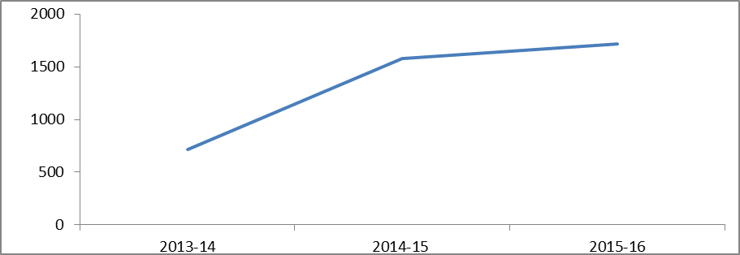

Figure 1: Services of MBS item 73336 for 2013-14 to 2015-16
Source: Department of Health

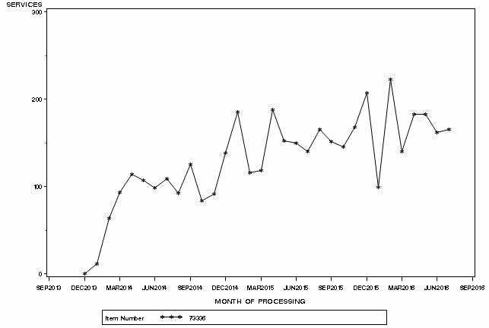

Figure 2: Month by month comparison of service volume for MBS item 73336 Dec 2013 to June 2016
Source: Medicare statistics online

Patient breakdown
The number of patients utilising this service is about 1,500 per year.
Most patients received a single service for this MBS item over the course of a year. Since the item was listed, 7% of patients have received two or more services (Tables 3 and 4). This is comparable to the retest rate of 9.4% for BRAF V600 that MSAC noted in its August 2012 meeting (MSAC PSD, app 1207, August 2013).
Males received the service two to three times more than females, with high utilisation in the 55-84 age groups (Figure 3). This is consistent with the expected population.

Table 2: Number of patients who received item 73336 at least once in 2013-14, 2014-15 or 2015-16
Number of Patients | NSW | VIC | QLD | SA | WA | TAS | NT | ACT | Australia
2013-14 | np | np | np | np | np | np | np | np | 677
2014-15 | 402 | 513 | 328 | 117 | 104 | np | np | np | 1,504
2015-16 | 599 | 380 | 429 | 77 | 88 | np | np | np | 1,615
NP = not published due to low volumes
Note: State breakdown redacted for 2013-14 due to low volumes

Table 3: Number of services per patient in 2013-14, 2014-15 and 2015-16
 | Services | # of patients | % of patients
2013-14 | 1 | 643 | 95%
 | 2+ | 34 | 5%
 | Total | 677 | 100%
2014-15 | 1 | 1,433 | 95%
 | 2+ | 71 | 5%
 | Total | 1,504 | 100%
2015-16 | 1 | 1,523 | 94%
 | 2+ | 92 | 5%
 | Total | 1,615 | 100%

Table 4: Number of services per patient since the service was listed on 1 December 2013 to June 2016
Services per patient | Number of patients | Percentage
1 | 3,479 | 93%
2 | 243 | 7%
3 | 12 | 0%
Total | 3,734 | 100%
Source for tables 2-4: Department of Health
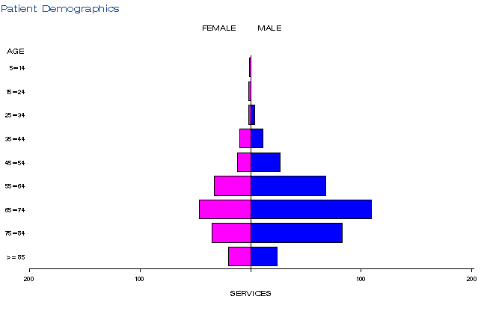
a)
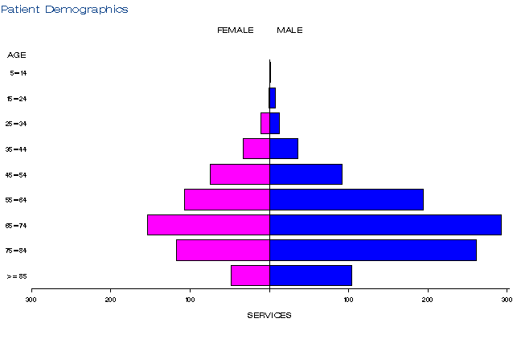
b))
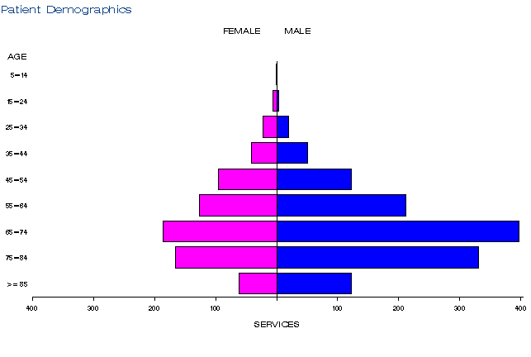
c)

Figure 3: Demographic profile for MBS item 73336 for 2013-14 (a), 2014-15 (b) and 2015-16 (c)
Source: Medicare Statistics Online

Practitioner breakdown
From 2013-14 to 2015-16, the number of practitioners providing this service grew from 31 to 52 (Table 5). The majority of practitioners were specialists in pathology and the remaining were specialists in haematology.
About 20% of practitioners are providing 80% of services (Table 7).

Table 5: Number of practitioners providing item 73336 in 2013-14 to 2015-16
Financial year | Australia
2013-14 | 31
2014-15 | 45
2015-16 | 52

Table 6: Practitioner specialties providing item 73336 from 2013-14 to 2015-16
 | 2013-14 | 2014-15 | 2015-16
Specialist - Pathology | 712 | 1,577 | 1,711

Table 7: Cumulative percentage of medical practitioners providing item 73336 and how many services each percentile accounts for in 2013-14 to 2015-16
 | 2013-14 | 2014-15 | 2015-16
10% | 57% | 68% | 64%
20% | 75% | 83% | 78%
30% | 85% | 89% | 88%
40% | 92% | 94% | 93%
50% | 96% | 96% | 96%
60% | 98% | 98% | 98%
70% | 99% | 99% | 99%
80% | 99% | 100% | 99%
90% | 100% | 100% | 100%
100% | 100% | 100% | 100%
Source for tables 5-7: Department of Health

Co-claiming
In 2014-15 and 2015-16, the service was most frequently claimed either by itself or with items 73938, 73940 and 72846 (Tables 9 & 10). The rate of claiming the service by itself decreased from 40% in 2013-14 to 13% in 2015-16 (Tables 8 & 10).

Table 8: Top 10 instances of co-claiming with MBS item 73336 in 2013-14
# | Items | Episodes | Number of Services | Schedule Fee for Combination | % of total episodes | Cumulative %
1 | 73336 | 283 | 284 | $65,590 | 40% | 40%
2 | 73336, 73938. | 195 | 391 | $46,816 | 28% | 68%
3 | 73336, 73940. | 64 | 129 | $15,668 | 9% | 77%
4 | 73336, 72846. | 29 | 58 | $8,426 | 4% | 81%
5 | 73336, 73939. | 23 | 46 | $5,367 | 3% | 84%
6 | 73336, 72846, 73939. | np | np | np | np
7 | 73336, 72830, 72846, 73924. | np | np | np | np
8 | 73336, 73928. | np | np | np | np
9 | 73336, 73931. | np | np | np | np
10 | 73336, 73930. | np | np | np | np
NP = not published due to low volumes

Table 9: Top 10 instances of co-claiming with MBS item 73336 in 2014-15
# | Items | Episodes | Number of Services | Schedule Fee for Combination | % of total episodes | Cumulative %
1 | 73336, 73940. | 423 | 847 | $102,259 | 27% | 27%
2 | 73336, 73938. | 278 | 556 | $66,414 | 18% | 45%
3 | 73336 | 255 | 256 | $59,123 | 16% | 61%
4 | 73336, 72846. | 147 | 296 | $43,001 | 9% | 70%
5 | 73336, 73939. | 130 | 260 | $30,336 | 8% | 78%
6 | 73336, 72846, 73939. | 46 | 138 | $13,476 | 3% | 81%
7 | 73336, 72846, 73940. | 20 | 60 | $6,016 | 1% | 82%
8 | 73336, 72830, 73924. | 19 | 57 | $9,875 | 1% | 83%
9 | 73336, 72830, 72846, 73924. | 12 | 48 | $6,952 | 1% | 84%
10 | 73336, 73928. | 9 | 18 | $2,132 | 1% | 85%

Table 10: Top 10 instances of co-claiming with MBS item 73336 in 2015-16
# | Items | Episodes | Number of Services | Schedule Fee for Combination | % of total episodes | Cumulative %
1 | 73336, 73938. | 297 | 594 | $70,953 | 16% | 16%
2 | 73336, 73940. | 261 | 523 | $63,184 | 14% | 30%
3 | 73336, 72846,73939. | 248 | 746 | $72,656 | 13% | 43%
4 | 73336, 73939. | 245 | 490 | $57,171 | 13% | 56%
5 | 73336 | 228 | 228 | $52,657 | 12% | 68%
6 | 73336, 72846. | 59 | 118 | $17,142 | 3% | 71%
7 | 73336, 72830, 72846, 73924. | 27 | 109 | $15,873 | 1% | 72%
8 | 73336, 72846, 73940. | 20 | 60 | $6,016 | 1% | 73%
9 | 73336, 73338, 73938. | 18 | 54 | $10,827 | 1% | 74%
10 | 73336, 72830, 72847, 73924. | 15 | 62 | $9,599 | 1% | 75%
Source for tables 8-10: Department of Health

Data on fee charged
The average fee in NSW increased from $242 in 2014-15 to $311 in 2015-16, potentially driven by the 95th percentile for fees in NSW going from $277 in 2014-15 to $693 in 2015-16 (Table 11). The rate of bulk billing was highest over the three years in NSW and VIC and lowest in QLD and WA.

Table 11: Statistics on fees charged for MBS item 73336 for 2014-15 to 2015-16.
 |  | Provider State/Territory
 |  | NSW | VIC | QLD | SA | WA | TAS | NT | ACT | Australia
2014-15 | Average Fee Charged | $242 | $225 | $296 | $242 | $230 | np | np | np | $258
 | Std Deviation | $21 | $47 | $61 | $28 | $58 | np | np | np | $60
 | Median Fee Charged | $231 | $196 | $299 | $231 | $196 | np | np | np | 231
 | 75th Percentile | $231 | $231 | $315 | $231 | $248 | np | np | np | 300
 | 95th Percentile | $277 | $351 | $355 | $298 | $323 | np | np | np | 355
 | Bulk-billing Rate | 93% | 90% | 66% | 79% | 37% | np | np | np | 81%
2015-16 | Average Fee Charged | $311 | $246 | $292 | $251 | $275 | np | np | np | $277
 | Std Deviation | $152 | $56 | $52 | $41 | $76 | np | np | np | $70
 | Median Fee Charged | $231 | $231 | $299 | np | $300 | np | np | np | $291
 | 75th Percentile | $321 | $284 | $315 | np | $307 | np | np | np | $300
 | 95th Percentile | $693 | $372 | $358 | np | $349 | np | np | np | $358
 | Bulk-billing Rate | 96% | 80% | 64% | 70% | 49% | np | np | np | 79%
Np = not printed
Source: Department of Health

Background
GlaxoSmithKline Australia (GSK) lodged a major submission to the March 2013 Pharmaceutical Benefits Advisory Committee (PBAC) meeting requesting PBS listing of dabrafenib for patients with locally advanced unresectable stage III or IV melanoma. GSK also submitted a complementary fit-for-purpose minor submission to the April 2013 MSAC meeting for the related BRAF V600 mutation testing.
Both submissions were deferred by the respective Committees. MSAC deferred the application for BRAF V600 mutation testing until PBAC reconsidered the PBS listing of dabrafenib.
GSK lodged a minor resubmission for dabrafenib to the July 2013 PBAC meeting. To ensure coordination of advice to the Minister from MSAC and PBAC, the Department prepared a short paper to enable the August 2013 MSAC meeting to reconsider BRAF V600 mutation testing.
The determination of the BRAF mutation status of melanoma tumours is important prior to commencing treatment with a BRAF inhibitor. The relationship between BRAF mutation status and a patient’s response to treatment with BRAF inhibitors (including dabrafenib) leads to a co-dependent relationship between BRAF mutation testing and BRAF inhibitor treatment.
Prior to the listing of this service on the MBS, a small number of laboratories in Australia did offer the service for a fee.
The listing was supported by PBAC at is July 2013 meeting and by MSAC at its August 2013 meeting.

Item descriptor
73336 | A test of tumour tissue from a patient with unresectable stage III or stage IV metastatic cutaneous melanoma, requested by, or on behalf of, a specialist or consultant physician, to determine if the requirements relating to BRAF V600 mutation status for access to dabrafenib under Pharmaceutical Benefits Scheme (PBS) are fulfilled.  Fee: $230.95 Benefit: 75% = $173.25 85% = $196.35

Applicant’s comments on MSAC’s public summary document
Nil response

Further information on MSAC
MSAC Terms of Reference and other information are available on the MSAC Website at: www.msac.gov.au.

DUSC report on Iplilimumab and dabrafenib: predicted vs actual analysis is on the Pharmaceutical Benefits Scheme website
The 95th percentile fee charged represents that 95% of the time the fee is below this amount but in 5% of cases, the fee is higher than this.

