**MSAC Application 1788**

**ArteraAI Prostate Biopsy Assay**

**PICO Set**

**ArteraAI Prostate Biopsy Assay for patients with localised prostate cancer**

# Intended purpose

This submission to MSAC is lodged to facilitate the listing of the ArteraAI Prostate Biopsy Assay on the Medicare Benefits Schedule (MBS). The intended purpose of the test is to inform the prognosis and help inform treatment decisions regarding use of short-term androgen deprivation therapy (ST-ADT) in patients with localised prostate cancer of intermediate risk who will undergo curative-intent radiotherapy. Currently clinicians rely on existing risk assessment tools to designate risk classification and to guide treatment decisions.

The ArteraAI Prostate Biopsy Assay is a software device based on artificial intelligence (AI) that assesses physician-provided clinical variables and whole slide images (WSI) of prostate needle biopsy specimens. The following is provided from the test:

* classification of patients into risk groups (low, intermediate or high) based on risk estimates of distant metastasis and prostate cancer specific mortality for patients with prostate cancer
* informing whether a patient with intermediate risk is more likely to benefit from the addition of ST-ADT or not via a ‘biomarker’ (predictive).

The ArteraAI Prostate Biopsy Assay will be used in conjunction with current risk assessment tools and clinical assessments that form the current basis of management of patients with localised prostate cancer. Listing the ArteraAI Prostate Biopsy Assay on the MBS would provide clinicians with an additional tool that, relative to not using the test, will improve prognostication and will allow for better informed use of ST-ADT in patients likely to benefit the most (Spratt 2022, Spratt 2024, Esteva 2022, Gerrard, 2024). Limited evidence exists demonstrating that ADT adjunct to radiotherapy will improve prostate cancer specific mortality in those with intermediate risk localised prostate cancer (Krauss, 2023). To this end, some patients are exposed to the potentially harmful adverse effects of ST-ADT, whilst not deriving a benefit. The use of the ArteraAI Prostate Biopsy Assay will help improve appropriate patient selection for adjunct ST-ADT by avoiding futile and potentially harmful treatment.

# Population

## Describe the population in which the proposed health technology is intended to be used:

*Prostate cancer*

Prostate cancer is cancer that forms in the tissues of the prostate. Australia has one of the highest incidence rates of prostate cancer with around 1 in 6 men diagnosed by age 85. Prostate cancer is the most common cancer amongst men and the cancer in men that is most likely to cause death (Australian Institute of Health and Welfare [AIHW] 2021). Advances in early detection and management focus on minimising harm and reducing overdiagnosis and overtreatment. Evidence from randomised trials guides these efforts, enhancing survival outcomes (Williams 2022).

*Diagnosis/prognosis and risk staging*

A number of diagnostic tools exist to establish diagnosis of prostate cancer, including digital rectal ultrasound, prostate specific antigen (PSA) levels, imaging and biopsy (Cornford 2024). PSA is organ but not cancer specific. Higher levels of PSA indicate a greater likelihood of prostate cancer (Cornford 2024). According to the Royal College of Pathologists of Australia (RCPA), screening of asymptomatic (low-risk) men for prostate cancer using the PSA test is not recommended, because it is not yet clear if the benefits of testing outweigh the potential harms (RCPA 2021). A prostate biopsy may be recommended if there is an elevated PSA or a rapid rise in PSA. Ultimately, a biopsy is needed to confirm whether prostate cancer is present (RACGP 2015). As such, prostate cancer diagnosis typically involves a tumour biopsy by a urologist, prompted by symptoms or elevated PSA levels. This is followed by hematoxylin and eosin (H&E) stained histopathology of core needle biopsies.

The Tumour Node Metastasis (TNM) staging system is used to describe the stage of the prostate cancer (see Table 1). Localised prostate cancer refers to when the tumour is confined to the prostate gland without having spread to other parts of the body. As per the TNM staging of prostate cancer, localised prostate cancer refers to T1 and T2 tumours (Cornford 2024).

Table 1: Clinical Tumour Node Metastasis (TNM) classification of prostate cancer

|  |  |  |
| --- | --- | --- |
| **Category** | | **Description** |
| **T - Primary Tumour (stage based on DRE only)** | |  |
| TX | | Primary tumour cannot be assessed |
| T0 | | No evidence of primary tumour |
| T1 | | Clinically inapparent tumour that is not palpable |
|  | T1a | Tumour incidental histological finding in 5% or less of tissue resected |
|  | T1b | Tumour incidental histological finding in more than 5% of tissue resected |
|  | T1c | Tumour identified by needle biopsy (e.g., because of elevated prostate-specific antigen [PSA]) |
| T2 | | Tumour that is palpable and confined within the prostate |
|  | T2a | Tumour involves one half of one lobe or less |
|  | T2b | Tumour involves more than half of one lobe, but not both lobes |
|  | T2c | Tumour involves both lobes |
| T3 | | Tumour extends palpably through the prostatic capsule |
|  | T3a | Extracapsular extension (unilateral or bilateral) |
|  | T3b | Tumour invades seminal vesicle(s) |
|  | T4 | Tumour is fixed or invades adjacent structures other than seminal vesicles: external sphincter, rectum, levator muscles, and/or pelvic wall |
| **N - Regional (pelvic) Lymph Nodes** | |  |
| NX | | Regional lymph nodes cannot be assessed |
| N0 | | No regional lymph node metastasis |
| N1 | | Regional lymph node metastasis |
| **M - Distant Metastasis** | |  |
| M0 | | No distant metastasis |
| M1 | | Distant metastasis |
|  | M1a | Non-regional lymph nodes |
|  | M1b | Bone(s) |
|  | M1c | Other site(s) |

Source: Cornford (2024)

Abbreviations: DRE; Digital Rectal Examination

Prostate cancer is graded using the Gleason score which is the visual interpretation of how abnormal the cells appear under a microscope. The Gleason score is calculated by combining the most extensive (primary) Gleason’s pattern, plus the second most common (secondary) Gleason’s pattern. The Gleason score may range from 2 to 10, however, most prostate cancers are given a score of three or higher. The International Society of Urological Pathology (ISUP) risk classification system uses the Gleason score to assign a Grade numbering 1 to 5 where one is assigned if the cancer looks like normal prostate tissue (Gleason score ≤6) and Grade 5 refer to cancers that look very abnormal (Gleason score 9–10) (see Table 2).

Table 2: Description of ISUP grade

|  |  |
| --- | --- |
| **ISUP Grade** | **Description** |
| Grade 1 | Gleason score ≤6 Only individual discrete well-formed glands |
| Grade 2 | Gleason score 3+4=7 Predominantly well-formed glands with lesser component of poorly formed / fused / cribriform glands |
| Grade 3 | Gleason score 4+3=7 Predominantly poorly formed / fused / cribriform glands with lesser component of well-formed glands |
| Grade 4 | Gleason score 4+4=8 Only poorly formed/fused/cribriform glands  Gleason score 3+5=8 Predominantly well-formed glands and lesser component lacking glands (or with necrosis)  Gleason score 5+3=8 Predominantly lacking glands (or with necrosis) and lesser component of well-formed glands |
| Grade 5 | Gleason score 9–10 Lacking gland formation (or with necrosis) with or without poorly formed / fused / cribriform glands |

Source: Shah (2018)

Abbreviations: ISUP, International Society of Urological Pathology

Following biopsy, a diagnosis and Gleason scores are communicated back to the urologist to guide risk classification and management decisions. Taken together, the information on tumour stage, Gleason score and PSA level will help inform the risk of prostate cancer progressing (Cornford 2024).

There are a number of risk classification systems, including, National Comprehensive Cancer Network (NCCN) [NCCN 2024], American Urological Society (AUS) [American Urological Association Guidelines 2022] and European Association of Urology (EAU) [Cornford 2024]. In Australia, the standard risk assessment system used is NCCN by radiation and medical oncologists whereas the urologists endorse the EAU classification system. As shown in Table 3, the EAU and NCCN risk assessment tools are almost identical. Similarities between intermediate risk grouping include a Gleason score 7 or PSA 10-20 ng/ml. However, a difference between the two is that the NCCN describes intermediate risk classification as T2b-T2c (T2b: tumour involves more than half of one lobe, but not both lobes; T2c: tumour involves both lobes) whilst EAU describes it only as T2b.

Table 3: Description of NCCN and EAU risk grouping

|  |  |  |
| --- | --- | --- |
| **Risk Group** | **NCCN description** | **EAU risk grouping description** |
| Low risk | T1–T2a,  Gleason score ≤6, and  PSA <10 ng ml | T1-2a*  Gleason score <7 (ISUP grade 1) and  PSA <10 ng/ml and |
| Intermediate risk | T2b–T2c or  Gleason score 7 or  PSA 10–20 ng ml | T2b*  Gleason Score 7 (ISUP grade 2/3) or  PSA 10-20 ng/ml |
| Favourable intermediate risk | Has all the following:  1 IRF, Grade Group 1 or 2 (Gleason Score less than 6 or Gleason Score 7), <50% biopsy cores positive (e.g., <6 of 12 cores) | N/A^ |
| Unfavourable intermediate risk | Has one or more of the following: 2 or 3 IRFs, Grade Group 3 (Gleason score 7), >50% biopsy cores positive (e.g. ≥ 6 of 12 cores) | N/A^ |
| High risk | T3a or  Gleason score 8–10 or  PSA >20 ng ml | T2c, T3-4 or  GS >7 (ISUP grade 4/5) or N+** PSA >20 ng/ml or  Any PSA, any GS (any ISUP grade), |
| Very high risk | T3b–T4 or primary Gleason pattern 5 or >5 cores with Gleason score 8–10; and metastatic risk: N1 or M1 with any T stage. | N/A |

Source: NCCN prostate cancer guidelines (2024); Xu (2018); Cornford (2024)

Abbreviations: EAU, European Association of Urology; GS; Gleason Score; IRF, intermediate-risk factor PSA, Prostate Specific Antigen; NCCN, National Comprehensive Cancer Network

*Based on digital rectal examination

**Based on CT/Bone scan

^EAU guidelines do not separate intermediate risk into favourable and unfavourable, however some of the treatment recommendations they make are separated into by NCCN favourable and unfavourable risk category.

*Management of localised prostate cancer of intermediate risk*

As per the EAU guidelines (Cornford 2024), and the NCCN (2024) guidelines, management of prostate cancer may involve active surveillance/watchful waiting, radiation therapy and adjuvant ADT or radical prostatectomy, with management strategy dependent on the risk classification of the cancer. In Australia, those with localised prostate cancer at intermediate or high risk, treatment consists of prostatectomy or radiotherapy and ADT may be considered as adjuvant therapy to radiotherapy (Williams, 2022).

The NCCN provides clear guidelines on the use of ADT (see Table 4). For patients with NCCN favourable intermediate risk, NCCN recommends for those with an expected survival of 10 years or more, active surveillance, radiation therapy, and radical prostatectomy with or without pelvic lymph node dissection, with monitoring and potential early radiation therapy with or without ADT for rising PSA levels. For those with 5-10 years expected survival, options include radiation therapy or observation (preferred). Radiation therapy alone is recommended for low-risk tumours, whereas higher-risk cases should consider adding ADT.

For patients with NCCN unfavourable intermediate risk with an expected survival of more than 10 years, options include radical prostatectomy with or without pelvic lymph node dissection (with monitoring and potential early radiation therapy for rising PSA), and radiation therapy with ADT. For those with 5-10 years expected survival, options are radiation therapy with ADT or observation. The NCCN panel recommends 4 to 6 months of ADT (e.g. ST-ADT) when external beam radiation therapy (EBRT) is given as initial treatment for unfavourable intermediate-risk prostate cancer, with ADT being optional if brachytherapy is added to EBRT. The EAU guidelines refer to NCCN recommendations for favourable and unfavourable intermediate risk stratification when recommending brachytherapy for intermediate risk patients.

According to local experts in the management of prostate cancer in Australia, adjuvant ADT is more likely used in those with high-risk localised cancer with duration extending beyond 6 months, whereas in those with intermediate risk localised prostate cancer undergoing radiation therapy with curative intent, a decision regarding the benefit to risk ratio of ST-ADT is made. In a multicentre randomised controlled trial of 1,492 patients with intermediate risk prostate cancer undergoing radiotherapy with or without ST-ADT (NRG Oncology/RTOG 0815), the addition of ST-ADT led to statistically significant improvements in distant metastases (DM) rates (HR [95% CI]: 0.25 [0.11, 0.57]; P <0.001), prostate cancer specific mortality (PCSM) (HR [95% CI]: 0.10 [0.01, 0.80]; P = 0.007), and PSA failures (HR [95% CI]: 0.52 [0.39, 0.70]; P <0.001). Increased overall survival rates at 8 years (84% with ST-ADT versus 79% without) were not statistically significant between with or without ST-ADT groups (Krauss 2023). The investigators concluded that these benefits should be weighed against the risk of adverse events and the impact of ST-ADT on the patients quality of life (Krauss 2023). ADT treatment puts the patients at risk of troublesome side effects such as decrease in bone health, cardiovascular disease, metabolic effects and sexual dysfunction (EVIQ guidelines[1]).

Table 4: Intermediate risk treatment recommendations by guideline

|  | **NCCN Guideline** | **EAU Guideline** |
| --- | --- | --- |
| **Favourable intermediate risk treatment** | >10 Years expected patient survival:   * Candidates for active surveillance * Radiation therapy * Radical prostatectomy ± pelvic lymph node dissection. Adverse feature(s) and no lymph node metastases: Monitoring (preferred) with consideration of early RT for a detectable and rising PSA or PSA >0.1 ng/mL or EBRT ± ADT.   5-10 years expected patient survival:   * Radiation therapy * Observation (preferred)   The use of RT alone should be considered in patients with low risk tumours, whereas those with higher risk should consider the addition of ADT. | * Offer watchful waiting in asymptomatic patients with life expectancy  < 10 years (based on comorbidities and age). * Offer radical prostatectomy to patients with a life expectancy of > 10 years. * Offer LDR brachytherapy to patients with good urinary function and NCCN favourable intermediate-risk disease. * IMRT/VMAT with IGRT or moderate hypofractionation, in combination with short-term androgen deprivation therapy (ADT) (4–6 months) * Fractionated high-dose rate (HDR) brachytherapy as monotherapy for selected patients. |
| **Unfavourable intermediate risk treatment** | >10 Years expected patient survival:   * Radical prostatectomy ± pelvic lymph node dissection. Adverse feature(s) and no lymph node metastases: Monitoring (preferred) with consideration of early RT for a detectable and rising PSA or PSA >0.1 ng/mL or EBRT ± ADT. * Radiation therapy + ADT   5-10 years expected patient survival   * Radiation therapy + ADT * Observation   The NCCN panel recommends 4 to 6 months of ADT when EBRT is given to patients as initial treatment of unfavourable intermediate-risk prostate cancer. If brachytherapy is added to EBRT in this setting, then 4 to 6 months ADT is optional. | * Offer watchful waiting in asymptomatic patients with life expectancy  < 10 years (based on comorbidities and age). * Offer radical prostatectomy to patients with a life expectancy of > 10 years. * Offer LDR brachytherapy boost combined with IMRT/VMAT plus IGRT to patients with good urinary function and NCCN unfavourable intermediate-risk disease, in combination with short-term ADT (four to six months). * Offer HDR brachytherapy boost combined with IMRT/VMAT plus IGRT to patients with good urinary function and NCCN unfavourable intermediate-risk disease, in combination with short-term ADT (four to six months). * IMRT/VMAT with IGRT or moderate hypofractionation, in combination with short-term androgen deprivation therapy (ADT) (4–6 months) * Fractionated high-dose rate (HDR) brachytherapy as monotherapy for selected patients. |

Source: American Urological Association guidelines (2022), Cornford (2024), NCCN prostate cancer guidelines (2024)

Abbreviations: ADT, Androgen Deprivation Therapy; EBRT, External beam radiotherapy; HDR, High Dose Rate; IGRT, Image Guided Radiotherapy; IMRT, Intensity Modulated Radiotherapy; ISUP, International Society for Urological Pathology; LDR, Low Dose Rate; NCCN, National Comprehensive Cancer Network; PSA, Prostate Specific Antigen; RT, Radiation therapy; VMAT, Volumetric Modulated Arc Therapy

The NCCN provide specific recommendations for ADT in localised prostate cancer (Table 5). There are two main classes of ADT medications: gonadotrophin-releasing hormone (GnRH) agonists or antagonists and anti-androgens. The aim of ADT is to slow and control cancer growth by reducing the level of male hormones. ST-ADT use is defined as 4 to 6 months of use and is recommended in NCCN intermediate risk category.

Table 5: NCCN recommendations on ADT for clinically localised disease

|  |
| --- |
| **ADT for clinically localised (N0, M0) disease** |
| * Neoadjuvant ADT for RP is strongly discouraged outside of a clinical trial. |
| * ADT should not be used as monotherapy in clinically localised prostate cancer unless there is a contraindication to definitive local therapy such as life expectancy ≤5 years and comorbidities. Under those circumstances, ADT may be used [see ADT for Patients on Observation Who Require Treatment and Those with Life Expectancy ≤5 Years (PROS-G, 5 of 5)]. |
| * Giving ADT before, during, and/or after radiation (neoadjuvant, concurrent, and/or adjuvant ADT) prolongs survival in selected patients treated with radiation. For short-term ADT with prostate-only RT, concurrent/adjuvant ADT is preferred over neoadjuvant ADT. Options are: * Luteinizing hormone-releasing hormone (LHRH) agonist alone   ◊ Goserelin, leuprolide, or triptorelin   * LHRH agonist (as above) plus first-generation antiandrogen (metastatic only)   ◊ Nilutamidea, flutamide, or bicalutamide   * LHRH antagonist   ◊ Degarelix or relugolixa   * LHRH agonist or antagonist with abiraterone (very high risk only) * For additional details on the use of RT with ADT by risk group, see PROS-I. |
| * Studies of short-term (4–6 mo) and long-term (2–3 y) neoadjuvant, concurrent, and/or adjuvant ADT all have used combined androgen blockade. Whether the addition of an antiandrogen is necessary requires further study. |
| * The largest randomised trial to date using the antiandrogen bicalutamide alone at high dose (150 mg) showed a delay in recurrence of disease but no improvement in survival; however, longer follow-up is needed |
| * Abiraterone can be added to EBRT and 2 years of ADT in patients with very-high-risk prostate cancer. In the STAMPEDE trial, the hazard ratios for OS with the addition of abiraterone to EBRT and ADT in patients with node-negative disease was 0.69 (95% CI, 0.49–0.96). Severe hypertension or cardiac disorders were noted in 10% of patients in the abiraterone arm and grade 3–5 liver toxicity was noted in 7%.   + Abiraterone should be given with concurrent steroid:   ◊ Prednisone 5 mg PO once daily for the standard formulation  ◊ Methylprednisolone 4 mg PO twice daily for the fine-particle formulation (category 2B) |

Source: NCCN prostate cancer guidelines (2024)

Abbreviations: ADT, adjuvant deprivation therapy; EBRT, external beam radiation therapy; RP, Radical Prostatectomy; RT, radiation therapy

a Not reimbursed via the PBS in Australia for prostate cancer.

*Utilisation of ST-ADT in patients with localised prostate cancer of intermediate risk in Australia*

A useful resource of evidence-based, consensus driven cancer treatment protocols and information for the use at the point of care are the eviQ guidelines[2], that are developed for the Australian context. The eviQ guidelines for prostate cancer are broadly based on NCCN guidelines. However, the eviQ guidelines for prostate cancer do not recommend adjuvant ADT in localised prostate cancer, which is inconsistent with the NCCN / EUA guidelines. The eviQ guidelines only recommend ADT in locally advanced or metastatic prostate cancer. To note, NCCN ‘very low’ and ‘low’ risk are considered ‘low risk’ in the context of eviQ prostate protocols also NCCN ‘high’ and ‘very high’ risk are considered ‘high’ risk in the context of eviQ prostate protocols.

A number of ADTs are listed on the PBS for use in patients with prostate cancer in Australia, including triptorelin, degarelix, goserelin and leuprorelin. However, treatment is restricted to locally advanced (stage C) or metastatic (stage D) carcinoma of the prostate (equivalent to T3 and T4). Furthermore, flutamide and bicalutamide are restricted to patients with metastatic prostate cancer (stage D equivalent to T4) and abiraterone is limited to castrate resistant metastatic carcinoma of the prostate. To this end, the eviQ guidelines for prostate cancer with respect to ADT is informed by the PBS restrictions for available ADT in Australia.

However, the PBS restrictions for ADT limiting use to patients with locally advanced or metastatic prostate cancer are at odds with utilisation of ADT in prostate cancer in Australia. A prospective cohort study of men with intermediate and high risk prostate cancer, as part of the Prostate Cancer Outcome Registry Victoria who received radiotherapy between January 2010 and December 2015 showed that 32% and 46% of patients intermediate favourable and unfavourable prostate cancer NCCN risk received ADT with radiotherapy (Ong 2017). Albeit somewhat dated, this study shows that off label prescribing of ADT in Australia occurs in patients with localised prostate cancer, where a considerable proportion of patients with intermediate risk are being treated with ADT despite the PBS restriction. Figure 1 clearly illustrates the disconnect between doctor’s recommendations and the PBS restriction.

The Applicant consulted the principal investigator of the forthcoming ASTuTE trial (see Summary of Evidence). The main objective of this study is to generate real world evidence at participating sites initially in Australia and determine the clinical utility of ArteraAI Prostate Biopsy Assay with respect to ADT shared treatment decisions. To be eligible for inclusion in this study, patients must have intermediate risk, localised adenocarcinoma of the prostate according to NCCN risk stratification (favourable and unfavourable intermediate risk) and planned radiation therapy of curative intent. The study will ascertain the magnitude in the change in management with respect to ST-ADT in these patients with intermediate risk. That is, clinicians firstly decide whether or not ST-ADT should be used in the patient based on the NCCN risk assessment tool. Then, the ArteraAI Prostate Biopsy Assay results are shared with the treating physician, who decide whether the patient should be treated with ST-ADT or not based on the ArteraAI Prostate Biopsy Assay. The fact that this study is conducted in patients with intermediate risk disease (localised prostate cancer) and the principal experiment is to determine change in ST-ADT management based on the test, illustrates that clinicians in Australia are currently prescribing ST-ADT outside of the PBS restrictions for ST-ADTs.

Whilst it is beyond the scope of the application to correct the PBS restrictions of ADT, it may be necessary for this to be addressed prior to listing ArteraAI Prostate Biopsy Assay on the MBS in the event the MBS item descriptor refers to ST-ADT use in localised prostate cancer.

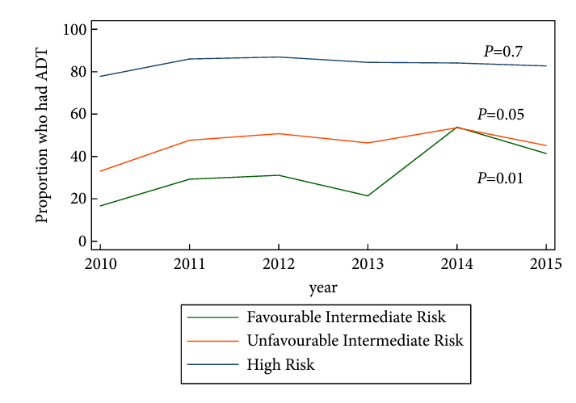

Figure 1: Proportion of men who received ADT with definitive radiotherapy by NCCN risk category

Source: Ong 2017

## Specify any characteristics of patients with, or suspected of having, the medical condition, who are proposed to be eligible for the proposed health technology, describing how a patient would be investigated, managed and referred within the Australian healthcare system in the lead up to being considered eligible for the technology:

The proposed patient population for the ArteraAI Prostate Biopsy Assay include men with localised prostate cancer that have an NCCN risk category of intermediate risk (favourable or unfavourable) who are planned to undergo curative-intent radiotherapy for prostate cancer, where intermediate risk is defined as follows:

Has all of the following:

* No high-risk group features
* No very-high-risk group features
* Has one or more intermediate risk factors (IRFs):
* Clinical stage cT2b-cT2c
* Grade Group 2 or 3 (Gleason Score 7 [3+4] or Gleason Score 7 [4+3])
* PSA 10-20ng/mL

**Favourable intermediate risk** (has all of the following):

* 1 intermediate risk factor (IRF)
* Grade Group 1 or 2 (Gleason Score <6 or Gleason Score 7 [3+4])
* <50% biopsy cores positive (e.g., <6 of 12 cores)
* **Unfavourable intermediate risk** (has ≥1 of the following):
* 2 or 3 IRFs
* Grade Group 3 (Gleason Score 7)
* ≥50% biopsy cores positive (e.g., >6 of 12 cores)

As per the instructions for use (provided as an attachment), the contraindications for the ArteraAI Prostate Biopsy Assay are as follows:

* Diagnosis of metastatic cancer
* Previous cancer treatment of curative intent

Prior to ArteraAI Prostate Biopsy Assay testing, a diagnosis of prostate cancer must be established on H&E stained histopathology of prostate core needle biopsies.

The initial evaluation for potential prostate cancer is typically conducted by a urologist, prompted by symptoms consistent with prostate cancer or elevated PSA levels.[3] in male patients. The urologist performs a prostate biopsy, which involves sampling cores of the prostate. These prostate cores are sent to a pathology laboratory, where each core is stained with H&E, which is typically sufficient for diagnosing the presence or absence of prostate cancer and assigning a Gleason score. The diagnosis, including Gleason scores of each core, are communicated back to the referring physician.

Localised prostate cancer is consistent with the cancer being contained within the prostate (stage T1 or T2). Risk classification will help inform management. The proposed population are those that have localised prostate cancer, of intermediate risk and in whom radiation therapy with curative intent is planned. The decision in these patients is whether or not ST-ADT should be used.

As noted previously, the risk stratification is established by urologists or by radiation oncologists. To note, the Urological Society of Australia and New Zealand (USANZ) have endorsed the European Association of Urology (EAU) guidelines for prostate cancer[4], whereas oncologists managing prostate cancer in Australia align with the NCCN guidelines for risk assessment and management. As discussed above, broadly speaking, the two guidelines are similar with respect to risk classification and management recommendations, noting that the EAU guidelines do not stratify intermediate risk patients into favourable and unfavourable which the NCCN guidelines do. The EAU guidelines refer to the NCCN guidelines with respect to treatment recommendations for those with favourable and unfavourable intermediate risk.

Importantly, the work up and lead up to diagnosis of patients will not change as a consequence of the introduction of the proposed test. Notably, the same whole slide images (WSI) of prostate needle biopsy samples used to inform the clinical risk assessment tools as per current standard of care would be used in the ArteraAI Prostate Biopsy Assay.

## Provide a rationale for the specifics of the eligible population:

The intended population relates to patients with localised prostate cancer of intermediate risk who are intended for curative radiotherapy. In these patients, the addition of ST-ADT may be considered. However, as discussed above, the clinician needs to consider the risk to benefit of adjunct ST-ADT in patients with intermediate risk, given the evidence shows that not all patients will have improved prostate cancer specific mortality and these treatments may cause potentially harmful adverse events that ultimately may compromise a patient’s life. According to the eviQ ADT for prostate cancer patient information fact sheet[5], some of the potential side effects include: sexual dysfunction, osteoporosis/bone health, hot flushes, changes in appearance and strength, fatigue, emotional and cognitive changes, risk of diabetes and heart disease.

The rationale for the specifics of the eligible population for the testing of ArteraAI Prostate Biopsy Assay is to inform risk classification (and hence inform prognosis) and to predict which patients will benefit from treatment with ST-ADT to inform management decision.

For intermediate risk patients, the ADT benefit model will help determine if the harm of significant adverse events is worth the clinical benefit, as research from ArteraAI has found that most patients diagnosed with intermediate risk localised prostate cancer will not experience any clinical advantage from hormone therapy (Gerrard 2024).

## Are there any prerequisite tests?

No

# Intervention

## Name of the proposed health technology:

ArteraAI Prostate Biopsy Assay

## Describe the key components and clinical steps involved in delivering the proposed health technology:

**Key Components***:*

The ArteraAI Prostate Biopsy Assay is a software device based on artificial intelligence (AI) that assesses physician-provided clinical variables and whole slide images (WSI) of prostate needle biopsy specimens to provide risk estimates of distant metastasis and prostate cancer specific mortality for patients with prostate cancer. The ArteraAI Prostate Biopsy Assay utilises AI for tissue morphology assessment. Results of the AI analysis together with age, PSA measurement and clinical staging (T-stage) are combined into algorithms.

The ArteraAI Prostate Biopsy Assay has two models:

1) classifies the patient into risk groups (prognosis), and

2) predicts whether a patient with intermediate risk is more likely to benefit from the addition of short term androgen deprivation therapy (ST-ADT) or not.

The ArteraAI Prostate Biopsy Assay is intended to assist clinicians with informing patients of their prognosis and with risk-based treatment decisions in localised prostate cancer who have intermediate prognostic risk based on the NCCN prostate cancer 2024 risk stratification.

Biopsy specimens must be treatment-naive and prepared from hematoxylin & eosin (H&E) stained tissue, and the images must come from a whole slide scanner validated for evaluation of formalin-fixed paraffin-embedded (FFPE) specimens.

The ArteraAI Prostate Biopsy Assay accepts images from the following systems:

* Philips Ultra Fast Scanner (ARTG registration number: 384705, ARTG start date: 25/02/2022)
* Grundium Ocus20 (ARTG registration number: 445350, ARTG start date: 04/04/2024)

Both have Global Medical Device Nomenclature of CT943 and the Product Category is Medical Device Included - IVD Class 1.

The physician-provided clinical variables include age, Gleason score, PSA measurement, and clinical tumour staging. An overview of the required clinical inputs variables for the ArteraAI Prostate Biopsy Assay is provided in Table 6.

Figure 2 and Figure 3 provide an example of the tissue classification and a description of the algorithms of ArteraAI Prostate Biopsy Assay respectively.

Table 6: Overview of required clinical input variables for the ArteraAI Prostate Biopsy Assay

|  |  |  |
| --- | --- | --- |
| **Variable** | **Measurement** | **Expected values** |
| Age | Years from date of birth to date of biopsy | 18–100 |
| Tumour stage | Clinical staging system | T1A, T1B, T1C, T1, T2A. T2B, T2C, T2, T3A, T3B. T3C, T3, T4A, T4B, T4C, T4 |
| Gleason grade (total, primary, secondary) | Pathologic assessment used for prostate cancer diagnosis | Primary Gleason: 3, 4, 5  Secondary Gleason: 3, 4, 5  Total Gleason: 6, 7, 8, 9, 10 |
| Baseline PSA | Baseline PSA blood levels in ng/mL in blood measured by clinical laboratories | 0–100 |

Source: ArteraAI Prostate Biopsy Assay Instructions for use (provided as an attachment)

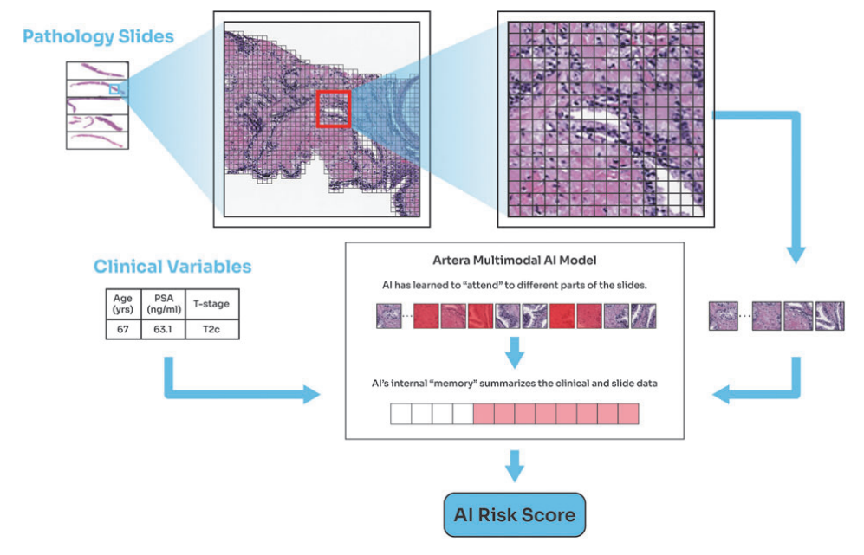

Figure 2: ArteraAI Prostate Biopsy Assay Tissue Classification and AI

Source: Gerrard 2024

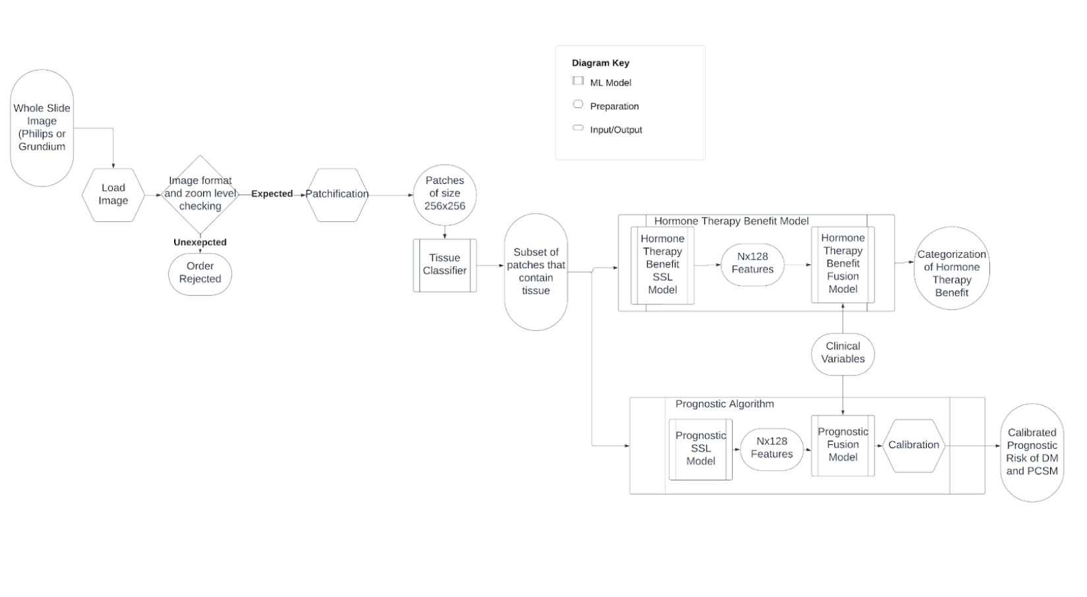

Figure 3: Algorithm for ArteraAI Prostate Biopsy Assay

**Overview of clinical steps:**

1. The ArteraAI Prostate Biopsy Assay is ordered by a treating clinician, usually a urologist, radiation oncologist, or medical oncologist, after an individual’s diagnosis of prostate cancer by a qualified histopathologist. *If there is no prostate cancer in any of the cores, ArteraAI Prostate Biopsy Assay should not be used.*
2. The ArteraAI Prostate Biopsy Assay is run on digitised images on prostate cancer core specimens. An individual at the pathology laboratory will retrieve the biopsy specimen containing the highest Gleason score as documented in the patient’s pathology report and digitise it using an approved scanner. The digital image provided by the pathology laboratory will be from a legally marketed whole slide imaging system. Image and other related quality control steps are performed per the instructions for use and any additional user site specifications. The image will be associated with the unique identifier and will be transferred to Artera’s infrastructure via the Artera Web portal.
3. The image, a unique patient identifier, and information provided by the treating clinician regarding the patient’s age, tumour stage, primary and secondary Gleason score, and baseline PSA measurement, are entered as data inputs that will be used by the software’s algorithm and transferred to Artera’s infrastructure via Artera’s Web portal. In addition, the NCCN clinical risk group of the patient, informed by the clinical variables, is required. This information will be provided by the treating clinician on a paper order form or via an electronic ordering system as determined by the pathology laboratory operating the test. The required clinical inputs for the ArteraAI Prostate Biopsy Assay are standard clinical variables used for assessment of the patient’s original prostate cancer diagnosis. The patient identifier is intended to provide end-to-end traceability whilst reducing risks associated with transfer and storage of protected health information.
4. ArteraAI Prostate Biopsy Assay uses the clinical data and the data from the digitised slide image as inputs to the Artera algorithms. The prognostic risk of distant metastasis and prostate cancer specific mortality algorithm is performed on all patients. For patients with clinically intermediate risk prostate cancer based on NCCN, the hormone therapy model results are provided. For other patients, these results are suppressed. To note, the proposed use of ArteraAI Prostate Biopsy Assay on the MBS is only intended for those with localised prostate cancer with intermediate risk
5. The Artera infrastructure produces a device report that summarises the ArteraAI algorithm results and transfers the device report to the pathology laboratory via the Artera Web portal. This infrastructure is located on a cloud server in Australia (Amazon Web Services Instance).
6. Once the device report is returned to the pathology laboratory, the pathology laboratory will use their in-house methods to convert device report to a laboratory report and return information to a clinician. The pathologist will confirm the presence of cancer within the image, approve the report in accordance with their laboratory standards, and release the test report to the treating clinician.

Typically the duration from the pathology laboratory receiving the patient's H&E slide to the physician receiving the test results is less than 2 business days. The time from a physician order to the pathology laboratory receiving the glass slide is variable.

**Test report output**

ArteraAI Prostate Biopsy Assay provides a probability of distant metastasis and recurrence within 5 and 10 years post-definitive treatment and a categorical benefit of ADT.

Excerpts from the test report presented below, show examples of the information that will be provided when ordering the test (Figure 4), the prognostic results output (Figure 5) and the predictive results output (Figure 6) along with supplemental information to inform the likelihood of benefiting from ST-ADT (Figure 7).

The biomarker AI model (eg, results displayed in Figure 6) works through combining tumour digital image features with clinical data to predict the benefit of adding ADT to radiotherapy for localised prostate cancer and was validated in the NRG/RTOG 9408 trial (Spratt, 2023).

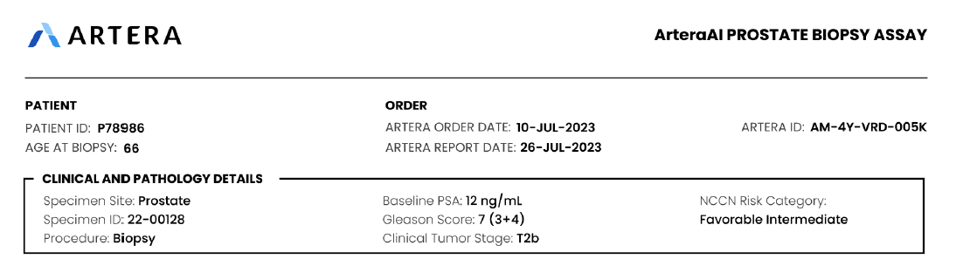

Figure 4: Example of information that was provided when ordering the ArteraAI Prostate Biopsy Assay

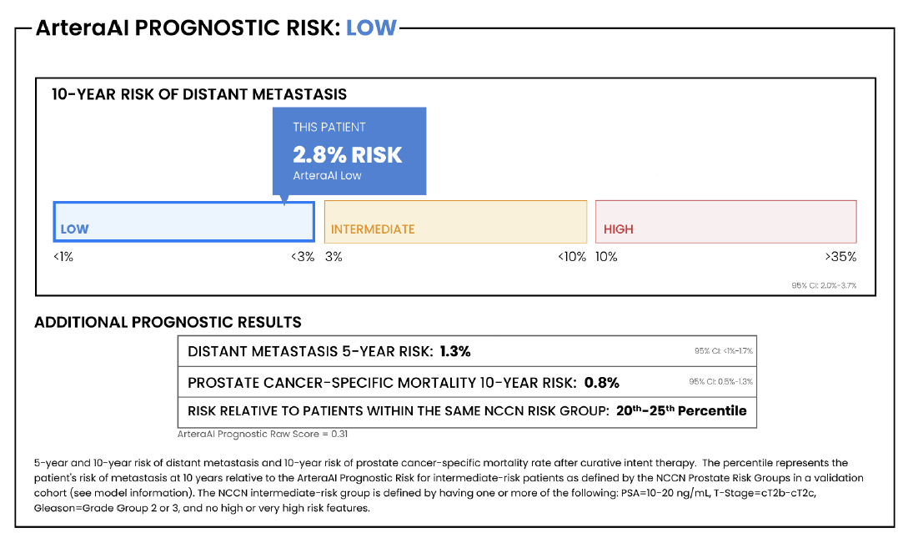

Figure 5: Example of prognostic results from the ArteraAI Prostate Biopsy Assay

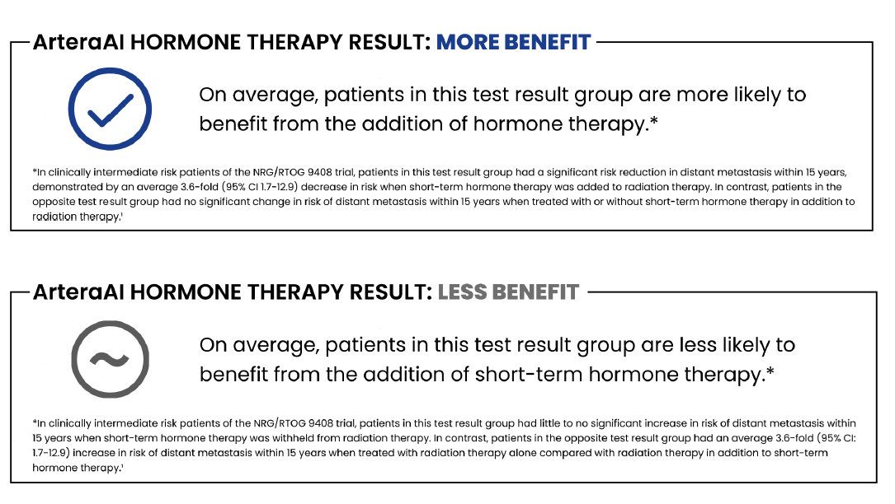

Figure 6: Example of predictive results from the ArteraAI Prostate Biopsy Assay outlining the likelihood of benefiting from ST-ADT (for intermediate risk patients based on NCCN assessment)

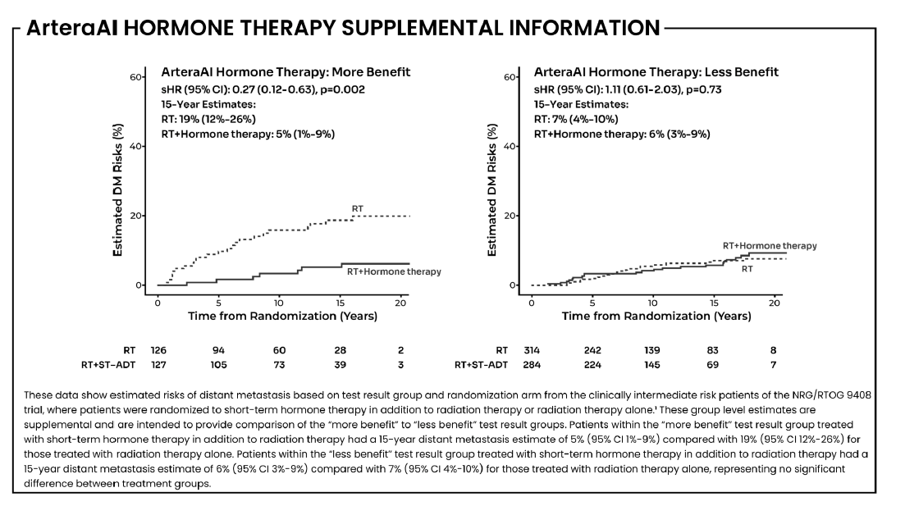

Figure 7: Example of predictive results from the ArteraAI Prostate Biopsy Assay

## **Identify how the proposed technology achieves the intended patient outcomes**:

The use of the ArteraAI Prostate Biopsy Assay improves the prognostication of patients, whereby the results from the AI test more accurately reflect their prognosis relative to NCCN risk groups (Esteva 2022; Spratt 2023; Spratt 2024; Gerrard 2024; Ross 2024). The improved prognostication relate to the value of knowing of an individual patient’s prognosis. Additionally, the ArteraAI Prostate Biopsy Assay will help inform which patients are more likely to benefit from ST-ADT and who are not (Gerrard 2023), ultimately helping with shared-decision making to avoid futile treatment intensification in patients who will derive minimal net benefit from treatment.

## Does the proposed health technology include a registered trademark component with characteristics that distinguishes it from other similar health components?

Yes, ArteraAI Prostate Biopsy Assay is a registered trademark of Artera, Inc.

## Explain whether it is essential to have this trademark component or whether there would be other components that would be suitable:

The ArteraAI Prostate Biopsy Assay is a proprietary AI test comprising two AI algorithmic models:

(1) a prognostic model of 5-year and 10-year prognosis of metastasis and death due to prostate cancer. The models are highly proprietary and are the core component of the test.

(2) A categorical benefit of ADT when combined with radiation therapy.

It would be preferable to have this trademark component in the listing to ensure the code is not used for non-researched AI tests. As an example of this, the gene expression profiling test item descriptor for breast cancer stipulates the trade name, EndoPredict (MBS item 73306).

## Are there any proposed limitations on the provision of the proposed health technology delivered to the patient (For example: accessibility, dosage, quantity, duration or frequency):

Yes

## Provide details and explain:

ArteraAI Prostate Biopsy Assay is to be used once per patient per lifetime.

## If applicable, advise which health professionals will be needed to provide the proposed health technology:

The ArteraAI Prostate Biopsy Assay will need to be run and monitored by a laboratory certified histotechnician.

A qualified histopathologist must review and certify the test report prior to test report delivery to the ordering clinician.

## If applicable, advise whether delivery of the proposed health technology can be delegated to another health professional:

The ArteraAI Prostate Biopsy Assay can be run and monitored by other qualified laboratory personnel if they are supervised by a certified laboratory histotechnician.

## If applicable, advise if there are any limitations on which health professionals might provide a referral for the proposed health technology:

The ordering clinician must be a licensed clinician as recognised by the Australian authorities.

The ArteraAI Prostate Biopsy Assay will be ordered principally by urologists, radiation oncologists, and medical oncologist.

## Is there specific training or qualifications required to provide or deliver the proposed service, and/or any accreditation requirements to support delivery of the health technology?

Yes

## Provide details and explain:

The laboratory histotechnician would require training on Whole Slide Imaging systems (Philips Ultra Fast or Grundium Ocus®20).

## Indicate the proposed setting(s) in which the proposed health technology will be delivered:

Consulting rooms

Day surgery centre

Emergency Department

Inpatient private hospital

Inpatient public hospital

Laboratory

Outpatient clinic

Patient’s home

Point of care testing

Residential aged care facility

Other (please specify)

The test is run in the laboratory with a whole slide imaging system (Philips Ultra Fast or Grundium Ocus®20) but the prostate biopsy sample can be taken in multiple settings.

## Is the proposed health technology intended to be entirely rendered inside Australia?

Yes

# Comparator

## Nominate the appropriate comparator(s) for the proposed medical service (i.e., how is the proposed population currently managed in the absence of the proposed medical service being available in the Australian healthcare system). This includes identifying healthcare resources that are needed to be delivered at the same time as the comparator service:

The main comparator to the ArteraAI Prostate Biopsy Assay reflect current standard of care (SoC) clinical practice to assess risk of patients with localised prostate cancer, and to inform which patients with intermediate risk should be treated with ST-ADT. As articulated previously, in Australia, the National Comprehensive Cancer Network (NCCN) and the European Association of Urology (EAU) risk groupings are used by radiation oncologists and urologists, respectively. There are no commercialised risk stratification prognostic classifier tests or tests predicting hormone therapy response registered for use in Australian in patients with prostate cancer, hence not listed on the MBS.

In terms of intermediate risk prostate cancer, the NCCN and EAU risk assessments are broadly similar (with the exception that the NCCN includes clinical stage T2c (tumour involves both lobes in the definition of ‘intermediate risk’ whereas the EAU risk assessment does not). Also, the EAU risk assessment does not stratify by unfavourable and favourable risk, which the NCCN assessment does. With respect to recommendations relating to ST-ADT in patients with intermediate risk (unfavourable and favourable), the EAU guidelines refer to the NCCN guidelines, hence the two sets of guidelines are reasonably exchangeable.

There are no other healthcare resources delivered at the same time as the comparator services, other than the specialist consultation for the treating physician. Currently used risk stratification tests are performed on H&E stained slides of prostate core biopsy tissue. Therefore, a prostate core needle biopsy is a prerequisite for risk stratification tests to determine prognosis or predict therapy response as per standard of care.

## List any existing MBS item numbers that are relevant for the nominated comparators:

No MBS item numbers exists for the comparators.

## Provide a rationale for why this is a comparator:

The nominated comparator to ArteraAI Prostate Biopsy Assay is the current standard of care to assess risk of patients with localised prostate cancer, based on the NCCN and EAU risk assessment tools. As mentioned above, whilst a number of different risk stratification tools exist for prostate cancer, Australian radiation oncologists generally rely on NCCN risk stratification for guiding treatment decisions, whilst USANZ has officially endorsed European Urological Association guidelines.

## Pattern of substitution – Will the proposed health technology wholly replace the proposed comparator, partially replace the proposed comparator, displace the proposed comparator or be used in combination with the proposed comparator?

None (used with the comparator)

Displaced (comparator will likely be used following the proposed technology in some patients)

Partial (in some cases, the proposed technology will replace the use of the comparator, but not all)

Full (subjects who receive the proposed intervention will not receive the comparator)

## Outline and explain the extent to which the current comparator is expected to be substituted:

Not applicable

# Outcomes

## List the key health outcomes (major and minor – prioritising major key health outcomes first) that will need to be measured in assessing the clinical claim for the proposed medical service/technology (versus the comparator):

Health benefits

Health harms

Resources

Value of knowing

Table 7: Key health outcomes from the ArteraAI Prostate Biopsy Assay

|  |  |  |
| --- | --- | --- |
| **Type** | **Outcome** | **Outcome description** |
| Health benefits | Predictive response to ST-ADT based on AI biomarkers  *Analytic accuracy - intraclass correlation coefficient | The test results will lead to health benefits in that the ArteraAI Prostate Biopsy Assay biomarker is predictive of response/benefit of ST-ADT in patients with intermediate risk localised prostate cancer. |
| Health harms | The test results will lead to a reduction in health harms because patients who are not likely to benefit from ST-ADT treatment can avoid the negative consequences of treatment. |
| Resources | The test results will help identify individuals who are unlikely to benefit from ST-ADT treatment, leading to a reduction in its use. Consequently, this will save resources by minimising unnecessary ST-ADT treatments. |
| Value of knowing | Analytic accuracy for prognosis in terms of low, intermediate or high risk for distant metastasis (5 and 10 year), biochemical failure (5 and 10 year) and prostate cancer specific survival.  *Area under the time-dependent receiver operator characteristic curve (AUC) of sensitivity and specificity  *Intraclass correlation coefficient | ArteraAI Prostate Biopsy Assay models have superior discriminatory performance across prognostic outcome relative to NCCN risk assessment tool. |

Abbreviations: AI, Artificial Intelligence; AUC, Area under the time-dependent receiver operator characteristic curve; NCCN, National Comprehensive Cancer Network; ST-ADT, Short Term Androgen Deprivation Therapy.

## Outcome description – include information about whether a change in patient management, or prognosis, occurs as a result of the test information:

A known limitation of the NCCN risk stratification groups (and other risk classification systems) is that they do not discriminate risk sufficiently to direct treatment management within risk strata nor do they predict if a treatment like ST-ADT, which induces undesirable adverse effects, is likely or not likely to improve outcomes for a particular patient. Compared with the NCCN risk stratification tool the ArteraAI Prostate Biopsy Assay models have superior discriminatory performance across all morbidity and disease related mortality endpoints: distant metastasis (5 and 10 year), biochemical failure (5 and 10 year), and prostate cancer specific survival (Esteva 2022). Therefore, the test will result in a change in prognosis that will be of value to the patient and the treating clinician.

The results from the ArteraAI Prostate Biopsy Assay will also inform the likelihood that a patient with intermediate risk localised prostate cancer, who is planned for curative intent radiation therapy, will benefit from adjuvant ST-ADT (Gerrard 2024, Spratt 2023). This information will lead to changes in management, resulting in health benefits, reduced health risks, and resource savings. A forthcoming study, the ASTuTE trial, is a decision impact study that will inform the extent of change in management as a consequence of the ArteraAI Prostate Biopsy Assay (refer to the Summary of Evidence section).

# Proposed MBS items

## How is the technology/service funded at present? (e.g., research funding; State-based funding; self-funded by patients; no funding or payments):

To date, the ArteraAI Prostate Biopsy Assay is not funded within Australia.

## Provide at least one proposed item with their descriptor and associated costs, for each Population/Intervention:

The proposed MBS item descriptor for the ArteraAI Prostate Biopsy Assay is provided below. To note, the item descriptor refers to patients with intermediate risk based on the NCCN risk assessment tool and includes the current criteria for favourable and unfavourable intermediate risk. In the context of future proofing the MBS item descriptor, the criteria for intermediate risk may be omitted (eg, in the event the criteria changes over time).

The brand name of the test is included in the proposed MBS descriptor, as discussed previously, to ensure the code is not used for non-researched AI tests. A relevant precedent is the gene expression profiling test item descriptor for breast cancer, which similarly includes the brand name, EndoPredict (MBS item 73306).

|  |  |
| --- | --- |
| MBS item number  (where used as a template for the proposed item) | NA |
| Category number | 6 |
| Category description | PATHOLOGY SERVICES - GROUP P5 - Tissue pathology |
| Proposed item descriptor | ArteraAI Prostate Biopsy Assay for men with localised prostate cancer that have a National Comprehensive Cancer Network (NCCN) risk category of intermediate risk (favourable or unfavourable), who are planned to undergo curative-intent radiotherapy for prostate cancer, where intermediate risk is defined as follows:  Has all of the following:   * No high-risk group features * No very-high-risk group features * Has one or more intermediate risk factors (IRFs):   + Clinical stage cT2b-cT2c   + Grade Group 2 or 3 (Gleason Score 7 [3+4] or Gleason Score 7 [4+3])   + PSA 10-20ng/mL   **Favourable intermediate risk:** (has all of the following)   * 1 intermediate risk factor (IRF) * Grade Group 1 or 2 (Gleason Score <6 or Gleason Score 7 [3+4]) * <50% biopsy cores positive (e.g., <6 of 12 cores)   **Unfavourable intermediate risk** (has at least one of the following)   * 2 or 3 IRFs * Grade Group 3 (Gleason Score 7) * ≥50% biopsy cores positive (e.g., >6 of 12 cores)   The artificial intelligence prostate biopsy assay should not be used in patients with a diagnosis of metastatic cancer or those who have previously received cancer treatment of curative intent.  The test may be used once per new prostate cancer diagnosis. |
| Proposed MBS fee | $1200 |
| Indicate the overall cost per patient of providing the proposed health technology | $1200 |
| Please specify any anticipated out of pocket expenses | $98.70 |
| Provide any further details and explain | Given this is an out of hospital procedure, Medicare will fund 85% of the proposed fee with the patient paying the gap. However, the gap in this instance of $180 exceeds the greatest permissible gap (GPG), hence the patient will pay the GPG of $98.70 and Medicare would pay the remainder of $1,101.30.  The proposed MBS fee for the ArteraAI Prostate Biopsy Assay covers the cost of the test and the fee for the pathologist. |

# Algorithms

## PREPARATION FOR USING THE HEALTH TECHNOLOGY

## Define and summarise the clinical management algorithm, including any required tests or healthcare resources, before patients would be eligible for the proposed health technology:

The clinical management algorithm including the proposed test (ArteraAI Prostate Biopsy Assay) is displayed in Figure 8. The algorithm shows prognostic risk stratification into low, intermediate or high risk of distant metastasis and prostate cancer specific mortality as a consequence of the proposed test and as a consequence of currently used risk stratification tools (NCCN, note the EUA is not included in the algorithm but as noted previously is broadly similar to the NCCN risk assessment tool). The biomarker model results from the ArteraAI Prostate Biopsy Assay predicts the benefit of adjuvant ADT, aiding clinicians in their treatment decision-making. No alternative predictive tests exists, meaning currently, clinicians decide which patients with intermediate risk should or should not be treated with ST-ADT based on the risk assessment tools and guidelines.

To run the ArteraAI Prostate Biopsy Assay, H&E stained slides of prostate tissue specimens obtained from a prostate biopsy is required. These prostate biopsy specimens are required as part of current standard of care, to establish diagnosis, inform staging and risk classification.

Additionally, the ArteraAI Prostate Biopsy Assay requires digitised images of the H&E stained specimens to run its software.

Is there any expectation that the clinical management algorithm before the health technology is used will change due to the introduction of the proposed health technology?

Yes

## Describe and explain any differences in the clinical management algorithm prior to the use of the proposed health technology vs. the comparator health technology:

Use of the ArteraAI Prostate Biopsy Assay requires digitisation of the biopsy images for use in the software based tool; this is not a requirement for the standard of care risk assessment tools (eg, NCCN and EAU). However, it should be noted that it is possible that the pathologist used digitised images of the prostate specimen to make a diagnosis and to establish Gleason grade, T stage and other factors.

## USE OF THE HEALTH TECHNOLOGY

## Explain what other healthcare resources are used in conjunction with delivering the proposed health technology:

There are no other healthcare resources required for the ArteraAI Prostate Biopsy Assay.

## Explain what other healthcare resources are used in conjunction with the comparator health technology:

There are no other healthcare resources required for comparator standard of care risk assessment tools.

## Describe and explain any differences in the healthcare resources used in conjunction with the proposed health technology vs. the comparator health technology:

Not applicable.

## CLINICAL MANAGEMENT AFTER THE USE OF HEALTH TECHNOLOGY

## Define and summarise the clinical management algorithm, including any required tests or healthcare resources, *after* the use of the proposed health technology:

The prognostication information received by the ArteraAI Prostate Biopsy Assay is not intended to change treatment decisions, rather will provide the patient and physician with additional information to inform the prognosis of the patient.

The ArteraAI Prostate Biopsy Assay biomarker will inform the likelihood of a patient benefiting from ST-ADT, and as such the results from the proposed test may reduce the use of ST-ADT in patients in whom treatment is likely to be futile, relative to the comparator risk assessment standard of care.

## Define and summarise the clinical management algorithm, including any required tests or healthcare resources, *after* the use of the comparator health technology:

Treatment decisions regarding ST-ADT in patients for intermediate risk patients with prostate cancer whom radiation therapy with curative intent is planned are based on standard of care including clinical risk assessment tools.

## Describe and explain any differences in the healthcare resources used *after* the proposed health technology vs. the comparator health technology:

As noted above, relative to standard risk assessment tools (NCCN, EAU) it is expected that use of ST-ADT will be reduced and therefore the costs of ADT therapy and health care resources utilised in treating adverse effects of ADT will be reduced.

## Insert diagrams demonstrating the clinical management algorithm with and without the proposed health technology:

The clinical management algorithm of ArteraAI Prostate Biopsy Assay is displayed in Figure 8.

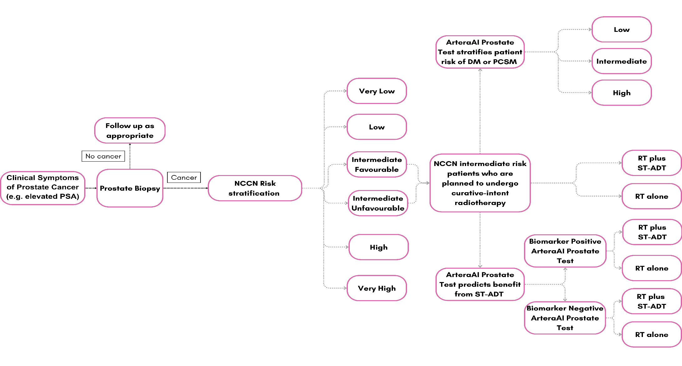

Figure 8: Clinical Management Algorithm of ArteraAI Prostate Biopsy Assay

Abbreviations: DM, Distant Metastasis; NCCN, National Comprehensive Cancer Network; PCSM, Prostate Cancer Specific Mortality; RT, Radiotherapy; ST-ADT, Short Term Androgen Deprivation Therapy

# Claims

## In terms of health outcomes (comparative benefits and harms), is the proposed technology claimed to be superior, non-inferior or inferior to the comparator(s)?

Superior

Non-inferior

Inferior

## Please state what the overall claim is, and provide a rationale:

Compared to the NCCN risk stratification tool, the ArteraAI Prostate Biopsy Assay models have superior discriminatory performance across all distant metastasis (5 and 10 year), biochemical failure (5 and 10 year), prostate cancer specific survival (Esteva 2022, Gerrard 2024; Ross 2024), improving the value of knowing for patients.

The ArteraAI Prostate Biopsy Assay ‘‘biomarker’’ is predictive of response/benefit of ST-ADT in patients with intermediate risk localised prostate cancer who are intended for radiotherapy with curative intent. The test results will lead to superior health outcomes because it will ensure patients who are not likely to benefit from ST-ADT treatment can avoid the negative consequences of treatment and those who are likely to benefit will receive treatment with ST-ADT.

The analyses by Gerrard (2024) used data from the NRG/RTOG 9408 trial which assessed the efficacy of adding ST-ADT to radiation therapy in men with localised prostate cancer to validate the predictive algorithm as per Spratt (2023) in a patient population of intermediate risk localised prostate cancer. The clinical validity for predictiveness was assessed using the significance of ST-ADT treatment interaction of the Fine and Gray regression model (two-sided p value <0.05 indicative of a statistically significant difference in distant metastasis due to ST-ADT use between the biomarker positive and negative cohorts, based on a comparison of hazard ratios). Of the 851 patients with NCCN intermediate risk 32% were classified as biomarker positive, where adding ST-ADT statistically significantly reduced the risk of DM compared with radiation therapy alone (sub distribution HR [sHR] 0.33, 95% CI [0.15–0.72], p = 0.006). Conversely, in the biomarker negative patients, no statistically significant difference was observed between adding ST-ADT versus radiotherapy alone (sHR 1.04, 95% CI [0.57–1.92], p = 0.89). Statistically significant interaction for treatment-by-algorithm for DM was observed (p = 0.02). Cumulative incidence estimates of DMs stratified by biomarker are shown in Figure 9.

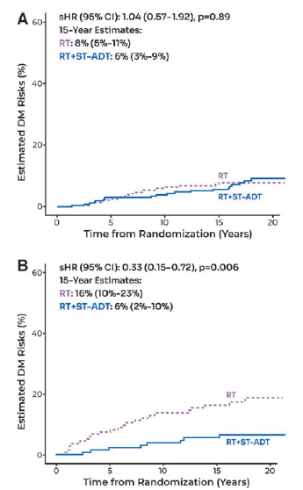

Figure 9: Cumulative incidence estimates of treatment arms by biomarker subgroups in the validation cohort of RTOG 9408 NCCN intermediate risk patients (n=851) (A) the biomarker negative group (B) the biomarker positive group

Abbreviations: CI, confidence interval; DM, distant metastasis; Est., estimated; RT, radiation therapy; RT + ST-ADT, radiation therapy + short term adjuvant deprivation therapy; sHR, sub distribution hazard ratio.

## Why would the requestor seek to use the proposed investigative technology rather than the comparator(s)?

N/A. The proposed test will be used in addition to standard of care (the comparator).

## Identify how the proposed technology achieves the intended patient outcomes:

ArteraAI Prostate Biopsy Assay provides men with intermediate risk localised prostate cancer the benefit of value of knowing their prognosis. Specifically, this will enable them to engage in better long-term planning (e.g. career, finances, and family), provide a greater sense of control over their own medical decisions, and enable a greater understanding of their likely future health care needs.

The ArteraAI Prostate Biopsy Assay biomarker test result provides the physician and the patient with the likelihood of benefiting from ST-ADT. By appropriately selecting patients for ST-ADT, treatment outcomes can be optimised, both in terms of ensuring those patients that are likely to benefit from ST-ADT will received it, and in terms of avoiding futile treatment and causing harm to patients that are unlikely to benefit from treatment. ST-ADT is associated with a range of negative consequences, including hot flushes, sexual dysfunction, deteriorating bone health, changes in appearance and strength, fatigue, emotional and cognitive changes, risk of diabetes and cardiovascular disease. These adverse effects in turn will impair the patients quality of life. Avoiding these adverse effects therefore represent net improvement of health outcomes.

## For some people, compared with the comparator(s), does the test information result in:

**A change in clinical management?** Yes

**A change in health outcome?** Yes

**Other benefits?**  Yes

## Please provide a rationale, and information on other benefits if relevant:

As discussed above the ArteraAI Prostate Biopsy Assay provides prognostic information reflecting value of knowing which is of benefit to the patient.

## In terms of the immediate costs of the proposed technology (and immediate cost consequences, such as procedural costs, testing costs etc.), is the proposed technology claimed to be more costly, the same cost or less costly than the comparator?

More costly

Same cost

Less costly

## Provide a brief rationale for the claim:

The test will be used in addition to the comparator (e.g. standard of care including NCCN and EAU risk assessment tools).

# Summary of Evidence

## Provide one or more recent (published) high quality clinical studies that support use of the proposed health service/technology

|  | **Type of study design\*** | **Title of journal article or research project** | **Short description of research** | **Website link to journal article or research** | **Date of publication** |
| --- | --- | --- | --- | --- | --- |
| 1. | Retrospective analysis of prospectively collected RCT data | Gerrard P, Zhang J, Yamashita R, et al. Analytical Validation of a Clinical Grade Prognostic and Classification Artificial Intelligence Laboratory Test for Men with Prostate Cancer | The paper validates two AI algorithms for prostate cancer prognosis and treatment prediction using data from 8 clinical trials involving over 10,000 patients. The development cohort included 3,977 cases, and the validation cohort included 1,509 cases (851 intermediate cases). The prognostic algorithm's ICC for analytical accuracy was 0.991, with intra-operator and inter-operator reliability ICCs of 0.981 and 0.994, respectively. The predictive algorithm had an ICC of 0.934, with 100% and 93.3% agreement for intra- and inter-operator reliability, respectively. The predictive model significantly stratified patients for benefit from ST-ADT.  In NCCN intermediate-risk patients from the RTOG 9408 trial (n=851), those in the biomarker-negative subset showed similar DM rates with RT alone (8%) and RT ST-ADT (6%). In contrast, the biomarker-positive subset exhibited a significant difference, with DM rates of 16% for RT alone and 6% for RT plus ST-ADT. | https://www.liebertpub.com/doi/abs/10.1089/aipo.2024.0004 | 18 April 2024 |
| 2. | Retrospective analysis of prospectively collected RCT data | Esteva A, Feng J, van der Wal D, et al. Prostate cancer therapy personalization via multi-modal deep learning on randomized phase III clinical trials [published correction appears in NPJ Digit Med. 2023;6(1):27]. NPJ Digit Med. 2022;5(1):71. doi:10.1038/s41746-022-00613-w | This study investigated a MMAI system for enhanced risk stratification and therapy personalisation in localised prostate cancer, using data from 5,654 patients across five phase III trials. The MMAI model, which includes digital histopathology and clinical data, outperformed the NCCN risk groups, with AUC improvements in endpoints like 5-year distant metastasis (0.83 vs. 0.72), 5-year biochemical failure (0.69 vs. 0.61), and 10-year prostate cancer-specific survival (0.77 vs. 0.67). Among patients with biomarker-positive profiles, those who received ADT showed significantly superior outcomes, indicating the model's potential to guide treatment decisions effectively. | <https://www.nature.com/articles/s41746-022-00613-w> | June 8, 2022 |
| 3. | Retrospective analysis of prospectively collected RCT data | Spratt DE, Tang S, Sun Y, Huang H, Chen E, Mohamad O, et al. Artificial intelligence predictive model for hormone therapy use in prostate cancer. *NEJM Evid* 2023;2(8) doi: 10.1056/EVIDoa2300023 | The study developed and validated an AI-derived predictive model to identify prostate cancer patients who would benefit from adding ADT to radiotherapy. Using data from 5,727 patients across five phase 3 trials, the model was tested on 1,594 patients from the NRG/RTOG 9408 trial. It found that 34% of patients were model-positive and significantly benefited from ADT, with reduced DM and PCSM. In contrast, model-negative patients showed minimal benefit. | <https://www.researchsquare.com/article/rs-2790858/v1> | April 21, 2023 |
| 4. | Retrospective analysis of prospectively collected RCT data | Ross AE, Zhang J, Huang HC, et al. External Validation of a Digital Pathology-based Multimodal Artificial Intelligence Architecture in the NRG/RTOG 9902 Phase 3 Trial. *Eur Urol Oncol*. Published online January 31, 2024. doi:10.1016/j.euo.2024.01.004 | This study aimed at externally validating a MMAI model for predicting outcomes in high-risk prostate cancer patients. It involved 318 participants from the NRG/RTOG 9902 clinical trial. The MMAI models, which incorporated digital histopathology and clinical features, were assessed for predicting DM and PCSM. Results indicated that the DM and PCSM MMAI scores were significantly associated with their respective endpoints (sHR for DM: 2.33, 95% CI 1.60–3.38; sHR for PCSM: 3.54, 95% CI 2.38–5.28). The MMAI models outperformed traditional clinical and pathological factors in prognostic accuracy. | <https://euoncology.europeanurology.com/article/S2588-9311(24)00029-4/abstract> | January 31, 2024 |
| 5. | Retrospective analysis of prospectively collected RCT data | Roach M, Zhang J, Esteva A, et al. 2022 ASCO Annual Meeting (Abstract 108). | This study evaluated prostate cancer risk in 5,624 men (17% AA, 80% white, 3% other) using MMAI models on digital histopathology from five clinical trials. The models showed comparable prognostic performance for AA and non-AA men, with AA having a younger median age (69 vs 71 years), higher median PSA (12 vs 10 ng/mL), and more high-risk cases (41% vs 33%). Both groups had similar 5-year biochemical failure (27%), distant metastasis (5%), 10-year prostate cancer-specific mortality (AA 5%, non-AA 7%), and overall survival rates (AA 58%, non-AA 60%). The MMAI models demonstrated strong prognostic signals and consistent trends across racial groups. | <https://ascopubs.org/doi/10.1200/JCO.2022.40.16_suppl.108> | June 2, 2022 |
| 6. | Retrospective analysis of prospectively collected RCT data | Spratt DE, Liu V, Yamshita R, et al. J Clin Oncol (41:6_suppl) Patient-level data meta-analysis of a multi-modal artificial intelligence (MMAI) prognostic biomarker in high-risk prostate cancer: Results from six NRG/RTOG phase III randomized trials.  2022 ASCO GU Cancers Symposium (Abstract 223) | This study validated the ArteraAI Prostate multi-modal AI (MMAI) prognostic biomarker using data from 1,088 men with high-risk prostate cancer across six phase III trials. The cohort had a median follow-up of 10.4 years, median PSA of 21 ng/mL, 60% with Gleason 8-10 disease, 37% with cT3-T4 disease, and 20% African American. The MMAI biomarker outperformed traditional clinical variables in predicting 5-year DM and PCSM, with significant associations (DM sHR 2.05, PCSM sHR 2.04). Higher MMAI quartiles correlated with increased 10-year DM (8% vs 31%) and 15-year PCSM (8% vs 34%) rates, enhancing personalised treatment decisions. | <https://ascopubs.org/doi/10.1200/JCO.2023.41.6_suppl.299> | February 16, 2022 |
| 7. | Retrospective analysis of prospectively collected RCT data | Tward J, Zhang J, Esteva A, et al. Prostate Cancer Risk Stratification in NRG Oncology Phase III Randomized Trials Using Multi-Modal Deep Learning with Digital Histopathology    2022 American Society for Radiation Oncology Annual Meeting (Abstract 2) | A study comprising 5,569 patients from 5 RTOG trials in which patients were stratified into deciles (n=557/decile) based on their MMAI prognostic scores demonstrated that the MMAI model could stratify patients into risk groups that more precisely and accurately reflect their prognosis compared to D’Amico/NCCN risk groups. | <https://www.urotoday.com/conference-highlights/astro-2022/140315-astro-2022-prostate-cancer-risk-stratification-in-nrg-oncology-phase-iii-randomized-trials-using-multi-modal-deep-learning-with-digital-histopathology.html> | Abstract published 2022  Manuscript submitted for publication  (date to be confirmed) |
| 8. | Retrospective analysis of prospectively collected RCT data | D.E. Spratt, Vinnie Y.T. Liu, A.Y. Jia et al., Meta-analysis of Individual Patient-level Data for a Multimodal Artificial Intelligence Biomarker in High-risk Prostate Cancer: Results from Six NRG/RTOG Phase 3 Randomized Trials, Eur Urol (2024), | This study evaluates the performance of ArteraAI Prostate, a MMAI prognostic biomarker. Utilising data from six phase 3 randomized trials, the study generated MMAI scores for each patient to predict time to DM, prostate cancer-specific mortality PCSM, and DDM. The high-risk validation cohort (n = 1088) had a median follow-up of 10.4 years. The MMAI model was significantly associated with DM (sHR 1.90), PCSM (sHR 2.06), and DDM (sHR 2.12), with an 18% absolute difference in 10-year DM risk between lower and higher MMAI quartiles. This biomarker was validated as independently prognostic over standard clinical and pathological variables, offering a scalable tool for personalized treatment decisions in high-risk prostate cancer patients. | https://doi.org/10.1016/j.  eururo.2024.06.019  https://www.sciencedirect.com/science/article/abs/pii/S0302283824024540?via%3Dihub | July 17, 2024 |

AA, African American; AI, Artificial Intelligence; AUC, Area Under the ROC Curve; CI, Confidence Interval; DDM, Death with DM; DM, Distant Metastasis; ICC, Intraclass Correlation Coefficient; MMAI, Multi-modal Artificial Intelligence; NCCN; National Comprehensive Cancer Network; PCa, Prostate Cancer; PCSM, Prostate Cancer Specific Metastasis; PSA, Prostate Specific Antigen; RCT, Randomised Control Trial; RTOG, Radiation Therapy Oncology Group; sHR, Sub distribution Hazard Ratio; ST-ADT, Short Term Androgen Deprivation Therapy

Identify yet-to-be-published research that may have results available in the near future (that could be relevant to your application).

|  | **Type of study design\*** | **Title of journal article or research project (including any trial identifier or study lead if relevant)** | **Short description of research (max 50 words)\*\*** | **Website link to journal article or research (if available)** | **Date of publication\*\*\*** |
| --- | --- | --- | --- | --- | --- |
| 1. | Prospective decision impact and health economics study | ASTuTE  Trial Registry Name: Australian New Zealand Clinical Trials Registry (ANZCTR)  Trial Registry ID Number: ACTRN12623000713695p | The ASTuTE Protocol is a prospective study (N=800) diagnosed with NCCN intermediate-risk prostate cancer, primarily recruited from GenesisCare sites in Australia. Participants are selected based on specific inclusion criteria (adult males over 18 with intermediate-risk localised adenocarcinoma of the prostate, an estimated life expectancy greater than 10 years, and a plan to undergo curative-intent radiotherapy) and exclusion criteria (insufficient tissue for testing, evidence of neuroendocrine or small cell differentiation, and node-positive or distant metastases (cN1 or cM1)). The study aims to evaluate the clinical utility of the ArteraAI Prostate Biopsy Assay in guiding ST-ADT treatment decisions, with a focus on tailoring therapy beyond the standard recommendations of the NCCN guidelines. | To be determined | 12 to 18 month decision impact study to be completed late 2024 (Enrollment ongoing) |

Abbreviations: ADT, Androgen Deprivation Therapy; NCCN, National Comprehensive Cancer Network

1. <https://www.eviq.org.au/medical-oncology/urogenital/prostate> (accessed 7 June 2024)
2. <https://www.eviq.org.au/medical-oncology/urogenital/prostate> (accessed 7 June 2024)
3. PSA Testing and Early Management of Test Detected Prostate Cancer: Clinical Practice Guidelines. Prostate Cancer Foundation of Australia, Cancer Council Australia and approved by National Health and Medical Research Council.

   * Average risk men offered pSA testing every 2 years from age 50-69 years with further investigation for PSA >3 ng/ml
   * Men 70 years and older advised that harms of PSA testing may be greater than benefits
   * Men at high risk (a father or a brother diagnosed with prostate cancer have 2.5 to 3x higher risk and should undergo testing every 2 years from 40-69 years.

  
4. https://www.usanz.org.au/info-resources/position-statements-guidelines#EAU (accessed 24 June, 2024)

   EAU Guidelines. USANZ has endorsed the EAU Guidelines subject to Australian and New Zealand conditions.
5. [www.eviq.org.au/getmedia/b1133405-c72e-4906-bb31-c309af59f50a/Patient-info-sheet-ADT-for-prostate-cancer-FINAL.pdf](http://www.eviq.org.au/getmedia/b1133405-c72e-4906-bb31-c309af59f50a/Patient-info-sheet-ADT-for-prostate-cancer-FINAL.pdf) (accessed 7 June 2023)