Final decision analytic protocol to guide the assessment of Holmium:YAG Laser Enucleation of the Prostate (HoLEP) for the Treatment of Benign Prostatic Hyperplasia

May 2011

Table of Contents
MSAC and PASC 3
Purpose of this document 3
Purpose of application 4
Intervention 4
Description 4
Administration, dose, frequency of administration, duration of treatment 4
Co-administered interventions 5
Background 8
Current arrangements for public reimbursement 8
Regulatory status 8
Patient population 8
Proposed MBS listing 8
Clinical place for proposed intervention 8
Comparator 14
Clinical claim 18
Outcomes and health care resources affected by introduction of proposed intervention 20
Outcomes 20
Health care resources 20
Proposed structure of economic evaluation (decision-analytic) 22
References 26

MSAC and PASC

The Medical Services Advisory Committee (MSAC) is an independent expert committee appointed by the Minister for Health and Ageing (the Minister) to strengthen the role of evidence in health financing decisions in Australia. MSAC advises the Minister on the evidence relating to the safety, effectiveness, and cost-effectiveness of new and existing medical technologies and procedures and under what circumstances public funding should be supported.

The Protocol Advisory Sub-Committee (PASC) is a standing sub-committee of MSAC. Its primary objective is the determination of protocols to guide clinical and economic assessments of medical interventions proposed for public funding.

Purpose of this document

This document is intended to provide a draft decision analytic protocol that will be used to guide the assessment of an intervention for a particular population of patients. The draft protocol will be finalised after inviting relevant stakeholders to provide input to the protocol. The final protocol will provide the basis for the assessment of the intervention.

The protocol guiding the assessment of the health intervention has been developed using the widely accepted “PICO” approach. The PICO approach involves a clear articulation of the following aspects of the research question that the assessment is intended to answer:

Patients – specification of the characteristics of the patients in whom the intervention is to be considered for use;
Intervention – specification of the proposed intervention
Comparator – specification of the therapy most likely to be replaced by the proposed intervention
Outcomes – specification of the health outcomes and the healthcare resources likely to be affected by the introduction of the proposed intervention

Purpose of application

A proposal for an application requesting MBS listing of Holmium:YAG Laser Enucleation of the Prostate (HoLEP) for the treatment of Benign Prostatic Hyperplasia (BPH) was received from MD Solutions Pty. Ltd. by the Department of Health and Ageing in May 2010.

Intervention

Description

Holmium:YAG lasers (active medium is a crystal of yttrium, aluminum, and garnet doped with holmium) are used for cutting soft tissue in several different surgical applications. Holmium:YAG lasers used for BPH are high powered and must deliver at least 100W of power and be end-firing. The laser is used to remove the prostate’s ‘lobes’ in two or three sections during endoscopic enucleation. The procedure is performed using a continuous flow rectoscope with a video system and saline irrigation to maintain a clear view. The dissected lobes are pushed into the bladder and endoscopic tissue morcellation is used to free them without cutting into the bladder. The tissue can be retrieved for examination for occult cancer cells which may not have been detected through other means. A detailed description of the surgical procedure is depicted by Gilling (2008).

The medical condition is benign prostatic hyperplasia (BPH) which refers to a non-malignant overgrowth of the prostate gland which is experienced to some degree by the majority of men over
50 years of age. BPH can give rise to physiological dysfunction or anatomical obstruction of the urinary tract (or a combination of these factors). The condition broadly involves three factors:

• A histological change of hyperplasia within the gland

• Clinically determined enlargement of the prostate gland

• The clinical syndrome of lower urinary tract symptoms (LUTS)

The size of the prostate gland does not necessarily correlate to the type or severity of symptoms that a man may experience. Clinical BPH is very common in the ageing man and is most often associated with various LUTS which can be broadly divided into two categories; obstructive and irritative. Moderate to severe symptoms are recognised as significantly impacting on quality of life.

Administration, dose, frequency of administration, duration of treatment

HoLEP is considered a definitive treatment for BPH; however, there is a failure rate. A second treatment, if required, could be a repeat HoLEP if the failure were due to incomplete removal of tissue but may also be one of the surgical alternatives: transuretheral resection of the prostate (TURP) or open prostatectomy. In most cases HoLEP would be undertaken once per patient.

HoLEP is undertaken in the operating suite of a hospital and has the potential to be undertaken as day surgery in some patients. The procedure can be carried out with either spinal or general anaesthesia. Hospital stay is typically 1 to 3 days with catheterisation times of 12-24 hours. Standard inpatient pathways requiring ward and recovery staff also applies. It requires the use of specialised instruments as follows:

• A high-powered holmium laser (>100W)

• An end-firing fibre 55 micron delivery system (available as both ‘single-use’ or ‘trimmable-re- useable’).

And where morcellation is undertaken:

• A morecellator pump control unit

• Morecellator blades

• Morcellator tubing.

The procedure would be undertaken by trained urologists with the assistance of nursing staff and an anaesthetist. There is a learning curve to develop skills in HoLEP which would require considerable investment from individual urologists in terms of both time and money. Therefore, HoLEP would be undertaken in specialist urology centres by specially trained urologists.

Co-administered interventions

Patients undergoing HoLEP would require specialist assessment by an urologist which may include measurement of urine flow rate and a renal tract ultrasound to establish a diagnosis of BPH and suitability for HoLEP. These assessments may be repeated during a follow up appointment with the specialist urologist. The frequency of use of these assessments is not expected to change with the introduction of HoLEP.

Table 1: Current MBS item descriptor for diagnostic/monitoring tests associated with HoLEP

Category 2 - DIAGNOSTIC PROCEDURES AND INVESTIGATIONS
MBS 11900

URINE FLOW STUDY including peak urine flow measurement, not being a service associated with a service to which item
11919 applies

Fee: $26.50 Benefit: 75% = $19.90 85% = $22.55
Category 5 – DIAGNOSTIC IMAGING SERVICES
MBS 55084

URINARY BLADDER, ultrasound scan of, by any or all approaches, where:

(a) the patient is referred by a medical practitioner for ultrasonic examination not being a service associated with a service to which an item in Subgroups 2 or 3 of the Group applies; and

(b) the referring medical practitioner is not a member of a group of practitioners of which the providing practitioner is a member; and

(c) the service is not performed with item 55600, 55603, 55036, 55038, 55044, 55731 or 11917 on the same date of service (R)

Bulk bill incentive

Fee: $98.25 Benefit: 75% = $73.70 85% = $83.55 (See para DIQ of explanatory notes to this Category)
Category 5 – DIAGNOSTIC IMAGING SERVICES
MBS 55085

URINARY BLADDER, ultrasound scan of, by any or all approaches, where the patient is not referred by a medical practitioner, not being a service associated with a service to which an item in Subgroups 2 or 3 applies; and the service is not performed with item 55600, 55603, 55037, 55039, 55045, 55733 or 11917 on the same date of service (NR)

Bulk bill incentive

Fee: $34.05 Benefit: 75% = $25.55 85% = $28.95 (See para DIQ of explanatory notes to this Category)
Category 5 – DIAGNOSTIC IMAGING SERVICES
MBS 55603

PROSTATE, bladder base and urethra, transrectal ultrasound scan of, where performed:

(a) personally by a medical practitioner who undertook the assessment referred to in (c) using a transducer probe or probes that:

(i) have a nominal frequency of 7 to 7.5 megahertz or a nominal frequency range which includes frequencies of 7 to 7.5 megahertz; and

(ii) can obtain both axial and sagittal scans in 2 planes at right angles; and

(b) following a digital rectal examination of the prostate by that medical practitioner; and

(c) on a patient who has been assessed by a specialist in urology, radiation oncology or medical oncology or a consultant physician in medical oncology who has:

(i)examined the patient in the 60 days prior to the scan; and

(ii)recommended the scan for the management of the patient's current prostatic disease (R) Bulk bill incentive
Fee: $109.10 Benefit: 75% = $81.85 85% = $92.75

Patients who experience complications from the procedure may require the following interventions:

• Blood transfusion (MBS items 73930, 65099 and 13706)

• Relief of urethral stricture/bladder neck stenosis (AR-DRG L66Z, 2008-09 costs of $2,504 per admission)

Given the clinical claim that HoLEP reduces complications associated with definitive treatment for BPH, these interventions may be used less frequently following HoLEP treatment. There is also a long term failure rate for HoLEP and patients may require a second operation for BPH: in this case, this failure rate, and hence the need for second operations, is likely to differ between HoLEP and the comparators.

Table 2: Current MBS item descriptor for blood transfusion items

Category 6 – PATHOLOGY SERVICES
MBS 73930

Initiation of a patient episode by collection of a specimen for a service for 1 or more services (other than those services described in items 73922, 73924 or 73926) if the specimen is collected by an approved pathology practitioner or an employee of an approved pathology authority from a person who is an in-patient of a hospital other than a recognised hospital. Unless item 73931 applies

Fee:$6.00 Benefit: 75% = $4.50 85% = $5.10
Category 6 – PATHOLOGY SERVICES
MBS 65099

Compatibility tests by crossmatch - all tests performed on any one day for up to 6 units, including: (a) all grouping checks of the patient and donor; and
(b) examination for antibodies, and if necessary identification of any antibodies detected; and

(c) (if performed) any tests described in item 65060, 65070, 65090 or 65096 (Item is subject to rule 5)
Fee: $109.65 Benefit: 75% = $82.25 85% = $93.25
Category 3 – THERAPUTIC PROCEDURES
MBS 13706

ADMINISTRATION OF BLOOD or bone marrow already collected

Fee: $80.20 Benefit: 75% = $60.15 85% = $68.20

Item 13706 is payable for the transfusion of blood, or platelets or white blood cells or bone marrow or gamma globulins. This item is not payable when gamma globulin is administered intramuscularly.

Background

Current arrangements for public reimbursement

HoLEP is available in private hospitals through self-funding, it is not currently reimbursed in the public or private setting. Due to the costs of equipment and training, HoLEP is not widely available in private hospitals.

Regulatory status

The Holmium:YAG laser has received TGA listing (registration number 157508). The indication is specified as follows: ‘the VersaPulsePowersuite Lasers are intended for the ablation, vaporisation, excision, incision, and immediate haemostasis of soft tissue through scope or open access.’

A number of tissue morecellators are listed on the TGA including MD Solutions VersaCut Tissue Morcellation System (registration number 176778) for ‘the vacuum extraction of soft tissue during surgical procedures.’

Patient population

Proposed MBS listing

The proposed fee for the HoLEP procedure, excluding morcellation, is $1203.18. This suggested fee is based on the TURP fee plus 20% which is added to cover the time to learn the technique. A fee of
$220 is proposed to cover the additional time and skill required for morcellation of the tissue. MSAC may wish to keep the two components of the procedure separate and establish separate MBS item numbers. Clinical advice is that some practitioners do not routinely perform morcellation and instead use a resectoscope loop to remove the prostate tissue once it has been almost completely enucleated. There is no MBS item number for this and it would occur infrequently (Expert Advice – Dr A. Tan).

Alternatively, if the two components were listed under the one MBS item, the total fee proposed would be $1423.18. PASC supported this option and questioned whether the higher cost for HoLEP in comparison to TURP is justified noting that the training costs should not be incorporated into the fee.

Table 3: Proposed MBS item descriptors for HoLEP

MBS [item number]

Category 3 – THERAPUTIC PROCEDURES

Endoscopic enucleation of the prostate using high powered (≥100W) laser and an end-firing, non-contact fibre with tissue morcellation (Anaes.)

Fee: $1423.18

Clinical place for proposed intervention

First-line management for men who present with BPH includes a variety of medications:

• apha receptor blockers

• 5-alpha reductase inhibitors

• anti-cholinergic drugs.

However, these medications are reported to have high failure rates and high discontinuation rates due to side-effects and the majority of men will have a gradual progression of symptoms and will eventually undergo ‘second-line’ or ‘definitive’ treatment. In addition, some men may not opt for initial medical management.

A man for whom first-line treatment is inappropriate or has failed is referred to a specialist for surgical assessment. Second-line treatment is most commonly TURP which is considered the “gold standard” for the treatment of bladder obstruction or open prostatectomy for men with large prostates. A number of alternative procedures are available (see ‘Comparator’ on page 14) of which transurethral needle ablation (TUNA), transurethral microwave thermotherapy (TUMT) and laser vaporisation of the prostate are included in the current clinical management algorithm (Figure 1) as they are also listed on the MBS.

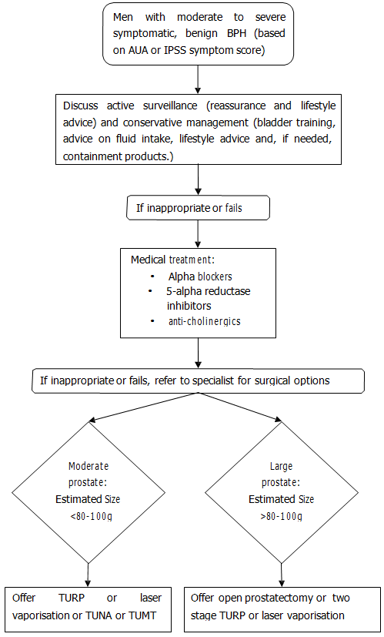

Figure 1 Current clinical management pathway

The eligible population for the proposed intervention is men with moderate to severe symptomatic BPH which is no longer manageable by the use of medications. The procedure may have specific benefits for men in whom standard TURP or open prostatectomy is contraindicated because of possible safety issues. These may include:

• Required use of anti-coagulants

• Medical co-morbidities

Moderate to severe lower urinary tract symptoms are defined using the American Urological Association (AUA) Symptom Score or the International Prostate Symptom Score (IPSS) with moderate symptoms defined as a score between 8 and 19 and severe symptoms defined as a score between 20 and 35.

For men with moderately sized prostates estimated to be less than 80 to 100g, HoLEP is proposed as an alternative procedure to TURP which is the most widely used surgical treatment for BPH (see Table 6). In comparison to TURP, HoLEP is proposed to have similar efficacy and to reduce the risk of bleeding and of TUR syndrome and may therefore be particularly valuable for men who are at higher risk of these adverse events such as those on anti-coagulation therapy, with a history of cardiac conditions and elderly, infirm men.

Laser vaporisation, TUNA and TUMT have MBS items and are comparative procedures however, due to their low utilisation and small cost to the MBS relative to TURP (Table 6), they are not considered as applicable comparators for this assessment and are not included in the proposed clinical management algorithm (Figure 2). HoLEP would be expected to replace these procedures where HoLEP is available, however, choice of procedure is often determined by the treating urologist and is dependent on their training and access to equipment.

In men with larger prostates estimated to be more than 80 to 100g, HoLEP is proposed as a less invasive alternative to open prostatectomy with fewer side-effects as a result. It is also an alternative to a two-stage TURP with similar efficacy and reduced risk. Laser vaporisation may also be performed in men with large prostates but due to low utilisation laser vaporisation is not included in the proposed clinical management algorithm (Figure 2) and is not considered a comparator for this assessment.

Figure 2 Proposed clinical management pathway

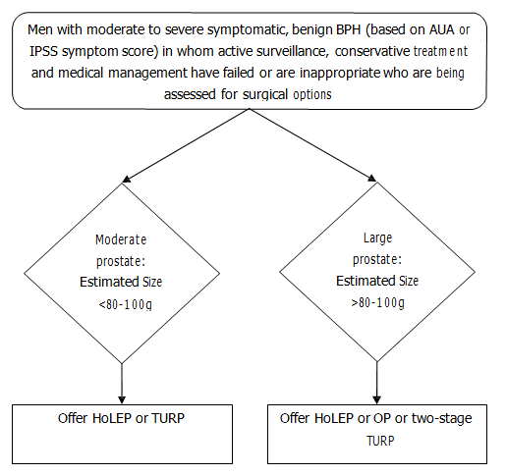

Eligible patients are men with moderate to severe symptomatic BPH and there are likely to be particular advantages to HoLEP for men who are at higher risk of adverse outcomes from TURP. Restricting the procedure to men with moderate to severe symptomatic BPH ensures that men who could be treated with lifestyle interventions do not receive unnecessary medical intervention.

The number of men who undergo treatment for BPH annually in Australia can be estimated from the AHIW National Hospital morbidity data using the ICD-10-AM classification for separations and the Australian Classification of Health Interventions (ACHI) codes for procedures.

Table 4 Separations for principal diagnosis of BPH 1998-2008

N40 Hyperplasia of prostate | Year
 | 98-99 | 99-00 | 00-01 | 01-02 | 02-03 | 03-04 | 04-05 | 05-06 | 06-07 | 07-08
Hospital Separations | 20,907 | 20,998 | 21,476 | 21,552 | 21,449 | 22,552 | 23,721 | 25,243 | 25,226 | 25,252
Average Length of Stay  (days) | 3.8 | 3.7 | 3.4 | 3.4 | 3.2 | 3.1 | 3.0 | 2.8 | 2.7 | 2.7
Source: AIHW National Hospital Morbidity Database

Table 5 Occurrences for principal procedures to treat BPH 2007-2008

ACHI (5thedn) |  | Procedure | Occurrences  (2007-08)
1165  Transuretheral prostatectomy | 37201-00 | Transurethral needle ablation of prostate [TUNA] | 64
 | 37203-00 | Transurethral resection of prostate [TURP] | 21963
 | 37203-02 | Transurethral electrical vaporisation of prostate | 36
1166 Other closed prostatectomy | 37203-03 | Cryoablation of prostate | 25
 | 37203-05 | High intensity focused ultrasound [HIFUS] (transrectal) of prostate | 68
 | 37203-06 | Other closed prostatectomy | 491
 | 37207-00 | Endoscopic laser ablation of prostate | 317
 | 37207-01 | Endoscopic laser excision of prostate | 323
1167 Open prostatectomy | 37200-03 | Suprapubic prostatectomy | 59
 | 37200-04 | Retropubic prostatectomy | 99
 | 37200-05 | Other open prostatectomy | 212
Source: AIHW National Hospital Morbidity Database

Table 6 Requested Medicare items processed from July 2007 to June 2010

MBS Item  Number | Procedure | Fee | 2007/08 | 2008/09 | 2009/10
37203 | Transurethral resection of prostate [TURP] | $1,002.65 | 12,158 | 12,557 | 12,690
37207 | Visual laser ablation | $833.65 | 319 | 460 | 699
37224 | Diathermy or visual laser destruction | $310.95 | 240 | 249 | 232
37200 | Open Prostatectomy | $977.80 | 141 | 153 | 142
37206 | Transurethral resection of prostate [TURP] (continuation within 10 days) | $536.95 | 24 | 30 | 33
37230 | Transurethral microwave thermotherapy [TUMT] | $1,002.65 | 59 | 62 | 28
37201 | Transurethral needle ablation [TUNA] | $797.45 | 37 | 17 | 13
37208 | Visual laser ablation (continuation within 10 days) | $400.30 | 2 | 2 | 2
37202 | Transurethral needle ablation [TUNA] (continuation within  10 days) | $400.30 | 3 | 1 | 1
37233 | Transurethral microwave thermotherapy [TUMT] (continuation within 10 days) | $536.95 | 1 | 0 | 1
Source: Medicare Australia Statistics

AIHW data records separations in both public and private hospitals in Australia; the Medicare items processed provide a guide as to the case mix for these procedures and the cost to the government. Based on AIHW data over 25,000 men were treated for BPH in 2007-08. All of these men would be potentially eligible for HoLEP, however actual utilisation on the MBS would be expected to be significantly lower than this based on HoLEP being an alternative option rather than a replacement for TURP, the public and private case mix and the training and skills requirements needed to undertake HoLEP.

Due to the training requirements to develop skills in HoLEP, it is estimated that uptake would initially be low and would increase gradually. One of the clinical benefits proposed for HoLEP is a reduced length of hospital stay; it is therefore noteworthy that length of stay has been declining for BPH hospital separations.

Comparator

Core surgical options

Three core surgical options are available for treating BPH: (i) Transurethral incisional prostatectomy (TUIP)
TUIP is a treatment for relieving urinary outflow obstruction caused by BPH which is only suitable for small prostates (<30g). An incision is made just distal to the urethral orifice on one or both sides and ends just proximal to the verumontanum. TUIP is technically easier, quicker and associated with less morbidity and cost than other options and can be performed using local anaesthesia. As this is a procedure restricted to small prostates, it is not considered a comparator to HoLEP.

(ii) Transuretheral resection of the prostate (TURP)

TURP is considered the surgical ‘gold standard’ and accounts for the vast majority of surgical procedures for BPH. Under general, epidural or spinal anaesthesia, a small electric loop is introduced into the urethra via a resectoscope. Slivers of excess tissue are excised and then electrical current is applied to cauterise the wound. Non-ionic fluid irrigant, usually 1.5% glycine, is used.

Complications can include bleeding that may require transfusion, acute urinary retention, infections and urethral stricture. A very rare and serious complication known as TUR syndrome (dilutional hyponatraemia) can also occur, although it is treatable. Larger prostates are considered poor candidates for TURP, in part due to longer resection times, leading to higher complication rates. Resection time can be limited to avoid complications with patients returning for a second TURP if further resection is required.

An indwelling catheter is usually required for 12 to 24 hours and a hospital stay of 1 to 3 days. TURP
requires full operating room facilities and utilises the following equipment:

• Standard diathermy generator with cutting and coagulation outputs

• Standard video-endoscopic equipment

The procedure is performed by a urologist with the assistance of nursing staff and an anaesthetist. Standard inpatient pathways requiring ward and recovery staff also apply.

Table 7: MBS item descriptors for TURP
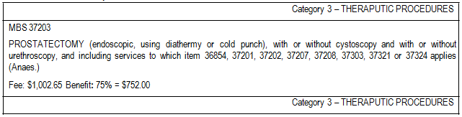

MBS 37206

PROSTATECTOMY (endoscopic, using diathermy or cold punch), with or without cystoscopy and with or without urethroscopy, and including services to which item 36854, 37303, 37321 or 37324 applies, continuation of, within 10 days of the procedure described by item 37201, 37203 or 37207 or which had to be discontinued for medical reasons (Anaes.)

Fee: $536.95 Benefit: 75% = $402.75

(iii) Open prostatectomy

Open prostatectomy is performed in men with very large prostates or those for whom hip or other medical conditions preclude the physical positioning required for TURP. Open prostatectomy is performed through a lower abdominal incision, and either through the bladder or through the capsule of the prostate. It involves a longer hospital stay and increased risk of bleeding in comparison to TURP but also offers lower retreatment rates and no risk of TUR syndrome. A general or spinal
anaesthetic is required.

Table 8: MBS item descriptor for open prostatectomy

Category 3 – THERAPUTIC PROCEDURES
MBS 37200

PROSTATECTOMY, open (Anaes.) (Assist.)
Fee: $977.80 Benefit: 75% = $733.35

Other treatments

In addition to the core surgical options described, there are a number of alternative minimally invasive techniques for treating BPH, three of which are funded on the MBS as listed below.

Visual laser ablation of the prostate (VLAP)

The item for VLAP on the MBS is believed to be accessed by several new types of laser but thought to be predominantly the “Greenlight” laser which is used for vaporisation of the prostate. Tissue vaporisation requires rapid localised heating with minimal depth of penetration and uses a high- powered potassium titanyl phosphate (KTP) laser that is selectively adsorbed by haemoglobin but is fully transmitted through water and is thus selectively absorbed by tissue with high haemoglobin content such as prostatic tissue. Laser vaporisation is performed using an irrigating cystoscope.

Laser vaporisation of the prostate can be performed with a range of aesthesia from a local prostate block with intravenous sedation to general anaesthesia. It requires operating room preparation and facilities and will be performed by a urologist with the assistance of an anaesthetist and nursing staff. Hospital stay is generally two days, therefore standard inpatient pathways requiring ward and recovery staff also apply.

A horizon scanning technology prioritising summary of photoselective vaporisation was undertaken by the Australian and New Zealand Horizon Scanning Network (ANZHSN 2007).

Transuretheral needle ablation (TUNA)

TUNA involves the delivery of radiofrequency energy via a modified urethral catheter attached to a generator to ablate prostate tissue. Two adjustable needles located at the end of the catheter are inserted into the prostate under endoscopic control. The radio frequency energy passes via the needles through the prostate causing a localised heating and resulting in areas of coagulative necrosis which either slough via the urethra or are reabsorbed during tissue repair. The procedure is performed under local or regional anaesthetic and an indwelling catheter is required for up to three days. It can be performed in a day-stay setting.

TUNA was assessed by MSAC in 2002 and recommended for interim funding for a period of three years with funding linked to the acquisition of data (MSAC 2002). The MBS item is restricted to men not fit for TURP due to high operative risk. TUNA was again considered by MSAC in March 2010 and public funding was supported without a repeat assessment based on clinical support, international evidence, and the small likelihood that sufficient Australian evidence could be collected for a full MSAC assessment.

Transuretheral microwave thermotherapy (TUMT)

TUMT uses microwave thermotherapy and is similar to TUNA in using heating of the tissue to cause areas of coagulative necrosis. The procedure is typically performed using an antenna mounted within a transurethral catheter through which cooling fluid circulates. TUMT can be performed in a day-stay setting using local anesthesia and oral analgesia along with sedation. Post operative catheterisation varies from 1 to 2 weeks.

TUMT was assessed by MSAC in 2005 and recommended for funding (MSAC 2005).

Table 9: MBS item descriptors for alternative treatments

Category 3 – THERAPUTIC PROCEDURES
MBS 37201

PROSTATE, transurethral radio-frequency needle ablation of, with or without cystoscopy and with or without urethroscopy, in patients with moderate to severe lower urinary tract symptoms who are not medically fit for transurethral resection of the prostate (that is, prostatectomy using diathermy or cold punch) and including services to which item 36854, 37203, 37206,
37207, 37208, 37303, 37321 or 37324 applies (Anaes.)

(See para T8.57 of explanatory notes to this Category)

Fee: $797.45 Benefit: 75% = $598.10
Category 3 – THERAPUTIC PROCEDURES
MBS 37202

PROSTATE, transurethral radio-frequency needle ablation of, with or without cystoscopy and with or without urethroscopy, in patients with moderate to severe lower urinary tract symptoms who are not medically fit for transurethral resection of the prostate (that is prostatectomy using diathermy or cold punch) and including services to which item 36854, 37303, 37321 or 37324 applies, continuation of, within 10 days of the procedure described by item 37201, 37203 or 37207 which had to be discontinued for medical reasons (Anaes.)

(See para T8.57 of explanatory notes to this Category)

Fee: $400.30 Benefit:75% = $300.25 85% = $340.30

Category 3 – THERAPUTIC PROCEDURES
MBS 37207

PROSTATE, endoscopic non-contact (side firing) visual laser ablation, with or without cystoscopy and with or without urethroscopy, and including services to which items 36854, 37201, 37202, 37203, 37206, 37321 or 37324 applies (Anaes.)

Fee: $833.65 Benefit: 75% = $625.25
Category 3 – THERAPUTIC PROCEDURES
MBS 37208

PROSTATE, endoscopic non-contact (side firing) visual laser ablation, with or without cystoscopy and with or without urethroscopy, and including services to which item 36854, 37303, 37321 or 37324 applies, continuation of, within 10 days of the procedure described by items 37201, 37203 or 37207 or which had to be discontinued for medical reasons (Anaes.)

Fee: $400.30 Benefit: 75% = $300.25
Category 3 – THERAPUTIC PROCEDURES
MBS 37230

PROSTATE, high-energy transurethral microwave thermotherapy of, with or without cystoscopy and with or without urethroscopy and including services to which item 36854, 37203, 37206, 37207, 37208, 37303, 37321 or 37324 applies (Anaes.)

Fee: $1,002.65 Benefit: 75% = $752.00 85% = $931.45
Category 3 – THERAPUTIC PROCEDURES
MBS 37233

PROSTATE, high-energy transurethral microwave thermotherapy of, with or without cystoscopy and with or without urethroscopy and including services to which item 36854, 37303, 37321 or 37324 applies, continuation of, within 10 days of the procedure described by item 37201, 37203, 37207, 37230 which had to be discontinued for medical reasons (Anaes.)

Fee: $536.95 Benefit: 75% = $402.75 85% = $465.75
Category 3 – THERAPUTIC PROCEDURES
MBS 37224

PROSTATE, diathermy or visual laser destruction of lesion of, not being a service associated with a service to which item
37201, 37202, 37203, 37206, 37207, 37208 or 37215 applies
(Anaes.)

Fee: $310.95 Benefit: 75% = $233.25 85% = $264.35
Explanatory note T8.57

Moderate to severe lower urinary tract symptoms are defined using the American Urological Association (AUA) Symptom
Score or the International Prostate Symptom Score (IPSS).

Patients not medically fit for transurethral resection of the prostate (TURP) can be defined as:

(i) Those patients who have a high risk of developing a serious complication from the surgery. Retrograde ejaculation is not considered to be a serious complication of TURP.

(ii) Those patients with a co-morbidity which may substantially increase the risk of TURP or the risk of the anaesthetic necessary for TURP.

Related Items: 37201, 37202

Other related treatments for BPH which are not currently funded on the MBS include:

• High-intensity focused ultrasound (HIFU)

• Transurethral laser coagulation of the prostate

• Transurethral electro-vaporisation of the prostate (TUVP)

• Transurethral ethanol ablation of the prostate (TEAP)

• Water-induced thermotherapy

• Bipolar resection of the prostate.

Recent NICE Clinical Practice Guidelines recommend the use of TURP, monopolar TUVP and HoLEP for surgical treatment of LUTS secondary to prostatic enlargement. They explicitly do not recommend TUNA, TUMT, HIFU, TEAP and laser coagulation. Laser vaporisation, bipolar TUVP and transurethral vaporisation resection of the prostate are recommended only when offered as part of a randomised controlled trial (National Institute for Health and Clinical Excellence 2010). A comparison of the characteristics of the main treatment options is provided in Table 10.

Table 10 Comparative characteristics of surgical treatment options (Adapted from Lourenco et al 2008 with clinical advice from Dr Awad and the application)

Procedure | Hospital stay | Energy source | Method of tissue removal | Period of catheterisation | MBS Item | MBS Fee
Minimally Invasive
TUMT | Day case | Microwave | Coagulative necrosis | 1-2 weeks | 37230 | $1,002.65
TUNA | Day case | Radio frequency | Coagulative necrosis | 3 days | 37201 | $797.45
Ablative
TURP | 1-3 days | Diathermy | Resection | 12-24 hours | 37203 | $1,002.65
Open prostatectomy | 3-5 days | None | Resection | 5-7 days | 37200 | $977.80
Laser vaporisation | Day case or overnight | Laser | Vaporisation | <24 hours | #  37207 | $833.65
HoLEP | 1-3 days | Laser | Enucleation | 12-24 hours | Proposed | $1203.18
# claimed under this number but subject to interpretation.

All comparators would require similar assessment and testing in the lead-up and follow-up to treatment and all would be undertaken by trained urologists in a hospital setting. The key differences in resource usage are expected to be the length of hospital stay, degree of nursing care, rate of complications, rate of reintervention and the equipment and training requirements of establishing each technique.

Clinical claim

Compared to TURP, HoLEP has the following potential benefits:
• No risk of burns or adverse cardiac effects due to electro-cautery

• No risk of TUR syndrome
• Reduced risk of bleeding and lower rates of transfusions
• Reduced risk of other operative complications
• Shorter duration of cathetherisation and quicker recovery time
• Reduced cost
• More tissue excised
• Minimally invasive but still allows for tissue retrieval
• Lower rates of re-intervention

Compared to TURP, HoLEP has the following potential harms:
• Longer duration of operation
• Longer learning curve for urologists and hence higher establishment costs
• Higher rates of re-intervention

Compared to open prostatectomy, HoLEP has the following potential benefits:
• Reduced risk of bleeding and lower rates of transfusions
• Reduced risk of other operative complications
• Shorter duration of cathetherisation and quicker recovery time
• Shorted hospital length of stay
• Reduced cost
• Minimally invasive but still allows for tissue retrieval

Compared to open prostatectomy, HoLEP has the following potential harms:
• Longer duration of operation
• Longer learning curve for urologists and hence higher establishment costs
• Higher rates of re-intervention

The benefits of HoLEP are proposed to be particularly relevant to men who are at elevated risk of operative complications, particularly bleeding or cardiac complications.

On the basis of these clinical claims, which are primarily the superior safety of HoLEP, it is expected that either a cost-effectiveness analysis or a cost-utility analysis would be undertaken (see Table 11.)

Table 11:Classification of an intervention for determination of economic evaluation to be presented

 |  | Comparative effectiveness versus comparator
 |  | Superior |  | Non-inferior | Inferior
Comparative safety versus comparator | Superior | CEA/CUA |  | CEA/CUA | Net clinical benefit | CEA/CUA
 |  |  |  |  | Neutral benefit | CEA/CUA*
 |  |  |  |  | Net harms | None^
 | Non-inferior | CEA/CUA |  | CEA/CUA* | None^
 | Inferior | Net clinical benefit | CEA/CUA | None^ | None^
 |  | Neutral benefit | CEA/CUA*
 |  | Net harms | None^
Abbreviations: CEA = cost-effectiveness analysis; CUA = cost-utility analysis

* May be reduced to cost-minimisation analysis. Cost-minimisation analysis should only be presented when the proposed service hasbeen indisputably demonstrated to be no worse than its main comparator(s) in termsof both effectiveness and safety, so the difference between the service and theappropriate comparator can be reduced to a comparison of costs. In most cases, therewill be some uncertainty around such a conclusion (i.e., the conclusion is often notindisputable). Therefore, when an assessment concludes that anintervention was no worse than a comparator, an assessment of the uncertainty aroundthis conclusion should be provided by presentation of cost-effectiveness and/or cost-utility analyses.
^ No economic evaluation needs to be presented; MSAC is unlikely to recommend government subsidy of this intervention

Outcomes and health care resources affected by introduction of proposed intervention

Outcomes

Safety
• Immediate complications
o bleeding
o acute urinary retention
o infection
o TUR syndrome (dilutional hyponatraemia)
o mortality
• Longer term complications
o Urethral stricture
o erectile dysfunction
o urinary incontinence or dysuria
Effectiveness
• Symptoms – peak flow, symptom score, bother score, post-void residual volume, prostate volume
• Quality of Life
• Treatment failure/re-treatment rate

Health care resources

The key differences in resource usage are expected to be the length of hospital stay, rate of complications, rate of reintervention and the equipment and training requirements of establishing each technique.

Table 12:List of resources to be considered in the economic analysis

 | Provider of resource |  | Setting in which resource is provided | Proportion of patients receiving resource | Number of units of resource  per relevant time  horizon per patient receiving resource | Disaggregated unit cost
 |  |  |  |  |  | MBS | Safety nets* | Other govt budget | Private health insurer | Patient | Total cost
Resources provided to deliver proposed intervention
‐ Holmium Laser  Unit | Manufacturer

 | Provider of resource |  | Setting in which resource is provided | Proportion of patients receiving resource | Number of  units of resource  per relevant time  horizon per patient receiving resource | Disaggregated unit cost
 |  |  |  |  |  | MBS | Safety nets* | Other govt budget | Private health insurer | Patient | Total cost
‐ Holmium Laser  Fibre | Manufacturer
‐ Morecellator pump control unit and morecellator blades | Manufacturer
‐ Specialist training in HoLEP | Specialist | Hospital
‐ Hospital stay | Nurse | Inpatient
‐ Operative duration | Specialist/Nur se | Inpatient
Resources provided in association with proposed intervention
‐ Blood  Transfusion | Specialist | Inpatient
‐ Stricture repair | Specialist | Inpatient
‐ Reintervention | Specialist | Inpatient

Proposed structure of economic evaluation (decision-analytic)

Table 13 PICO criteria and decision option(s) for HoLEP for BPH – Prostate estimated as <80-100g

Patients | Intervention | Comparator(s) | Outcome claims
Patients with symptomatic benign prostatic hyperplasia (BPH) or lower urinary tract symptoms (LUTS) of the prostate which is no longer manageable by the use of medication | Endoscopic enucleation of the prostate using high- powered (≥100W) laser and an end-firing, non-contact fiber with Tissue Morcellation. | Transurethral resection of the prostate (TURP) | Safety  • Immediate complications  - bleeding  -acute urinary retention  -infection  -TUR syndrome  (dilutional hyponatraemia)  -mortality  • Longer term complications  -Urethral stricture  -erectile dysfunction  -urinary incontinence or dysuria  Effectiveness  • Symptoms – peak flow, symptom score, bother score, post-void  residual volume, prostate volume  • Quality of Life  • Treatment failure/re- treatment rate  Costs  • Length of operation  • Length of catheterisation  • Length of hospital stay  • Training  • Equipment  • Staffing
Decision option(s) (ie question(s) for public funding)
In men with symptomatic BPH no longer manageable with medications, and with an expected prostate size less than 80 to
100g, what is the safety and effectiveness of HoLEP in comparison to TURP, laser vaporisation, TUNA and TUMT? Is it cost effective?

Table 14 PICO criteria and decision option(s) for HoLEP for BPH – prostate estimated as >80-100g

Patients | Intervention | Comparator | Outcome claims
Patients with symptomatic benign prostatic hyperplasia  (BPH) or lower urinary tract symptoms (LUTS) of the  prostate which is no longer manageable by the use of medications; and in whom standard TURP is contraindicated because of  estimated prostate gland  size >80-100g | Endoscopic enucleation of the prostate using high-  powered (≥100W) laser and an end-firing, non-contact  fiber with Tissue  Morcellation. | Open Prostatectomy (OP)  Two stage Transurethral resection of the prostate (TURP) | Safety  • Immediate complications  - bleeding  -acute urinary retention  -infection  -TUR syndrome (dilutional hyponatraemia)  -mortality  • Longer term complications  -Urethral stricture  -erectile dysfunction  -urinary incontinence or dysuria  Effectiveness  • Symptoms – peak flow, symptom score, bother score, post-void  residual volume, prostate volume  • Quality of Life  • Treatment failure/re- treatment rate  Cost  • Length of operation  • Length of catheterisation  • Length of hospital stay  • Training  • Equipment  • Staffing
Decision option(s) (ie question(s) for public funding)
In men with symptomatic BPH no longer manageable with medications, and with an expected prostate size greater than 80 to 100g, what is the safety and effectiveness of HoLEP in comparison to open prostatectomy or two-stage TURP? Is it cost
effective?

The assessment report for MSAC application 1014 TransUrethral Needle Ablation (TUNA) for the treatment of benign prostatic hyperplasia includes a decision analysis incorporating Markov processes and is highly relevant to the current application. It was used as a template to assist in developing the proposed decision analytic for HoLEP. The following points will need to be taken into consideration in undertaking a decision analytic model for HoLEP:

• The time horizon needs to be defined within the model based on the availability of data and/or our uncertainty regarding extrapolation (eg. 5 or 10 years)
• The model assumes that patients will only undergo a maximum of two procedures over the time horizon of the model. This seems a reasonable assumption as the treatment failure rates

are likely to be relatively low and therefore, very few patients would experience two treatment failures.
• Treatment options after a failed first procedure are defined in the model as follows:
o Moderate prostate:
ƒ Failed HoLEP: second HoLEP or TURP
ƒ Failed TURP: second TURP
o Large prostate
ƒ Failed HoLEP: second HoLEP, TURP, OP
ƒ Failed two-stage TURP: OP or repeat TURP
ƒ Assume no failure rate for OP
• The model includes the following health states:
o Well: treatment successful
o Persistent side effects: treatment largely successful but resulting in significant and persistent side effects
o Treatment failure: treatment was not successful but did not cause new significant or persistent side effects
o Dead: death from procedure
• The model also considers the rates of immediate complications from the procedure which do not have a persistent effect such as bleeding and TUR syndrome.
• A Markov framework could be used to explicitly incorporate time, and the transition between health states over time (refer to App 1014 for an example).
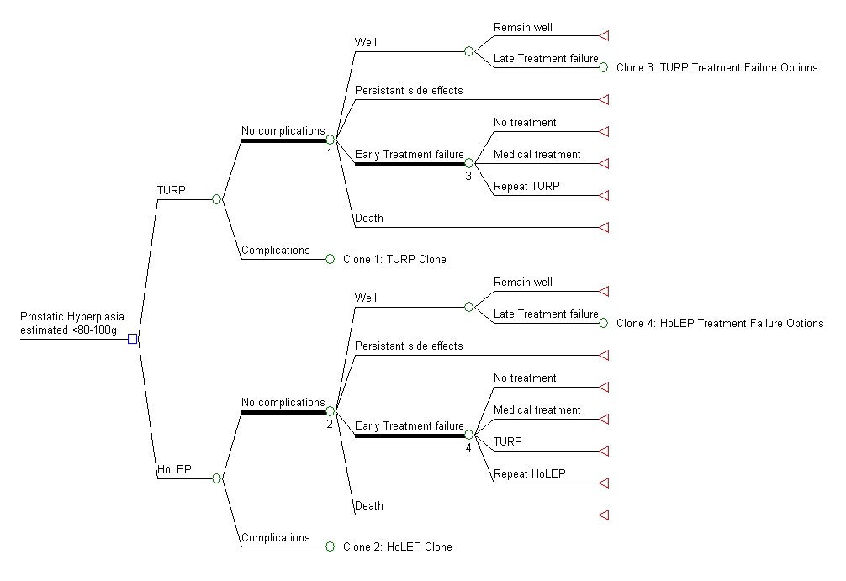

Figure 3 Possible decision analytic for men with moderate prostates estimated as <80-100g

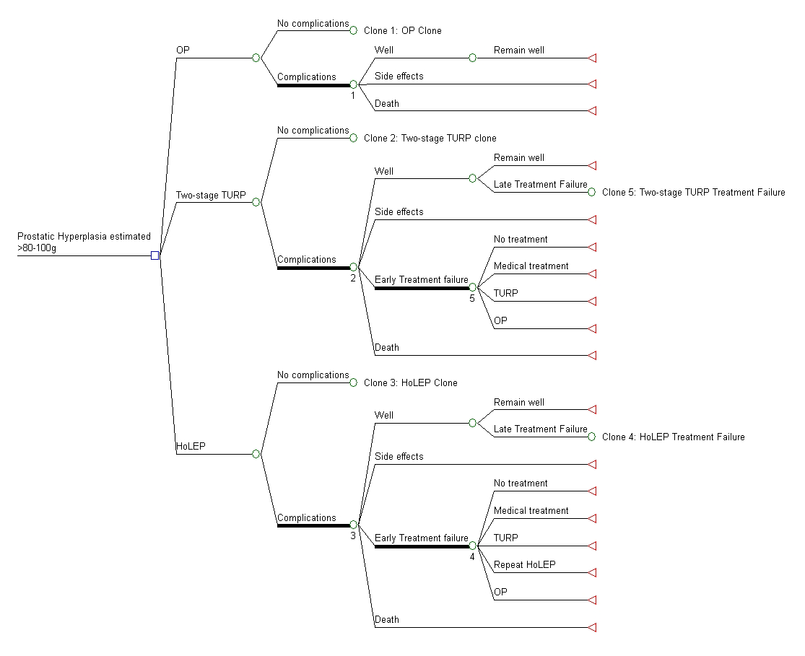

Figure 4 Possible decision analytic for patients with large prostates estimated as >80-100g

References
ANZHSN 2007, Photoselective vaporisation for benign prostatic hyperplasia. Canberra: HealthPACT. Gilling, P 2008.Holmium Laser Enucleation of the Prostate (HoLEP), BJU International,101 (1),131-
142.

Lourenco, T, Armstrong, N et al 2008.Systematic review and economic modelling of effectiveness and cost utility of surgical treatments for men with benign prostatic elargement, Health Technology Assessment,12 (35),

MSAC 2002, Transuretheral Needle Ablation (TUNA) for the treatment of benign prostatic hyperplasia.
Canberra: Department of Health and Ageing.

MSAC 2005, High-energy transurethral microwave thermotherapy for benign prostatic hyperplasia.
Canberra: Department of Health and Ageing.

National Institute for Health and Clinical Excellence 2010, The management of lower urinary tract symptoms in men. NICE Clinical Guidance 97.London: National Clinical Guideline Centre.

