**MSAC Application 1787**

**Immunohistochemistry testing of solid tumour tissue to determine folate receptor alpha (FRα) expression status in adults with platinum-resistant ovarian cancer, for access to PBS Elahere™ (mirvetuximab soravtansine)**

**PICO Set Document**

**July 2024**

*The following document and proposal may evolve based on clinical consultation over time. AbbVie is not responsible for the manufacture or supply of the companion diagnostic and may be subject to further input from Roche Diagnostics.*

# Population

## Describe the population in which the proposed health technology is intended to be used:

Ovarian cancer is the leading cause of death from gynecological cancers globally, and in Australia has the highest death rate at 4.8% of all female cancers per year. There are currently no recommended screening tests for ovarian cancer and the absence of definitive symptoms makes it difficult to diagnose in the early stages; at the time of diagnosis women are typically in advanced stage disease leading to the poor five-year survival rate of just 48% (ACRF 2024).

Ovarian cancer can be classified in two histological subtypes, epithelial and non-epithelial, with 90% of all ovarian cancer epithelial in origin (Reid et al 2017). For patients diagnosed with advanced epithelial ovarian cancer, treatment goals are to maximize or maintain health-related quality of life, while attempting to control disease or minimize further progression. There is no cure for these patients and the standard of care for newly diagnosed women with advanced stage epithelial ovarian cancer is cytoreductive surgery and platinum-based chemotherapy, followed by Poly-ADP ribose polymerase inhibitors (PARPis), such as olaparib, which have been incorporated as recommended maintenance therapy options after first-line (1L) chemotherapy in a subset of patients with pathogenic BRCA gene 1 and 2 mutations. Although most patients initially respond to platinum-based treatment, up to 80% of patients experience disease recurrence, and nearly all patients with recurrent disease will eventually develop platinum resistance for which the prognosis is poor (Lokadasan et al 2016; Davis et al 2014). There remains an urgent need to address the significant unmet need for these patients.

Folate receptor alpha (FRɑ) is a protein that is expressed in nearly all ovarian cancers and is both a predictive biomarker and a novel therapeutic target (Scaranti et al 2020). Mirvetuximab soravtansine is a FRα-directed antibody and microtubule inhibitor conjugate with a unique ability to specifically target FRα, which is overexpressed in ovarian cancer solid tumours and minimally expressed by healthy tissue. Mirvetuximab soravtansine is proposed to be funded for adult patients with platinum-resistant epithelial ovarian, fallopian tube, or primary peritoneal cancer (PROC) whose tumours have a high level of FRα expression, also referred to as “FRα-positive”. The FRα-positive expression status may be determined using a validated immunohistochemistry (IHC) assay to detect the percentage of viable tumour cells from with membrane staining for FRα, with the clinical cut-off being ≥ 75% tumour cells on a validated IHC test.

This application proposes IHC testing for FRα expression status to determine PBS eligibility for mirvetuximab soravtansine in adult patients with platinum-resistant epithelial ovarian, fallopian tube, or primary peritoneal cancer whose tumours are FRα-positive.

## Specify any characteristics of patients with, or suspected of having, the medical condition, who are proposed to be eligible for the proposed health technology, describing how a patient would be investigated, managed and referred within the Australian healthcare system in the lead up to being considered eligible for the technology:

Most women with ovarian cancer experience at least one symptom in the year prior to their diagnosis. Symptoms of ovarian cancer are often vague, generalised and non-gynaecological.

**Investigative tests to confirm diagnosis – workup:**

Several tests may be performed to investigate the symptoms of ovarian cancer and confirm diagnosis. Commonly performed tests include:

* physical examination of the abdomen and pelvis, including rectal examination.
* imaging of the pelvis and abdomen using transvaginal ultrasound, abdominal ultrasound, computed tomography (CT) scans, magnetic resonance imaging (MRI) scans or positron emission tomography (PET) scans
* chest X-rays
* blood tests to check for tumour markers such as CA125, and to measure complete blood count and levels of chemicals in the blood
* use of scopes to see inside the gastrointestinal tract
* biopsy – where a small sample of tissue is removed to be examined under a microscope. This is usually done as part of the initial surgery, because the only way to confirm a diagnosis of ovarian cancer is through an operation. The surgeon will also take samples of any fluid in the abdomen

**Clinical Staging of Ovarian cancer:**

* Stage I: the cancer is in 1 or both ovaries and has not spread to other organs or tissues.
* Stage II: the cancer is in 1 or both ovaries and has spread to other organs in the pelvis, such as the uterus, fallopian tubes, bladder or colon.
* Stage III: the cancer is in 1 or both ovaries and has spread outside the pelvis to other parts of the abdomen or nearby lymph nodes.
* Stage IV: the cancer has spread to other parts of the body beyond the pelvis and abdomen, such as the lungs or liver.

**Genetic Testing:**

The eviQ guidelines (2023a) recommends that a woman with invasive epithelial ovarian cancer should consider genetic testing for a heritable pathogenic BRCA1 or BRCA2 gene variants in the following situations:

* individuals with a combined BRCA1 and BRCA2 pathogenic variant probability of ≥10% using the Manchester score (a validated pathogenic variant prediction tool).
* individuals with a combined BRCA1, BRCA2 and PALB2 pathogenic variant probability of ≥10% using CanRisk (a validated pathogenic variant prediction tool). This may include unaffected individuals and obligate carriers with ≥10% pathogenic variant probability as well as individuals from a population where a common founder pathogenic variant exists.
* individuals with high grade ovarian cancer diagnosed at any age.
* individual with advanced (FIGO III-IV), high-grade serous or high-grade epithelial ovarian, fallopian tube or primary peritoneal cancer to determine eligibility relating to BRCA status for access to certain PBS therapies.

A medical oncologist or gynaecological oncologist would request or refer a patient on for BRCA testing. Tumour tissue specimens for the majority of target patient population will be available for testing following primary tumour debulking surgery or may be obtained as formalin-fixed paraffin-embedded (FFPE) blocks, which were archived following primary tumour debulking surgery. Retrieval and review of one or more archived FFPE block are forwarded on to the specialist molecular diagnostic laboratories who are able to analyse the tissue.

## Provide a rationale for the specifics of the eligible population:

Initial chemotherapy treatment for ovarian cancer typically yields high response rates; however, most tumours subsequently relapse and eventually become resistant to platinum-based regimens. Current therapies in platinum-resistant ovarian cancer consist primarily of nonplatinum chemotherapy. Patients with platinum-resistant ovarian cancer receiving nonplatinum chemotherapy alone have had poor responses, with an objective response ranging from 4 to 13% (Moore et al 2023) Additional challenges in the treatment of platinum-resistant ovarian cancer include the lack of meaningful, predictive biomarkers, as well as chemotherapy-associated hematologic and gastrointestinal toxic effects and cumulative neuropathy, which can impede the continuation of treatment. Thus, platinum-resistant ovarian cancer has a poor prognosis with few effective therapeutic options, none of which have shown a substantial overall survival benefit.

## Are there any prerequisite tests?

Yes

## Are the prerequisite tests MBS funded?

Yes. BRCA testing currently funded under the MBS are listed in **Table 1** below.

**Table 1 MBS items for testing BRCA mutations for ovarian cancer patients currently on MBS**

| **MBS Item** | **Description** |
| --- | --- |
| 73295 | Detection of germline BRCA1 or BRCA2 pathogenic or likely pathogenic gene variants, in a patient with advanced (FIGO III-IV) high-grade serous or high-grade epithelial ovarian, fallopian tube or primary peritoneal cancer for whom testing of tumour tissue is not feasible, requested by a specialist or consultant physician, to determine eligibility for olaparib under the PBS. Maximum one test per lifetime. |
| 73296 | Characterisation of germline gene mutations, requested by a specialist or consultant physician, including copy number variation in BRCA1 and BRCA2 genes and one or more of the following genes STK11, PTEN, CDH1, PALB2, or TP53 in a patient with breast or ovarian cancer for whom clinical and family history criteria, as assessed by the specialist or consultant physician who requests the service using a quantitative algorithm, place the patient at >10% risk of having a pathogenic mutation identified in one or more of the genes specified above. |
| 73297 | Characterisation of germline gene mutations, requested by a specialist or consultant physician, including copy number variation in *BRCA1* and *BRCA2* genes and one or more of the following genes *STK11, PTEN, CDH1, PALB2*, or *TP53* in a patient who is a biological relative of a patient who has had a pathogenic mutation identified in one or more of the genes specified above, and has not previously received a service under item 73296. |
| 73301 | A test of tumour tissue from a patient with advanced (FIGO III-IV), high-grade serous or high-grade epithelial ovarian, fallopian tube or primary peritoneal cancer, requested by a specialist or consultant physician, to determine eligibility relating to BRCA status for access to olaparib under the PBS.  Applicable once per primary tumour diagnosis |
| 73302 | Characterisation of germline gene variants including copy number variants, in BRCA1 or BRCA2 genes, in a patient who has had a pathogenic or likely pathogenic variant identified in either gene by tumour testing and who has not previously received a service to which items 73295, 73296 or 73297 applies, requested by a specialist or consultant physician.  Applicable once per primary tumour diagnosis |

Source: MBS Online http://www9.health.gov.au/mbs/search. MBS = Medicare Benefits Schedule

Abbreviations: BRCA, breast cancer gene; FIGO, Federation Internationale de Gynecologie et d'Obstetrique; PBS, Pharmaceutical Benefits Scheme; MBS, Medicare Benefits Scheme; PTEN, Phosphatase and tensin homolog gene; PALB2, Partner and Localizer of BRCA2; STK11, serine-threonine kinase 11; CDH1, Cadherin-1; TP53, transformation-related protein 53.

## Provide details to fund the prerequisite tests:

Available on the MBS.

# Intervention

## Name of the proposed health technology:

Test: Ventana FOLR1 (FOLR1-2.1) RxDx Assay.

Treatment: Elahere™ (mirvetuximab soravtansine).

## Describe the key components and clinical steps involved in delivering the proposed health technology:

This application proposes that the FRα status of patients with platinum-resistant epithelial ovarian cancer be used to determine eligibility for PBS supply of mirvetuximab soravtansine, a targeted antibody-drug conjugate therapy. The Ventana FOLR1 (FOLR1-2.1) RxDx Assay, henceforth referred to as ‘Ventana FOLR1’ is a Roche Diagnostics product with current FDA approval as a companion diagnostic for mirvetuximab soravtansine and is the only currently validated diagnostic assay for FRα status at the time of this application. AbbVie is not the Sponsor of Ventana FOLR1 and therefore not responsible for regulatory approval, manufacture, or supply.

The assessment of FRα status in patients involves taking a biopsy of the tumour and performing an immunohistochemistry (IHC) assay (i.e. Ventana FOLR1) to detect the percentage of tumour cells expressing FRα, with the clinical cut-off ≥ 75% viable tumour cells with membrane staining at moderate and/or strong intensity levels. The testing would be done by a pathologist alongside other immunohistochemical tests which are done routinely. It is proposed that test results of the Ventana FOLR1 should be interpreted by a qualified pathologist in conjunction with histological examination, relevant clinical information, and proper controls.

## **Identify how the proposed technology achieves the intended patient outcomes**:

Folate receptor alpha (FRα) is commonly expressed in ovarian cancers, and minimally expressed in healthy tissue, making it a useful biomarker and obvious therapeutic target. In SORAYA, the phase II trial of mirvetuximab soravtansine, 36% of patients with PROC with evaluable tissue samples were FRα-positive (Matulonis et al 2023).

The Ventana FOLR1 assay is a qualitative immunohistochemical assay using mouse monoclonal anti-FOLR1, clone FOLR1-2.1, intended for use in the assessment of folate receptor alpha (FOLR1) protein in formalin-fixed, paraffin-embedded epithelial ovarian, fallopian tube or primary peritoneal cancer tissue specimens by light microscopy. This assay is for use with OptiView DAB IHC Detection Kit for staining on a BenchMark ULTRA instrument (FDA 2022). The assay has FDA approval as a companion diagnostic for the FRα targeted therapy mirvetuximab soravtansine.

## Does the proposed health technology include a registered trademark component with characteristics that distinguishes it from other similar health components?

Yes.

## Explain whether it is essential to have this trademark component or whether there would be other components that would be suitable:

At the time of this submission, the Ventana FOLR1 (FOLR1-2.1) RxDx Assay is expected to be the only FRα assay in Australia.

## Are there any proposed limitations on the provision of the proposed health technology delivered to the patient (For example: accessibility, dosage, quantity, duration or frequency):

No

## Provide details and explain:

## IHC testing is a well-established technique in all major pathology labs.

## If applicable, advise which health professionals will be needed to provide the proposed health technology:

The application recommends that ordering FRα testing be restricted to gynaecologists and oncologists once a diagnosis of platinum-resistant ovarian cancer (PROC) has been established.

A certified pathologist would be responsible for conducting the testing and reporting of results. It is proposed that FRα testing be eligible to be carried out in any pathology laboratory holding the appropriate accreditation to claim pathology services through the MBS.

Delivery of the FRα test results would be provided by a pathologist with knowledge and expertise in testing for gastric cancer and immunohistochemistry testing. IHC testing is a well-established technique in all major pathology laboratories. Laboratories already have the platform infrastructure. The FRα antibody and reagents to perform FRα IHC testing are the only additional resource required.

As a consequence, billing of the intervention would be done by the pathologist.

## If applicable, advise whether delivery of the proposed health technology can be delegated to another health professional:

It is not anticipated that any other professional, other than a certified pathologist would be able to conduct IHC testing for FRα expression.

## If applicable, advise if there are any limitations on which health professionals might provide a referral for the proposed health technology:

It might be considered that testing be restricted to a specialist or consultant physician once a diagnosis of ovarian cancer has been established.

## Is there specific training or qualifications required to provide or deliver the proposed service, and/or any accreditation requirements to support delivery of the health technology?

Yes

## Provide details and explain:

A certified pathologist would be responsible for conducting the test and reporting the results. Consistent with introduction of diagnostic tests associated with access to other targeted therapies, pathologist training and quality assurance programs would be developed with respect to delivery of diagnostic tests for access to PBS treatment.

## Indicate the proposed setting(s) in which the proposed health technology will be delivered:

**X Consulting rooms**

**X Day surgery centre**

Emergency Department

Inpatient private hospital

Inpatient public hospital

**X Laboratory**

**X Outpatient clinic**

Patient’s home

Point of care testing

Residential aged care facility

Other (please specify)

## Is the proposed health technology intended to be entirely rendered inside Australia?

Yes

# Comparator

## Nominate the appropriate comparator(s) for the proposed medical service (i.e., how is the proposed population currently managed in the absence of the proposed medical service being available in the Australian healthcare system). This includes identifying healthcare resources that are needed to be delivered at the same time as the comparator service:

Test comparator: “No testing”, as testing for FRα is not currently funded, nor available or part of the current treatment algorithm.

Treatment comparator: Non-platinum containing, single-agent systemic chemotherapy (paclitaxel, pegylated liposomal doxorubicin or topotecan). There is no recommendation of one specific chemotherapy. The choice of non-platinum containing chemotherapy is dependent on patient characteristics, previous treatment and clinician and patient choice.

## List any existing MBS item numbers that are relevant for the nominated comparators:

As the proposed comparator is no testing, there are no eligible MBS items.

## Provide a rationale for why this is a comparator:

Test Comparator: As testing for FRα is not currently funded, the appropriate comparator is 'no testing’.

Treatment Comparator: Non-platinum treatment and supportive care options are understood to be the standard of care in patients not eligible for platinum rechallenge due to progression on platinum-based therapy or after a short treatment-free interval. Options include paclitaxel, topotecan, or pegylated liposomal doxorubicin (PLD). The prognosis of these patients is poor and the main treatment objectives are symptom palliation and maintenance QoL.

Non-platinum chemotherapy can be given alone or with bevacizumab. However, bevacizumab is only TGA registered for recurrent, platinum-resistant ovarian cancer in Australia for patients who have not received bevacizumab (or any prior anti-angiogenic treatment) and have received no more than two prior chemotherapy regimens. This aligns with the latest ESMO guidelines which also only recommend bevacizumab if it has not been received in prior lines and no contraindications are present. Overall, based on current understanding, the number of patients receiving bevacizumab in a PROC setting in Australia is expected to be negligible.

## As such, the nominated comparator for mirvetuximab soravtansine is non-platinum chemotherapy.

## Pattern of substitution – Will the proposed health technology wholly replace the proposed comparator, partially replace the proposed comparator, displace the proposed comparator or be used in combination with the proposed comparator?

None (used with the comparator)

Displaced (comparator will likely be used following the proposed technology in some patients)

Partial (in some cases, the proposed technology will replace the use of the comparator, but not all)

Full (subjects who receive the proposed intervention will not receive the comparator)

## Outline and explain the extent to which the current comparator is expected to be substituted:

The proposed medical service (FRα testing) facilitates eligibility to treatment with mirvetuximab soravtansine as monotherapy. ‘Partial’ substitution is ticked above as it is assumed that a large majority of eligible patients would begin to receive the FRα testing and similarly almost all patients who are FRα -high would receive mirvetuximab soravtansine - however there may be some eligible patients who may not receive the test or mirvetuximab soravtansine for various reasons including clinician choice or patient preference.

# Outcomes

## List the key health outcomes (major and minor – prioritising major key health outcomes first) that will need to be measured in assessing the clinical claim for the proposed medical service/technology (versus the comparator):

**X Health benefits**

Health harms

Resources

Value of knowing

## Outcome description – include information about whether a change in patient management, or prognosis, occurs as a result of the test information:

The test is a predictive companion diagnostic. As a result of a positive FRα test, a change in clinical management would occur. Patients would be eligible to receive mirvetuximab soravtansine on the PBS, resulting in improved health outcomes such as increased progression-free survival, overall survival and maintenance of quality of life.

Test outcomes

* Analytical validity
* Clinical validity
* Clinical utility

Drug outcomes

* Safety and tolerability, including adverse events
* Effectiveness, including overall survival, progression-free survival, response rates, quality of life

# Proposed MBS items

## How is the technology/service funded at present? (e.g., research funding; State-based funding; self-funded by patients; no funding or payments):

Not currently funded.

## Provide at least one proposed item with their descriptor and associated costs for each:

|  |  |
| --- | --- |
| MBS item number  (where used as a template for the proposed item) | N/A |
| Category number | Category 6 |
| Category description | Pathology Services |
| Proposed item descriptor | A test of tumour tissue for the detection of FRα tumour expression, in a patient with:   * platinum-resistant ovarian cancer   As requested by a specialist or consultant physician, to determine eligibility for treatment with mirvetuximab soravtansine under the Pharmaceutical Benefits Scheme (PBS) |
| Proposed MBS fee | $74.50 (based on comparable IHC item 72814 for PD-L1 testing, to be confirmed through submission process). |
| Indicate the overall cost per patient of providing the proposed health technology | A detailed analysis will be presented in the co-dependent MSAC/PBAC submission. |
| Please specify any anticipated out of pocket expenses | A detailed analysis will be presented in the co-dependent MSAC/PBAC submission. |
| Provide any further details and explain | A detailed analysis will be presented in the co-dependent MSAC/PBAC submission. |

# Algorithms

## PREPARATION FOR USING THE HEALTH TECHNOLOGY

## Define and summarise the clinical management algorithm, including any required tests or healthcare resources, before patients would be eligible for the proposed health technology:

González-Martín et al (2023) outlines the most recent treatment guidelines from the European Society for Medical Oncology (ESMO) for advanced epithelial ovarian cancer (EOC), which is inclusive of International Federation of Gynaecology and Obstetrics (FIGO) stage III and IV cancer of the ovary, fallopian tube, or peritoneum. These generally align well with the Australia eviQ guidelines for treatment regimens in ovarian cancer (eviQ 2023b). Along with a consideration of PBS restrictions, these resources have been adapted and presented below in **Figure 1**. AbbVie notes that the below algorithm requires Australian clinical expert validation and input, and is subject to change throughout the co-dependent application and consultation process.

The gold standard for initial management of advanced EOC management is primary cytoreductive surgery, if patients are physically able to undergo surgery and complete resection seems achievable, followed by systemic neoadjuvant chemotherapy (ChT). Standard ChT concludes platinum-based regimens such as carboplatin with paclitaxel, or alternatively with docetaxel or pegylated liposomal doxorubicin (PLD) if paclitaxel is contraindicated. This can be given with or without concomitant bevacizumab. Following induction ChT treatment with or without bevacizumab, PARPis are recommended for maintenance treatment in patients with BRCA1/2 mutation or with homologous recombination deficiency (HRD+) BRCA wildtype (wt) tumours. Under the latest PBS restrictions, these PARPis can also be given with or without bevacizumab.

After first-line treatment, if a patient relapses then re-assessment of several patient characteristics is recommended in order to determine the most appropriate subsequent treatment approach – including histotype, potential for surgery, BRCA1/2 status, number of prior lines of therapy, exposure and response to prior treatment, treatment-free interval, residual toxicity, patient’s general condition, and patient preference. In patients who are considered platinum-sensitive (PSOC) and platinum is an option, carbo-platinum with paclitaxel, PLD, or gemcitabine is recommended, with or without bevacizumab. Following induction treatment in this relapsed (second line) setting, bevacizumab can also be used for maintenance or alternatively olaparib monotherapy is PBS-funded for maintenance treatment in this setting for patients who have BRCA1/2 mutations.

In patients who are considered platinum-resistant (PROC), or platinum is not considered an appropriate option for other reasons, single-agent non-platinum ChT regimens can be used, including paclitaxel, topotecan, and PLD, based on patient preference or toxicity considerations. Bevacizumab may be used but is not recommended for patients who have previously been exposed to bevacizumab. Gemcitabine is also noted in the ESMO guidelines as an option in this setting, however gemcitabine is only TGA registered for combination use with carboplatin, so is not believed to play a large role in PROC treatment. Supportive care options and early palliative care may also be required.

**Figure 1 Current treatment algorithm for epithelial ovarian cancer**

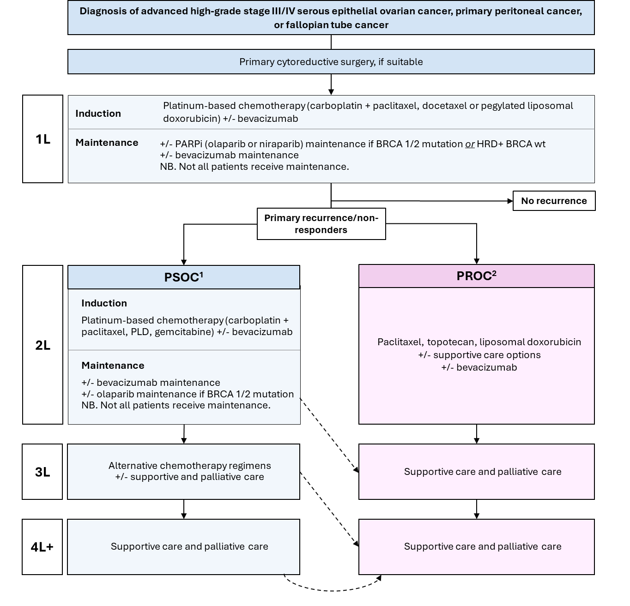

Sources: Ledermann et al 2024; González-Martín et al (2023); PBS Website.   
Abbreviations: +/-, with or without; BRCA, breast cancer gene; PARPi, poly (ADP-ribose) polymerase inhibitor; PFI, platinum-free interval until relapse; PLD, pegylated liposomal doxorubicin. HRD, homologous recombination deficiency.  
1. PSOC = platinum sensitive ovarian cancer. Traditionally defined as a platinum-free interval before recurrence of ≥6 months. Latest guidelines by ESMO indicate this decision is driven by several patient characteristics described in the paragraph above.

2. PROC = platinum-resistant ovarian cancer. Traditionally defined as a platinum-free interval before recurrence of ≤6 months. Latest guidelines by ESMO (2023) indicate this decision is driven by several patient characteristics described in the paragraph above.

**Dashed lines** indicate how platinum-sensitive patients may become platinum resistant while progressing through therapy lines.

Is there any expectation that the clinical management algorithm before the health technology is used will change due to the introduction of the proposed health technology?

The proposed positioning of mirvetuximab soravtansine based on the clinical trial evidence of patients with FRα high tumour expression (new proposed MBS item), is in patients with platinum-resistant advanced ovarian cancer. Mirvetuximab soravtansine could provide an alternative treatment agent to single agent chemotherapy in this subset of patients. For patients who receive mirvetuximab soravtansine in second-line or beyond, they may still receive other existing options in preceding or subsequent lines of therapy.

The proposed algorithm may evolve based on clinician/expert feedback, which will be incorporated into the codependent PBAC/MSAC submissions.

**Figure 2 Proposed future treatment algorithm**

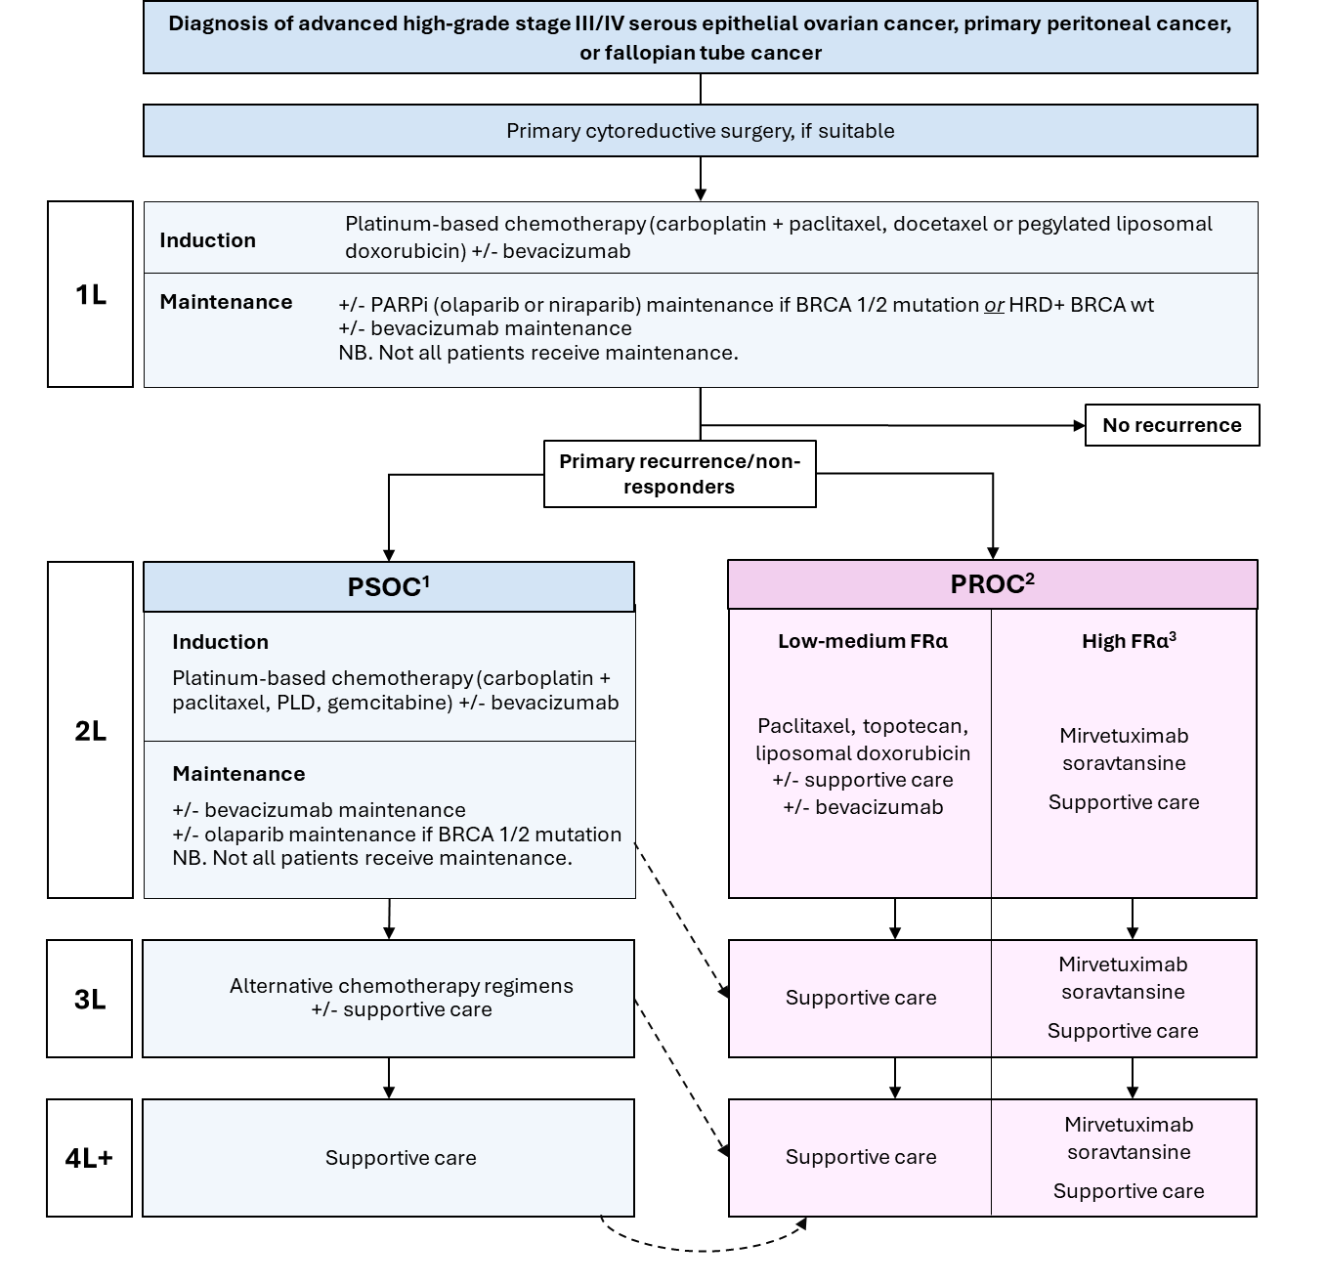

Sources: Ledermann et al 2024; González-Martín et al (2023); PBS Website.  
Abbreviations: +/-, with or without; BRCA, breast cancer gene; PARPi, poly (ADP-ribose) polymerase inhibitor; PFI, platinum-free interval until relapse; PLD, pegylated liposomal doxorubicin. HRD, homologous recombination deficiency.

1. PSOC = platinum sensitive ovarian cancer. Traditionally defined as a platinum-free interval before recurrence of ≥6 months. Latest guidelines by ESMO indicate this decision is driven by patient characteristics/not solely by 6 month time period.13

2. PROC = platinum-resistant ovarian cancer. Traditionally defined as a platinum-free interval before recurrence of ≤6 months. Latest guidelines by ESMO (2023) indicate this decision is driven by patient characteristics/not solely by 6 month time period, e.g., this group represents all patients where “platinum is not the best option” including for patient choice/quality of life reasons.13  
3. High FRα expression to be determined by new MBS item - VENTANA FOLR1 immunohistochemistry test, with ≥75% of expression on tumour cells.

**Dashed lines** indicate how platinum-sensitive patients may become platinum resistant while progressing through therapy lines.

## Describe and explain any differences in the clinical management algorithm prior to the use of the proposed health technology vs. the comparator health technology:

As described in the items above, the use of the Ventana FOLR1 test will be introduced to replace no testing for patients with platinum-resistant ovarian cancer. In eligible patients identified using the test, the use of mirvetuximab soravtansine will replace the use of chemotherapy and supportive care options.

## USE OF THE HEALTH TECHNOLOGY

## Explain what other healthcare resources are used in conjunction with delivering the proposed health technology:

## Healthcare resources that are used in conjunction with Ventana FOLR1 IHC testing include obtaining tumour tissue specimen, which is already being conducted as part of routine care (e.g. tumour debulking or biopsy), therefore no additional costs associated.

## Explain what other healthcare resources are used in conjunction with the comparator health technology:

## No other medical services or healthcare resources need to be delivered at the same time.

## Describe and explain any differences in the healthcare resources used in conjunction with the proposed health technology vs. the comparator health technology:

The comparator is no testing + standard of care chemotherapy.

## CLINICAL MANAGEMENT AFTER THE USE OF HEALTH TECHNOLOGY

## Define and summarise the clinical management algorithm, including any required tests or healthcare resources, *after* the use of the proposed health technology:

The clinical management algorithms for advanced ovarian cancer (**Figure 1** and **Figure 2**) propose that FRα status testing is undertaken in patients with resistance to platinum chemotherapy. If a patient is FRα-positive (i.e. has high FRα tumour expression) it is proposed that mirvetuximab soravtansine would replace non-platinum chemotherapy as standard treatment.

## Define and summarise the clinical management algorithm, including any required tests or healthcare resources, *after* the use of the comparator health technology:

The clinical management algorithms for advanced ovarian cancer (Figure 1 and Figure 2) determine that no further testing is required in patients with resistance to platinum chemotherapy, with single agent chemotherapy being offered as the current standard of care.

## Describe and explain any differences in the healthcare resources used *after* the proposed health technology vs. the comparator health technology:

Utilisation of PBS funded mirvetuximab soravtansine.

## Insert diagrams demonstrating the clinical management algorithm with and without the proposed health technology:

Current treatment algorithm – see **Figure 1**.

Proposed future treatment algorithm – see **Figure 2**.

The above algorithms are based on AbbVie’s understanding of the future treatment landscape at the time of this submission and may evolve depending on clinical feedback and consultation.

# Claims

## In terms of health outcomes (comparative benefits and harms), is the proposed technology claimed to be superior, non-inferior or inferior to the comparator(s)?

**X Superior**

Non-inferior

Inferior

## Please state what the overall claim is, and provide a rationale:

Superiority vs. No testing + standard of care therapy (chemotherapy).

## Why would the requestor seek to use the proposed investigative technology rather than the comparator(s)?

Initial chemotherapy treatment for ovarian cancer typically yields high response; however, most tumours subsequently relapse and eventually become resistant to platinum-based regimens. Current therapies in platinum-resistant ovarian cancer consist primarily of nonplatinum chemotherapy. Patients with platinum-resistant ovarian cancer receiving nonplatinum chemotherapy alone typically have a poor response. FRα testing to determine eligibility for mirvetuximab soravtansine is expected to lead to a change in clinical management, as patients who have ovarian cancer with high FRα expression will be eligible for targeted treatment.

## Identify how the proposed technology achieves the intended patient outcomes:

In the MIRASOL trial, among participants with platinum-resistant, FRα-positive ovarian cancer, treatment with mirvetuximab soravtansine showed a significant benefit over chemotherapy with respect to progression-free and overall survival and objective response.

## For some people, compared with the comparator(s), does the test information result in:

**A change in clinical management?** **Yes**

**A change in health outcome?** **Yes**

**Other benefits?**  **No**

## Please provide a rationale, and information on other benefits if relevant:

N/A. A detailed description of the clinical evidence and patient benefits for the proposed test and treatment will be provided in the PBAC/MSAC submission.

## In terms of the immediate costs of the proposed technology (and immediate cost consequences, such as procedural costs, testing costs etc.), is the proposed technology claimed to be more costly, the same cost or less costly than the comparator?

**X More costly**

Same cost

Less costly

## Provide a brief rationale for the claim:

There will be a cost for testing for the approved MBS item number, and if the test results confirm FRα-positive ovarian cancer, the patient will be eligible to access PBS treatment with mirvetuximab soravtansine.

# 

# Summary of Evidence

## Provide one or more recent (published) high quality clinical studies that support use of the proposed health service/technology. At ‘Application Form lodgement’,

|  | **Type of study design** | **Title of journal article or research project** | **Short description of research** | **Website link to journal article or research** | **Date of publication** |
| --- | --- | --- | --- | --- | --- |
| 1. | Phase III, open-label, randomised, controlled trial | Mirvetuximab Soravtansine in FRα-Positive, Platinum-Resistant Ovarian Cancer (MIRASOL)  NCT04209855 | Among participants with platinum-resistant, FRα-positive ovarian cancer, treatment with mirvetuximab soravtansine showed a significant benefit over chemotherapy with respect to progression-free and overall survival and objective response. | https://www.nejm.org/doi/full/10.1056/NEJMoa2309169  N Engl J Med 2023; 389:2162-2174 | Dec 7 2023 |
| 2. | Phase II single-arm, study | Efficacy and Safety of Mirvetuximab Soravtansine in Patients With Platinum-Resistant Ovarian Cancer With High Folate Receptor Alpha Expression: Results From the SORAYA Study  NCT04296890 | mirvetuximab soravtansine demonstrated consistent clinically meaningful antitumor activity and favourable tolerability and safety in patients with FRα-high PROC who had received up to three prior therapies, including bevacizumab, representing an important advance for this biomarker-selected population. | https://ascopubs.org/doi/full/10.1200/JCO.22.01900  J Clin Oncol 2023; 41:2436-2445. | Jan 30 2023 |
| 3. | Phase III, open-label, randomised, controlled trial | Phase III, randomized trial of mirvetuximab soravtansine versus chemotherapy in patients with platinum-resistant ovarian cancer: primary analysis of FORWARD I  NCT02631876 | While mirvetuximab treatment in all FRα-positive ovarian cancer patients did not lead to a significant improvement on the primary endpoint of profession-free survival - significant benefits were observed in the pre-specified subgroup of FRa-high patients. | https://www.annalsofoncology.org/article/S0923-7534(21)00157-5/pdf  J Ann Onc 2021; 32:757-765. | Mar 2 2021 |

Identify yet-to-be-published research that may have results available in the near future (that could be relevant to your application).

At the time of writing, AbbVie is not aware of any research relevant to this application which will be published in the near future.

# Reference List

Australia Cancer Research Foundation (ACRF). Accessed March 2024. Available at https://www.acrf.com.au/news/ovarian-cancer/ovarian-cancer-statistics/.

Australia Cancer Research Foundation (ACRF). Accessed March 2024. Available at https://www.acrf.com.au/news/ovarian-cancer/ovarian-cancer-statistics/.

Davis, A. et al. (2014) “Platinum resistant” ovarian cancer: What is it, who to treat and how to measure benefit? Gynecologic oncology. [Online] 133 (3), 624–631.

eviQ Guidelines (2023a). Cancer Institute NSW Cancer Genetics ID: 620 v.13 BRCA1, BRCA2 and PALB2 (truncating variants). Available at: https://www.eviq.org.au/cancer-genetics/adult/genetic-testing-for-heritable-pathogenic-variants/620-brca1-brca2-and-palb2-truncating-variants

eviQ Guidelines (2023b). Ovarian Cancer. Available at: https://www.eviq.org.au/medical-oncology/gynaecological/ovarian

FDA 2022 VENTANA FOLR1 (FOLR-2.1) RxDx Assay https://www.accessdata.fda.gov/cdrh_docs/pdf22/P220006A.pdf

González-Martín, A. et al. (2023) Newly diagnosed and relapsed epithelial ovarian cancer: ESMO Clinical Practice Guideline for diagnosis, treatment and follow-up. Annals of oncology. [Online] 34 (10), 833–848.

Ledermann, J. A. et al. (2024) ESGO–ESMO–ESP consensus conference recommendations on ovarian cancer: pathology and molecular biology and early, advanced and recurrent disease. Annals of oncology. [Online] 35 (3), 248–266.

Lokadasan, R. et al. (2016) Targeted agents in epithelial ovarian cancer: review on emerging therapies and future developments. Ecancermedicalscience. [Online] 10626–626.

Matulonis, U. A. et al. (2023) Efficacy and Safety of Mirvetuximab Soravtansine in Patients With Platinum-Resistant Ovarian Cancer With High Folate Receptor Alpha Expression: Results From the SORAYA Study. Journal of clinical oncology. [Online] 41 (13), 2436–2445.

Moore, K. N. et al. (2021) Phase III, randomized trial of mirvetuximab soravtansine versus chemotherapy in patients with platinum-resistant ovarian cancer: primary analysis of FORWARD I. *Annals of oncology*. [Online] 32 (6), 757–765.

Moore, K. N. et al. (2023) Mirvetuximab Soravtansine in FRα-Positive, Platinum-Resistant Ovarian Cancer. The New England journal of medicine. [Online] 389 (23), 2162–2174.

Reid, B. M. et al. (2017) Epidemiology of ovarian cancer： a review. Cancer biology & medicine. [Online] 14 (1), 9–32.

Scaranti, M. et al. (2020) Exploiting the folate receptor α in oncology. Nature reviews. Clinical oncology. [Online] 17 (6), 349–359.