Application Form

(New and Amended Requests for Public Funding)
(Version 2.5)

This application form is to be completed for new and amended requests for public funding (including but not limited to the Medicare Benefits Schedule (MBS)). It describes the detailed information that the Australian Government Department of Health requires in order to determine whether a proposed medical service is suitable.
Please use this template, along with the associated Application Form Guidelines to prepare your application. Please complete all questions that are applicable to the proposed service, providing relevant information only. Applications not completed in full will not be accepted.
The application form will be disseminated to professional bodies / organisations and consumer organisations that have will be identified in Part 5, and any additional groups that the Department deem should be consulted with. The application form, with relevant material can be redacted if requested by the Applicant.
Should you require any further assistance, departmental staff are available through the contact numbers and email below to discuss the application form, or any other component of the Medical Services Advisory Committee process.
Phone: +61 2 6289 7550
Fax: +61 2 6289 5540
Email: hta@health.gov.au
Website: www.msac.gov.au

PART 1 – APPLICANT DETAILS

Applicant details (primary and alternative contacts)
Corporation / partnership details (where relevant):
Corporation name:
ABN:
Business trading name:

Primary contact name: Redacted
Primary contact numbers
Business: Redacted
Mobile: Redacted
Email: Redacted

Alternative contact name: Redacted
Alternative contact numbers
Business: Redacted
Mobile: Redacted
Email: Redacted

(a) Are you a consultant acting on behalf of an Applicant?
Yes
No

(b) If yes, what is the Applicant(s) name that you are acting on behalf of?

(a) Are you a lobbyist acting on behalf of an Applicant?
Yes
No

If yes, are you listed on the Register of Lobbyists?
Yes
No

PART 2 – INFORMATION ABOUT THE PROPOSED MEDICAL SERVICE

Application title

Hepascore a test to diagnose and monitor liver fibrosis severity in chronic liver disease

Provide a succinct description of the medical condition relevant to the proposed service (no more than 150 words – further information will be requested at Part F of the Application Form)
Chronic hepatitis C, chronic hepatitis B, alcoholic liver disease and non-alcoholic fatty liver disease (NAFLD) are the major causes of chronic liver disease. It has been estimated that more than 6 million people in Australia have chronic liver disease. 300,000 have chronic hepatitis C, 200,000 have chronic hepatitis B, 5.5 million have NAFLD and 4.5 million are at risk of alcoholic liver disease. Hepatitis C and hepatitis B are blood-borne diseases of the liver caused by hepatitis C virus (HCV) and hepatitis B virus (HBV) respectively. Alcoholic liver disease is caused by excessive alcohol consumption. NAFLD is a metabolic disorder characterized by excessive triglyceride accumulation in hepatocytes. All these diseases can lead to prolonged liver cell damage and formation of liver fibrosis. Liver fibrosis progression is usually asymptomatic for the first two decades and eventually results in liver cirrhosis when hepatocellular carcinoma, liver related complications and death occur.

Provide a succinct description of the proposed medical service (no more than 150 words – further information will be requested at Part 6 of the Application Form)
Hepascore is a blood test developed in Australia that assesses liver fibrosis severity and predicts clinical outcome. It has been well validated worldwide and has a high accuracy to predict significant liver fibrosis and cirrhosis. It has been routinely performed in Western Australia for patients with chronic liver disease since 2004. It uses four serum test results, namely: alpha2-macroglobulin, hyaluronic acid, bilirubin and gamma-glutamyl transpeptidase, as well as age and gender. The biomarkers are analysed using a 5ml blood sample and the Hepascore value is calculated according to a validated formula. The Hepascore test can be performed at the same time as blood is collected from patients for other purposes such as liver function tests at community pathology centres.

(a) Is this a request for MBS funding?
Yes
No

If yes, is the medical service(s) proposed to be covered under an existing MBS item number(s) or is a new MBS item(s) being sought altogether?
Amendment to existing MBS item(s)
New MBS item(s)

If an amendment to an existing item(s) is being sought, please list the relevant MBS item number(s) that are to be amended to include the proposed medical service:

If an amendment to an existing item(s) is being sought, what is the nature of the amendment(s)?
- An amendment to the way the service is clinically delivered under the existing item(s)
- An amendment to the patient population under the existing item(s)
- An amendment to the schedule fee of the existing item(s)
- An amendment to the time and complexity of an existing item(s)
- Access to an existing item(s) by a different health practitioner group
- Minor amendments to the item descriptor that does not affect how the service is delivered
- An amendment to an existing specific single consultation item
- An amendment to an existing global consultation item(s)
- Other (please describe below):

If a new item(s) is being requested, what is the nature of the change to the MBS being sought?
- A new item which also seeks to allow access to the MBS for a specific health practitioner group
- A new item that is proposing a way of clinically delivering a service that is new to the MBS (in terms of new technology and / or population)
- A new item for a specific single consultation item
- A new item for a global consultation item(s)

Is the proposed service seeking public funding other than the MBS?
Yes
No

If yes, please advise:

What is the type of service:
Therapeutic medical service
Investigative medical service
Single consultation medical service
Global consultation medical service
Allied health service
Co-dependent technology
Hybrid health technology

For investigative services, advise the specific purpose of performing the service (which could be one or more of the following):
- To be used as a screening tool in asymptomatic populations
- Assists in establishing a diagnosis in symptomatic patients
- Provides information about prognosis
- Identifies a patient as suitable for therapy by predicting a variation in the effect of the therapy
- Monitors a patient over time to assess treatment response and guide subsequent treatment decisions
- Is for genetic testing for heritable mutations in clinically affected individuals and, when also appropriate, in family members of those individuals who test positive for one or more relevant mutations (and thus for which the Clinical Utility Card proforma might apply)

Does your service rely on another medical product to achieve or to enhance its intended effect?
Pharmaceutical / Biological
Prosthesis or device
No

(a) If the proposed service has a pharmaceutical component to it, is it already covered under an existing Pharmaceutical Benefits Scheme (PBS) listing?
Yes
No

If yes, please list the relevant PBS item code(s):

If no, is an application (submission) in the process of being considered by the Pharmaceutical Benefits Advisory Committee (PBAC)?
Yes (please provide PBAC submission item number below)
No

If you are seeking both MBS and PBS listing, what is the trade name and generic name of the pharmaceutical?
Trade name:
Generic name:

(a) If the proposed service is dependent on the use of a prosthesis, is it already included on the Prostheses List?
Yes
No

If yes, please provide the following information (where relevant):
Billing code(s):
Trade name of prostheses:
Clinical name of prostheses:
Other device components delivered as part of the service:

If no, is an application in the process of being considered by a Clinical Advisory Group or the Prostheses List Advisory Committee (PLAC)?
Yes
No

Are there any other sponsor(s) and / or manufacturer(s) that have a similar prosthesis or device component in the Australian market place which this application is relevant to?
Yes
No

If yes, please provide the name(s) of the sponsor(s) and / or manufacturer(s):

Please identify any single and / or multi-use consumables delivered as part of the service?
Single use consumables:
Blood Sample Collection
• Alcohol wipes
• Vacutainer Scalp Vein / Butterfly Needle Collection: Blue Luer-Lok multi sample adapters supplied pre-packaged with a needle holder (barrel).
• Serum (SST) and Lithium Heparin blood collection tubes
Blood Analysis
• Specialist diagnostic kits from various manufacturers and suppliers which are TGA approved in-vitro devices (IVDs).
• Testing is performed on highly automated analysers that require single use consumables such as cuvettes, pipette tips and wash buffers as part of the analytical process.

Multi-use consumables:
Automated analysers

PART 3 – INFORMATION ABOUT REGULATORY REQUIREMENTS

(a) If the proposed medical service involves the use of a medical device, in-vitro diagnostic test, pharmaceutical product, radioactive tracer or any other type of therapeutic good, please provide the following details:
• Hepascore is a liver function test derived from a panel of four serum analytes which is capable of accurately predicting the extent of liver fibrosis (scarring) in a wide variety of liver diseases. It is a non-invasive method for assessment of liver fibrosis or cirrhosis in adults.
• The main advantages of non-invasive fibrosis tests like Hepascore are the absence of risks and the potential to reflect the status of the entire liver. Thus, it represents a new class of liver function tests which gives information on fibrosis previously unavailable from serum tests. It is a significant advance in patients with liver disease and it replaces liver biopsy, a more expensive and potentially dangerous test. Moreover, Hepascore makes monitoring fibrosis progression possible, whereas repeated liver biopsies are fraught with difficulty and therefore, seldom performed.
• Hepascore is an index calculated from the following analytes: gamma glutamyl transferase, bilirubin, hyaluronic acid and alpha-2-macrglobulin, which are all considered as Class 2 IVD.

Is the medical device classified by the TGA as either a Class III or Active Implantable Medical Device (AIMD) against the TGA regulatory scheme for devices?
Class III
AIMD
N/A

(a) Is the therapeutic good to be used in the service exempt from the regulatory requirements of the Therapeutic Goods Act 1989?
Yes (If yes, please provide supporting documentation as an attachment to this application form)
No

If no, has it been listed or registered or included in the Australian Register of Therapeutic Goods (ARTG) by the Therapeutic Goods Administration (TGA)?
Yes (if yes, please provide details below)
No

ARTG listing, registration or inclusion number:
• Abbott Diagnostics gamma glutamyl transferase: ARTG Identifier 179428, IVD Class 2
• Abbott Diagnostics total bilirubin: ARTG Identifier 185778, IVD Class 2
• Wako Chemicals GmbH hyaluronic acid: ARTG Identifier 227137, IVD Class 2
• DAKO alpha-2-macrglobulin: ARTG Identifier 200116, IVD Class 2
These tests are performed on both the Abbott Architect c16000 (ARTG identifier 199356) as well as Beckman Olympus AU2700 (ARTG identifier 231011) – both Medical Device – IVD Class 1

TGA approved indication(s), if applicable:
TGA approved purpose(s), if applicable:

If the therapeutic good has not been listed, registered or included in the ARTG, is the therapeutic good in the process of being considered for inclusion by the TGA?
Yes (please provide details below)
No

Date of submission to TGA:
Estimated date by which TGA approval can be expected:
TGA Application ID:
TGA approved indication(s), if applicable:
TGA approved purpose(s), if applicable:

If the therapeutic good is not in the process of being considered for listing, registration or inclusion by the TGA, is an application to the TGA being prepared?
Yes (please provide details below)
No

Estimated date of submission to TGA: May 2017
Proposed indication(s), if applicable: Hepascore is an index derived from serum markers (hyaluronic acid, alpha-2-macroglobulin, gamma glutamyl transferase and bilirubin)
Proposed purpose(s), if applicable:

PART 4 – SUMMARY OF EVIDENCE

Provide an overview of all key journal articles or research published in the public domain related to the proposed service that is for your application (limiting these to the English language only). Please do not attach full text articles, this is just intended to be a summary.
 | Type of study design* | Title of journal article or research project (including any trial identifier or study lead if relevant) | Short description of research (max 50 words)** | Website link to journal article or research (if available) | Date of publication***
1. | Study of diagnostic accuracy | Hepascore: an accurate validated predictor of liver fibrosis in chronic hepatitis C infection | This study developed Hepascore as a serum fibrosis marker to assess the severity of liver fibrosis in 117 chronic hepatitis C patients and validated in a separate cohort of 104 chronic hepatitis C patients. | http://www.ncbi.nlm.nih.gov/pubmed/16055434 | 2005/08/02
2. | Study of diagnostic accuracy | Comparison of test performance profile for blood tests of liver fibrosis in chronic hepatitis C | This study compared the diagnostic accuracy of several serum fibrosis markers in 356 chronic hepatitis C patients, namely: Fibrotest, APRI, FibroMeter, and Hepascore. | https://www.ncbi.nlm.nih.gov/pubmed/?term=17156890 | 2006/12/13
3. | Study of diagnostic accuracy | Prospective comparison of six non-invasive scores for the diagnosis of liver fibrosis in chronic hepatitis C | This study compared the diagnostic accuracy of six serum fibrosis markers in 180 chronic hepatitis C patients, namely: MP3, Fibrotest, Fibrometer, Hepascore, Forns' score and APRI. | https://www.ncbi.nlm.nih.gov/pubmed/?term=17321634 | 2007/02/27
4. | Study of diagnostic accuracy | Optimized stepwise combination algorithms of non-invasive liver fibrosis scores including Hepascore in hepatitis C virus patients | This study included 467 chronic hepatitis C patients and found that Hepascore was an accurate non-invasive marker for > or =F2 and F4 diagnosis. . | https://www.ncbi.nlm.nih.gov/pubmed/?term=18498446 | 2008/05/24
5. | Study of diagnostic accuracy | Comparison of non-invasive liver fibrosis biomarkers in HIV/HCV co-infected patients: the fibrovic study--ANRS HC02 | This study included 272 patients with HIC/HCV co-infection and found that, Fibrometer, Hepascore and Fibrotest outperformed SHASTA, APRI, Forns index, and Fib-4 for the prediction of significant liver fibrosis. | https://www.ncbi.nlm.nih.gov/pubmed/?term=18314219 | 2008/03/04
6. | Study of diagnostic accuracy | Evaluating the accuracy and increasing the reliable diagnosis rate of blood tests for liver fibrosis in chronic hepatitis C | This study compared five serum makers, namely: FibroMeter, Fibrotest, Fib-4, APRI and Hepascore, in 1056 patients with chronic hepatitis C. | https://www.ncbi.nlm.nih.gov/pubmed/?term=18492022 | 2008/05/22
7. | Meta-analysis | Diagnostic accuracy, reproducibility and robustness of fibrosis blood tests in chronic hepatitis C: a meta-analysis with individual data | This study evaluated the diagnostic accuracy of liver fibrosis tests (FibroMeter, Fibrotest, APRI, Hepascore) and its influencing factors in a meta-analysis with individual data. Four independent centers provided four blood tests and Metavir staging from 825 patients with chronic hepatitis C. | https://www.ncbi.nlm.nih.gov/pubmed/?term=18655779 | 2008/07/29
8. | Study of diagnostic accuracy | Validation of Hepascore, compared with simple indices of fibrosis, in patients with chronic hepatitis C virus infection in United States | This study included 391 patients with chronic hepatitis C and found that Hepascore accurately predicted likelihood of developing fibrosis and could alleviate the need for liver biopsy in a subset of patients | https://www.ncbi.nlm.nih.gov/pubmed/?term=19514117 | 2009/06/11
9 | Study of diagnostic accuracy | Improved diagnostic accuracy of blood tests for severe fibrosis and cirrhosis in chronic hepatitis C. | This study included 1056 patients with chronic hepatitis C and evaluated the accuracy of FibroMeter, Fibrotest, Hepascore and APRI to diagnose severe fibrosis and cirrhosis respectively. | https://www.ncbi.nlm.nih.gov/pubmed/19060630 | 2008/12/09
10. | Study of diagnostic accuracy | Comparison of liver fibrosis blood tests developed for HCV with new specific tests in HIV/HCV co-infection | This study included 467 patients with HCV/HIV co-infection and compared 5 non-specific and 2 specific blood tests for liver fibrosis. | https://www.ncbi.nlm.nih.gov/pubmed/?term=20493576 | 2010/05/25
11. | Study of diagnostic accuracy | Comparison of nine blood tests and transient elastography for liver fibrosis in chronic hepatitis C: the ANRS HCEP-23 study | This multicentre prospective study included 463 chronic hepatitis C patients and found that performance of Fibroscan was reduced due to uninterpretable results. Fibrotest, Fibrometer, and Hepascore performed best and similarly for diagnosis of significant fibrosis and cirrhosis. | https://www.ncbi.nlm.nih.gov/pubmed/?term=21781944 | 2011/07/26
12. | Study of diagnostic accuracy | Prospective evaluation of FibroTest, FibroMeter, and HepaScore for staging liver fibrosis in chronic hepatitis B: comparison with hepatitis C | This study included 510 patients mono-infected with hepatitis B or C and found that the diagnostic performance of blood tests (FibroTest, FibroMeter, and HepaScore) is similar in hepatitis B and C. | https://www.ncbi.nlm.nih.gov/pubmed/?term=24631902 | 2014/03/19
13. | Study of diagnostic accuracy | Performance of 11 biomarkers for liver fibrosis assessment in HIV/HBV co-infected patients | This study included 108 patients with HIV/HBV co-infection and compared the performance of 11 biochemical scores to estimate liver fibrosis. | https://www.ncbi.nlm.nih.gov/pubmed/?term=19398234 | 2009/04/29
14. | Study of diagnostic accuracy | Staging of liver fibrosis in chronic hepatitis B patients with a composite predictive model: a comparative study | This study included 78 patients with chronic hepatitis B and found that Hepascore, SLFG, and Fibrometer have a better diagnostic value than APRI, FIB-4 and Forn's index | https://www.ncbi.nlm.nih.gov/pubmed/?term=20101779 | 2010/01/27
15. | Study of diagnostic accuracy | Comparison of noninvasive models of fibrosis in chronic hepatitis B | This study examined noninvasive fibrosis models [Hepascore, Fibrotest, APRI, hepatitis e antigen (HBeAg)-positive and -negative models] in 179 chronic hepatitis B patients. | http://www.ncbi.nlm.nih.gov/pubmed/21748376 | 2011/07/13
16. | Study of diagnostic accuracy | Non-invasive tests in prediction of liver fibrosis in chronic hepatitis B and comparison with post-antiviral treatment results | This study included 76 patients with chronic hepatitis B and compared the performance of a series of non-invasive tests (APRI, S-index, SLFG, FIB-4, Forn's index and Hepascore) to detect fibrosis | https://www.ncbi.nlm.nih.gov/pubmed/?term=23391746 | 2013/02/09
17. | Study of diagnostic accuracy | Complex non-invasive fibrosis models are more accurate than simple models in non-alcoholic fatty liver disease | This study included 242 patients with non-alcoholic fatty liver disease and found that complex (Hepascore, Fibrotest, FIB4) fibrosis models have superior accuracy to detect liver fibrosis than simple serum models (APRI, BARD). | https://www.ncbi.nlm.nih.gov/pubmed/?term=21950746 | 2011.10
18. | Study of diagnostic accuracy | Assessment of asymptomatic liver fibrosis in alcoholic patients using fibroscan: prospective comparison with seven non-invasive laboratory tests | This study included 103 patients with alcoholic liver disease and compared the accuracy of seven non-invasive laboratory tests to detect liver fibrosis. | https://www.ncbi.nlm.nih.gov/pubmed/?term=18705692 | 2008/08/19
19. | Study of diagnostic accuracy | Diagnostic and prognostic values of noninvasive biomarkers of fibrosis in patients with alcoholic liver disease | This study consecutively included 218 patients with alcoholic liver disease and compared the diagnostic and prognostic values of FibroTest versus the recently patented biomarkers, FibrometerA, and Hepascore. | http://www.ncbi.nlm.nih.gov/pubmed/19053048 | 2008/12/05
20. | Meta-analysis | The Ability of Hepascore to Predict Liver Fibrosis in Chronic Liver Disease: a Meta-analysis | This meta-analysis included 21 studies and concluded that Hepascore was a clinically useful measure of liver fibrosis in patients with common causes of chronic liver disease. | https://www.ncbi.nlm.nih.gov/pubmed/?term=26991726 | 2016/03/19
* Categorise study design, for example meta-analysis, randomised trials, non-randomised trial or observational study, study of diagnostic accuracy, etc.
**Provide high level information including population numbers and whether patients are being recruited or in post-recruitment, including providing the trial registration number to allow for tracking purposes.
*** If the publication is a follow-up to an initial publication, please advise.

Identify yet to be published research that may have results available in the near future that could be relevant in the consideration of your application by MSAC (limiting these to the English language only). Please do not attach full text articles, this is just intended to be a summary.
 | Type of study design* | Title of research (including any trial identifier if relevant) | Short description of research (max 50 words)** | Website link to research (if available) | Date***
1. | For yet to be published research that may have results relevant to your application, insert the type of study design in this column and columns below | For yet to be published research that may have results relevant to your application, insert the title of research (including any trial identifier if relevant) in this column and columns below | For yet to be published research that may have results relevant to your application, insert a short description of research (max 50 words) in this column and columns below | For yet to be published research that may have results relevant to your application, insert a website link to this research (if available) in this column and columns below | For yet to be published research that may have results relevant to your application, insert date in this column and columns below
2. | Insert study design | Insert title of research | Insert description | Insert website link | Insert date
3. | Insert study design | Insert title of research | Insert description | Insert website link | Insert date
4. | Insert study design | Insert title of research | Insert description | Insert website link | Insert date
5. | Insert study design | Insert title of research | Insert description | Insert website link | Insert date
6. | Insert study design | Insert title of research | Insert description | Insert website link | Insert date
7. | Insert study design | Insert title of research | Insert description | Insert website link | Insert date
8. | Insert study design | Insert title of research | Insert description | Insert website link | Insert date
9. | Insert study design | Insert title of research | Insert description | Insert website link | Insert date
10. | Insert study design | Insert title of research | Insert description | Insert website link | Insert date
11. | Insert study design | Insert title of research | Insert description | Insert website link | Insert date
12. | Insert study design | Insert title of research | Insert description | Insert website link | Insert date
13. | Insert study design | Insert title of research | Insert description | Insert website link | Insert date
14. | Insert study design | Insert title of research | Insert description | Insert website link | Insert date
15. | Insert study design | Insert title of research | Insert description | Insert website link | Insert date
* Categorise study design, for example meta-analysis, randomised trials, non-randomised trial or observational study, study of diagnostic accuracy, etc.
**Provide high level information including population numbers and whether patients are being recruited or in post-recruitment.
***Date of when results will be made available (to the best of your knowledge).

PART 5 – CLINICAL ENDORSEMENT AND CONSUMER INFORMATION

List all appropriate professional bodies / organisations representing the group(s) of health professionals who provide the service (please attach a statement of clinical relevance from each group nominated):
Rendering practitioners - Australian Association of Clinical Biochemists, Royal College of Pathologists
Referring Practitioners - Gastroenterological Society of Australia, the Royal Australasian College of Physicians, the Royal Australasian College of General Practitioners, Australian Liver Association, Australasian Society for Infectious Diseases, the Australasian Society for HIV Medicine.

List any professional bodies / organisations that may be impacted by this medical service (i.e. those who provide the comparator service):
Nil

List the relevant consumer organisations relevant to the proposed medical service (please attach a letter of support for each consumer organisation nominated):
Hepatitis Australia, Liver Foundation, Diabetes Australia, Alcoholics Anonymous, Heart Foundation

List the relevant sponsor(s) and / or manufacturer(s) who produce similar products relevant to the proposed medical service:
Nil

Nominate two experts who could be approached about the proposed medical service and the current clinical management of the service(s):

Name of expert 1: Redacted
Telephone number(s): Redacted
Email address: Redacted
Justification of expertise: Paragraph Redacted

Name of expert 2: Redacted
Telephone number(s): Redacted
Email address: Redacted
Justification of expertise: Paragraph Redacted
Please note that the Department may also consult with other referrers, proceduralists and disease specialists to obtain their insight.

PART 6 – POPULATION (AND PRIOR TESTS), INDICATION, COMPARATOR, OUTCOME (PICO)

PART 6a – INFORMATION ABOUT THE PROPOSED POPULATION

Define the medical condition, including providing information on the natural history of the condition and a high level summary of associated burden of disease in terms of both morbidity and mortality:
All patients with chronic liver disease are at risk of developing advanced liver fibrosis or cirrhosis. Hepascore has been validated in Australian and international populations and has good to excellent diagnostic accuracy for assessing liver fibrosis in all forms of chronic liver disease including chronic hepatitis C, chronic hepatitis B, alcoholic liver disease and NAFLD. Therefore, these patients are the target population for the use of Hepascore.
Chronic hepatitis C is a blood borne disease and most patients in Australia are infected with HCV through intravenous drug use. It is estimated that there were 307,000 patients with chronic hepatitis C in Australia in 2012 (1). The burden of liver disease due to HCV infection is projected to triple by 2030 (2). HCV infection causes long term liver damage and may result in the progression liver fibrosis to cirrhosis. Approximately 5 to 30% of patients with chronic hepatitis C develop severe fibrosis or cirrhosis over 20 to 30 years after initial infection. It is estimated that HCV infection results in 2550 death per year in Australia (1).
Chronic hepatitis B is also a blood borne disease and the common transmission routes include: vertical transmission at birth, sexual transmission and intravenous drug use. It is estimated that 211,086 individuals had chronic hepatitis B in Australia in 2012 (1). The natural course of chronic HBV infection is generally divided into three phases: immune tolerance phase, immune reactive phase and non-replicative phase. The immune tolerance phase, which lasts seven to 30 years, is characterized by HBeAg positivity, high level of HBV DNA, no evidence of active liver disease (normal aminotransferases) and no or slow progression of liver fibrosis. Immune reactive phase is characterised by HBeAg positivity, decreased level of HBV DNA, increased or fluctuating levels of aminotransferases and more rapid progression of fibrosis. This phase ends with seroconversion to anti-HBe and enters the non-replicative phase. The annual rate of serum conversion for patients in the immune reactive phase is estimated to be 10 to 20%. Patients who remain in the immune reactive phase are at greater risk of developing cirrhosis. Overall 15 to 20% of chronic hepatitis B patients develop cirrhosis during their lifetime (1).

Alcoholic liver disease results from excessive alcohol consumption. The spectrum of alcoholic liver disease ranges from steatosis (fat infiltration), alcoholic hepatitis, to alcoholic fibrosis that includes cirrhosis. The prevalence of alcoholic liver disease is usually underestimated as most cases remain undetected during the asymptomatic early stages of the disease. There is no accurate prevalence data for alcoholic liver disease in Australia. Extrapolating from the Busselton population prevalence data it is estimated that at least 165,000 people have alcoholic liver disease in Australia. 8 to 20% of patients with alcoholic fatty liver will progress to develop alcoholic cirrhosis.

NAFLD is the most common cause of chronic liver disease in Australia affecting approximately 5.5 million people (1). It is characterised by accumulation of fat in liver cells. The risk factors for NAFLD include obesity, dyslipidaemia and diabetes. The majority of NAFLD patients will not develop liver related morbidity and mortality in their lifetime, as only 5% of NAFLD patients progress to cirrhosis and 1.7% of patients die from liver disease (3). However, given the high prevalence of NAFLD in Australia there will still be a large number of patients who will develop cirrhosis (270,000) and premature liver related death (93,000).

Most causes of chronic liver disease share a similar clinical course with a prolonged asymptomatic early phase during which the risk of liver related morbidity and mortality is minimal. Liver fibrosis accumulates silently during this early phase and may eventually progress to cirrhosis. Regardless of the aetiology of chronic liver disease, the risk of developing hepatocellular carcinoma, liver related complications and liver related death increases dramatically after the development of severe fibrosis and cirrhosis. During the clinically compensated cirrhosis phase, the annual incident rate of developing liver related complications, hepatocellular carcinoma and death is estimated to be 6.37%, 3.36% and 4.58% respectively (4). Decompensated cirrhosis occurs when clinical evident liver complications develop and this phase rapidly progresses towards death or liver transplantation. The median survival for patients with decompensated cirrhosis is approximately two years.

Specify any characteristics of patients with the medical condition, or suspected of, who are proposed to be eligible for the proposed medical service, including any details of how a patient would be investigated, managed and referred within the Australian health care system in the lead up to being considered eligible for the service:
Population 1: Chronic hepatitis C patients
The diagnosis of chronic hepatitis C is made with a positive HCV antibody test and a detectable HCV RNA load performed on two occasions more than 6 months apart. The median age of chronic hepatitis C patients is 50-59 years (1). Approximately 60% of chronic hepatitis C patients are males (1). Genotype 1 is the most common HCV genotype in Australia (54.5%), followed by genotype 3 (36.8%). It was estimated that only 11% of chronic hepatitis C patients were successfully treated up to 2014 (5). The proportion of patients with advanced fibrosis or cirrhosis was approximately 19% (5). Most patients with chronic hepatitis C are followed up by general practitioners. All chronic hepatitis C patients are eligible for Hepascore. This includes those who have never been treated and those who have failed previous anti-viral treatment.

Population 2: Chronic hepatitis B patients
The diagnosis of chronic hepatitis B is made with a positive hepatitis B surface antigen (HBsAg) test. The median age of chronic hepatitis B patients is 40-49 years and approximately 50% of them are males (1). In Australia, 14% of patients with chronic hepatitis B have cirrhosis (6). Among the non-cirrhotic patients the prevalence of HBeAg negativity is approximately 70% (7). The great majority of HBeAg-negative patients have normal ALT levels and undetectable serum HBV DNA (8). All patients with chronic hepatitis B are eligible for Hepascore before treatment. Non-cirrhotic patients not on treatment are eligible for an annual Hepascore test.

Population 3: Patients with NAFLD and alcoholic liver disease
NAFLD is diagnosed based on the presence of metabolic risk factors, demonstration of hepatic steatosis using ultrasound scan and the exclusion of other causes of chronic liver disease (9). The prevalence of advanced liver fibrosis and cirrhosis is approximately 9% and 5% respectively (10). Approximately one third of NAFLD patients develop fibrosis progression during the clinical course of disease (10). All patients with NAFLD are eligible for a Hepascore test. Those non-cirrhotic patients are eligible for one or two yearly Hepascore tests.
Alcoholic liver disease is diagnosed by documentation of excess alcohol consumption >20 g/d in females and >30 g/d in males and who have clinical and/or biological abnormalities suggestive of liver injury (11). One large study that included 1407 patients with alcoholism or alcoholic liver disease and who underwent a liver biopsy found that 14% of patients had normal liver, 28% steatosis alone, 20% fibrosis (with or without steatosis), 8.5% alcoholic hepatitis, and 29% cirrhosis (12). All patients with alcoholic liver disease are eligible for a Hepascore test. Those non-cirrhotic patients are eligible for one or two yearly Hepascore tests.

Define and summarise the current clinical management pathway before patients would be eligible for the proposed medical service (supplement this summary with an easy to follow flowchart [as an attachment to the Application Form] depicting the current clinical management pathway up to this point):

Population 1: Chronic hepatitis C patients.
In most cases, patients with chronic hepatitis C were diagnosed and followed up by general practitioners. The diagnosis of chronic hepatitis C is made using a positive HCV antibody test and a detectable HCV RNA load performed on two occasions more than 6 months apart. The routine assessments of chronic hepatitis C include medical history; use of concomitant medications; physical examination; HBV, HIV, HAV serology; full blood count; liver function test; renal function test (urea; electrolytes, creatinine); INR (flowchart 1). Liver ultrasound is only indicated for cirrhotic patients to screen for hepatocellular carcinoma.

Population 2: Chronic hepatitis B patients
Most patients with chronic hepatitis B are diagnosed and followed up by general practitioners. The diagnosis of chronic hepatitis B is confirmed by positive HBV surface antigen (HBsAg). The routine assessments of chronic hepatitis B include, medical history and concomitant medications; physical examination; HBsAb, HBeAg, HBeAb, HBV viral load; HDV, HCV, HIV, HAV serology; full blood count, liver function test, INR; and liver ultrasound for high risk patients of hepatocellular carcinoma (flowchart 2).

Population 3: Patients with alcoholic liver disease or NAFLD
Most patients with NAFLD and alcoholic liver disease are diagnosed and followed up by general practitioners. Initial assessment for liver disease includes medical history; physical examination (features of cirrhosis, BMI, waist circumference); HBV, HCV serology; full blood count, liver function test; fasting blood glucose, HbA1c, OGTT; serum lipids study and liver ultrasound. Tests for coeliac and thyroid diseases, polycystic ovary syndrome and rare liver diseases (Wilson, autoimmune disease, α1-antitrypsin deficiency) may be performed. NAFLD is diagnosed based on the presence of metabolic risk factors (overweight, diabetes, dyslipidaemia), evidence of hepatic steatosis using ultrasound scan and the exclusion of other causes of chronic liver disease (9). Alcoholic liver disease is diagnosed by documentation of excess alcohol consumption >20g/d for females or >30 g/d for males and the presence of clinical and/or biological abnormalities suggestive of liver injury (11) (flowchart 3).

PART 6b – INFORMATION ABOUT THE INTERVENTION

Describe the key components and clinical steps involved in delivering the proposed medical service:
Hepascore is a blood test that is performed in medical biochemistry laboratories. Bilirubin and gamma-glutamyl transpeptidase are commonly measured on an automated biochemistry analyser, as part of a liver function test. Hyaluronic acid (Wako, Germany) and alpha-2-macroglobulin (Dako, USA) are performed on a fully automated chemistry analyser (Olympus AU2700, Beckman). The Hepascore result ranges from 0 to 1.0. Higher values (e.g. >0.5) are predictive of more severe liver fibrosis. Hepascore may rarely be falsely elevated in systemic inflammatory conditions such as rheumatoid arthritis, acute hepatitis, the non-fasting state and when bilirubin is elevated due to biliary obstruction, haemolysis or gilberts syndrome. Interpretation of the Hepascore value in these states needs to be made with caution. Hepascore has been validated in Australian and international patients with chronic hepatitis C, chronic hepatitis B, alcoholic liver disease and NAFLD (table 1) [Adams, Bulsara et al. 2005; Raftopoulos, George et al. 2011; Adams, George et al. 2011; Naveau, Gaude et al. 2009; Huang, Adams et al.2016]. The cut points for test interpretation vary according to the type of liver disease. An example of the test report and interpretation is given in figure 1. General practitioners and specialists can order the test from clinical biochemistry laboratories. The Hepascore test result may be available within three to four days of blood collection.

Table 1: Interpretation of Hepascore values in chronic liver disease

Disease type | Hepascore | interpretation | Sen | Spe | PPV | NPV
Hepatitis C | ≥0.50 | detect significant fibrosis | 63% | 89% | 88% | 64%
 | ≥0.85 | detect cirrhosis | 71% | 89% | 55% | 94%
Hepatitis B | ≥0.50 | detect significant fibrosis | 79% | 74% | 69% | 83%
 | ≥0.87 | detect cirrhosis | 87% | 85% | 35% | 99%
Alcoholic liver disease | ≥0.25 | detect significant fibrosis | 90% | 37% | 71% | 68%
 | ≥0.95 | detect cirrhosis | 90% | 87% | 75% | 95%
Non-alcoholic fatty liver disease | ≥0.44 | detect significant fibrosis | 51% | 88% | 74% | 73%
 | ≥0.70 | detect cirrhosis | 87% | 89% | 45% | 99%
Note: Sen: sensitivity; Spe: specificity; PPV: positive predictive value; NPV: negative predictive value.

Figure 1: An example of the Hepascore test report.

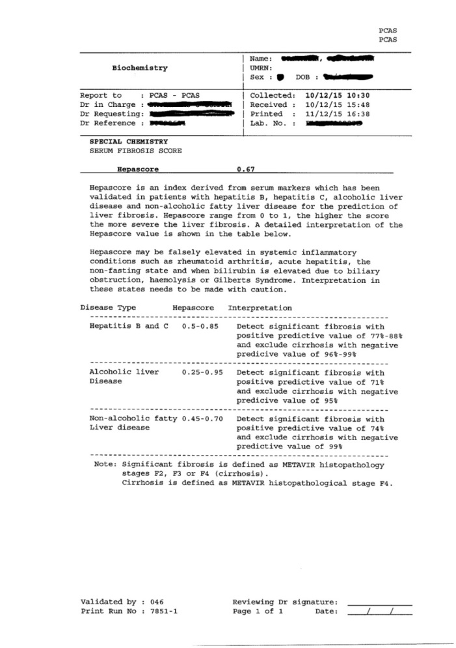

Does the proposed medical service include a registered trademark component with characteristics that distinguishes it from other similar health components?
This test is registered as: Hepascore TM.

If the proposed medical service has a prosthesis or device component to it, does it involve a new approach towards managing a particular sub-group of the population with the specific medical condition?
N/A

If applicable, are there any limitations on the provision of the proposed medical service delivered to the patient (i.e. accessibility, dosage, quantity, duration or frequency):
No limitations.

If applicable, identify any healthcare resources or other medical services that would need to be delivered at the same time as the proposed medical service:
Nil

If applicable, advise which health professionals will primarily deliver the proposed service:
General practitioners, general physicians, gastroenterologists/hepatologists

If applicable, advise whether the proposed medical service could be delegated or referred to another professional for delivery:

If applicable, specify any proposed limitations on who might deliver the proposed medical service, or who might provide a referral for it:

If applicable, advise what type of training or qualifications would be required to perform the proposed service as well as any accreditation requirements to support service delivery:

(a) Indicate the proposed setting(s) in which the proposed medical service will be delivered (select all relevant settings):
Inpatient private hospital
Inpatient public hospital
Outpatient clinic
Emergency Department
Consulting rooms
Day surgery centre
Residential aged care facility
Patient’s home
Laboratory
Other – please specify below

- Where the proposed medical service is provided in more than one setting, please describe the rationale related to each:

Is the proposed medical service intended to be entirely rendered in Australia?
Yes
No – please specify below

PART 6c – INFORMATION ABOUT THE COMPARATOR(S)

Nominate the appropriate comparator(s) for the proposed medical service, i.e. how is the proposed population currently managed in the absence of the proposed medical service being available in the Australian health care system (including identifying health care resources that are needed to be delivered at the same time as the comparator service):
Comparators: clinical assessment including medical history, physical examination and routine laboratory tests (liver function test, full blood count, INR).

Does the medical service that has been nominated as the comparator have an existing MBS item number(s)?
Yes (please provide all relevant MBS item numbers below)
No

GP consultation: MBS 3 to 51, 193, 195, 197, 199, 2497-2559
Specialist consultation: MBS 119, 131, 132, 291-299
Liver function test: MBS 66512
Coagulation study: MBS 65120
Full blood count: MBS 65070

Define and summarise the current clinical management pathways that patients may follow after they receive the medical service that has been nominated as the comparator (supplement this summary with an easy to follow flowchart [as an attachment to the Application Form] depicting the current clinical management pathway that patients may follow from the point of receiving the comparator onwards including health care resources):
Population 1: Chronic hepatitis C patients.
Direct-acting antiviral therapies are now rebated by the PBS for all patients with chronic hepatitis C. Identifying the HCV genotype and evaluating for the presence of cirrhosis are the key issues in the pre-treatment assessment as both determine the choice of anti-viral regimen and treatment duration (table 2, table 3) (http://www.pbs.gov.au/info/healthpro/explanatory-notes/general-statement-hep-c). Treatment duration varies from 8 weeks to 24 weeks. Additionally, six-monthly assessment (physical examination, full blood examination, liver function test, INR), six-monthly ultrasound surveillance for hepatocellular carcinoma and 2-3 yearly endoscopic surveillance for oesophageal varices are performed for all cirrhotic patients (flowchart 4). Cirrhotic patients should be under specialist care.

Table 2. The recommended choice and duration of hepatitis C antiviral treatment regimens for non-cirrhotic patients
Genotype | Treatment naive | Treatment experienced
1 | LEDIPASVIR + SOFOSBUVIR [8 or 12 wks]  OR DACLATASVIR and SOFOSBUVIR [12 wks]  OR SOFOSBUVIR and PEG-IFN and RBV [12 wks]  OR PARITAPREVIR + RITONAVIR + OMBITASVIR (&) DASABUVIR [12 wks]  OR PARITAPREVIR + RITONAVIR + OMBITASVIR (&) DASABUVIR (&) RBV [12 wks]  OR GRAZOPREVIR + ELBASVIR [12 wks]  OR SOFOSBUVIR + VELPATASVIR [12 wks] | LEDIPASVIR + SOFOSBUVIR [12 wks]  OR DACLATASVIR and SOFOSBUVIR [12 or 24 wks]  OR SOFOSBUVIR and PEG-IFN and RBV [12 wks]  OR PARITAPREVIR + RITONAVIR + OMBITASVIR (&) DASABUVIR [12 wks]  OR PARITAPREVIR + RITONAVIR + OMBITASVIR (&) DASABUVIR (&) RBV [12 wks]  OR GRAZOPREVIR + ELBASVIR [12 wks]  OR GRAZOPREVIR + ELBASVIR and RBV [16 wks]  OR SOFOSBUVIR + VELPATASVIR [12 wks]
2 | SOFOSBUVIR and RBV [12 wks]  OR SOFOSBUVIR + VELPATASVIR [12 wks] | SOFOSBUVIR and RBV [12 wks]  OR SOFOSBUVIR + VELPATASVIR [12 wks]
3 | DACLATASVIR and SOFOSBUVIR [12 wks]  OR SOFOSBUVIR and RBV [24 wks]  OR SOFOSBUVIR and PEG-IFN and RBV [12 wks]  OR SOFOSBUVIR + VELPATASVIR [12 wks] | DACLATASVIR and SOFOSBUVIR [12 wks]  OR SOFOSBUVIR and RBV [24 wks]  OR SOFOSBUVIR and PEG-IFN and RBV [12 wks]  OR SOFOSBUVIR + VELPATASVIR [12 wks]
4 | SOFOSBUVIR and PEG-IFN and RBV [12 ws]  OR GRAZOPREVIR + ELBASVIR [12 wks]  OR SOFOSBUVIR + VELPATASVIR [12 wks] | SOFOSBUVIR and PEG-IFN and RBV [12 ws]  OR GRAZOPREVIR + ELBASVIR [12 wks]  OR GRAZOPREVIR + ELBASVIR and RBV [16 wks]  OR SOFOSBUVIR + VELPATASVIR [12 wks]
5 or 6 | SOFOSBUVIR and PEG-IFN and RBV [12 wks]  OR SOFOSBUVIR + VELPATASVIR [12 wks] | SOFOSBUVIR and PEG-IFN and RBV [12 wks]  OR SOFOSBUVIR + VELPATASVIR [12 wks]

Table 3. The recommended choice and duration of hepatitis C antiviral treatment regimens for cirrhotic patients
Genotype | Treatment naive | Treatment experienced
1 | LEDIPASVIR + SOFOSBUVIR [12 wks]  OR DACLATASVIR and SOFOSBUVIR and RBV  [12 wks]  OR DACLATASVIR and SOFOSBUVIR [24 wks]  OR SOFOSBUVIR and PEG-IFN and RBV [12 wks]  OR PARITAPREVIR + RITONAVIR + OMBITASVIR (&) DASABUVIR (&) RBV [12 wks]  OR GRAZOPREVIR + ELBASVIR [12 wks]  OR SOFOSBUVIR + VELPATASVIR [12 wks] | LEDIPASVIR + SOFOSBUVIR [24 wks]  OR DACLATASVIR and SOFOSBUVIR [24 wks]  OR DACLATASVIR and SOFOSBUVIR and RBV [12 wks]  OR SOFOSBUVIR and PEG-IFN and RBV [12 wks]  OR PARITAPREVIR + RITONAVIR + OMBITASVIR (&) DASABUVIR (&) RBV [12 or 24 wks]  OR GRAZOPREVIR + ELBASVIR [12 wks]  OR GRAZOPREVIR + ELBASVIR and RBV [16 wks]  OR SOFOSBUVIR + VELPATASVIR [12 wks]
2 | SOFOSBUVIR and RBV [12 wks]  OR SOFOSBUVIR + VELPATASVIR [12 wks] | SOFOSBUVIR and RBV [12 wks]  OR SOFOSBUVIR + VELPATASVIR [12 wks]
3 | SOFOSBUVIR and RBV [24 wks]  OR DACLATASVIR and SOFOSBUVIR [24 wks]  OR SOFOSBUVIR and PEG-IFN and RBV [12 wks]  OR DACLATASVIR and SOFOSBUVIR and RBV [12 or 24 wks]  OR SOFOSBUVIR + VELPATASVIR [12 wks] | SOFOSBUVIR and RBV [24 wks]  OR DACLATASVIR and SOFOSBUVIR [24 wks]  OR SOFOSBUVIR and PEG-IFN and RBV [12 wks]  OR DACLATASVIR and SOFOSBUVIR and RBV [12 or 24 wks]  OR SOFOSBUVIR + VELPATASVIR [12 wks]
4 | SOFOSBUVIR and PEG-IFN and RBV [12 ws]  OR GRAZOPREVIR + ELBASVIR [12 wks]  OR SOFOSBUVIR + VELPATASVIR [12 wks] | SOFOSBUVIR and PEG-IFN and RBV [12 ws]  OR GRAZOPREVIR + ELBASVIR [12 wks]  OR GRAZOPREVIR + ELBASVIR and RBV [16 wks]  OR SOFOSBUVIR + VELPATASVIR [12 wks]
5 or 6 | SOFOSBUVIR and PEG-IFN and RBV [12 wks]  OR SOFOSBUVIR + VELPATASVIR [12 wks] | SOFOSBUVIR and PEG-IFN and RBV [12 wks]  OR SOFOSBUVIR + VELPATASVIR [12 wks]

Population 2: Chronic hepatitis B patients.
The management algorithm for chronic hepatitis B was developed using the guidelines developed in Europe (European Association for the Study of the Liver, 2012), Asian Pacific area (Asian Pacific Association for the Study of the Liver, 2012) and United States (American Association for the Study of Liver Diseases, 2009).
The presence of cirrhosis, HBV viral load, the presence of HBeAg and ALT level are the key factors of pre-therapy assessment as these variables guide the patient selection for life-long anti-HBV therapy. Anti-HBV treatment indications include: (1) non-cirrhotic patients with HBV DNA levels greater than 20,000 IU/mL, positive HBeAg and evidence of chronic liver injury determined by elevated serum ALT or liver biopsy; (2) non-cirrhotic patients with DNA levels greater than 2,000 IU/mL, negative HBeAg and evidence of chronic liver injury determined by elevated serum ALT or liver biopsy; (3) cirrhotic patients with any detectable HBV DNA. The standard anti-HBV therapy is daily tablets of Entecavir, Tenofovir, Lamivudine or adefovir dipivoxil and these are generally continued lifelong. (http://www.pbs.gov.au/medicine/item/10279B) (http://www.pbs.gov.au/medicine/item/10310P) (http://www.pbs.gov.au/medicine/item/10315X) (http://www.pbs.gov.au/medicine/item/10290N). Interferon therapy is rarely used. Six-monthly assessment (physical examination, full blood examination, liver function test, INR) is performed for all chronic hepatitis B patients. HBV viral load and renal function are monitored every six months for those who commence anti-HBV treatment. Additionally, six-monthly ultrasound surveillance for hepatocellular carcinoma and 2-3 yearly endoscopic surveillance for oesophageal varices should be initiated for all cirrhotic patients. Cirrhotic patients should also be under specialist care (flowchart 5).

Population 3: Patients with NAFLD or alcoholic liver disease.
The management of NAFLD patients includes dietary and lifestyle advice, weight loss and medications for metabolic risk factors such as diabetes and hyperlipidaemia that may be present. Annual assessments of patients to determine liver fibrosis progression are performed for non-cirrhotic patients: physical examination; full blood count; liver function test, glucose and lipids. Six-monthly assessment (physical examination, full blood examination, liver function test, INR, glucose and lipids), six-monthly ultrasound surveillance for hepatocellular carcinoma and 2-3 yearly endoscopic surveillance for esophageal varices are performed for all cirrhotic patients. Cirrhotic patients should also be under specialist care (flowchart 6).
The management of alcoholic liver disease patients includes advice on alcohol abstinence or reduction and treatment for alcoholic dependence. Annual assessments of liver disease are performed for non-cirrhotic patients and these include: physical examination; full blood count and liver function test. Six-monthly assessment (physical examination, full blood examination, liver function test, INR), six-monthly ultrasound surveillance for hepatocellular carcinoma and 2-3 yearly endoscopic surveillance for esophageal varices are performed for all cirrhotic patients. Cirrhotic patients should also be under specialist care (flowchart 6).

(a) Will the proposed medical service be used in addition to, or instead of, the nominated comparator(s)?
Yes
No

If yes, please outline the extent of which the current service/comparator is expected to be substituted:
Hepascore is proposed to be used in addition to the comparator (clinical assessment including medical history, physical examination and routine laboratory tests (liver function test, coagulation study, full blood count).

Define and summarise how current clinical management pathways (from the point of service delivery onwards) are expected to change as a consequence of introducing the proposed medical service including variation in health care resources (Refer to Question 39 as baseline):
Population 1: Chronic hepatitis C patients
Hepascore is proposed to be used in the pre-treatment assessment and for the diagnosis of cirrhosis. It is recommended that repeated Hepascore be performed to monitor the progression of liver fibrosis in those patients that are untreated and non-cirrhotic. This will also ensure the early detection of liver cirrhosis. One study has assessed the utility of repeated Hepascore tests in the management of patients with chronic hepatitis C (13). This study found that a repeat Hepascore test performed at a minimum of a one-year interval was of benefit in routine clinical practice. The increase or decrease in Hepascore predicted worsening or improvement in adverse liver related outcomes and guided patient management.
Population 2: Chronic hepatitis B patients
Hepascore is proposed to be used in the pre-treatment assessment and for the diagnosis of cirrhosis. Annual Hepascore tests are proposed for use in those patients that are untreated and non-cirrhotic.
Population 3: Patients with NAFLD or alcoholic liver disease
Hepascore is proposed to be used in the initial assessment for the diagnosis of cirrhosis in NAFLD and alcoholic liver disease. Repeated Hepascore tests are proposed for use in those patients that are non-cirrhotic and have ongoing risk factors. Hepascore will be performed every two years in patients with no or minimum fibrosis (Hepascore <0.25 ALD, Hepascore <0.44 NAFLD- table 1) and performed annually in those patients with significant fibrosis (Hepascore >0.25 ALD, Hepascore >0.44 NAFLD- table 1).

PART 6d – INFORMATION ABOUT THE CLINICAL OUTCOME

Summarise the clinical claims for the proposed medical service against the appropriate comparator(s), in terms of consequences for health outcomes (comparative benefits and harms):
44.1. Incremental clinical utility of Hepascore compared to its comparator (clinical assessment).
Population 1: Chronic hepatitis C patients and the use of DAA
Recent Australian guidelines recommend that DAA anti-HCV treatment should be offered to all patients with chronic hepatitis C infection. It is also recommended that non-invasive methods are used to determine the presence of cirrhosis in patients with chronic hepatitis C prior to commencing DAA treatment. Hepascore is one of the recommended non-invasive methods for the diagnosis of cirrhosis. The presence or absence of cirrhosis has been incorporated into the PBS general statement for drugs for the treatment of Hepatitis C and this information must be provided for all patients at the time of application for PBS treatment. The accurate diagnosis of cirrhosis is one of the key points required when deciding the duration and type of DAA treatment (tables 4, 5). A false positive diagnosis of cirrhosis may result in inappropriate prolonged therapy and increased cost. A false negative diagnosis of cirrhosis will potentially decrease treatment duration and therefore decrease chance of cure.
The use of Hepascore, compared to usual clinical assessment, will minimise these incorrect diagnoses of cirrhosis in chronic hepatitis C (flowchart 7). One study found that clinical assessment (expert clinicians reviewing clinical and laboratory data, see flow chart 1,2,3) had a sensitivity of 53% and a specificity of 56% to detect cirrhosis in patients with chronic hepatitis C (14). In a large cohort of Australian patients with chronic hepatitis C the prevalence of cirrhosis was 8% (15). Using the clinical assessment 4% of patients will have an incorrect diagnosis of no cirrhosis and therefore receive inadequate anti-HCV DAA therapy and no screening for hepatocellular carcinoma and oesophageal varices. These cirrhotic patients have a three-year accumulative probability of 3% to develop hepatocellular carcinoma, a three-year probability of 16% to develop liver related complications and a three-year probability of 9% to have liver related death (15). Furthermore, 40% of patients will be incorrectly diagnosed with cirrhosis and will receive unnecessarily prolonged therapy and medical services including surveillance for hepatocellular carcinoma and oesophageal varices and specialist care. A meta-analysis in 2016 found that Hepascore had a AUROC of 0.89 and a cut point of 0.84 had a sensitivity of 0.72 and a specificity of 0.88 (16). When using Hepascore and assuming the prevalence of cirrhosis is 8%, only 2% of patients will have an incorrect diagnosis of cirrhosis and 11% of patients will be incorrectly diagnosed with cirrhosis. The use of Hepascore will reduce the need for prolonged DAA therapy and hepatocellular carcinoma and variceal surveillance in 29% of chronic hepatitis C patients.

Table 4: PBS DAA regimens - treatment durations for treatment naïve patients with or without cirrhosis.
 | Non-cirrhotic patients | Cirrhotic patients
Geno 1 | Ledipasvir + Sofosbuvir [8 or 12 wks]  or  Daclatasvir and Sofosbuvir [12 wks] | Ledipasvir + Sofosbuvir [12 wks]  or  Daclatasvir and Sofosbuvir [24 wks]
Geno 3 | Daclatasvir and Sofosbuvir [12 wks]  or  Sofosbuvir and Rbv [24 wks] | Daclatasvir and Sofosbuvir [24 wks]  or  Daclatasvir and Sofosbuvir and Rbv [12 or 24 wks]
Note: only those DAA treatments with different durations for patients with and without cirrhosis are shown. Rbv - ribavirin

Table 5: PBS DAA regimens - treatment durations for treatment experienced patients with or without cirrhosis.
 | Non-cirrhotic patients | Cirrhotic patients
Geno 1 | Ledipasvir + Sofosbuvir [12 wks]  or  Daclatasvir and Sofosbuvir [12 or 24 wks]  or  Paritaprevir + Ritonavir + Ombitasvir (&) Dasabuvir [12 wks] | Ledipasvir + Sofosbuvir [24 wks]  or  Daclatasvir and Sofosbuvir [24 wks]  or  Paritaprevir + Ritonavir + Ombitasvir (&) Dasabuvir (&) Ribavirin [12 or 24 wks]
Geno 3 | Daclatasvir and Sofosbuvir [12 wks]  or  Sofosbuvir and Rbv [24 wks] | Daclatasvir and Sofosbuvir [24 wks]  or  Daclatasvir and Sofosbuvir and Rbv [12 or 24 wks]
Note: only those DAA treatments with different durations for patients with and without cirrhosis are shown. Rbv - ribavirin

Population 2: Chronic hepatitis B patients
The presence or absence of cirrhosis has been incorporated into the PBS authority requirements for the treatment of Hepatitis B and this information must be provided for all patients at the time of application for PBS treatment with tenofovir, entecavir, lamivudine and adefovir. Hepascore is used to diagnose cirrhosis in patients with chronic hepatitis B. All patients with HBV and cirrhosis are entitled to receive life long anti-HBV drugs if any HBV DNA is detected (no lower level) (table 6). HBV patients without cirrhosis require a minimal HBV DNA level to be present and an elevated ALT or liver biopsy evidence of chronic liver injury, to be eligible for treatment. 56% of cirrhotic patients have detectable HBV DNA and thus would be eligible for anti-HBV therapy. In contrast, only 21% of non-cirrhotic patients fulfilled the indications for treatment (7). A false positive diagnosis of cirrhosis will result in inappropriate prolonged therapy and increased cost. A false negative diagnosis of cirrhosis will inappropriately prevent treatment in patients with low HBV DNA levels.
The use of Hepascore, compared to usual clinical assessment, will minimise these incorrect diagnoses of cirrhosis in chronic hepatitis B (flowchart 8). No study has evaluated the accuracy of clinical assessment in chronic hepatitis B patients, however it is highly likely to be equivalent to the study that included chronic hepatitis C patients that had a sensitivity of 53% and a specificity of 56% to detect cirrhosis (14). A large Australian cohort of chronic hepatitis B patients found the prevalence of cirrhosis was 14% (6). Using the clinical assessment, 7% of patients will have an incorrect diagnosis of no cirrhosis and 38% of patients will be incorrectly diagnosed with cirrhosis. This means about 3% (7% x 56% - 7% x 21%) of patients with cirrhosis will incorrectly not receive anti-HBV therapy and surveillance for hepatocellular carcinoma and oesophageal varices. This will increase the risk of developing liver related complications and hepatocellular carcinoma. One study that included chronic hepatitis B patients who had cirrhosis or advanced liver fibrosis found that the two-year accumulative probability of developing liver related events (hepatocellular carcinoma, liver related complications or liver related death) was 12.5% in those who did not receive anti-HBV treatment compared to 5% in those who commenced anti-HBV treatment (17). The two-year probability of hepatocellular carcinoma was 5% in those who did not receive anti-HBV treatment compared to 2.5% in those who commenced anti-HBV treatment (17). Furthermore, an estimated 13% (38% x (1-21%) – 38% x (1-56%)) of non-cirrhotic patients will receive lifelong anti-HBV treatment with added cost for no significant clinical benefit. Hepascore has a sensitivity of 0.87 and a specificity of 0.86 for the diagnosis of cirrhosis in chronic hepatitis B. With a prevalence of cirrhosis of 14% (6), 2% of patients will have an incorrect diagnosis of cirrhosis and 12% of patients will be incorrectly diagnosed with cirrhosis. Hepascore will reduce the percentage of cirrhotic patients who incorrectly do not receive treatment and screening to 1% and the percentage of non-cirrhotic patients who receive unnecessary treatment and screening to 4%. The use of Hepascore will reduce the need for lifelong therapy and hepatocellular cancer and variceal surveillance in 9% of chronic hepatitis B patients.
Hepascore is also proposed to be used annually to monitor the progression of liver fibrosis in those patients without cirrhosis. Using the same calculation stated above, the use of Hepascore will reduce the percentage of patients who incorrectly do not receive the surveillance for hepatocellular carcinoma and oesophageal varices from 7% to 2%. It will also reduce the percentage of patients who receive unnecessary medical service (surveillance for hepatocellular carcinoma and oesophageal varices and specialist care) from 38% to 12%.

Table 6: Anti-HBV treatment indication for patients with and without cirrhosis.

Requirement | Cirrhotic patients | Non-cirrhotic patients
HBV DNA level | detectable | >20,000 IU/mL if HBeAg positive  OR >2,000 IU/mL if HBeAg negative
Evidence of chronic liver injury | not required | Determined by confirmed elevated serum ALT or liver biopsy

Population 3: Patients with NAFLD or alcoholic liver disease
The presence of cirrhosis in patients with NAFLD or alcoholic liver disease is the most important indication for the initiation of ultrasound scan surveillance for hepatocellular carcinoma (HCC) and endoscopic surveillance for oesophageal varices. International guidelines for the clinical management of patients with cirrhosis recommend that these patients require 6-monthly ultrasound surveillance for HCC and 2-3 yearly surveillance for oesophageal varices. Hepascore will be used as a non-invasive test to determine the presence of cirrhosis and thus commence surveillance programs.
The use of Hepascore, compared to usual clinical assessment, will minimise these incorrect diagnoses of cirrhosis in NAFLD (flowchart 9). No study has evaluated the accuracy of clinical assessment to diagnose cirrhosis in NAFLD and the accuracy of clinical assessment to diagnose cirrhosis in chronic hepatitis C was limited (sensitivity of 53%, specificity of 56%). The prevalence of cirrhosis is 5% in NAFLD (10). Using the clinical assessment 2% of patients will have an incorrect diagnosis of no cirrhosis and therefore receive no screening for hepatocellular carcinoma and oesophageal varices. One study that included NAFLD patients with advanced fibrosis and cirrhosis found that the three-year accumulative probability of liver related complications was 6.6% and the three-year probability of overall mortality was 3.3% (18). Furthermore, 42% of patients will be incorrectly diagnosed with cirrhosis and will receive unnecessary medical services including surveillance for hepatocellular carcinoma and oesophageal varices and specialist care. Hepascore achieved a sensitivity of 0.87 and a specificity of 0.89 to diagnosis cirrhosis in NAFLD (19). Using Hepascore and assuming the prevalence of cirrhosis is 5%, only 1% of patients will have an incorrect diagnosis of no cirrhosis and 9% of patients will be incorrectly diagnosed with cirrhosis.
The use of Hepascore, compared to usual clinical assessment, will minimise these incorrect diagnoses of cirrhosis in alcoholic liver disease (flowchart 10). The prevalence of cirrhosis is 29% in alcoholic liver disease (12). Using the clinical assessment 14% of patients will have an incorrect diagnosis of no cirrhosis and therefore receive no screening for hepatocellular carcinoma and oesophageal varices. One study found that the one year probability of death was 17% among those patients with alcoholic liver disease who have compensated cirrhosis and the one year probability of liver related complication was 22% for those patients (20). Furthermore, 31% of patients will be incorrectly diagnosed with cirrhosis and will receive unnecessarily medical services including surveillance for hepatocellular carcinoma and oesophageal varices and specialist care. Hepascore achieved a sensitivity of 0.90 and a specificity of 0.87 to diagnosis cirrhosis in alcoholic liver disease (21). Given the prevalence of cirrhosis is 29%, using Hepascore test only 3% of patients will have an incorrect diagnosis of no cirrhosis and 9% of patients will be incorrectly diagnosed with cirrhosis.
44.2 Other potential comparators
1) FibroScan
The MSAC application for Hepascore has several significant improvements in clinical utility compared with the FibroScan application.
- Hepascore has been widely validated in many Australian and international patients with chronic liver disease. This includes patients with chronic hepatitis C, chronic hepatitis B, NAFLD and alcoholic liver disease. All four patient groups are included in the Hepascore application. The incremental clinical utility using Hepascore in these groups was analysed in detail. The FibroScan application only included patients with chronic hepatitis C or chronic hepatitis B.
- Hepascore is a blood test which can be performed by any standardized medical biochemistry laboratory. The test can be ordered and performed on a blood sample taken for other routine biochemical tests. This means that an increased number of patients may be assessed for the presence of cirrhosis at the site of primary care both in metropolitan and rural Australian communities. In contrast, FibroScan needs to be performed by a skilled operator and is mainly available in tertiary public hospitals and some private specialist rooms.
- The Hepascore application has incorporated the new PBS treatment guidelines for DAA anti-HCV drugs in chronic hepatitis C patients and the PBS treatment guidelines for anti-HBV drugs in chronic hepatitis B in the incremental clinical utility assessments.
- The Hepascore application has used clinical assessment for determining the presence of cirrhosis and not liver biopsy as the comparator to Hepascore in cost benefit analysis. This change reflects real world clinical practice.
- The proposed fee (See part 8) for Hepascore is $30.70 (Benefit: 75%= $23.03 85%=$26.10) which is substantially cheaper than the proposed FibroScan fee of $55.65. Hepascore will allow primary care general practitioners to assess patients for the presence or absence of cirrhosis and remove the cost of a specialist review in this process. Moreover, only those patients with significant fibrosis would subsequently need to be reviewed by a medical specialist.
2) Genetic tests
A number of genetic polymorphisms have been identified in patients with liver disease that are associated with an increased rate of fibrosis progression. These polymorphisms do not accurately predict the presence of cirrhosis and need further development. Other genetic tests are being developed for the detection of HCC. These tests are not developed or validated sufficiently to be of clinical value. They will likely be of clinical use in those patients who have established cirrhosis and who are at greatly increased risk of HCC. The non-invasive diagnosis of cirrhosis using Hepascore will still be a critical requirement for the future use of these tests.

Please advise if the overall clinical claim is for:
Superiority
Non-inferiority

Below, list the key health outcomes (major and minor – prioritising major key health outcomes first) that will need to be specifically measured in assessing the clinical claim of the proposed medical service versus the comparator:
Safety Outcomes:
Hepascore is a non-invasive test of liver fibrosis and liver related clinical outcomes. There are no related risks or potential side effects apart from venesection which is also performed as a part of clinical assessment.

Clinical Effectiveness Outcomes:
Primary outcomes - 1. Appropriate use of anti-viral therapy for cirrhotic and non-cirrhotic patients with chronic HCV infection and chronic HBV infection.
2. Determine appropriate timing of surveillance for hepatocellular carcinoma and oesophageal varices in cirrhotic patients and referral for specialist care.
3. The added cost of the Hepascore test.
Secondary outcomes – rates of adverse liver related clinical outcomes. Liver related complications (variceal bleeding, liver failure, ascites, encephalopathy, hepatorenal syndrome, spontaneous bacterial peritonitis), hepatocellular cancer and liver related death or liver transplantation.

PART 7 – INFORMATION ABOUT ESTIMATED UTILISATION

Estimate the prevalence and/or incidence of the proposed population:
Population 1: Chronic hepatitis C patients.
It is estimated that there were 307,000 patients with chronic hepatitis C in Australia (1).
Population 2: Chronic hepatitis B patients.
It is estimated that 211,086 individuals had chronic hepatitis B in Australia (1).
Population 3: Patients with alcoholic liver disease and NAFLD.
The prevalence of alcoholic liver disease is usually underestimated as most cases remain undetected during the asymptomatic early stages of the disease. There is no accurate prevalence data for alcoholic liver disease in Australia. Extrapolating from the Busselton population prevalence data it is estimated that at least 165,000 have alcoholic liver disease in Australia. NAFLD is the most common cause of chronic liver disease in Australia affecting approximately 5.5 million people (1).

Estimate the number of times the proposed medical service(s) would be delivered to a patient per year:
Population 1: Chronic hepatitis C patients.
Hepascore is proposed to be used in the pre-treatment assessment and for the diagnosis of cirrhosis. Annual Hepascore tests are proposed for use in those patients that are untreated and non-cirrhotic. Given the high success rate of the new DAA anti-HCV treatment it is unlikely Hepascore will be required after treatment.
Population 2: Chronic hepatitis B patients.
Hepascore is proposed to be used in the pre-treatment assessment and for the diagnosis of cirrhosis. Annual Hepascore tests are proposed for use in those patients that are untreated and non-cirrhotic.
Population 3: Patients with NAFLD or alcoholic liver disease.
Hepascore is proposed to be used in the initial assessment for the diagnosis of cirrhosis in NAFLD and alcoholic liver disease. Repeated Hepascore tests are proposed for use in those patients that are non-cirrhotic and have ongoing risk factors. Hepascore will be performed every two years in patients with no or minimum fibrosis (Hepascore <0.25 ALD, Hepascore <0.44 NAFLD- table 1) and performed annually in those patients with significant fibrosis (Hepascore >0.25 ALD, Hepascore >0.44 NAFLD- table 1).

How many years would the proposed medical service(s) be required for the patient?
Population 1: Chronic hepatitis C patients.
Hepascore will be used once a year until the development of cirrhosis or successful treatment.
Population 2: Chronic hepatitis B patients.
Hepascore will be used once a year until the development of cirrhosis or successful viral suppression with treatment.
Population 3: Patients with alcoholic liver disease and NAFLD.
Hepascore will be used once a year until the development of cirrhosis or elimination of ongoing risks factors (eg alcohol abstinence).

Estimate the projected number of patients who will utilise the proposed medical service(s) for the first full year:
Year 1 – 30,000 patients.

Estimate the anticipated uptake of the proposed medical service over the next three years factoring in any constraints in the health system in meeting the needs of the proposed population (such as supply and demand factors) as well as provide commentary on risk of ‘leakage’ to populations not targeted by the service:
Year 2 – 40,000 patients; year 3 – 50,000 patients; year 4 – 60,000 patients.
A potential barrier affecting the uptake rate may be a lack of knowledge by medical practitioners of the availability and effectiveness of the Hepascore test. A potential for use of the Hepascore test in non-targeted populations such as acute liver injury exists. Both of these issues can be addressed by education of medical practitioners.
PART 8 – COST INFORMATION

Indicate the likely cost of providing the proposed medical service. Where possible, please provide overall cost and breakdown:
The proposed cost of a Hepascore test is $30.70 per sample. This fee includes the costs of performing the automated panel of serum bilirubin, gamma-glutamyl transpeptidase, alpha-2-macroglobulin and hyaluronic acid analysis as well calculating the score. Alpha-2-macroglobulin is measured by a technique similar to Beta-2-microglobulin (item 66629) and hyaluronic acid is measured by a technique similar to those tests listed in item 66779. The major cost of performing the Hepascore analysis are due to these two analytes (alpha-2-macroglobulin and hyaluronic acid).

Specify how long the proposed medical service typically takes to perform:
Once a blood sample is collected, it is typically centrifuged and aliquoted within the hour.
The samples are then sent to a central processing laboratory (eg PathWest QEII) for processing. The gamma-glutamyl transpeptidase and bilirubin tests are typically performed on the same day. The remaining two tests (alpha-2-macroglobulin and hyaluronic acid) are typically batched and performed thrice weekly.
On average, a Hepascore test is usually completed within three to four days depending on where the sample originates from and when it is received in the processing laboratory.

If public funding is sought through the MBS, please draft a proposed MBS item descriptor to define the population and medical service usage characteristics that would define eligibility for MBS funding.
Category 6 – Pathological services; Group P2 Chemical

Proposed item descriptor: Serum marker of liver fibrosis and clinical outcomes:
(a) quantitation in serum of bilirubin, gamma-glutamyl transpeptidase, alpha-2-macroglobulin and hyaluronic acid.
Fee: $30.70 Benefit: 75%= $23.03 85%=$26.10

PART 9 – FEEDBACK
The Department is interested in your feedback.

How long did it take to complete the Application Form?
200 hours

(a) Was the Application Form clear and easy to complete?
Yes
No

If no, provide areas of concern:

(a) Are the associated Guidelines to the Application Form useful?
Yes
No

If no, what areas did you find not to be useful?
Insert feedback here

(a) Is there any information that the Department should consider in the future relating to the questions within the Application Form that is not contained in the Application Form?
Yes
No

If yes, please advise:
Insert feedback here

Reference:
1. GESA. The economic cost and health burden of liver diseases in Australia. In. http://www.gesa.org.au/files/editor_upload/File/GESA%20report%2028032013_web.pdf; 2013.
2. Thompson AJ. Australian recommendations for the management of hepatitis C virus infection: a consensus statement. Med J Aust 2016;204:268-272.
3. Adams LA, Lymp JF, St Sauver J, Sanderson SO, Lindor KD, Feldstein A, Angulo P. The natural history of nonalcoholic fatty liver disease: a population-based cohort study. Gastroenterology 2005;129:113-121.
4. Alazawi W, Cunningham M, Dearden J, Foster GR. Systematic review: outcome of compensated cirrhosis due to chronic hepatitis C infection. Aliment Pharmacol Ther 2010;32:344-355.
5. Dore GJ, Law M, MacDonald M, Kaldor JM. Epidemiology of hepatitis C virus infection in Australia. J Clin Virol 2003;26:171-184.
6. Bell SJ, Lau A, Thompson A, Watson KJ, Demediuk B, Shaw G, Chen RY, et al. Chronic hepatitis B: recommendations for therapy based on the natural history of disease in Australian patients. J Clin Virol 2005;32:122-127.
7. Chan HL, Leung NW, Hussain M, Wong ML, Lok AS. Hepatitis B e antigen-negative chronic hepatitis B in Hong Kong. Hepatology 2000;31:763-768.
8. Hadziyannis SJ, Vassilopoulos D. Hepatitis B e antigen-negative chronic hepatitis B. Hepatology 2001;34:617-624.
9. European Association for the Study of the Liver . Electronic address eee, European Association for the Study of D, European Association for the Study of O. EASL-EASD-EASO Clinical Practice Guidelines for the management of non-alcoholic fatty liver disease. J Hepatol 2016;64:1388-1402.
10. Singh S, Allen AM, Wang Z, Prokop LJ, Murad MH, Loomba R. Fibrosis progression in nonalcoholic fatty liver vs nonalcoholic steatohepatitis: a systematic review and meta-analysis of paired-biopsy studies. Clin Gastroenterol Hepatol 2015;13:643-654.e641-649; quiz e639-640.
11. European Association for the Study of L. EASL clinical practical guidelines: management of alcoholic liver disease. J Hepatol 2012;57:399-420.
12. Naveau S, Giraud V, Borotto E, Aubert A, Capron F, Chaput JC. Excess weight risk factor for alcoholic liver disease. Hepatology 1997;25:108-111.
13. Jeffrey AW, Huang Y, de Boer WB, Adams LA, MacQuillan G, Speers D, Joseph J, et al. Improved Hepascore in hepatitis C predicts reversal in risk of adverse outcome. World J Hepatol 2017;9:850-856.
14. Bain VG, Bonacini M, Govindarajan S, Ma M, Sherman M, Gibas A, Cotler SJ, et al. A multicentre study of the usefulness of liver biopsy in hepatitis C. J Viral Hepat 2004;11:375-382.
15. Huang Y, de Boer WB, Adams LA, MacQuillan G, Bulsara MK, Jeffrey GP. Clinical outcomes of chronic hepatitis C patients related to baseline liver fibrosis stage: a hospital-based linkage study. Intern Med J 2015;45:48-54.
16. Huang Y, Adams LA, Joseph J, Bulsara M, Jeffrey GP. The Ability of Hepascore to Predict Liver Fibrosis in Chronic Liver Disease: a Meta-analysis. Liver Int 2016.
17. Liaw YF, Sung JJ, Chow WC, Farrell G, Lee CZ, Yuen H, Tanwandee T, et al. Lamivudine for patients with chronic hepatitis B and advanced liver disease. N Engl J Med 2004;351:1521-1531.
18. Gastaldelli A, Kozakova M, Hojlund K, Flyvbjerg A, Favuzzi A, Mitrakou A, Balkau B. Fatty liver is associated with insulin resistance, risk of coronary heart disease, and early atherosclerosis in a large European population. Hepatology 2009;49:1537-1544.
19. Adams LA, George J, Bugianesi E, Rossi E, De Boer WB, van der Poorten D, Ching HL, et al. Complex non-invasive fibrosis models are more accurate than simple models in non-alcoholic fatty liver disease. J Gastroenterol Hepatol 2011;26:1536-1543.
20. Jepsen P, Ott P, Andersen PK, Sorensen HT, Vilstrup H. Clinical course of alcoholic liver cirrhosis: a Danish population-based cohort study. Hepatology 2010;51:1675-1682.
21. Naveau S, Gaude G, Asnacios A, Agostini H, Abella A, Barri-Ova N, Dauvois B, et al. Diagnostic and prognostic values of noninvasive biomarkers of fibrosis in patients with alcoholic liver disease. Hepatology 2009;49:97-105.

Clinical management guideline references:
a) Chronic hepatitis C
- Thompson AJ. Australian recommendations for the management of hepatitis C virus infection: a consensus statement. Med J Aust 2016;204:268-272.
b) Chronic hepatitis B
- European Association For The Study Of The Liver. EASL clinical practice guidelines: Management of chronic hepatitis B virus infection. J Hepatol 2012;57:167-185.
- Liaw YF, Kao JH, Piratvisuth T, Chan HL, Chien RN, Liu CJ, Gane E, et al. Asian-Pacific consensus statement on the management of chronic hepatitis B: a 2012 update. Hepatol Int 2012;6:531-561.
c) NAFLD
- European Association for the Study of the Liver. EASL-EASD-EASO Clinical practice guidelines for the management of non-alcoholic fatty liver disease. J Hepatol 2016;64:1388-1402.
- Chalasani N, Younossi Z, Lavine JE, et al. The diagnosis and management of non-alcoholic fatty liver disease: practice Guidelines by the American Association for the Study of Liver Diseases, American College of Gastroenterology, and the American Gastroenterological Association. Hepatology 2012;55:2005-2023.
d) Alcoholic liver disease
- European Association for the Study of Liver. EASL clinical practical guidelines: management of alcoholic liver disease. J Hepatol 2012;57:399-420.
- O'Shea RS, Dasarathy S, McCullough AJ. Alcoholic liver disease. Hepatology 2010;51:307-328.

Attachments:
Flowchart 1: Chronic hepatitis C - Management pathway before comparator or Hepascore.
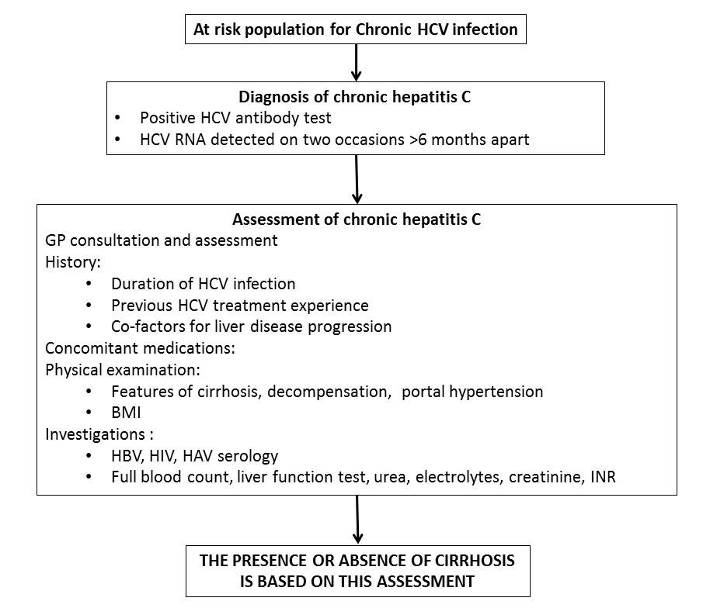

Flowchart 2: Chronic hepatitis B - management pathway before comparator or Hepascore.
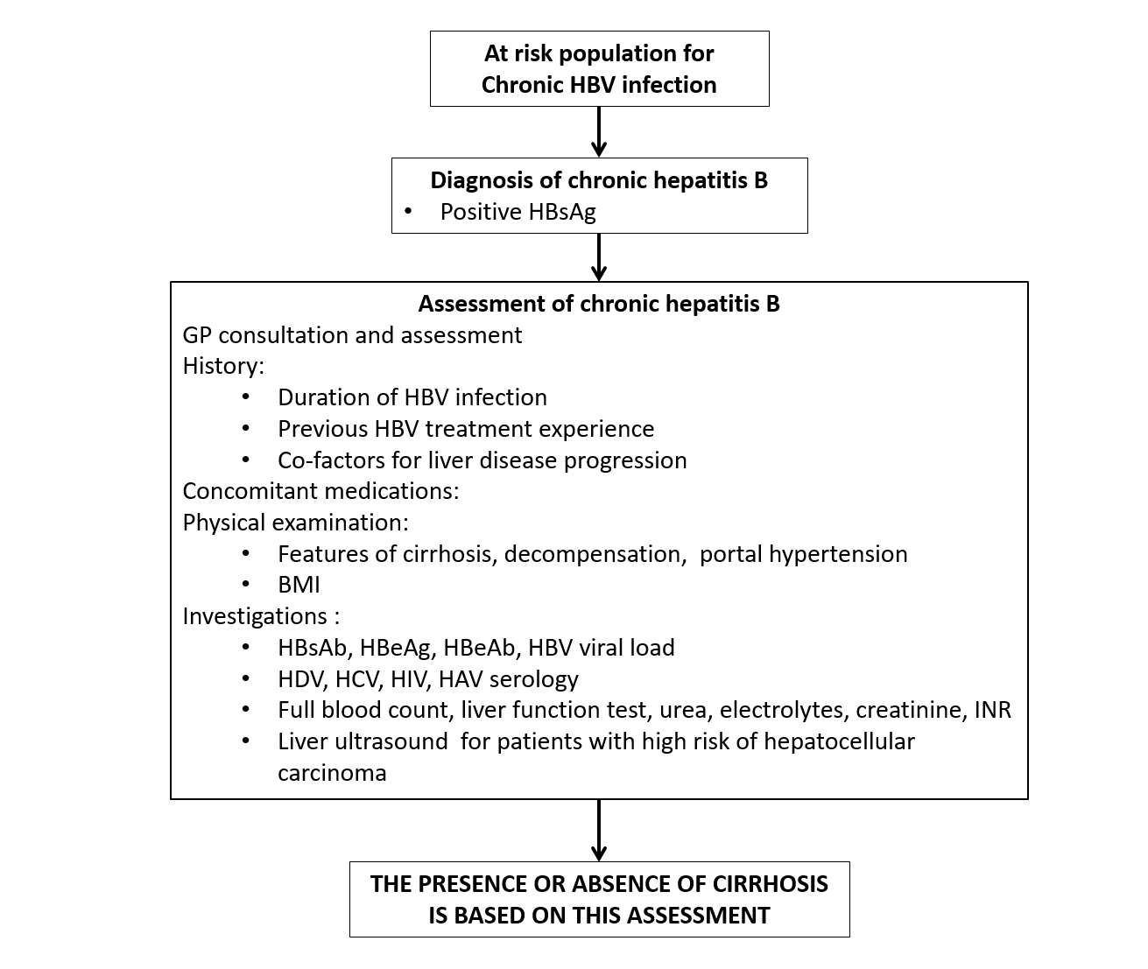

Flowchart 3: NAFLD or alcoholic liver disease - management pathway before comparator or Hepascore.
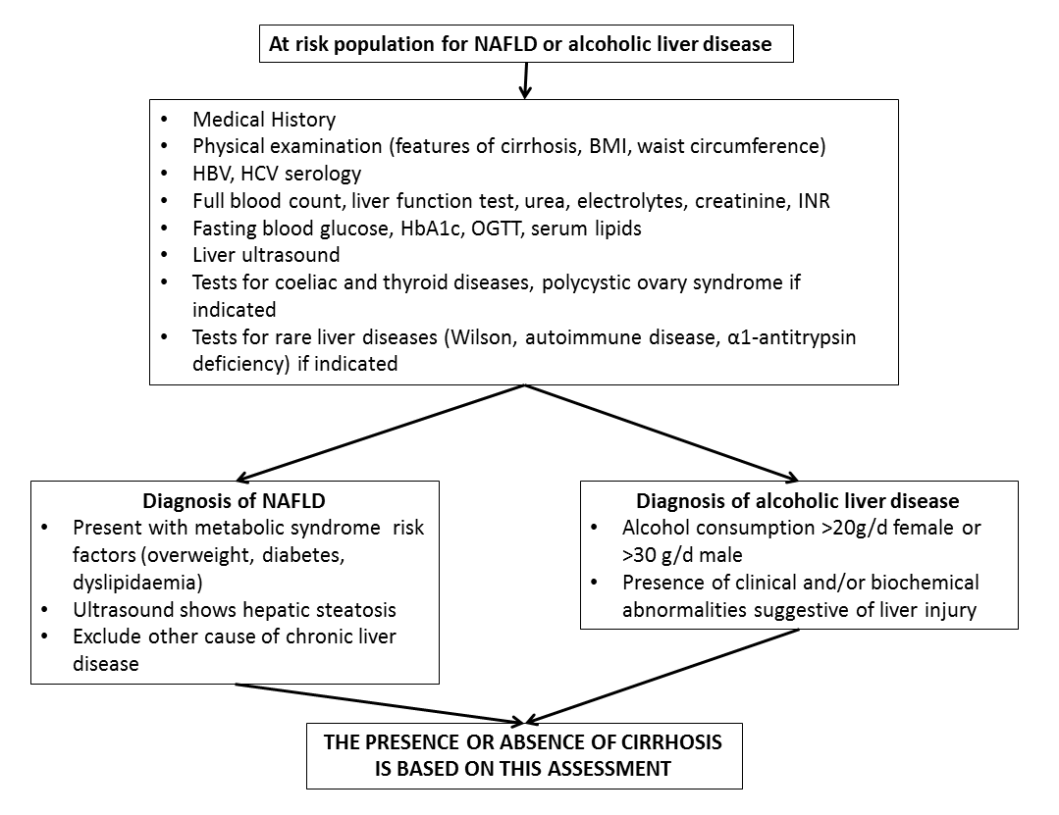
Flowchart 4: Chronic hepatitis C - management pathway after comparator or Hepascore.
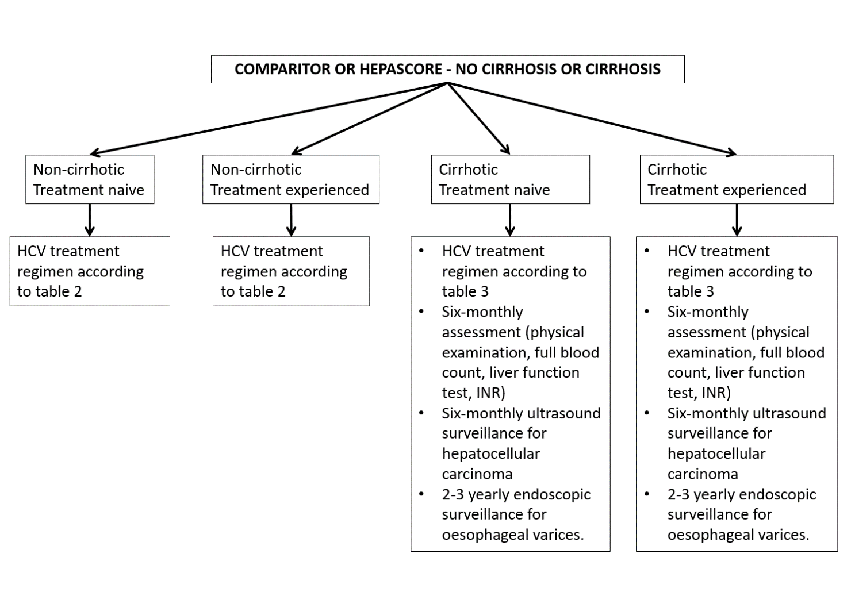
Flowchart 5: Chronic hepatitis B - management pathway after comparator or Hepascore.
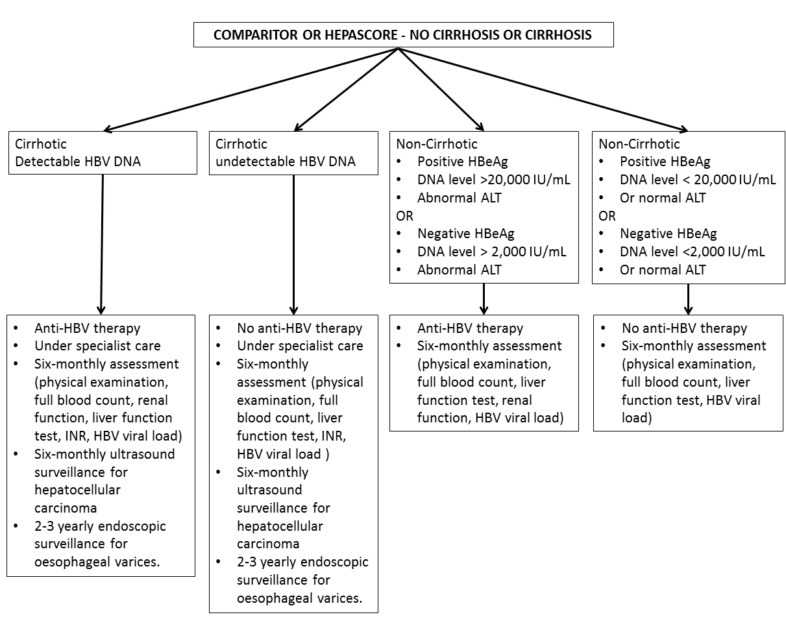
Flowchart 6: NAFLD or alcoholic liver disease - management pathway after comparator or Hepascore.
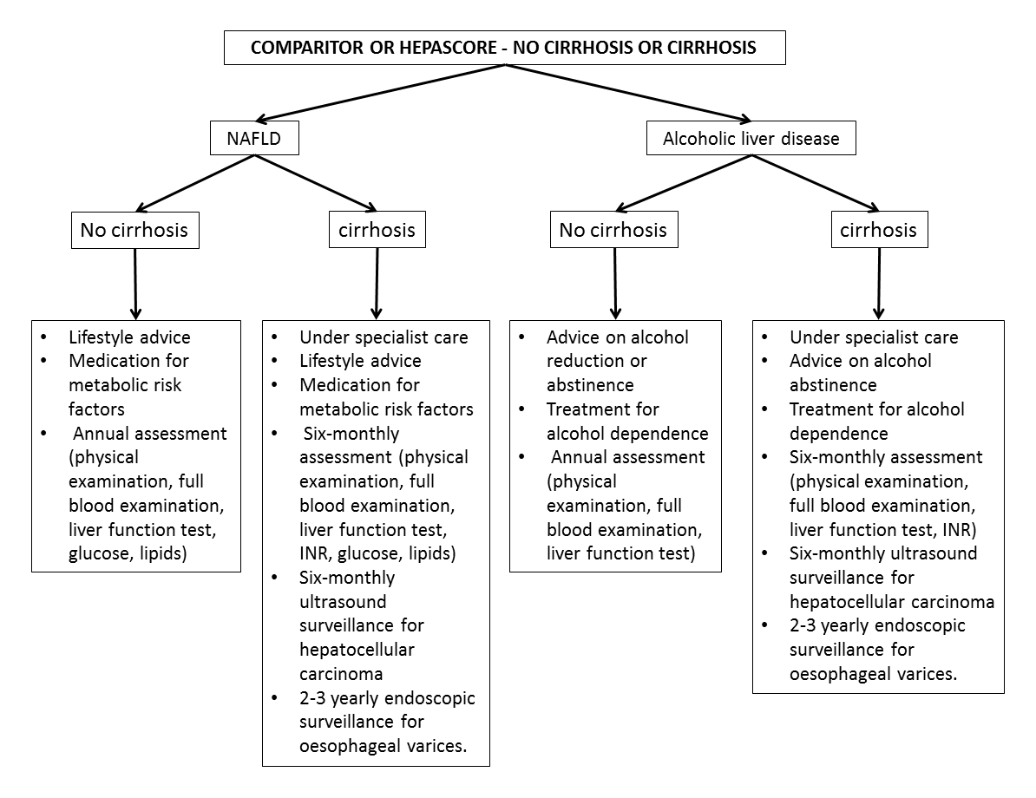
Flowchart 7: Incremental utility of Hepascore in chronic hepatitis C
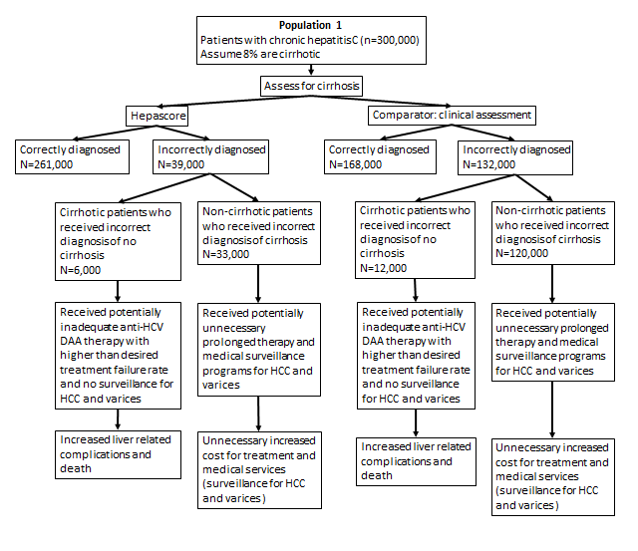

Flowchart 8: Incremental utility of Hepascore in chronic hepatitis B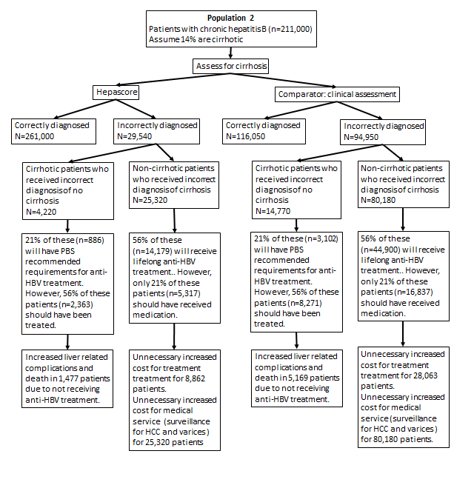

Flowchart 9: Incremental utility of Hepascore in NAFLD
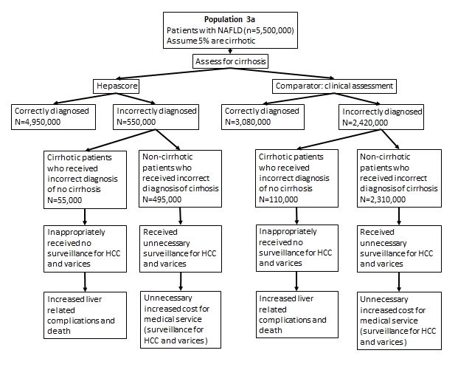

Flowchart 10: Incremental utility of Hepascore in alcoholic liver disease
