Public Summary Document
Application No. 1510 – Emicizumab for routine prophylaxis to prevent bleeding or reduce frequency of bleeding episodes in patients with haemophilia A (congenital factor VIII deficiency) with factor VIII inhibitors
Applicant: Roche Products Pty Ltd
Date of MSAC consideration: MSAC 74th Meeting, 22-23 November 2018
Context for decision: MSAC makes its advice in accordance with its Terms of Reference, visit the MSAC website

Purpose of application
An application seeking public funding through listing on the National Blood Authority’s (NBA’s) National Product List (NPL) for routine prophylaxis to prevent bleeding or reduce the frequency of bleeding episodes in patients with haemophilia A (congenital factor VIII deficiency) with factor VIII inhibitors was received from Roche Products Pty Ltd by the Department of Health.

MSAC’s advice to the Minister
After considering the strength of the available evidence in relation to comparative safety, clinical effectiveness and cost-effectiveness, MSAC did not support emicizumab for routine prophylaxis to prevent bleeding or reduce frequency of bleeding episodes in patients with haemophilia A with factor VIII inhibitors. MSAC accepted that there was strong evidence that emicizumab substantially reduced the frequency of bleeding episodes; however, MSAC was concerned that the economic justification for funding came from reductions in current practice, which has not itself been shown to be acceptably cost-effective. Rather than consolidate potentially cost-ineffective practice, MSAC requested that the cost-effectiveness of current practice be determined as a means to then determine the cost-effectiveness of emicizumab in the proposed population. MSAC was also concerned that there were practical difficulties in ensuring that, over time, emicizumab would remain limited to the proposed target population.

Summary of consideration and rationale for MSAC’s advice
MSAC noted that emicizumab is a prescription medicine and a blood-related product that has orphan drug status assigned by the Therapeutic Goods Administration (TGA). The application is therefore seeking public funding through listing on the NBA NPL using the MSAC process, and no MBS item is required.
MSAC noted that emicizumab is a recombinant, humanised, bispecific monoclonal antibody that mimics the function of factor VIII. It is administered at home by the patient or carer as a once-weekly subcutaneous injection, once the person has been sufficiently trained and assessed as capable to self-administer. Emicizumab is used for routine prophylaxis and is not intended or indicated for on-demand treatment. Breakthrough bleeds in the requested population would still require management using bypass agents (BPAs). Application 1510 is for patients with inhibitors to factor VIII – the Australian Bleeding Disorders Registry indicates that the intended eligible population would be 61 individuals. MSAC noted that a further application for patients who do not have factor VIII inhibitors is anticipated in the future.
MSAC considered the comparators – BPA prophylaxis plus on-demand BPAs, or no prophylaxis plus on-demand BPAs – to be appropriate. MSAC noted that both emicizumab and BPA prophylaxis are associated with thromboembolic and bleeding adverse events, and the applicant’s claim of non-inferior safety was considered appropriate. However, MSAC noted that the claim of non-inferior safety is subject to considerable uncertainty and is not supported by any statistical evaluation of frequency and severity of adverse events. The limitations of the evidence base (including infrequent events, small numbers of patients and short follow-up times) suggest that any safety comparison is likely to be underpowered, and no minimal clinically important difference for safety outcomes was defined in any trial.
Regarding clinical effectiveness, MSAC noted the large reductions in annual bleed rate (ABR) from the clinical trials using emicizumab. In the HAVEN 1 trial, emicizumab reduced the ABR by 87% (P < 0.0001, ABR ratio 0.13, 95% CI: 0.06 to 0.28), with ABR = 23.3 in the no-prophylaxis arm and ABR = 2.9 in the emicizumab arm. Although not subjected to statistical analysis, the randomised trial also reported 22/35 = 63% of patients in the emicizumab arm had zero bleeding events compared with 1/18 = 6% in the no-prophylaxis arm. In the HAVEN 2 trial, the ABR was reduced by 99% (95% CI: 97.7 to 99.4).
MSAC noted the potential for a progressive decline in effectiveness over time if the patient develops antibodies against emicizumab. MSAC noted that the rate of antibody development against emicizumab was approximately 0.7% in around 400 patients studied, but that there were currently insufficient data to accurately judge this risk.
MSAC noted that emicizumab was dominant in the economic analysis against both comparators. ESC had requested that the assessment group conduct further sensitivity analyses, and emicizumab retained dominance under almost all scenarios. For dominance not to hold, the assessment group made extreme simultaneous changes to several drivers of the economic model, which were not considered to be reasonable scenarios overall.
MSAC noted the high cost of emicizumab at $redacted per patient per year, based on the undiscounted cost-effectiveness model for the overall estimated cost of emicizumab per patient divided by the overall estimated life-years per patient. MSAC acknowledged the difficulties in requesting a fair annual treatment cost for a rare condition, but noted that this requested cost is much higher than any other subsidised medicines, including medicines in the Life Saving Drugs Program. MSAC noted the financial estimates indicating that emicizumab would have a net cost saving to the NPL compared with the cost of BPAs. However, MSAC considered that this did not necessarily mean that emicizumab was cost-effective, as BPAs had not themselves undergone cost-effectiveness analysis, and dominance itself was not sufficient for decision making in this context. MSAC also considered that it may not be plausible to assume that patients take lifelong BPA prophylaxis, given this is not preferred by patients, and may therefore not be a realistic comparator in the long-term. MSAC therefore requested that the cost-effectiveness of current practice should be determined first, so that the value of emicizumab could be more accurately assessed in the proposed population.
MSAC recognised the clear unmet need for effective treatment strategies in haemophilia A patients who currently have inhibitors and noted the strong support from stakeholder groups. However, it was also noted that, despite this, the high cost of emicizumab may be unacceptable to consumers, and considered that the benefits of other therapies should also be evaluated.
The potential for leakage was also considered to be high, and would have substantial implications for the size of the patient population. MSAC noted that the eligible population would need to be clearly defined as patients who currently have inhibitors (n = 61), rather than those who have had inhibitors in the past (n = 174), or those who have not been tested or have had an equivocal test result for inhibitors (n = 850). Based on this uncertainty, MSAC foreshadowed that a total expenditure cap might be needed for listing of emicizumab on the NPL.
Overall, MSAC concluded that emicizumab is superior in effectiveness and non-inferior in safety compared with BPAs, noting some data limitations and uncertainties. However, MSAC considered that the cost-effectiveness of current treatments in the total haemophilia A population should be evaluated before a meaningful comparative economic assessment of emicizumab in the proposed population can be done.

Background
MSAC has not previously considered this application.

Prerequisites to implementation of any funding advice
There are currently four Australian Register of Therapeutic Goods (ARTG) listings related to this application: 293761, 293760, 293759 and 293758; corresponding to 30mg/1mL, 60mg/0.4mL, 150mg/1mL and 105mg/0.7mL of emicizumab vials for injection, respectively.

Proposal for public funding
Emicizumab is a prescription medicine and a blood-related product that has orphan drug status assigned by the TGA. The application is therefore seeking public funding through listing on the National Blood Authority’s NPL, and no MBS item is required.

Summary of public consultation feedback/consumer issues
Five responses were received in the consultation feedback, two from professional organisations, one from a consumer organisation, and two haematologists. The feedback was positive and supportive of public funding on the NPL for emicizumab.
The application noted that experience has been limited to the clinical trial setting to date and stated that comprehensive educational programmes will be implemented for healthcare professionals involved in the treatment of haemophilia A patients with inhibitors, including supporting patient education, to ensure the optimal and safe use of emicizumab in the Australian clinical setting.

Proposed intervention’s place in clinical management
The proposed clinical management algorithm for patients with haemophilia A is provided in Figure 1.
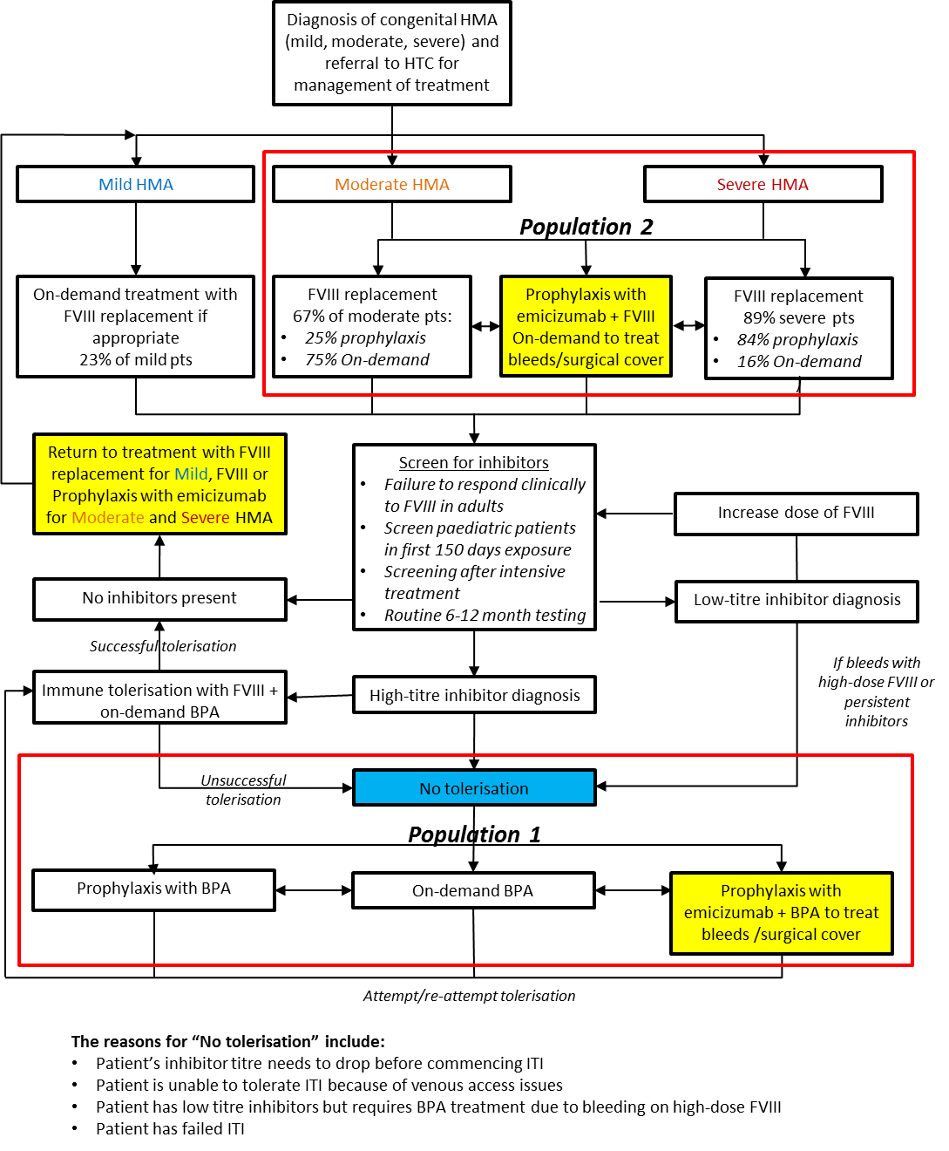
Figure 1 Proposed clinical management algorithm for patients with congenital haemophilia A (HMA)
The application stated that for patients with inhibitors (population 1), emicizumab represents a novel therapy option which would replace prophylaxis with factor VIII bypassing agents (BPA)s or provide an option for patients for whom BPAs are not a viable prophylactic regimen. While BPAs may still be required to treat bleeds and for surgical cover, usage will be greatly reduced since breakthrough bleeding while on emicizumab prophylaxis is significantly reduced, with the majority of patients experiencing no bleeds requiring BPA treatment.

Comparator
Two comparators were proposed by PASC for this population: (1) prophylaxis with BPAs plus on demand BPAs to treat bleeds; (2) no prophylaxis with BPAs plus on demand BPAs to treat bleeds or as surgical cover. The application stated that both activated prothrombin complex concentrate (aPCC) and recombinant factor VIIa are BPAs publicly reimbursed on the NBA’s NPL.

Comparative safety
The application identified one randomised trial (HAVEN 1) and two non-randomised (HAVEN 2, n=63 and NIS BH29768, n=24) studies contributing clinical evidence for emicizumab prophylaxis in the treatment of haemophilia A patients with factor VIII inhibitors.
In adult and adolescent haemophilia A patients ≥ 12 years of age, HAVEN 1 reported a randomised comparison of prophylactic use of emicizumab (Arm A, n=35) with on demand use of BPAs as current standard of care (Arm B, n=18). Other patients in the study enabled also an intra-patient comparison of emicizumab prophylaxis (Arm C, n=49) compared to prophylactic use of BPAs utilising historical data from the same patients who participated in the non-interventional study NIS BH29768. HAVEN 2 was conducted in children < 12 years of age.
To supplement the evidence from the intra-patient comparison of Arm C in HAVEN 1, an indirect treatment comparison (ITC) was undertaken comparing emicizumab prophylaxis with BPA (aPCC or recombinant factor VIIa) prophylaxis (via the available randomised evidence). BPA trials were identified from a Cochrane review of BPA prophylaxis published by Chai-Adisaksopha in 2017 and supplementary literature and manual searches: Antunes 2014, Leissinger 2011 and Konkle 2007.
The application stated that the tolerability of emicizumab prophylaxis was demonstrated by the low number of withdrawals from treatment (4 patients; 2.1% of 189 patients treated with emicizumab). For the randomised comparison in HAVEN 1 (Arm A versus Arm B) the total number of adverse events (AEs) was higher in the emicizumab prophylaxis arm. The most commonly reported AEs in the emicizumab arm were injection site reactions (ISRs); for treatment with on demand BPAs, the most common AE was upper respiratory tract infection. Four patients in each arm experienced serious AEs (SAEs) [12% emicizumab prophylaxis and 22% on demand BPAs]. For the intra-patient comparison in Arm C, the overall incidence of AEs was similar between emicizumab and prior BPAs, whereas the incidence of clinically important AEs (SAEs and Grade ≥3 AEs) was greater with BPA prophylaxis (37.5% vs. 12.5%). In HAVEN 2, the most common AEs reported were nasopharyngitis and ISRs. No patients withdrew from treatment or had their emicizumab dose modified/interrupted due to AEs.
Patients treated with emicizumab prophylaxis in HAVEN 1 reported significantly more AEs compared to the trials of BPA prophylaxis, but this is explained by the differing safety reporting and analysis methods and period of observation between the trials. Notably, HAVEN 1 had the lowest rate of SAEs compared to the trials of BPA prophylaxis.

Comparative effectiveness
HAVEN 1
For the primary endpoint of treated bleeds for the randomised population, the application stated that there was a statistically significant 87% reduction in annual bleed rate with emicizumab prophylaxis compared with on demand treatment with BPAs (Arm A vs. B). A total of 22 of 35 patients (62.9%) in Arm A had no treated bleeds at all. The intra-patient comparisons of bleed rates in Arms A and C showed a statistically significant reduction of ABR of 92% and 79% for emicizumab prophylaxis compared with prior on demand or prophylactic BPAs respectively, with 17 of 24 patients (70.8%) in each comparison experiencing zero treated bleeds (Table 1).
Table 1 HAVEN 1 and NIS BH29768: Overview of bleeding endpoints in patients ≥ 12 years of age
 | HAVEN 1  Randomised comparison |  | HAVEN 1 & NIS BH29768  Intra-patient comparisons
Parameter | Arm A  emicizumab prophylaxisª | Arm B  On demand BPAª | Arm A  emicizumab prophylaxis^{b} | NIS  On demand BPA^{b} | Arm C  emicizumab prophylaxis^{b} | NIS  BPA prophylaxis^{b}
n | 35 | 18 | 24 | 24 | 24 | 24
Median efficacy period (weeks) | 29.29 | 24.14 | 29.72 | 21.14 | 32.14 | 30.14
Primary bleeding endpoint - treated bleeds
ABR | 2.9 | 23.3 | 1.7 | 21.6 | 3.3 | 15.7
ABR ratio (95% CI) | 0.13 (0.057, 0.277) |  | 0.08 (0.031, 0.198) |  | 0.21 (0.089, 0.486)
P-value ^{c} | •0.0001 |  | •0.0001 |  | 0.0003
Zero treated bleeds
N (%) | 22 (62.9%) | 1 (5.6%) | 17 (70.8%) | 2 (8.3%) | 17 (70.8%) | 3 (12.5%)
Source: Adapted from Table B.25, Section B.6.1.1 and Table B.26, Section B.6.1.1 of the SBA
Abbreviations: ABR = annualised bleeding rate; BPA = bypass agents
Notes: ª. ITT population. ^{b}. NIS population (patients previously enrolled in NIS BH29768). ^{c}. Non stratified Wald test.
In addition, the application stated that there were statistically significant and clinically meaningful improvements in the physical subscale and total health score of the Haem-A-QoL, a measure of health-related quality of life (HRQoL) specific to haemophilia A, and in health status, as measured by EQ-5D-5L, on emicizumab prophylaxis compared with on-demand treatment that were maintained with longer follow up.
Indirect Treatment Comparison (ITC): HAVEN 1 to BPA prophylaxis
The ITC presented confirmed that the efficacy of emicizumab prophylaxis is superior to aPCC and recombinant factor VIIa prophylaxis across the bleeding endpoints compared, with the indirect estimate of effect always favouring emicizumab (Table 2).
Table 2 ITC results for emicizumab versus meta-analysed BPA prophylaxis
Total bleeds | Rate ratio | Lower 95% CL | Upper 95% CL
Fixed effects | 0.32 | 0.30 | 0.34
Random effects | 0.31 | 0.27 | 0.36
Source: Section Bi.6.4 of SBA; ‘emi vs BPAs’ worksheet in the emicizumab ITC spreadsheet, Clinical Appendix
Notes: emicizumab is favoured if the rate ratio is <1
HAVEN 2
The application stated that the annualised bleeding rate (ABR) (treated bleeds) for treated patients aged < 12 years and on the same dose for at least 12 weeks (n=59) was shown to be 0.3 (95% CI: 0.13; 0.52), with 87% of patients experiencing no treated bleeds and 90% patients without any treated joint bleeds. For the intra-patient comparison of patients previously enrolled in the NIS BH29768 and treated prophylactically or on demand with BPAs, there was a 98% reduction in the ABR for treated bleeds when patients were treated with emicizumab prophylaxis, with 78% of patients experiencing no treated bleeds (Table 3).
Table 3 HAVEN 2 and NIS BH29768: Overview of bleeding endpoints in patients < 12 years of age
 | HAVEN-2  1.5 mg/kg emicizumab weekly |  |  | HAVEN-2 & NIS BH29768  Intra-patient comparisons
Endpoint | ABR* (95% CI) | Median ABR (IQR) | % zero bleeds  (95% CI) | Previous prophylactic/on demand BPAs |  | Emicizumab 1.5 mg/kg weekly
n | 59 | 59 | 59 | 18 |  | 18
Treated bleeds | 0.3 (0.13, 0.52) | 0.0 (0.00, 0.00) | 86.4 (75.0, 94.0) | 19.8 (15.31, 25.69) |  | 0.4 (0.15, 0.88)
All bleeds | 3.8 (2.2, 6.52) | 0.0 (0.00, 3.42) | 55.9 (42.4, 68.8)
Treated spontaneous bleeds | 0.0 (0.00, 0.17) | 0.0 (0.00, 0.00) | 98.3 (90.9, 100.0)
Treated joint bleeds | 0.2 (0.07, 0.39) | 0.0 (0.00, 0.00) | 89.8 (79.2, 96.2)
Treated target joint bleeds | 0.1 (0.01, 0.65) | 0.0 (0.00, 0.00) | 96.6 (88.3, 99.6)
% reduction  RR (95% CI) |  |  |  | 98%  0.02 (0.008, 0.043)
% patients with 0 bleeds (95% CI) |  |  |  | 5.6 (0.1, 27.3) | 77.8 (52.4, 93.6)
Source: Adapted from Table B.36, Section B.6.3.1 and Table B.37, Section B.6.3.1 of the SBA
Abbreviations: ABR = annualised bleeding rate; BPA = bypass agents
In addition, the application stated that there were substantial improvements (change from baseline) in the caregiver’s perception of the child’s HRQoL, in particular physical health, and improvements in the child’s own perception of HRQoL after 13 weeks of emicizumab prophylaxis that were sustained over time.
Clinical claim
The application stated that prophylaxis with weekly subcutaneous emicizumab was associated with superior health outcomes for congenital haemophilia A patients with factor VIII inhibitors through improved efficacy (reduction in bleeds and improved quality of life) and at least non-inferior safety, if not superior safety, in comparison to treatment with the BPAs (aPCC and recombinant factor VIIa) administered in either an on demand or prophylactic manner.

Economic evaluation
The application presented a cost utility analysis comparing emicizumab prophylaxis with on demand BPAs and BPA prophylaxis (Table 4).
Table 4 Summary of economic evaluation
Element of economic evaluation | MSAC’s preference for the base-case scenario
Perspective | Australian government perspective
Comparator | BPA on-demand & BPA prophylaxis
Type of economic evaluation | Cost-utility analysis
Sources of evidence | Overall model structure: systematic literature review  Mortality: systematic literature review  Bleeding events: trial-based results  Hospitalisation: trial-based results
Time horizon | Lifetime (from birth to death, assuming 100 years)
Outcomes | Quality adjusted life years (QALYs)
Methods used to generate results | Markov model
Health states | Alive  Dead  Bleeding events (transient)  Arthroplasty (transient)
Cycle length | One year
Discount rate | 5% per annum
Software packages used | Excel
Source: Critique for 1510
Abbreviations: ABR, Annualised bleed rate; BPA, bypassing agent
The results from the economic analysis (discounted) are summarised in Table 5.
Table 5 Incremental cost-effectiveness: discounted
 | Cost | Incremental cost | Effectiveness (QALYs) | Incremental effectiveness | ICER
Emicizumab prophylaxis vs. on demand BPAs
Emicizumab prophylaxis | $redacted | –$2,371,277 | 16.1 | 3.7 | Emicizumab dominant
On demand BPAs | $redacted |  | 12.4
Emicizumab prophylaxis vs. BPA prophylaxis
Emicizumab prophylaxis | $redacted | –$37,130,313 | 16.1 | 2.8 | Emicizumab dominant
BPA prophylaxis | $redacted |  | 13.2
Source: ‘Results Table’ tab of Section D workbook accompanying the SBA
Abbreviations: BPAs, by passing agents; ICER, incremental cost-effectiveness ratio; QALYs, quality-adjusted life years
The application’s sensitivity analysis results are presented for the comparison with on demand BPAs (Figure 2) and BPA prophylaxis (Figure 3).
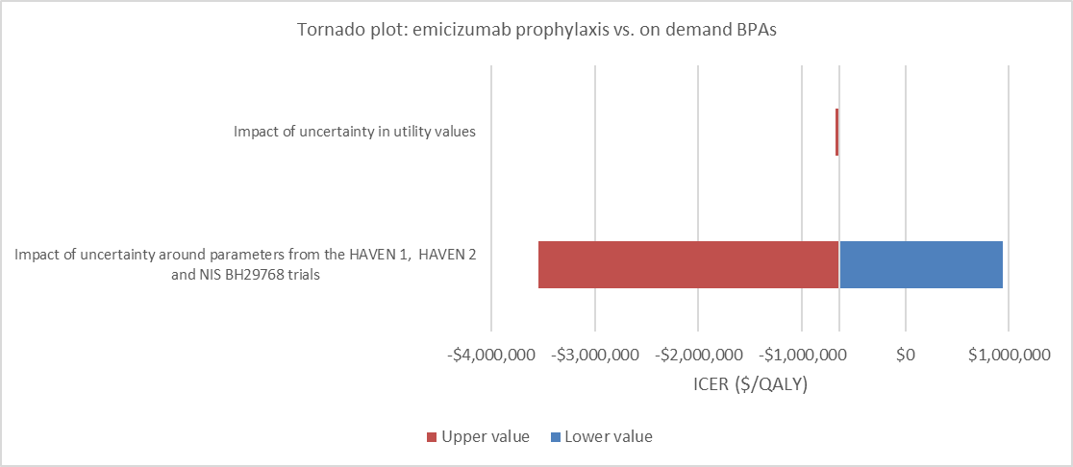
Figure 2 Tornado plots of one-way sensitivity analyses: discounted ICER ($/QALY); vs. on demand BPAs
Abbreviations: BPA = bypass agents; ICER = incremental cost-effectiveness ratio; QALY = quality-adjusted life year
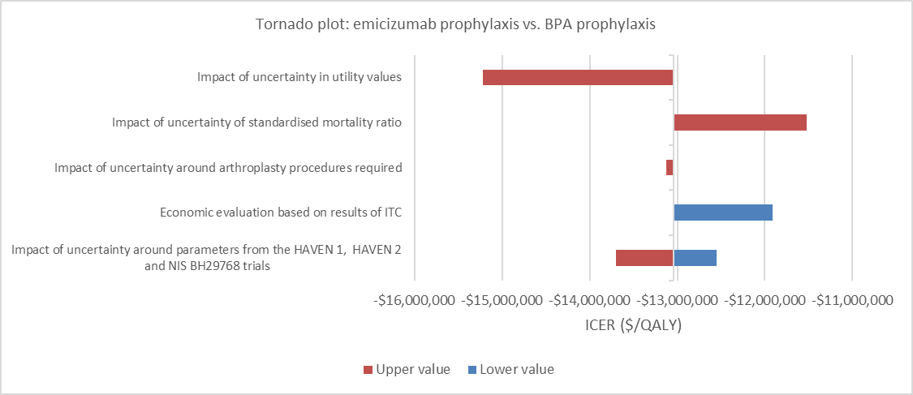
Figure 3 Tornado plots of one-way sensitivity analyses: discounted ICER ($/QALY); vs. BPA prophylaxis

Financial/budgetary impacts
The application stated an epidemiological (and a stakeholder engagement) approach were used to estimate the financial implications of the introduction of emicizumab (Table 6).
Table 6 Total costs to the NPL for listing emicizumab compared to BPA (both on-demand and prophylaxis)
 | Year 1 | Year 2 | Year 3 | Year 4 | Year 5
Emicizumab costs to the NPL
Patient numbers | 16 | 33 | 34 | 35 | 35
Adult | $redacted | $redacted | $redacted | $redacted | $redacted
Paediatric | $redacted | $redacted | $redacted | $redacted | $redacted
Sub-total cost | $redacted | $redacted | $redacted | $redacted | $redacted
BPA on-demand (as episodic treatment in the presence of emicizumab)
Adult | $redacted | $redacted | $redacted | $redacted | $redacted
Paediatric | $redacted | $redacted | $redacted | $redacted | $redacted
Sub-total cost | $redacted | $redacted | $redacted | $redacted | $redacted
Total costs of the intervention
Total cost | $redacted | $redacted | $redacted | $redacted | $redacted
Total costs of the comparator (BPA prophylaxis plus on-demand)
Adult | $redacted | $redacted | $redacted | $redacted | $redacted
Paediatric | $redacted | $redacted | $redacted | $redacted | $redacted
Total cost | $redacted | $redacted | $redacted | $redacted | $redacted
Net costs to the NPL(Cost differences between the intervention and the comparator)
Net adult | $redacted | $redacted | $redacted | $redacted | $redacted
Net paediatric | $redacted | $redacted | $redacted | $redacted | $redacted
Net costs | –$591,313 | –$1,898,310 | –$2,649,465 | –$2,668,944 | –$2,688,423
Note: adult patients referred by the application were the patient cohort age >12 years old. Paediatric patients were < 12 years old.

Key issues from ESC for MSAC
ESC key issue | ESC advice to MSAC
Findings from direct evidence and indirect evidence of effectiveness, and uncertainty surrounding the safety profile of emicizumab | Emicizumab is superior in effectiveness and appears to be non-inferior in safety relative to bypass agents, although the duration of follow-up in clinical trials is only 24 weeks and there is a possibility of adverse events (such as the development of antibodies to emicizumab) emerging beyond this period.
Lack of exact alignment between the proposed eligible population in the PASC-approved PICO and the available RCT evidence | Suggest using an alternative description of the population that is consistent with the intention of the application and consistent with the TGA-approved indication, but which specifies neither severity of haemophilia A nor inhibitor titre:  ‘Patients with haemophilia A with factor VIII inhibitors considered (by the AHCDO Tolerisation Committee) to be eligible for routine prophylaxis’.  However, this description would limit use to patients who currently have inhibitors, and would exclude patients with a history of inhibitors that has resolved, and this would be contrary to the intention of PASC.
Uncertainty regarding data from patients aged 12 years and younger | Subcutaneous injection of emicizumab provides clear advantages in children as it would avoid the need to insert a central venous access device, and uncertainty regarding the safety of emicizumab can be addressed by established haemophilia treatment centre arrangements and the Risk Management Plan proposed by the applicant.
Simplistic model | The critique expressed uncertainty about the appropriateness of the simplistic model, but the rejoinder seems to allay these concerns.
Sensitivity of ICERs to inputs | Uncertainties around annualised bleeding rates, days hospitalised, mortality ratios and utility values were largely dealt with in the application and rejoinder.

ESC discussion
ESC noted that emicizumab is a prescription medicine and a blood-related product that has orphan drug status assigned by the Therapeutic Goods Administration (TGA). The application is therefore seeking public funding through listing on the National Blood Authority’s NPL using the MSAC process, and no MBS item is required.
ESC noted that the current application is for management of haemophilia A in patients who have factor VIII inhibitors, but a future application is anticipated for patients with haemophilia A and no factor VIII inhibitors.
ESC noted that emicizumab is a recombinant, humanised, bispecific monoclonal antibody that mimics the function of factor VIII. It is administered at home by the patient or carer as a once-weekly subcutaneous injection, once the person has been sufficiently trained and assessed as capable to self-administer. Emicizumab is used for routine prophylaxis and is not intended or indicated for on-demand treatment.
ESC noted that Australia has a well-established system for managing haemophilia patients. This includes national clinical practice guidelines, organisations such as the National Blood Authority and the Australian Haemophilia Centre Directors’ Organisation (AHCDO), and data collection through the Australian Bleeding Disorders Registry. The majority of patients are managed through 18 haemophilia treatment centres.
ESC noted that the combined prevalence of haemophilia A and B in Australia is 13 per 100,000. In 2016, the total number of haemophilia A patients was 2298. ESC noted that patients with currently confirmed inhibitors represent only a small proportion of this (3% of these patients, or 61 individuals).
ESC noted that clinical management of haemophilia A involves prophylaxis to reduce the chance of serious bleeding, plus on-demand treatment of bleeds when they do occur. Prophylaxis and on-demand treatment use replacement factor VIII; however, some patients develop antibodies to factor VIII, known as inhibitors. The risk of developing inhibitors is 13% in patients with mild or moderate haemophilia A, and 30% in patients with severe disease. These inhibitors reduce the effectiveness of factor VIII and make bleeds more difficult to control. The rate of hospitalisation for major bleeds in patients with inhibitors is claimed to be two times higher than the rate for patients without inhibitors.
Patients with inhibitors can be treated with increased doses of factor VIII. If they no longer respond to these increased doses, they can be treated with BPAs, which are administered frequently via slow intravenous injection. Prophylaxis with BPAs is much less effective than prophylaxis with factor VIII in patients without inhibitors. Patients with inhibitors do not prefer using BPAs for prophylaxis, and the majority of these patients use no prophylaxis, but use BPAs on demand. Patients with inhibitors can also be treated using immune tolerisation induction (ITI), which is administered regularly over months to years via a central venous access device. ESC noted that ITI is not a comparator for emicizumab, but the impact of emicizumab on ITI utilisation may be relevant for financial estimates.
ESC noted that a patient’s inhibitor status is not fixed – inhibitors can resolve spontaneously or following ITI. Although the potential eligible population defined by PASC included patients with a history of using BPAs for inhibitors, the applicant has clearly limited the requested population to those currently with inhibitors (i.e, by limiting the financial estimates to the ~61 individuals cited above). ESC noted that if the eligible population is limited to patients who currently use BPAs for inhibitors (and excludes those with a history of using BPAs for inhibitors) then there is stronger alignment with the available evidence. Patients who develop inhibitors, but are yet to start BPAs, might start emicizumab earlier than they would start BPAs.
ESC noted the applicant’s clinical claim that emicizumab in patients with inhibitors has superior effectiveness and non-inferior safety compared with BPA prophylaxis plus on-demand BPAs, or no prophylaxis plus BPAs on demand. Outcome measures were annualised bleed rate (ABR, primarily defined as bleeding events which required treatment by BPAs), responder status (percentage of patients with zero bleeds), health-related quality of life, incidence and severity of adverse events, and mortality.
ESC noted the clinical trial data for emicizumab. The HAVEN 1 study included a randomised trial of emicizumab prophylaxis versus no prophylaxis (on demand BPAs) in males ≥12 years of age with inhibitors, and two additional non-randomised arms. It included 109 patients, 53 of whom were randomised, with 35 patients receiving emicizumab and 18 patients continuing on demand BPAs. In this randomised trial, emicizumab reduced the ABR by 87% (P < 0.0001, ABR ratio = 0.13, 95% CI: 0.06 to 0.28), with ABR = 2.9 in the emicizumab arm and ABR = 23.3 in the no-prophylaxis arm. Although not subjected to statistical analysis, the randomised trial also reported 22/35 = 63% of patients in the emicizumab arm had zero bleeding events compared with 1/18 = 6% in the no-prophylaxis arm.
The critique of the application used an alternative statistical method. ESC noted that the result was still three times the minimum clinically important difference (MCID) of 20% to 25% accepted by PASC.
HAVEN 2 was a non-randomised study in children under 12 years of age who were receiving treatment with BPAs. Another non-interventional study documented the number and type of bleeds in patients with inhibitors under routine clinical practice and estimated the number of bleeds over time. ESC considered that the claim of clinical superiority had been established in the application, and that the large effect size across the randomised comparison counterbalanced the risk of bias in the results reported from the non-randomised studies.
Regarding safety, ESC noted the most common adverse events following emicizumab were low grade or injection site reactions. ESC noted the low numbers of patient withdrawals from the studies, indicating emicizumab has high acceptability. However, emicizumab was associated with serious adverse events including thromboembolic events and thrombotic microangiopathy, in association with concurrent use of BPAs.
In the pre-ESC response, the applicant noted that these serious adverse events occurred early in the clinical development program and that since then guidance and instructions about concurrent use of BPAs has been developed as part of a detailed risk mitigation strategy. No further thrombotic events have been reported since these measures were implemented. ESC also noted that the TGA-approved product information has a black box warning to avoid concurrent use of BPAs unless no other alternatives are available. Additional risk management plan activities have also been developed to address safety concerns.
The critique noted that the claim of non-inferior safety compared with BPA prophylaxis is appropriate, but is subject to considerable uncertainty and is not supported by any pre-specified statistical evaluation of frequency and severity of adverse events. The limitations of the evidence base (including infrequent events, small numbers of patients and short follow-up times) suggest that any safety comparison is likely to be underpowered and no MCID for safety outcomes was defined in any trial.
ESC noted that the GRADE assessments in the critique assesses the included trials as being at moderate to high risk of bias; however, ESC noted that the critique did not take into account the large effect size, which could have been applied to assign a higher GRADE level (i.e. offset the concerns about bias). ESC noted that extensive advice had been received redacted from the Committee for Medicinal Products for Human use regarding the design and conduct of the HAVEN 1 and 2 trials. In addition, the TGA delegate considered the design of HAVEN 1 to be strong relative to requirements for studies of factor products to treat haemophilia.
ESC noted that the proposed population is an ‘orphan’ population with high clinical need, where randomised controlled trial evidence is difficult to generate. ESC also noted that there is a well-established context for monitoring safety and use of blood products in Australia. ESC noted that, although there are residual concerns regarding the longer-term safety profile of emicizumab and some uncertainty regarding its effectiveness in children under 12 years of age, the magnitude of its effectiveness in adolescents and adults is highly clinically significant, and uncertainties would likely be mitigated by the well-established policy and monitoring mechanisms.
ESC noted that although a continuation rule was not required to achieve acceptable cost-effectiveness, there may be a case for ceasing emicizumab in patients whose inhibitors have resolved.
ESC noted the following clinical policy issues for MSAC:
Haemophilia A patients with inhibitors typically have a severe phenotype, for which best-practice management is prophylaxis. Administration of emicizumab as prophylaxis is significantly less burdensome on patients and their carers than administration of BPAs or ITI. However, BPAs would still be required to manage breakthrough bleeds as emicizumab is not indicated for on-demand use.
Haemophilia is a highly specialised area of care with well-established management frameworks, and the AHCDO Tolerisation Committee is best-placed to make patient-specific decisions regarding the use of emicizumab in the proposed population.
The availability of emicizumab might displace use of ITI – except that emicizumab could be lifelong, whereas ITI is typically administered for 1 to 2 years.
Emicizumab potentially interferes with current assays measuring factor VIII activity and inhibitor levels. It is unclear whether existing tests would need to be modified or new tests created to accurately measure these levels in emicizumab-treated patients.
It is unclear whether an investigative test is required to measure the presence of antibodies against emicizumab.
ESC noted the economic evaluation, which was a cost-utility analysis. ESC noted the relatively simple structure of the model, but acknowledged that more complex modelling provided by the applicant yielded similar outcomes. ESC also noted that the critique had identified 11 additional published economic analyses, which took various approaches to including arthroplasty in their models.
ESC noted that emicizumab was dominant and cost saving compared with prophylactic BPAs and on-demand BPAs. Sensitivity analyses did not change this finding. However, ESC noted that not all sensitivity analyses appeared in the tornado plots in the application, and recommended that this is addressed by the applicant.
ESC noted the translation issues raised in the critique. These included the applicability to the Australian population of the BPA on-demand data from the HAVEN trials, and the appropriateness of annualising trial data on the number of bleeds, which is subject to substantial uncertainties and potential biases due to short trial duration. ESC considered that this uncertainty is largely overridden by the certain clinical benefit and overall cost savings.
ESC noted that the ICERs were highly variable depending on the age group and the source data used to calculate annualised bleed rates. The model was sensitive to changes in consumption and price, and the simplicity of the model most likely underestimated the clinical benefit. ESC considered that from the on demand arm there is the potential for leakage, in that patients who are not taking BPA may do so for a short time in order to access emicizumab. ESC recommended that the costings for the on-demand arm are rechecked before the MSAC meeting to ensure the cost per episode of bleeding and the overall cost are correct.
ESC noted that the cost of emicizumab to the NPL was estimated to increase from $redacted million in year 1 to $redacted million in year 5, but that cost offsets were larger and were also likely to be underestimated. ESC noted that listing emicizumab was estimated to save the NPL overall between $0.6 million in year 1 and $2.7 million in year 5.
ESC noted strong support for the application from Haemophilia Foundation Australia, which included case studies of substantially increased quality of life in individuals who had received emicizumab. ESC noted the perceived advantages from the consumer perspective of reduced hospitalisations, greater adherence, and improved health and social outcomes.
In summary, ESC noted the large clinical benefit and associated cost savings for emicizumab. ESC considered that safety was non-inferior to the comparators and that any adverse events could be managed in the context of Australia’s well-established systems for people with bleeding disorders.

Other significant factors
Nil

Applicant’s comments on MSAC’s Public Summary Document
Roche is disappointed by MSAC's recommendation, particularly since PASC proposed in the ratified PICO Confirmation that emicizumab's cost-effectiveness be determined in a cost-utility analysis versus bypassing agents. Despite recognising that access to emicizumab will offer superior health outcomes for patients with high unmet need and deliver savings to government compared with current practice, the recommendation proposes to delay access in order to conduct a review of the cost-effectiveness of the current standard of care currently funded on the National Products List. Roche believes this will be complex, lengthy and unlikely to result in a better outcome for patients, clinicians and government. Regrettably, patients will forgo the benefits associated with emicizumab treatment and the government will forego the savings whilst any review is undertaken. Roche is hopeful that a pragmatic solution can be found to enable access to emicizumab and will continue to work with MSAC and the National Blood Authority to this end.

Further information on MSAC
MSAC Terms of Reference and other information are available on the MSAC Website:
visit the MSAC website

