Application 1510:
Emicizumab for routine prophylaxis to prevent bleeding or reduce the frequency of bleeding episodes in patients with Haemophilia A (congenital Factor VIII deficiency) with or without Factor VIII inhibitors
PICO Confirmation
(To guide a new application to MSAC)
(Version 1.0)

Population one
Summary of PICO/PPICO criteria to define the question(s) to be addressed in an Assessment Report to the Medical Services Advisory Committee (MSAC):
Component | Description
Patients | Patients with congenital haemophilia A¹ with factor Vlll inhibitors who:  - are receiving or have a history of prophylactic use of BPAs (BPAs [activated prothrombin complex concentrate or recombinant activated human factor VIIa])²  - are receiving or have a history of on demand use of BPAs  Note: the above populations should be the subject of subgroup analyses at the assessment phase.
Intervention | Prophylaxis³ with emicizumab⁴ plus on-demand^{4,5} BPAs to treat bleeds or as surgical cover
Comparator | Prophylaxis³ with BPAs plus on-demand BPAs to treat bleeds  No prophylaxis plus on-demand BPAs to treat bleeds or as surgical cover
Outcomes | Safety  - Incidence and severity of adverse events  - Mortality  Effectiveness  - Primary effectiveness  - Reduction in number of bleeds over time (bleed rate)⁶  - Secondary effectiveness  - Responder status  - Other bleeding related outcomes such as: reduction in number of joint bleeds over time, reduction in number of target joint bleeds over time, reduces individual bleed rate compared to historical bleed rate and number of treated bleeds per month or year etc.  - Health-related quality of life  - Joint health outcomes  - Chronic pain associated with haemophilia  - Number of missed days of work/activity/school  Healthcare resources  - Cost offsets (including costs of immune tolerance therapy)  - Costs of delivering the intervention  - Costs of managing adverse events or breakthrough bleeding  - Cost per Quality Adjusted Life-Year (QALY) gained
¹ At the assessment phase, it may be relevant to consider whether patient age is likely to impact on the safety or effectiveness of emicizumab. ² Inhibitors currently present - Patient has a positive screening test result. ³ Considered to be with the intent of treating for 52 weeks/year. ⁴ In the HAVEN 1 trial, emicizumab was prescribed as follows: the loading dose consisted of 3.0 mg per kilogram of body weight weekly for four weeks followed by 1.5 mg/kg weekly thereafter. If after the loading dose period or in the subsequent time on trial, a patient experienced at least two spontaneous and clinically significant treated bleeds, they could increase the weekly dose to 3.0 mg/kg. ⁵ On-demand (episodic) treatment: Treatment given at the time of clinically evident bleeding. ⁶Regarding bleed rate, PASC noted a minimal 20-25% reduction would be considered clinically significant.

Population two
Summary of PICO/PPICO criteria to define the question(s) to be addressed in an Assessment Report to the Medical Services Advisory Committee (MSAC):
Component | Description
Patients | Patients with congenital haemophilia A¹ without Factor VIII inhibitors²
Intervention | Prophylaxis³ with emicizumab⁴ plus on-demand⁵ factor VIII to treat bleeds or as surgical cover
Comparator | Prophylaxis³ with factor VIII plus on-demand factor VIII to treat bleeds  No prophylaxis plus on-demand factor VIII to treat bleeds or as surgical cover
Outcomes | Safety  - Incidence and severity of adverse events  - Mortality  Effectiveness  - Primary effectiveness  - Reduction in number of bleeds over time (bleed rate)⁶  - Secondary effectiveness  - Responder status  - Other bleeding related outcomes such as: reduction in number of joint bleeds over time, reduction in number of target joint bleeds over time, reduces individual bleed rate compared to historical bleed rate and number of treated bleeds per month or year etc.  - Health-related quality of life  - Joint health outcomes  - Chronic pain associated with haemophilia  - Number of missed days of work/activity/school  Healthcare resources  - Cost offsets (including costs of immune tolerance therapy)  - Costs of delivering the intervention  - Costs of managing adverse events or breakthrough bleeding  - Cost per Quality Adjusted Life-Year (QALY) gained
¹ At the assessment phase it may be relevant to consider whether patient age is likely to impact on the safety or effectiveness of emicizumab. ² Without includes patients that have previously had inhibitors (historical) and have either had spontaneous remission or successful tolerisation. ³ Considered to be with the intent of treating for 52 weeks/year. ⁴ In the HAVEN 1 trial emicizumab was prescribed as follows: the loading dose consisted of 3.0 mg per kilogram of body weight weekly for 4 weeks followed by 1.5 mg/kg weekly thereafter. If after the loading dose period or in the subsequent time on trial a patient experienced at least two spontaneous and clinically significant treated bleeds they could increase the weekly dose to 3.0 mg/kg. Note that: the HAVEN 3 trial (population two) is examining two-weekly dosing of 3mg/kg after 4 weeks of weekly 3mg/kg, in addition to the dosing regimen examined in HAVEN 1. ⁵ On-demand (episodic) treatment: Treatment given at the time of clinically evident bleeding.⁶ Regarding bleed rate, PASC noted a minimal 20-25% reduction would be considered clinically significant.

Population
Patients with congenital haemophilia A (cHMA) considered eligible for routine prophylaxis with the factor VIII (FVIII) mimic emicizumab that are relevant to this application include:
- Patients that have received plasma derived or recombinant FVIII (rFVIII) products and have a positive FVIII inhibitor status.
- Patients with moderate to severe disease that do not have FVIII inhibitors. This includes patients who have never received plasma derived or recombinant FVIII products and patients who have previously developed an inhibitor to these products that has resolved spontaneously or through immune tolerisation induction.
The applicant has indicated that the first of these patient groups has been prioritised for review due to the availability of published evidence (HAVEN 1) and an unmet clinical need for novel interventions for patients with inhibitors. However, as a subsequent submission may be received for the second population (in which clinical trials are ongoing) this PICO confirmation outlines key information relevant to this group.
Haemophilia A is the result of a deficiency in coagulation factor VIII that can be inherited, the result of a spontaneous mutation or acquired. It is characterised by a slowed blood clotting process resulting in prolonged or renewed bleeding from trauma or surgical procedures. In severe cases bleeding occurs spontaneously and is a cause of major morbidity and can be life-threatening. In Australia, HMA is the dominant form with a reported incidence of 9.8 per 100 000 (National Blood Authority 2016a), and in 2015-16 The Australian Bleeding Disorders Registry (2016) included 2,149 persons with symptomatic HMA.
Congenital haemophilia A is inherited in an X-linked manner, accounting for its over-representation in males. The pathogenic FVIII variant is passed from heterozygous females to their children, with a 50 per cent chance of passing it on with each pregnancy; for male children, if the pathogenic variant is inherited, they will be affected, while females may become carriers. Some heterozygous women can also display low clotting activity and are considered to have haemophilia. Spontaneous genetic mutation can occur, and accounts for 1 in 3 of cHMA cases. Risk factors for cHMA include a family history of bleeding and being male (Klamroth 2017; National Blood Authority 2016a; Witmer and Young 2013).
The severity of Haemophilia A is affected by the degree of FVIII deficiency. Test results are usually reported as a percentage of a ‘normal’ plasma level of FVIII and a normal test result ranges from 50 per cent to 150 per cent. Levels below 50 per cent can result in abnormal bleeding, although serious spontaneous bleeds are usually associated with levels below 6 per cent (National Blood Authority 2016a; Witmer and Young 2013).
The relationship between FVIII levels and haemophilia severity and bleeding episodes is characterised in the Table 1.
Table 1 Factor VIII deficiency level and relationship with bleeding (National Blood Authority 2016a)¹
Severity | Clotting factor level | Characteristic bleeding episodes²
Severe | <1 IU/dl (<0.01 IU/ml) or  <1% of normal | Spontaneous bleeding into joints or muscles,  predominantly in the absence of identifiable  haemostatic challenge
Moderate | 1– 5 IU/dl (0.01– 0.05 IU/ml) or  1–5% of normal | Occasional spontaneous bleeding; prolonged  bleeding with minor trauma or surgery
Mild | 5–40 IU/dl (0.05–0.40 IU/ml) or  5% to <40% of normal | Severe bleeding with major trauma or surgery;  spontaneous bleeding is rare
¹ Source, Taken from Table 1-1 of Guidelines for the management of haemophilia (2nd edition)
² Note that site of bleeding affects whether it is considered a serious or life-threatening bleed. Bleeding into the joints (70-80% of bleeds), muscles (10-20% of bleeds) and mucous membranes are considered serious bleeds. Intracranial, neck or throat or gastrointestinal bleeds are considered life-threatening.

Routine care/management of people with Haemophilia A is complex and includes both prophylactic strategies aimed at minimising the chance of serious bleeding (rare when FVIII level is > 1 IU/dl) and on-demand treatment of bleeds when they do occur. Replacement FVIII is the mainstay of both prophylaxis and treatment of bleed; however, up to a third of patients will eventually develop alloantibodies to FVIII (FVIII inhibitors) which renders replacement therapy ineffective and makes bleeding episodes more difficult to control (Witmer and Young 2013). This subgroup of cHMA patients are the primary target for emicizumab prophylaxis in population one. Within this population there are further distinctions between patients with inhibitors in terms of low versus high-titre inhibitors and the severity of haemophilia, these determine the choice of prophylactic and treatment strategies.

Population one: Haemophilia A patients with inhibitors
FVIII inhibitors develop through a T-cell dependent event that includes antigen-presenting cells, B- and T-helper lymphocytes and inhibition can be complete (Type I inhibitors: dose-dependent linear inhibition kinetics) or incomplete (Type II inhibitors: complex kinetics resulting in incomplete inhibition). Patients who develop inhibitors to FVIII replacement typically do so within 90-120 days from exposure to FVIII (Witmer and Young 2013). Factors affecting inhibitor development are complex and not well understood but include genetic and environmental factors (Chai-Adisaksopha et al 2017). In severe cHMA the development of inhibitors is more common and, more likely to be Type I inhibitors, which signals a major complication for prophylaxis and treatment of bleeds. The complications associated with frequent and difficult to manage bleeding impact on the patient’s overall health, joint health, and quality of life. In addition, there is evidence to suggest that development of inhibitors increases the bleeding related mortality rate in the HMA population (Walsh et al 2015).

Population one: Estimate of patient numbers
The application states that eligible patients are those with cHMA and have persistent FVIII inhibitors (an inhibitor titre of ≥0.5BU/mL confirmed on repeat testing, Part 7, response 45 Application 1510). The applicant states that approximately 47 patients would be eligible for emicizumab. This estimate is congruent with the number of patients who have inhibitors but who are not currently receiving or who have failed ITI, as reported in the 2015-16 annual report published by the Australian Bleeding Disorders Registry (ABDR), Table 2.
Table 2 HMA patients inhibitor status: adapted from Table 14 of The Australian Bleeding Disorders Registry annual report 2015-16
Inhibitor Status | Number in The Australian Bleeding Disorders Registry
Total patients in registry at 30 June 2016 | 2,298
No inhibitors (never present) | 1209
Untested or equivocal result(s) | 851
With inhibitors  Patients on immune tolerisation induction  Not on immune tolerisation induction | 61  17  37
Historically present*  High titre  Low titre  Tolerised* | ≈174  70  99  <5
*includes estimated numbers, registry reported <5 rather than actual n

Population two: Haemophilia A patients without inhibitors
The second patient population in which emicizumab may be considered as an alternative to prophylaxis with either plasma derived or recombinant FVIII are those patients with moderate to severe disease who;
- have not been screened for inhibitors or,
- have tested negative for inhibitors or,
- have had spontaneous remission of inhibitors or,
- have undergone successful immune tolerisation therapy and returned to FVIII prophylaxis.
These patients represent subgroups of the broader HMA population. Within these subgroups, patients may be assigned to either continuous or intermittent prophylaxis or on-demand treatments for bleeds or surgical cover, noting that for the paediatric population with severe disease prophylaxis is considered standard care (Practice Point 1.9, page 6 (Australian Haemophilia Centre Directors’ Organisation 2010)).

Population two: Estimate of patient numbers
Population two considers the broad cHMA population. Table 3 provides an overview of cHMA patients in the Australian registry for the past five years and the proportion of patients in each category who received a blood product in that year (Australian Bleeding Disorders Registry 2016). The applicant proposes that patients with mild disease would not be considered for emicizumab as published and ongoing trials have largely enrolled patients with severe disease. The ABDR reported number of patient with moderate to severe disease to be 885 of which 737 received plasma derived or recombinant products for either prophylaxis or treatment of bleeds. Based on the proportion of patient receiving prophylaxis (Figure 3 and 4) the number of patient eligible to receive emicizumab would reduce to 530. However, this estimate of size of the patient population should be confirmed at the time of formal submission taking into consideration timing of prophylaxis commencement, dosing regimen and continuation of prophylaxis into adulthood. All these factors will be influenced by the bleeding phenotype of the individual patient.
Table 3 Number of patients Haemophilia A patients and the percentage who received a blood product during that year data derived from the Australian Bleeding Disorders Registry annual report 2015-16, Tables 5- 7.
Haemophilia Diagnostic Grouping
Year | 2011-12 | 2012-13 | 2013-14 | 2014-15 | 2015-16
Congenital haemophilia A
Asymptomatic Carrier Factor VIII Deficiency (HMA) | 197 (NA) | 218 (3) | 241 (NA) | 190 (3) | 226 (NA)
Factor VIII Deficiency (HMA) | 1,680 (54) | 1,723 (56) | 1,752 (54) | 1,793 (54) | 1,972 (51)
Symptomatic Carrier Factor VIII Deficiency (HMA) | 140 (11) | 150 (10) | 162 (11) | 175 (8) | 103 (9)
Hereditary (excluding asymptomatic carriers) total | 1,820 (50) | 1,873 (52) | 1,914 (50) | 1,968 (50) | 2,075 (49)
Number with moderate disease | 212 (64) | 218 (64) | 217 (59) | 214 (70) | 225 (67)
Number with severe disease | 595 (92) | 611 (93) | 629 (92) | 640 (90) | 660 (89)

Rationale
In considering the appropriate population for emicizumab which is a novel FVIII mimic the following should be considered: the registration status of emicizumab; the populations in which it has been trialled; and, the populations with the greatest clinical need.

Registration status of the drug
Emicizumab has priority review status for orphan drug designation with the Therapeutic Goods Administration (effective 29/08/2017) for the routine prophylaxis to prevent bleeding or reduce the frequency of bleeding episodes in patients with haemophilia A (congenital FVIII deficiency) with FVIII inhibitors (Population one).
Emicizumab also has orphan drug designation status (effective 25/08/2017) for routine prophylaxis in patients with haemophilia A (Population two).

Trial populations
To date there have been three in-human trials of emicizumab published, of which the initial phase I and II trials enrolled HMA patients with or without inhibitors. In the recently published phase III (randomised controlled trial; HAVEN 1) of emicizumab the population was restricted to the subgroup of patients with inhibitors (Table 7). There is also an ongoing phase III (randomised controlled trial; HAVEN 3) of emicizumab in the population without inhibitors. The applicant has been clear that evidence in this population is unlikely to be submitted for consideration in the first submission based assessment as it does not pertain to population one; however, such evidence would support an application to fund emicizumab for prophylaxis in population two.
It is logical to separate these groups as patients with inhibitors require consideration separate to the broad HMA population owing to differences in their management and baseline risk for bleeding events.
To date published trials have enrolled patients 12 years or older (HAVEN 1, patients had a median age of 28), ongoing trials in the paediatric population have been identified (HAVEN 2). The proposed TGA listing will not restrict emicizumab according to patient age. New patients not switching from other treatments are anticipated to be largely paediatric patients given the nature of the disease. At the assessment phase it may be relevant to consider whether patient age is likely to impact on the safety or effectiveness of emicizumab.

Clinical need and disease severity
With respect to the eligibility criteria proposed it is clear that the clinical need for novel prophylaxis is greater in patients with FVIII inhibitors for whom ITI therapy had failed or in the absence of natural resolution of inhibitor development. These patients are complex to manage and disproportionately affected by the burden of complications associated with HMA. Therefore, the rationale for population one is a logical extension of the unmet clinical need in this group.
In addition when considering the patient population most likely to benefit from prophylaxis the severity of disease and baseline risk for bleeding are important considerations. In practice, eligible patients would be managed by specialist centres where such issues would be addressed comprehensively. Given the proposed population it is likely that most eligible patients would have severe disease; however, in trials inclusion criteria have been mixed.
PASC recommended that population one should reflect groups with greatest need, i.e. patients with a clinical need for BPAs. PASC advised this would be preferable to attempting to define inhibitor status or severity (titre) in population one’s definition. At the assessment phase it will therefore be relevant to present subgroup analyses in patients who:
- are receiving or have a history of prophylactic or on-demand use of bypassing agents (BPAs[activated prothrombin complex concentrate or recombinant activated human factor VIIa]).
- are receiving or have a history of on demand use of BPAs.
At the assessment phase it may be relevant to consider whether disease severity or history of prophylaxis has an impact on the safety or effectiveness of emicizumab.

Prior tests used to define populations one
Table 4 describes common tests that are performed to identify the eligible population. These tests are routinely performed and it is not expected that any new tests are required for access to emicizumab. However, for population one, a subset of the HMA population, access will be predicated on the results of screening for and quantification of FVIII inhibitors.
Table 4 Investigative services relevant to the proposed population (National Blood Authority 2016a; The Royal College of Pathologists of Australia 2015)
Investigative tests | Relevant notes
Initial evaluation  - Full blood count  - Activated partial thromboplastin time (APPT)  - Prothrombin time  - International normalised ratio | There is an isolated prolongation of the APTT in severe and moderate haemophilia; the test may not be sufficiently sensitive to detect those with mild haemophilia, with factor VIII or IX levels >30%
Diagnosis of haemophilia A  - Plasma (factor VIII) assay  - von Willebrand factor antigen | Normal von Willebrand factor levels distinguish mild haemophilia from von Willebrands disease
Development of inhibitors  - Coagulation factor inhibitors test | Test based on the inability of normal plasma to correct prolonged APTT (or PT). Further testing is required for quantifying inhibitor levels
Quantification of inhibitor  - Bethesda assay | Inhibitors may be low or high titre; A low-responding inhibitor is defined as an inhibitor level that is persistently below 5 Bethesda units  (BU)/ml, whereas a high-responding inhibitor is defined by a level of at least 5 BU/ml
Carrier diagnosis  - Patient and family history  - Plasma (factor VIII) assay  - von Willebrand factor antigen  - DNA analysis | For carriers the ratio of factor VIII: von Willebrand factor antigen is often reduced (<0.7). Some carriers have completely normal coagulation results, and the possibility of a carrier state cannot be excluded on these assays. Molecular genetics testing increases the detection rate, but a definitive answer cannot always be obtained

Inhibitor status
In patients with inhibitors a low titre does not cause major therapeutic problems and may become undetectable over time, even with continued FVIII therapy (The Royal College of Pathologists of Australia 2015). High-titre inhibitors pose a major therapeutic problem. The National Blood Authority guidelines on the management of haemophilia provide the following guidance on screening for inhibitors (National Blood Authority 2016a):
- “For children, inhibitors should be screened once every 5 exposure days until 20 exposure days, then every 10 exposure days between 21 and 50 exposure days, and at least two times a year until 150 exposure days.
- For adults with more than 150 exposure days, apart from a 6–12 monthly review, any failure to respond to adequate factor concentrate replacement therapy in a previously responsive patient is an indication to assess for an inhibitor.
- Inhibitors should also be assessed in all patients who have been intensively treated for more than 5 days, within 4 weeks of the last infusion.
- Inhibitors should also be assessed before surgery or if recovery assays are not as expected, and when clinical response to treatment of bleeding is suboptimal in the postoperative period.”
- All patients newly diagnosed with an inhibitor should be referred to the Australian Haemophilia Centre Directors’ Organisation Tolerisation Committee for discussion (PP6.4 pg. 10, National Blood Authority 2016a).
The development of inhibitors has implications for management that are discussed under intervention and comparators.

Intervention
Emicizumab is a recombinant, humanised, bispecific monoclonal antibody that bridges activated factor IX (FIXa) and factor X (Figure 1). In haemophilia A the deficiency in FVIII (or the presents of antibodies to replacement FVIII) disrupts the maturation of clotting factor X because it cannot be bound with factor IX. Emicizumab mimics the function of FVIII allowing maturation of factor X (Figure 1).
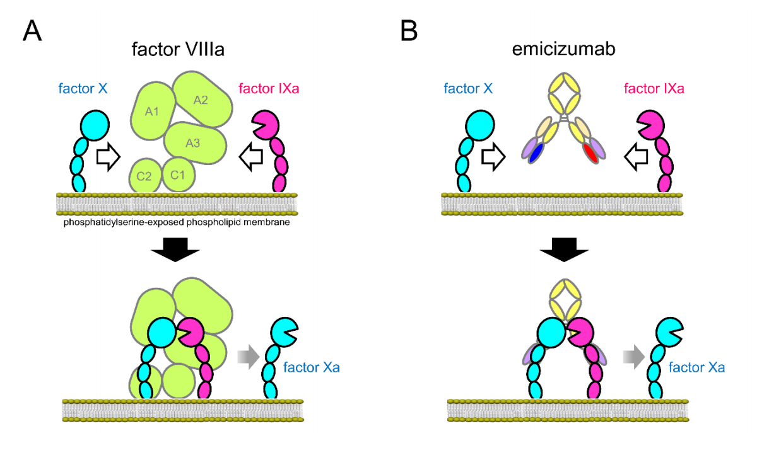
Figure 1 Schematic Illustrations of the Action of factor VIIIa and Emicizumab as a Cofactor Promoting the Interaction between FIXa and FX –as produced in the supplementary appendix to Shima (2016)
While emicizumab will be evaluated as a prescription medicine by the Therapeutic Goods Administration, the National Blood Authority and Jurisdictional Blood Committee advised on 13 December 2016 that emicizumab can be evaluated as a blood-related product (as defined in Clause 40 and Section 3) under Schedule 4 the National Blood Authority Act 2003.

Anticipated use

Dosage and frequency of treatment
Emicizumab is intended to be used for routine prophylaxis to prevent bleeding or reduce the frequency of bleeding episodes in adults and children with cHMA (with and without factor VIII inhibitors). The applicant states that emicizumab will be taken as a once-weekly subcutaneous injection in an ongoing manner.
PASC confirmed that the proposed dosing schedule is as per the HAVEN 1 trial (Oldenburg et al 2017). In the HAVEN 1 trial emicizumab was prescribed as follows: the loading dose consisted of 3.0 mg per kilogram of body weight weekly for four weeks followed by 1.5 mg/kg weekly thereafter. If after the loading dose period or in the subsequent time on trial a patient experienced at least two spontaneous and clinically significant treated bleeds they could increase the weekly dose to 3.0 mg/kg. Dosing in various ongoing and published trials is reported in Table 7, it is understood that dosing submitted to the TGA aligns with that reported in HAVEN 1.
See table 7 for an overview of dosing in published and ongoing trials, the impact of different dosing regimens on the safety and effectiveness of emicizumab is unknown. At the assessment phase it may be relevant to consider whether it is possible to define a minimum therapeutically effective dose, noting that a four weekly administration schedule is being considered in ongoing trials.

Restrictions
No restrictions on dose have been proposed and it is clear that the proposal is for an unrestricted duration of treatment. It is anticipated that in patients whose bleeding is well controlled with emicizumab, prophylaxis could be lifelong, or until the development of drug autoantibodies or unacceptable toxicity.
In the event of frequent or severe breakthrough bleeding events on emicizumab it may be relevant to consider whether there is any indication for stopping rules to reflect treatment futility. Furthermore, it may be relevant to consider whether dose escalation has a role in more refractory patients. This could be investigated at the assessment phase.
Additionally, at the assessment phase it may be relevant to consider the appropriate strategy for managing bleeding events and to consider whether the co-administration of emicizumab and BPAs represents any additional risk of thrombotic events.
In the HAVEN 1 trial the following adverse events of particular note were reported among all patients who received emicizumab: thrombotic microangiopathy (TMA) in three patients (2.9%) and thrombotic event in two patients (1.9%). One death was reported in a patient being treated with emicizumab who was given activated prothrombin complex concentrate for bleeding; however, on developing signs of TMA the patient discontinued activated prothrombin complex concentrate and ultimately died due to haemorrhage. According to Roche, all thrombolic events occurred in patients receiving BPAs for breakthrough bleeding, specifically in patients receiving >100 U/kg daily for 24 or more hours. Thrombolic events are a known risk of BPAs and therefore there is some uncertainty regarding whether:
- thrombolic events are attributable to BPAs alone; or,
- the combination of emicizumab and BPAs adds additional risk of thrombolic events; or,
- monotherapy with emicizumab has an independent risk of thrombolic events.
Therefore, it may be relevant at the assessment phase to consider what constitutes a safe rescue strategy in patients on emicizumab who experience breakthrough bleeding.

Place in treatment
The National Blood Authority guidelines on Haemophilia define a range of replacement therapy protocols for HMA (Table 5). Emicizumab is intended to be used as routine prophylaxis; this has been interpreted as suitable for primary, secondary or tertiary prophylaxis. Emicizumab is not indicated as an on-demand treatment.
Table 5 Definitions of factor replacement therapy protocols(National Blood Authority 2016a)
Protocol | Definition
On-demand (Episodic) treatment | Treatment given at the time of clinically evident bleeding
Continuous¹ prophylaxis/  Primary prophylaxis | Regular continuous prophylaxis initiated in the absence of documented osteochondral joint disease, determined by physical examination or imaging studies (or both), and  started before the second clinically evident large joint bleed and age 3 years.^{2.}
Secondary prophylaxis | Regular continuous¹ prophylaxis started after two or more bleeds into large joints,² and before the onset of joint disease documented by physical examination and imaging studies
Tertiary prophylaxis | Regular continuous prophylaxis started after the onset of joint disease documented by physical examination and plain radiographs of the affected joints
Intermittent (‘periodic’) prophylaxis | Prophylaxis given to prevent bleeding for periods not exceeding 45 weeks in a year
¹ ‘Continuous’ is defined as the intent of treating for 52 weeks/year, and receiving a minimum of an a priori defined frequency of infusions for at least 45 weeks (85%) of the year under consideration.
² ‘Large joints’ are ankles, knees, hips, elbows and shoulders.

Place in treatment in population one
For patients with inhibitors, emicizumab represents a novel therapy option which the applicant indicates would replace prophylaxis with BPAs or provide an option for patients for whom BPAs are not a viable prophylactic regimen (Table 6 describes common prophylaxis or on-demand regimens with BPAs for patients with inhibitors). This is indicated in trial enrolment and by the clinical pathway for emicizumab (inclusion criteria of HAVEN 1).
Additionally feedback from clinical experts has indicated that emicizumab may be used as a bridge to tolerisation therapy in some patients, particularly those in whom placement of a central venous access device is contraindicated. For others, emicizumab may be preferred over tolerisation particularly if the patient would have difficulty complying with a rigorous tolerisation schedule.
For patients with inhibitors, emicizumab represents a novel therapy option that could provide a form of prophylaxis not currently available for this patient group.
However, it is also important to note that emicizumab will not eliminate the need for BPAs entirely. Breakthrough bleeding in patients with inhibitors while on emicizumab prophylaxis will still require acute treatment.

Place in treatment in population two
For population two, the standard of care for prophylaxis to protect joint health is intravenous infusions of FVIII (from 25 to 40 IU/kg) three times per week or on alternate days with on-demand treatments to manage acute bleeding or surgery cover. The duration of FVIII replacement and the dose is dependent on the severity of haemophilia and the seriousness of the bleed or surgical procedure being managed. Protein modifications intended to delay recombinant FVIII clearance and reduce infusion frequency have been trialled; however, the burden of treatment in HMA patients is still high. In patients with cHMA without inhibitors emicizumab would be expected to replace both prophylactic FVIII replacement (cohort 4 of HAVEN 3 and patients in Shima et al 2016) and on-demand FVIII treatment (HAVEN 3 inclusion criteria).

Provider and setting
The intervention is not currently reimbursed in the private or public setting in Australia. The following active trials have study sites in Australia (HAVEN 1, 3 and 4 and STASEY – see Table 7) – it is expected that a small number of patients in Australia have had access to emicizumab in the trial setting.
As noted by the applicant, management of HMA is complex and patients would be managed in specialist centres where the diverse needs of patients and their families can be met by a multidisciplinary team of healthcare professionals. Additionally, patients that develop inhibitors to treatment with plasma derived or recombinant FVIII are currently referred to the Australian Haemophilia Centre Directors’ Organisation Tolerisation Committee for discussion of their management (National Blood Authority 2016a). A patient being considered for emicizumab will be within the care of these centres and their suitability for treatment is likely to take into account a multitude of complex factors.
Emicizumab would initially be administered by a healthcare provider (likely a trained nurse) at the treating centre with a view to training the patient or the patient’s caregiver in administration, if suitable. The applicant states that emicizumab would be provided with a “convenience kit” to facilitate patient self-administration. How frequently emicizumab would be dispensed to a patient or caregiver and the frequency of follow-up or arrangements for monitoring in these patients has not been specified at this stage. PASC recommended that, during the assessment phase, more clarification is provided on how emicizumab will be administered and by whom, upon the likely movement to self-administration (and the consequences for monitoring the disease, including dose adjustment of emicizumab).
There is some uncertainty regarding how emicizumab would be dispensed and controlled owing to differences in the treatment of Schedule 4 – prescription only medicines and blood products traditionally used to manage this patient group. The applicant has indicated that the appropriate arrangements for access are currently under investigation.

Rationale
No alternative uses of the intervention have been identified.

Comparator(s)

Comparator(s) in population one
Patients with inhibitors, particularly those with high-titre inhibitors (> 5 BU/mL), are at increased risk of uncontrollable haemorrhage, devastating joint damage, and subsequent disability. For patients with low titre inhibitors effective management can often be achieved with higher doses of FVIII and for up to half of patients with inhibitors they may disappear when treated normally. However, for those whose inhibitors are persistent and/or bleeding profile interfere with a patient’s quality of life, prophylaxis with BPAs might be considered.
The following therapy strategies might be considered comparators to emicizumab. In all situations emicizumab could be used after failure (or relapse) on those treatments or as a replacement/alternative to them.
The first comparator to emicizumab is prophylaxis with BPAs (strategy 1) as this comparator represents the patient group with a clear indication for routine prophylaxis. The second comparator is on-demand BPAs (strategy 2) this represents a patient group that may benefit from emicizumab but do not currently receive prophylaxis.
- Prevention of bleeding with prophylactic administration of BPAs
Prophylaxis with BPAs is considered for some patients who have FVIII inhibitors (Australian Haemophilia Centre Directors’ Organisation 2010). BPAs are short acting and are required daily (or multiple times a week) when used for prophylaxis. Trials examining the effectiveness of BPAs as secondary prophylaxis for patients with inhibitors demonstrate decreased bleeding and improved quality of life (Antunes et al 2014; Stasyshyn et al 2014). As compared to on-demand treatment, prophylaxis with BPAs has demonstrated reductions in the annual rates of bleeding in the order of 60-70 per cent (Leissinger et al 2011).
Young et al (2011) recommends that prophylaxis be considered for patients whose condition has failed to respond to ITI and who have recurrent significant bleeding (i.e. a target joint or life-threatening haemorrhages). Adverse events with BPAs are relatively rare (ranging between approximately 2.5 and 8.0 per 100,000 infusions) but can be serious and include myocardial infarction, disseminated intravascular coagulation, arterial and venous thrombosis, pulmonary embolism, and stroke (Sborov and Rodgers 2013). Factors determining which BPA to use for prophylaxis include: frequency of infusions, volume of infusion, cost, and anamnestic response. In patients who are planned for tolerisation it may be preferable to use a recombinant activated human factor VIIa as opposed to activated prothrombin complex concentrate due to a small risk of anamnesis (Kempton and White 2009).
- Treatment of bleeding events in an on-demand manner
In all patients with inhibitors the management of bleeding events or planned surgery requires either high dose FVIII or BPAs in an on-demand fashion. Treatment of bleeding in a patient with an inhibitor is based on the classification of the inhibitor.
- A low-titre inhibitor (<5 BU) can be overcome with higher doses of FVIII, however, prophylactic regimens may still be used to avoid increasing titre levels with on-demand treatment.
- Bleeding in a patient with a high-titre inhibitor must be treated with BPAs.
In general, BPAs can achieve haemostasis but they are considered less effective than FVIII replacement in patients without an inhibitor (Witmer and Young 2013). In some cases patients with a low-titre inhibitor may be treated with BPAs if the treating physician deems it appropriate, particularly if a patient continues to bleed despite increasing doses of FVIII. These patients who might currently receive BPAs despite having a low-titre inhibitor and therefore emicizumab might be a comparator to BPAs in some low-titre inhibitor patients.

Comparator(s) in population two
The main comparator in population two is prophylaxis with FVIII which the national guidelines indicate is commonly provided as per one of the following protocols (National Blood Authority 2016a):
- the Malmö protocol: 25–40 IU/kg per dose administered three times a week; or,
- the Utrecht protocol: 15–30 IU/kg per dose administered three times a week.
However, there is some uncertainty about the minimum therapeutically effective dose. Individualised protocols are considered that are based on disease severity and the pharmacokinetics FVIII replacements. For very young children less frequent administration, escalated as appropriate might be considered.
For the management of bleeding or as surgical cover in patients not receiving prophylaxis, FVIII is given on-demand according to varied doses and durations depending on the type of haemorrhage and the target level of FVIII. The duration of on-demand treatment can be as short as 24 hours or as long as two weeks depending on the response of the patient and the need for secondary prophylaxis after bleeding. Table 7-1 of the guidelines for the management of haemophilia in Australia covers a range of scenarios (National Blood Authority 2016a). The table below outlines currently available products on the National Products List.
Table 6 Plasma and recombinant products supplied under contract by the National Blood Authority in 2015-16 (2016b) and guidelines for use as per the 2010 guidance for treatment of inhibitors in Haemophilia A and Haemophilia B from the Australian Haemophilia Centre Directors Organisation (2010)
Product | Suppliers  Dosage form  Cost | Details
Bypassing agents
FEIBA® activated prothrombin complex concentrate | Baxalta Australia Pty Ltd  500 IU/BF 500 IU/NF 1000 IU/ NF 2500IU  $2.40 per IU | Bleeding management: is 60-100 units/kg twice per day.  The maximum daily dose of FEIBA is 200 units/kg/day.  Prophylaxis: 75-100 units/kg three times a week.
NovoSeven® (recombinant activated human FVIIa, eptacog alfa) | Novo Nordisk Pharmaceuticals Pty Ltd  1mg/2mg/5mg and 8mg  $1,316.65 per mg | Bleeding management: 90 μg/kg. Doses may need to be repeated every 2– 3 hours until bleeding settles and in children may need to be higher.  Prophylaxis: 90μg/kg daily for up to 3 months.
Recombinant or
plasma derived factor VIII
Advate® | Baxalta Australia Pty Ltd  250IU/ 500 IU/ 1000 IU/ 1500 IU/ 2000 IU/3000 IU  $0.30 per IU | Bleeding management (low-titre inhibitor): 50-100 IU/kg repeated every 8-12 hours.  Tolerisation: A typical regimen is 100 IU/kg/day, followed by reassessment every 3 months, with escalating treatment in difficult cases.
Xyntha® | Pfizer Australia Pty Ltd  250IU/ 500 IU/ 1000 IU/ 2000 IU/3000 IU  $0.36 per IU | As above
Kogenate FS | Bayer Australia Limited  250IU/ 500 IU/ 1000 IU/ 2000 IU/3000 IU  $0.59per IU | As above
Biostate® (plasma derived) | CSL Behring (Australia) Pty Ltd  250IU/ 500 IU/ 1000 IU  $0.87 per IU | As above

Rationale
Additional potential comparator for population one: Eradication of inhibitory antibodies to restore normal FVIII pharmacokinetics (or Immune Tolerance Induction [ITI]). PASC agreed that ITI is not an appropriate comparator but that the potential impact of emicizumab availability on utilisation of ITI could be explored in the economic evaluation.

Table 7 Published and ongoing clinical trials of emicizumab
Trial ID  Year or expected completion  Level of evidence | Patients | Intervention(s) and comparator(s)  N | Outcome(s) | Impact on bleeding
Published trials
Oldenburg et al(Oldenburg et al 2017)/ HAVEN 1  2017  Open-label RCT | >12 years of age, congenital haemophilia A, history of high titre factor VIII inhibitor (≥5 Bethesda units/mL). Receiving episodic or prophylactic treatment with BPAs  Group A and B: patients with a history of episodic treatment with BPAs (randomised assignment). Group C: patients with a history of prophylaxis with BPAs. Group D: patients who could not enrol in the HAVEN 1 trial | Group A: emicizumab 3 mg/kg/week subcutaneously for 4 weeks (loading dose) followed by 1.5 mg/kg/week for 24 weeks in total* (N=35)  Group B: No prophylaxis with emicizumab (N=18)  Group C: as per group A (N=49)  Group D: as per group A (N=7) | Primary effectiveness  Rate of treated bleeding events (bleeding rate) over ≥ 24 weeks in Group A vs. Group B  Secondary effectiveness  Bleeding related endpoints, health-related quality of life  Safety  adverse events, injection- site reactions, serious adverse events, thromboembolic events, abnormal laboratory values and antidrug antibodies | Annualised bleeding rate: 2.9 (95% 1.7 to 5.0, Group A) vs. 23.3 (95%CI 12.3 to 43.9, Group B), p<0.001
Shima et a(Shima et al 2016)l /121934  2016  Open-label, dose escalation study  Note: conference abstracts report on a 9.5 months extension of this study | > 12 years of age with severe haemophilia A with or without factor VIII inhibitors, patients without inhibitors had previously received regular factor VIII prophylaxis while those with inhibitors had previously received episodic or regular BPAs and had ≥ 6 bleeds in the last 6 months | Cohort 1: emicizumab 1 mg/kg/week subcutaneously for 1 week (loading dose) followed by 0.3 mg/kg/week for 12 weeks in total (N=6)  Cohort 2: emicizumab 3 mg/kg/week subcutaneously for 1 week (loading dose) followed by 1 mg/kg/week for 12 weeks in total (N=6)  Cohort 3: emicizumab 3 mg/kg/week subcutaneously for 1 week (loading dose) followed by 3 mg/kg/week for 12 weeks in total (N=6) | Effectiveness outcomes  Emicizumab plasma concentrations and plasma anti-emicizumab antibodies  Safety outcomes  included adverse events, laboratory test results, vital signs, and 12-lead electrocardiograms  Exploratory outcomes  Annualised bleeding rate | Median annualised bleeding rates decreased from 32.5 (range, 8.1 to 77.1) to 4.4 (range, 0.0 to 59.5) in cohort 1, from 18.3 (range, 10.1 to 38.6) to 0.0 (range, 0.0 to 4.3) in cohort 2, and from 15.2 (range, 0.0 to 32.5) to 0.0 (range, 0.0 to 4.2) in cohort 3
Unpublished trials
HAVEN 3  REDACTED  Open-label RCT | >12 years of age, severe congenital haemophilia A without inhibitors to factor VIII who have previously received episodic treatment with factor VIII or prophylaxis with factor VIII (cohort 4 only) | Cohort 1: emicizumab 3 mg/kg/ week subcutaneously for 4 weeks, followed by 1.5 mg/kg/week up to maximum up to 2 years.  Cohort 2: emicizumab 3 mg/kg/ week subcutaneously for 4 weeks, followed by 3 mg/kg/every 2 weeks up to maximum up to 2 years.  Cohort 3: episodic factor VIII treatment with the opportunity to switch to emicizumab prophylaxis after 24 weeks on-study.  Cohort 4: emicizumab 3 mg/kg/ week subcutaneously for 4 weeks, followed by 1.5 mg/kg/week up to maximum up to 2 years | Primary effectiveness  Number of bleeds over time  Secondary effectiveness  Bleeding related endpoints, health-related quality of life  Safety  adverse events, antidrug antibodies, inhibitor development | NA
HAVEN 2  REDACTED  Open-label, single arm study | Children (less than ≤12 years of age) and adolescents (12 to 17 years of age) with haemophilia A and factor VIII inhibitors who are currently receiving treatment with BPAs | emicizumab 3 mg/kg/ week subcutaneously for 4 weeks, followed by 1.5 mg/kg/week up to maximum up to 52 years. From 12 weeks onwards, the dose can be increased from 1.5 to 2.25 mg/kg/week or from 2.25 to 3.0 mg/kg/week if the participant has developed ≥2 bleeds in 12 weeks from Week 5 or 9, respectively | Primary effectiveness  Number of bleeds over time  Secondary effectiveness  Bleeding related endpoints, health-related quality of life  Safety  Not specified | NA
HAVEN 4  REDACTED  Open-label, two-stage study | Severe haemophilia A with or without inhibitors against factor VIII | Expansion arm: emicizumab 3 mg/kg/ week subcutaneously for 4 weeks, followed by 6 mg/kg/every 4 weeks for at least 24 weeks  Run in arm: emicizumab at a dose of 6 mg/kg every 4 weeks for a minimum of 24 weeks | Primary effectiveness  Number of bleeds over time  Secondary effectiveness  pharmacokinetics, health-related quality of life  Safety  adverse events, antidrug antibodies | NA
STASEY  REDACT  single arm, open-label safety and tolerability study | >12 years of age, congenital haemophilia A with persistent inhibitors against factor VIII and documented on-demand or prophylaxis with BPA within the last 6 months | emicizumab 3 mg/kg/ week subcutaneously for 4 weeks, followed by 1.5 mg/kg/week up for two years in total | Primary  Incidence and severity of adverse events  Secondary  Bleeding related outcomes, pharmacokinetics, health-related quality of life, antidrug antibodies | NA
NCT03154437  NR  Open-label, expanded access program | Congenital haemophilia A of any severity and documented history of high-titre inhibitor, history of treatment with on-demand or prophylactic BPAs for at least the last 24 weeks | emicizumab 3 mg/kg/ week subcutaneously for 4 weeks, followed by 1.5 mg/kg/week up until unacceptable toxicity or other reason for discontinuation | NR | NA
* After at least 24 weeks of emicizumab prophylaxis, participants could continue taking maintenance therapy with 1.5 mg per kilogram weekly or, if they had had at least two spontaneous and clinically significant treated bleeding events in the past 24 weeks of emicizumab administration, both occurring after the end of the loading dose period (termed “suboptimal control of bleeding”), start taking an increased dose of 3.0 mg per kilogram weekly.
BPA = bypassing agent; NA = not applicable; NR = not reported; RCT = randomised controlled trial

Outcomes
The applicant has stated the following clinical claim “weekly subcutaneous emicizumab is associated with superior health outcomes for HMA patients with factor VIII inhibitors through improved efficacy (reduction in bleeds), improved convenience and acceptable safety over currently available treatments.” In supporting this claim the applicant specifies the following relevant outcomes:

Safety
- Incidence and severity of adverse events

Primary effectiveness
- Reduction in number of bleeds over time (bleed rate)

Secondary endpoints
- Reduction of number of bleeds over time compared with the patient’s historical bleed rate
- Reduction in number of joint bleeds over time
- Reduction in number of target joint bleeds over time
- Health-related quality of life
These outcomes are considered equally relevant to population two; however, no formal application for this population has yet been received and PASC may wish to revisit this issue if, and when, such a submission is received.
Prophylaxis is the routine use of a replacement FVIII or BPA to prevent or reduce bleeding episodes. If this is achieved then patients could also expect a protective effect on joint health or a slower progression of joint damage, improved ability to participate in social activities and the workforce and thereby improved overall physical and psychological health. The outcomes suggested by the applicant speak to these potential benefits.
The applicant has clarified that clinician input suggests that a 20-25 per cent reduction in bleed rates between prophylactic regimens would be considered clinically meaningful. Additionally, the absence of bleeding at the patient level would be considered particularly meaningful. In the absence of published literature defining criteria for superiority in terms of effectiveness or a minimally clinically important difference for relevant outcomes these are suggested as indicators of significant patient-relevant benefit. PASC agreed that both outcomes are clinically meaningful and could be accepted as a minimally clinically important difference.
Criteria for concluding superiority relative to each appropriate comparator should be specified at the assessment phase in order to support the clinical claim associated with emicizumab. In the absence of a pre-specified superiority criteria (e.g. 20% or more reduction in the bleeding rate compared to x) superiority should be tested with a point estimate and 95% confidence intervals relative to the null hypothesis that there is no difference between the compared alternatives. To conclude superiority the 95% confidence interval should exclude the possibility that there is no difference between the compared strategies.

Other relevant considerations
Reduction in number of bleeds over time can be measured using a range of definitions, the most common being absolute number of bleeding, annualised bleeding rate and bleeds per month (Chai-Adisaksopha et al 2015). In particular, the annualised bleeding rate is often the primary outcome in clinical studies involving prophylaxis regimens and has been used previously to establish the superiority of prophylaxis in comparison with on-demand therapy. Lessinger et al (2011) defined prophylaxis success as ≥ 50% reduction in bleeding events from the on‐demand period to the prophylaxis period, i.e., a Prophylaxis Effect Ratio ≥ 50% although what proportion of patients would need to experience this for superiority to be determined was not defined.
Relative to prophylaxis with BPAs it is expected that the difference in bleeding with BPAs and emicizumab would be smaller than when compared to on-demand therapy and therefore it may be sufficient to detect a statistically significant difference in bleeding rates to conclude superiority. Clinical input on the appropriate criteria for determining superiority at the assessment phase is advisable.
Bleeding rates typically account only for frequency of bleeding and do not necessarily provide information about the functional limitations that may result from bleeding (Recht et al 2016). Additional patient-relevant outcomes that may be of interest include:
- Overall number of bleeds per month/year etc.
- Number of treated bleeds per month/year etc.
- Joint bleeding/haemarthrosis rate per month/year etc.
- Number of patients with zero treated bleeds
- Joint health outcomes
- Chronic pain associated with haemophilia
- Development of new target joints
- Outcome of treated bleeds
- Number of missed days of work/activity/school
- Hospitalisations for bleeding events or adverse events associated with prophylaxis
- Frequency of prophylaxis required/ medication burden
- Adherence or barriers to adherence
- Mortality
With respect to health-related quality of life there are a number of generic measures that may be applicable; however, there are specific validated scales for haemophilia such as the Haem-A-QoL (Wyrwich et al 2015) which may be relevant at the assessment phase.

Healthcare system
Patients with HMA and inhibitors are a challenge to manage, requiring high costs over their lifetimes for effective management. The cost of prophylaxis in HMA is high due to the requirement for lifelong therapy and spending on factor replacement has been reported to comprises 80 per cent of the total direct expenditures for patients with haemophilia (A and B) in the US (Chen 2016). Costs rise substantially in:
- Patients with complications, such as HIV seropositivity and arthropathy. It has been reported that co-infection results in a 59% increase in total annual medical costs for haemophilia patients (Chen 2016).
- Patients with inhibitors, these patients are up to twice as likely to be hospitalised for a bleeding complication, and treatment costs associated with inhibitors can be many times greater than for those without inhibitors (Chen 2016; Rocha et al 2015).
The drug acquisition costs of various treatment options must be considered in the context of patient quality of life and management of the entire bleeding episodes. Although prophylaxis is expensive, when effective, the cost of prophylaxis may be offset by savings in treating bleeding episodes and in the cost of treating complications of them. Relevant healthcare resource considerations include:

Drug acquisition and provision
- The cost of emicizumab is unknown; however, at the assessment phase the cost of emicizumab per administration (supplied as a kit) will be relevant. Other potential costs include:
  - training costs for patients or caregivers to be able to administer routine prophylaxis,
  - assistance with administration from a healthcare provider, if required; and,
  - costs associated with monitoring for safety issues, although the applicant has indicated that no additional medical services for this purpose will be required.

Resources provided in association with routine prophylaxis with emicizumab
- Management of breakthrough bleeding will be an additional cost associated with emicizumab prophylaxis. It is anticipated that BPAs will be used to treat bleeds and the costs will depend on choice of BPA, severity of the bleed and the frequency of breakthrough bleeding on emicizumab.
- Ambulance transport/emergency department visit/hospitalisation costs associated with breakthrough bleeding.

Resources provided to deliver the comparator(s)
- For population two only: the cost and burden of FVIII prophylaxis or on-demand treatment
- ITI typically involves administering infusions of large doses of clotting factor concentrates to a patient on a daily basis for many weeks or months.
- Prophylaxis with BPAs requires daily (or close to daily) administration of BPAs which is a costly management strategy as patients require lifelong prophylaxis.
- Similar to above, all patients will incur costs associated with episodic bleeding that might necessitate on-demand treatment with FVIII or BPAs and potentially a hospitalisation.
- The cost of various items on the National Products List is available in Table 6.

Potential cost offsets
- The annual probability of a severe haemophilic with inhibitors not on prophylaxis developing a bleed was estimated by Earnshaw et al 2015 (derived from Lessinger [2011]) as minor bleed: 23.6 per annum, and a major bleed: 2.6 per annum. Treatment for these bleeds will include additional doses of BPAs in inhibitor patients (or FVIII in population 2) and typically require between 1 and 4 infusions of activated prothrombin complex concentrate to stop bleeding.
- Furthermore, Earnshaw estimated that 53% of bleeds occur in target joints, and, it has been estimated that severe HMA patients who do not receive prophylaxis are at risk of requiring two orthopaedic procedures over 50-year time horizon. The costs associated with such procedures can be high (Smith et al 1996).
- If such bleeding events are prevented with prophylaxis the subsequent costs associated with their management can be avoided.
Indirect costs also contribute to the economic burden associated with haemophilia and include lost productivity, unpaid labour by caregivers, and haemophilia related disability (Dalton 2015). When considering costs associated with various comparators the frequency of administration, associated costs and burden on patients and caregivers could be considered.
Rationale
No additional comments

Current clinical management algorithm for patients with congenital haemophilia
The applicant has provided the following clinical management algorithm.
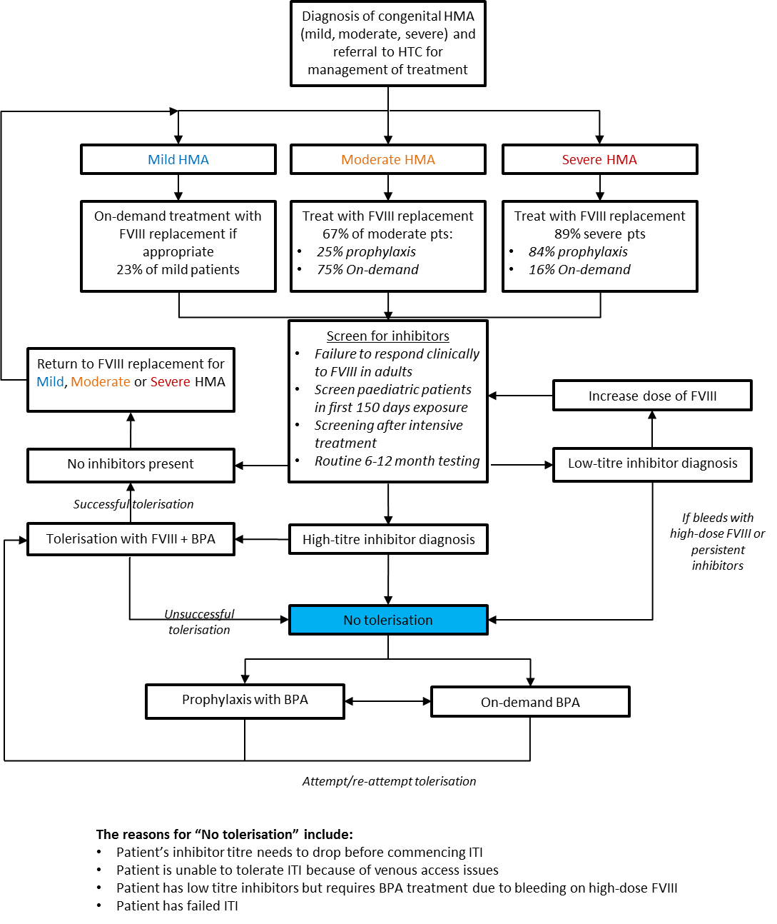
Figure 3 Current clinical management pathway for patients with congenital haemophilia (HMA) as provided by the applicant

Proposed clinical management algorithm for identified for populations one and two
The applicant has provided the following clinical management algorithm.
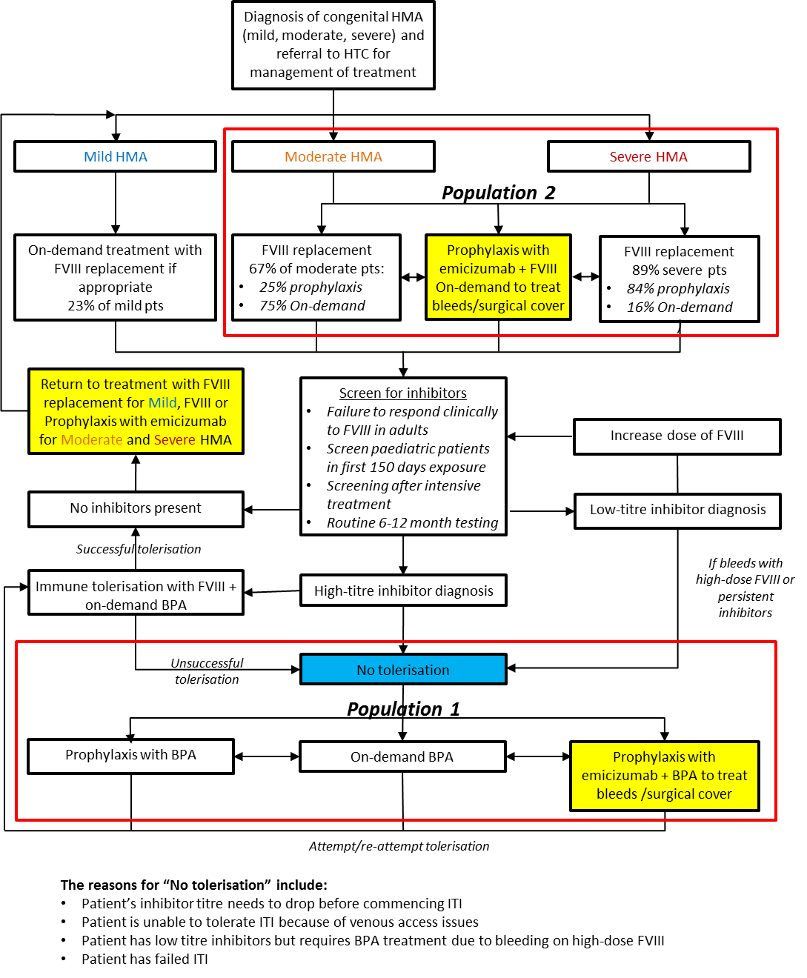

Figure 4 Proposed clinical management pathway for patients with congenital haemophilia (HMA) as provided by the applicant.

Proposed economic evaluation
The applicant has specified that the comparative claim is one of superior effectiveness and non-inferior safety as follows “weekly subcutaneous emicizumab is associated with superior health outcomes for HMA patients with factor VIII inhibitors through improved efficacy (reduction in bleeds), improved convenience and acceptable safety over currently available treatments.”
Given that the applicant is claiming superiority relative to currently available treatments then a cost-effectiveness analysis or cost-utility analysis is appropriate to determine whether the increase in health outcomes (and any cost offsets) justifies the increased expense (presumed). Based on the plentiful literature on HMA it should be feasible to present a cost-utility analysis quantifying the QALY gains associated with the proposed listing of emicizumab. PASC agreed that a cost-utility analysis would be preferred with multiple health states to be integrated.
Where no direct clinical evidence comparing emicizumab to a relevant comparator is available a comparison of effectiveness and safety will therefore be indirect. A list of ongoing and published studies has been tabulated which provides some indication of possible comparisons.
PASC specified that the analysis would need to include multiple health states and should incorporate different management regimens for HMA to capture the expected clinical outcomes and costs of each over an appropriate time.
PASC noted the potential for entry of emicizumab into the algorithm at multiple points and this had implications to whether partial or whole of disease modelling be adopted. Given that two populations, each with separate comparators, have been identified by PASC then two partial disease models may be more informative to MSAC in evaluating the cost effectiveness of emicizumab for these populations.
It is likely necessary to distinguish several health states including high and low-titre inhibitor patients and those who have failed or relapsed after ITI as this signals differences in management approaches and expected complications. Table 8 provides an overview of relevant features of a range of prophylactic strategies for patients with HMA.
Table 8 Overview of different treatment strategies to facilitate collection of appropriate administration and utilisation costs associated with potential comparators (Australian Haemophilia Centre Directors’ Organisation 2010; National Blood Authority 2016a; Oldenburg et al 2017; Sborov and Rodgers 2013; Witmer and Young 2013)
 | Regimen and dosing  Duration of treatment  Time required | Management of bleeding episodes
Increased dose of FVIII (low-titre inhibitor only – not currently specified as a comparator) prophylaxis | - Administration of FVIII ≥ 3 times per week  - Dose to maintain trough levels of 2% or higher  - Lifelong treatment  - Infusion (15-20 minutes) | Dose calculations are directed towards achieving an FVIII activity level of 30-40% for most mild haemorrhages, of at least 50% for severe bleeds (e.g., from trauma) or prophylaxis of major dental surgery or major surgery, and 80-100% in life-threatening haemorrhage. BPAs might be required
Immune tolerisation | - Ongoing, frequent, uninterrupted exposure to FVIII with concentrate or recombinant products. Doses up to 200 IU/kg/day  - Takes months to years  - After successful immune tolerisation induction¹ scheduled FVIII prophylaxis 2 or 3 times per week is recommended  - Infusion (15-20 minutes). This frequently necessitates a central venous access device | Larger than normal doses of FVIII in low responders. Otherwise BPAs can be used. BPAs may be added in patients at high risk of bleeding and is continued until the inhibitor titre falls below 1 BU
Prophylaxis with bypassing agents | - Factor eight inhibitor bypassing activity prophylaxis: 75-100 units/kg three times a week or  - NovoSeven prophylaxis: 90μg/kg daily  - For lifelong treatment  - Infusion (approx. 30 minutes) | BPAs at bleeding management dosing
Prophylaxis with emicizumab | - Loading dose consisted of 3.0 mg per kilogram of body weight weekly for 4 weeks followed by 1.5 mg/kg weekly thereafter  - Subcutaneous injection, minimal time | BPAs at bleeding management dosing
¹ Success is defined as: 1.The inhibitor titre can no longer be measured.2.Factor recovery is greater than 66% of normal.3.The half-life of FVIII is greater than 6 hours. BPA = bypassing agent

Proposed item descriptor
Emicizumab is proposed for reimbursement on the National Products List managed by the National Blood Authority. New blood and blood-related products reviewed by the Jurisdictional Blood Committee may be referred to MSAC for evidence based evaluation of the safety, clinical effectiveness or cost-effectiveness. No MBS item descriptor is required for this application.

References
Antunes, SV, Tangada, S, Stasyshyn, O, Mamonov, V, Phillips, J, Guzman-Becerra, N, Grigorian, A, Ewenstein, B & Wong, WY 2014, 'Randomized comparison of prophylaxis and on-demand regimens with FEIBA NF in the treatment of haemophilia A and B with inhibitors', Haemophilia, vol.20(1), pp. 65-72.
Australian Bleeding Disorders Registry 2016, Australian Bleeding Disorders Registry (ABDR) Annual Report 2015-16, viewed 29 September 2017, <http://www.blood.gov.au/data-analysis-reporting>.
Australian Haemophilia Centre Directors’ Organisation 2010, Guidelines for the treatment of inhibitors in Haemophilia A and Haemophilia B, viewed 04/10/2017 2017, <http://www.ahcdo.org.au/documents/item/16>.
Chai-Adisaksopha, C, Nevitt, SJ, Simpson, ML, Janbain, M & Konkle, BA 2017, 'Bypassing agent prophylaxis in people with hemophilia A or B with inhibitors', Cochrane Database Syst Rev, vol.9pp. Cd011441.
Chen, SL 2016, 'Economic costs of hemophilia and the impact of prophylactic treatment on patient management', Am J Manag Care, vol.22(5 Suppl), pp. s126-33.
Dalton, DR 2015, 'Hemophilia in the managed care setting', Am J Manag Care, vol.21(6 Suppl), pp. S123-30.
Earnshaw, SR, Graham, CN, McDade, CL, Spears, JB & Kessler, CM 2015, 'Factor VIII alloantibody inhibitors: cost analysis of immune tolerance induction vs. prophylaxis and on-demand with bypassing treatment', Haemophilia, vol.21(3), pp. 310-9.
Kempton, CL & White, GC, 2nd 2009, 'How we treat a hemophilia A patient with a factor VIII inhibitor', Blood, vol.113(1), pp. 11-7.
Klamroth, R 2017, 'A new era of treatment for patients with haemophilia A?', Hamostaseologie, vol.37(3), pp. 216-18.
Leissinger, C, Gringeri, A, Antmen, B, Berntorp, E, Biasoli, C, Carpenter, S, Cortesi, P, Jo, H, Kavakli, K, Lassila, R, Morfini, M, Negrier, C, Rocino, A, Schramm, W, Serban, M, Uscatescu, MV, Windyga, J, Zulfikar, B & Mantovani, L 2011, 'Anti-inhibitor coagulant complex prophylaxis in hemophilia with inhibitors', N Engl J Med, vol.365(18), pp. 1684-92.
National Blood Authority 2016a, Guidelines for the management of haemophilia in Australia, viewed 29 September 2017, <https://www.blood.gov.au/system/files/HaemophiliaGuidelines-interactive-updated-260317v2.pdf>.
National Blood Authority 2016b, National Blood Authority Annual Report 2015–16, viewed 29 September 2017, <https://www.blood.gov.au/pubs/1516report/sites/default/files/publication/nba-annual-report-2015-16.pdf>.
Oldenburg, J, Mahlangu, JN, Kim, B, Schmitt, C, Callaghan, MU, Young, G, Santagostino, E, Kruse-Jarres, R, Negrier, C, Kessler, C, Valente, N, Asikanius, E, Levy, GG, Windyga, J & Shima, M 2017, 'Emicizumab Prophylaxis in Hemophilia A with Inhibitors', N Engl J Med, vol.377(9), pp. 809-18.
Rasekh, HR, Imani, A, Karimi, M & Golestani, M 2011, 'Cost-utility analysis of immune tolerance induction therapy versus on-demand treatment with recombinant factor VII for hemophilia A with high titer inhibitors in Iran', ClinicoEconomics and Outcomes Research: CEOR, vol.3pp. 207-12.
Recht, M, Konkle, BA, Jackson, S, Neufeld, EJ, Rockwood, K & Pipe, S 2016, 'Recognizing the need for personalization of haemophilia patient-reported outcomes in the prophylaxis era', Haemophilia, vol.22(6), pp. 825-32.
Rocha, P, Carvalho, M, Lopes, M & Araújo, F 2015, 'Costs and utilization of treatment in patients with hemophilia', BMC Health Services Research, vol.15pp. 484.

Royal College of Pathologists of Australia 2015, RCPA manual: Haemophilia, viewed 29 September
2017 2017, <http://www.rcpa.edu.au/Library/Practising-Pathology/RCPA-Manual/Items/Clinical-Problems/H/Haemophilia>.
Sborov, DW & Rodgers, GM 2013, 'How I manage patients with acquired haemophilia A', Br J Haematol, vol.161(2), pp. 157-65.
Shima, M, Hanabusa, H, Taki, M, Matsushita, T, Sato, T, Fukutake, K, Fukazawa, N, Yoneyama, K, Yoshida, H & Nogami, K 2016, 'Factor VIII-Mimetic Function of Humanized Bispecific Antibody in Hemophilia A', N Engl J Med, vol.374(21), pp. 2044-53.
Smith, PS, Teutsch, SM, Shaffer, PA, Rolka, H & Evatt, B 1996, 'Episodic versus prophylactic infusions for hemophilia A: a cost-effectiveness analysis', J Pediatr, vol.129(3), pp. 424-31.
Stasyshyn, O, Antunes, S, Mamonov, V, Ye, X, Epstein, J, Xiong, Y & Tangada, S 2014, 'Prophylaxis with anti-inhibitor coagulant complex improves health-related quality of life in haemophilia patients with inhibitors: results from FEIBA NF Prophylaxis Study', Haemophilia, vol.20(5), pp. 644-50.
van den Berg, HM, Hashemi, SM, Fischer, K, Petrini, P, Ljung, R, Rafowicz, A, Carcao, M, Auerswald, G, Kurnik, K, Kenet, G & Santagostino, E 2016, 'Increased inhibitor incidence in severe haemophilia A since 1990 attributable to more low titre inhibitors', Thromb Haemost, vol.115(4), pp. 729-37.
Walsh, CE, Soucie, JM & Miller, CH 2015, 'Impact of inhibitors on hemophilia A mortality in the United States', Am J Hematol, vol.90(5), pp. 400-5.
Witmer, C & Young, G 2013, 'Factor VIII inhibitors in hemophilia A: rationale and latest evidence', Therapeutic Advances in Hematology, vol.4(1), pp. 59-72.
Wyrwich, KW, Krishnan, S, Poon, JL, Auguste, P, von Maltzahn, R, Yu, R & von Mackensen, S 2015, 'Interpreting important health-related quality of life change using the Haem-A-QoL', Haemophilia, vol.21(5), pp. 578-84.
Young, G, Auerswald, G, Jimenez-Yuste, V, Konkle, BA, Lambert, T, Morfini, M, Santagostino, E & Blanchette, V 2011, 'When should prophylaxis therapy in inhibitor patients be considered?', Haemophilia, vol.17(5), pp. e849-57.

FVIII replacements should include all forms approved for clinical use: plasma-derived, recombinant and fusion products
When a bleed occurs, FVIII brings together the clotting factors IXa and X, which is a critical step in the formation of a blood clot to help stop bleeding. In FVIII deficiency this process in impaired causing prolonged bleeding or even spontaneous bleeds.
Acquired Haemophilia A is rare, occurring in patients without a personal or family history of bleeding disorders. The Applicant has clarified that the population with acquired disease would not be considered for emicizumab owing to different bleeding profiles in this population and a paucity of clinical evidence to support the use of emicizumab in this group.
Considered to be the total of symptomatic carriers, in addition to acquired or inherited haemophilia A, Table 2 for subtotals.
The risk of developing an inhibitor is approximately 13% in patients with non-severe haemophilia A and increases to 30% in patients with severe haemophilia - van den Berg, HM, Hashemi, SM, Fischer, K, Petrini, P, Ljung, R, Rafowicz, A, Carcao, M, Auerswald, G, Kurnik, K, Kenet, G & Santagostino, E 2016, 'Increased inhibitor incidence in severe haemophilia A since 1990 attributable to more low titre inhibitors', Thromb Haemost, vol.115(4), pp. 729-37.A ibid.
Based on the number of patients in whom recent tests were available and who had persistent inhibitors which is a subset of the total number of patients with repeat positive tests.
This has been interpreted by the HTA group to mean patients who are currently or who have previously received prophylactic or on-demand bypassinging agents.
The Applicant understands that these guidelines are considered out of date and require revision. Advice received by the applicant is that, in the absence of updated Australian Guidelines, the AHCDO’s Tolerisation Committee refer to the UKHCDO Guidelines: Collins PW, Chalmers E, Hart DP, Liesner R, Rangarajan S, Talks K, et al. (2013). Diagnosis and treatment of factor VIII and IX inhibitors in congenital haemophilia: 4th edition, British Journal of Haematology 160(2): 153-170.
which can be defined as ‘the smallest difference in score in the domain of interest which patients perceive as beneficial and which would mandate, in the absence of troublesome side effects and excessive cost, a change in the patient’s management’(Jaeschke et al 1989).

