Applicant Submitted Protocol
for
Gastric Contractility Modulation (GCM) therapy for patients with Type 2 Diabetes with Obesity

Medical Services Advisory Committee
Application 1386

For Consideration by the
Protocol Advisory Sub-Committee (PASC)

September 2014

Table of Contents
1) Title of Application 1
2) Purpose of application 1
3) Population and medical condition eligible for the proposed medical services 3
4) Intervention – proposed medical service 7
5) Co-dependent information (if not a co-dependent application go to Section 6) 12
6) Comparator – clinical claim for the proposed medical service 12
7) Expected health outcomes relating to the medical service 13
8) Fee for the proposed medical service 15
9) Clinical Management Algorithm - clinical place for the proposed intervention 18
10) Regulatory Information 20
11) Decision analytic 20
12) Healthcare resources 22
13) Questions for public funding 22

Title of Application
Gastric Contractility Modulation (GCM) therapy for patients with Type 2 Diabetes with Obesity.

Purpose of application
Please indicate the rationale for the application and provide one abstract or systematic review that will provide background.
This application requests the MBS listing of Gastric Contractility Modulation (GCM) therapy for the treatment of Type 2 Diabetes Mellitus (T2DM) patients with obesity, who are inadequately controlled on standard oral glucose lowering (anti-diabetic) therapy, aged ≥ 18 years, have normal triglyceride levels (fasting plasma triglycerides ≤1.7mmol/l) and HbA1c ≥ 7.5%.
The objective of the submission based assessment (SBA) will be to demonstrate the clinical and cost effectiveness of GCM therapy in the treatment of Type 2 Diabetes with Obesity.
There are currently no published systematic reviews which provide background information on GCM therapy in the proposed population, as GCM therapy is a novel treatment. It is anticipated that two important studies will be published and therefore be available over the coming months. These publications include: (1) a randomised, blinded, 12-month cross over trial; and (2) a 3 year long term extension trial. MetaCure Australia Pty Ltd (MetaCure) will ensure that relevant documents are forwarded to the Medical Services Advisory Committee (MSAC) when they are available.
Originally this GCM therapy was named TANTALUS® and this name is reflected in the early publications. Subsequently, TANTALUS® was renamed and approved in Australia as the “DIAMOND (TANTALUS) Gastric Implantable Pulse Generator (IPG) and Charge Coil (CC) – Gastric contractility modulation system pulse generator”. For simplicity, the term DIAMOND™ system is used throughout this DAP to describe the device. This means that any publication which includes any of these names refers to the same device. The name DIAMOND is an acronym for “Diabetes Improvement And MetabOlic Normalisation Device”.
The understanding of the mechanism of action and optimal patient targeting of the DIAMOND™ system has evolved over time. In the initial stages of development and clinical research the DIAMOND™ system was viewed as a treatment for weight loss in an obese population. This is reflected in early animal and human studies.
Recently, the mechanism of action of the DIAMOND™ system has become more clearly understood. This has improved the understanding of the optimal target patient population who will gain the greatest clinical benefit.
The DIAMOND™ system is now viewed as a treatment for diabetes in patients with a defined set of risk factors. The focus of treatment is to reduce HbA1c in adult patients, with elevated HbA1c; who have failed oral antidiabetic treatment; have a BMI >30 and <45 kg/m² and; have normal triglycerides. With the exception of patients with normal triglycerides, the more recently completed pivotal studies specifically enrol this patient population. The additional benefits to patients with normal triglycerides have been identified in sub-group analyses. The primary endpoint in the recent studies is HbA1c. This is well recognised as the goal of diabetes management.
Alternate devices which have already been assessed by PASC and are primarily used for the treatment of obesity rather than diabetes, are the EnteroMedics Maestro device (DAP 1263) and GI Dynamics Gastrointestinal liner “EndoBarrier” (DAP 1367). Bariatric surgeries are currently funded under Medicare.
The DIAMOND™ system and the EnteroMedics Maestro device, have different indications and mechanisms of action. The ARTG approved intended purpose for the EnteroMedics Maestro Rechargable Neuroregulator – Gastric contractility modulation system pulse generator is used to generate vagal blocking (VBLOC) therapy for weight reduction in obese patients.
The Maestro device is thought to modify hunger as the mechanism to achieve weight loss in obese patients. According to the Maestro DAP “ intermittent blocking of the activity of the vagal nerve by means of a neuroregulator may lead to weight loss via several potential mechanisms including: inhibition of gastric accommodation leading to early satiation (fullness); and, inhibition of gastric contractions leading to enhanced satiety (reduced hunger). Intra-abdominal vagal nerve modulation therapy has been investigated and is proposed for use in the management of obesity (Consultation Decision Analytic Protocol (DAP) to guide the assessment of intra-abdominal vagal nerve modulation for the management of obesity October p6).

The Gastrointestinal liner “EndoBarrier” (DAP 1367) is a physical barrier device which blocks the absorption of nutrients through the duodenum-jejunal. This intervention is currently only for a 12 month intervention in a lifetime. Its mechanism of action is to reduce food uptake and weight. Weight loss is well recognised as providing a range of clinical benefits, such as, remission and/or prevention of diabetes, osteoarthritis, cardiovascular disease, and a variety of cancers (Preventative Health Taskforce, 2009).
The EndoBarrier (DAP 1367) requested MSAC listing is for “clinically severe obesity, with or without uncontrolled type diabetes mellitus”. The MSAC submission for the DIAMOND™ system is different; listing is sought for control of diabetes and the DIAMOND™ system works by regulating the secretion of insulin to more physiological levels and so improve glyceamic control.
Bariatric surgery is indicated for clinically severe obesity which are patients with a Body Mass Index (BMI) of 40kg/m² or more, or patients with a BMI of 35kg/m² or more with other major medical co-morbidities (such as diabetes, cardiovascular disease, cancer). The goal of bariatric surgeries is to reduce weight and the mechanism of action is through the physical restriction of the consumption of food.

The DIAMOND™ system is distinct from bariatric surgery because the DIAMOND™ system is a non-anatomical altering intervention that works through electrical stimulation. The DIAMOND™ system works physiologically, rather than through altering the patient’s anatomy. Therefore, these interventions are not clinically interchangeable.

The DIAMOND™ system is not comparable with these devices. This is because it has:
- a different mode of action;
- an indication to improve glyceamic control and induced weight loss; and
- is indicated in a different population.

Population and medical condition eligible for the proposed medical services
Provide a description of the medical condition (or disease) relevant to the service.
Diabetes
Type 2 diabetes mellitus (T2DM) is the most common form of diabetes in Australia, accounting for contributing more than 85% to the total number of people with diabetes in Australia. Type 2 diabetes is a chronic and progressive medical condition that results from two major metabolic dysfunctions: insulin resistance and then pancreatic islet cell dysfunction causing a relative insulin deficiency. In the individual, these occur due to modifiable lifestyle-related risk factors interacting with genetic risk factors.
The relative insulin deficiency leads to chronic hyperglycaemia and multiple disturbances in carbohydrate, protein and fat metabolism including:
- ß islet cell dysfunction, failure of response to insulin signalling and increased islet cell apoptosis
- α cell dysfunction with elevated glucagon levels
- resultant disorders of hepatic gluconeogenesis and insulin resistance with elevated glucose production
- muscle cell insulin resistance with decreased glucose uptake
- kidney adaptation with altered gluconeogenesis and increased glucose reabsorption via increased sodium glucose transporter protein activity
- diminished incretin hormonal production or incretin resistance
- maladaptive cerebral hormonal responses to insulin and appetite
- increased lipolysis with elevated free fatty acids.
Diabetes is associated with a myriad of complications which affect the feet, eyes, kidneys, and cardiovascular health. Nerve damage in the lower limbs affects around 13% of Australians with diabetes, diabetic retinopathy occurs in over 15% of Australians with diabetes, and diabetes is now the leading cause of end-stage kidney disease. In people with diabetes, cardiovascular disease (CVD) is the primary cause of death, with around 65% of all CVD deaths in Australia occurring in people with diabetes or pre-diabetes. Furthermore, 41% of people with diabetes also report poor psychological well-being with reports of anxiety, stress, depression and feeling ‘burned-out’ from coping with their diabetes. Moreover, diabetes is ranked in the top 10 leading causes of death in Australia (Baker IDI, Heart and Diabetes Institute).
If diabetes continues to rise at the current rates, up to 3 million Australians over the age of 25 years will have diabetes by the year 2025. For type 2, this is likely driven by rising obesity, the ageing population, dietary changes, and sedentary lifestyles (2012).

Obesity as a risk factor for Type 2 Diabetes development
It should be underlined that the major factor determining the development of type
2 diabetes and its course is obesity and obesity-associated insulin resistance. Insulin resistance occurs in 100% people suffering from diabetes and/or obesity and disorders of lipid metabolism, 50% of people with hypertension, 25-45% people not suffering from overweight and diabetes and in 10-25% healthy people with normal body weight. Weight loss leads to lower blood glucose levels and increases insulin sensitivity.
The risk of developing diabetes increases with the degree of obesity. Diabetes develops in 15% of people with BMI ≥35 kg/m². The risk of developing T2DM is 3-times greater in individuals with overweight (BMI 25–30 kg/m²), 20-greater in individuals with obesity (BMI >30 kg/m²) and 93-times greater in individuals with BMI >35 kg/m² (Colditz, Willett et al. 1995, Field, Coakley et al. 2001).

Define the proposed patient population that would benefit from the use of this service.
MetaCure requests reimbursement for a Gastric Contractility Modulation (GCM) device that is implanted via a minimally invasive procedure in patients with uncontrolled T2DM. These patients are obese (BMI ≥30 kg/m² and <45 kg/m²), inadequately controlled on standard oral glucose lowering (anti-diabetic) therapy, aged ≥ 18 years, have normal triglyceride levels (fasting plasma triglycerides ≤1.7mmol/l) and HbA1c ≥ 7.5%.
Within this broad population, MetaCure are seeking listing for a subgroup of patients who achieve the best outcome from the therapy. Therefore the following subpopulations will be examined:
- Patients who require additional treatment and would refuse injectable therapy. This group have the following characteristics:
  - Suffer from fear of injecting or injection phobia;
  - Incapable of injecting due to physical restrictions (arthritis, problems with hands, dexterity, etc.);
  - Choose not to have injectable therapy because of frequency of injection and associated complications;
  - Contradicted for injectable therapy for any other reason.
- Patients who require additional treatment and would prefer GCM therapy rather than accepting injectable therapy.
If GCM therapy were not available, these patients would accept injectable therapy.

Indicate if there is evidence for the population who would benefit from this service
The pivotal studies which will be included in the MSAC application cover the patients in the listing criteria. There are 2 controlled trials of the use of the DIAMOND™ system which demonstrate the safety and efficacy of the treatment in controlling diabetes (Harold E. Lebovitz, Bernhard Ludvik et al unpublished; Wong, Kong, Osaki et al unpublished). he first of these is a cross over study with sham control and the second the control group is injectable insulin. Both these studies have patients who match the population in the MSAC submission. In addition a longer term follow-up study provides further evidence on the positive clinician risk benefit offered by of the DIAMOND™ system in this population.

The criteria for listing includes patients with a BMI ≥30 kg/m² and <45 kg/m². The cross over study included an obese population (mean 105.5kg) with elevated HbA1c (mean HbA1c 8.3-8.4%, mmol/mol). Patients were over 18 years. The controlled trial comparing the DIAMOND™ system and insulin (Wong, Kong, Osaki et al unpublished) included patients who were on average obese (mean BMI 30 kg/m²), with elevated HbA1c (mean HbA1c 9%, mmol/mol), had been on >2 OAD medications and were over 18 years (mean age approximately 48 years).
The evidence around the extra efficacy resulting from the targeting of treatment to patients with fasting plasma triglycerides ≤1.7mmol/l); is based on the analysis which found that patients with normal triglyceride levels (fasting plasma triglycerides ≤1.7mmol/l) gained larger reductions in HbA1c than patients with elevated triglycerides (Lebovitz, Ludvik et al. 2013).

The definition of patients with inadequately controlled on standard oral glucose lowering (anti-diabetic) therapy would be patients who have an elevated HbA1c (≥7.5%) and be on maximum tolerated doses of at least 2 OAD therapies. These therapies would include all oral anti-diabetic drugs available through public subsidy on the PBS. These treatments would include metformin, sulphonylurea, thiazolidinedione, a DPP4 inhibitor, acarbose and a SGLT 2 inhibitor. The Australian General practice management of type 2 diabetes guidelines 2014-15 recommends that the goal for optimum management of Type 2 diabetes should be to target HbA1c to a level of ≤7% mmol/mol (range between 6.5 and 7.5%). (RACGP 2014-15 page iv, Table 2).

As outlined above, the proposed patient population for which MBS listing is being sought includes patients with T2DM who are:
- obese (BMI ≥30 kg/m² and <45 kg/m²);
- inadequately controlled on standard oral glucose lowering (anti-diabetic) therapy;
- aged ≥ 18 years;
- have normal triglyceride levels (fasting plasma triglycerides ≤1.7mmol/l);
- HbA1c ≥ 7.5%.
The key clinical evidence which will be included in the MSAC submission will include the above proposed population. Subpopulation data will be extracted from the relevant clinical trials where appropriate, to assess the clinical efficacy and cost-effectiveness in this group of patients.
Furthermore, as outlined previously, there are two subpopulations for which MBS listing is being sought. The benefits of GCM therapy in each of these populations are outlined below.
- Patients who require additional treatment and would refuse injectable therapy. This group would be:
  - Suffer from fear of injecting or injection phobia;
  - Incapable of injecting due to physical restrictions (arthritis, problems with hands, dexterity, etc.);
  - Choose not to have injectable therapy because of frequency of injection and associated complications;
  - Contradicted for injectable therapy for any other reason.
A major problem for managing T2DM is the need for intensification of therapies, often by the addition of new agents and increasing doses over time. Once oral therapies are no longer achieving an appropriate response as defined by HbA1c, injectable therapies are often the only alternative. However, for the reasons outlined above, injectable therapies are an inappropriate choice for many patients. These patients refuse treatment with injectable therapies, and as such they continue to have uncontrolled T2DM.
As outlined previously, uncontrolled T2DM is associated with a range of macrovascular and microvascular complications, including an increased risk of cardiovascular mortality. Also neuropathy, severe renal insufficiency, retinopathy and leg ulcers developed in the course of inadequately controlled T2DM will contribute to the increased mortality and morbidity. These are associated with ongoing medical management challenges as well as significant costs to the healthcare system.

- Patients who require additional treatment and would prefer GCM therapy rather than accepting injectable therapy
Insulin therapy is often associated with hypoglycaemic episodes. It is has been identified that insulin and associated hypoglycaemia is one of the top causes of adverse drug events related to emergency-department visits. Almost two thirds of the patients with hypoglycaemia presenting to the emergency department have severe, insulin-related adverse events, including shock, loss of consciousness, seizure or injury due to fainting. About one third of patients are hospitalised (Busko 2014). Therefore, an overall reduction in hypoglycemic events has important and beneficial clinical implications.
Insulin often results in weight gain, and this weight gain is commonly excessive, adversely affecting cardiovascular risk profile. It is worth noting that diabetes guidelines advocate that weight is a consideration in each step of the algorithm, emphasising not only the fact that excess weight is usually a major underlying factor in the development of T2DM, but also demonstrating awareness that drugs such as insulin, cause significant and harmful weight gain (Haslam 2008).
Furthermore, the implications of having to inject several times a day can have a negative effect on patients overall quality of life.

Provide details on the expected utilisation, if the service is to be publicly funded.
Table 1 provides a preliminary estimate of the prevalent pool of patients who are potential candidates for GCM therapy on the MBS. These preliminary estimates suggest a prevalent pool of approximately 19,396 patients who could be eligible for GCM therapy in Australia.
The uptake of GCM therapy has not been considered for the two proposed populations, and this analysis will be included in the MSAC submission.
Table 1 Estimation of prevalent pool of potential candidate patients for the DIAMOND™ system
Population | Estimated prevalence | Number of Australians | Source
Total with diabetes in Australia |  | 999,000 | ABS (2013) 4338.0 Profiles of Health
Total Type 2 Diabetes Mellitus | 84.8% | 846,978 | ABS (2013) 4338.0 Profiles of Health
Percentage with BMI  ≥ 30 and <45 kg/m² | 26.9% | 227,837 | ABS (2013) 4338.0 Profiles of Health, Overweight and Obesity
Percentage with normal triglycerides | 55.0% | 125,310 | (Lebovitz, Ludvik et al. 2013) Fasting plasma triglycerides predict the glycaemic response to treatment of Type 2 diabetes by gastric electrical stimulation. A novel lipotoxicity paradigm
Patients that failed oral therapies | 15.5% | 19,396 | CDC: http://www.cdc.gov/diabetes/statistics/meduse/fig2.htm. Assumed that people who are on only insulin have failed orals. Assumed all Type 1 patients are on insulin.

As actual uptake will be a sub-set of this population, in reality the number of patients being treated with the DIAMOND™ system would be smaller than this population.

Intervention – proposed medical service
Provide a description of the proposed medical service.
The DIAMOND™ system is an advanced implantable electrical stimulator used to apply gastric stimulation. It works by enhancing the contractility force of a patient’s gastric muscles, in particular in the pre-antral area, only when the patient eats. It should be noted the DIAMOND™ system does not change the frequency (rhythm) of gastric contraction. This modifies hormone secretion, favourable affecting glucose and fat metabolism. At the same time, the stimulation causes patients to feel full sooner to increase satiety and consume less food. The result is an improvement in blood glucose levels as measured by a reduction in HbA1c, which is accompanied by weight loss, reduction of blood pressure, waist circumference and blood lipid levels.

The DIAMOND™ system is implanted by a minimally invasive laparoscopic procedure. The IPG is connected by small electrodes to the patient’s stomach. It uses these electrodes to automatically sense when the patient is eating, and to send signals to the stomach muscles (and through them to the patient’s brain) which enhance the patient’s normal satiety feeling. The rate of the stimulation is dictated by the patient’s natural gastric activity. This makes treatment using the DIAMOND™ system personalised to each patient’s specific eating habits and physiology, without requiring or causing anatomical changes.

GCM is delivered for approximately 75 - 90 min, starting at the detected onset of a meal. Electrical pulses are delivered to the antral electrodes synchronised to local intrinsic gastric slow waves. Electrical pulses used a biphasic symmetric waveform having a phase duration of 6ms, a repetition rate of 83 Hz, and a pulse duration of 1200ms. The amplitude and timing of the waveform are adjusted to each individual subject (amplitude range, 5–15 mA) and are set at the highest amplitude that did not induce uncomfortable sensation.

Below is a schematic of the DIAMOND™ system that shows the key components.
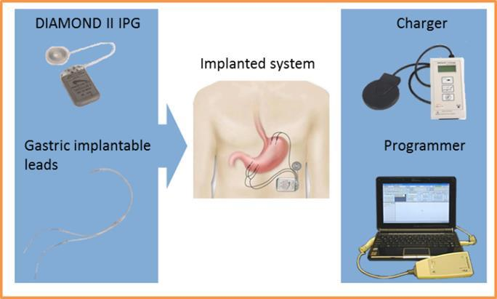

The DIAMOND™ system IPG is an internally powered (rechargeable lithium-ion battery) device that monitors intrinsic gastric electrical and mechanical activity and delivers GCM signals to the stomach.

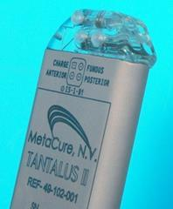
The DIAMOND™ system IPG is programmable, i.e., the parameters that control its functioning can be set by the attending medical/technical personnel to suit the patient’s needs. The DIAMOND™ system IPG communicates telemetrically with the Programmer. The Programmer can modify the IPG’s parameters, record statistics, maintain a log of the activity of the IPG, record standard programs for future use, reprogram the IPG with safe values in emergencies, etc.

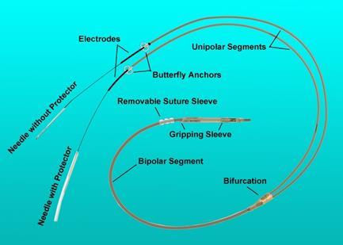
The DIAMOND™ system IPG is connected to three UltraFlex leads, two for sensing local antrum activity and to deliver GCM, and one for sensing local fundus activity. The UltraFlex leads have IS-1-BI connectors.

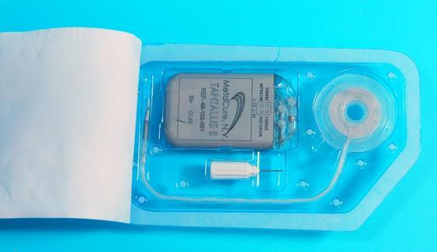
The DIAMOND™ system IPG is also connected to an implantable Charge Coil. The Charge Coil has a custom connector which prevents accidental placement into the IPG ports designated for the UltraFlex leads. Likewise, the IPG has a custom port for the implantable Charge Coil, which prevents accidental placement of UltraFlex leads into the port.

The DIAMOND™ system charger is an external, portable unit designed to charge an implanted DIAMOND™ system IPG. It transfers energy to the implanted device transcutaneously via electromagnetic induction.
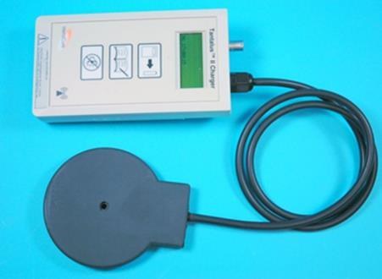

Delivery of the intervention
The DIAMOND™ system (IPG and electrodes) are implanted in a minimally-invasive laparoscopic procedure under general anaesthesia. A major benefit of implanting the DIAMOND™ system is that there is no manipulation and rearrangement of the patient’s anatomy and the device can be switched on or off in situ or removed.

Implanting the UltraFlex Leads:
Three bipolar electrodes are implanted: One bi-polar gastric lead is placed in the fundus for recording of fundus distension, and two bi-polar leads are placed in the pyloric antrum for slow-wave detection and signal delivery. Each electrode is made of an 18 mm long, 0.5-mm-diameter platinum–iridium coil coated with titanium nitride. Each electrode is inserted subserosally to the outer stomach wall and secured on both ends (anchor + nylon thread and titanium clip), and the electrode is fully embedded in the gastric wall. The electrodes are connected to the implantable device, which performed both the detection and the stimulation tasks. The device is implanted subcutaneously on the left upper side of the abdomen.
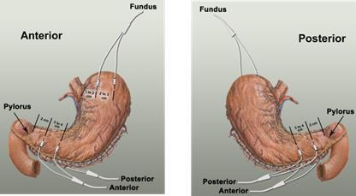

Implanting the IPG:
When all the electrodes are in place, a subcutaneous pocket for the DIAMOND™ system IPG is created. Before surgery the position of the DIAMOND™ IPG and Charge Coil is determined. The IPG is placed in parallel to the ribs, inferior to the rib cage. After the IPG is inserted, the connector pins of the electrode leads are tunnelled to the site of the IPG pocket. Once implanted, the IPG remains in the patient for 15 years.

Implantation of the Charge Coil:
The Charge Coil is placed in a subcutaneous pocket at the lower left lower part of the rib cage. The coil should be placed approximately 2cm (not deeper than 4cm) from the surface of the skin.

If the service is for investigative purposes, describe the technical specification of the health technology and any reference or “evidentiary” standard that has been established.
Not applicable.

Indicate whether the service includes a registered trademark with characteristics that distinguish it from any other similar health technology.
The placement service provision does not have a registered trademark associated with it. The treating Physician uses a trademarked programmer and wand for interrogating and programming of the IPG.
Indicate the proposed setting in which the proposed medical service will be delivered
It is proposed that the insertion of the DIAMOND™ system will be delivered in either an inpatient private or public hospital setting. The laparoscopic procedure takes approximately 2 hours to complete, and usually requires one overnight hospital stay.
After the implantation of the device, and at a normal post-surgical follow-up at approximately one week, the patient’s device will be switched on to initiate therapy. Thereafter, medical management of the patient will revert to the treating endocrinologist. One to two times a year this will involve the interrogation of the IPG.

Describe how the service is delivered in the clinical setting.
The procedure is performed by a laparoscopic surgeon, with the support of an assistant surgeon and one anaesthetist. The laparoscopic procedure takes approximately 2 hours to complete, and usually requires one overnight hospital stay. An endoscopy may be performed during the laparoscopic procedure to verify that the electrodes did not penetrate through stomach mucosa. In line with other laparoscopic surgical procedures, prophylactic antibiotics are recommended.
The main requirements for the procedure are associated with administering anaesthesia, and performing an endoscopy. This equipment is available at all hospitals offering laparoscopic surgical procedures, and therefore no additional resources are required in terms of capital equipment and infrastructure. The laparoscopic surgeon performing the procedure will undergo a formal training by MetaCure at specialised centres.
Patients who will receive GCM therapy will have been referred by a treating endocrinologist to a trained laparoscopic surgeon. As outlined previously, after the insertion of the DIAMOND™ IPG, patients will be managed by their treating endocrinologist.

Co-dependent information (if not a co-dependent application go to Section 6)
Please provide detail of the co-dependent nature of this service as applicable.
Not applicable

Comparator – clinical claim for the proposed medical service
Please provide details of how the proposed service is expected to be used
There are two comparators for the DIAMOND™ system. Each relate specifically to the two patient populations in which the DIAMOND™ system will be used. All patients using the DIAMOND™ system would follow the criteria:
- Type 2 Diabetes with Obesity (BMI ≥ 30 and <45 kg/m²)
- Patients uncontrolled on oral medications
- ≥ 18 years
- Normal triglycerides (fasting plasma triglycerides ≤1.7mmol/l)
- HbA1c ≥ 7.5%
The above patient population would be divided into the following subpopulations:
- Patients who require additional treatment and would refuse injectable therapy. This group would be:
- Suffer from fear of injecting or injection phobia;
- Incapable of injecting due to physical restrictions (arthritis, problems with hands, dexterity, etc.);
- Choose not to have injectable therapy because of frequency of injection and associated complications;
- Contradicted for injectable therapy for any other reason.
The comparator for this group is oral anti-diabetic (OAD) medication providing inadequate control.

- Patients who require additional treatment and would prefer GCM therapy rather than accepting injectable therapy. If GCM therapy were not available, these patients would accept injectable therapy.
The comparator for this group would be injectable therapy.
It is anticipated that patents will continue on optimal medical therapy (OMT).
Bariatric and other surgical interventions for weight loss are not considered to be appropriate comparators for the DIAMOND™ system. As discussed in detail in section 2 above, The DIAMOND™ system is not comparable with these devices because it:
- has a different mode of action;
- has an indication to improve glyceamic control and induced weight loss; and
- is indicated in a different population.

Expected health outcomes relating to the medical service
Identify the expected patient-relevant health outcomes if the service is recommended for public funding
If GCM therapy is recommended for public funding, the expected patient-relevant benefits would be:
- An improvement in HbA1c and blood glucose levels;
- A reduction in microvascular and macrovascular complications;
- Weight loss;
- Reduction of waist circumference;
- Reduced hypoglycaemic episodes;
- Improved compliance, due the automated and personalised therapy of the IPG. This is associated with better clinical outcomes;
- Reduction in cardiovascular risk factors, including cholesterol and blood pressure;
- Improved health-related quality of life;
- Reduction in complications associated with uncontrolled T2DM, leading to reduced hospitalisations, morbidity and quality of life.

Describe any potential risks to the patient.
There are minimal risks associated with GCM therapy, and the related adverse events are transient and consistent with laparoscopic procedures. This was the finding of the pivotal studies and global safety reporting. Adverse events reported for the DIAMOND™ system will be presented in detail in the full MSAC application.
It should be noted that a major benefit of implanting the DIAMOND™ system is that there is no manipulation and rearrangement of the patient’s anatomy and the device can be switched on or off in situ or removed.

Specify the type of economic evaluation.
As described above, the MSAC submission for GCM therapy will seek reimbursement in two patient populations. This application provides a summary of the results that would form the basis of the economic evaluation.
- In patients who are inadequately controlled on OADs, and refuse the addition of injectable therapies, the clinical claim is:
- GCM therapy offers superior clinical efficacy compared to OAD medication providing inadequate control;
- GCM therapy is ’superior in terms of diabetic treatment safety compared to OAD medication providing inadequate control. There are a number of well documented side effects related to high dose combination oral antidiabetic therapies (RACGP 2014-15, p49). It should be noted the insertion of the IPG is associated with transient and common side-effects of a laparoscopic procedure.
Table 2: Classification of an intervention for determination of economic evaluation to be presented
 |  | Comparative effectiveness versus comparator
 |  | Superior |  | Non-inferior | Inferior
Comparative safety versus comparator | Superior | Refuse the addition of injectable therapies (population 1)  CEA/CUA |  | CEA/CUA | Net clinical benefit | CEA/CUA
 |  |  |  |  | Neutral benefit | CEA/CUA*
 |  |  |  |  | Net harms | None^
 | Non-inferior | CEA/CUA |  | CEA/CUA | None^
 | Inferior | Net clinical benefit | CEA/CUA | None^ | None^
 |  | Neutral benefit | CEA/CUA*
 |  | Net harms | None^
- Abbreviations: CEA = cost-effectiveness analysis; CMA = cost-minimisation analysis; CUA = cost-utility analysis
- ^No economic evaluation needs to be presented; MSAC is unlikely to recommend government subsidy of this intervention

- In patients who require additional treatment and would prefer GCM therapy rather than accepting injectable therapy, the clinical claim is:
- GCM therapy is non-inferior to injectable therapies in terms of clinical efficacy;
- GCM therapy is superior to injectable therapies in terms of clinical safety. It should be noted the insertion of the IPG is associated with transient and common side-effects of a laparoscopic procedure. However compared with the hypoglycaemic events and weight gain related complications with injectable therapies, GCM therapy offers superior safety.

Based on these claims, a cost-effective or cost-utility analysis is appropriate for both patient populations as outlined in Table 33.

Table 33: Classification of an intervention for determination of economic evaluation to be presented
 |  | Comparative effectiveness versus comparator
 |  | Superior |  | Non-inferior | Inferior
Comparative safety versus comparator | Superior | CEA/CUA |  | Prefer GCM therapy rather than accepting injectable therapy (population 2)  CEA/CUA | Net clinical benefit | CEA/CUA
 |  |  |  |  | Neutral benefit | CEA/CUA*
 |  |  |  |  | Net harms | None^
 | Non-inferior | CEA/CUA |  | CEA/CUA | None^
 | Inferior | Net clinical benefit | CEA/CUA | None^ | None^
 |  | Neutral benefit | CEA/CUA*
 |  | Net harms | None^
Abbreviations: CEA = cost-effectiveness analysis; CMA = cost-minimisation analysis; CUA = cost-utility analysis
^ No economic evaluation needs to be presented; MSAC is unlikely to recommend government subsidy of this intervention

Fee for the proposed medical service
Type of funding proposed for this service and details of the proposed fee.
The proposed funding and MBS item descriptors are outlined in Table 4. Separate item descriptors and funding are suggested for the following:
- Insertion, removal or replacement of the IPG;
- Insertion, removal or replacement of the three (3) gastric leads;
- Interrogation of the Implantable Pulse Generator (IPG) device.
It should be noted that the insertion and removal of both the IPG and gastric leads will require approximately the same technical complexity and duration. As such the proposed MBS fees for the process of insertion and removal should be set at the same level.
There are currently no reimbursed GCM therapies on the MBS. It is proposed that the implantation of the IPG device and gastric leads are similar to those associated with Implantable Cardiac Devices and cardiac electrodes (leads) (MBS item numbers 38353, 38356, 38365, 38368, 38654 and 11721). These MBS item numbers are appropriate as they are representative of the technical characteristics of the insertion, removal or replacement of the IPG and gastric leads and follow-up interrogation. This is outlined in further detail in Table 5.
As noted previously, the laparoscopic procedure is approximately 2 hours in duration. It is stipulated in the Medicare Benefits Schedule that the proposed MBS fee “is regarded as being reasonable on average for the service having regard to usual and reasonable variations in the time involved in performing the service on different occasions and to reasonable ranges of complexity and technical difficult” (Medicare Benefits Schedule, page 34). Therefore the proposed MBS codes reflect the MBS standard fee setting approach for the proposed interventions.
Table 4: Proposed MBS item descriptors
Category 3 - THERAPEUTIC PROCEDURES
MBS Item number XXXX
Permanent Implantable Pulse Generator (IPG) device insertion, removal or replacement of, for a patient with all of the following:
- Type 2 Diabetes Mellitus with Obesity (BMI ≥ 30 and <45 kg/m²);
- Inadequately controlled on standard oral glucose lowering (anti-diabetic) therapy;
- ≥ 18 years;
- Normal triglycerides (fasting plasma triglycerides ≤1.7mmol/l);
- HbA1c ≥ 7.5%.

Fee: $255.45 Benefit: 75% = $191.60

MBS Item number XXXXX
The permanent insertion, removal or replacement of three (3) bipolar gastric leads through laparoscopic procedure under general anaesthesia. The gastric leads are implanted and sutured in place: one pair in the fundus, one pair in the anterior antrum, and one pair in the posterior antrum, and then connected to the Implantable Pulse Generator (IPG).
Fee: $1,224.60 Benefit: 75% = $918.45

MBS Item number XXXXX
Interrogation of the Implantable Pulse Generator (IPG) device for the following:
- Interrogate the IPG therapeutic parameters as currently programmed;
- Modify IPG therapeutic parameters;
- Retrieve statistics accumulated by the IPG as it operates;
- Log the activity of the IPG;
- Store standard programs for future use.

Fee: $69.75 Benefit: 75% = $52.35 85% = $59.30

Table 5 Comparison of Schedule fees for MBS items relating to Implantable Cardiac Devices and cardiac electrodes (leads)
Description | Item code | Value
38353 | PERMANENT CARDIAC PACEMAKER, insertion, removal or replacement of, not for cardiac resynchronisation therapy, including cardiac electrophysiological services where used for pacemaker implantation | $255.45
38365 | Permanent cardiac synchronisation device (including a cardiac synchronisation device that is capable of defibrillation), insertion, removal or replacement of, for a patient | $255.45
38368 | Permanent transvenous left ventricular electrode, insertion, removal or replacement of through the coronary sinus, for the purpose of cardiac resynchronisation therapy, including right heart catheterisation and any associated venogram of left ventricular veins, other than a service associated with a service to which item 35200 or 38200 applies, for patients | $1,224.60
38654 | Permanent left ventricular electrode, insertion, removal or replacement of via open thoracotomy, for the purpose of cardiac resynchronisation therapy, for a patient | $1,224.60
38356 | DUAL CHAMBER PERMANENT TRANSVENOUS ELECTRODES, insertion, removal or replacement of, including cardiac electrophysiological services where used for pacemaker implantation | $837.35
11721 | IMPLANTED PACEMAKER TESTING of atrioventricular (AV) sequential, rate responsive, or antitachycardia pacemakers, including reprogramming when required, not being a service associated with a service to which Item 11700 or 11718 applies | $69.75

Please indicate the direct cost of any equipment or resources that are used with the service relevant to this application, as appropriate.
The following costs are relevant to GCM therapy, and will therefore be included in the economic evaluation:
- DIAMOND™ IPG device;
- Gastric leads
- The cost associated with the insertion, removal or replacement of IPG device
- Insertion, removal or replacement of gastric leads
- Professional/clinic visits
- Anaesthesia
- Hospital stay
- Endoscopy
- GP visits
- Ongoing interrogation of device
- Prophylactic antibiotics
- Endocrinologist visit
- Anti-diabetic medications
- Anti-diabetic monitoring
- Management of adverse events/complications
- Outpatient visits
- Emergency service

Clinical Management Algorithm - clinical place for the proposed intervention
The protocol for DIAMOND™ system requests reimbursement for a Gastric Contractility Modulation (GCM) device in patients with uncontrolled T2DM. These patients are obese (BMI ≥30 kg/m² and <45 kg/m²), inadequately controlled on standard oral glucose lowering (anti-diabetic) therapy, aged ≥ 18 years, have normal triglyceride levels (fasting plasma triglycerides ≤1.7mmol/l) and HbA1c ≥ 7.5%.
Within this broad population, MetaCure are seeking listing for a subgroup of patients who achieve the best outcome from the therapy. Therefore the following subpopulations will be examined:
- Patients who require additional treatment and would refuse injectable therapy. This group would be:
  - Suffer from fear of injecting or injection phobia;
  - Incapable of injecting due to physical restrictions (arthritis, problems with hands, dexterity, etc.);
  - Choose not to have injectable therapy because of frequency of injection and associated complications;
  - Contradicted for injectable therapy for any other reason.
- Patients who require additional treatment and would prefer GCM therapy rather than accepting injectable therapy. If GCM therapy were not available, these patients would accept injectable therapy.

Patients who require additional treatment and would refuse injectable therapy:
These patients would continue to have uncontrolled T2DM, which is associated with a range of macrovascular and microvascular complications, including an increased risk of cardiovascular mortality. Also neuropathy, severe renal insufficiency, retinopathy and leg ulcers developed in the course of inadequately controlled T2DM will contribute to the increased mortality and morbidity with associated costs.
Patients who require additional treatment and would prefer GCM therapy rather than accepting injectable therapy:
Insulin therapy commonly results in weight gain, and is often associated with hypoglycaemic episodes. The weight gain associated with insulin can be excessive, adversely affecting cardiovascular risk profile. It is worth noting that diabetes guidelines advocate that weight is a consideration in each step of the algorithm, emphasising not only the fact that excess weight is usually a major underlying factor in the development of T2DM, but also demonstrating awareness that drugs such as insulin, cause significant and harmful weight gain (Haslam 2008). Furthermore, the implications of having to inject several times a day can have a negative effect on patients overall quality of life. Hypoglycaemia is the leading limiting factor in glycemic management of insulin-treated type 2 diabetes (Cryer 2002). It is well established that the use of insulin is associated with increased risks of hypoglycaemia and weight gain (RACGP 2014-15). In contrast, the double blind cross over study of GCM therapy demonstrated no increase in hypoglycaemic episodes when GCM therapy is added onto oral anti-diabetic medications.

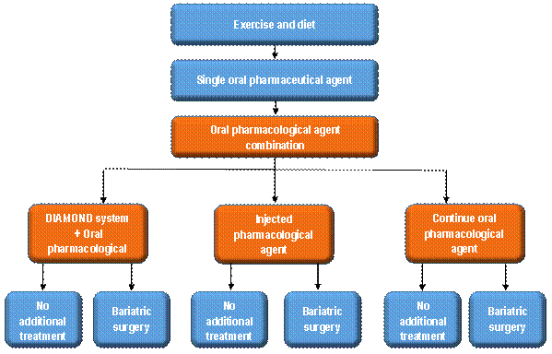
Figure 1 Clinical management algorithm in patients who require additional treatment

The treatment algorithm, should GCM therapy be listed on the MBS in this patient population, is outlined in Figure 1

Regulatory Information
Please provide details of the regulatory status. Noting that regulatory listing must be finalised before MSAC consideration.
The DIAMOND™ system was approved by the Therapeutic Goods Administration (TGA) in April 2012. The approved TGA intended purpose is as follows:
“For the treatment of Obesity and Type 2 Diabetics with Obesity. Intended to improve glycemic control and induce weight loss by monitoring intrinsic gastric electrical and mechanical activity and then delivering gastric contractility modulation signals to the stomach.”
The TGA approved indication is wider than the requested MSAC application. The population in the MSAC application reflects the current set of clinical evidence and economic value of the DIAMOND™ system in a narrower sub-population. As explained in Section 2, above, the understanding of the optimal place in treatment for the DIAMOND™ system has evolved over time, as additional studies have been completed.
Currently, the implantation of the DIAMOND™ system is not reimbursed through Medicare or subject to public funding by any other means. Patients who access treatment must currently pay for the device implantation out of their own pocket. MetaCure has initiated an application to have the DIAMOND™ system included on the Prostheses List.

Decision analytic
The figure below sets out the basic model structure. Where the DIAMOND™ system offers superior efficacy the model will be driven by improved HbA1c. Treatment to target HbA1c is the primary objective of glyceamic control in Type 2 diabetes. The cycle lengths of the model will be 6 months and the model will be run for a number of different long-term time horizons. It will be capable of being run as a lifetime model. A detailed model explanation will be provided in the MSAC submission

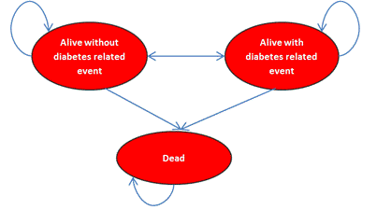
Figure 2 Basic model structure

Table 6 summarises the population, intervention, comparator and outcomes of GCM therapy for both the proposed populations.

Table 6: Summary of extended PICO to define research question that assessment will investigate
Patients | Intervention | Comparator | Outcomes to be assessed | Healthcare resources to be considered
Patients who require additional treatment and would refuse injectable therapy | DIAMOND™ system  (plus OMT) | Comparator 1: OAD medications that are providing inadequate control | HbA1c  Weight loss  Adverse events  Complications associated with T2DM  Quality of life/utilities  Mortality | IPG device  Gastric leads  Insertion, removal or replacement of IPG device  Insertion, removal or replacement of gastric leads  Professional/clinic visits  Anaesthesia  Hospital stay  Endoscopy  GP visits  Ongoing interrogation of device  Prophylactic antibiotics  Endocrinologist visit  Anti-diabetic medications  Anti-diabetic monitoring  Management of adverse events/complications  Outpatient visits  Emergency service
Patients who require additional treatment and would accept injectable therapy | DIAMOND™ system  (plus OMT) | Comparator 2: Injectable therapy | HbA1c  Weight  Hypoglycaemic events  Adverse events  Complications associated with T2DM  Quality of life | IPG device  Gastric leads  Insertion, removal or replacement of IPG device  Insertion, removal or replacement of gastric leads  Professional/clinic visits  Anaesthesia  Hospital stay  Endoscopy  GP visits  Ongoing interrogation of device  Prophylactic antibiotics  Endocrinologist visit  Anti-diabetic medications  Anti-diabetic monitoring  Management of adverse events/complications  Outpatient visits  Emergency service
Abbreviations: AEs, adverse events; OAD, Oral Anti-diabetic; OMT (optimal medical therapy)
Blood tests will be included in the economic evaluation to monitor and identify patients who are inadequately controlled on standard oral glucose lowering (anti-diabetic) therapy. This will include home based blood glucose monitoring, HbA1c levels, triglycerides and cholesterol levels.

Healthcare resources
Using Table 7 provide a list of the health care resources whose utilisation is likely to be impacted should the proposed intervention be made available as requested

Some of the health care resources whose utilisation is likely to be impacted should the proposed intervention be made available:
- Surgeon specialist time
- Hospital bed days
- Anaesthesia specialist time
- Anti-diabetic medications
- General practitioner time
- Accident and emergency visits

Questions for public funding
Please list questions relating to the safety, effectiveness and cost-effectiveness of the service / intervention relevant to this application,
- What are the medical and financial implications of inadequately controlled T2DM?

- What are the ideal patient population that would get the maximum benefit from GCM therapy?

- Which clinical group will be initiating treatment with GCM therapy?

- What proportion of patients who are receiving oral anti-diabetic (OAD) medication that is providing inadequate control, would accept injectable therapy?

- In patients who are uncontrolled on oral anti-diabetic (OAD) medication, what proportion would prefer not to have to start injectable therapy?

Table 7 List of resources to be considered in the economic analysis
 | Provider of resource | Setting in which resource is provided | Proportion of patients receiving resource | Number of units of resource per relevant time horizon per patient receiving resource | Disaggregated unit cost
 |  |  |  |  | MBS | Safety nets* | Other government budget | Private health insurer | Patient | Total cost
Resources provided to identify eligible population
None over and above current standard practice a
Resources provided to deliver proposed intervention
Insertion, removal or replacement of IPG device | Surgeon/ specialist | Private/public hospital | 100% | TBD | $255.45 | TBD |  |  |  | TBD
Insertion, removal or replacement of the gastric leads | Surgeon/ specialist | Private/public hospital | 100% | TBD | $1,224.60 | TBD |  |  |  | TBD
IPG device | Manufacturers | Private/public hospital | 100% | TBD |  |  | TBD | TBD |  | TBD
Gastric leads | Manufacturers | Private/public hospital | 100% | TBD |  |  | TBD | TBD |  | TBD
Anaesthesia | Specialist | Private/public hospital | 100% | TBD | TBD |  |  |  |  | TBD
Assistant surgeon | Surgeon/ specialist | Private/public hospital | 100% | TBD | TBD | TBD |  |  |  | TBD
Endoscopy | Specialist | Private/public hospital | 100% | TBD | TBD |  |  |  |  | TBD
Hospital stay | Hospital | Private/public hospital | 100% | TBD | TBD |  | TBD |  |  | TBD
Ongoing interrogation of device | Hospital | Private/public hospital | 100% | TBD | $69.75 |  |  |  |  | TBD
Prophylactic antibiotics | Hospital/PBS | Private/public hospital | 100% | TBD |  |  | TBD |  | TBD | TBD
Endoscopy | Specialist | Private/public hospital | 100% | TBD | TBD |  |  |  |  | TBD
Hospital stay | Hospital | Private/public hospital | 100% | TBD | TBD |  | TBD |  |  | TBD
Resources provided in association with the proposed intervention
Endocrinologist visit | Specialist | Private/public hospital | 100% | TBD | TBD |  |  |  | TBD | TBD
GP visits | GP | Community | TBD | TBD |  |  | TBD |  | TBD | TBD
Outpatient visits | Specialist | Private/public hospital | TBD | TBD |  |  | TBD |  |  | TBD
Resources provided to deliver comparator 1: oral anti-diabetic (OAD) medication providing inadequate control.
Endocrinologist visit | Specialist | Private/public hospital | 100% | TBD | TBD |  |  |  | TBD | TBD
GP visits | GP | Community | TBD | TBD |  |  | TBD |  | TBD | TBD
Outpatient visits | Specialist | Private/public hospital | TBD | TBD |  |  | TBD |  |  | TBD
Emergency service | Hospital | Private/public hospital | TBD | TBD |  |  | TBD |  |  | TBD
Hospital stay | Hospital | Private/public hospital | TBD | TBD |  |  | TBD |  |  | TBD
Inpatient nights | Hospital | Private/public hospital | TBD | TBD |  |  | TBD | TBD |  | TBD
Anti-diabetic medications | PBS | Community | TBD | TBD |  |  | TBD |  | TBD | TBD
Resources provided to deliver comparator 3: Injectable therapy
Endocrinologist visit | Specialist | Private/public hospital | 100% | TBD | TBD |  |  |  | TBD | TBD
GP visits | GP | Community | TBD | TBD |  |  | TBD |  | TBD | TBD
Outpatient visits | Specialist | Private/public hospital | TBD | TBD |  |  | TBD |  |  | TBD
Emergency service | Hospital | Private/public hospital | TBD | TBD |  |  | TBD |  |  | TBD
Hospital stay | Hospital | Private/public hospital | TBD | TBD |  |  | TBD |  |  | TBD
Inpatient nights | Hospital | Private/public hospital | TBD | TBD |  |  | TBD | TBD |  | TBD
Anti-diabetic medications | PBS | Community | TBD | TBD |  |  | TBD |  | TBD | TBD
Resources provided in association with comparators 1 and 2 (and proposed intervention)
Ongoing diabetes management, including GP and specialists consultations, A&E visits, hospitalisations as required (likely to vary according to outcomes achieved)
Resources used to manage patients successfully treated with the proposed intervention
Ongoing diabetes management, including GP and specialists consultations, A&E visits, hospitalisations as required (likely to vary according to outcomes achieved)
Resources used to manage patients who are unsuccessfully treated with the proposed intervention
Ongoing diabetes management, including GP and specialists consultations, A&E visits, hospitalisations as required (likely to vary according to outcomes achieved)
* Include costs relating to both the standard and extended safety net.

References:
Harold E. Lebovitz, Bernhard Ludvik, Jaroslaw Kozakowski, Wieslaw Tarnowski, Mateusz Zelewski, Irit Yaniv, Tse’ela Schwartz Gastric Electrical Stimulation Treatment of Type 2 Diabetes: Effects of Implantation versus Chronic Meal-Initiated Stimulation. A Randomized Blinded Cross-over Trial. Unpublished.
Lebovitz Ludvik Kozakowski
RACGP Diabetes Australia General Practice Managment of Type 2 Diabetes 2014-2015.
Wong S, Kong AP, Osaki R, Ng VW, Andrea Luk, Chan LL, Lam CC, Lebovitz HE, Ng EK, Chan JC A Prospective Case-Control Study To Compare The Efficacy Of Laparoscopic Placement Of Gastric Contraction Modulator (TANTALUS II - DIAMOND) Versus Supplementary Insulin Treatment In Obese Type 2 Diabetic Patients 2014.
(2012). Australian Health Survey: Biomedical Results for Chronic Disease, 2011-2012 Cat number 4364.0.55.005.
(2012). Diabetes: the silent pandemic and its impact on Australia, Baker IDI Heart and Diabetes Insitute.
Busko, M. (2014). "Insulin Related Hypoglcemia: Common, Costly, Preventable." Medscape(March 11).
Colditz, G. A., W. C. Willett, A. Rotnitzky and J. E. Manson (1995). "Weight gain as a risk factor for clinical diabetes mellitus in women." Ann Intern Med 122(7): 481-486.
Cryer, P. E. (2002). "Hypoglycaemia: the limiting factor in the glycaemic management of Type I and Type II diabetes." Diabetologia 45(7): 937-948.
Field, A. E., E. H. Coakley, A. Must, J. L. Spadano, N. Laird, W. H. Dietz, E. Rimm and G. A. Colditz (2001). "Impact of overweight on the risk of developing common chronic diseases during a 10-year period." Arch Intern Med 161(13): 1581-1586.
Haslam, D. (2008). "Managing obesity and type 2 diabetes: the challenges of guideline implementation." Drugs in Context 4(2): 937-948.
Lebovitz, H. E., B. Ludvik, I. Yaniv, W. Haddad, T. Schwartz and R. Aviv (2013). "Fasting plasma triglycerides predict the glycaemic response to treatment of type 2 diabetes by gastric electrical stimulation. A novel lipotoxicity paradigm." Diabet Med 30(6): 687-693.

Appendix A – List of trials of GCM and the inclusion criteria of each trial
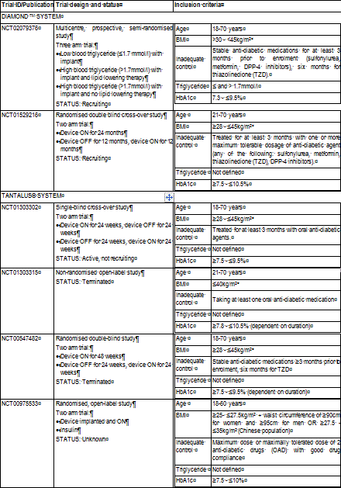
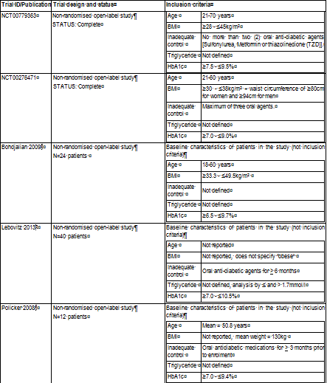
Bohdjalian A, et al (2009). Improvement in glycemic control in morbidly obese type 2 diabetic subjects by gastric stimulation. Obes Surg 19: 1221-7.
Lebovitz HE, et al (2013). Fasting plasma triglycerides predict the glycemic response to treatment of type 2 diabetes by gastric electrical stimulation. A novel lipotoxicity paradigm. Diab Med 30:687-93.
Policker S, et al (2008). Electrical stimulation of the gut for the treatment of type 2 diabetes: the role of automatic eating detection. J Diab Sci Tech 2(5): 906-12.
Sanmiguel CP, et al (2009). Gastric electrical stimulation with the TANTALUS® system in obese type 2 diabetes patients: effect on weight and glycemic control. J Diab Sci Tech 3(4): 1-7

The definition of normal triglycerides used for this application is consistent with the GCM therapy clinical trial data. In some cases, normal triglycerides are defined as fasting plasma triglycerides <2.0mmol/l ((2012). Australian Health Survey: Biomedical Results for Chronic Disease, 2011-2012 Cat number 4364.0.55.005.

