**Applicant Submitted Protocol:**

**Endobronchial Coil System for the treatment of Severe Emphysema**

**Medical Services Advisory Committee**

**Application 1401**

**For consideration by the**

**Protocol Advisory Sub-Committee (PASC)**

**August/2015**

## 1) Title of Application

Endobronchial Coil System for the treatment of severe emphysema: Application 1401

## 2) Purpose of application

***Please indicate the rationale for the application and provide one abstract or systematic review that will provide background.***

The endobronchial coil system for severe emphysema is an innovative, established treatment that is new to Australia and that does not apply to any existing MBS item. This application seeks to apply for a MBS item number and benefit.

The comparator to this service is best practice management for emphysema which includes the staged introduction of medications and pulmonary rehabilitation in response to symptom presentation and severity.

There have been more than 3500 patients treated internationally of which 80% are in the commercial setting and 20% under clinical study protocols. A total of five peer-reviewed publications reporting on over 140 patients are indexed, including one randomized, controlled trial (RCT), see below. The endobronchial coil system procedure has demonstrated clinically significant improvements in exercise capacity, lung function, and quality of life for patients suffering from emphysema whilst maintaining a good safety profile.

**Abstract Example:**

**Shah PL et al. Endobronchial coils for the treatment of severe emphysema with hyperinflation (RESET): a randomised controlled trial. *The Lancet Respiratory Medicine*. May 2013; 1:233-240**

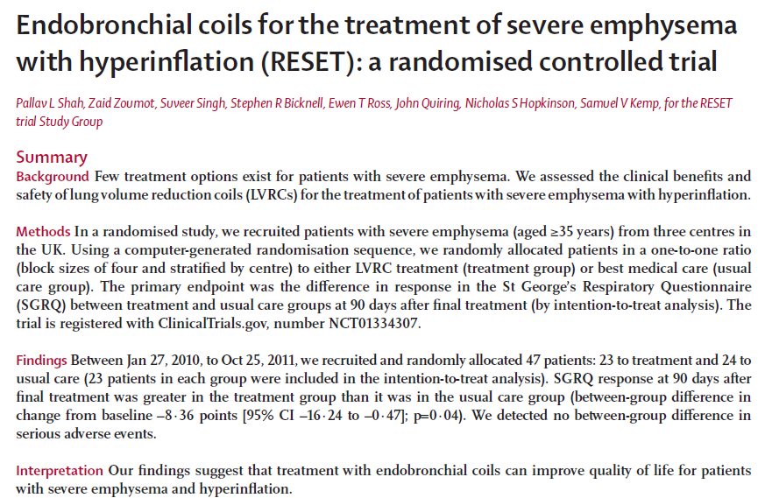

## 3) Population and medical condition eligible for the proposed medical services

**Provide a description of the medical condition (or disease) relevant to the service.**

Emphysema

* A degenerative phenotype of Chronic Obstructive Pulmonary Disease (COPD) defined pathologically as the presence of permanent enlargement of the airspaces distal to the terminal bronchioles, accompanied by destruction of elastin in alveolar walls and without obvious fibrosis[1].
* Emphysema is a pathological diagnosis, and consists of alveolar dilatation and destruction. Breathlessness with exertion, chest tightness and wheeze are the results of airway narrowing and impaired gas exchange. The loss of lung elastic tissue in emphysema may result in airway wall collapse during expiration, leading to dynamic hyperinflation and consequent increased work of breathing[2]
* Emphysema is the phenotype of COPD targeted for this treatment. Patients with “mixed” phenotypes including minimal amounts of chronic bronchitis or small airways disease are also candidates, as long as they are primary emphysema-dominant phenotype patients. Patients with chronic bronchitis, small airways disease COPD phenotypes, or patients with a predominant asthma component are not candidates for this treatment.

Emphysema due to Smoking

* Smoking causes destruction of lung tissue and alveoli, and irritation of the airways, causing inflammation and damage to the cilia which line the bronchial tubes, resulting in difficulty clearing the airways of mucus.
* Alveoli that normally support the physical shape and function of the airways are progressively destroyed, resulting in airway collapse and air trapping, leading to hyperinflation of the diseased lung.
* Tissue that normally holds airways open (with a generally round open cross section) gets destroyed which makes these airways unable to hold their functional shape upon exhalation

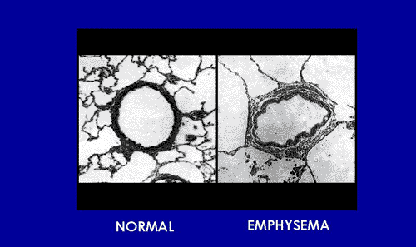

**Elasticity is lost and the airway is not held open - high flow resistance if allowed to collapse**

Inhalation with Emphysema

* The lung is expanded to create low pressure in the lung (relative to the atmosphere) and air is drawn in where there is less elasticity (most damaged areas) preferentially. Areas of low elasticity (high damage) trap air and hyperinflate, compressing healthier parts of the lung and preventing them from expanding normally.

Exhalation with Emphysema

* Pressures are elevated in the lung to exhaust gas out
* Radial outward forces, holding airways open, are reduced by the disease
* Air is trapped or shut off during exhalation because the pressure throughout the lung simply compresses airways and allows portions of them to be collapsed flat
* The closed off airways passages makes exhalation difficult to impossible
* This process is commonly referred to as air trapping

Hyper-inflation

* The most diseased regions of the lung trap air, causing them to inflate larger and larger during breathing cycles. This is exacerbated by the breaking down of the alveolar walls.
* The more non-destroyed regions of the lung (the lung tissue that is still functioning to exchange gas) gets compressed by the hyper-inflated portion
* The compression effectively compromises the only remaining tissue that is exchanging gas in the lung
* This effect can be observed during 6 minute walk tests where the patient abruptly stops during the 6 minute period because they are exhausted and can't continue.
* Also during activity, the trapping of air causes the lungs to progressively hyperinflate (dynamic hyperinflation)—which in turn causes significant shortness of breath

Classification of Disease Distribution

Weder et al[3] has presented a classification in which three types of relevant morphologic types of emphysema distribution are considered.

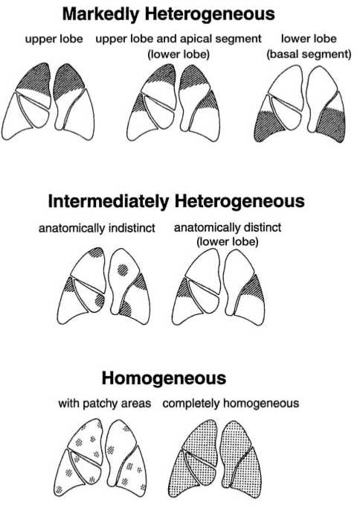

Figure 1. Three major types of emphysema distribution were

defined: markedly heterogeneous (upper panel), intermediately

heterogeneous (middle panel), and homogeneous (lower panel).

Classification of Disease Severity

The Global Initiative for Chronic Obstructive Lung Disease (GOLD)[4] provides classification of airflow limitation severity in COPD based on Post-Bronchodilator FEV1.

|  |  |  |  |
| --- | --- | --- | --- |
| Stage I | Mild COPD | FEV1/FVC<0.70 | FEV1≥ 80% normal |
| Stage II | Moderate COPD | FEV1/FVC<0.70 | FEV1 50-79% normal |
| Stage III | Severe COPD | FEV1/FVC<0.70 | FEV1 30-49% normal |
| Stage IV | Very Severe COPD | FEV1/FVC<0.70 | FEV1 <30% normal, or <50% normal with chronic respiratory failure present* |

* Usually, this means requiring long-term oxygen therapy.

Lung Foundation Australia also provides classification[5] of airflow limitation in COPD on Post -Bronchodilator FEV1.

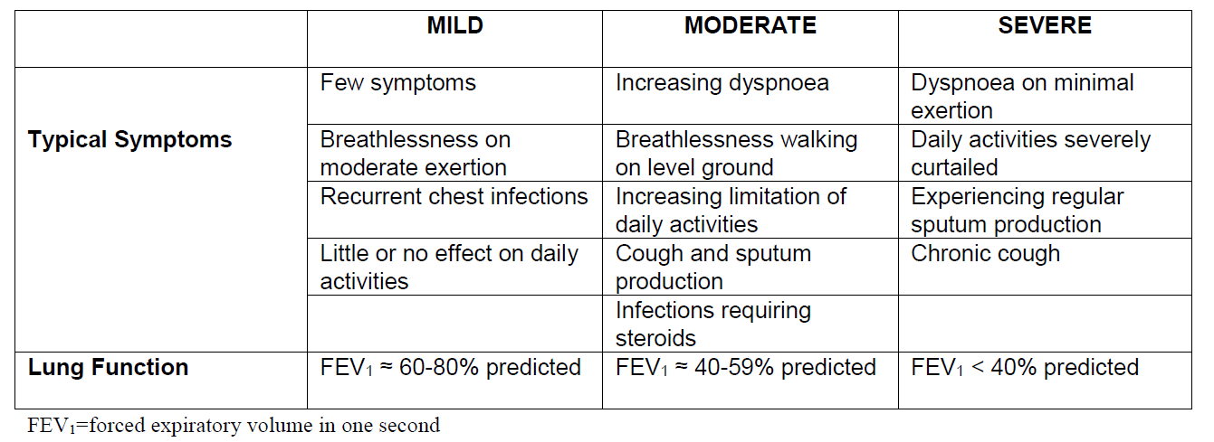

Please note: As all patient selection criteria in clinical trial for endobronchial coil procedure has been performed using the GOLD classification of disease, patient selection for coil treatment will continue to utilise the GOLD classification criteria.

**Define the proposed patient population that would benefit from the use of this service. This could include issues such as patient characteristics and /or specific circumstances that patients would have to satisfy in order to access the service.**

COPD patients with emphysema phenotype with the following selection criteria:

| INCLUSION CRITERIA | EXCLUSION CRITERIA |
| --- | --- |
| * GOLD COPD III / IV * Patients aged > 35 years * Residual Volume >175% * Total Lung Capacity > 100% * post BD FEV ≤ 45% predicted * Sufficient Structural Tissue (CT) with preserved airways (visual analysis) * Homogenous or heterogeneous disease distribution | * Giant Bullae (Approx. 1/3 of lobe or greater) * Medical necessity of continuous anticoagulant or antithrombotic treatment (except Aspirin) * Clinically significant bronchiectasis * Pulmonary Hypertension (PAP > 50mmHg) * Patients with signs of current lung infection |

Emphysema patients are the population intended to be treated with the coil procedure. Discerning emphysema from bronchitis represents a challenge for physicians however both the GOLD guidelines and Lung Foundation Australia define Chronic bronchitis is daily sputum production for at least three months of two or more consecutive years.[6],[7]  Chronic Bronchitis is not an indication for treatment with endobronchial coils.

There are 3 other inclusion/exclusion criteria used in the published coil studies, which were criteria included in the National Emphysema Treatment Trial (NETT), the 1,218 patient randomized, controlled trial comparing lung volume reduction surgery (LVRS) to optimal medical management. These criteria may also be considered; notes below address how these criteria are used in commercial practice in Europe.

| Criterion | Notes |
| --- | --- |
| Patients must have ceased smoking for at least 8 weeks | **Smoking cessation efforts (which may include transition to nicotine patches instead of smoking) are an important element of emphysema management.** |
| Patient must achieve a minimal 6MW distance of 140m | **This criterion is used in NETT to ensure patients were not too frail to undergo surgery. In Europe, patients who are able to complete a 6MWT are considered eligible for the endoscopic implants, which is a far lower risk procedure than surgery.** |
| Patients are excluded if they have had lung surgery, transplant or lobectomy. | **Patients should be considered for treatment with coils after single-lung transplant to manage native-lung hyperinflation. Patients may also be treated with coils as a “bridge to transplant”, with the goal of stabilizing emphysema patients on the transplant list.** |

The Coil ‘Instructions for Use’ document indicates the safety effectiveness of Coil therapy has not been established in the following patient populations:

• Patients >75 years of age

• Children under the age of 18

• Pregnant or lactating women

• Patients who have not quit smoking

• FEV1 <15% of predicted value

• Patients with DLCO </= 20% of predicted value

• Patients with giant bullae

• Patients with pulmonary hypertension

• Patients with serious bleeding disorders

• Patients who have had prior lung transplant, LVRS, median sternotomy, or lobectomy

• Patients with Alpha-1 antitrypsin deficiency

• Patients with congestive heart failure or recent myocardial infarction

• Patients with moderate to severe chronic inflammatory autoimmune disorders that have tendency to cause an overactive immune system response

These patient populations have not been added to the coil procedure MBS protocol exclusion criteria as these populations were not listed in exclusion criteria in coil procedure research. These populations are unstudied or currently in study (e.g. Alpha-1 antitrypsin deficiency), and may be treated at the discretion of the treating physician based on the physician’s risk versus benefit assessment.

**Indicate if there is evidence for the population who would benefit from this service i.e. international evidence including inclusion / exclusion criteria. If appropriate provide a table summarising the population considered in the evidence.**

Evidence for the population to benefit from this service is presented in the following 4 publications:

Table 1 Slebos DJ et al. Bronchoscopic Lung Volume Reduction Coil treatment of patients with severe heterogeneous emphysema. CHEST 2012;142(3):574-582

| Inclusion Criteria | Exclusion Criteria |
| --- | --- |
| * FEV 1 < 45% of predicted * TLC > 100% of predicted * mMRC dyspnea score > 1 * Non-smoker for > 8 wk * Heterogeneous emphysema, determined by the treating physician | * Change in FEV 1 > 20% post bronchodilator * Dlco < 20% predicted * Right ventricular pressure > 50 mm Hg * > 3 hospitalizations due to COPD exacerbations in the previous 12 months * Clinically significant bronchiectasis * Previous lung surgery, or a giant bulla ( > 1/3 of the lung volume) * 6-min walk test < 140 m * Any use of clopidogrel or coumarins * Any disease that might compromise survival (such as active lung cancer), or any other disease likely to interfere with completion of study or follow-up assessments, or that would adversely affect outcomes |

Table 2 2. Shah PL et al. Endobronchial coils for the treatment of severe emphysema with hyperinflation (RESET): a randomised controlled trial. The Lancet Respiratory Medicine. May 2013; 1:233-240

| Inclusion Criteria | Exclusion Criteria |
| --- | --- |
| • Aged ≥35 years  • High resolution CT scan indicates unilateral or bilateral emphysema  • High resolution CT scan indicates homogeneous or heterogeneous emphysema  • A post-bronchodilator FEV1 ≤45% predicted  • Total lung capacity >100% predicted  • Patient has marked dyspnoea score ≥2 on modified Medical Research Council scale of 0–4  • Patient has stopped smoking for a minimum of 8 weeks before enrolment | • A change in FEV1 greater than 20% post-bronchodilator  • A single-breath diff using capacity for carbon monoxide <20% predicted  • A history of recurrent clinically significant respiratory infection  • An uncontrolled pulmonary hypertension defined by right ventricular pressure >50 mm Hg or evidenced by echocardiogram  • An inability to walk >140 m in 6 min  • Evidence of other diseases that can compromise survival—e.g. lung cancer or renal failure  • Pregnant or lactating  • An inability to tolerate bronchoscopy under heavy sedation or anaesthesia  • Clinically significant bronchiectasis  • Giant bullae greater than a third of lung volume  • Previous lung volume reduction surgery, lung transplant, or lobectomy  • Participation in other pulmonary drug studies within 30 days of enrolment  • Taking greater than 20 mg prednisone (or similar steroid) daily  • On clopidogrel or unable to stop treatment for 1 week before the procedure |

Table 3 3. Deslee G et al. Lung Volume Reduction coil treatment for patients with severe emphysema: a European multicentre trial. Thorax Online First 2 June, 2014 doi:10.1136/thoraxjnl-2014-205221

| Inclusion Criteria | Exclusion Criteria |
| --- | --- |
| * >35 years of age * CT scan indicates bilateral heterogeneous emphysema * Post-bronchodilator FEV1 <45% of predicted * Total lung capacity >100% of predicted * RV >175% of predicted * mMRC ≥2 (0–4) * Stopped smoking for >8 weeks prior to entering the study | * Change in FEV1 >20% post-bronchodilator * TLCO <20% of predicted History of recurrent clinically significant respiratory infection * Pulmonary hypertension: right ventricular pressure >50 mm Hg * Inability to walk >140 m in 6 min * Previous LVR surgery, lung transplant or lobectomy * Clinically significant bronchiectasis * Giant bullae more than one-third lung volume * Severe destructed homogeneous emphysema by CT scan * Patient on antiplatelet agent (e.g. clopidogrel) or anticoagulant therapy (e.g. heparin or coumadin) or has not been weaned off prior to procedure |
| 4. Klooster K. et al. Lung Volume Reduction Coil Treatment in Chronic Obstructive Pulmonary Disease Patients with Homogeneous Emphysema: A Prospective Feasibility Trial. *Respiration* | |
| Inclusion Criteria | Exclusion Criteria |
| * >35 years of age * CT scan indicating homogeneous emphysema * Post-bronchodilator FEV1 ≤35% predicted * Post-bronchodilator FVC ≤90% predicted * TLC >120% predicted * RV >225% predicted * RV/TLC >60% * Dyspnea score >1 on mMRC scale of 0–4 * – Stopped smoking for a minimum of 6 months prior to procedure | * DLCO <20% predicted * History of recurrent clinically significant respiratory infection * Uncontrolled pulmonary hypertension defined by right ventricular pressure >50 mm Hg * Inability to walk >140 m (150 yards) in 6 min * Evidence of other disease that may compromise survival, such as lung cancer, etc. * Clinically significant bronchiectasis * Giant bullae >1/3 lung volume * Previous LVR surgery, lung transplant or lobectomy * >20 mg prednisone (or equivalent) daily * Antiplatelet agent which cannot be weaned off prior to procedure |

**Provide details on the expected utilisation, if the service is to be publicly funded.**

It is estimated about 1000 Australians would benefit from the coil procedure based on the following rationale.

Prevalence of COPD in AUSTRALIA

• Toelle [8] reports that the weighted prevalence of GOLD stage III or IV COPD is 0.9% in all people aged 40 years or over (Toelle 2013, Table 2)

• The ABS reports the estimated number of Australians age 40 years or over was 10,713,254 in 2014[9]

• Thus, there are approximately 96,419 Australians aged 40 or over who have GOLD stage III or IV COPD

It is not clear what proportion of these people have COPD due to emphysema only, as the Toelle study does not distinguish between COPD due to emphysema and chronic bronchitis.

Estimating Prevalence of Emphysema in AUSTRALIA

There is no published or available data that estimates the prevalence of emphysema in Australia.

Data from www.lung.org, the U.S. American Lung Association calculates the following::

* + In 2011, 12.7 million U.S. adults (aged 18 and over) were estimated to have COPD. However, close to 24 million U.S. adults have evidence of impaired lung function, indicating an under diagnosis of COPD.
  + In 2011, an estimated 10.1 million Americans reported a physician diagnosis of chronic bronchitis. Chronic bronchitis affects people of all ages, although people aged 65 years or more have the highest rate at 64.2 per 1,000 persons.
  + Of the estimated 4.7 million Americans ever diagnosed with emphysema, 92 percent are 45 or older.
  + In 2011, COPD prevalence ranged from less than 4 percent in Washington and Minnesota to more than 9 percent in Alabama and Kentucky.

This data demonstrates that 4.7 million Americans have been diagnosed with emphysema, which is 37% of the total number diagnosed with COPD.

37% of the estimated 96,410 Australian COPD population over the age of 40 who have GOLD stage III or IV equates to an estimated subpopulation of 35,675 COPD sufferers with GOLD stage III or IV emphysema over the age of 40.

Australian Emphysema patients suitable for coil therapy

The following factors will determine the population of emphysema patients accessing coil treatment:

Many of the potential 35,675 emphysema patients may:

* Demonstrate a “mixed phenotype” disease, meaning a combination of chronic bronchitis and emphysema, or emphysema with a significant asthma component.
* Be adequately managed and no longer symptomatic on optimized medications, or die prior to qualifying for the treatment.
* Demonstrate excluding co-morbidities common to COPD patients, including lung cancer, heart or vascular disease, bronchiectasis, and/or significant pulmonary hypertension.
* Fail to meet other inclusion/exclusion selection criteria
* Fail to satisfy procedural requirements for anesthesia, e.g. frailty, age, health status
* Be in the care of a general practitioner, a respiratory physician or a medical pulmonologist. Patients must be referred to an interventional pulmonologists trained in the coil procedure so it is expected a number of suitable patients may not be advanced through the appropriate referral channels to receive the treatment.

It is estimated that a pool of about 1000 Australians may utilise the coil procedure service.

## 4) Intervention – proposed medical service

***Provide a description of the proposed medical service.***

The service is a therapeutic procedure to implant lung coils via bronchoscope with fluoroscopic guidance whilst patient is under conscious sedation or general anaesthesia. One lobe is treated per procedure, with the most diseased lobe usually treated first. Full treatment is bilateral; the second lobe will be treated 30-60 days after the first. Whilst the bronchoscope is held by an assistant, the rendering practitioner employs a delivery system to sound the airway, assess a safety distance from pleura, measure airway to assess for coil sizing, and finally deliver and deploy the Coil, under fluoroscopic guidance. The deployed Coil can be viewed under fluoroscopy, and then released from the Forceps. Ten to fourteen Coils (10-12 upper lobe, 11-14 lower lobe) should be distributed evenly throughout the sub-segments of each treated lobe, to optimize re-tensioning effects of the Coils. The procedure duration is typically 30-45 minutes, depending on patient anatomy and physician experience.

Implantation Procedure

Step 1: Advance Guidewire into sub segment  
**Step 1: Advance Guidewire into sub segment**

* Bronchoscope is directed into the targeted airway.
* Guidewire is advanced under fluoroscopic guidance into airway and radio opaque markers located on the Guidewire help to determine appropriate Coil length.
* The Guidewire should not be advanced beyond curves in the airway that indicate close proximity to the pleura.

Step 1: Advance Guidewire into sub segment

**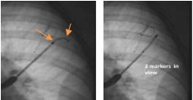  
Step 2: Advance delivery Catheter**

* Advance delivery Catheter to align with tip

of Guidewire.

* Count markers to select optimum Coil

length.

Step 2: Advance delivery Catheter

* Load the selected Coil into the Cartridge by passing the Forceps into and through the Cartridge and grasping the proximal ball of the Coil, and pulling the Coil into the Cartridge; the Cartridge straightens the Coil for passing into the Catheter.

Step 3: Coil deployment

**Step 3: Coil deployment**

* Bronchoscope is secured to prevent migration.
* The Cartridge is locked onto the proximal end of the Catheter and the Coil is advanced to the tip of the Catheter.
* The Coil is deployed by withdrawing the Catheter OFF the Coil until 3cm of the Coil tip is deployed.
* The Catheter is then simultaneously pulled back as the Forceps (attached to the Coil) is advanced forward; and stopped once visible on fluoroscopy.
* After deployment the Coil re- assumes its coiled shape and can be released by the Forceps, which is then removed for reloading of the next Coil.
* Catheter is left in place for the next deployment.

Step 3: Coil deployment

Mechanism of Action

The Coil is designed to increase elastic recoil to improve lung compliance and shift preferential filling from diseased to healthier tissue. It reduces air trapping and hyperinflation by radially suspending and tethering airways open and maintains airway patency, preserving distal access and flow.

The coil is designed to compress the diseased tissue, adjust lung compliance, and help increase the lung's elastic recoil.

The coil mechanism of action is discussed in the following published articles:

**Shah PL et al. Endobronchial coils for the treatment of severe emphysema with hyperinflation (RESET): a randomised controlled trial. The Lancet Respiratory Medicine. May 2013; 1:233-240**

“The beneﬁcial eﬀects of LVRCs could be due to regional compression of the lung and subsequent expansion of better-functioning areas of the lung. An additional mechanism is that coils re-establish tethering in the small airways, thereby improving elastic recoil of the lung. Restoration of lung tension and the stretch on the small airways supports the walls of the small airways, holding them open and preventing premature collapse or narrowing during expiration. This improved patency of airways during expiration allows the gradual release of trapped gas, indicated by reduction of residual volume and fall in residual volume to total lung capacity ratio. This mechanism would also reduce dynamic hyper inﬂation and could explain the improvement in exercise capacity that has been seen after LVRC treatment.”

**Deslee G, Klooster K, Hetzel M, et al. Lung volume reduction coil treatment for patients with severe emphysema: a European multicentre trial. Thorax Published Online First: 2 June 2014 doi:10.1136/thoraxjnl-2014-20522**

“It can be hypothesised that LVR coil treatment is similarly efﬁcient in both heterogeneous and homogeneous emphysema because of a different mechanism of action from true ‘lung volume reducing’ therapies, as the primary mechanism of action of coils appears to be mechanical re-tensioning of the airway network rather than just reducing absolute lung volume alone.”

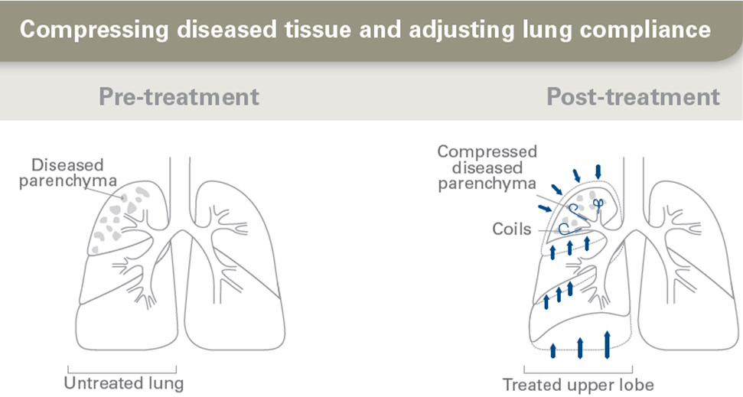

The coil is designed to maintain airway patency, preserving distal access while reducing airway collapse during exhalation and exercise.

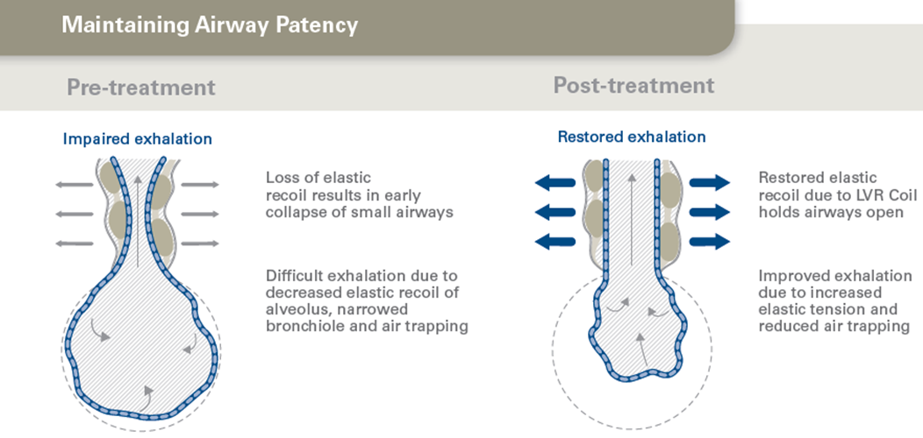

Indications for Use

The endobronchial Coil System is intended to improve exercise capacity, lung function and quality of life in patients with both heterogeneous and homogeneous emphysema.

Contraindications

The endobronchial Coil system is contraindicated for:

* Patient for whom bronchoscopic procedures are contraindicated
* Patients with evidence of active infection on the lungs
* Patients with known allergies to Nitinol (nickel-titanium)

Warnings

* Do not use the device if the package is damaged as sterility may be compromised.
* Store this product in a dry place
* Failure to follow loading and deployment procedure may cause damage to the Coil. Discard and replace if needed.
* The Coil System should be used with caution and only after careful consideration, especially in patients with:
* History of recurrent clinically significant respiratory infections
* Clinically significant bronchiectasis
* Patients requiring long term high dose oral steroids
* Hypercapnia

Do not attempt to resterilize any of the Coil System components. All components are provided sterile and have been designed and tested for single use only. If the surface finish of the Coil is scratched, nicked or otherwise compromised, re-use could result in functional failure or could possibly cause the implant to break. The product components were not designed to be adequately cleaned and sterilized for re-use, and thus re-use could result in infection or infectious disease. In addition, the Coil and Delivery System components may not function as intended if re-used after being subjected to re-sterilisation that requires elevated temperatures.

The safety effectiveness of Coil therapy has not been established in the following patient populations:

• Patients >75 years of age

• Children under the age of 18

• Pregnant or lactating women

• Patients who have not quit smoking

• FEV1 <15% of predicted value

• Patients with DLCO </= 20% of predicted value

• Patients with giant bullae

• Patients with pulmonary hypertension

• Patients with serious bleeding disorders

• Patients who have had prior lung transplant, LVRS, median sternotomy, or lobectomy

• Patients with Alpha-1 antitrypsin deficiency

• Patients with congestive heart failure or recent myocardial infarction

• Patients with moderate to severe chronic inflammatory autoimmune disorders that have a

tendency to cause an overactive immune system response

***Caution – These instructions are provided as a general informational guide for the safe, effective use of the endobronchial Coils. Medical practitioners should always rely on their clinical experience and judgment, including current sterile techniques and surgical practices.***

Precautions

Read all labels and instructions prior to use. Ignoring or not fully recognising or understanding the Instructions For Use may result in procedural difficulties and/or complications.

The endobronchial Coil System is intended to be used with a bronchoscope with a 2.8mm minimum Inner Diameter working channel and a 65cm maximum working length.

**Caution – using with incompatible bronchoscope may result in equipment or device damage.**

Magnetic Resonance Imaging (MRI) Information

The Coil was determined to be MR-Conditional according to the terminology specified in the American Society for Testing and Materials (ASTM) F2503-08 Standard Practice for Marking Medical Devices and Other Items for Safety in the Magnetic Resonance Environment.

• A patient with this device will be scanned safely after placement under the following conditions:

• Static magnetic field of 3-Tesla or less

• Spatial magnetic gradient field of 720-Gauss/cm or less

• Maximum MR system reported whole-body-average specific absorption rate (SAR) of 3-W/kg for 15

minutes of scanning

Complications

Potential complications include, but are not limited to, the following:

• Bleeding (local)

• Bronchospasm

• COPD exacerbation

• Cough

• Death

• Hemoptysis

• Hoarseness

• Infection (including pneumonia)

• Pain

• Pneumothorax

• Respiratory acidosis

• Shortness of breath

• Tissue hyperplasia or other localized tissue reaction at the Coil implant site

• Tissue perforation/dissection

***If the service is for investigative purposes, describe the technical specification of the health technology and any reference or “evidentiary” standard that has been established.***

Not Applicable

***Indicate whether the service includes a registered trademark with characteristics that distinguish it from any other similar health technology.***

RePneu®, LVRC®, PneumRx® are registered trademarks. Designed for Emphysema™ is a trademark of PneumRx. Ahead of the Curve in Pulmonary Medicine™ is a trademark of PneumRx. The coil’s mechanism of action is patent-protected and distinct from other endoscopic lung volume reducing techniques. The Coil’s mechanism of action is mechanical re-tensioning of the airway network, which decreases airway resistance, air trapping, and hyperinflation through mechanical tethering and foreshortening of airways.

***Indicate the proposed setting in which the proposed medical service will be delivered and include detail for each of the following as relevant: inpatient private hospital, inpatient public hospital, outpatient clinic, emergency department, consulting rooms, day surgery centre, residential aged care facility, patient’s home, laboratory. Where the proposed medical service will be provided in more than one setting, describe the rationale related to each.***

Proposed setting is inpatient public hospital and inpatient private hospital as the product may be funded by government in a public institution or private health insurance company in the setting of a private hospital. This service requires access to a bronchosuite or operating theatre and an average of one overnight length of stay for the patient.

***Describe how the service is delivered in the clinical setting. This could include details such as frequency of use (per year), duration of use, limitations or restrictions on the medical service or provider, referral arrangements, professional experience required (e.g.: qualifications, training, accreditation etc.), healthcare resources, access issues (e.g.: demographics, facilities, equipment, location etc.).***

Coils are intended as permanent implants, and are delivered by an interventional pulmonologist /bronchoscopist or a thoracic surgeon. The procedure is performed under general anaesthesia or conscious sedation, per physician preference, in a bronchoscopy suite or operating suite. Appropriate personnel to manage patient sedation is required, as well as a fluoroscopy system. The patient would require a minimum of 24 hours monitoring, hence length of stay is estimated at 1-2 nights in a hospital if patient is without complications, in a facility equipped to manage potential adverse events. In European clinical studies, the average hospital stay was 1 night.

Clinical evidence suggests that sustained therapy effectiveness requires bilateral lobe treatment, hence this procedure is to be performed twice on the same patient with an interval of approximately 4-8 weeks.

The treating physician must already be very experienced with bronchoscopy and familiar with fluoroscopy, and will receive in-depth procedural training, procedural qualification and proctoring to implant endobronchial coils.

An assistant is required to hold the position of the bronchoscope while the physician implants the coils. An assistant is also required to load each coil into the cartridge and pass the cartridge to the physician to be luer-locked to the working channel of the bronchoscope.

The learning curve is operator dependent. A minimum requirement for performing the procedure would be that the operator is at least a pulmonologist with experience in interventional pulmonology or a thoracic surgeon with experience in interventional pulmonology. This would entail requiring experience with bronchoscopy and imaging techniques.

Training takes the form of proctoring sessions, where it is suggested that the trainee observes at 5 procedures and then performs 5 procedures under supervision by an experienced physician. A Clinical Field Specialist is in attendance at all initial procedures.

## 5) Co-dependent information (if not a co-dependent application go to Section 6)

***Please provide detail of the co-dependent nature of this service as applicable.***

This application is co-dependent in application to list a new prosthesis on the Prosthesis List

* N3712, N3713 Lung Coil and Lung Coil Delivery System

## 6) Comparator – clinical claim for the proposed medical service

***Please provide details of how the proposed service is expected to be used, for example is it to replace or substitute a current practice; in addition to, or to augment current practice.***

The comparator to this service is currently available services for ‘best practice management’ for the treatment of severe COPD as outlined in section 9 of this report. This service is in addition to currently available services and not intended to replace or substitute for any other available services. It is unclear whether all emphysema patients in Australia and New Zealand have access to optimal medical management, which includes pharmacologic therapy, pulmonary rehabilitation (formal or home-based program), influenza and pneumococcal vaccinations, smoking cessation counseling, and supplemental oxygen as required.

## 7) Expected health outcomes relating to the medical service

***Identify the expected patient-relevant health outcomes if the service is recommended for public funding, including primary effectiveness (improvement in function, relief of pain) and secondary effectiveness (length of hospital stays, time to return to daily activities).***

Based on the “RESET” RCT and other single arm studies published, the expected patient-relevant benefits are in relation to improvements in dyspnea (decreased breathlessness) quality of life, pulmonary function and exercise capacity, compared to patients receiving only optimal medical management.

Patient relevant safety benefits to be considered in the assessment:

* Complications requiring surgical removal of the coils
* Respiratory failure
* Mortality

These safety criteria below reflect commonly occurring conditions even in patients with severe emphysema who have NOT had endoscopic coil treatment. These are also risk factors of the bronchoscopy procedure, and tracking of these criteria should factor in published data on the risk profile of bronchoscopy itself9.

* COPD symptom exacerbation
* Haemoptysis
* Pneumothorax
* Lower respiratory tract infection

The “REVOLENS” RCT by the French Ministry of Health consists of 100 patients and is due to be published in mid-2016. The “RENEW” RCT for FDA consists of 300 patients and is due to be published in late 2016.

Long Term effectiveness of the coil procedure was investigated with voluntary follow up of 35 patients at a single site with annual visits up to 3 years[10]. Coil treatment was determined as safe with no late pneumothoraces, coil migrations or unexpected adverse events. Clinical benefit of coil treatment was sustained over time with nearly half of the patients maintaining the minimal clinically important difference (MCID) improvement in 6 minute walk distance (6MWD) test, St Georges Respiratory Questionnaire (SGRQ), and dyspnea scores (mMRC).

***Describe any potential risks to the patient.***

As with any medical procedure, there are risks and complications associated with the bronchoscopy procedure as well as with the Coil treatment.

Risks of Bronchoscopy include:

* The possibility of fever, bleeding, spasm, irregular heartbeat, shortness of breath, infection, pneumonia, air leaks from the lungs, which may or may not require a chest tube, collapse of part of the lung, or temporary loss of consciousness. There is a possibility of puncturing the airway when a bronchoscope is inserted.
* Wheezing, coughing with or without the presence of a small of amount of blood, or shortness of breath during the first few days after each procedure.
* Temporary hypoxia following the procedure.

The use of the coil may be linked to possible risks, in addition the possible complications of bronchoscopy:

* Difficulty with or impossibility of implanting the Coil; accidental implantation of the Coil into the wrong location; pneumonia; or complications, which could require surgical removal of the Coil. Unexpected complications or unforeseeable risks that are not currently known could occur. If complications occur, emergency surgery or another type of care is required to treat the condition. Emergency surgeries are linked with higher degrees of risk than scheduled operations.
* If the Coil needs to be removed this would require a similar medical procedure as was performed to implant the Coil. Note that Coil removal has only been tested out to two months post implantation.
* The side effects of general anesthesia and other medications required to perform bronchoscopy include, but are not limited to, post bronchoscopy pain, nausea, vomiting, drowsiness, slurred speech, tremor, fatigue, low blood pressure, increased carbon dioxide in your blood, slowing of the heart rate, anxiety, confusion, dizziness, shivering, bronchospasms, respiratory depression and changes in your liver or heart function.
* Emphysema patients undergoing procedures of the lung (including bronchoscopy alone) risk severe bronchospasm, collapse of part of the lungs, or death.
* The Coil has not been tested for potential risks associated with pregnancy. Coil treatment may involve risks to the patient (or to the embryo or fetus, if the patients becomes pregnant), which are currently unforeseeable.

***Specify the type of economic evaluation.***

## 8) Fee for the proposed medical service

***Explain the type of funding proposed for this service.***

This is a therapeutic procedure with the following considerations for a procedural benefit:

1. Procedural Time: expected procedural time is 50-60 mins, depending on physician experience and patient anatomy, in comparison with a standard bronchoscope taking 10mins. Experienced physicians in Europe are completing the procedure with an average of 38 minutes. Less experienced physicians may require up to 90 minutes to complete a coil procedure.

Procedural times in published studies are as follows:

|  |  |  |  |  |  |
| --- | --- | --- | --- | --- | --- |
|  | Title | Authors | Date | Publication | Procedural Time |
| 1 | Bronchoscopic lung volume reduction with a dedicated coil: a clinical pilot study | Herth F, Eberhard R, Gompelmann D, Slebos DJ, Ernst A. | 2010 | Therapeutic advances in respiratory disease | 40 min  Range 20-75 min |
| 2 | Bronchoscopic Lung Volume Reduction Coil Treatment of Patients with Severe Heterogeneous Emphysema | Slebos D, Klooster K, Ernst A *et al.* | Sept 2012 | CHEST | 36.5 min  Range 20-60 min |
| 3 | Endobronchial coils for the treatment of severe emphysema with hyperinflation (RESET): a randomised controlled trial | Shah P, Zoumot Z, Singh S, *et al.* | April 2013 | The Lancet | 44.9min  Range 20-88 min |
| 4 | Lung Volume reduction coil treatment for patients with severe emphysema: a European multicentre trial | Deslee G. Klooster K, Hetzel M, *et al.* | 2 June 2014 | Thorax Online First | 49.9 min  Range 20-135 min |
| 5 | Lung Volume Reduction Coil Treatment in Chronic Obstructive Pulmonary Disease Patients with Homogenous Emphysema: A Prospective Feasibility Trial | Klooster K, Hacken N, Franz I *et al.* | 28 May 2014 | Respiration | 33min  Range 22-55 min |

2. Training and Expertise: Investment of time for training by the rendering practitioner

European commercial experience since 2010 has demonstrated that most practitioners develop competency after approximately 5 – 8 procedures (3 – 4 patients). The company employs trained clinical proctors to support physicians during cases until practitioners have demonstrated competency.

The coil manufacturer is in the process of creating an accreditation program for the coil procedure, which will be used in Europe and the U.S. as well as Australia.

3. Risk of Adverse Events: including COPD exacerbations, pneumonia, haemoptysis, and pneumothorax. The majority of events do resolve spontaneously or with standard medical care and do not require re-submission to hospital[11]. Note that the bronchoscopy procedure itself entails an ~20% risk of SAE within the 6 months following the procedure, as evidenced in the EASE trial[12], where a sham bronchoscopy was performed.

See published study synopses, above.

4. Relative to other services:

* Eg.1 MBS Item 30710 EBUS is $563.30. Endobronchial Coil Procedure requires greater skill, training and expertise whilst carrying a greater degree of technical complexity and risk.
* Eg.2 MBS Item 41889 Standard Bronchoscopy is $178.05 as a comparison is relatively a quick and simple diagnostic (not interventional) procedure at 10 mins and does not require use of fluoroscopy.
* Eg.3 MBS item 38318 Percutaneous Transluminal Rotational Atherectomy of more than 1 coronary artery, including balloon angioplasty, with insertion of 1 or more stents ($1,586.35). The coil procedure is similar in comparison to this service for the following features:
* Similar patient status - both patients very fragile and suffering from dyspnea
* Similar procedural equipment with similar implantation technique - Guidewire, catheter, and deployed under fluoroscopic guidance
* Similar Risk of serious complications that, while rare, can be potentially life-threatening.
  + - for coils – risk of severe hemoptysis or pneumothorax / lung consolidation
    - for cardiac – risk of tamponade
* Similar procedural time - 60mins (up to 90mins for new user) although may reduce to 45mins with experience.
* Same Risk for physicians - exposure to radiation (managed by wearing of leads and thyroid protectors)
* Similar Post-procedure care – standard inpatient, with facility equipped to manage high risk complications, i.e. ICU as necessary.
* Similar length of stay - 1 - 5 days (at least 1)

**Please indicate the direct cost of any equipment or resources that are used with the service relevant to this application, as appropriate.**

Other direct costs associated with this procedure are as follows:

Existing Resources within hospital:

* Staffed Theatre for 1 hour
* Theatre Staff - Bronchoscope Assistant - 2 x nurses, Anaesthetists
* Bronchoscope (Multi patient- Use)
* C-Arm Fluoroscope - Capital on site

Procedure related direct costs:

* Coils and Delivery System $23,750
  + Delivery System $1750 ea
    - 1 delivery system is used per procedure
  + Coils $2200 ea
    - Between 10-14 coils are placed per procedure
  + The $23,750 procedural fee is bases on the use of 1 Delivery System and 10 coils
* Recovery of 1-2 nights in hospital: Approx $1100 per day + night
* Anaesthesia costs
  + MBS item number 20520 ($118.80) with 6 units.

**Provide details of the proposed fee.**

Proposed MBS Listing

The proposed MBS item descriptor is located in Table 1. The proposed schedule fee is based on MBS item 38318 (Percutaneous Transluminal Rotational Atherectomy of more than 1 coronary artery, including balloon angioplasty, with insertion of 1 or more stents) as this most closely resembles the coil procedure in terms of complexity and time. The fee for item 38318 is $1,586.35 as of May 2015.

Procedural Fee: $1586.35

Assistant Fee: MBS Item 51303 Benefit ⅕ of procedural Fee

Anesthetists Fee: MBS Item 20520 Benefit $118.80 with average of 6 units

**Table 1: Proposed MBS item descriptor for Coil Procedure**

| Category [3] – [THERAPEUTIC PROCEDURES] |
| --- |
| Group [T8 – SURGICAL OPERATIONS]  Subgroup [8 – EAR, NOSE AND THROAT]  MBS [Item Number]  Fluoroscopy guided minimally invasive lung volume reduction in using endobronchial coils one lobe of a patient with GOLD Stage III or IV emphysema remaining symptomatic despite optimized medication.  (Anaes.)(Assist)  Fee: [$1586.35]  [Relevant Explanatory Notes]  Not being a service associated with item numbers 41892,41898, 41895 |

## 9) Clinical Management Algorithm - clinical place for the proposed intervention

*Provide a clinical management algorithm (e.g.: flowchart) explaining the current approach (see (6) Comparator section) to management and any downstream services (aftercare) of the eligible population/s in the absence of public funding for the service proposed preferably with reference to existing clinical practice guidelines.*

Current Approach to the Management of Severe Emphysema in Australia

The current approach to managing severe emphysema is to optimise bronchodilators, inhaled glucocorticosteroids, pulmonary rehabilitation and long term oxygen where necessary[13],[14]. Patients with heterogeneous disease, low baseline perfusion to the target lobe, and with complete fissures (resulting in no collateral ventilation) may also be suitable for endobronchial valves.

The GOLD guidelines for the treatment of COPD are broadly accepted internationally, including Australian physicians, as best medical practice. Lung Foundation Australia, a local authority in the management of respiratory disease, offers the “COPDX” Guidelines for the management of Australian COPD patients. COPDX guidelines are congruent with the GOLD guidelines with the staged introduction of treatments in response to symptom presentation and severity. A clinical management algorithm explaining the current approach to emphysema management is provided on page 31.

**Gold Treatment Guidelines**10

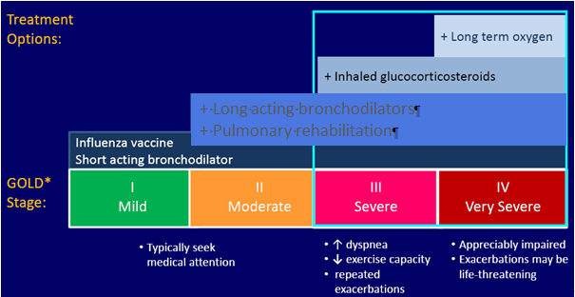

**COPDX Guidelines by Lung Foundation Australia**[15]

|  |  |
| --- | --- |
| **Executive Summary of the COPDX guidelines** | **Evidence level** |
| **C: Confirm diagnosis and assess severity** |  |
| * Smoking is the most important risk factor in the development of COPD | I |
| * Consider COPD in all smokers and ex-smokers over the age of 35 years | II |
| * The diagnosis of COPD rests on the demonstration of airflow limitation which is not fully reversible | II |
| * It is important in general practice settings to obtain accurate spirometric assessment | III-3 |
| * If airflow limitation is fully or substantially reversible (FEV1 response to bronchodilator>400ml),   the patient should be treated as for asthma | |
| * Consider COPD in patients with other smoking-related diseases | I |
| * **O: Optimise function** | |
| * Inhaled bronchodilators provide symptom relief and may increase exercise capacity | I |
| * Long term use of systemic corticosteroids is not recommended | I |
| * Inhaled corticosteroids should be considered in patients with moderate to severe COPD and frequent exacerbations | I |
| * Pulmonary rehabilitation reduces dyspnoea, fatigue, anxiety and depression, improves exercise capacity, emotional function and health-related quality of life and enhances patients’ sense of control over their condition | I |
| * Pulmonary rehabilitation reduces hospitalisation and has been shown to be cost-effective | II |
| * Prevent or treat osteoporosis | |
| * Identify and treat hypoxaemia and pulmonary hypertension | I |
| * In selected patients, a surgical approach may be considered for symptom relief | III-2 |
| **P: Prevent deterioration** | |
| * Smoking cessation reduces the rate of decline of lung function | I |
| * Treatment of nicotine dependence is effective and should be offered to smokers in addition to counselling | I |
| * Influenza immunisation reduces the risk of exacerbations, hospitalisation and death | I |
| * Mucolytics may reduce the frequency and duration of exacerbations | II |
| * Long-term oxygen therapy (>15h/day) prolongs life in hypoxaemic patients (PaO2<55mmHg, or 7.3kPa) | I |
| **D: Develop support network and self-management plan** | |
| * COPD imposes handicaps which affect both patients and carers | II |
| * Enhancing quality of life and reducing handicap requires a support team | |
| * Patients and their family/friends should be actively involved in a therapeutic partnership with a range of health professionals | II |
| * Multidisciplinary care plans and individual self-management plans may help to prevent or manage crises | III-2 |
| * Patients who take appropriate responsibility for their own management may have improved outcomes | III-1 |
| * Anxious and depressive symptoms and disorders are common comorbidities in people with COPD | I |
| **X: Manage eXacerbations** | |
| * An exacerbation is an event in the natural course of the disease characterised by a change in the patient’s baseline dyspnoea, cough and/or sputum that is beyond normal day to day variations, is acute in onset and may warrant a change in regular medication in a patient with underlying COPD | |
| * Early diagnosis and treatment may prevent admission | III-2 |
| * Multidisciplinary care may assist home management | II |
| * Inhaled bronchodilators are effective treatments for acute exacerbations | I |
| * Systemic corticosteroids reduce the severity of and shorten recovery from acute exacerbations | I |
| * Exacerbations with clinical signs of infection (increased volume and change in colour of sputum and/or fever, leukocytosis) benefit from antibiotic therapy | II |
| * Controlled oxygen delivery (28%, or 0.5-2.0L/min) is indicated for hypoxaemia | |
| * Non-invasive positive pressure ventilation is effective for acute hypercapnic ventilatory failure | I |
| * Involving the patient’s general practitioner in a case conference and developing a care plan may facilitate early discharge | |

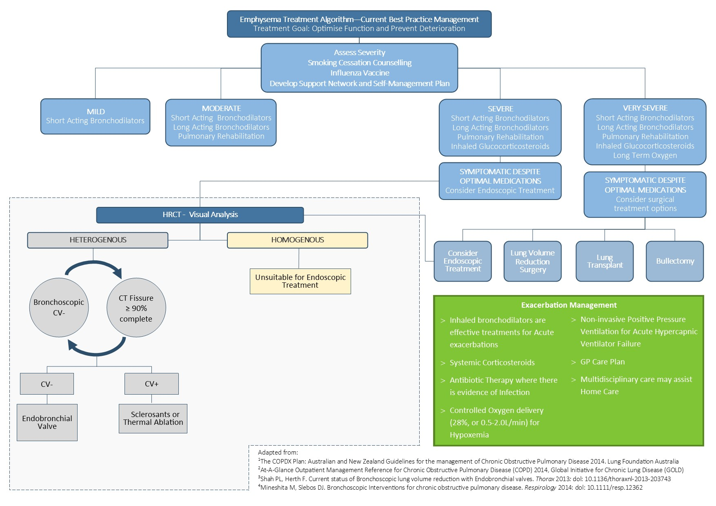

***Provide a clinical management algorithm (e.g.: flowchart) explaining the expected management and any downstream services (aftercare) of the eligible population/s if public funding is recommended for the service proposed.***

Clinical Management Algorithm for Coil System

A proposed clinical management algorithm for the coil procedure is outlined on page 33.

Emphysema presents specific treatment challenges, due mainly to collateral ventilation, disease distribution (upper and lower lobes) and disease diffusion (heterogeneous and homogenous) and patient frailty, resulting in patients presenting with co-morbidities who are prone to COPD exacerbations and respiratory events. They often require intensive specialist assessment and intervention.

The Coil is designed to work independently of collateral ventilation, is effective in treating upper and lower lobes and effectively treats heterogeneous and homogeneous emphysema.

Patients unsuitable for any endoscopic treatment are those with a homogenous disease distribution and very high (>75%) tissue destruction, as well as heterogeneous patients whose fissures are not intact and who have very high (>75%) tissue destruction. There are two non-implant treatment techniques which are not currently available due to removal from their commercial markets (Aeris® Aeriseal polymer foam sealant, and Uptake Medical thermal vapor ablation).

Proposed Aftercare following treatment

Patients are required to attend a follow up appointment following the procedure and return to the rendering physician's care in the event of adverse event, otherwise the patient can return to referring physicians for standard care and management. No further costs are expected with this therapy.

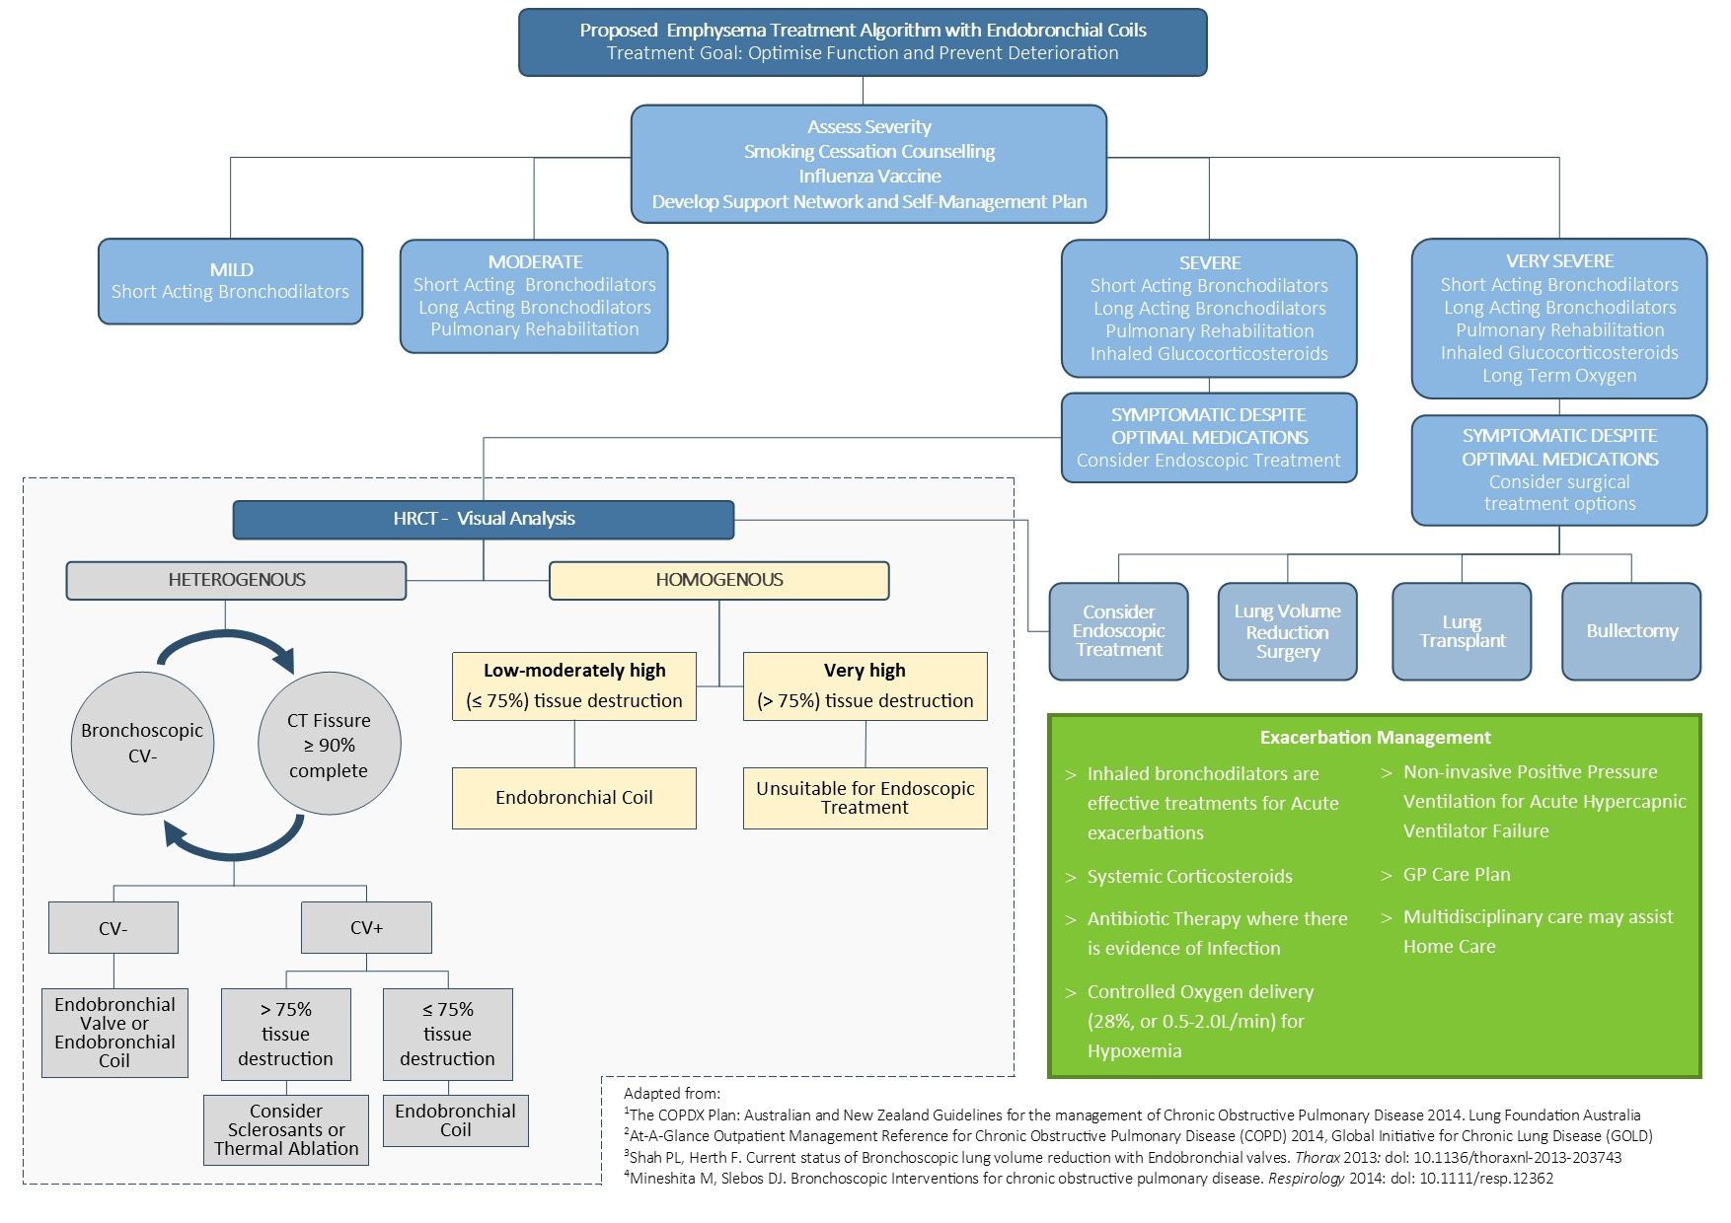

## 10) Regulatory Information

***Please provide details of the regulatory status. Noting that regulatory listing must be finalised before MSAC consideration.***

The lung coil and associated Delivery System is TGA registered.

* ARTG 239034 Endobronchial Coil
* ARTG 224628 Endobronchial Coil Delivery System

Registration Status – International

| ***Country*** | ***Date and Type of Initial Registration*** | ***Registered Indication*** |
| --- | --- | --- |
| *USA (FDA)* | *Expected 2016* | *FDA approval for an IDE trial in May 2012. Enrollment completed and are continuing to follow up. Pre-market approval (PMA) approval (to market the device in the US) expected in 2016* |
| *Conformite European*  *(CE)* | *Issued 08 October 2010*  *CE 511022* | *“The RePneu Coil System is intended to improve the exercise capacity, lung function and quality of life in patients with both heterogeneous and homogenous emphysema.”* |

## 11) Decision analytic

*Provide a summary of the PICO as well as the health care resource of the comparison/s that will be assessed, define the research questions and inform the analysis of evidence for consideration by MSAC (as outlined in Table 1).*

**Table 1: Summary of PICO to define research question**

| PICO | Comments |
| --- | --- |
| Patients | Severe/Very Severe Emphysema   | INCLUSION CRITERIA | EXCLUSION CRITERIA | | --- | --- | | * GOLD COPD III / IV * Patients aged > 35 years * Residual Volume >175% * Total Lung Capacity > 100% * post BD FEV ≤ 45% predicted * Sufficient Structural Tissue (CT) * Homogenous or heterogeneous disease distribution * Patients must be aged over 35 years * Patients must have ceased smoking for at least 8 weeks | * Giant Bullae (Approx. 1/3 of lobe or greater) * Medical necessity of continuous anticoagulant or antithrombotic treatment (except Aspirin) * Clinically significant bronchiectasis * Pulmonary Hypertension (PAP > 50mmHg) * Patients with signs of current lung infection * Cannot walk >140m in 6 minutes * previous lung volume reduction surgery, lung transplant or lobectomy | |
| Intervention | Endobronchial Coil System Procedure |
| Comparator | Current Best Management Practice |
| Outcomes | **Health:** Improvements in dyspnea (decreased breathlessness) quality of life, pulmonary function and exercise capacity, compared to patients receiving only optimal medical management.  **Safety:** Patient relevant safety benefits to be considered in the assessment:  • Complications requiring surgical removal of the coils  • Respiratory failure  • Mortality  These safety criteria below are commonly occurring conditions even in patients with severe emphysema who have NOT had endoscopic coil treatment.  • COPD symptom exacerbation  • Haemoptysis  • Pneumothorax  • Lower respiratory tract infection  **Resources:** Inpatient services, Fluoroscopy, Bronchoscopy and Coil System devices. |
| For investigative services | |
| Prior tests |  |
| Reference standard |  |

## 12) Healthcare resources

***Using tables 2 and 3, provide a list of the health care resources whose utilisation is likely to be impacted should the proposed intervention be made available as requested whether the utilisation of the resource will be impacted due to differences in outcomes or due to availability of the proposed intervention itself.***

*Note: As discussed with Erinn (HTA) on 6/2/15 this section is to be completed at a later date.

**Table 2: List of resources to be considered in the economic analysis**

|  | **Provider of resource** | **Setting in which resource is provided** | **Proportion of patients receiving resource** | **Number of units of resource per relevant time horizon per patient receiving resource** | **Disaggregated unit cost** | | | | | |
| --- | --- | --- | --- | --- | --- | --- | --- | --- | --- | --- |
| **MBS** | **Safety nets\*** | **Other government budget** | **Private health insurer** | **Patient** | **Total cost** |
| **Resources provided to identify eligible population** | | | | | | | | | | |
| Resource 1 |  |  |  |  |  |  |  |  |  |  |
| Resource 2 |  |  |  |  |  |  |  |  |  |  |
| **Resources provided to deliver proposed intervention** | | | | | | | | | | |
| Resource 1 |  |  |  |  |  |  |  |  |  |  |
| Resource 2 |  |  |  |  |  |  |  |  |  |  |
| **Resources provided in association with proposed intervention** | | | | | | | | | | |
| Resource 1 |  |  |  |  |  |  |  |  |  |  |
| Resource 2 |  |  |  |  |  |  |  |  |  |  |
| **Resources provided to deliver comparator 1** | | | | | | | | | | |
| Resource 1 |  |  |  |  |  |  |  |  |  |  |
| Resource 2 |  |  |  |  |  |  |  |  |  |  |
| **Resources provided in association with comparator 1**  (e.g., pre-treatments, co-administered interventions, resources used to monitor or in follow-up, resources used in management of adverse events, resources used for treatment of down-stream conditions) | | | | | | | | | | |
| Resource 1 |  |  |  |  |  |  |  |  |  |  |
| Resource 2 |  |  |  |  |  |  |  |  |  |  |
| **Resources provided to deliver comparator 2** | | | | | | | | | | |
| Resource 1 |  |  |  |  |  |  |  |  |  |  |
| Resource 2 |  |  |  |  |  |  |  |  |  |  |
| **Resources provided in association with comparator 2** | | | | | | | | | | |
| Resource 1 |  |  |  |  |  |  |  |  |  |  |
| Resource 2 |  |  |  |  |  |  |  |  |  |  |
| **Resources used to manage patients successfully treated with the proposed intervention** | | | | | | | | | | |
| Resource 1 |  |  |  |  |  |  |  |  |  |  |
| Resource 2 |  |  |  |  |  |  |  |  |  |  |
| **Resources used to manage patients who are unsuccessfully treated with the proposed intervention** | | | | | | | | | | |
| Resource 1 |  |  |  |  |  |  |  |  |  |  |
| Resource 2 |  |  |  |  |  |  |  |  |  |  |
| **Resources used to manage patients successfully treated with comparator 1** | | | | | | | | | | |
| Resource 1 |  |  |  |  |  |  |  |  |  |  |
| Resource 2 |  |  |  |  |  |  |  |  |  |  |
| **Resources used to manage patients who are unsuccessfully treated with comparator 1** | | | | | | | | | | |
| Resource 1 |  |  |  |  |  |  |  |  |  |  |
| Resource 2 |  |  |  |  |  |  |  |  |  |  |

* Include costs relating to both the standard and extended safety net.

**Table 3: Alternative summary of resources table for state transition models**

|  | Provider of resource | Setting in which resource is provided | Proportion  of patients receiving resource | Number of units of resource per cycle per patient receiving resource | **Disaggregated unit cost** | | | | | |
| --- | --- | --- | --- | --- | --- | --- | --- | --- | --- | --- |
| MBS | Safety nets* | Other government budgets  (PBS, hospitals,  etc) | Private health insurer | Patient | Total cost |
| **Health state 1** | | | | | | | | | | |
| Resource 1 |  |  |  |  |  |  |  |  |  |  |
| Resource 2 |  |  |  |  |  |  |  |  |  |  |
| **Health state 2** | | | | | | | | | | |
| Resource 1 |  |  |  |  |  |  |  |  |  |  |
| Resource 2 |  |  |  |  |  |  |  |  |  |  |
| **Health state 3** | | | | | | | | | | |
| Resource 1 |  |  |  |  |  |  |  |  |  |  |
| Resource 2 |  |  |  |  |  |  |  |  |  |  |

* Include costs relating to both the standard and extended safety net.

## 13) Questions for public funding

*Please list questions relating to the safety, effectiveness and cost-effectiveness of the service / intervention relevant to this application, for example:*

*• Which health / medical professionals provide the service*

*• Are there training and qualification requirements*

*• Are there accreditation requirements*

*Note: As discussed with Erinn from HTA on 6/2/15 this section is to be completed by Policy Department

**Please list questions relating to the safety, effectiveness and cost-effectiveness of the service / intervention relevant to this application, for example:**

**• Which health / medical professionals provide the service**

The endobronchial coil procedure is provided by interventional pulmonologists and thoracic surgeons with bronchoscopic interests.

**• Are there training and qualification requirements**

The rendering physician will receive procedural training by case observation followed by proctoring 5-8 cases. The number of cases required for proctoring is operator dependent on experience and skill.

**• Are there accreditation requirements**

The training program is not currently accredited however an accredited training program is being created for the purpose of this procedure.

1. Snider GL, Kleinerman J, Thurlbeck WM, Bengali ZK. The definition of emphysema: report

   of a National Heart, Lung and Blood Institute, Division of Lung Diseases, Workshop. Am Rev

   Respir Dis 1985; 132: 182–185.
2. Lung Foundation: COPDX Guidelines The COPDX Plan: Australian and New Zealand Guidelines

   for the management of Chronic Obstructive Pulmonary Disease 2014, June 2014
3. Weder W, Thurnheer R, Stammberger U, et al. Radiologic emphysema morphology is associated with outcome after surgical lung volume reduction. Ann Thorac Surg 1997; 64:313–320
4. Pocket Guide to COPD Diagnosis, Management and Prevention, A Guide for Health Care Professionals, Updated 2014. Global Initiative for Chronic Obstructive Lung Disease
5. The COPDX Plan: Australian and New Zealand Guidelines for the management of Chronic Obstructive Pulmonary Disease 2014. Lung Foundation Australia.
6. At-A-Glance Outpatient Management Reference for Chronic Obstructive Pulmonary Disease (COPD) 2014, Global Initiative for Chronic Lung Disease (GOLD)
7. Lung Foundation: COPDX Guidelines The COPDX Plan: Australian and New Zealand Guidelines

   for the management of Chronic Obstructive Pulmonary Disease 2014, June 2014
8. Toelle BG, Xuan W, Bird TE, Abramson MJ, Atkinson DN, Burton DL, et al. Respiratory symptoms and illness in older Australians: the Burden of Obstructive Lung Diseases (BOLD) study. Medical Journal of Australia. 2013;198(3):144-8
9. Australian Bureau of Statistics 3101.0 - Australian Demographic Statistics, Sep 2014
10. Hartman JE, Klooster K, Gortzak K, ten Hacken NH, Slebos DJ.[Long-term follow-up after bronchoscopic lung volume reduction treatment with coils in patients with severe emphysema.](http://www.ncbi.nlm.nih.gov/pubmed/25418910) Respirology. 2015 Feb;20(2):319-26. doi: 10.1111/resp.12435. Epub 2014 Nov 23.
11. Shah PL et al. Endobronchial coils for the treatment of severe emphysema with hyperinflation (RESET): a randomised controlled trial. The Lancet Respiratory Medicine. May 2013; 1:233-240
12. Shah, PL et al. Bronchoscopic lung-volume reduction with Exhale airway stents for emphysema (EASE trial): randomised, sham-controlled, multicentre trial. The Lancet , Volume 378 , Issue 9795 , 997 - 1005
13. At-A-Glance Outpatient Management Reference for Chronic Obstructive Pulmonary Disease (COPD) 2014, Global Initiative for Chronic Lung Disease (GOLD)
14. The COPDX Plan: Australian and New Zealand Guidelines for the management of Chronic Obstructive Pulmonary Disease 2014. Lung Foundation Australia.
15. The COPDX Plan: Australian and New Zealand Guidelines for the management of Chronic Obstructive Pulmonary Disease 2014. Lung Foundation Australia.