**MSAC Application 1786**

**Freestyle Libre 2 for people with insulin-dependent type 2 diabetes, gestational diabetes and type 3c diabetes**

**PICO Set Document**

# Population

**Describe the population in which the proposed health technology is intended to be used:**

People with type 2 diabetes (T2D) requiring insulin therapy. This includes all combinations with other medicines for T2D. All patients with T2D on insulin therapy are recommended to routinely monitor their blood glucose control via self-monitoring of blood glucose (SMBG). FreeStyle Libre 2 (FSL2) will provide a superior glucose monitoring alternative for this population.

The proposed T2D insulin-using population includes a subpopulation using intensive insulin therapy (IIT), i.e. patients requiring multiple daily insulin injections or (less commonly) continuous subcutaneous insulin infusion (CSII) who are recommended to undergo frequent monitoring of their blood glucose control (multiple times per day, e.g. with meals).

Natural History of T2D and burden of disease

Epidemiological data show alarming values that predict a worrisome projected future for T2DM (Galicia-Garcia 2020). In Australia diabetes contributed to approximately 16,700 deaths in 2018 (10.5% of all deaths; of these 56% were attributed to T2D, 39% were due to unspecified diabetes and 5% due to T1D) (AIHW 2020). Patients with T2D have a 15% increased risk of all-cause mortality compared with people without diabetes, with cardiovascular disease (CVD) as the greatest cause of morbidity and mortality associated with T2D (Gaede 2003).

The prevalent co-morbidity and mortality for those with T2D is cardiovascular disease. T2D is a multisystem disease with a strong correlation with CVD development (Sarwar 2010, Gast 2012) T2D leads to a two- to four-fold increase in the mortality rate of adults from heart disease and stroke and is associated with both micro- and macro-vascular complications, the latter consisting of accelerated atherosclerosis leading to severe peripheral vascular disease, premature coronary artery disease (CAD) and increased risk of cerebrovascular diseases (Haffner 1998, Beckman 2002, Nesto 2004). These factors lead to T2D being considered a significant risk factor for CVD (NCEP 2002). In Australia the latest data shows that myocardial infarctions and angioplasties account collectively for 7% of the complications recorded in the last 12 months for T2D patients (Australian National Diabetes Audit 2022).

Dyslipidaemia is also a common feature of T2D, and increases the incidence of atherosclerosis and mortality of diabetic patients (Battisti 2003). The hallmark of diabetic dyslipidaemia is a characteristic dyslipidaemia profile consisting of elevated triglycerides (TG), TG-rich lipoproteins (TRLs), low-density lipoproteins (LDLs), and reduced high-density lipoprotein (HDL) levels (Lewis 1996, Sparks 2012, Vergès 2015).

One of the most cited complications of T2D is peripheral neuropathy, accounting for 25% of the complications recorded in the last 12 months by those with T2D. Other comorbidities include foot problems (a hallmark of peripheral neuropathy) and kidney and eye disease as well as depression (Nowakowska 2019, Australian National Diabetes Audit 2022).

Key risk modifiable factors include obesity, the strongest risk factor for T2DM (Bellou 2018), associated with metabolic abnormalities resulting in insulin resistance (Cho 2017). There exists an inverse linear relationship between BMI and age at T2D diagnosis (Hillier 2003).

The burden of disease of T2D in Australia is substantive. In 2022 in Australia, T2D was responsible for 125,500 disability-adjusted life years (DALY) which equates to 3.9 DALY’s per 1,000 population (AIHW 2023). This resulted in T2D being attributed as the 12th leading contributor to total disease burden in Australia. In 2018, 4.3% of the total burden of disease could have been prevented by reducing exposure to the modifiable risk factor ‘high blood plasma glucose levels’ (including diabetes). Diabetes in general places a great burden on Australia’s healthcare system, having been allocated approximately $3 billion of Australia’s expenditure in 2019, 61% of which was allocated to T2D (AIHW 2023).

Profile of an Australian T2D person

### Largely uncontrolled HbA1c

In 2021, the mean HbA1c among T2D patients was 8.1%, with standard deviation ± 1.8 (Quigley 2022), indicating that there remains a need for achievement of greater glucose control. In fact, 72.6% of Australians with T2D fail to meet their HbA1c target of 7%. This compares with 81.7% of Australians with T1D failing to meet their HbA1c target of 7% (Australian National Diabetes Audit 2021). Whilst there isn’t any Australian specific data, an analysis of US database notes that in T2D with IIT 85% fail to meet their HbA1c target of 7% (Brixner 2019).

### A chronic condition in an older population

The age-standardised prevalence rate of self-reported diabetes increased in 2017-18 to 4.4% (AIHW 2020). The age distribution from the 2022 audit showed that the average age of people with T2D was 63.8±13.5 years and median diabetes duration was 12.1 (interquartile range 5.3, 20.5) years (Australian National Diabetes Audit 2022).[1]

Greater burden of T2D prevalence in indigenous population and in lower socioeconomic areas (AIHW 2020)

Indigenous Australians are overrepresented in T2D statistics. Eighteen percent of Indigenous Australians aged 25 and over have T2D compared to around 6% of the general population (ABS 2019). A two-fold greater prevalence of T2D is seen in the lowest, compared with the highest, socioeconomic areas, as well as greater relative risks of being hospitalised for diabetes (1.7 times), dying from diabetes (2.4 times) and burden of disease (2.2 times) (AIHW 2023).

REDACTED (Prospection 2022).

### A more obese population

The Australian Bureau of Statistics (ABS) reported in 2018 that among the adult population, those who are obese are approximately 5 times more likely to have T2D than those of the ‘normal’ weight class (9.8% vs 2%) (ABS 2013, ABS 2018). Aboriginal and Torres Strait Islanders are at an increased risk of being diagnosed with T2D from the age of 35 years (Diabetes Australia 2022) and have a higher-than-average proportion of their population that is obese (BMI of 30 or greater) (Table 1).

This highlights the necessity of effective and easy to use clinical management devices and lifestyle information, particularly in at risk groups.

Table 1: Obesity by indigenous status

|  |  |  |  |  |  |
| --- | --- | --- | --- | --- | --- |
| **Sex** | **Body Mass Index** | **Indigenous** | | **Non-Indigenous** | |
| **2018-19 a, b** | | **2017-18 a, b** | |
| **%** | **95% CI** | **%** | **95% CI** |
| Males | Overweight but not obese | 31.8 | 28.3–35.3 | 42.0 | 40.5–43.5 |
|  | Obese | 45.0 | 41.1–48.9 | 32.1 | 30.6–33.6 |
|  | Overweight or obese | 76.8 | 73.2–80.4 | 74.1 | 72.8–75.4 |
| Females | Overweight but not obese | 27.6 | 24.8–30.4 | 29.5 | 28.2–30.8 |
|  | Obese | 49.1 | 46.1–52.1 | 29.2 | 28.0–30.4 |
|  | Overweight or obese | 76.8 | 74.0–79.6 | 58.7 | 57.5–59.9 |
| Persons | Overweight but not obese | 29.6 | 27.3–31.9 | 35.6 | 34.6–36.6 |
|  | Obese | 47.2 | 44.7–49.7 | 30.6 | 29.7–31.5 |
|  | Overweight or obese | 76.8 | 74.5–79.1 | 66.3 | 65.4–67.2 |

(a) Estimates for 2017–18 and 2018–19 include people who have an imputed height, weight and/or BMI score due to not having a measured height, weight or both (39.9% of Aboriginal and Torres Strait Islander people aged 18 years and over and 33.8% of all respondents aged 18 years and over in 2017–18) (ABS 2018, ABS 2019b). (b) 2017–18 and 2018–19 estimates use published ABS data that has been randomly adjusted to avoid the release of confidential data. Discrepancies may occur between sums of the component items and totals. Source:(AIHW 2022)

**Specify any characteristics of patients with the medical condition, or suspected of, who are proposed to be eligible for the proposed health technology, describing how a patient would be investigated, managed and referred within the Australian health care system in the lead up to being considered eligible for the technology:**

The FSL2 proposed target population is patients with T2D who require insulin treatment and therefore need to undertake regular SMBG.

Patients with T2D are usually diagnosed by their general practitioner (GP) after presenting with symptoms (e.g., increased thirst, urination and tiredness) or via a routine blood test that shows glycaemia. According to the Australian T2D Diabetes Glycaemic Management Algorithm (available at: [20220908 T2D Algorithm 06.09.2022.pdf (diabetessociety.com.au)](https://diabetessociety.com.au/downloads/20220908%20T2D%20Algorithm%2006.09.2022.pdf) (Australian Diabetes Society 2022)), patients should receive education regarding lifestyle including weight loss, healthy diet and physical activity and be investigated for any comorbidities that can impact glycaemic control. A HbA1c target should be set (commonly ≤7%, but appropriately individualised; HbA1c monitoring, plus kidney function testing etc. that may also be required is funded via MBS items).

Following the decision to initiate medical therapy there are a range of oral therapies and injectable therapies that can be considered for use, either as mono, dual or multiple therapies. Most patients would commence on oral therapies, before being considered for an injectable therapy or insulin, if control cannot be maintained on less intensive therapies.

Hence patients using insulin therapy are also likely to be taking oral hypoglycaemic agents, with oral agents initiated as recommended in the Australian T2D management algorithm (Australian Diabetes Society 2022). Recommended first line oral agents may include metformin and sulfonylreas following lifestyle measures including healthy diet, physical activity and weight management (Australian Diabetes Society 2022). Treatment intensification options include adding additional oral agents, injectable therapies and potentially insulin (Australian Diabetes Society 2022).

With increasing complexity of therapy it is recommended in the T2D Diabetes Glycaemic Management Algorithm that GPs consider specialist endocrinology consultation, and this is likely to generally occur before patients are prescribed insulin therapy.

Once a decision is made to initiate insulin therapy, patients may commence on either basal insulin or co-formulated (pre-mixed insulin) depending on patient factors which can be intensified if needed according to glycaemic response (RACGP 2020a).

**Provide a rationale for the specifics of the eligible population:**

Self-monitoring of blood glucose (SMBG) is recommended for patients with T2D who are using insulin and have been educated in appropriate alterations in insulin dose (RACGP 2020b). FSL2 provides an important valid option for regular glucose monitoring in the T2D insulin-using population. The actionable insights provided by FSL2 is superior to the point in time SMBG tests. The RACGP T2D management guidelines note that “*there is an emerging role for continuous glucose monitoring and flash glucose monitoring in patients with type 2 diabetes on complex insulin regimens who have not achieved their glycaemic targets*” (RACGP 2020b).

A subpopulation of the proposed total eligible population is patients requiring IIT (i.e. requiring multiple insulin injections per day) who may be required to test their blood glucose multiple times per day. In this high need subpopulation, the requirement to more frequently ‘finger prick’ and test blood glucose is more onerous (e.g. painful, time consuming) and use of FLS2 may provide a more easily managed, less painful option to frequently monitor glucose control.

### Treatment goals

Treatment is individualised with the commonly held target for HbA1c of ≤7% (≤53 mmol/mol) (NDSS 2022). However, the goal is optimising the glucose control for an individual patient, with ‘optimal control’ varying depending on the balance between benefits and risks and the patient’s priorities and disease features (Figure 2).

Figure 2: Approach to individualising HbA1c targets (RACGP 2020b)

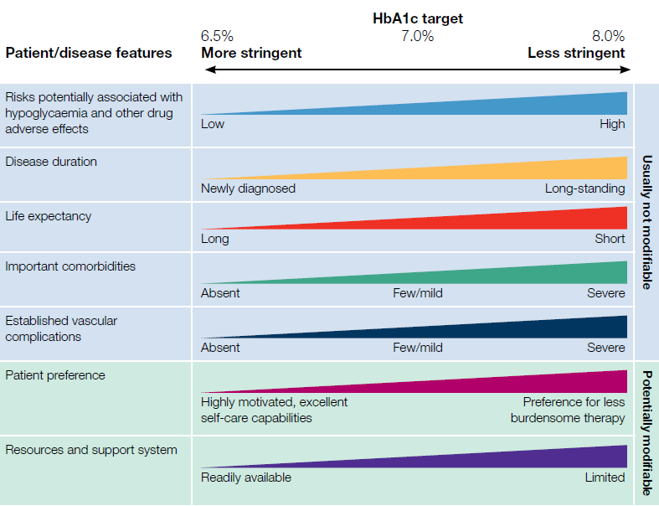

Source: (RACGP 2020b) Figure 1 p. 52

### Recommended treatment of T2D

Treatment of T2D follows a stepwise approach that can include dietary modification, monotherapy, dual therapy and multiple therapies with a variety of PBS approved combinations that include insulin (Figure 3).

The ADS treatment algorithm is not reproduced here but is available at: [20220908 T2D Algorithm 06.09.2022.pdf (diabetessociety.com.au)](https://diabetessociety.com.au/downloads/20220908%20T2D%20Algorithm%2006.09.2022.pdf) (Australian Diabetes Society 2022). Available drugs/drug classes include metformin, sulfonylureas, SGLT2 inhibitors (e.g., dapagliflozin), GLP-1RA (e.g., semaglutide), DPP-4 inhibitor (e.g., sitagliptin) and insulin. Less commonly acarbose or TZDs (e.g., pioglitazone) can be used.

The transition between treatments is vital to provide effective treatment. Initially, those with T2D are encouraged to make lifestyle changes, such as healthy eating and increasing physical activity aiming to catalyse weight loss for those that are overweight or obese, as well as quitting smoking and limiting alcohol consumption. Monotherapies are used in patients when lifestyle changes are no longer effective in achieving treatment aims. Oral therapies such as metformin are most used at this stage. As can be seen in Figure 3, in 2016 in Australia, 46.5% of T2D patients used monotherapies (DUSC. 2017). If HbA1c levels do not meet established targets using monotherapies, dual therapies and finally multiple therapies will be used. Dual therapies were used by 36.8% of T2D patients with 16.7% using multiple therapies to treat T2D in 2016 (DUSC. 2017). Multiple therapies should be used for more than two months to determine their effectiveness; however, it is common for multiple oral therapies to be ineffective in achieving treatment goals and are therefore useful in overcoming patients’ hesitancy regarding insulin use (NPSS Medicine Wise 2004). The most frequently utilised insulin treatments are presented in Figure 4.

Figure 3: T2D population’s treatments

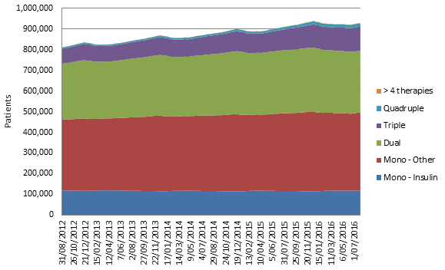

Source: (DUSC. 2017)

Figure 4: Top 10 drug regimens containing insulin

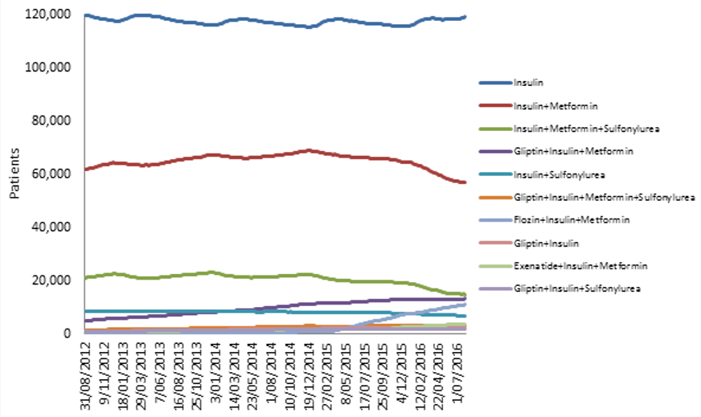

Source: (DUSC. 2017)

Note that the DUSC 2017 estimates of the number of T2D patients using insulin (and all combinations of insulin) in Figure 4 appear somewhat lower than the NDSS reports of registered insulin users. At the end of July 2016, the DUSC reports ~248,000 people on insulin (with ~120,000 T1D and the remaining mostly T2D), whilst the NDSS snapshot reports 383,000 (with ~120,000 T1D and ~250,000 T2D). This highlights a 100,000+ difference in people using insulin combination treatment vs how many are registered to use insulin on the NDSS.

T2D requiring insulin

Insulin therapy is commenced in patients who are in 'secondary failure', that is after the 'failure' of oral hypoglycaemic drugs to maintain glycaemic control. Traditionally, there has been a stepwise introduction of glucose-lowering interventions, with the final “step” of insulin therapy being administered 10–15 years after diagnosis (Nathan 2002). More recent data is provided from a study investigating progression to insulin initiation from oral treatments over a 6-year period (Inzucchi 2015). This study demonstrated that 26.6% of sitagliptin user-initiated insulin versus 34.1% of sulfonylurea users over 6 years (p=0.03).

### Insulin therapy in practice

Insulin should be initiated in patients with T2D who are taking 25% maximal doses of non-insulin glucose-lowering medicines and who have suboptimal glycaemic control (HbA1c or blood glucose above individualised targets), whether they are asymptomatic or symptomatic (RACGP 2020b). Patients usually commence either basal insulin therapy or co-formulated or pre-mixed insulin, depending on individual patient and disease characteristics (RACGP 2020b).

Basal insulin alone has a slightly lower risk of hypoglycaemia, especially if the fasting glucose is consistently above target, however premixed or co-formulated insulin may be more appropriate and simpler for a patient where fasting and postprandial glucose are both consistently elevated (RACGP 2020b). Non-insulin glucose-lowering medicines should generally be continued when insulin is commenced (RACGP 2020b).

For patients on basal insulin it is necessary to intensify treatment to meet glycaemic targets, prescribers can consider the following options (Australian Diabetes Society 2022):

* Add a SGLT2 inhibitor, or
* Add GLP-1RA, or
* Add bolus insulin with meals, or
* change to premixed/co-formulated insulin.

### Monitoring glucose levels

SMBG in T2D is recommended for (RACGP 2020b):

* People on **insulin** and sulfonylureas, which can cause hypoglycaemia
* People not on insulin who are having difficulty achieving glycaemic control
* When monitoring hypo/hyperglycaemia arising from intercurrent illness
* During pre-pregnancy and pregnancy management for established or gestational diabetes
* When there is a clinical need for monitoring, such as during changes in management or lifestyle, or for conditions or medications requiring data on glycaemic patterns that HbA1c cannot provide
* When HbA1c estimations are unreliable (e.g., haemoglobinopathies).

Routine SMBG for people with T2D who are considered low risk and who are using oral glucose-lowering drugs (with the exception of sulfonylureas) is not recommended (RACGP 2020b). Method and frequency of monitoring should reflect individual circumstances and therapeutic aims, with SMBG most effective where the person with diabetes and their healthcare providers have the knowledge, skills and willingness to incorporate SMBG and therapy adjustments into diabetes care plans (RACGP 2020b).

In regards to access to Flash glucose monitoring, Diabetes Australia supports the subsidy of this technology to make it more accessible for people with diabetes (Diabetes Australia 2017). Diabetes Australia recommends that subsidised access to flash glucose monitoring (sensors) should be made available to adults with type 1 diabetes or type 2 diabetes using insulin (Diabetes Australia 2017).

**Are there any prerequisite tests?**

Yes

**Are the prerequisite tests MBS funded?**

Yes

# Intervention

**Name of the proposed health technology:**

FreeStyle Libre 2 Continuous Glucose Monitoring System

**Describe the key components and clinical steps involved in delivering the proposed health technology:**

### Freestyle Libre 2 System components

FreeStyle Libre 2 Continuous Glucose Monitoring System (FSL2) is a novel, sensor-based, factory-calibrated monitoring system with two key components: a disposable 14-day sensor and a reader (using either a smartphone App or a physical reader). It is designed to continuously measure glucose levels in the interstitial fluid and provides glucose trends, variability, and patterns across a 24-hour period (Abbott Diabetes Care).

FSL2 is registered by the TGA as a suitable replacement for self monitoring of blood glucose (SMBG) for people (age four and older) with diabetes who use insulin. FSL2 doesn’t require painful finger prick testing and also has additional alarms that can warn of impending episodes of high or low glucose levels.

The FSL digital ecosystem includes two mobile medical Apps. The FreeStyle LibreLink to read glucose levels and FreeStyle LibreLinkUp to enable authorized caregivers to remotely receive alarms and glucose data (Figure 6). The app data can be automatically uploaded to LibreView (Figure 7), which enables patients and HCPs to see the full glycaemic picture including the Ambulatory Glucose Profile (AGP). (Abbott Diabetes Care). LibreView in particular has been instrumental during COVID-19 lockdowns by enabling convenient remote data-sharing with the HCP during patient telehealth consultations.

A disposable 14-day sensor is inserted into the subcutaneous tissue at the back of the upper arm. This sensor includes an inbuilt transmitter that transits glucose data to the App or Reader (Figure 5).

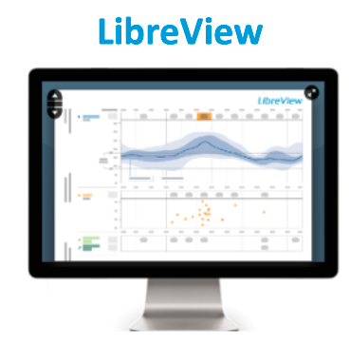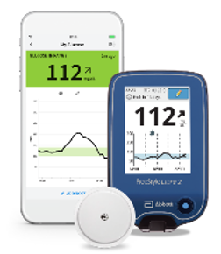

Figure 7: LibreView (AGP)

Figure 6: FreeStyle Libre digital ecosystem1,2

Figure 5: FreeStyle Libre 2

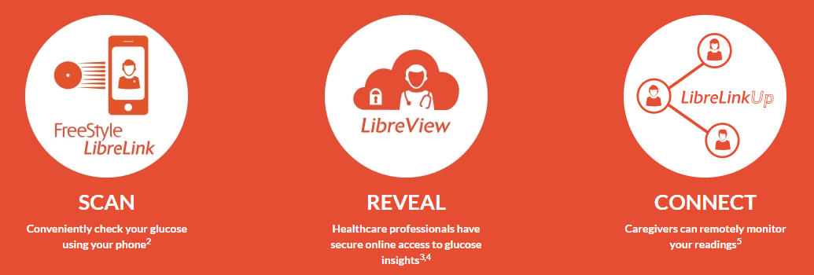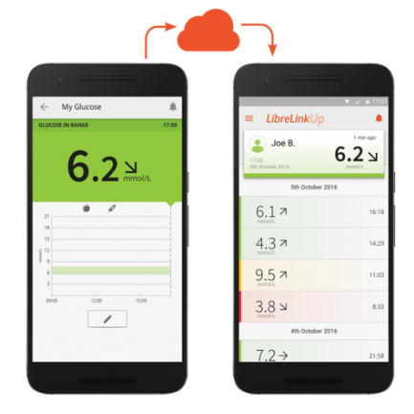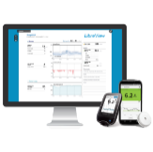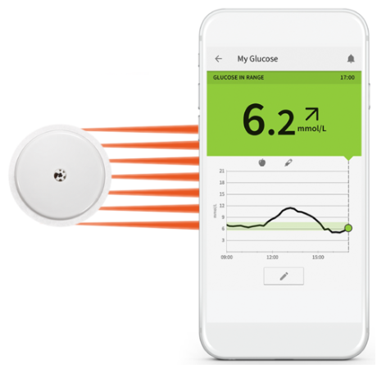

1. The LibreView website is only compatible with certain systems and browsers. Please check www.libreview.com for additional information. 2. LibreLinkUp is only compatible with certain mobile devices and operating systems. Please check www.librelinkup.com for more information about device compatibility before using the app. Use of LibreLinkUp requires registration with LibreView. The LibreLinkUp mobile app is not intended to be a primary glucose monitor: home users must consult their primary device(s) and a healthcare professional before making any medical interpretation and therapy adjustments from the information provided by the app.

### Clinical steps involved in delivering the proposed health technology

FSL2 is recommended for patients on insulin who require insulin treatment, including the subpopulation on IIT (i.e., patients on a basal/bolus treatment and those on CSII) who may require more frequent monitoring. Like the type 1 diabetes (T1D) access arrangements via the NDSS, the T2D insulin-using population will have continuous access to FSL2 sensors via the NDSS (after initial signed approval from relevant healthcare professionals).

Importantly, T2D insulin-using patients have a similar recommendation to T1D patients to routinely monitor their glucose levels due to the risk of hypoglycaemia (RACGP 2020b). In the subpopulation who are using insulin injected multiple times per day it is recommended to monitor blood glucose more frequently each day in order to adjust/titrate insulin dosing to meet glycaemic targets (RACGP 2020a).

Following a recommendation to use FSL2 from a HCP, patients would obtain the FSL2 system via the NDSS, consistent with the general procedure that patients with T1D currently follow to obtain FSL2 (i.e., the HCP fills out a form (<https://www.ndss.com.au/about-the-ndss/ndss-forms/>) which is lodged with the NDSS and once processed, applicants can obtain FSL products from an NDSS access point, usually a community pharmacy).

**Identify how the proposed technology achieves the intended patient outcomes:**

Regular monitoring of blood glucose is recommended for all patients on insulin, since it can cause hypoglycaemia (RACGP 2020b). The subpopulation of patients on ITT are required to monitor their blood glucose more frequently, and depending on results may need to adjust their insulin dose up or down (RACGP 2020a). Hence in the short term, use of FSL2 allows T2D patients on insulin to appropriately manage their insulin dosing regimen. The improved glycaemic control resulting from optimised insulin dosing allows patients to maintain appropriate control more consistently.

Poor glycaemic control is associated with adverse longer term sequalae including (RACGP 2020b):

* cardiovascular complications (stroke, myocardial infarction),
* microvascular ophthalmic complications (retinopathy, refractive errors, cataracts, maculopathy, glaucoma)
* microvascular neuropathy (peripheral and autonomic neuropathy, foot complications)
* microvascular nephropathy (chronic kidney disease)

(leading to foot ulcers, amputations) and

Improved glycaemic control from accurate, more frequent (i.e. involving less pain than multiple skin pricks required with test strips) testing with FSL2 can result in in improved insulin dosing, leading to better short and long term glycaemic control, leading to a reduced risk of developing adverse, long term T2D complications.

For the T2 IIT subpopulation a recent survey of leading Australian diabetes healthcare professionals notes a high clinical need for the Federal Government to reimburse FSL2 for all patients with T2D IIT. The highlighted reasons why FSL2 would be beneficial for T2D IIT include:

* T2 IIT burden from finger pricking
* T2 IIT are not currently meeting HbA1c targets
* Need to reduce hypoglycaemia
* Need to reduce glucose variability / improve TIR
* Need to reduce hospitalisations
* Need to improve quality of life
* FSL2 remote monitoring capability
* FSL2 optional glucose alarms
* Need for better glucose management with easy-to-use reports (LibreView.com)
* Option to share glucose data with loved ones (LibreLinkUp App)
* Other(s) specified: Need to receive more complete information; Improves mental health, decreases worrying and burden of DM; Better glucose control would reduce chronic complication risk.

**Does the proposed health technology include a registered trademark component with characteristics that distinguishes it from other similar health components?**

Yes

**Explain whether it is essential to have this trademark component or whether there would be other components that would be suitable:**

**Are there any proposed limitations on the provision of the proposed health technology delivered to the patient (For example: accessibility, dosage, quantity, duration or frequency):**

No

**Provide details and explain:**

**If applicable, advise which health professionals will be needed to provide the proposed health technology:**

GPs, endocrinologists, and diabetes educators would be most likely to recommend use of FSL2 to help a patient manage their T2D on insulin. The NDSS currently allows the following authorised health professionals to certify use of FSL2 in T1D: credentialled diabetes educators, nurse practitioner, physician and paediatrician, but not GPs or practice nurses.

Where utilised, FSL2 Ambulatory Glucose Profile (AGP) reports via the LibreView App enhance Government approved telemedicine consultations, streamlining timely access to diabetes support via remote support from authorised HCPs.

**Is there specific training or qualifications required to provide or deliver the proposed service, and/or any accreditation requirements to support delivery of the health technology?**

No

**Indicate the proposed setting(s) in which the proposed health technology will be delivered:** (select all relevant settings)

Consulting rooms

Day surgery centre

Emergency Department

Inpatient private hospital

Inpatient public hospital

Laboratory

Outpatient clinic

Patient’s home

Point of care testing

Residential aged care facility

Other (please specify)

**Is the proposed health technology intended to be entirely rendered inside Australia?**

Yes

# Comparator

**Nominate the appropriate comparator(s) for the proposed medical service (i.e. how is the proposed population currently managed in the absence of the proposed medical service being available in the Australian health care system). This includes identifying health care resources that are needed to be delivered at the same time as the comparator service:**

SMBG with blood glucose test strips.

The Australian National Diabetes Audit (ANDA) data for 2021 indicates that 83.7% of people with T2D perform regular blood glucose monitoring, with 81.3% of these using finger pricking (Australian National Diabetes Audit 2022). Many patients with T2D report that they do not perform finger pricking as often as recommended by their HCP (31.8%) or are unsure of the recommended testing frequency (5.8%) (Australian National Diabetes Audit 2022). With current SMBG testing, 71.3% of Australians with T2D fail to meet a HbA1c target of 7% (Australian National Diabetes Audit 2022).

Once a patient with T2D requires insulin treatment, regular glucose monitoring is recommended (RACGP 2020b) and in the IIT subpopulation more frequent monitoring is recommended (RACGP 2020a), compared with the overall T2D insulin using population . Insulin, has a very narrow therapeutic index and hence requires careful, intensive, ongoing glucose monitoring to ensure appropriate dosage titration and maintenance (RACGP 2020a). A recent survey of Australia's leading diabetes health professionals suggests that Australian T2D IIT patients currently use SMBG testing within a range of 4 or less to 9 or more times per day.

**Please provide a rationale for why this is a comparator:**

SMBG with blood glucose test strips are the technology most used by patients with T2D for self-testing of blood glucose control. ANDA survey data indicates that 83.7% of people with T2D perform regular blood glucose monitoring, with the majority (81.3%) of using finger pricking testing (Australian National Diabetes Audit 2022). Hence FSL2 glucose monitoring will replace SMBG with test strips for people with T2D requiring insulin treatment.

**Pattern of substitution – Will the proposed health technology wholly replace the proposed comparator, partially replace the proposed comparator, displace the proposed comparator or be used in combination with the proposed comparator?**

None – used with the comparator

Displaced – comparator will likely be used following the proposed technology in some patients

Partial – in some cases, the proposed technology will replace the use of the comparator, but not in all cases

Full – subjects who receive the proposed intervention will not receive the comparator

**Please outline and explain the extent to which the current comparator is expected to be substituted:**

FLS2 is TGA-approved as a full replacement of SMBG and, due to factory calibration, does not require SMBG calibrations during use. There is no need for SMBG tests to dose insulin – even when glucose is low, falling or rapidly changing. SMBG is only required if a FSL2 user’s glucose readings and alarms do not match symptoms or expectations.

# Outcomes

(Please copy the below questions and complete for each outcome)

**List the key health outcomes (major and minor – prioritising major key health outcomes first) that will need to be measured in assessing the clinical claim for the proposed medical service/technology (versus the comparator):**

Health benefits

Health harms

Resources

Value of knowing

FSL2 is superior to SMBG for T2D patients on insulin in assisting patients to maintain glycaemic targets, with a significant impact in lowering HbA1c and longer-term outcomes such as reduction in cardiovascular events, diabetic neuropathy, retinopathy, nephropathy, and peripheral vascular diseases.

### T2D insulin requiring population

This is similar to what was found in a modified Delphi survey of patients, endocrinologists, primary care physicians and healthcare funders with key priority outcomes identified as reducing the risk of heart attacks, lowering HbA1c levels and avoiding hypoglycaemic events (Neilson 2019).

The following outcomes have been accepted as being clinically meaningful in T2D to be measured in clinical trials and practice (FDA 2008, Neilson 2019):

* Shorter term outcomes:
  + Change in HbA1c from baseline (most important): HbA1c is the standard of care for testing and monitoring diabetes, specifically T2D (WHO 2011) and is measured every 3-6 months. HbA1c remains, according to FDA requirements, the primary outcome to be measured for the demonstration of glycemia-lowering efficacy for new diabetes drugs (FDA 2008). Target HbA1c levels in T2D patients should be tailored to the individual, balancing the improvement in microvascular complications with risk of hypoglycaemia (Cheung 2009).
  + Health-related quality of life (QoL)
  + Patient satisfaction
  + Avoiding hypoglycaemic events
* Intermediate to longer term outcomes (Neilson 2019):
  + Reduction in cardiovascular events (rated the most meaningful outcome)
  + Diabetes-related hospital admission rate
  + Weight loss
  + Reducing risk of diabetes-related kidney disease
  + Reducing risk of diabetes-related neuropathy/nerve damage
  + Reducing risk of emergency room visits from diabetes
  + Reducing risk of diabetes-related retinopathy/eye disease
  + Reducing risk of diabetes-related amputations and foot ulcers

Survey respondents were also asked what were the most feasible outcomes that could be collected for T2D, with the top 5 being, reducing (Neilson 2019):

* HbA1c
* The risk of hospitalisations from diabetes
* Weight
* The risk of diabetes related kidney disease
* The risk of emergency room visits from diabetes

### T2D IIT subpopulation

A recent survey of Australia’s leading diabetes health professionals suggests that many outcomes are of similar importance to T2D IIT and T1D including the requirement to frequently monitor blood glucose levels, to monitoring of HbA1c and the occurrence of glycaemic events. Macrovascular complications (e.g. cardiovascular events, strokes, myocardial infarction) may be of particular concern in T2D, with microvascular complications (e.g. neuropathy, retinopathy) of similar concern in T1D and T2D (Table 1).

Table 1: Similarities between T1D and T2D IIT outcomes: Are they similar (i.e., relevant to both) or even more relevant to T2D IIT patients?

| Outcome | Similar | More relevant to T2D IIT |
| --- | --- | --- |
| Monitoring blood glucose levels (Frequency and need to monitor glucose levels) | **✓** |  |
| Willingness to comply with treatment and monitoring of their glucose levels | **✓** |  |
| HbA1c | **✓** |  |
| Hypoglycaemic events | **✓** |  |
| Hyperglycaemic events | **✓** |  |
| Hyperglycaemic hyperosmolar syndrome (HHS) |  | **✓** |
| Cardiovascular events |  | **✓** |
| Cerebral Stroke |  | **✓** |
| Myocardial Infarction |  | **✓** |
| CABG/Angioplasty |  | **✓** |
| Peripheral Vascular Disease |  | **✓** |
| Peripheral Neuropathy | **✓** |  |
| Foot Ulceration | **✓** |  |
| Lower Limb Amputation | **✓** |  |
| End Stage Kidney Disease | **✓** |  |
| Blindness | **✓** |  |
| Retinopathy | **✓** |  |
| Microalbuminuria | **✓** |  |
| Macroalbuminuria | **✓** |  |
| Other (please specify) | - | Weight gain, NASH fibrosis, dementia, diabetes distress (mental wellbeing, depression, anxiety |

Source: Data on file

Compared with the large number of similarities between T2D IIT (basal-bolus) and T1D insulin users the same survey also noted the much smaller number of differences, which included:

* Difference in acute diabetes events in T2D from hyperglycaemia: T2D IIT can have Hyperglycaemic hyperosmolar syndrome (HHS) whilst T1D can have diabetic ketoacidosis (DKA).
* Age commencing intensive insulin therapy. Earlier for T1D vs T2D IIT.
* Other(s) specified: T1D focus on flexibility for exercise; T2D concern about weight gain; T1D has more glucose variability.

**Outcome description – please include information about whether a change in patient management, or prognosis, occurs as a result of the test information:**

Patient management is immediately and directly informed by use of FSL2 results with patients with T2D altering their insulin dosing (as recommended by their HCP) according to whether glucose targets are achieved based on individualised management guidance.

**Proposed NDSS items**

**How is the technology/service funded at present? (for example: research funding; State-based funding; self-funded by patients; no funding or payments):**

Self-funded by patients with T2D on insulin.

FSL2 is subsidised via the National Diabetes Services Scheme (NDSS) for patients with T1D (fully subsidised for concessional patients & age<21, partly-subsidised for non-concessional patients).

# Algorithms

## Preparation for using the health technology

**Define and summarise the clinical management algorithm, including any required tests or healthcare resources, before patients would be eligible for the proposed health technology:**

Treatment of T2D follows a stepwise approach that can include dietary modification, monotherapy, dual therapy and multiple therapies with a variety of PBS approved combinations that include insulin. An overview of the current treatment of T2D treatment is provided in Figure 8. While patients taking oral therapies for T2D may routinely self-monitor blood glucose, once patients with T2D are taking insulin self-monitoring is particularly important due to the risk of hypoglycaemia occurring (RACGP 2020b).

The ADS treatment algorithm is not reproduced here but is available at: [20220908 T2D Algorithm 06.09.2022.pdf (diabetessociety.com.au)](https://diabetessociety.com.au/downloads/20220908%20T2D%20Algorithm%2006.09.2022.pdf) (Australian Diabetes Society 2022). Available drugs/drug classes include metformin, sulfonylureas, SGLT2 inhibitors (e.g., dapagliflozin), GLP-1RA (e.g., semaglutide), DPP-4 inhibitor (e.g., sitagliptin) and insulin. Less commonly acarbose or TZDs (e.g., pioglitazone) can be used.

The transition between treatments is vital to provide effective treatment. Initially, those with T2D are encouraged to make lifestyle changes, such as healthy eating and increasing physical activity aiming to catalyse weight loss for those that are overweight or obese, as well as quitting smoking and limiting alcohol consumption. Monotherapies are used in patients when lifestyle changes are no longer effective in achieving treatment aims. Oral therapies such as metformin are most used at this stage. In 2016 in Australia, 46.5% of T2D patients used monotherapies (DUSC. 2017). If HbA1c levels do not meet established targets using monotherapies, dual therapies and finally multiple therapies will be used. Dual therapies were used by 36.8% of T2D patients with 16.7% using multiple therapies to treat T2D in 2016 (DUSC. 2017)

### T2D requiring insulin

Insulin therapy is commenced in patients who are in 'secondary failure', that is after the 'failure' of oral hypoglycaemic drugs to maintain glycaemic control. Traditionally, there has been a stepwise introduction of glucose-lowering interventions, with the final “step” of insulin therapy being administered 10–15 years after diagnosis (Nathan 2002). More recent data is provided from a study investigating progression to insulin initiation from oral treatments over a 6-year period (Inzucchi 2015). This study demonstrated that 26.6% of sitagliptin user-initiated insulin versus 34.1% of sulfonylurea users over 6 years (p=0.03). The NDSS reports that 25% of people with T2D registered for the NDSS required insulin treatment (NDSS 2023b).

Once a decision is made to initiate insulin therapy, patients may commence on either basal insulin or co-formulated (pre-mixed insulin) depending on patient factors (RACGP 2020b).

Subsequently, insulin therapy can be adjusted as clinically required based on frequent fasting blood glucose measurements (over the previous 2 or 3 days) if glycaemic control is not obtained and maintained (RACGP 2020a):

* Adjusting the basal insulin dose twice weekly (practitioner-led titration), or adjusted every 3 days (patient-led titration)
* Adjusting the pre-mixed insulin dose once or twice weekly
* Adding rapid acting (prandial) insulin in addition to basal insulin

Hence insulin using patients can progress to IIT that requires multiple daily injections of insulin and more frequent blood sugar self-monitoring.

**Is there any expectation that the clinical management algorithm *before* the health technology is used will change due to the introduction of the proposed health technology?**

No

## Use of the health technology

**Explain what other healthcare resources are used in conjunction with delivering the proposed health technology:**

The resources required to deliver FSL2 are not expected to differ from that used to deliver the comparator. Resources required include HCP visits to initially diagnose T2D then routinely monitor treatment, adjusting treatment as required. This may include use of oral and injectable treatments for diabetes and routine (e.g. 3 to 6 monthly) monitoring of HbA1c.

**Explain what other healthcare resources are used in conjunction with the comparator health technology:**

No specific healthcare resources are used in conjunction with SMBG testing, as it is done by the patient (or carer) at home.

**Describe and explain any differences in the healthcare resources used in conjunction with the proposed health technology vs. the comparator health technology:**

There are no differences in healthcare resources used in conjunction with FSL2 compared with SMBG testing using finger prick testing, with both tests self (or carer) administered at home.

Patients with T2D should undergo regular review of their treatment, including undergoing regular HbA1c testing (3-6 monthly), however this should occur regardless of the type of blood glucose self-monitoring used by patients.

HbA1c is the standard of care for monitoring glycaemic control in diabetes, including in T2D (WHO 2011) and should be measured every 3 months when the target HbA1c is not reached (NDSS 2022). This may be reduced to 6 monthly HbA1c monitoring when target HbA1c is achieved (RACGP 2020b) Whilst modelling shows that any HbA1c reduction is important, a reduction of 0.3% (European Medicines Agency 2012), or more, can also be clinically meaningful. In terms of minimally clinically important difference with active treatments, a 0.5% reduction (or more) in HbA1c is generally accepted to be of clinical importance (Clar 2010, Cummins 2010). However, there is no clear consensus on this matter and a smaller reduction may be considered important from a public health perspective, if achieved on a wide scale (Farmer 2012) or where the effect is indirect (via behavioural change).

According to the Australian T2D Glycaemic management algorithm target HbA1c is determined at ≤7% (≤53 mmol/mol) or individualised (e.g. target may be ≤8% in older patients) (NDSS 2022).

The use of SMBG by a person with diabetes can be helpful in developing a longitudinal glucose profile and as an aid in making day-to-day decisions (Kirk 2010). It is important to remember that the prevention of hypoglycaemia does not rely purely on adjustment of medication, but also on patient education, including instruction in blood glucose monitoring (Cheung 2009). Once on insulin, patients are advised to check blood glucose levels at least before breakfast, before lunch or dinner, two hours after a meal, before bed and before driving or exercising, that is, a minimum of 4 times a day (RACGP 2020a, NDSS 2023b). Australian Clinical Experts recommend this is the minimum and recommend more testing for some individuals.

## Clinical management after the use of health technology

**Define and summarise the clinical management algorithm, including any required tests or healthcare resources, *after* the use of the proposed health technology:**

People with T2D who require insulin, including the subpopulation requiring IIT, will be recommended FSL2 as an alternative to SMBG, to monitor their diabetes control. Use of FSL2 can lead to better clinical management of T2D due to the improved information provided by the

There are no additional required tests or healthcare resources used post introduction of FSL2, compared with use of finger prick SMBG testing, with all T2D patients on insulin requiring ongoing monitoring of their condition by HCPs.

**Define and summarise the clinical management algorithm, including any required tests or healthcare resources, *after* the use of the comparator health technology:**

The comparator SMBG provides information on blood glucose control that will be utilised by patients and HCPs to make changes to T2D therapy. The current treatment algorithm (using the comparator SMBG) is provided in Figure 8. Patients with T2D, including insulin users, should be routinely followed up by their HCPs, including discussion of SMBG measurements and HbA1c control and any consequent requirement for therapy changes, including intensification of treatment to meet glycaemic targets.

**Describe and explain any differences in the healthcare resources used *after* the proposed health technology vs. the comparator health technology:**

Following replacement of SMBG by FSL2 to measure ongoing glycaemic control, there is no expected differences to healthcare resource use, compared with when SMBG using finger prick testing is used. T2D insulin using patients are routinely followed up by HCPs with their therapy intensified if they are not meeting glycaemic targets.

Over the longer term, improved glycaemic control resulting from use of FSL2, rather than SMBG using finger prick testing, is expected to result in reduced use of healthcare resources required to treat longer term diabetic complications (which will be described and modelled in the ADAR).

## Algorithms

**Insert diagrams demonstrating the clinical management algorithm with and without the proposed health technology:**

**Note:** Please ensure that the diagrams provided do not contain information under copyright.

The current treatment algorithm with use of SMBG to monitor glycaemic control in T2D patients using insulin is provided in Figure 8.

Figure 8: Current use of SMBG to monitor blood glucose levels in T2D patients using insulin

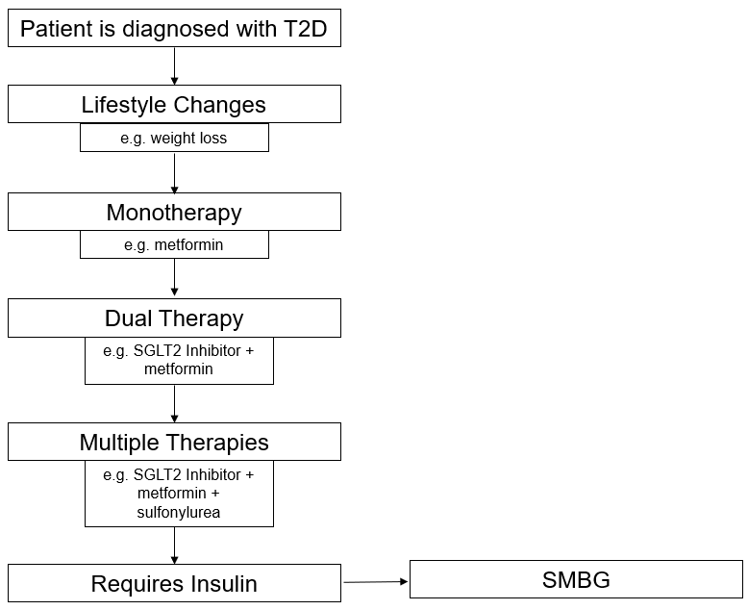

SMBG: Self monitoring of blood glucose; SGLT2 inhibitor: sodium–glucose co-transporter-2 inhibitor; T2D: Type 2 diabetes

The proposed change in the treatment algorithm that includes use of FSL2 in place of SMBG by some T2D insulin using patients is provided in Figure 9.

Figure 9: Change in algorithm with the introduction of FSL2

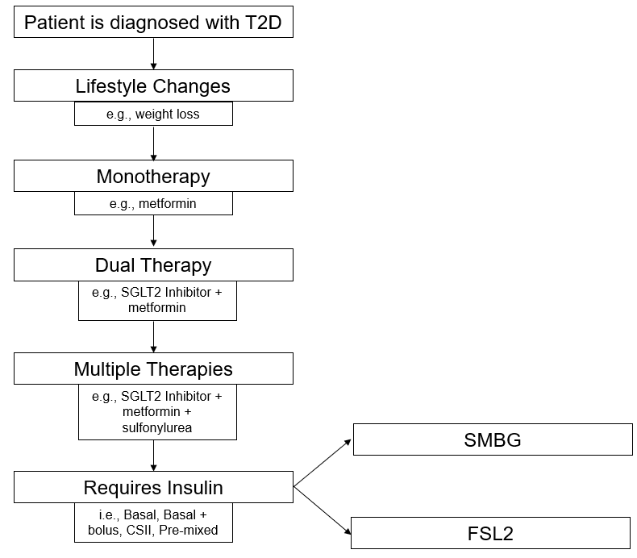

CSII: continuous subcutaneous insulin infusion; FSL2: Freestyle Libre 2; IIT: intensive insulin treatment; SMBG: Self monitoring of blood glucose; SGLT2 inhibitor: sodium–glucose co-transporter-2 inhibitor; T2D: Type 2 diabetes

# Claims

**In terms of health outcomes (comparative benefits and harms), is the proposed technology claimed to be superior, non-inferior or inferior to the comparator(s)?**

Superior

Non-inferior

Inferior

**Please state what the overall claim is, and provide a rationale:**

The clinical claim is that FSL2 provides superior efficacy in terms of glycaemic control and non-inferior safety compared to SMBG.

The rationale for the claim is that use of FSL2 results in statistically and clinically significantly greater improved in glycaemic control (measured as HbA1c change in key trials and other markers of glycaemic control including time in glycaemic range and the occurrence of hypo/hyperglycaemia). Improvement in HbA1c outcomes observed in the clinical studies is also associated with improved long term diabetes control and reduced development of diabetic complications. Use of FSL2 also results in reduced healthcare resource use(e.g. reduced hospital admissions), improved patient satisfaction and quality of life, reported in clinical trials and during real world use.

**Why would the requestor seek to use the proposed investigative technology rather than the comparator(s)?**

FSL2 provides a more convenient and less painful option to regularly self-monitor blood glucose (compared with finger pricking), particularly because of the multiple times per day SMBG may be required per day. The RACGP T2D Management Guidelines note the “*emerging role for continuous glucose monitoring and flash glucose monitoring in patients with T2D on complex insulin regimens who have not achieved their glycaemic targets*” (RACGP 2020b). The more frequent use of SMBG by the IIT subpopulation, compared with less intensive insulin regimens, makes use of FSL2 a more convenient and less painful option (compared with finger pricking), because of the multiple times per day SMBG is recommended to be monitored in these patients.

International guidelines (including American Diabetes Association (ADA), International Diabetes Federation (IDF), Diabetes Canada, and the UK National Institute for Health and Care Excellence (NICE)) recognise the value of CGM in achieving glucose control. For example, in the updated ADA guidelines on diabetes technology it is recommended that patients on either basal insulin or on MDI/CSII insulin should be offered the option of real time CGM, including the intermittently scanned FSL2 CGM devices (ElSayed 2022).

Recommendation on which glucose monitoring device better suits an individual patient will be made by relevant HCPs based on individual patient’s circumstances, preferences and needs, including their capability to safely use the device (ElSayed 2022).

**Identify how the proposed technology achieves the intended patient outcomes:**

Improved glucose monitoring allows for better self-management behaviour, including more frequent titration of insulin therapies leading to improved disease control and less risk of harms. This can lead to reduced adverse short-term outcomes including hypoglycaemia and acute diabetes events including hospitalisations, hyperosmolar hyperglycaemic state (HHS)

Longer term outcomes that can be improved with better control achieved via more frequent SMBG with FSL include reduced adverse cardiovascular events (stroke, myocardial infarction), peripheral vascular disease, kidney events, neuropathy leading to retinopathy/eye disease, foot ulcers and amputations. Improved disease control is associated with improved quality of life and satisfaction with treatment, plus productivity benefits with reduced absenteeism etc.

**For some people, compared with the comparator(s), does the test information result in:**

**A change in clinical management?** Yes

**A change in health outcome?** Yes

**Other benefits?** No

**In terms of the immediate costs of the proposed technology (and immediate cost consequences, such as procedural costs, testing costs etc.), is the proposed technology claimed to be more costly, the same cost or less costly than the comparator?**

More costly

Same cost

Less costly

**Provide a brief rationale for the claim:**

The acquisition cost of the proposed technology is higher than that of the comparator.

Use of FSL2 results in improved health outcomes, including glycaemic control (HbA1c improvement), leading to reduced healthcare costs associated with treating adverse impacts and complications arising fromT2D, which will be evaluated in a modelled cost-effectiveness evaluation provided as part of the ADAR.

# Summary of Evidence

**Provide one or more recent (published) high quality clinical studies that support use of the proposed health service/technology. At ‘Application Form lodgement’, please do not attach full text articles; just provide a summary (repeat columns as required).**

**Identify yet-to-be-published research that may have results available in the near future (that could be relevant to your application). Do not attach full text articles; this is just a summary (repeat columns as required).**

An updated, comprehensive literature search will be undertaken for the ADAR. There is a large, increasing body of evidence (identified previously with literature searches, plus ongoing evidence scanning by the Sponsor) supporting effectiveness and safety of FSL2 in patients with T2D requiring insulin. The body of evidence supporting use of FSL2 includes two randomised, comparative studies of FSL vs. SMBG, meta-analyses of multiple studies and real world study evidence (RWE) including observational studies.

One published meta-analysis report (Kroger 2020, study 2 below) combined data from 3 similar retrospective cohort studies conducted in different European countries , with 2 of the cited cohort studies also listed as separate studies/publications (a separate publication for the third study was not identified). This publication by Kroger et al. (2020) meta-analysed 3 studies that included only the T2D IIT population with a -0.9% (standard error (SE 0.05; p<0.0001) change from baseline in HbA1c seen across the studies after the introduction of FSL2.

The Evan’s 2020 meta-analysis (study 1 below) combined studies in people with T1D and T2D that reported HbA1c outcomes following 2-4 months use of FSL2, with a statistically and clinically significant -0.55% (95% CI -0.70%, -0.39%) reduction from baseline in HbA1c that was independent of study length, type of diabetes or age. Some of the T2D IIT studies listed below were included in this meta-analysis, including the randomised controlled studies Haak 2017 and Yaron 2019 and the observational study Ish-Shalom 2016.

It is anticipated that a similar meta-analysis of studies reporting comparable key outcomes will be required for the assessment report, to provide overall measures of efficacy and safety in the T2D insulin using population. All outcomes will be included with a mix of RWE and controlled trials including RCTs. A recent survey of Australia’s leading diabetes health professionals supports use of RWE outcomes. Many note that RWE are informative / particularly important for broader populations, provided that RCTs show a benefit with some also noting that RWE outcomes data are equally important to RCT (RWE complementary to RCT). Results from both comparative trials and RWE are used to inform recommendation to consider use of FSL2 (and other glucose monitoring devices) in the PICO population of T2D patients using insulin (ElSayed 2022).

While cost-effectiveness data is not reported in the Application (with data to be presented in the ADAR), it should be noted that the validity of the clinical and economic evidence for FSL2 has been evaluated in T2D insulin requiring patients by a number of international HTA bodies, including ones Australia has agreed to collaborate with (i.e. in Canada (CADTH) in the UK (NICE) and Health Technology Wales), with funding recommended for patients requiring insulin therapy, not just in the IIT subpopulation.

For example, the Wales HTA guidance notes that: “*The evidence supports the routine adoption of Freestyle Libre flash glucose monitoring to guide blood glucose regulation in people with diabetes who require treatment with insulin. The use of Freestyle Libre flash glucose monitoring in these people improves the proportion of time that the blood glucose is in target range and reduces time in hypo and hyperglycaemia*.“

Note that all these HTA bodies assessed data across a range of outcomes including time in glycaemic range and the occurrence of hypo/hyperglycaemia in addition to HbA1c and all used data from observational studies, in addition to RCTS in making their clinical assessments of FSL effectiveness

An overview of key studies supporting the use of FSL2 in patients with T2D using insulin is provided in the following table.

|  | Type of study design* | Title of journal article or research project (including any trial identifier or study lead if relevant) | Short description of research (max 50 words)** | Website link to journal article or research (if available) | Date of publication*** |
| --- | --- | --- | --- | --- | --- |
| **Meta-analyses of FSL in T1D and T2D (Evans 2020), in the T2D insulin using population (3 studies meta-analysed in Kroger 2020 and Wright 2021 that includes meta-analysed data from multiple centres)** | | | | | |
| 1 | Meta-analysis of studies reporting change from baseline in HbA1c up to 12 months | EVANS M, et al 2020. The Impact of Flash Glucose Monitoring on Glycaemic Control as Measured by HbA1c: A Meta-analysis of Clinical Trials and Real-World Observational Studies. Diabetes Ther; 11(1): 83-95. (Evans 2020) | 29 studies reported HbA1c change data up to 12 months in a total of 1723 participants with T1D or T2D using FSL. Overall mean change in laboratory HbA1c across study subjects at 2–4 months was -0.55% (95% CI -0.70, -0.39). Amongst the 1023 adults, mean change in HbA1c was 0.56% (95% CI -0.76, -0.36). As expected from a broad population, substantial heterogeneity was seen with both analyses. No significant differences in HbA1c change from baseline were detected between T1D and T2D. | [Evans 2020](https://pubmed.ncbi.nlm.nih.gov/31673972/) | Online 31 October 2019 |
| 2 | Meta-analysis of data from 3 retrospective observational, multicentre studies | KROGER, J., et al. 2020. Three European Retrospective Real-World Chart Review Studies to Determine the Effectiveness of Flash Glucose Monitoring on HbA1c in Adults with Type 2 Diabetes. Diabetes Therapy, 11, 279-291. (Kroger 2020)  **(REFER study)** | Random effects meta-analysis of 3 retrospective, non-interventional chart review studies in Austria, France and Germany. Included N=363 T2DM receiving basal bolus insulin regimen who had used FSL for ≥3 months.  Mean (SE) HbA1c from before FSL (≤90 days before initiating) vs 3–6 months after (90–194 days following initiation) was reduced signiﬁcantly in Austria by 0.9% ± 0.8%, *p<0.0001*), in France by 0.8% ± 1.1, (*p<0.0001*) and in Germany by 0.9% ± 1.1], *p<0.0001*). Across all 3 countries (Austria, France, Germany), HbA1c reduction of 0.9% (SE 0.05; p<0.0001) was achieved during the studies. | [Kroger 2020](https://pubmed.ncbi.nlm.nih.gov/31833041/) | Online 12 Dec 2019 |
| **FSL Studies for inclusion in the meta-analyses to be conducted for the application in T2D insulin using population (including the studies in the Study 2 Kroger 2020 meta-analysis)** | | | | | |
| **Comparative studies** | | | | |  |
| 3 | Randomised trial, open-label, multicentre | HAAK, T., et al. 2017. Flash Glucose-Sensing Technology as a Replacement for Blood Glucose Monitoring for the Management of Insulin-Treated Type 2 Diabetes: a Multicenter, Open-Label Randomized Controlled Trial. Diabetes Ther, 8, 55-73. (Haak 2017)  **REPLACE study**  **NCT02082184** | Randomised to FSL (n=149) or SMBG (n=75). Mean (SE) age 59.0 ± 9.9, 59.5 ± 11.0 years, Baseline HbAa1c 8.7% ± 0.97, 8.8% ± 1.05 for FSL vs. SMBG.  Mean (SE) HbA1c change from baseline at 6 months: FSL -0.29% ± 0.07 vs. SMBG -0.31% ± 0.09; *p=0.8222*. A difference in HbA1c was detected in participants aged 65 years or less: FSL -0.53 ± 0.09% vs. SMBG -0.20 ± 0.12%; (p = 0.0301). Mean time spent in hypoglycaemia (<3.9 mmol/L): 43% reduction with FSL vs. SMBG with mean difference -0.47 hr ± SE 0.13 (*p=0.0006*).  54% reduction in mean time spent in nocturnal hypoglycaemia (<3.9 mmol/L) with FSL vs. SMBG: Mean (SE) treatment difference -0.29 ± 0.08 per 7 hr for FSL vs. SMBG (*p=0.0001*). | [Haak 2017](https://pubmed.ncbi.nlm.nih.gov/28000140/) | Online 20 December 2016. |
| 4 | Randomised trial, open-label, 2 centres. | YARON, M., et al, 2019. Effect of flash glucose monitoring technology on glycemic control and treatment satisfaction in patients with type 2 diabetes. Diabetes Care, 42, 1178-1184. (Yaron 2019)  **NCT02809365** | On MDI insulin, including at least 1 prandial injection. Randomised to FSL (n = 53) or the standard care (SMBG) group (n = 48) and followed for 10 weeks. Mean (SD) age: FSL 66 ± 8.4 and SMBG 68 ± 6.7 years. Baseline HbA1c: FSL 8.3 ± 0.74%, SMBG 8.7 ± 0.87%.  Significant mean (SD) reduction in HbA1c vs SMBG (-0.82 ± 0.84 % vs-0.33 ± 0.78% at 10 weeks; *p=0.005*). No severe hypoglycaemia or serious adverse events occurred during the study. | [Yaron 2019](https://pubmed.ncbi.nlm.nih.gov/31036546/) | 29 April 2019 |
| 5 | Prospective, comparative (matched cases), observational, multicentre. | BOSI, E., et al 2022. The use of flash glucose monitoring significantly improves glycemic control in type 2 diabetes managed with basal bolus insulin therapy compared to self-monitoring of blood glucose: A prospective observational cohort study. Diabetes Research and Clinical Practice, 183, 109172. (Bosi 2022) | T2D using MDI insulin therapy for ≥1 year and new to FSL use (<3 months) or continuing with SMBG were matched (1:2 ratio) for baseline HbA1C (within ±0.5%, recorded ≤3 months previously), study site, and baseline data collection date. Including all eligible records: N=322, n=234 with complete records. Mean (SE) baseline HbA1c: 8.9% ± 0.8 and 8.9% ± 0.8 in the FSL and SMBG groups, respectively. Mean (SE) HbA1c significantly reduced in FSL vs. SMBG for 3-6 months by 0.3% ± 0.12% (*p=0.0112*). | [Bosi 2022](https://pubmed.ncbi.nlm.nih.gov/34883185/) | Online 6 Dec 2021 |
| **Observational studies (RWE)** | | | | | |
| 6 | Prospective, observational, single centre | AL HAYEK, A et al. 2021. The Impact of Flash Glucose Monitoring on Markers of Glycaemic Control and Patient Satisfaction in Type 2 Diabetes. Cureus, 13, e16007. (Al Hayek 2021) | T2D managed with MDI insulin therapy and HbA1c ≥7%. In N=54 patients mean (SD) HbA1c significantly improved by 0.44% from 8.22% ± 0 .69 at baseline to 7.78% ± 0.71 at 12 weeks (*p<0.001*). Confirmed hypoglycaemic episodes reduced from mean 4.43 ± 1.51 episodes/month to 1.24 ± 1.15 (difference: -3.19, *p<0.001*). | [Al Hayek 2021](https://pubmed.ncbi.nlm.nih.gov/34354874/) | 28 June 2021 |
| 7 | Retrospective, observational | BERGENSTAL RM et al. 2021 Flash CGM Is Associated With Reduced Diabetes Events and Hospitalizations in Insulin-Treated Type 2 Diabetes. J Endocr Soc; 5(4): bvab013. (Bergenstal 2021) | Cohort identified (N=2,463) with T2D using short or rapid acting insulin who commenced FSL in a US inpatient, outpatient and pharmacy claims database. FSL was commenced from Nov 2017-Sep 2018 with a minimum 6 month baseline data required.  Acute diabetes-related event rates (hypoglycaemia, hypoglycaemic coma, hyperglycaemia, diabetic ketoacidosis, and hyperosmolarity) decreased from 0.180 to 0.072 events/patient-year (hazard ratio [HR]: 0.39 [0.30, 0.51]; *p<0.001*) and all cause hospitalisation rates decreased from 0.420 to 0.283 events/patient-year (HR: 0.68 [0.59 0.78]; *p<0.001*) during the first 6 months after FSL initiation vs. 6 months prior. | [Bergenstal 2021](https://pubmed.ncbi.nlm.nih.gov/33644623/) | 1 April 2021 |
| 8 | Retrospective chart review, multi-centre and meta-analysis  Meta-analysis component of study includes data from Canadian centres reported in (Elliott 2021) | CARLSON, A.L et al. 2022. Flash glucose monitoring in type 2 diabetes managed with basal insulin in the USA: A retrospective real-world chart review study and meta-analysis. BMJ Open Diabetes Research and Care 10(1): e002590. (Carlson 2022) | Meta-analysis (n=191) of data from centres using basal insulin (mean (SD) age 60.0 ± 11.3) showed mean (SE) HbA1c significantly decreased by 1.1% ± 0.14%, from baseline mean (SD) 9.2% ± 1.0% to 8.1%±1.1% (p≤0.0001). Heterogeneity: I2=74.9% explained by differences in baseline HbA1c between sites. HbA1c improvement observed by age group, BMI, insulin use duration and sex. | [Carlson 2022](https://drc.bmj.com/content/10/1/e002590.long) | Online January 20, 2022 |
| 9 | Retrospective cohort | EEG-OLOFSSON K, et al. 2020. 74-LB: Sustainable HbA1c Decrease at 12 Months for Adults with Type 1 and Type 2 Diabetes Using the FreeStyle Libre System: A Study within the National Diabetes Register in Sweden. Diabetes 2020; 69(Supplement_1). (Eeg-Olofsson 2020) | Swedish National Diabetes Register data from 1 Jan 2014 to 25 June 2019 used identify T1D and T2D population with FSL use (N=39,554). Statistically signiﬁcant HbA1C reductions achieved and sustained at 12 months in FSL naïve users (i.e. prior to baseline) T1D (-0.44%) and T2D (-0.66% with 95% CI -0.84, -0.49; p<0.0001).  Note that it may be a T2D IIT population reported, however this is not clearly stated in the abstract. The T2D population characteristics will be confirmed prior to inclusion in the Assessment Report. | [Eeg-Olofsson 2020](https://diabetesjournals.org/diabetes/article/69/Supplement_1/74-LB/59054/74-LB-Sustainable-HbA1c-Decrease-at-12-Months-for) | 1 June 2020 |
| 10 | Retrospective cohort  Data from this study was included in the meta-analysis reported in (Carlson 2022) | ELLIOTT, T et al. 2021. The impact of flash glucose monitoring on glycated hemoglobin in type 2 diabetes managed with basal insulin in Canada: A retrospective real-world chart review study. Diabetes and Vascular Disease Research 18(4): 14791641211021374.  (Elliott 2021) | N=91 T2D treated with basal insulin for ⩾1 year and using FSL for ⩾3 months  HbA1c significantly decreased by 0.8% ± 1.1 (mean ± SD, [p< 0.0001]) from mean baseline HbA1c 8.9% ± 0.9 to 8.1% ± 1.0 at 3–6 months after initiation of FSL. | [Stada 2021](https://journals.sagepub.com/doi/full/10.1177/14791641211021374?rfr_dat=cr_pub++0pubmed&url_ver=Z39.88-2003&rfr_id=ori%3Arid%3Acrossref.org) | 4 July 2021 |
| 11 | Retrospective, observational | FASCHING, P. et al. 2019. Effectiveness of freestyle libre flash glucose monitoring system observed in real-world, chart review study in Austria, in adults with type 2 diabetes. Diabetes, 68. (Fasching 2019) | Patients included in Kroger 2020 meta-analysis – see study 2 above for overview including meta-analysed results. | [Fasching 2019](https://diabetesjournals.org/diabetes/article/68/Supplement_1/96-LB/58369/96-LB-Effectiveness-of-FreeStyle-Libre-Flash) | 1 June 2019 |
| 12 | Retrospective, observational | HANAIRE, H., et al. 2019. Real-world, chart review study to determine the effectiveness of freestyle libre flash glucose monitoring system, in adults with type 2 diabetes in France. Diabetes, 68. (Hanaire 2019) | Patients included in Kroger 2020 meta-analysis – see study 2 above for overview including meta-analysed results. | [Hanaire 2019](https://diabetesjournals.org/diabetes/article/68/Supplement_1/92-LB/58374/92-LB-Real-World-Chart-Review-Study-to-Determine) | 1 June 2019 |
| 13 | Prospective, observational | IDA, S. et al. 2020. Effects of Flash Glucose Monitoring on Dietary Variety, Physical Activity, and Self-Care Behaviors in Patients with Diabetes. J Diabetes Res 2020: 9463648. (Ida 2020) | N=48 T2D using insulin were followed for 12 weeks post FSL initiation. There was an increase in moderate/high category scores for International Physical Activity Questionnaire IPAQ (P <0:001) and for treatment satisfaction reported via Diabetes Treatment Satisfaction Questionnaire (DTSQ). HbA1c decreased signiﬁcantly (from mean (SD) 7.7 ± 1.2 to 7.4 ± 0.8, (P =0.025). | [Ida 2020](https://pubmed.ncbi.nlm.nih.gov/32352017/) | 9 April 2020 |
| 14 | Prospective, observational | ISH-SHALOM, M., et al. 2016. Improvement in Glucose Control in Difficult-to-Control Patients With Diabetes Using a Novel Flash Glucose Monitoring Device. J Diabetes Sci Technol, 10, 1412-1413. (Ish-Shalom 2016) | N=31 T2D receiving MDI insulin with a mean baseline 8.9% ± SE 0.26. Mean (SE) HbA1C decreased by −1.33% ± 0.29 at 8 weeks (*p<0.0001*) and plateaued thereafter. For patients who continued using the device (n=27), the mean (SE) HbA1c change was maintained for 24 weeks (–1.21% ± 0.42; *p=0.009*). No events of major hypoglycaemia were reported. | [Ish-Shalom 2016](https://pubmed.ncbi.nlm.nih.gov/27277660/) | 9 July 2016 |
| 15 | Retrospective observational | MILLER, E et al. (2020). HbA1c Reduction after Initiation of the FreeStyle Libre System in Type 2 Diabetes Patients on Long-Acting Insulin or Noninsulin Therapy." Diabetes 69(Supplement_1).  (Miller 2020) | Evaluates change in HbA1c from baseline to 6mo and baseline to 12mo after starting FSL for T2D patients on long-acting insulin (LAI). Baseline (6/12 mo cohorts) HbA1c 8.5%/8.4%.  The 6mo T2D LAI cohort (n=277) had reduced mean (SE) HbA1c by -0.6% ± 0.09% (P<0.0001). The 12mo T2D LAI cohort (n=207) had reduced HbA1c by -0.5% ± 0.09% (P=0.0014). | [Miller 2020](https://diabetesjournals.org/diabetes/article/69/Supplement_1/84-LB/56726/84-LB-HbA1c-Reduction-after-Initiation-of-the) | 1 June 2020 |
| 16 | Prospective, observational | OGAWA, W., et al. 2021. Effect of the FreeStyle LibreTM flash glucose monitoring system on glycemic control in individuals with type 2 diabetes treated with basal-bolus insulin therapy: An open label, prospective, multicenter trial in Japan. Journal of Diabetes Investigation, 12, 82-90. (Ogawa 2021) | N=94 T2D on basal-bolus insulin regimens for up to 90 days. There was a signiﬁcant improvement in mean (SD) HbA1c at study end compared with baseline: 7.07% ± 0.84 vs 7.46% ± 0.91%; a change of -0.39% ± 0.81 (*p<0.0001*). Mean (SD) time in hypoglycaemia (<3.9 mmol/L; primary outcome) was non-significantly reduced from 0.51 ± 0.93 h/day to 0.47 ± 0.63 h/day at study end, a change of -0.04 ± 0.83 hr/day (-8.1%) (*p=0.6354*). Mean time in range (3.9-10.0 mmol/L) and treatment satisfaction (measured on DTSQ) significantly improved by study end compared with baseline (*p<0.0001*). | [Ogawa 2021](https://pubmed.ncbi.nlm.nih.gov/32562376/) | 1 January 2021 |
| 17 | Retrospective, observational | **RELIEF study using French National Claims database**  **1 year data: (Roussel 2021)**  ROUSSEL, R et al. 2021. Important Drop in Rate of Acute Diabetes Complications in People With Type 1 or Type 2 Diabetes After Initiation of Flash Glucose Monitoring in France: The RELIEF Study. Diabetes Care 44(6): 1368-1376.  **2 year data : (Riveline 2022)**  RIVELINE, J.P et al. 2022. "Reduced Rate of Acute Diabetes Events with Flash Glucose Monitoring Is Sustained for 2 Years After Initiation: Extended Outcomes from the RELIEF Study. Diabetes Technol Ther 24(9): 611-618.  **2 year data: (Guerci 2022)**  GUERCI, B et al. (2022). Important decrease in hospitalizations for acute diabetes events following FreeStyle Libre system initiation in people with type 2 diabetes on basal insulin therapy in France. Diabetes technology & therapeutics. | **2 year data: (Riveline 2022)**  N=41,027 T2D initiating FSL between August 1 and December 31 2017 (>95% T2D with insulin). In the 2 years after FSL initiation, hospitalizations for ADEs were reduced by 48%, driven by reductions in DKA. After 2 years mean consumption of blood glucose test strips had fallen after 2 years by -84% in T2D.  (Roussel 2021 reports 1 year outcomes results for the same T2D majority insulin-using population and collection period as Riveline 2022; data is not reported here for brevity).  **2 year data (Guerci 2022) (different period to Riveline 2022, basal insulin only):**  N=5,933 with T2DM on basal insulin initiated FSL between August 1 2017 and December 31 2018. 2.01% had at least one hospitalization for any acute diabetes events (ADE) in the year before FSL initiation, compared to 0.75% (1 year) and 0.60% (2 years). Reductions in ADEs were driven by 75% fewer diabetic ketoacidosis (DKA) admissions, with 44% reduction in severe hypoglycaemia admissions. educed ADEs persisted after 2 years, with a further 43% reduction in DKA rates. | [Roussel 2021](https://diabetesjournals.org/care/article/44/6/1368/138708/Important-Drop-in-Rate-of-Acute-Diabetes)  [Riveline 2022](https://www.liebertpub.com/doi/full/10.1089/dia.2022.0085)  [Guerci 2022](https://pubmed.ncbi.nlm.nih.gov/36094418/) | Online 20 April 2021  Online 24 August 2022  Online 24 November 2022 (hardcopy published January 2023) |
| 18 | Retrospective, observational | ROSE, L., et al. 2021. Improving HbA1c Control in Type 1 or Type 2 Diabetes Using Flash Glucose Monitoring: A Retrospective Observational Analysis in Two German Centres. Diabetes therapy : research, treatment and education of diabetes and related disorders, 12, 363-372. (Rose 2021) | N=176 with T2D on insulin (100% MDI) who initiated FSL as part of standard care. Significant change in mean HbA1c of -0.54% was observed at 3 months and sustained, with a mean (SE) change of -0.38% ± 0.17 at 12 months (*p=0.014*). There was a significant mean (SE) HbA1c improvement from baseline at 12 months of -0.62% ± 0.22 (*p<0.01*) in patients with baseline HbA1c of >7.5%-10%. The mean change in HbA1c in those with baseline HbA1c >10% was -3.73% at 12 months vs. baseline (*p<0.01*). | [Rose 2021](https://pubmed.ncbi.nlm.nih.gov/33314006/) | Online 1 December |
| 19 | Retrospective, observational | WRIGHT, E.E et al. 2021. Use of Flash Continuous Glucose Monitoring Is Associated With A1C Reduction in People With Type 2 Diabetes Treated With Basal Insulin or Noninsulin Therapy. Diabetes Spectrum 34(2): 184-189. (Wright 2021) | Mean (SD) age 51.6, Total cohort with T2D N=1034 with N=306 on basal insulin. Reduction in basal insulin group of HbA1c from baseline 10.1 to 9.0, change of -1.1% (p<0.001). | [Wright 2021](https://diabetesjournals.org/spectrum/article/34/2/184/33000/Use-of-Flash-Continuous-Glucose-Monitoring-Is) | 10 February 2021 |

BMI: body mass index; DKA: diabetic ketoacidosis; FSL: Freestyle Libre; HbA1c: glycated haemoglobin; SD: standard deviation; SE: standard error; T2D: Type 2 diabetes

* Categorise study design, for example meta-analysis, randomised trials, non-randomised trial or observational study, study of diagnostic accuracy, etc.

**Provide high level information including population numbers and whether patients are being recruited or in post-recruitment, including providing the trial registration number to allow for tracking purposes. For yet to be published research, provide high level information including population numbers and whether patients are being recruited or in post-recruitment.

*** If the publication is a follow-up to an initial publication, please advise. For yet to be published research, include the date of when results will be made available (to the best of your knowledge).

Reference list

ABS. (2013). "Obesity and chronic disease." Retrieved October 2022, from <https://www.abs.gov.au/articles/obesity-and-chronic-disease#cite-window2>.

ABS. (2018). "Diabetes." National Health Survey Retrieved October 2022, from <https://www.abs.gov.au/statistics/health/health-conditions-and-risks/diabetes/2017-18#:~:text=Type%202%20diabetes%20was%20more,3.5%25%20in%202007%2D08>.

ABS. (2019). "National Aboriginal and Torres Strait Islander Health Survey." Retrieved October 2022, from <https://www.abs.gov.au/statistics/people/aboriginal-and-torres-strait-islander-peoples/national-aboriginal-and-torres-strait-islander-health-survey/2018-19>.

AIHW. (2020). "Diabetes." Retrieved July 2023, from <https://www.aihw.gov.au/reports/diabetes/diabetes/contents/deaths-from-diabetes>.

AIHW. (2022). "Overweight and obesity." Retrieved October 2022, from <https://www.aihw.gov.au/reports/australias-health/overweight-and-obesity>.

AIHW. (2023). "Diabetes: Australian facts." Retrieved July 2023, from <https://www.aihw.gov.au/reports/diabetes/diabetes/contents/summary>.

Al Hayek, A., M. Al Dawish and M. El Jammal (2021). "The Impact of Flash Glucose Monitoring on Markers of Glycaemic Control and Patient Satisfaction in Type 2 Diabetes." Cureus **13**(6): e16007.

Australian Diabetes Society. (2022). "ADS Position Statements/Guidelines - Type 2 Diabetes Mellitus." from <https://diabetessociety.com.au/position-statements-guidelines-type-2.asp>.

Australian National Diabetes Audit (2021). Annual Report: Australian Quality Clinical Audit 2021 Annual Report, Australian Government Department of Health.

Australian National Diabetes Audit (2022). Australian National Diabetes Audit Annual Report 2022. Monash University, School of Public Health and Preventive Medicine, January 2023, Report No 15. <https://www.monash.edu/__data/assets/pdf_file/0003/3218205/anda-2022-final-annual-report.pdf>.

Battisti, W.P., J. Palmisano and W.E. Keane (2003). "Dyslipidemia in patients with type 2 diabetes. relationships between lipids, kidney disease and cardiovascular disease." Clin Chem Lab Med **41**(9): 1174-1181.

Beckman, J.A., M.A. Creager and P. Libby (2002). "Diabetes and atherosclerosis: epidemiology, pathophysiology, and management." Jama **287**(19): 2570-2581.

Bellou, V., L. Belbasis, I. Tzoulaki, et al. (2018). "Risk factors for type 2 diabetes mellitus: An exposure-wide umbrella review of meta-analyses." PLOS ONE **13**(3): e0194127.

Bergenstal, R.M., M.S.D. Kerr, G.J. Roberts, et al. (2021). "Flash CGM Is Associated With Reduced Diabetes Events and Hospitalizations in Insulin-Treated Type 2 Diabetes." J Endocr Soc **5**(4): bvab013.

Bosi, E., G. Gregori, C. Cruciani, et al. (2022). "The use of flash glucose monitoring significantly improves glycemic control in type 2 diabetes managed with basal bolus insulin therapy compared to self-monitoring of blood glucose: A prospective observational cohort study." Diabetes Research and Clinical Practice **183**: 109172.

Brixner, D., A. Ermakova, Y. Xiong, et al. (2019). "Clinical and Economic Outcomes of Patients with Type 2 Diabetes on Multiple Daily Injections of Basal-bolus Insulin (MDI) Therapy: A Retrospective Cohort Study." Clin Ther **41**(2): 303-313.e301.

Carlson, A.L., T.D. Daniel, A. Desantis, et al. (2022). "Flash glucose monitoring in type 2 diabetes managed with basal insulin in the USA: A retrospective real-world chart review study and meta-analysis." BMJ Open Diabetes Research and Care **10**(1): e002590.

Cheung, N.W., J.J. Conn, M.C. d'Emden, et al. (2009). "Position statement of the Australian Diabetes Society: individualisation of glycated haemoglobin targets for adults with diabetes mellitus." Med J Aust **191**(6): 339-344.

Cho, J., H. Hong, S. Park, et al. (2017). "Insulin Resistance and Its Association with Metabolic Syndrome in Korean Children." Biomed Res Int **2017**: 8728017.

Clar, C., K. Barnard and E. Cummins, et al., (2010). Self-monitoring of blood glucose in type 2 diabetes: systematic review. outhampton (UK), SNIHR Journals Library.

Cummins, E., P. Royle, A. Snaith, et al. (2010). "Clinical effectiveness and cost-effectiveness of continuous subcutaneous insulin infusion for diabetes: systematic review and economic evaluation." Health Technol Assess **14**(11): iii-iv, xi-xvi, 1-181.

Diabetes Australia (2017). Position Statement: Glucose self-monitoring in adults with type 1 diabetes or type 2 diabetes. <https://www.diabetesaustralia.com.au/wp-content/uploads/Glucose-position-statement-2017.pdf>, Diabetes Australia.

Diabetes Australia (2022). Type 2 diabetes.

DUSC. (2017). Medicines for the treatment of diabetes

Eeg-Olofsson, K., A.-M. Svensson, S. FranzÉN, et al. (2020). "74-LB: Sustainable HbA1c Decrease at 12 Months for Adults with Type 1 and Type 2 Diabetes Using the FreeStyle Libre System: A Study within the National Diabetes Register in Sweden." Diabetes **69**(Supplement_1): 74-LB.

Elliott, T., S. Beca, R. Beharry, et al. (2021). "The impact of flash glucose monitoring on glycated hemoglobin in type 2 diabetes managed with basal insulin in Canada: A retrospective real-world chart review study." Diabetes and Vascular Disease Research **18**(4): 14791641211021374.

ElSayed, N.A., G. Aleppo, V.R. Aroda, et al. (2022). "7. Diabetes Technology: Standards of Care in Diabetes—2023." Diabetes Care **46**(Supplement_1): S111-S127.

European Medicines Agency (2012). "Guideline on clinical investigation of medicinal products in the treatment or prevention of diabetes mellitus. CPMP/EWP/1080/00 Rev. 1." Available at: <https://www.ema.europa.eu/en/clinical-investigation-medicinal-products-treatment-prevention-diabetes-mellitus>.

Evans, M., Z. Welsh, S. Ells, et al. (2020). "The Impact of Flash Glucose Monitoring on Glycaemic Control as Measured by HbA1c: A Meta-analysis of Clinical Trials and Real-World Observational Studies." Diabetes Ther **11**(1): 83-95.

Farmer, A. (2012). "Use of HbA1c in the diagnosis of diabetes." Bmj **345**: e7293.

Fasching, P., H. Brath, C. Ebenbichler, et al. (2019). "Effectiveness of freestyle libre flash glucose monitoring system observed in real-world, chart review study in Austria, in adults with type 2 diabetes." Diabetes **68**(Supplement 1).

FDA (2008). Guidance for Industry Diabetes Mellitus — Evaluating Cardiovascular Risk in New Antidiabetic Therapies to Treat Type 2 Diabetes, U.S. Department of Health and Human Services Food and Drug Administration Center for Drug Evaluation and Research (CDER)

Gaede, P., P. Vedel, N. Larsen, et al. (2003). "Multifactorial intervention and cardiovascular disease in patients with type 2 diabetes." N Engl J Med **348**(5): 383-393.

Galicia-Garcia, U., A. Benito-Vicente, S. Jebari, et al. (2020). "Pathophysiology of Type 2 Diabetes Mellitus." International journal of molecular sciences **21**(17): 6275.

Gast, K.B., N. Tjeerdema, T. Stijnen, et al. (2012). "Insulin resistance and risk of incident cardiovascular events in adults without diabetes: meta-analysis." PLoS One **7**(12): e52036.

Guerci, B., R. Roussel, F. Levrat-Guillen, et al. (2022). "Important decrease in hospitalizations for acute diabetes events following FreeStyle Libre system initiation in people with type 2 diabetes on basal insulin therapy in France." Diabetes technology & therapeutics.

Haak, T., H. Hanaire, R. Ajjan, et al. (2017). "Flash Glucose-Sensing Technology as a Replacement for Blood Glucose Monitoring for the Management of Insulin-Treated Type 2 Diabetes: a Multicenter, Open-Label Randomized Controlled Trial." Diabetes Ther **8**(1): 55-73.

Haffner, S.M., S. Lehto, T. Rönnemaa, et al. (1998). "Mortality from coronary heart disease in subjects with type 2 diabetes and in nondiabetic subjects with and without prior myocardial infarction." N Engl J Med **339**(4): 229-234.

Hanaire, H., P.Y. Benhamou, C. Bures, et al. (2019). "Real-world, chart review study to determine the effectiveness of freestyle libre flash glucose monitoring system, in adults with type 2 diabetes in France." Diabetes **68**(Supplement 1).

Hillier, T.A. and K.L. Pedula (2003). "Complications in young adults with early-onset type 2 diabetes: losing the relative protection of youth." Diabetes Care **26**(11): 2999-3005.

Ida, S., R. Kaneko, K. Imataka, et al. (2020). "Effects of Flash Glucose Monitoring on Dietary Variety, Physical Activity, and Self-Care Behaviors in Patients with Diabetes." J Diabetes Res **2020**: 9463648.

Inzucchi, S.E., K. Tunceli, Y. Qiu, et al. (2015). "Progression to insulin therapy among patients with type 2 diabetes treated with sitagliptin or sulphonylurea plus metformin dual therapy." Diabetes Obes Metab **17**(10): 956-964.

Ish-Shalom, M., J. Wainstein, I. Raz, et al. (2016). "Improvement in Glucose Control in Difficult-to-Control Patients With Diabetes Using a Novel Flash Glucose Monitoring Device." Journal of Diabetes Science and Technology **10**(6): 1412-1413.

Kirk, J.K. and J. Stegner (2010). "Self-monitoring of blood glucose: practical aspects." J Diabetes Sci Technol **4**(2): 435-439.

Kroger, J., P. Fasching and H. Hanaire (2020). "Three European Retrospective Real-World Chart Review Studies to Determine the Effectiveness of Flash Glucose Monitoring on HbA1c in Adults with Type 2 Diabetes." Diabetes Therapy **11**(1): 279-291.

Lewis, G.F. and G. Steiner (1996). "Acute effects of insulin in the control of VLDL production in humans. Implications for the insulin-resistant state." Diabetes Care **19**(4): 390-393.

Miller, E., Brandner and E. Wright, JR. (2020). "84-LB: HbA1c Reduction after Initiation of the FreeStyle Libre System in Type 2 Diabetes Patients on Long-Acting Insulin or Noninsulin Therapy." Diabetes **69**(Supplement_1).

Nathan, D.M. (2002). "Clinical practice. Initial management of glycemia in type 2 diabetes mellitus." N Engl J Med **347**(17): 1342-1349.

NCEP (2002). "Third Report of the National Cholesterol Education Program (NCEP) Expert Panel on Detection, Evaluation, and Treatment of High Blood Cholesterol in Adults (Adult Treatment Panel III) final report." Circulation **106**(25): 3143-3421.

NDSS. (2022). "Australian Type 2 Diabetes Glycaemic management algorithm " Retrieved October 2022, from <https://diabetessociety.com.au/downloads/20220908%20T2D%20Algorithm%2006.09.2022.pdf>.

NDSS. (2023a). "All types of diabetes." Retrieved July 2023, from <https://www.ndss.com.au/wp-content/uploads/ndss-data-snapshot-202303-all-types-diabetes.pdf>.

NDSS. (2023b). "Insulin Therapy." Retrieved July 2023, from <https://www.ndss.com.au/wp-content/uploads/ndss-data-snapshot-202303-insulin-therapy-diabetes.pdf>.

Neilson, L.M., E.C.S. Swart, C.B. Good, et al. (2019). "Identifying Outcome Measures for Type 2 Diabetes Value-Based Contracting Using the Delphi Method." J Manag Care Spec Pharm **25**(3): 324-331.

Nesto, R.W. (2004). "Correlation between cardiovascular disease and diabetes mellitus: current concepts." Am J Med **116 Suppl 5A**: 11s-22s.

Nowakowska, M., S.S. Zghebi, D.M. Ashcroft, et al. (2019). "The comorbidity burden of type 2 diabetes mellitus: patterns, clusters and predictions from a large English primary care cohort." BMC Medicine **17**(1): 145.

NPSS Medicine Wise (2004). Starting insulin treatment in type 2 diabetes.

Ogawa, W., Y. Hirota, T. Osonoi, et al. (2021). "Effect of the FreeStyle LibreTM flash glucose monitoring system on glycemic control in individuals with type 2 diabetes treated with basal-bolus insulin therapy: An open label, prospective, multicenter trial in Japan." Journal of Diabetes Investigation **12**(1): 82-90.

Prospection (2022). Report on Australian insulin using type 2 diabetes patients. Data on file.

Quigley, M., A. Earnest, N. Szwarcbard, et al. (2022). "Exploring HbA1c variation between Australian diabetes centres: The impact of centre-level and patient-level factors." PLOS ONE **17**(2): e0263511.

RACGP (2020a). Appendix 2: Guide to insulin initiation and titration: Management of type 2 diabetes: A handbook for general practice. The Royal Australian College of General Practitioners,. <https://www.racgp.org.au/clinical-resources/clinical-guidelines/key-racgp-guidelines/view-all-racgp-guidelines/diabetes/appendices/appendix-2-guide-to-insulin-initiation>.

RACGP (2020b). The Royal Australian College of General Practitioners. Management of type 2 diabetes: A handbook for general practice. East Melbourne, Vic: RACGP, 2020. <https://www.racgp.org.au/clinical-resources/clinical-guidelines/key-racgp-guidelines/view-all-racgp-guidelines/diabetes/introduction>.

Riveline, J.P., R. Roussel, E. Vicaut, et al. (2022). "Reduced Rate of Acute Diabetes Events with Flash Glucose Monitoring Is Sustained for 2 Years After Initiation: Extended Outcomes from the RELIEF Study." Diabetes Technol Ther **24**(9): 611-618.

Rose, L., G. Klausmann and A. Seibold (2021). "Improving HbA1c Control in Type 1 or Type 2 Diabetes Using Flash Glucose Monitoring: A Retrospective Observational Analysis in Two German Centres." Diabetes Ther **12**(1): 363-372.

Roussel, R., J.-P. Riveline, E. Vicaut, et al. (2021). "Important Drop in Rate of Acute Diabetes Complications in People With Type 1 or Type 2 Diabetes After Initiation of Flash Glucose Monitoring in France: The RELIEF Study." Diabetes Care **44**(6): 1368-1376.

Sarwar, N., P. Gao, S.R. Seshasai, et al. (2010). "Diabetes mellitus, fasting blood glucose concentration, and risk of vascular disease: a collaborative meta-analysis of 102 prospective studies." Lancet **375**(9733): 2215-2222.

Sparks, J.D., C.E. Sparks and K. Adeli (2012). "Selective hepatic insulin resistance, VLDL overproduction, and hypertriglyceridemia." Arterioscler Thromb Vasc Biol **32**(9): 2104-2112.

Vergès, B. (2015). "Pathophysiology of diabetic dyslipidaemia: where are we?" Diabetologia **58**(5): 886-899.

WHO (2011). Use of Glycated Haemoglobin (HbA1c) in the Diagnosis of Diabetes Mellitus. Abbreviated Report of a WHO Consultation, World Health Organization.

Wright, E.E., M.S.D. Kerr, I.J. Reyes, et al. (2021). "Use of Flash Continuous Glucose Monitoring Is Associated With A1C Reduction in PeopleWith Type 2 Diabetes Treated With Basal Insulin or Noninsulin Therapy." Diabetes Spectrum **34**(2): 184-189.

Yaron, M., E. Roitman, G. Aharon-Hananel, et al. (2019). "Effect of flash glucose monitoring technology on glycemic control and treatment satisfaction in patients with type 2 diabetes." Diabetes Care **42**(7): 1178-1184.

1. This dataset may be over-representative of patients with type 1 diabetes (T1D) with 29% of patients vs. 9% of NDSS identifying as T1D NDSS. (2023a). "All types of diabetes." Retrieved July 2023, from https://www.ndss.com.au/wp-content/uploads/ndss-data-snapshot-202303-all-types-diabetes.pdf.