MSAC Application 1770
Valve-in-valve transcatheter aortic valve implantation for patients with symptomatic structural valve deterioration resulting in aortic stenosis, insufficiency/regurgitation or both

Applicant: Edwards Lifesciences Pty Ltd

PICO Confirmation

Summary of PICO/PPICO criteria to define question(s) to be addressed in an Assessment Report to the Medical Services Advisory Committee (MSAC)
Table 1 PICO for Valve in valve (ViV) Transcatheter aortic valve implantation (TAVI) system in patients with symptomatic structural valve deterioration (SVD): PICO Set 1
Component | Description
Population | Patients with symptomatic structural valve deterioration (SVD) with valve failing after a surgical aortic valve replacement (SAVR) or transcatheter aortic valve implantation (TAVI) that results in stenosis, insufficiency, or both, and who are at high risk for SAVR, where high risk is determined by a heart team and defined as fulfilling at least one of the following criteria:  - Society of Thoracic Surgeons’ Predicted Risk of Mortality (STS-PROM) score >8% OR  - Moderate to severe frailty OR  - No more than two major organ system compromises not to be improved postoperatively OR  - A possible procedure-specific impediment  Note, the assessment report may expand the proposed patient population to include those with intermediate surgical risk.
Intervention | Valve-in-valve (ViV) TAVI
Comparators | Main comparator SAVR
Outcomes | Safety outcomes:  - Bleeding complications  - Vascular and access-related complications  - Cardiac structural complications (e.g., coronary obstruction and coronary structure perforation)  - Conduction disturbances and arrythmias including, but not limited to:  - New permanent pacemaker  - Left bundle branch block  - New onset atrial fibrillation  - Paravalvular leak (also called paravalvular regurgitation)  - Myocardial infarction  - Aortic valve reintervention (e.g. treatment crossover between ViV TAVI to SAVR)  - Acute kidney injury  Efficacy/effectiveness outcomes including, but not limited to, patient-relevant outcomes:  - Overall survival  - Stroke  - Patient-prosthesis mismatch  - Hospitalisation or rehospitalisation  - Composite of death, stroke or rehospitalisation  - Health-related quality of life (HRQOL)  Cost-effectiveness:  - Cost per life-year gained  - Cost per quality-adjusted life year (QALY) gained.  Healthcare resources:  - Cost of valvular prosthesis  - Cost associated with complications and changes in clinical management (testing required before the procedure, length of hospital stay, post-discharge rehabilitation).  Total Australian Government Healthcare costs:  - Total cost to the Medical Benefits Schedule (MBS)  - Total cost to other Government health budgets (e.g. Pharmaceutical Benefits Scheme [PBS], State and Territory Government health budgets, including public hospitals).
Assessment questions | What is the safety, effectiveness and cost-effectiveness of ViV TAVI versus SAVR in patients with symptomatic SVD?

Purpose of application
An application requesting Medicare Benefits Schedule (MBS) listing of valve-in-valve (ViV) transcatheter aortic valve implantation (TAVI) using the SAPIEN 3 Ultra balloon expanding valve (BEV) system for patients with symptomatic heart valve disease (stenosis, insufficiency, or both) due to structural valve deterioration (SVD) after a surgical aortic valve replacement (SAVR) or TAVI and who are at high risk for open heart surgery, was received from the Edwards Lifesciences Pty Limited by the Department of Health and Aged Care (DoHAC).
The applicant’s clinical claim is that ViV TAVI results in:
- Superior health outcomes (comparative benefits and harms) compared to repeat SAVR.
- Non-inferior health outcomes of TAVI-in-TAVI compared to TAVI-in-SAVR
TAVI has previously been listed under three MBS items. Items 38495 and 38514 for the treatment of symptomatic severe aortic stenosis in patients at high risk and intermediate risk, respectively, for open aortic valve replacement surgery, device agnostic. Item 38522 for the treatment of symptomatic severe native calcific aortic stenosis for patients with low risk for surgery, device agnostic. All items are listed with a fee of $1,576.45.

PICO criteria

Population
The proposed population for ViV TAVI is patients with symptomatic heart valve disease (stenosis, insufficiency, or both) due to SVD with the bioprosthetic aortic valve failing after undergoing a SAVR or TAVI necessitating valve replacement, and who are at high risk for SAVR, where high risk is determined by a heart team and defined as fulfilling at least one of the following criteria:
- Society of Thoracic Surgeons’ Predicted Risk of Mortality (STS-PROM) score >8% OR
- Moderate to severe frailty OR
- No more than two major organ system compromises not to be improved postoperatively OR
- A possible procedure-specific impediment
The applicant specified during the PICO process that this population only includes patients with SVD and excludes those who have non-SVD such as regurgitation and patients with native calcific aortic stenosis. The applicant also indicated that condition in both populations (prior SAVR and prior TAVI populations) would behave in a similar manner, presenting similar symptoms related to stenosis, insufficiency or both.
The STS-PROM score is an accepted tool to predict the 30-day risk of SAVR and serves as a starting point for risk assessment in TAVI candidates (Otto et al., 2017).
The 2014 American Heart Association (AHA) and American College of Cardiology (ACC) guidelines for the management of patients with valvular heart disease (Nishimura et al., 2014) define moderate to severe frailty, as the presence of two or more of the seven frailty indices of Katz Activities of Daily Living (independence in feeding, bathing, dressing, transferring, toileting, urinary continence), and independence in ambulation (i.e. no walking aid required or 5-meter walk in <6 seconds). Other frailty scoring systems may be applied as well (Nishimura et al., 2014).
The applicant specified that patients determined to be at high risk for surgery are required to meet one of the following criteria: the STS-PROM score ≥8% or other comorbidities. The applicant also indicated that there are no procedure-specific impediments.
PASC agreed with the proposed high risk criteria as it aligns with the definition of high risk in the 2014 AHA/ACC and 2017 ACC consensus guidelines and with the approach of other relevant Ratified PICO applications for TAVI (1603 and 1635) that included patients with symptomatic severe aortic stenosis at intermediate risk and low risk for surgery, respectively.
The TGA indication for SAPIEN 3 Ultra Transcatheter Heart Valve system (ARTG 343715) is for:
- Relief of aortic stenosis in patients with symptomatic heart disease due to severe native calcific aortic stenosis who are judged by a Heart Team, including a cardiac surgeon, to be appropriate for the transcatheter heart valve replacement therapy
- Patients with symptomatic heart disease due to failing (stenosed, insufficient, or combined) of a surgical or transcatheter bioprosthetic aortic valve or surgical bioprosthetic mitral valve who are judged by a heart team, including a cardiac surgeon, to be at high or greater risk for open surgical therapy (i.e., predicted risk of surgical mortality ≥ 8% at 30 days, based on the Society of Thoracic Surgeons (STS) risk score and other clinical co-morbidities unmeasured by the STS risk calculator).

Structural valve deterioration (SVD)
Surgical bioprosthetic valves are susceptible to SVD. SVD is a multifactorial process mediated by calcification of the connective tissue, leading to valve dysfunction and eventually valve failure (Rodriguez-Gabella et al., 2017). Standardised definitions of SVD and bioprosthesis valve failure (BVF) is now endorsed by the European Association of Percutaneous Cardiovascular Interventions (EAPCI), European Society of Cardiology (ESC), and European Association for Cardio-Thoracic Surgery (EACTS) (Capodanno et al., 2017).
The term SVD includes permanent intrinsic changes of the valve (e.g., leaflet tear, calcification, pannus deposition, flail, fibrotic leaflet) leading to degeneration and/or dysfunction, which in turn may result in stenosis or intra-prosthetic regurgitation (Capodanno et al., 2017). SVD can be detected using imaging studies or at the time of reoperation or autopsy and can arise in both symptomatic and asymptomatic patients. SVD can be characterized as hemodynamic dysfunction (moderate and severe) and/or morphological SVD and echocardiography is the principal imaging modality for the detection of SVD (Capodanno et al., 2017).
Moderate haemodynamic SVD (any of the following):
- Mean transprosthetic gradient ≥20 mmHg and <40 mmHg
- Mean transprosthetic gradient ≥10 and <20 mmHg change from baseline
- Moderate intra-prosthetic aortic regurgitation, new or worsening (>1+/4+) from baseline
Severe haemodynamic SVD (any of the following):
- Mean transprosthetic gradient ≥40 mmHg
- Mean transprosthetic gradient ≥20 mmHg change from baseline
- Severe intra-prosthetic aortic regurgitation, new or worsening (>2+/4+) from baseline
Morphological SVD (any of the following):
- Leaflet integrity abnormality (i.e. torn or flail causing intra-frame regurgitation)
- Leaflet structure abnormality (i.e. pathological thickening and/or calcification causing valvular stenosis or central regurgitation)
- Leaflet function abnormality (i.e. impaired mobility resulting in stenosis and/or central regurgitation)
- Strut/frame abnormality (i.e. fracture)
The term BVF integrates severe SVD (i.e. the aetiology) with its clinical consequences (thereby avoiding over-interpretation of valve-related outcomes in asymptomatic patients with no clinical impact) and is recommended by the Task Force as the main outcome of interest in studies assessing the long-term performance of TAVI and SAVR (Capodanno et al., 2017). Importantly, BVF may occur in the setting of SVD but also as the consequence of pathophysiological processes unrelated to SVD, such as thrombosis, endocarditis or non-structural valve dysfunction. BVF includes any of the following: (i) bioprosthetic valve dysfunction at autopsy, very likely related to the cause of death, or ‘valve-related death’, defined as any death caused by bioprosthetic valve dysfunction in the absence of confirmatory autopsy; (ii) aortic valve reintervention (i.e. valve-in-valve TAVI, paravalvular leak closure or SAVR); and (iii) severe haemodynamic SVD (Capodanno et al., 2017).
PASC noted that valve failure can result as a consequence of SVD and non-SVD and queried if the definition of symptomatic SVD is sufficient or whether diagnostic parameters should be included. The applicant’s clinical expert suggested the indication defined in the proposed service for SVD is the correct approach given that SVD can result in aortic stenosis and intra-prosthetic regurgitation. PASC advised that it is important to include patients with regurgitation as it is not covered within the current MBS item for TAVI.
PASC queried whether it was possible to define populations where BEV or self-expandable valve (SEV) devices were most suitable, with a separate population who are eligible for both, to allow for better structured comparisons. The applicant’s clinical expert suggested that the majority of patients would be eligible for both, SEV and BEV, and that they are interchangeable in most circumstances. PASC noted the applicant’s clinical expert expressed preference for the inclusion of the intermediate risk population (in addition to the high risk population) stating that there is a high clinical need for this group evident by the significant proportion of such patients needing ViV TAVI in clinical practice, and it is a safer alternative to SAVR. The applicant also stated there are data for both populations, but prospective 5-year data for ViV TAVI (including BEV and SEV) is available mostly from high risk and prohibitive patients. The ACOR data includes intermediate risk patients and a manuscript including analyses of this population is under review.

Incidence
The incidence of SVD in patients who have undergone SAVR is unclear/inconclusive. Studies on the performance or durability of surgical aortic bioprostheses during the first decade after SAVR have reported rates of freedom from SVD of 85% or more at 10 years (Rodriguez-Gabella et al., 2017). However, comparison between studies remains challenging due to the multiplicity of definitions and times used to evaluate SVD post-SAVR. This is consistent with a systematic review which analysed the durability of surgical aortic biological valves in 167 studies and 12 US FDA reports (Fatima et al., 2019). The authors concluded that there was a significant heterogeneity in the individual study definitions for SVD. Available data on surgical aortic bioprostheses did not provide a reliable benchmark for SVD at long-term follow-up.
There is limited data pertaining to the long-term durability of TAVI predominantly due to their initial use in older and higher risk patients that often did not survive beyond 7 to 8 years (Montarello et al., 2023). The NOTION trial provides randomized data beyond 5 years and represent the longest reported follow-up of a patient population randomised to TAVI or SAVR, including a younger and lower risk patient cohort with a longer life expectancy (Jorgensen et al., 2021; Montarello et al., 2023). The results shows that there was a significantly lower rate of SVD in the TAVI group compared to SAVR (13.9% vs. 28.3%, p = 0.0017), but a similar risk of bioprosthesis valve failure (8.7% vs. 10.5%, p = 0.61). The risk of severe SVD was 2.2% in the TAVI cohort vs. 6.8% in the SAVR cohort, p = 0.068).
PASC noted that redo TAVI procedures were done 2 days to 11.6 years [median 3 years: Interquartile range: 0 to 5 years] after the native TAVI (Landes et al., 2021). However, PASC noted that the time frame of SVD is difficult to ascertain clearly from the literature and noted that durability of bioprostheses may differ between SAVR and TAVI populations. PASC advised that TAVI in TAVI and TAVI in SAVR populations should be considered separately and that population size and utilisation estimates should be based on both populations (currently do not include TAVI in TAVI subpopulation), including multiple uses of the intervention and appropriate valve fail rates for each population. PASC also advised that the application should specify what proportion of patients who fail ViV TAVI will proceed to have SAVR.
PASC queried whether there is a population difference in usage for each type of TAVI device eligible under the proposed MBS item that is agnostic to the type of TAVI device. The applicant’s pre-PASC response provided access to 5-year Australian Cardiac Outcomes Registry (ACOR) data. The applicant provided outcome data for these devices but not pre-procedural data that may show some differences in population characteristics.

Utilisation estimates
The application suggested that in Australia there are approximately 9000 SAVR annually with a fail rate at 10 years of 1%. The application indicated that 90 patients will utilise the proposed technology for the first full year and the estimated uptake rate will be 90% at Year 1, Year 2, Year 3 and Year 4. The application also indicated that the technology would be only used once per patient. Joshi et al. (2018) showed that patients can undergo multiple aortic valve replacements. This study included 83.2% (263/316) of patients with first redo SAVR, 13.3% (42/316) with a second redo SAVR and 3.5% (11/316) with third redo SAVR or beyond.
In 2023, MBS item 38484 (SAVR with bioprosthesis or mechanical prothesis) was claimed 1413 times, item 38495 (TAVI for high-risk population) was claimed 2355 times, item 38514 (TAVI for intermediate-risk population) was claimed 393 times and item 38522 (TAVI for low-risk population) was claimed 185 times. Previously, in 2022, MBS item 38484 was claimed 1427 times, item 38495 was claimed 2084 times, item 38514 was claimed 198 times and item 38522 was claimed 88 times. The number of SAVR per year estimated in the application differed from the number of SAVR procedures claimed.
PASC noted that TGA indications for ViV TAVI using both BEV and SEV devices currently include high risk patients (except ViV TAVI using the SEV device for TAVI in TAVI subpopulation). PASC noted that the timing of a potential (in parallel) TGA application for ViV TAVI in the intermediate risk population may be a reason for the application to include high risk population only. PASC also noted that if the proposed population is expanded in this application to include SVD patients with failing valve at intermediate surgical risk, it may introduce complexity because multiple economic models (within each population classified by surgical risk; and their subpopulations) may need to be included in the assessment; as well as consideration of the availability of the evidence base in both populations. PASC noted these considerations would be a matter for the applicant when progressing to the assessment phase.

Current management of SVD
Transthoracic echocardiography (TTE) is the primary imaging modality for the assessment of SVD and bioprosthetic valve dysfunction and failure in SAVR and TAVI valves. Computed tomography (CT) and transesophageal echocardiography (TEE) may also be used when standard imaging is suboptimal or to provide additional information regarding the aetiology of the valve dysfunction. After TAVI and SAVR, echocardiography should be performed before discharge or within 30 days after valve implantation (i.e. baseline imaging), at 1 year after valve implantation and annually thereafter (with additional follow-up assessments and/or integration of other imaging modalities as necessary and/or determined by the attending physician) (Capodanno et al., 2017). All patients receiving bioprosthetic implantation, and especially those diagnosed with SVD, should receive education about possible symptoms of bioprosthetic dysfunction and the need to seek prompt medical evaluation if these appear (Dvir et al., 2018).
The treatment for SVD and dysfunctional surgical heart valves has conventionally been SAVR (repeat surgery) of the failed bioprosthesis (Cote et al., 2017; Rodriguez-Gabella et al., 2017). However, repeat SAVR has been associated with increased morbidity and mortality, and a significant proportion of patients are refused for reoperation (Rodriguez-Gabella et al., 2017). ViV procedures have been identified as a feasible, less-invasive treatment option for patients with degenerated surgically implanted bioprostheses, and the 2017 ACC/AHA guidelines currently recommend this approach in high-risk patients with aortic bioprosthesis dysfunction (Otto et al., 2017; Rodriguez-Gabella et al., 2017).
PASC noted the applicant’s clinical expert advice that younger SVD patients with failing valve at lower surgical risk levels may have greater risk of prosthesis mismatch and should have SAVR.

Intervention
The proposed intervention is ViV TAVI using the BEV system. The term ViV TAVI describes several clinical scenarios, including TAVI inside of a degenerated surgical valve (TAVI-in-SAVR), TAVI inside of a degenerated TAVI valve (TAVI-in-TAVI), and even TAVI inside of a TAVI valve, which was previously placed in degenerated SAVR valves (TAVI-in-TAVI-in-SAVR) (Perdoncin et al., 2022; Vrachatis et al., 2020).
In Australia, TAVI is performed in a cardiac catheterisation or an operating room. TAVI is performed under general anaesthesia or local anaesthesia with sedation. For transfemoral delivery (relevant to this application), the latter is often sufficient. The procedure is performed without cardio-pulmonary bypass.
TAVI is usually performed under the guidance of fluoroscopy and transoesophageal echocardiography (TOE). Aortography may also be used. A percutaneous sheath is inserted into the access artery with a guide wire that is pushed passed the aortic valve. The aortic valve is predilated via balloon valvuloplasty while the heart is rapidly paced. The BEV is mounted on a balloon catheter and is inserted percutaneously over the guidewire until it crosses the aortic valve. Optimum positioning is confirmed by fluoroscopy. Once the correct position is confirmed, the heart is again rapidly paced, and the balloon is expanded until the device meets the native annular walls. The balloon is then deflated, and the catheter and guidewire are removed. Immediately following the procedure, aortography and TOE are again performed to assess the location and the degree of any aortic regurgitation, and the functioning of the coronary arteries. Patients are then transferred for monitoring to either a coronary care, high dependency or intensive care unit.
The SAPIEN 3 Ultra BEV system consists of the SAPIEN 3 Ultra Valve and the Commander Delivery system delivery. The SAPIEN 3 Ultra Valve comprises a balloon-expandable, radiopaque, cobalt-chromium frame, trileaflet bovine pericardial tissue valve, and polyethylene terephthalate inner and outer fabric skirts. The Commander Delivery system allows for either transfemoral or subclavian/axillary access implantation of the SAPIEN 3 Ultra Valve.
There are also a number of consumables involved. Single use consumables comprise: angioplasty kit which includes drapes, manifolds and extensions tubing; small and large bore vascular access sheaths; lock syringes; 2 x 3-way taps; 3 x bowls; 2 x galley pots; temporary pacing wire; pre-shaped catheters; and standard or speciality wires. Multi-use consumables comprise: temporary pacing cable; temporary pacing box; and transthoracic or transoesophageal probe.
PASC noted that the application requested the intervention to be device agnostic as per the proposed MBS item. PASC noted that SEV devices (CoreValve Evolut R and the CoreValve Evolut PRO systems) are TGA approved for TAVI in SAVR population but not currently for TAVI in TAVI population.
The TGA indication for the CoreValve Evolut R system (ARTG 284003) and the CoreValve Evolut PRO system (ARTG 319850) is for:
- Relief of aortic stenosis in patients with symptomatic heart disease due to severe native calcific aortic stenosis who are judged by a heart team, including a cardiac surgeon, to be appropriate for the transcatheter heart valve replacement therapy;
- Patients with a stenosed, insufficient, or combined surgical bioprosthetic valve failure necessitating valve replacement who are at high or greater risk for surgical aortic valve replacement (AVR) where high risk is defined as Society of Thoracic Surgeons operative risk score ≥8% or documented heart team agreement of risk for AVR due to frailty or comorbidities.
A meta-analysis comparing ViV TAVI with SEV versus BEV conducted by Hamilton et al. (2020) showed that there was no significant difference in all-cause mortality at 12 months (SEV 10.3% vs BEV 12.6%, p = 0.165, I2 = 0%), or 3 years (SEV 21.2% vs BEV 31.2%, p = 0.407, I2 = 63.79). SEV had lower transvalvular gradients after procedure and acute kidney injury, but higher rates of pacemaker insertion, moderate or severe paravalvular regurgitation and need for ≥2 valves (all p < 0.05). There were no differences in stroke, coronary obstruction, bleeding, or vascular complications. Despite significant differences in key procedural outcomes between SE and BE valves when used for ViV TAVI, the authors found no difference in 12-month mortality (primary endpoint). The authors suggested that tailored device selection may further reduce the risk of adverse procedural outcomes, particularly over the longer term.
At present, prior to receiving a Medicare-eligible TAVI procedure, a TAVI patient must have been assessed at a TAVI Case Conference (by a TAVI ‘Heart Team’) as having an unacceptably high risk for SAVR and suitable to receive the TAVI procedure. There is an MBS item for coordination (item 6080) and participation in the conference (6081). The present application seeks to have these same ‘accompanying’ MBS items for the proposed new MBS item.
A TAVI case conference comprises at least a cardiothoracic surgeon, an interventional cardiologist and a specialist or consultant physician who does not perform TAVIs. The team assesses a patient’s risk and technical suitability to receive TAVIs, taking into account the patient’s risk, cognitive function and frailty. TAVI case conferences are routinely convened in healthcare facilities in which TAVIs are undertaken.
TAVIs are only performed by accredited TAVI practitioners in accredited TAVI health facilities (public or private hospital). TAVI practitioners comprised appropriately qualified interventional cardiologists or cardiothoracic surgeons. Cardiothoracic surgeons must have completed the Cardiothoracic Surgery Program and be eligible to be a Fellow of the Royal Australasian College of Surgeons, or otherwise qualified to practice cardiothoracic surgery in Australia. Interventional cardiologists must have completed the Advanced Training Curriculum in Cardiology and be eligible to be a Fellow of the Royal Australasian College of Physicians or otherwise qualified to practice interventional cardiology in Australia. Additionally, the interventional cardiologist or cardiothoracic surgeon must be an accredited by Cardiac Accreditation Services Limited (CASL). CASL is a national body comprising representatives from the Australian and New Zealand Society of Cardiac and Thoracic Surgeons (ANZSCTS) and the Cardiac Society of Australia and New Zealand (CSANZ).
Other than the SAPIEN 3 Ultra BEV system and the TAVI case conference, other healthcare resources required for ViV TAVI comprise:
Procedure:
- CT scan
- Echocardiography
- Anaesthetist and anaesthesia

Post-procedure:
- Care in intensive care unit, if required
- Care in hospital ward
- Management of complications, if required
The application indicated that key difference between ViV TAVI and repeat SAVR is that ViV TAVI is minimally invasive, while repeat SAVR requires major open heart surgery with cardio-pulmonary bypass. As a consequence, peri-operative complications are more significant for repeat SAVR, and length of hospital stay is longer.
PASC considered the assessment report should present data for both BEV and SEV. The applicant’s pre-PASC response indicated that the 5-year ACORD data shows that there are significant differences between TAVI BEV and TAVI SEV, which appears favourable for TAVI BEV. In this context, PASC advised that the application should present a comparison between BEV and SEV to demonstrate that health outcomes would be non-inferior regardless of the type of TAVI device used under the proposed service.

Comparator(s)
The comparator is SAVR, the current standard for treatment of SVD post TAVI or post SAVR for patients with high surgical risk. SAVR is an open-heart surgical procedure to repair or remove the narrowed aortic valve and replace it with a bioprosthetic or mechanical aortic valve. A SAVR procedure requires general anaesthetic and extracorporeal circulation, with access via a sternotomy or a less invasive transthoracic approach all of which require a bypass machine.
SAVR can only be undertaken by cardiothoracic surgeons who have completed the Cardiothoracic Surgery Program and are eligible to be a Fellow of the Royal Australasian College of Surgeons or otherwise qualified to practise cardiothoracic surgery in Australia.
SAVR has an existing MBS item 38484 for the replacement of the aortic or pulmonary valve with bioprosthesis or mechanical prosthesis as a complete medical service. The associated fee is $2,234.35.
The application indicated that the proposed technology would replace SAVR in patients at high surgical risk needing repeat aortic valve replacement who meet eligibility criteria, based on the advantage of TAVI over SAVR in terms of peri-procedural risks and health outcomes. The applicant specified that SAVR will be partially replaced given various reasons, including practitioner preference, patient preference and circumstantial factors.
PASC noted that medical management (± balloon valvuloplasty) was not included as a comparator but this was included as a comparator in the previous TAVI application for high-risk population. PASC agreed that medical management should be excluded as a comparator because the applicant’s clinical expert indicated that there is no medical management that prolongs life or sufficiently relieves symptoms in patients with severe heart disease.

Outcomes
Safety outcomes:
- Bleeding complications
- Vascular and access-related complications
- Cardiac structural complications (e.g., coronary obstruction and coronary structure perforation)
- Conduction disturbances and arrythmias including, but not limited to:
  - New permanent pacemaker
  - Left bundle branch block
  - New onset atrial fibrillation
- Paravalvular leak (also called paravalvular regurgitation)
- Myocardial infarction
- Aortic valve reintervention
- Acute kidney injury
Efficacy/effectiveness outcomes including, but not limited to, patient-relevant outcomes:
- Overall survival
- Stroke
- Patient-prosthesis mismatch
- Hospitalisation or rehospitalisation
- Composite of death, stroke or rehospitalisation
- Health-related quality of life (HRQOL)
Healthcare system
Cost-effectiveness:
- Cost per life-year gained
- Cost per quality-adjusted life year (QALY) gained.
Healthcare resources:
- Cost of valvular prosthesis
- Cost associated with complications and changes in clinical management (testing required before the procedure, length of hospital stay, post-discharge rehabilitation).
Total Australian Government Healthcare costs:
- Total cost to the Medical Benefits Schedule (MBS)
- Total cost to other Government health budgets (e.g. Pharmaceutical Benefits Scheme [PBS], State and Territory Government health budgets, including public hospitals).
The proposed outcomes are based on the updated recommendation from the Valve Academic Research Consortium (VARC) for the most appropriate clinical endpoints and standardised definitions to be used in the conduct of transcatheter and surgical aortic valve clinical research (VARC-3 Writing Committee et al., 2021). These outcomes also align with previous Ratified PICO applications for TAVI items for low risk population (application 1635) and for intermediate risk population (application 1603).
The application did not specify if HRQOL would be measured with a disease specific tool and/or standardised tool. The VARC-3 Writing Committee et al. (2021) recommended using both disease specific tools, such Kansas City Cardiomyopathy Questionnaire (KCCQ), and standardised tools such as EuroQol-five dimension tool (EQ-5D) or Short-Form-36 (SF-36) questionnaire.
PASC suggested the addition of two safety and effectiveness outcomes relevant for the proposed SVD cohorts: (1) treatment crossover between VIV TAVI to SAVR and (2) patient-prosthesis mismatch (PPM) especially in TAVI in SAVR, given this has significant implications for the long-term survival and it is more prevalent in the TAVI in SAVR population.
PASC suggested that the application uses reference standards including HRQOL measures such as KCCQ, EQ-5D and SF-36 questionnaires.
The application indicated that there are no differences in the types of outcomes post ViV TAVI compared to post repeat SAVR and highlighted that the likelihoods of their occurrences differ significantly.
PASC noted that the ACOR registry provided reporting of clinical outcomes for all TAVI but the results provided currently doesn’t clearly distinguish between ViV TAVI for SAVR or TAVI.

Clinical management algorithms
The application presented the current and new clinical management algorithms for patients with symptomatic structural valve deterioration at high surgical risk in Figure 1 and Figure 2, respectively.

Current clinical algorithm for the identified population
Figure 1 Current clinical management algorithm for patients with symptomatic SVD at high surgical risk included in the application.
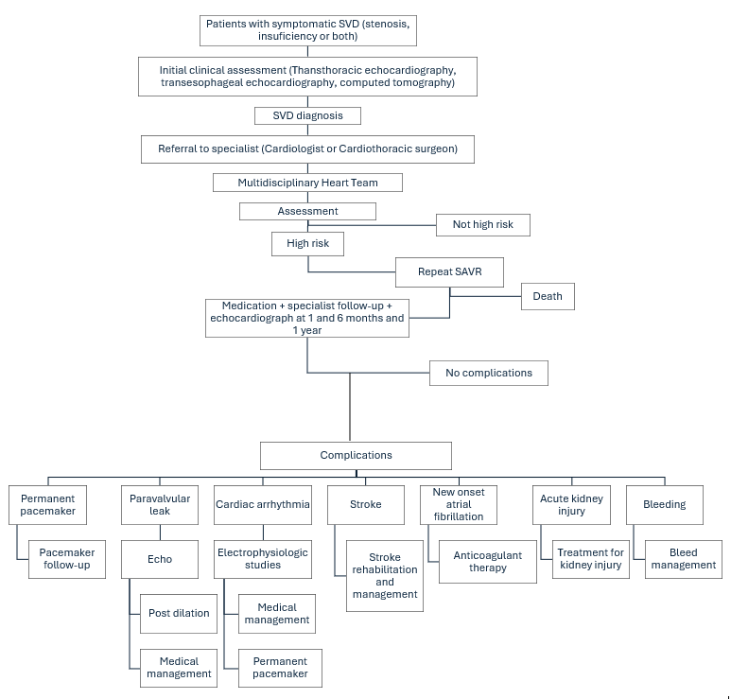
Source: Figure 1, p17 of the application.
SAVR= Surgical aortic valve replacement; SVD= Structural valve deterioration.

Proposed clinical algorithm after the use of the proposed health technology
Figure 2 Applicant - Proposed clinical management algorithm after using the proposed health technology for patients with symptomatic SVD at high surgical risk.
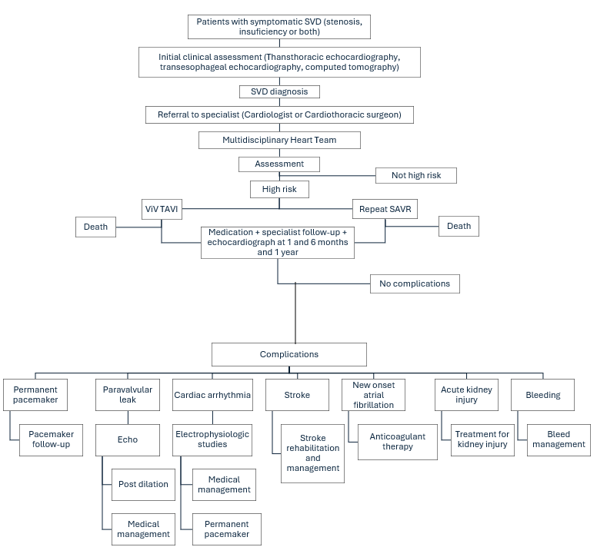Source: Figure 2, p18 of the application.
SAVR= Surgical aortic valve replacement; SVD= Structural valve deterioration; TAVI= transcatheter aortic valve implantation; ViV= valve-in-valve
The application specified that the key difference between clinical management algorithm prior to the use of the proposed health technology vs. the comparator health technology is the option of ViV TAVI for patient management. The clinical pathway after ViV TAVI is the same as after repeat SAVR. Secondary outcomes and their management are unchanged.
PASC suggested that the application uses reference standards including VARC-3 and previous PICO standard outcomes along with the patient-prothesis mismatch outcome in the current and proposed algorithms. Figure 3 and Figure 4 present the current and new clinical management algorithms including the proposed outcomes, respectively.
Figure 3 Assessment group - Current clinical management algorithm for patients with symptomatic SVD at high surgical risk included in the application.
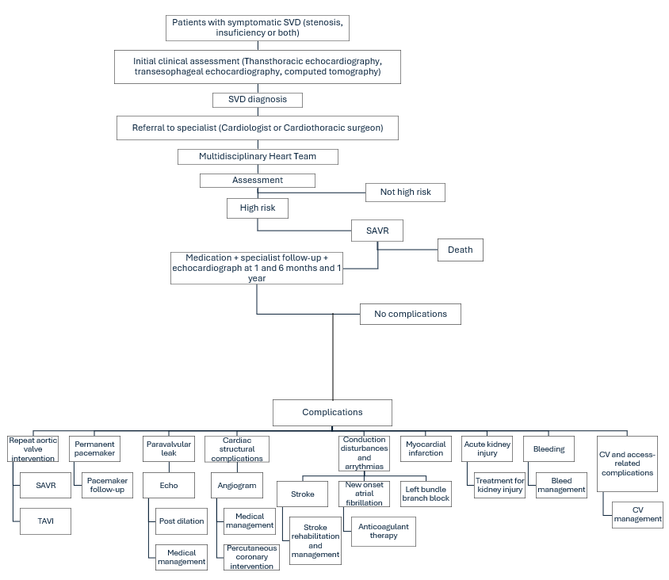
Source: Produced during preparation of PICO from Figure 1, p17 of the application, and VARC-3 Writing Committee et al. (2021).
CV= Cardiovascular; SAVR= Surgical aortic valve replacement; SVD= Structural valve deterioration; TAVI= transcatheter aortic valve implantation.

Figure 4 Assessment group - Proposed clinical management algorithm after using the proposed health technology for patients with symptomatic SVD at high surgical risk.
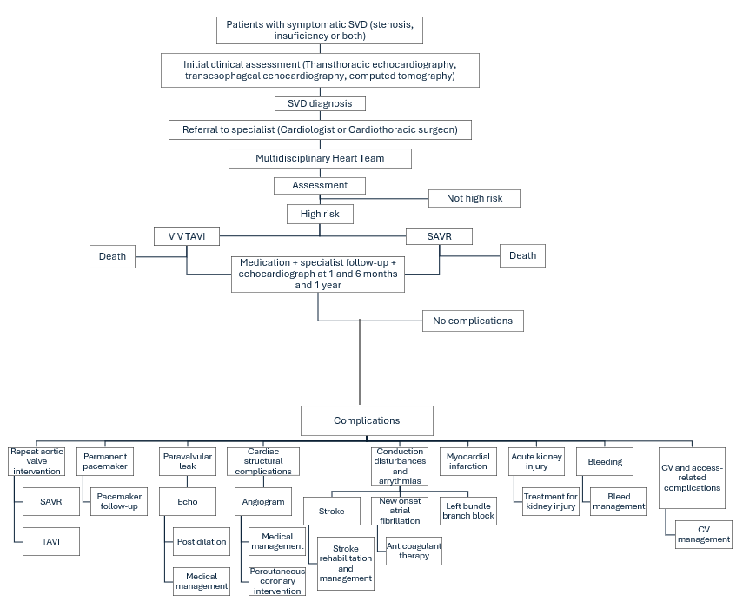Source: Produced during preparation of PICO from Figure 2, p18 of the application, and VARC-3 Writing Committee et al. (2021).
CV= Cardiovascular; SAVR= Surgical aortic valve replacement; SVD= Structural valve deterioration; TAVI= transcatheter aortic valve implantation; ViV= valve-in-valve

Proposed economic evaluation
The clinical claim is that ViV TAVI is superior to repeat SAVR in patients with symptomatic SVD categorised as high risk. The appropriate economic evaluation is a cost-effectiveness or cost-utility analysis for this claim as highlighted in the guidelines presented in Table 2.
PASC advised to include both TAVI BEV and TAVI SEV in the intervention and therefore a cost-effectiveness or cost-utility analysis comparing ViV TAVI and SAVR is appropriate.
Table 2 Classification of comparative effectiveness and safety of the proposed intervention, compared with its main comparator, and guide to the suitable type of economic evaluation
Comparative safety- |  | Comparative effectiveness
 | Inferior | Uncertainª | Noninferior^{b} | Superior
Inferior | Health forgone: need other supportive factors | Health forgone possible: need other supportive factors | Health forgone: need other supportive factors | ? Likely CUA
Uncertainª | Health forgone possible: need other supportive factors | ? | ? | ? Likely CEA/CUA
Noninferior^{b} | Health forgone: need other supportive factors | ? | CMA | CEA/CUA
Superior | ? Likely CUA | ? Likely CEA/CUA | CEA/CUA | CEA/CUA
CEA=cost-effectiveness analysis; CMA=cost-minimisation analysis; CUA=cost-utility analysis
? = reflect uncertainties and any identified health trade-offs in the economic evaluation, as a minimum in a cost-consequences analysis
ª ‘Uncertainty’ covers concepts such as inadequate minimisation of important sources of bias, lack of statistical significance in an underpowered trial, detecting clinically unimportant therapeutic differences, inconsistent results across trials, and trade-offs within the comparative effectiveness and/or the comparative safety considerations
^{b} An adequate assessment of ‘noninferiority’ is the preferred basis for demonstrating equivalence
Cells shaded yellow correspond to the comparison with repeat SAVR
Cells shaded light blue correspond to the comparison with TAVI SEV.

The application anticipated that the improvement in clinical outcomes, as well as the reduced length of hospital stay, will result in ViV TAVI being associated with overall less costs to the Australian healthcare system compared to repeat SAVR. The application stated that this has been observed in previous health economic evaluations of TAVI versus SAVR in native aortic valves (for low-risk and intermediate-risk populations) submitted for MSAC consideration, and two cost-effectiveness evaluations have been published (Zhou et al., 2019; Zhou et al., 2021). The current application indicated that a cost-effectiveness analysis will be undertaken in the MSAC submission.

Clinical evidence for the proposed population and clinical claim
The application indicated that there have been no head-to-head studies comparing ViV TAVI to repeat SAVR post SVD. The benefits of ViV TAVI over repeat SAVR were drawn from the following preliminary evidence, which is specific to patients with bioprosthetic valve deterioration/degeneration, but does not differentiate between patients who have previously undergone TAVI and those who have previously undergone SAVR:
The application stated that ViV TAVI is superior to redo SAVR as it provides significant improvements in short-term mortality, bleeding and length of hospital stay according to an umbrella meta-analysis of published meta-analyses by Aedma et al. (2022). This umbrella analysis synthesised the results from nine meta-analyses, and found that ViV TAVI compared to redo SAVR was associated with a significantly lower risk of procedural mortality (odds ratio [OR] 0.52, 95% CI: 0.27-0.98; p=0.04), 30-day mortality (OR 0.60, 95% CI: 0.53-0.68; p<0.00001), and shorter length of hospital stay (MD: − 2.44 days; 95% CI: − 4.10 to − 0.77; p < 0.004). There was no significant difference in long term mortality (OR:1.08 95%CI: 0.90–1.29; p = 0.42), hospital readmission (OR:1.16 95%CI: 0.93–1.43; p = 0.18), and acute myocardial infarction (OR: 1.15, 95%CI: 0.84–1.59; p = 0.38). The likelihood of stroke (OR 0.71, 95% CI: 0.59-0.84; p<0.0001), major bleeding (OR 0.44, 95% CI:0.35-0.57; p<0.000001), acute kidney injury (OR 0.57, 95% CI: 0.43-0.75; p<0.0001), and new permanent pacemaker insertion (OR 0.67, 95% CI: 0.52-0.86; p<0.002) were significantly lower with ViV TAVI than with redo SAVR. However, ViV TAVI was associated with a higher risk of vascular complications (OR 2.70, 95% CI: 1.58-4.62; p<0.0003).
A published propensity score-matched study (Landes et al., 2021) compared TAVI-in-TAVI versus TAVI-in-SAVR. Overall, the study demonstrated acceptable outcomes up to one year after TAVI-in-TAVI, including no significant difference in mortality at 30 days (3% vs. 4.4%; p=0.570) or one year (11.9% vs. 10.2%; p=0.633). Procedural success was observed in 120 cases (72.7%) for TAVI-in-TAVI versus 103 cases (62.4%) for TAVI-in-SAVR (p=0.045). Procedural safety was achieved in 116 cases (70.3%) for TAVI-in-TAVI versus 119 cases (72.1%) in TAVI-in-SAVR (p=0.715). Thus, in propensity score–matched cohorts of TAVI-in-TAVI versus TAVI-in-SAVR patients, TAVI-in-TAVI was associated with higher procedural success and similar procedural safety or mortality. The application stated that this suggests that TAVI-in-TAVI is non-inferior to TAVI-in-SAVR.
It is noted in the umbrella meta-analysis, that there is overlapping of the patient population due to the same observational studies being included in most of the meta-analysis (Aedma et al., 2022). A metanalysis conducted by Nalluri et al. (2018) showed that there was no significant difference between ViV-TAVI and redo SAVR for procedural, 30 day and 1 year mortality rates. ViV-TAVI was associated with lower risk of permanent pacemaker implantation (OR: 0.43, CI: 0.21-0.89; P = 0.02) and a trend toward increased risk of paravalvular leak (OR: 5.45, CI: 0.94-31.58; P = 0.06). There was no significant difference for stroke, major bleeding, vascular complications and postprocedural aortic valvular gradients more than 20 mm-hg.

Proposal for public funding
The proposed MBS item descriptor, including proposed fee is summarised in Table 3. The proposed item and fee were based on the existing TAVI agnostic MBS item 38495 for high-risk population (see Table 6 in Appendix).
Table 3 Proposed MBS item descriptor.
Category 3 – Therapeutic procedures
MBS item XXXXX
Valve-in-valve TAVI, for the treatment of symptomatic structural valve deterioration following surgical aortic valve replacement or TAVI, performed via transfemoral delivery, unless transfemoral delivery is contraindicated or not feasible, if:
a) the TAVI patient is at high risk for surgery; and
b) the service:
(i) is performed by a TAVI Practitioner in a TAVI Hospital; and
(ii) includes all intraoperative diagnostic imaging that the TAVI Practitioner performs upon the TAVI Patient;
Fee: $1,576.45
Source: p10 of the application.
MBS= Medicare Benefits Schedule; TAVI= transcatheter aortic valve implantation
Note: ‘Symptomatic’ was added by the Assessment group.
PASC noted that for TAVI in SAVR and TAVI in TAVI (after 5 years restriction) some patients with SVD and symptomatic AS may already be covered under existing MBS items 38495 (TAVI in high risk patients) and 38514 (TAVI in intermediate risk patients). PASC advised that a new MBS item is required for ViV TAVI given that the current items by definition of AS excludes those with SVD and regurgitation, and as such do not allow for the treatment of all patients with ViV TAVI.
PASC suggested the new MBS item for the proposed service for ViV TAVI to be agnostic to the type of TAVI device and that application should present data for both BEV and SEV devices including a within intervention comparison to demonstrate whether health outcomes would be non-inferior regardless of the type of TAVI device used under the proposed service.
The existing item 38495 specified the following restrictions (Table 6 in Appendix), which were not included in the proposed MBS item:
- The service includes valvuloplasty, if required;
- Not being a service which has been rendered within 5 years of a service to which this item or item 38514 or 38522 applies’, which was not included in the proposed MBS item.
These restrictions have applied to all current TAVI items, including patients at low-risk (Items 38522) and intermediate-risk for surgery (Items 38514) (See Table 7 and Table 8 in Appendix). The Health Insurance (Section 3C General Medical Services – Transcatheter Aortic Valve Implantation) Amendment Determination 2023 specified that the balloon valvuloplasty service (MBS item 38270) is inherent to the TAVI procedure (DoHAC, 2023). Therefore, item 38270 should not be claimed for a service performed on the same occasion as a TAVI service under item 38495, 38514 or 38522.
PASC queried whether the proposed item for ViV TAVI should include valvuloplasty and a 5-year restriction (similar to native TAVI). PASC advised to include valvuloplasty as part of the new MBS item along with more detailed information on ancillary procedures (Cost and current MBS items) based on the following discussion:
- The applicant’s pre-PASC response indicated that valvuloplasty is performed in about 30% of VIV TAVI cases and therefore should be included in the MBS descriptor.
- The applicant’s clinical expert suggested to include additional ancillary procedures such as balloon valve fracture and leaflet modification which may be performed for ViV TAVI procedures. This will likely have an additional fee given it is not a routine part of ViV TAVI procedure, but it adds more time to the procedure and other expensive surgical equipment.
The application stated that the overall cost per patient of providing the proposed health technology is:
- Total MBS costs: approximately $3500, including for the TAVI case conference and other services.
- Total hospital costs: approximately $50,000, including $29,000 for the SAPIEN 3 Ultra BEV system.
The application also stated that there is no anticipated out of pocket (OOP) expenses. The cost estimates were based on the previous MSAC application 1635 (TAVI for patients at low risk for surgery).
The applicant indicated that out of pocket cost may apply to the private sector, but it does not apply to the public sector, although there is a long waiting list. The applicant clarified there is a current benefit of $22,932 on the Prosthesis List and their company charge a cost between $28,000 and $29,000 for the valve itself. PASC determined that an out of pocket cost should be noted and accessibility of rural/remote populations need to be considered.
PASC noted that the estimated total cost is $85,000 per patient and noted the HTA group queried whether a more detailed cost breakdown could be included. The applicant indicated that they are willing to provide this and that there are additional required consumables including angioplasty balloon, which are not provided by them. PASC advised that the cost to the overall health system should include cost breakdown of associated MBS items such as TAVI conference, ancillary procedures, imaging, anaesthesia, and consumables. However, PASC noted these were matters to be addressed in the assessment phase.
The Health Insurance (Section 3C General Medical Services - Transcatheter Aortic Valve Implantation) Determination 2018 outlines the definitions of a TAVI Patient, TAVI Hospital, TAVI Practitioner and TAVI Case Conferences (DoHAC, 2024).
TAVI Patient means a patient who, as a result of a TAVI Case Conference, has been assessed as having a high, intermediate or low risk for open surgical aortic valve replacement and is recommended as being suitable to receive the service described in item 38495, 38514 or 38522.
TAVI Hospital means a hospital, as defined by subsection 121‑5(5) of the Private Health Insurance Act 2007, that is clinically accepted as being a suitable hospital in which the service described in item 38495, 38514 or 38522 may be performed.
TAVI Practitioner means a cardiothoracic surgeon or interventional cardiologist who is accredited by the Cardiac Accreditation Services Limited.
TAVI Case Conference means a process by which:
- there is a team of 3 or more participants, where:
- the first participant is a cardiothoracic surgeon; and
- the second participant is an interventional cardiologist; and
- the third participant is a specialist or consultant physician who does not perform a service described in item 38495, 38514 or 38522 for the patient being assessed; and
- either the first or the second participant is also a TAVI Practitioner; and
- the team assesses a patient’s risk and technical suitability to receive the service described in item 38495, 38514 or 38522, taking into account matters such as:
- the patient’s risk and technical suitability for a surgical aortic valve replacement; and
- the patient’s cognitive function and frailty; and
- the result of the assessment is that the team makes a recommendation about whether or not the patient is suitable to receive the service described in item 38495, 38514 or 38522; and
- the particulars of the assessment and recommendation are recorded in writing.

TAVI Case Conference Items
There is an existing MBS item for coordination (item 6080) of the case conference and an existing MBS item for participation in the conference (6081), presented in Table 4 and Table 5. As mentioned above, the present application seeks to have these same ‘accompanying’ MBS items for the proposed new MBS item.
Table 4 MBS item 6080 descriptor
Category 1 – Professional attendances
MBS item 6080
Coordination of a TAVI Case Conference by a TAVI Practitioner where the TAVI Case Conference has a duration of 10 minutes or more.
(Not payable more than once per patient in a five-year period.)

Fee: $56.05 Benefit: 75% = $42.05 85% = $47.65
Source: MBS online
MBS= Medicare Benefits Schedule; TAVI= transcatheter aortic valve implantation

Table 5 MBS item 6081 descriptor
Category 1 – Professional attendances
MBS item 6081
Attendance at a TAVI Case Conference by a specialist or consultant physician who does not also perform the service described in item 6080 for the same case conference where the TAVI Case Conference has a duration of 10 minutes or more.
(Not payable more than twice per patient in a five-year period.)

Fee: $41.80 Benefit: 75% = $31.35 85% = $35.55
Source: MBS online
MBS= Medicare Benefits Schedule; TAVI= transcatheter aortic valve implantation

Summary of public consultation input
PASC noted and welcomed consultation input from 3 organisations and 1 interventional cardiologist. The 3 organisations that submitted input were:
- Hearts4heart
- Medtronic Australasia Pty Ltd
- Abbott Medical Australia Pty Ltd
The consultation feedback received was all supportive.
Clinical need and public health significance
The main benefits of public funding received in the consultation feedback included improved safety and procedure outcomes, reduced risk of complications, post procedural care and recovery time when compared to the open-heart surgery, less invasive procedure, not requiring general anaesthesia, reduced procedural times and reduced burden on public health system.
No disadvantages of public funding received in the consultation feedback.
Other services identified in the consultation feedback such as case conferencing and cardiac imaging being needed to be delivered before or after the intervention are available and funded already.
Indication(s) for the proposed medical service and clinical claim
The consultation feedback was mixed regarding the proposed population. Some feedback advocated not to restrict the intervention to “high risk patients” as all patients with bioprosthetic aortic valve SVD could benefit, limiting to high-risk patients is inconsistent with current Australian or International practice, and the ACOR dataset could inform comparative outcomes for VIV TAVI patients with STS score <8%.
Feedback supported to include patients with SVD and experiencing severe stenosis, severe regurgitation and significant mixed regurgitation and stenosis and an additional non-SVD population with paravalvular aortic regurgitation. Feedback noted that VIV TAVI should be considered as a part of a lifetime management strategy in patients with all risk categories. They stated that use in lower risk patients could reduce the number of open-heart surgeries they will require over their lifetime (each at increased risk). The feedback highlighted the importance of selecting patients and suggested not to carry out the procedure in patients with severe stenosis related to patient -prosthesis mismatch to avoid the worsening of the condition.
The consultation feedback agreed with proposed clinical claim, while Abbott noted the lack of direct evidence to support the ViV TAVI in prior TAVI patients with SVD.
The consultation feedback agreed with the proposed comparator.

Cost information for the proposed medical service
Consultation feedback ranged from disagreeing to agreeing with service descriptor. Medtronic disagreed with limiting the item descriptor to balloon expanding valves TAVI (BEVs)and supported to be device agnostic.
The consultation feedback supported the fee be same as the existing MBS fees for TAVI.
Additional comments
Abbott noted the possibility of estimated uptake rate may be higher as the prevalence estimates appear to have excluded the annual rate of TAVI procedures and their failure rates.
Consumer Feedback
Hearts4heart stated that patients can sit out of bed and walk within hours of their procedure and that patients may be discharged to their own home the next day compared with a much longer recovery for open heart surgery. They considered patient preference is essential when considering the right therapy and was supportive of broader access to TAVI.
PASC noted the consultation feedback was generally supportive for ViV TAVI. PASC noted that the consultation feedback disagreed on restricting the proposed population to high risk only, suggesting to expand the criteria to all patients with SVD and severe paravalvular aortic regurgitation not from SVD in TAVI.
PASC noted issues with accessibility of VIV TAVI in rural areas and the current out of pocket cost for consumers. The applicant’s clinical expert indicated that this is a very specialised procedure that is limited to tertiary hospitals (public and private) equipped with onsite cardiac surgery and accreditation for TAVI implantation, which are found in larger cities rather than in rural areas.

Next steps
PASC advised that, upon ratification of the post-PASC PICO, the application can proceed to the Evaluation Sub-Committee (ESC) stage of the MSAC process.
PASC noted the applicant has elected to progress its application as an ADAR (Applicant Developed Assessment Report).

Applicant Comments on Ratified PICO
The applicant had no comment.

Appendix
Table 6 MBS item 38495 descriptor
Category 3 – Therapeutic Procedures
MBS item 38495
TAVI, for the treatment of symptomatic severe aortic stenosis, performed via transfemoral delivery, unless transfemoral delivery is contraindicated or not feasible, if:
(a) the TAVI Patient is at high risk for surgery; and
(b) the service:
(i) is performed by a TAVI Practitioner in a TAVI Hospital; and
(ii) includes all intraoperative diagnostic imaging that the TAVI Practitioner performs upon the TAVI Patient; and
(iii) includes valvuloplasty, if required;
not being a service which has been rendered within 5 years of a service to which this item or item 38514 or 38522 applies (H)
Multiple Operation Rule
(Anaes.) (Assist.)

Fee: $1,576.45 Benefit: 75% = $1,182.35
Fee: $56.05 Benefit: 75% = $42.05 85% = $47.65
Source: MBS online, MBS fee at the time of PASC consideration
MBS= Medicare Benefits Schedule; TAVI= transcatheter aortic valve implantation

Table 7 MBS item 38522 descriptor
Category 3 – Therapeutic Procedures
MBS item 38522
TAVI, for the treatment of symptomatic severe native calcific aortic stenosis, performed via transfemoral delivery, unless transfemoral delivery is contraindicated or not feasible, if:
(a) the TAVI Patient is at low risk for surgery; and
(b) the service:
(i) is performed by a TAVI Practitioner in a TAVI Hospital; and
(ii) includes all intraoperative diagnostic imaging that the TAVI Practitioner performs upon the TAVI Patient; and
(iii) includes valvuloplasty, if required;
not being a service which has been rendered within 5 years of a service to which this item or item 38495 or 38514 applies (H)
Multiple Operation Rule
(Anaes.) (Assist.)

Fee: $1,576.45 Benefit: 75% = $1,182.35
Source: MBS online, MBS fee at the time of PASC consideration
MBS= Medicare Benefits Schedule; TAVI= transcatheter aortic valve implantation

Table 8 MBS item 38514 descriptor
Category 3 – Therapeutic Procedures
MBS item 38514
TAVI, for the treatment of symptomatic severe aortic stenosis, performed via transfemoral delivery, unless transfemoral delivery is contraindicated or not feasible, if:
(a) the TAVI Patient is at intermediate risk for surgery; and
(b) the service:
(i) is performed by a TAVI Practitioner in a TAVI Hospital; and
(ii) includes all intraoperative diagnostic imaging that the TAVI Practitioner performs upon the TAVI Patient; and
(iii) includes valvuloplasty, if required;
not being a service which has been rendered within 5 years of a service to which this item or item 38495 or 38522 applies (H)
Multiple Operation Rule
(Anaes.) (Assist.)

Fee: $1,576.45 Benefit: 75% = $1,182.35
Source: MBS online, MBS fee at the time of PASC consideration
MBS= Medicare Benefits Schedule; TAVI= transcatheter aortic valve implantation

References
Aedma, S. K., Khan, N., Altamimi, A., Ali, N., Jain, S., Raol, K., Madireddy, S., Rakholiya, J., Raheem, A., Desai, R., Patel, U. K., Rabbani, R., & Pothuru, S. (2022). Umbrella Meta-analysis Evaluating the Effectiveness of ViV-TAVI vs Redo SAVR. SN Comprehensive Clinical Medicine, 4(1), 63. https://doi.org/10.1007/s42399-022-01136-x

Capodanno, D., Petronio, A. S., Prendergast, B., Eltchaninoff, H., Vahanian, A., Modine, T., Lancellotti, P., Sondergaard, L., Ludman, P. F., Tamburino, C., Piazza, N., Hancock, J., Mehilli, J., Byrne, R. A., Baumbach, A., Kappetein, A. P., Windecker, S., Bax, J., & Haude, M. (2017). Standardized definitions of structural deterioration and valve failure in assessing long-term durability of transcatheter and surgical aortic bioprosthetic valves: a consensus statement from the European Association of Percutaneous Cardiovascular Interventions (EAPCI) endorsed by the European Society of Cardiology (ESC) and the European Association for Cardio-Thoracic Surgery (EACTS). Eur J Cardiothorac Surg, 52(3), 408-417. https://doi.org/10.1093/ejcts/ezx244

Cote, N., Pibarot, P., & Clavel, M. A. (2017). Incidence, risk factors, clinical impact, and management of bioprosthesis structural valve degeneration. Curr Opin Cardiol, 32(2), 123-129. https://doi.org/10.1097/HCO.0000000000000372

DoHAC. (2022). Transcatheter Aortic Valve Implantation (TAVI) – new and amended services. DoHAC. Retrieved 27 February 2024 from https://www.mbsonline.gov.au/internet/mbsonline/publishing.nsf/Content/Factsheet-TAVI-July22

DoHAC. (2023, December). Health Insurance (Section 3C General Medical Services – Transcatheter Aortic Valve Implantation) Amendment Determination 2023. DoHAC. Retrieved 1 March 2024 from https://www.legislation.gov.au/F2023L01670/asmade/text

DoHAC. (2024, 17 January). Health Insurance (Section 3C General Medical Services –Transcatheter Aortic Valve Implantation) Determination 2018. DoHAC. Retrieved 1 March 2024 from https://www.legislation.gov.au/F2018L01670/latest/text

Dvir, D., Bourguignon, T., Otto, C. M., Hahn, R. T., Rosenhek, R., Webb, J. G., Treede, H., Sarano, M. E., Feldman, T., Wijeysundera, H. C., Topilsky, Y., Aupart, M., Reardon, M. J., Mackensen, G. B., Szeto, W. Y., Kornowski, R., Gammie, J. S., Yoganathan, A. P., Arbel, Y., . . . Investigators, V. (2018). Standardized Definition of Structural Valve Degeneration for Surgical and Transcatheter Bioprosthetic Aortic Valves. Circulation, 137(4), 388-399. https://doi.org/10.1161/CIRCULATIONAHA.117.030729

Fatima, B., Mohananey, D., Khan, F. W., Jobanputra, Y., Tummala, R., Banerjee, K., Krishnaswamy, A., Mick, S., Tuzcu, E. M., Blackstone, E., Svensson, L., & Kapadia, S. (2019). Durability Data for Bioprosthetic Surgical Aortic Valve: A Systematic Review. JAMA Cardiol, 4(1), 71-80. https://doi.org/10.1001/jamacardio.2018.4045

Hamilton, G. W., Koshy, A. N., Fulcher, J., Tang, G. H. L., Bapat, V., Murphy, A., Horrigan, M., Farouque, O., & Yudi, M. B. (2020). Meta-analysis Comparing Valve-In-Valve Transcatheter Aortic Valve Implantation With Self-Expanding Versus Balloon-Expandable Valves. Am J Cardiol, 125(10), 1558-1565. https://doi.org/10.1016/j.amjcard.2020.02.021
Jorgensen, T. H., Thyregod, H. G. H., Ihlemann, N., Nissen, H., Petursson, P., Kjeldsen, B. J., Steinbruchel, D. A., Olsen, P. S., & Sondergaard, L. (2021). Eight-year outcomes for patients with aortic valve stenosis at low surgical risk randomized to transcatheter vs. surgical aortic valve replacement. Eur Heart J, 42(30), 2912-2919. https://doi.org/10.1093/eurheartj/ehab375

Joshi, Y., Achouh, P., Menasche, P., Fabiani, J. N., Berrebi, A., Carpentier, A., Latremouille, C., & Jouan, J. (2018). Multiple reoperations on the aortic valve: outcomes and implications for future potential valve-in-valve strategy. Eur J Cardiothorac Surg, 53(6), 1251-1257. https://doi.org/10.1093/ejcts/ezx469

Landes, U., Sathananthan, J., Witberg, G., De Backer, O., Sondergaard, L., Abdel-Wahab, M., Holzhey, D., Kim, W. K., Hamm, C., Buzzatti, N., Montorfano, M., Ludwig, S., Conradi, L., Seiffert, M., Guerrero, M., El Sabbagh, A., Rodes-Cabau, J., Guimaraes, L., Codner, P., . . . Webb, J. G. (2021). Transcatheter Replacement of Transcatheter Versus Surgically Implanted Aortic Valve Bioprostheses. J Am Coll Cardiol, 77(1), 1-14. https://doi.org/10.1016/j.jacc.2020.10.053

Montarello, N. J., Willemen, Y., Tirado-Conte, G., Travieso, A., Bieliauskas, G., Sondergaard, L., & De Backer, O. (2023). Transcatheter aortic valve durability: a contemporary clinical review. Front Cardiovasc Med, 10, 1195397. https://doi.org/10.3389/fcvm.2023.1195397

Nalluri, N., Atti, V., Munir, A. B., Karam, B., Patel, N. J., Kumar, V., Vemula, P., Edla, S., Asti, D., Paturu, A., Gayam, S., Spagnola, J., Barsoum, E., Maniatis, G. A., Tamburrino, F., Kandov, R., Lafferty, J., & Kliger, C. (2018). Valve in valve transcatheter aortic valve implantation (ViV-TAVI) versus redo-Surgical aortic valve replacement (redo-SAVR): A systematic review and meta-analysis. J Interv Cardiol, 31(5), 661-671. https://doi.org/10.1111/joic.12520

Nishimura, R. A., Otto, C. M., Bonow, R. O., Carabello, B. A., Erwin, J. P., 3rd, Guyton, R. A., O'Gara, P. T., Ruiz, C. E., Skubas, N. J., Sorajja, P., Sundt, T. M., 3rd, Thomas, J. D., & Members, A. A. T. F. (2014). 2014 AHA/ACC Guideline for the Management of Patients With Valvular Heart Disease: executive summary: a report of the American College of Cardiology/American Heart Association Task Force on Practice Guidelines. Circulation, 129(23), 2440-2492. https://doi.org/10.1161/CIR.0000000000000029

Osnabrugge, R. L., Mylotte, D., Head, S. J., Van Mieghem, N. M., Nkomo, V. T., LeReun, C. M., Bogers, A. J., Piazza, N., & Kappetein, A. P. (2013). Aortic stenosis in the elderly: disease prevalence and number of candidates for transcatheter aortic valve replacement: a meta-analysis and modeling study. J Am Coll Cardiol, 62(11), 1002-1012. https://doi.org/10.1016/j.jacc.2013.05.015

Otto, C. M., Kumbhani, D. J., Alexander, K. P., Calhoon, J. H., Desai, M. Y., Kaul, S., Lee, J. C., Ruiz, C. E., & Vassileva, C. M. (2017). 2017 ACC Expert Consensus Decision Pathway for Transcatheter Aortic Valve Replacement in the Management of Adults With Aortic Stenosis: A Report of the American College of Cardiology Task Force on Clinical Expert Consensus Documents. J Am Coll Cardiol, 69(10), 1313-1346. https://doi.org/10.1016/j.jacc.2016.12.006

Perdoncin, E., Paone, G., & Byku, I. (2022). Valve-in-valve Transcatheter Aortic Valve Replacement for Failed Surgical Valves and Adjunctive Therapies. US Cardiology Review 2022;16:e09. https://doi.org/10.15420/usc.2021.20

Pibarot, P., Herrmann, H. C., Wu, C., Hahn, R. T., Otto, C. M., Abbas, A. E., Chambers, J., Dweck, M. R., Leipsic, J. A., Simonato, M., Rogers, T., Sathananthan, J., Guerrero, M., Ternacle, J., Wijeysundera, H. C., Sondergaard, L., Barbanti, M., Salaun, E., Genereux, P., . . . Heart Valve, C. (2022). Standardized Definitions for Bioprosthetic Valve Dysfunction Following Aortic or Mitral Valve Replacement: JACC State-of-the-Art Review. J Am Coll Cardiol, 80(5), 545-561. https://doi.org/10.1016/j.jacc.2022.06.002

Rayner, C., & Adams, H. (2023). Aortic stenosis and transcatheter aortic valve implantation in the elderly. Australian Journal for General Practitioners, 52(7), 458-463. https://www1.racgp.org.au/ajgp/2023/july/aortic-stenosis-and-transcatheter-aortic-valve-imp

Rodriguez-Gabella, T., Voisine, P., Puri, R., Pibarot, P., & Rodes-Cabau, J. (2017). Aortic Bioprosthetic Valve Durability: Incidence, Mechanisms, Predictors, and Management of Surgical and Transcatheter Valve Degeneration. J Am Coll Cardiol, 70(8), 1013-1028. https://doi.org/10.1016/j.jacc.2017.07.715

Strange, G., Scalia, G. M., Playford, D., & Simon, S. (2021). Uncovering the treatable burden of severe aortic stenosis in Australia: current and future projections within an ageing population. BMC Health Serv Res, 21(1), 790. https://doi.org/10.1186/s12913-021-06843-0

Thaden, J. J., Nkomo, V. T., & Enriquez-Sarano, M. (2014). The global burden of aortic stenosis. Prog Cardiovasc Dis, 56(6), 565-571. https://doi.org/10.1016/j.pcad.2014.02.006

Vahanian, A., Alfieri, O., Andreotti, F., Antunes, M. J., Barón-Esquivias, G., Baumgartner, H., Borger, M. A., Carrel, T. P., De Bonis, M., Evangelista, A., Falk, V., Lung, B., Lancellotti, P., Pierard, L., Price, S., Schäfers, H. J., Schuler, G., Stepinska, J., Swedberg, K., . . . Zembala, M. (2012). Guidelines on the management of valvular heart disease (version 2012): the Joint Task Force on the Management of Valvular Heart Disease of the European Society of Cardiology (ESC) and the European Association for Cardio-Thoracic Surgery (EACTS). Eur J Cardiothorac Surg, 42(4), S1-44. https://doi.org/10.1093/ejcts/ezs455

Varadarajan, P., Kapoor, N., Bansal, R. C., & Pai, R. G. (2006). Clinical profile and natural history of 453 nonsurgically managed patients with severe aortic stenosis. Ann Thorac Surg, 82(6), 2111-2115. https://doi.org/10.1016/j.athoracsur.2006.07.048

VARC-3 Writing Committee, Genereux, P., Piazza, N., Alu, M. C., Nazif, T., Hahn, R. T., Pibarot, P., Bax, J. J., Leipsic, J. A., Blanke, P., Blackstone, E. H., Finn, M. T., Kapadia, S., Linke, A., Mack, M. J., Makkar, R., Mehran, R., Popma, J. J., Reardon, M., . . . Leon, M. B. (2021). Valve Academic Research Consortium 3: updated endpoint definitions for aortic valve clinical research. Eur Heart J, 42(19), 1825-1857. https://doi.org/10.1093/eurheartj/ehaa799

Vrachatis, D. A., Vavuranakis, M., Tsoukala, S., Giotaki, S., Papaioannou, T. G., Siasos, G., Deftereos, G., Giannopoulos, G., Raisakis, K., Tousoulis, D., Deftereos, S., & Vavuranakis, M. (2020). "TAVI: Valve in valve. A new field for structuralists? Literature review". Hellenic J Cardiol, 61(3), 148-153. https://doi.org/10.1016/j.hjc.2019.10.016

Zhou, J., Liew, D., Duffy, S. J., Walton, A., Htun, N., & Stub, D. (2019). Cost-effectiveness of transcatheter aortic valve implantation compared to surgical aortic valve replacement in the intermediate surgical risk population. Int J Cardiol, 294, 17-22. https://doi.org/10.1016/j.ijcard.2019.06.057
Zhou, J. Y., Liew, D., Duffy, S. J., Walton, A., Htun, N., & Stub, D. (2021). Cost-Effectiveness of Transcatheter Versus Surgical Aortic Valve Replacement in Low-Risk Patients With Severe Aortic Stenosis. Heart Lung Circ, 30(4), 547-554. https://doi.org/10.1016/j.hlc.2020.09.934

