MSAC Application 1158:

Final Decision Analytic Protocol (DAP) to guide the assessment of robotic image-guided stereotactic precise beam radiosurgery and radiotherapy for prostate cancer.

January 2012

Table of Contents

MSAC and PASC 3

Purpose of this document 3

Purpose of application 4

Intervention 4

Description 4

Co-administered interventions 9

Background 11

Current arrangements for public reimbursement 11

Regulatory status 14

Patient population 15

Proposed MBS listing 15

Clinical place for proposed intervention 17

Comparator 20

Clinical claim 21

Outcomes and health care resources affected by introduction of proposed intervention 23

Outcomes 23

Health care resources 23

Proposed structure of economic evaluation 27

References 29

Appendix 1 30

Full MBS item descriptors plus explanatory notes 30

Appendix 2 34

Decision trees to supplement information provided in PICO tables and clinical algorithms. 34

# MSAC and PASC

The Medical Services Advisory Committee (MSAC) is an independent expert committee appointed by the Minister for Health and Ageing (the Minister) to strengthen the role of evidence in health financing decisions in Australia. MSAC advises the Minister on the evidence relating to the safety, effectiveness, and cost-effectiveness of new and existing medical technologies and procedures and under what circumstances public funding should be supported.

The Protocol Advisory Sub-Committee (PASC) is a standing sub-committee of MSAC. Its primary objective is the determination of protocols to guide clinical and economic assessments of medical interventions proposed for public funding.

## Purpose of this document

This document is intended to provide a decision analytic protocol that will be used to guide the assessment of an intervention for a particular population of patients.

The protocol guiding the assessment of the health intervention has been developed using the widely accepted “PICO” approach. The PICO approach involves a clear articulation of the following aspects of the research question that the assessment is intended to answer:

**P**atients – specification of the characteristics of the patients in whom the intervention is to be considered for use;

**I**ntervention – specification of the proposed intervention

**C**omparator – specification of the therapy most likely to be replaced by the proposed intervention

**O**utcomes – specification of the health outcomes and the healthcare resources likely to be affected by the introduction of the proposed intervention.

## Purpose of application

An application requesting Medicare Benefits Schedule (MBS) listing of radiotherapy delivered by the CyberKnife® robotic radiosurgery system (from herein referred to as CyberKnife® for brevity) for patients with lung, prostate, breast, and other less common extracranial cancers (e.g. in the spine, kidney, liver, and pancreas) was received from Device Technologies Australia by the Department of Health and Ageing in March 2011.

This protocol will consider the CyberKnife® robotic radiosurgery system for patients with prostate cancer only. Other cancers will be considered in separate documents.

NHMRC Clinical Trials Centre (CTC), as part of its contract with the Department of Health and Ageing, drafted an earlier version of this DAP to guide the assessment of the safety, effectiveness and cost- effectiveness of robotic radiosurgery system for patients with prostate cancer in order to inform MSAC’s decision-making regarding public funding of the intervention.

# Intervention

## Description

External beam radiotherapy (EBRT) is a cancer treatment that delivers high-energy radiation to tumour sites with the primary goal of killing and stopping the division of tumour cells. The delivery of radiation to tumour cells can take place during a single session or over a series of sessions. For clarification on the terminology used in this protocol, radiosurgery refers to radiation treatment that is delivered in a single session, whereas radiotherapy refers to radiation treatment that is delivered over multiple sessions.

When treatment is delivered over several sessions it is important to account for small variations in the position and movement of the tumour. These movements are the result of normal physiologic processes such as breathing or the differential arrangement of internal organs. In order to better target the tumour during radiation therapy individual treatment sessions can be guided using imaging information collected from x-rays, CT, ultrasound or similar imaging technologies. The use of imaging technologies as part of the planning and delivery of a course of radiation therapy allows for the more accurate delivery of radiation to the tumour thus reducing radiation exposure to surrounding healthy tissue. This strategy is known as image-guided radiation therapy (IGRT).

There are numerous systems capable of delivering IGRT (e.g. Axesse™ by Elekta and Novalis TX™ by BrainLAB/Varian Medical Systems). According to clinical experts, CyberKnife® has different capabilities to other IGRT technologies currently available. The primary differentiating feature of CyberKnife® compared to other EBRT systems is the robotic manipulator. The robotic manipulator allows for a greater range of treatment delivery angles and higher accuracy than alternative systems.

Another feature of the CyberKnife® system is that it delivers radiation employing continual image guidance. The continual image guidance allows intra-fraction motion tracking where every beam position can be automatically corrected for any target motion without user intervention or treatment interruptions (Accuray Inc., 2009). This motion tracking system along with the robotic manipulator

allows for the delivery of a large number of non-isocentric non-coplanar beams without the need to reposition the patient for each beam. This is claimed to enable CyberKnife® to treat tumours from many angles throughout the body, with sub-millimetre accuracy, and precision.

While the Department of Health and Ageing acknowledges that there are currently numerous systems available that deliver IGRT it has come to a position that the CyberKnife® system is sufficiently unique as to warrant an assessment as a stand-alone technology. Should other manufacturers wish to have IGRT delivered with alternate platforms listed on the MBS they are invited to submit an application.

The claimed accuracy of the CyberKnife® system allows treatment to be hypofractionated, which means higher doses of radiation may be delivered per treatment thus reducing the total number of treatment sessions required. Radiotherapy for prostate cancer delivered using the CyberKnife® system is typically performed over four or five sessions, whereas conventional EBRT may require up to 39 sessions.

While the number of treatment sessions required when radiotherapy is delivered by CyberKnife® is reduced, individual treatment sessions last longer. Treatment with conventional radiotherapy treatment lasts 15-20 minutes whereas CyberKnife® treatment times are typically 45-60 minutes. The increase in treatment time is a function of the radiation field delivered by CyberKnife® being smaller than conventional radiation therapy systems and the use of intra fraction motion tracking throughout treatment delivery. As a result of the increased treatment times required per patient whereas a standard radiation therapy system has an annual patient throughput of around 400 patients even the most efficient CyberKnife® centres in Europe and the US system treat 200-300 patients annually (Accuray Inc., pers. comm., 31 August 2011). An outline of the platforms expected patient throughput and referral patterns must be presented in the final assessment.

Equipment and software of the CyberKnife® system:

The CyberKnife® system consists of a number of pieces of equipment and software. For completeness the key pieces of physical equipment and software involved in treating a range of cancers and not just prostate cancer are listed:

Physical equipment:

* Robotic manipulator - a high precision robotic manipulator capable of repeatable sub- millimetre accuracy;
* Linear accelerator (linac) - a lightweight and compact 1000MU/min 6MV X-band linac,
* X-ray sources - low-energy x-ray sources that generate orthogonal x-ray images, and
* Image detectors to capture the high-resolution images throughout the treatment. The continual feeding of images to the CyberKnife® software programmes allows the latest digital

radiographs to be compared to ones previously generated. This allows the software programme to determine the real-time patient positioning and tumour location.

Optional pieces of equipment:

* RoboCouch® patient position system, which can align patients precisely with six degrees of freedom;
* Synchrony® respiratory tracking system, which allows the beam to move with the motion of a tumour throughout the respiratory cycle;
* Xchange® robotic collimator changer (only in the CyberKnife® VSI™ system), which automatically exchanges the collimators; and
* Iris™ variable aperture collimator (only in the CyberKnife® VSI™ system) enables multiple field sizes to be combined within each treatment.

Software is the other key part of the CyberKnife® system and includes:

* A time-based imaging programme that allows users to dynamically optimise intra-fraction imaging frequency, without interrupting treatment, based on the condition of the patient;
* MultiPlan® treatment planning system designed for the CyberKnife® system that creates simple and complex treatment plans;
* Monte Carlo dose calculation that can be done in minutes (instead of hours or days as with other systems);
* CyberKnife® data management system;
* InTempo™ adaptive imaging system for prostate tracking (only in the CyberKnife® VSI™
  + system), automatically adapts imaging frequency to optimally track the prostate for motion;
* Sequential optimisation algorithm for rapidly developing treatment plans for each patient
  + (only in the CyberKnife® VSI™ system);
* AutoSegmentation™ programme that can automatically generate accurate contours from patient image data for prostate, rectum, bladder, seminal vesicles, and femoral heads with minimal user input (only in the CyberKnife® VSI™ system);
* QuickPlan programme that automatically generates treatment plans (only in the CyberKnife® VSI™ system);
* 6D skull tracking system, non-invasively calculates tumour location and displacement in 6D
  + using image properties and bony anatomy reference points;
* 4D treatment optimisation and planning system, that considers movement of the tumour as well as the movement and deformation of surrounding healthy tissues;
* Xsight® spine tracking system, a fiducial-less method, using the bony anatomy of the spine as reference points, for locating and tracking tumours in the spine; and
* Xsight® lung tracking system, a fiducial-less method for identifying and tracking tumour targets in the lung.

Excluded technologies:

This protocol excludes other treatment modes such as GammaKnife (which is primarily for tumours in the brain and cranial nerves, an indication not being investigated in this protocol), Tomotherapy (which delivers radiation to the tumour in ‘slices’ instead of the tumour as a whole), and proton beam radiotherapy machines.

As outlined above, IGRT delivered by any other system aside from CyberKnife® is excluded from this protocol.

Prostate cancer in Australia:

Prostate cancer is the most commonly diagnosed cancer in Australia (excluding basal and squamous cell skin cancers) and the second most common cause of cancer death in men after lung cancer. In

2007, 19,403 cases of prostate cancer were diagnosed in Australian men and there were 2,938

deaths attributed to the disease. The incidence of prostate cancer has fluctuated since the introduction of prostate specific antigen (PSA) testing with a rapid peak in the early 1990s following its introduction, a levelling out in the late 1990s and a further increase from 2002. The age standardised incidence rate in 2007 was 182.9 per 100,000 males. Cancer specific mortality has fallen steadily over the past decade to 31.0 per 100,000 males. The mean age at diagnosis was 68.4 in 2007 and the lifetime risk of developing prostate cancer before the age of 75 was 1 in 7 men (Australian Institute of Heatlh and Welfare, 2010).

Due to the fact that the prostate is mobile over the course of radiation therapy, the ability of the CyberKnife® system to monitor the movement of the prostate in real time and deliver radiation beams with sub-millimetre accuracy leads to this system having the potential to avoid damage to tissue surrounding the tumour during treatment. In turn, this may lead to reduced adverse events from radiotherapy in patients that receive treatment using this technology over conventional EBRT systems that require a greater margin of error during treatment.

## Administration, dose, frequency of administration, duration of treatment

Administration:

The administration of radiotherapy is carried out by a team including radiation oncologists, medical physicists, and radiation therapists. Depending on site to be treated additional expertise involved in the treatment planning and delivery may include a diagnostic radiologist, anaesthetist, dosimetrist or surgeon.

The same patient referral procedure for conventional EBRT will apply to CyberKnife®. There will be no changes to the treatment procedures or to the providers of those procedures.

Treatment with the CyberKnife® system, as with any EBRT method, requires five stages:

1. Simulation
2. Planning
3. Treatment
4. Treatment verification
5. Patient follow-up.

The exact procedures required in each stage will and should vary depending on what type of cancer is being treated and individual patient circumstances, however a general protocol for EBRT that is also applicable to CyberKnife® is described below.

**Simulation:** Prior to treatment, the patient undergoes imaging procedures to determine the size, shape and location of the tumour. A simulation study begins with a standard high-resolution CT scan, however other imaging techniques, such as MRI, angiography or PET, may also be used. Patients undergo simulation in the same position as treatment will be delivered.

**Planning:** Imaging data are digitally transferred to a planning workstation where the treating physician identifies the exact size, shape and location of the tumour to be targeted as well as the surrounding vital structures to be avoided. A qualified physician and/or radiation oncologist or physicist then generates a treatment plan to provide the desired radiation dose to the identified tumour location while avoiding damage to the surrounding healthy tissue.

**Treatment:** During the procedure the patient must be immobilised in order to reduce movement of the tumour throughout the treatment process. For standard EBRT treatment each session will typically last between 15 and 20 minutes. Treatment sessions using the CyberKnife® system are longer than conventional EBRT sessions and will last between 45 and 60 minutes. A prostate cancer patient will typically undergo up to 39 sessions using conventional EBRT which is reduced to between four and five sessions with the use of CyberKnife®.

When treatment is being delivered using the CyberKnife® system (or any other IGRT system) imaging information is captured and compared to the original imaging data collected during the simulation stage. The implantation of fiducial markers prior to patient simulation enhances the accuracy of the imaging information collected both during simulation and IGRT treatment. Comparing the images collected during treatment with original imaging information allows for the correction of any movement of the patient and tumour throughout the treatment and ensures precise delivery of radiation to the tumour target.

**Treatment verification:** Follow-up imaging, generally with CT, is performed throughout the course of treatment to assess the status of the tumour. When radiotherapy is delivered using conventional EBRT a patient may have treatment verification performed up to 12 times (approximately once every three treatment sessions). Due to the higher radiation doses delivered with CyberKnife® treatment verification would occur after each session.

**Patient follow up:** Additional testing such as biochemical marker (PSA) assessment and monitoring of toxicity events are performed to assess the patient’s ongoing response to treatment. Patient follow up upon completion of a course of radiation treatment is undertaken at six weeks, 12 weeks, 6 months, 12 months and then every 6 months.

Dose:

The total dose of radiation delivered throughout a course of treatment for prostate cancer with the

CyberKnife® system is typically 33.5-38Gy.

Frequency of administration:

Radiotherapy treatment for prostate cancer using CyberKnife® generally requires between four and five individual treatment sessions. Treatment sessions using the CyberKnife® system are typically given daily or on alternative days.

Duration of treatment:

An individual treatment session with CyberKnife® typically lasts between 45 and 60 minutes. The total course of treatment is between four and 10 days depending on the number and spacing of individual treatment sessions.

Training and accreditation requirements:

Some training and accreditation will be required before using the CyberKnife® system. Staffing requirements and quality assurance programs would be similar to facilities providing conventional EBRT.

Facility requirements and geographic limitations:

Treatment will be given primarily in an outpatient setting and would be carried out in the same specially designed bunkers as conventional EBRT. The capital equipment for the CyberKnife® system replaces the equipment for the conventional EBRT.

Similarly to other IGRT systems, access to CyberKnife® would most likely be limited to speciality facilities located in capital cities and potentially major regional centres.

The location of facilities to deliver IGRT primarily in capital cities can impose hardship and costs on those patients that do not live near a treatment centre as they often need to travel long distances or live away from home for the duration on their treatment (which may be up to seven weeks). The reduced duration of treatment times with the CyberKnife® system may play a role in reducing costs

for patients that need to travel in order to be able to access treatment in major centres.

## Co-administered interventions

The same tests are used in the lead up and monitoring of treatment whether a patient receives treatment with the CyberKnife® or alternative EBRT systems. The MBS items for these procedures are provided in Table 1.

**Table 1. MBS item descriptors for lead up and monitoring procedures associated with delivering radiotherapy to prostate cancer patients.**

|  |  |  |
| --- | --- | --- |
| **MBS number** | **Procedure** | **Fee** |
| 104 | Specialist consultation (initial) | $82.30 |
| 105 | Specialist consultation (ongoing) | $41.35 |
| 73928 | Specimen collection | $6.00 |
| 66655 | PSA quantitation (initial) | $20.30 |
| 66656 | PSA quantitation (ongoing) | $20.30 |

Resources used for patient simulation and dosimetry are equivalent whether treatment is provided using CyberKnife® or alternative EBRT systems. These procedures are currently publicly reimbursed under existing MBS item numbers and are summarised in Table 2.

**Table 2. MBS item numbers for all radiotherapy treatment protocols requiring patient simulation and dosimetry.**

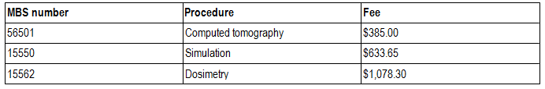

The use of fiducial markers is required for patients undergoing treatment with the CyberKnife® system. Fiducial markers are also available to patients undergoing conventional EBRT treatment. The cost of fiducial markers themselves is not currently listed on the MBS or Prostheses list and must be borne either by the patient or health care service provider. The MBS items associated with the implantation of fiducial markers are given in Table 3.

**Table 3. MBS item numbers associated with the implantation of fiducial markers into the prostate.**

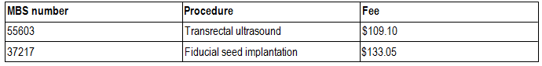

For patients with locally advanced disease (high risk patient stratification) neo-adjuvant/concurrent hormone therapy (androgen deprivation therapy) is typically co-administered with radiotherapy.

# Background

## Current arrangements for public reimbursement

The CyberKnife® system is currently not in use in Australia and thus not currently publicly reimbursed. Radiotherapy delivered by other systems is currently delivered in capital cites and major regional centres by a combination of public and private clinics. An audit of Australian cancer treatment services (Cancer Australia and Cancer Council Australia, 2010) showed that the bulk of radiotherapy services are provided on an outpatient basis and that most radiotherapy treatments are

billed through Medicare. Given the high capital cost and specialty treatments delivered by the CyberKnife® system it is most likely that access to this technology would initially be limited to major hospitals in capital cities.

Treatment verification is another procedure performed when a patient undergoes radiotherapy. The

MBS items associated with patient treatment and verification are provided in Table 4.

**Table 4. MBS item numbers for radiation treatment and verification using a single photon linear accelerator in the treatment of prostate cancer.**

|  |  |  |
| --- | --- | --- |
| **MBS number** | **Procedure** | **Fee** |
| 15218 | Radiation oncology treatment (1 field) | $57.40 |
| 15233 | Radiation oncology treatment (2-5 fields) | $57.40 + $36.50 per extra field |
| 15705 | Verification | $76.60 |

In the application it is proposed that 5,910 prostate cancer patients (based on item utilisation divided by average number of treatments) received conventional EBRT in 2009/2010 and that these patients would be eligible for treatment with CyberKnife®. An assessment undertaken by (Tamblyn et al.,

2011) estimated that in 2010 5,000 men would be diagnosed with localised prostate cancer. These

men would be treated in different ways including active surveillance, brachytherapy, radiotherapy and surgery. Given that prostate cancer patients may undergo a range of treatments it would not be expected that all patients with localised prostate cancer will receive radiotherapy whether it be delivered by the CyberKnife® or existing delivery systems. A more robust claim of the population estimate will be required in the assessment of evidence.

The simulation, dosimetry and verification steps involved in the planning and delivery of radiotherapy are currently reimbursed through the MBS. The figures presented in Table 5 represent claims relating to the treatment of all types of cancer. Usage figures specifically for prostate cancer are not able to be obtained from the Medicare Australia item reports service. However, as each patient that undergoes radiation treatment will require treatment simulation and dosimetry the number of claims for these procedures will be almost equivalent. A small number of patients that undergo the radiotherapy planning process elect not to go through the treatment process and will seek alternative therapeutic options. Advice from clinical experts indicates that this number will be small and, as such, will not have a major impact on the economic assessment of introducing CyberKnife®.

As fewer treatment sessions are required when radiotherapy is delivered using the CyberKnife® system there would be a corresponding reduction in the number of treatment verification claims required with the use of CyberKnife® over conventional EBRT systems.

**Table 5. Usage (number of claims) for MBS items common to all protocols for simulation, dosimetry, and verification. Source: MBS Item Reports online, accessed 28 July 2011.**

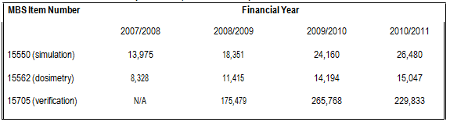

The Department of Health and Ageing runs the Radiation Oncology Health Program Grants (ROHPG) to contribute towards the capital costs incurred by radiation oncology providers for major radiation oncology equipment. Payments through this scheme are made on a ‘per service’ basis to eligible service providers that successfully applied for support. A summary of applicable MBS items upon which a ROHPG may be paid as well as the level of payment is given in Table 6.

**Table 6. MBS items eligible for additional payments for capital equipment purchase under the ROHPG program.**

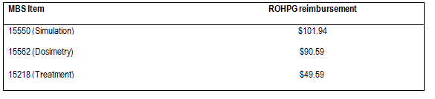

A summary of the resource use for the use of single photon energy linac (as used by CyberKnife®) system is given in Table 7 below. As not all treatment centres may receive ROHPG payments, the costs to DoHA with and without these payments is presented.

**Table 7. Summary of costs for the current radiation treatment of prostate cancer with a single photon energy linac. Number of treatments = 39 using 5 fields. Source: MBS Book operating from 1 July 2011.**

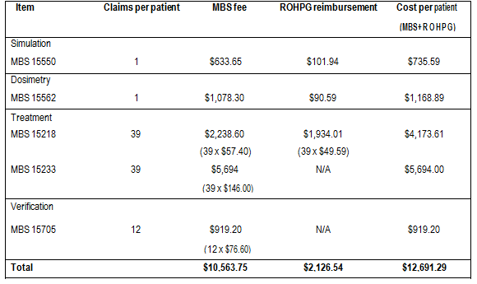

A comparative course of treatment using EBRT with a dual photon energy linac and 35 sessions is provided in Table 9. Dose-escalation treatment is where up to 39 treatment sessions are required is become standard clinical practice, subsequently the costs presented in Table 7 give an upper estimate of the treatment cost for delivering radiation treatment to prostate cancer patients. The implementation of dose-escalation radiotherapy requires the use of fiducial markers and this would increase the overall cost of treatment by approximately $242 (refer to Table 3).

## Regulatory status

The TGA registration number is ARTG # 155887 with an ARTG start date of 10th October 2008. The sponsor is Device Technologies Australia Pty Ltd. The device is described as a linear accelerator system. The intended purpose of the device is: “A system intended to provide treatment planning, image-guided stereotactic radiosurgery for lesions, tumours and conditions anywhere in the body where radiation treatment in indicated. The system operates on the principle of linear acceleration of electrons, providing a predictable radiation field in a beam of well defined dimensions”(Australian Register of Therapeutic Goods, 2008).

The proposed MBS listing is consistent with the TGA approved indication.

# Patient population

## Proposed MBS listing

The proposed MBS item for the CyberKnife® system would fall under Category 3 – Therapeutic Procedures, which is the case for currently listed radiotherapy services. It is proposed that treatment with CyberKnife® should be rebated in the same way as current procedures for radiotherapy. Separate fees have been proposed for the treatment and verification stages of delivering radiotherapy using the CyberKnife® system.

**Table 8. Proposed MBS item fee and descriptor for radiotherapy using the CyberKnife® system in prostate cancer.**

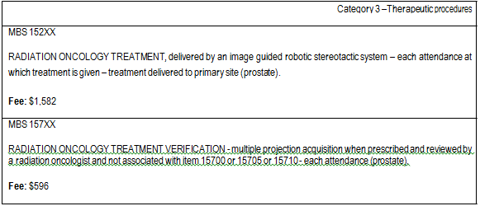

Figures used by the applicant in the calculation of the fees are provided in Table 9. The fee for radiation oncology treatment was calculated on the basis of cost-neutrality for the treatment component across an entire course of treatment be it delivered by CyberKnife® or existing radiotherapy platforms.

The fees for a course of treatment presented in Table 7 and Table 9 differ by $3,116.25 due to the following factors:

1. The fees in Table 7 were calculated for a course of treatment using 39 sessions instead of 35.

Increasing the number of treatment sessions from 35 to 39 represents a dose escalation treatment regimen. Expert clinical opinion suggests that delivery of up to 39 radiation treatment sessions is becoming routine clinical practice.

2. The fees in Table 7 were calculated on the basis that a patient receiving radiotherapy delivered with a conventional delivery system would only undergo treatment verification after every third treatment session rather than every session.

a. Expert clinical opinion suggests that this situation best reflects current clinical practice. Treatment verification would take place after each treatment session if delivery was made using CyberKnife®.

b. The difference in the number of treatment verification procedures performed has the biggest impact on the difference (-$1,761.80) in calculated costs for a course of radiation treatment.

3. The ROHPG grant amounts presented in Table 7 relate to treatment delivered using a single photon energy linac (as used by CyberKnife®) instead of a dual photon energy linac as used in the calculation of fees in Table 9.

**Table 9. MBS item numbers and utility figures for the current radiation treatment of prostate cancer with a dual photon energy linac. Number of treatments = 35 using 5 fields. Source: Applicant supplied data.**

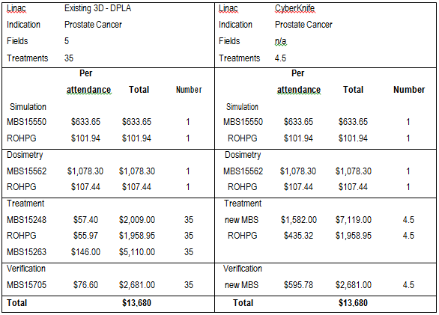

As currently presented, the Department of Health and Ageing does not accept the fee proposed by the applicant for radiation oncology treatment on the basis that it does not comply with Departmental requirements for input-based fee determination. The applicant is requested to either amend or justify the existing fee in a fashion that meets to Departments guidelines for input-based fee determination. Appropriate documentation must be submitted to the Department for an assessment of the proposed fee ahead of the final assessment in order to allow the Department to scrutinise the proposed fee for compliance with Departmental guidelines. If the fee proposed in the original application requires amendment only the amended fee is to be used in the cost-effectiveness analysis.

The Department further notes that the proposed fee for treatment verification is $519.40 higher than the existing MBS item number (15705) although no justification for this difference is given. As with the radiation oncology treatment fee the Department requires justification or amendment of the

proposed treatment verification fee such that Departmental requirements for input-based fee determination are met.

The proposed fee structure is based on a per-treatment service delivery model. Given the relatively high fee in comparison to that of existing EBRT the Department has raised concerns regarding the potential for high overall treatment costs should there be unrestricted funding regarding the number of radiotherapy treatment sessions delivered by CyberKnife®. In order to address these concerns it is requested that a capped fee for an entire course of treatment be explored and take into account the expected patient throughput and referral patterns. This fee is to include all radiation oncology consultations, planning, simulation, dosimetry and treatment sessions similar to MBS item 15600. If there is potential for an overall cost difference between a per-attendance and per-course of treatment fee structure the consequences of this difference are to be modelled as part of the cost-effectiveness analysis.

## Clinical place for proposed intervention

Initial cancer diagnosis and clinical assessment would consist of prostate specific antigen (PSA) blood testing, digital rectal examination (DRE) and needle biopsy. Following diagnosis the treatment options for localised prostate cancer include active surveillance, surgery (radical prostatectomy), brachytherapy and radiotherapy. These treatments are typically used alone but may occasionally be used in combination. The choice of initial treatment is highly variable and is influenced by estimated life expectancy, co-morbidities, potential therapy side effects, and patient preference.

Low and intermediate risk patients

In line with the clinical practice guidelines published by the Australian & New Zealand faculty of radiation oncology gentio-urinary group (Hayden et al., 2010), the clinical indications and guidelines published by the CyberKnife® Society, and after consultation with clinical experts it has been determined that use of the CyberKnife® system to deliver radiation treatment is most suitable in the following settings:

• Primary treatment for localised prostate cancer, ‘low risk patient stratification’: PSA <10ng/ml

AND Gleason ≤ 6 AND T1-T2a.

• Primary treatment for localised prostate cancer, ‘intermediate risk patient stratification’: PSA

10-20ng/ml OR Gleason =7 OR T2b-c.

When it is decided to pursue a course of radiation treatment this may be delivered by brachytherapy or EBRT. While both of these techniques deliver radiation to the tumour they differ in the way in which this is achieved. Brachytherapy involves the implantation of radioisotopes directly into the prostate whereas with EBRT radiation is delivered non-invasively from an external radiation source.

In the context of delivering radiotherapy to low and intermediate risk prostate cancer patients the use of CyberKnife® would be a direct replacement for radiotherapy delivered by existing EBRT systems and an alternative to brachytherapy.

**Figure 1. Management algorithm for low and intermediate risk prostate cancer patients undergoing radiotherapy as primary treatment for localised disease. The treatment algorithm for CyberKnife® is highlighted grey.**

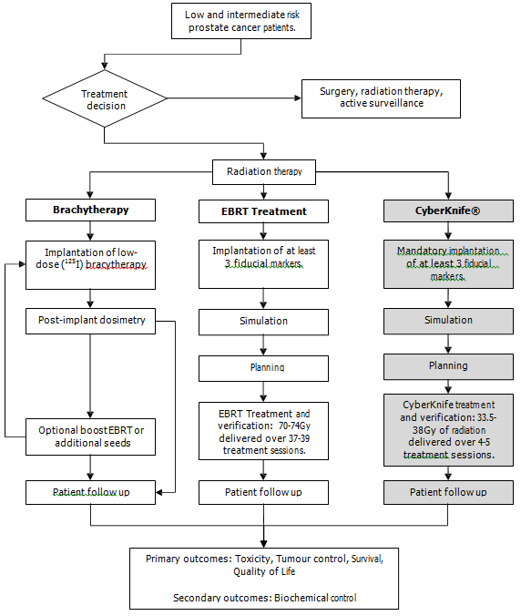

For the clinical algorithm in Figure 1 once a patient commences radiotherapy on one platform it is unlikely that they will migrate to another, i.e. radiotherapy will be all treatment sessions for a single patient will be delivered using either CyberKnife® or conventional EBRT systems.

There is potential variation (e.g. premature cessation of treatment due to adverse toxicity events) within each algorithm, however as the sources of this variation are equivalent they have not been shown.

High risk patients

Radiotherapy may also be considered as an adjuvant treatment for ‘high risk’ patients that are also receiving androgen deprivation therapy (ADT). The ‘high risk patient stratification’ is defined as patients with PSA >20ng/ml OR Gleason 8-10 OR T3/4 (Hayden et al., 2010).

In the treatment of ‘high risk’ patients radiotherapy delivered using the CyberKnife® system would be a replacement for other EBRT systems.

**Figure 2. Management algorithm for high risk prostate cancer patients receiving radiotherapy as an adjuvant to**

**ADT. The treatment algorithm for CyberKnife® is highlighted grey.**

Figure 2. Management algorithm for high risk prostate cancer patients receiving radiotherapy as an adjuvant to
ADT. The treatment algorithm for CyberKnife® is highlighted grey.


As with the clinical algorithm for low and intermediate risk patients, once a patient commences radiotherapy on one platform it is unlikely that they will migrate to another. Again, there is potential variation (e.g. premature cessation of treatment due to adverse toxicity events) within each algorithm, however as the sources of this variation are equivalent they have not been shown.

# Comparator

External Beam Radiotherapy

One comparator is radiotherapy delivered using conventional EBRT systems. For the purposes of this protocol this will include systems designed to enhance the accuracy of the delivery of EBRT such as

3D conformal radiotherapy (3DCRT) and intensity-modulated radiotherapy (IMRT). Details on enhanced EBRT systems are given below.

• 3D conformal radiotherapy: The system works using complex software and a multileaf collimator to manipulate the profile of radiation beams allowing them to be shaped to fit the profile of the target tumour.

• Intensity-modulated radiotherapy: A variant of 3DCRT, IMRT uses sophisticated software and hardware to vary the shape and intensity of radiation delivered to different parts of the treatment area. The goal of IMRT is to increase the radiation dose to the areas that need it and reduce radiation exposure in sensitive areas of surrounding normal tissue.

The delivery of EBRT is currently listed on the MBS (Table 5). For the purposes of this protocol, the

CyberKnife® system is considered as a replacement to other systems that deliver EBRT.

Brachytherapy

The other comparator considered in this protocol is low-dose rate brachytherapy (LDRBT). This comparator relates only to the treatment of prostate cancer patients in the low and intermediate risk stratifications. Treatment with LDRBRT involves the implantation of radioisotopes directly into the prostate. Implantation is carried out under transrectal ultrasound guidance and can be performed as a day-patient procedure, although it may involve an overnight stay. In the great majority of cases LDRBT is used as monotherapy for low-to-intermediate risk prostate cancer, however patients may also receive EBRT along with brachtherapy as part of a boost treatment.

Brachytherapy for low to intermediate risk prostate cancer patients is currently listed in the MBS and is only recommended for use in patients with a gland volume of less than or equal to 40cc and who have a life expectancy of at least 10 years.

**Table 10. MBS item numbers for the treatment of prostate cancer with brachytherapy.**

|  |  |  |
| --- | --- | --- |
| **MBS number** | **Procedure** | **Fee** |
| 15539 | Brachytherapy planning | $603.55 |
| 15338 | Radioactive seed implantation  (radiation oncology component) | $900.15 |
| 37220 | Radioactive seed implantation  (urological component) | $1,004.65 |
| Prosthesis list code ON001 | Brachytherapy seeds | $6,500.00 |

For the purposes of this protocol brachytherapy is considered as an alternative treatment approach to the delivery of radiation treatment by EBRT (including CyberKnife®).

This protocol excludes other treatment modes such as GammaKnife (which is primarily for tumour in the head, which is an indication not being investigated) as well as Tomotherapy (which delivers radiation to the tumour in ‘slices’ instead of the tumour as a whole), and proton beam radiotherapy machines.

# Clinical claim

The clinical claim stated in the application is given in bold below.

**External beam robotic image guided radiosurgery delivered by CyberKnife is at least as effective, safe and cost- effective as the currently MBS funded 3D EBRT delivered by a conventional linear accelerator.**

Compared to conventional EBRT radiotherapy delivered by CyberKnife® has the following potential

benefits:

* Ability to deliver radiotherapy more accurately which may lead to
  + Reduced toxicity
  + Improved tumor control
* The potential to make treatment more acceptable to patients through its ability to hypofractionate and reduce the number of treatment sessions.

Compared to EBRT, Cyberknife® has the following potential harms:

* Possible reduced rates of tumour control.

On the basis of this, the clinical claim for CyberKnife® is that it may have both superior effectiveness and superior safety compared to other EBRT systems.

**Table 11. Classification of an intervention for determination of economic evaluation to be presented**

|  |  |  |  |  |  |  |
| --- | --- | --- | --- | --- | --- | --- |
|  | | **Comparative effectiveness versus comparator** | | | | |
| Superior | | Non-inferior | Inferior | |
| **Comparative safety versus comparator** | Superior | CEA/CUA | | CEA/CUA | Net clinical benefit | CEA/CUA |
| Neutral benefit | CEA/CUA* |
| Net harms | None^ |
| Non-inferior | CEA/CUA | | CEA/CUA* | None^ | |
| Inferior | Net clinical benefit | CEA/CUA | None^ | None^ | |
| Neutral benefit | CEA/CUA* |
| Net harms | None^ |

Abbreviations: CEA = cost-effectiveness analysis; CUA = cost-utility analysis

* May be reduced to cost-minimisation analysis. Cost-minimisation analysis should only be presented when the proposed service has been indisputably demonstrated to be no worse than its main comparator(s) in terms of both effectiveness and safety, so the difference between the service and the appropriate comparator can be reduced to a comparison of costs. In most cases, there will be some uncertainty around such a conclusion (i.e., the conclusion is often not indisputable). Therefore, when an assessment concludes that an intervention was no worse than a comparator, an assessment of the uncertainty around this conclusion should be provided by presentation of cost-effectiveness and/or

cost-utility analyses.

^ No economic evaluation needs to be presented; MSAC is unlikely to recommend government subsidy of this intervention

As stated in the application:

**“The economic evaluation with [sic] be a cost-minimisation analysis based on the claim that external beam robotic image guided radiosurgery delivered by CyberKnife® is at least as safe and effective (non-inferior) and thus cost- effective as the comparator.”**

As per the guidelines established by the Department of Health and Ageing a “cost-minimisation analysis should only be presented when the proposed service has been indisputably demonstrated to be no worse than its main comparator(s) in terms of both effectiveness and safety, so the difference between the service and the appropriate comparator can be reduced to a comparison of costs.”

PASC agreed that a cost-effectiveness analysis be conducted.

# Outcomes and health care resources affected by introduction of proposed intervention

## Outcomes

The outcome measures applicable to assessing the response to radiation treatment of prostate cancer are:

Safety:

Rates of acute and long-term toxicity events of the gastrointestinal and urinary tracts. e.g. urinary incontinence, urethral stricture, impotence, diarrhea, rectal bleeding and death.

Effectiveness:

* Tumour response determined by the tumours physical reaction to treatment as well as the decline and stabilisation of PSA levels.
* Local control as determined by the cessation of tumour growth.
* Progression free survival rates
* Overall survival rates.
* Quality of life

Due to the recent development of the CyberKnife® system there is likely to be a relatively low number of publications reporting on the effectiveness of this technology. A literature review presented by (Tipton et al., 2011) showed that trials reporting on the use of SBRT in the treatment of prostate cancer patients had a mean follow-up time of 20.1 months (range two weeks to 74.4 months). Subsequently, the majority of outcomes that could be assessed in a cost-effectiveness analysis will be of short-term outcomes or proxy markers for long-term effects.

## Health care resources

As previously outlined the main difference in resource utilisation between radiation treatment delivered by the CyberKnife® system and conventional EBRT will be in the number of treatment sessions required. Whereas current EBRT treatment is given in up to 39 treatment sessions, treatment with CyberKnife® is typically completed in only four or five sessions.

As radiotherapy treatment for multiple types of cancer are performed using conventional EBRT systems, and there is an expected increase in demand for access to these systems in the future, the introduction of CyberKnife® is unlikely to have an impact on the overall utilisation of existing EBRT infrastructure as the transfer of specific prostate cancer patients onto the CyberKnife® system will free up access opportunities on existing systems for other cancer patients.

The requirement of fiducial marker implantation when radiation treatment is delivered using CyberKnife® may lead to an increase in the use of this procedure should CyberKnife® become available. However, as the use of fiducial markers to aid in the delivery of current EBRT has recently been added to the MBS (as an interim item) it is expected that the use of fiducial markers will become standard for all radiotherapy systems. Subsequently it would be anticipated that there will be an increase in the use of fiducial makers regardless of whether CyberKnife® is introduced or not.

Should treatment with the CyberKnife® system result in changes in the rates of acute and long-term toxicities there would be corresponding change in the utilisation of the health care resources used to treat or manage these complications. Similar changes in the rates of recurrence would result in a corresponding change in the utilisation of the health care resources used to treat or manage this.

The nature and utilisation rates of health care resources used to identify eligible patients for treatment using either the CyberKnife® system or conventional EBRT systems are equivalent and would not be altered with the potential introduction of CyberKnife®.

**Table12: List of resources to be considered in the economic analysis**

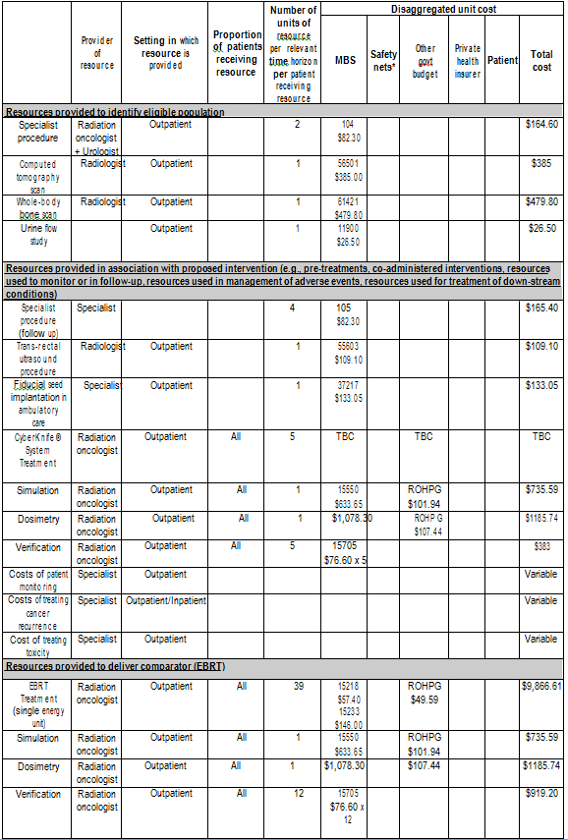

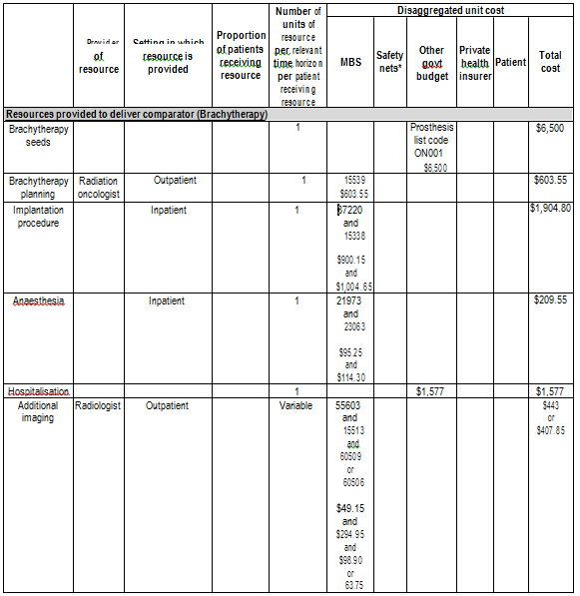

# Proposed structure of economic evaluation

PASC agreed that a cost-effectiveness analysis be performed instead of a cost-minimisation analysis. This recommendation is made on the grounds that:

• There is not a consensus view that radiotherapy delivered by CyberKnife® is indisputably recognised as being no worse than conventional EBRT.

• The technology has the potential for superior effectiveness.

• The technology has the potential for superior safety.

**Table13. PICO Criteria and decision options for the use of CyberKnife® over conventional EBRT or low dose rate brachytherapy in the delivery of radiotherapy to low and intermediate risk prostate cancer patients.**

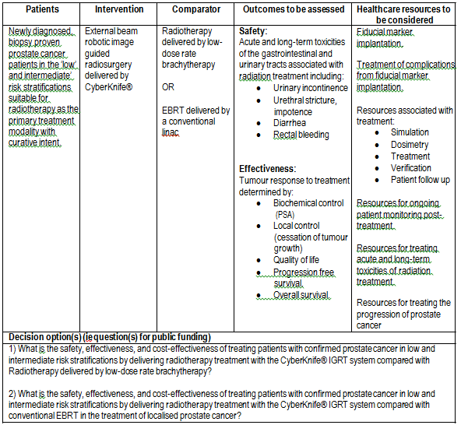

**Table14. PICO Criteria and decision options for the use of CyberKnife® over conventional EBRT in the delivery of radiotherapy to high risk prostate cancer patients.**

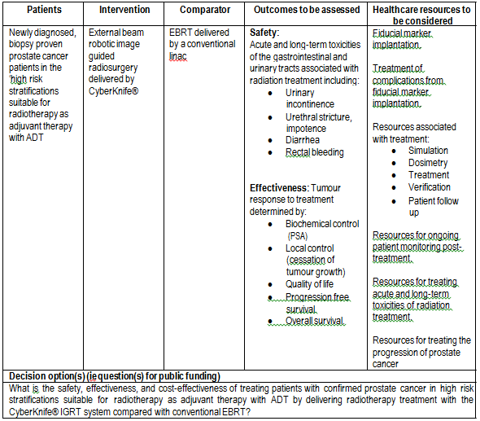

For a graphical representation of each of the PICO tables given above please refer to appendix two. Please note that the decision trees are provided for the purposes of supplementing the information given in the PICO tables and clinical algorithms and may not reflect the cost-effectiveness models required in the final assessment.

# References

Accuray Inc. 2009. CyberKnife® System product information brochure [Online]. Available:

<http://www.accuray.com/products/index.aspx>[Accessed 27/06/2011].

Australian Institute of Heatlh and Welfare 2010, Cancer in Australia, 2010. Cancer series no. 60. Cat. no. CAN 56. Australian Institute of Heatlh and Welfare**,** Canberra.

Australian Register of Therapeutic Goods 2008. Public summary document for #155887: Device

Technologies Australia Pty Ltd - Accelerator system. Therapeutic Goods Administration.

Cancer Australia and Cancer Council Australia 2010, Review of national cancer control activity in

Australia. Cancer Australia**,** Canberra.

Hayden, A., Martin, J., Kneebone, A., Lehman, M., Wiltshire, K., Skala, M., Christie, D., Vial, P., Mcdowall, R. & Tai, K. 2010. Australian & New Zealand Faculty of Radiation Oncology Genito Urinary Group: 2010 consensus guidelines for definitive external beam radiotherapy for prostate carcinoma. Journal of Medical Imaging and Radiation Oncology, 54**,** 513-525.

Commonwealth of Australia 2011. Brachytherapy for the treatment of prostate cancer. MSAC Application 1089.1, Review of Interim Funded Service. Canberra [Accessed]

The CyberKnife Society WHITE PAPER - Prostate Cancer and Stereotactic Radiosurgery. [http://www.cksociety.org/document/docdownload.aspx?docid=619](http://www.cksociety.org/document/docdownload.aspx?docid=619%20) [Accessed 05/08/2011]

Tipton, K., Launders, J.H., Inamdar, R., Miyamoto, C. & Schoelles, K. 2011. Stereotactic Body

Radiation Therapy: Scope of the Literature. Annals of Internal Medicine, 154**,** 737.

# Appendix 1

## Full MBS item descriptors plus explanatory notes

**MBS item descriptors for lead up and monitoring procedures associated with delivering radiotherapy to prostate cancer patients.**

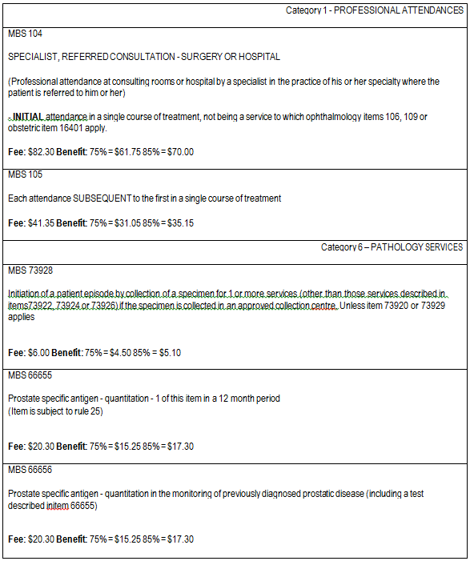

**MBS item numbers for all radiotherapy treatment protocols requiring patient simulation, dosimetry and verification**

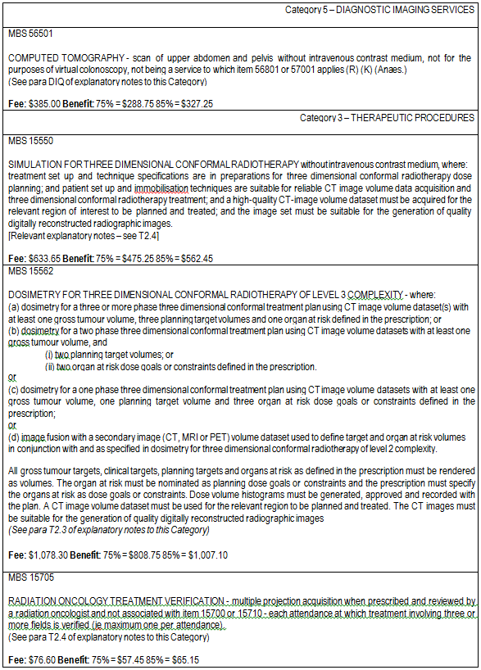

**MBS item numbers associated with the implantation of fiducial markers into the prostate.**

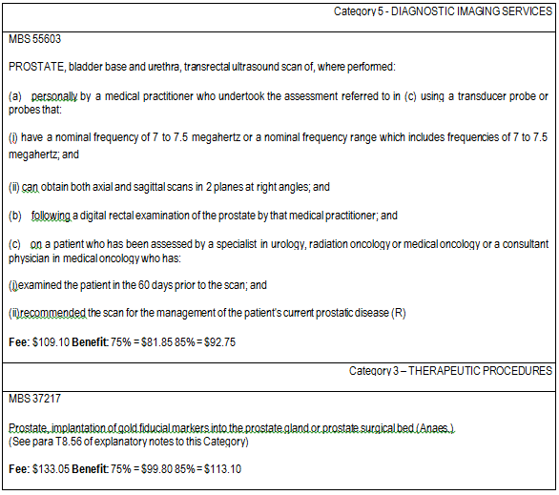

MBS item number for stereotactic radiosurgery.

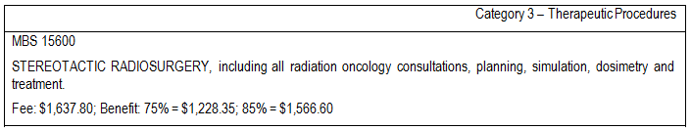

**MBS item numbers for radiation treatment using a single photon linear accelerator in the treatment of prostate cancer.**

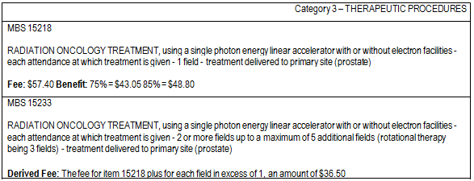

**MBS item numbers for the treatment of prostate cancer with brachytherapy.**

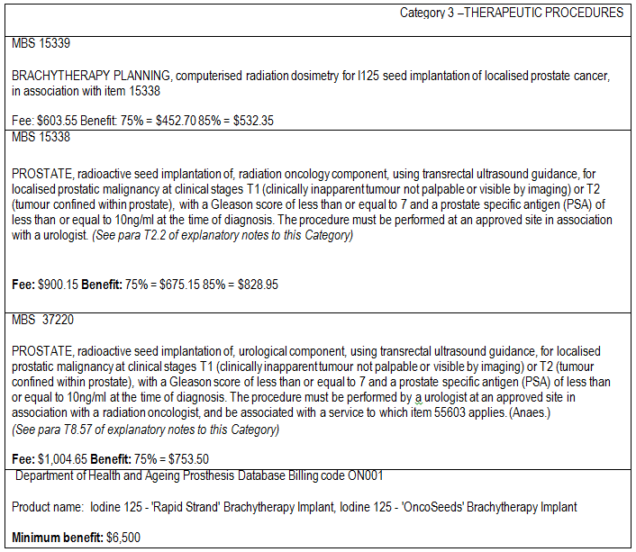

# Appendix 2

## Decision trees to supplement information provided in PICO tables and clinical algorithms.

Please note that the decision trees given here are provided for the purposes of supplementing the information given in the PICO tables and clinical algorithms and may not reflect the cost-effectiveness models required in the final assessment.

**Decision tree representing treatment options in patients with low and intermediate risk prostate cancer.**

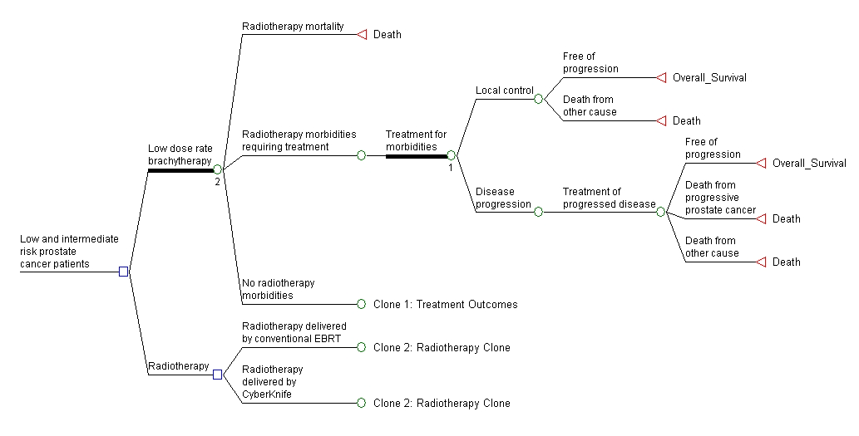

Decision tree representing treatment options in patients with high risk prostate cancer.

