**MSAC Application 1762**

**Amendment to HER-2 MBS item to allow for trastuzumab deruxtecan for the treatment of patients with metastatic gastric or gastroesophageal junction adenocarcinoma**

**PICO Set Document**

# Population

**Describe the population in which the proposed health technology is intended to be used:**

Patients with metastatic gastric or gastro-oesophageal junction (GEJ) adenocarcinoma who have progressed on trastuzumab containing regimens.

The main objectives of this application is to request an amendment to the current MBS item (73342) descriptor for human epidermal growth factor receptor 2 (HER2) testing to include trastuzumab deruxtecan (ENHERTU™) regimen, to seek the advice of the MSAC secretariat regarding the appropriate MSAC process for the proposed minor change to the descriptor and also seek guidance regarding retesting requirements in support of our PBAC submission noting that trastuzumab deruxtecan will be used in patients who have previously progressed on trastuzumab.

Based on historical precedence for trastuzumab deruxtecan (e.g. HER2 testing for treatment of patients with unresectable, metastatic HER2-low breast cancer) we note that a submission to MSAC was not required. On February 1,2023, the MSAC Executive advised regarding an application for trastuzumab deruxtecan in patients with HER2-low breast cancer: “*The MSAC Executive advised that a codependent submission to MSAC is not needed for this application. If a positive recommendation is received from the PBAC, the Department can seek policy approval from the Government to implement the relevant changes to the MBS item as a part of the PBS listing process.”*

If there is an option for the item descriptor amendment to progress without MSAC consideration and before a PBAC submission or PBS listing, we will also be able to provide this advice to the PBAC.

**Specify any characteristics of patients with the medical condition, or suspected of, who are proposed to be eligible for the proposed health technology, describing how a patient would be investigated, managed and referred within the Australian health care system in the lead up to being considered eligible for the technology:**

Gastric and GEJ adenocarcinomas are the fifth most common cancers and fourth leading cause of cancer deaths worldwide, affecting both men and women. There were approximately 1 million incident cases and more than 769 000 associated deaths in 2020. (Sung H 2020) In Australia, the estimated incidence of gastric and GEJ cancer diagnosed in 2022 was 2,572 patients (1,661 males + 911 females) with an overall five-year survival rate (2014-2018) of 37%. (Cancer Australia, AIHW). Approximately one in five gastric and GEJ adenocarcinomas are HER2-positive, an aggressive subtype that correlates with poor outcomes. (Iqbal N, 2014, ACS 2020)

HER2 expression is a prognostic biomarker that is routinely screened in Australian clinical practice in patients with metastatic gastric or GEJ adenocarcinoma to determine eligibility to trastuzumab. In accordance with PBS criteria, HER2 positivity is demonstrated by:

* immunohistochemical (IHC) examination giving a staining intensity score of 2+ or 3+; and
* a positive in situ hybridisation (ISH) result based on more than 6 copies of HER2 in the same tumour tissue sample; and
* ISH result based on the ratio of HER2 to chromosome 17 being more than 2 in the same tumour tissue sample (HER2 count >6 and HER2/CEP17 ratio >2).

The recommended first-line treatment for HER2-positive metastatic gastric or GEJ adenocarcinoma is to combine trastuzumab, an anti-HER2 antibody, with a standard first-line chemotherapy regimen. However, ultimately the majority of HER2 positive patients progress on first-line treatment and prognosis is poor with median survival of less than 9 months (Shitara et al, 2020).

Currently no other anti-HER2 treatments are approved for patients who progress on trastuzumab, so treatment options for these patients typically involve challenging them with an alternative chemotherapeutic agent that the patient has not yet been exposed to. As such, there remains a significant unmet clinical need for effective treatments for patients with metastatic gastric or GEJ cancer who have progressed on trastuzumab.

Clinical trial results (DESTINY-Gastric [DG] - 01 [Shitara et al, 2020] and DESTINY-Gastric [DG] - 02 [Van Cutsem E at al. 2023]) show that trastuzumab deruxtecan when used in patients who have progressed on trastuzumab, results in a clinically meaningful improvement in response rates and survival outcomes.

Currently, testing HER2 status in patients with metastatic gastric or GEJ cancer is standard practice to establish first line access to PBS funded trastuzumab. However, retesting for HER2 expression is not routinely performed beyond first-line treatment due to the lack of HER2-targeted therapies available in later settings so, current treatment guidelines do not include recommendations for HER2 retesting following progression. (Lordick F 2022; NICE guideline 2020; Bartley AN 2016; Japanese GC guidelines 2021; NCCN guidelines 2022).

With the availability of trastuzumab deruxtecan as a treatment option in later lines, it may be appropriate to retest HER2 status in some patients. Although retesting is currently not common practice, it is AstraZeneca’s understanding that this is allowable under relevant existing MBS items without the need for any further amendment, beyond the minor amendment to the descriptor being requested for the MBS item 73342.

As will be discussed further in this application, there is some evidence that there can be down-regulation of HER2 in a proportion of GEJ patients. Therefore, with the availability of trastuzumab deruxtecan on the PBS, there may be some circumstances where clinicians may wish to retest to verify HER2 status before initiating trastuzumab deruxtecan. The decision to retest patients will be balanced by the challenges of rebiopsying patients noting that this can be an invasive, traumatic, and challenging procedure which places considerable burden to the patients and the health care sector. Based on AstraZeneca’s discussions with a number of clinicians, there is a clear preference for the retesting to be at the discretion of the clinician depending on the clinical circumstance.

Therefore, other than the request for an amendment to the current MBS item (73342) descriptor for HER2 testing to include the trastuzumab deruxtecan regimen, no further MBS changes are required to support the use of trastuzumab deruxtecan on the PBS.

Overall, AstraZeneca expects that the availability of trastuzumab deruxtecan on the PBS will have minimal budget impact to the MBS given the small number of eligible patients, and noting that the testing, interpretation and reporting paradigm will remain unchanged.

**Provide a rationale for the specifics of the eligible population:**

HER2 testing prior to initiating first line therapy is already a routine part of the clinical management of metastatic gastric or GEJ adenocarcinoma in Australia.

AstraZeneca, will be seeking PBS listing for the treatment of adult patients with metastatic gastric or GEJ adenocarcinoma who have progressed following trastuzumab, based on data from the pivotal DG - 01 (Shitara et al, 2020) and DG - 02 (Van Cutsem E at al. 2023) studies, the studies that will form the basis of AstraZeneca’s application for an extension of the indication for trastuzumab deruxtecan.

Trastuzumab deruxtecan is a humanized anti-HER2 IgG1 monoclonal antibody with the same amino acid sequence as trastuzumab, covalently linked to a topoisomerase I inhibitor payload, via a tetrapeptide-based cleavable linker. Topoisomerase I inhibitor has 10-fold higher potency than the active metabolite (SN-38)† of the commonly used chemotherapy irinotecan. Upon binding to HER2 receptors expressed on the cell surface, trastuzumab deruxtecan is internalized by the cell and intracellular lysosomal enzymes upregulated in tumour cells cleave the peptide linker facilitating the release of the payload to the cytoplasm of tumour cells. The released payload enters the cell nucleus and causes damage to the tumour cell’s DNA, resulting in tumour cell death. The payload also has high cell-membrane permeability that enables elimination of both target tumour cells and the surrounding tumour cells (bystander killing effect) (Nakada et al, 2019; Ogitani et al. 2016). These unique structural and mechanistic features of trastuzumab deruxtecan results in potent anti-tumour activity compared to trastuzumab monotherapy or earlier generation antibody drug conjugates such as trastuzumab emtansine.

Clinical evidence for trastuzumab deruxtecan

The main clinical evidence supporting the efficacy and safety of trastuzumab deruxtecan is from two completed phase II studies (DG-01, DG-02) and one ongoing phase 3 study (DESTINY-Gastric 04 [DG-04]). (Table 8)

DG-01 recruited patients without a requirement for a post-trastuzumab progression biopsy (HER2 retesting) whereasin DG-02 and DG-04, a post-trastuzumab progression biopsy (HER2 retesting) was mandated. Specifically, in DG-02, the biopsy could be from the primary or metastatic tumour site(s) and to account for possible heterogeneity of HER2 expression, multiple biopsies were required and fine need aspiration biopsies were not acceptable.

AstraZeneca has discussed with several clinicians whether they would routinely rebiopsy and retest HER2 status following progression on trastuzumab, before commencing treatment with trastuzumab deruxtecan. The overwhelming response was that rebiopsying is logistically difficult, burdensome, potentially harmful to patients and will inevitably lead to treatment delays. As such, the decision to rebiopsy needs to be on a case-by-case basis.

Of note is that in the main publication for the DG-02 study, although re-testing HER2 status was mandated, it was acknowledged that in clinical practice conducting another biopsy in these patients is not always feasible or appropriate depending on the clinical condition of the patient. Furthermore, the publication points out that, to be reliable given heterogeneity in gastric and GEJ cancer, multiple core biopsies are required which is often not viable.

In DG-01, there was a clinically meaningful overall survival gain of 4.1 months for gastric and GEJ adenocarcinoma patients treated with trastuzumab deruxtecan compared to the comparator arm (physicians’ choice of chemotherapy). (Shitara et al, 2020) The DG-01 study did not require post-trastuzumab HER2 testing for recruitment so 70% of the patients were not retested (30% were tested during or after first line trastuzumab treatment). In a post hoc analysis from DG-01, the impact of retesting for HER2 positivity on survival was investigated and it was shown that there was no substantial difference in survival benefits between HER2 re-tested vs not retested patients. Moreover, when objective response rates of the patients in DG-01 who were treated with trastuzumab deruxtecan with low tumour HER2 mRNA levels (RNAseq log value below 9.7), no plasma HER amplification and low plasma HER2 copy number (below 6) was compared to their respective high HER2 expressing cohorts utilising these different analytical methods, they also demonstrated anti-tumour activity which was better than the objective response rates observed in the control arm of DG-01. This observation was also true for the patients who has low serum HER2 extracellular domain (ECD) in comparison with patients who had high serum ECD levels, a test that indicates active levels of HER2 in patients.

DG-02 (Van Cutsem et al, 2023) included a population that was retested for HER2 positivity in 2L+ setting which also resulted in extended survival for patients who failed trastuzumab therapies and maintained their HER2 positivity.

Data on down-regulation of HER2 expression

Despite DG-01 showing better survival outcomes for patients who were predominantly not retested prior to trastuzumab deruxtecan treatment, some small scale retrospective studies show that treatment with trastuzumab can lead to either down-regulation (predominant) (Grieb BC 2021, Seo et al 2019, Pietrantonio, F 2016) or up-regulation of expression of HER2 (Grieb BC 2021 , Park SR et al 2016). To date, large prospective or retrospective studies that investigate down-regulation of HER2 positivity after trastuzumab therapy in the first-line setting in gastric or GEJ adenocarcinoma have not yet been conducted.

Down-regulation of HER2 expression can be linked to intra-tumoral heterogenous expression of HER2 in gastric and GEJ adenocarcinoma, a parameter that may not be captured in the number of tumour fragments tested in HER2 immunochemistry in Australia (Zhang H et al, 2020). A large Australian real world evidence study in gastric and GEJ adenocarcinoma patients shows that the heterogeneity of HER2 positivity is 40% and to capture this heterogeneity at least staining of 5 tumour fragments instead of 3 is recommended. (Kumarasinghe MP 2017). Another scientific theory that explains the down regulation of HER2 expression post trastuzumab based therapy is ‘selective pressure’, where HER2 negative cells clones start dominating the tumour upon inhibition and elimination of HER2 expressing cells by anti-HER2 therapies. (Pietrantonio F, 2016, Shu et al, 2018). Interestingly, trastuzumab deruxtecan’s unique mechanism of action, i.e. its bystander killing effect, does not require high expression of HER2 on cell surface as evident by Destiny-Breast 04 trial (Modi S et al, 2022). DG-01 exploratory biomarker analysis also implies patients may have had down-regulated expression of HER2 but still benefit from trastuzumab deruxtecan.

Noting the challenges of performing another biopsy and the observation that an all-comer population still benefits from trastuzumab deruxtecan, AstraZeneca intend to request a PBS restriction for trastuzumab deruxtecan which does not require the need for a post-trastuzumab progression biopsy.

**Are there any prerequisite tests?**

Yes

**Are the prerequisite tests MBS funded?**

Yes

**Please provide details to fund the prerequisite tests:**

To establish HER2 status in metastatic gastric and GEJ cancer patients, there are two existing MBS items (IHC and ISH). (**Table 1**) This application is seeking a slight amendment to Item 73342 to ensure this is applicable to trastuzumab deruxtecan (**Table 2**). To facilitate this, patients require a biopsy to obtain tumour tissue and for some patients, an overnight hospital stay may be necessary.

Table 1 MBS items to determine HER2 status required for access to trastuzumab

|  |  |
| --- | --- |
| **Item No** | **Descriptor** |
| 72868 | *Immunohistochemical examination of biopsy material by immunofluorescence, immunoperoxidase or other labelled antobody techniques with multiple antigenic specifities per specimen – 1 to 3 of the following antibodies – oestrogen, progesterone and c-erb-B2 (HER2) (Item is subject to rule 13)*  *Fee: $74.50 Benefit: 75% = $55.90 85% = $63.35* |
| 73342 | *An in situ hybridisation (ISH) test of tumour tissue from a patient with metastatic adenocarcinoma of the stomach or gastro-oesophageal junction, with documented evidence of human epidermal growth factor receptor 2 (HER2) overexpression by immunohistochemical (IHC) examination giving a staining intensity score of 2+ or 3+ on the same tumour tissue sample, requested by, or on the advice of, a specialist or consultant physician who manages the treatment of the patient to determine if the requirements relating to HER2 gene amplification for access to* ***trastuzumab*** *under the Pharmaceutical Benefits Scheme are fulfilled.*  *Fee: $315.40 Benefit: 75% = $236.55 85% = $268.10* |

# Intervention

**Name of the proposed health technology:**

The nominated main intervention in HER2 positive gastric and GEJ cancer post-trastuzumab is:

* Trastuzumab deruxtecan with or without retesting of HER2 status. It is proposed that the decision to retest is according to clinical discretion.

The proposed health technology is the existing MBS item 73342. A modification to the descriptor as outlined in **red** is requested to expand use of the current test so it can also be applied to trastuzumab deruxtecan on the PBS (**Table 2**). This is the wording proposed by the MSAC Secretariat in email correspondence received by AstraZeneca on Thursday, 8 June 2023.

Table 2: Proposed change to existing MBS item

|  |  |
| --- | --- |
| **Item No** | **Descriptor** |
| 73342 | *An in situ hybridisation (ISH) test of tumour tissue from a patient with metastatic adenocarcinoma of the stomach or gastro-oesophageal junction, with documented evidence of human epidermal growth factor receptor 2 (HER2) overexpression by immunohistochemical (IHC) examination giving a staining intensity score of 2+ or 3+ on the same tumour tissue sample, requested by, or on the advice of, a specialist or consultant physician who manages the treatment of the patient to determine if the requirements relating to HER2 gene amplification for access to* ***a******trastuzumab****-****containing agent*** *under the Pharmaceutical Benefits Scheme are fulfilled.*  *Fee: $315.40 Benefit: 75% = $236.55 85% = $268.10* |

**Describe the key components and clinical steps involved in delivering the proposed health technology:**

Currently, in order to determine HER2 status in the first-line metastatic gastric cancer setting, patients are routinely biopsied and then IHC and ISH tested. Largely, this practice will not change with the availability of trastuzumab deruxtecan on the PBS. In some circumstances, where retesting is feasible and at the clinician’s discretion, patients may undergo a re-test of HER2 status prior to commencing trastuzumab deruxtecan.

**Identify how the proposed technology achieves the intended patient outcomes:**

As described previously, establishing HER2 status is routine practice prior to initiation of first-line trastuzumab treatment, as outlined in the PBS restriction (PBS Item [10581X](https://www.pbs.gov.au/medicine/item/10581x)). (Table 3)

Table 3:Trastuzumab PBS restriction (PBS item [10581X](https://www.pbs.gov.au/medicine/item/10581x))

|  |
| --- |
| Metastatic (Stage IV) HER2 positive adenocarcinoma of the stomach or gastro-oesophageal junction  **Treatment Phase:** Initial treatment  **Clinical criteria:**  Patient must have evidence of human epidermal growth factor receptor 2 (HER2) positivity as demonstrated by immunohistochemistry 2+ or more in tumour material,  AND  Patient must have evidence of HER2 gene amplification as demonstrated by in situ hybridisation results based on more than 6 copies of HER2 in the same tumour tissue sample,  AND  Patient must have evidence of HER2 gene amplification as demonstrated by in situ hybridisation results based on the ratio of HER2 to chromosome 17 being more than 2 in the same tumour tissue sample,  AND  Patient must commence treatment in combination with platinum based chemotherapy and capecitabine; OR  Patient must commence treatment in combination with platinum based chemotherapy and 5 fluorouracil,  AND  Patient must not have previously received this drug for this condition,  AND  Patient must not have received prior chemotherapy for this condition,  AND  Patient must have a WHO performance status of 2 or less,  AND  The treatment must not be used in a patient with a left ventricular ejection fraction (LVEF) of less than 45% and/or with symptomatic heart failure.  Cardiac function must be tested by echocardiography (ECHO) or multigated acquisition (MUGA), prior to initiating treatment with this drug for this condition. |

In patients who fail on trastuzumab, trastuzumab deruxtecan is likely to be prefered over the current standard of care, chemotherapy, improving overall survival irrespective of knowing HER2 status prior to commencing treatment.

**Does the proposed health technology include a registered trademark component with characteristics that distinguishes it from other similar health components?**

No

**Explain whether it is essential to have this trademark component or whether there would be other components that would be suitable:**

The current MBS funded ISH test (73342) doesn’t have a specific trademark component. The Roche anti-HER2/neu (4B5) Rabbit Monoclonal Primary Antibody is the evidentiary standard HER2 clone utilised in the DG-01 and DG-02 studies. This antibody is utilised by approximately 85% of all accredited tertiary hospital and private laboratories providing IHC testing for HER2 in Australia. However, other TGA/IVD registered HER2 Antibody assays used to determine the biomarker status of HER2 are also available and suitable components i.e. Agilent’s HercepTest.

**Are there any proposed limitations on the provision of the proposed health technology delivered to the patient (For example: accessibility, dosage, quantity, duration or frequency):**

No

**Provide details and explain:**

If HER2 retesting is deemed necessary to verify HER2 status prior to trastuzumab deruxtecan, the current testing, interpretation and reporting paradigm will remain unchanged as systems are already in place to report on the diagnostic criteria required to identify patients with this disease phenotype.

The current relevant HER2 testing MBS items allow for retesting. Noting the challenges with biopsies outlined previously, with the availability of trastuzumab deruxtecan, retesting rates may increase but given the small number of patients the impact to the MBS is likely to be small.

**If applicable, advise which health professionals will be needed to provide the proposed health technology:**

A registered anatomical pathologist is responsible for conducting the detection, diagnosis and reporting of the pathology result to help guide and determine treatment.

**If applicable, advise whether delivery of the proposed health technology can be delegated to another health professional:**

N/A

**If applicable, advise if there are any limitations on which health professionals might provide a referral for the proposed health technology:**

A registered anatomical pathologist is responsible for conducting the detection, diagnosis and reporting of the pathology results which guide and determine treatment. A specialist (e.g. medical oncologist, gastric surgeon, gastroenterolgoist, interventional radiologist) provides the specimen and a test request form for IHC and ISH testing of HER2.

**Is there specific training or qualifications required to provide or deliver the proposed service, and/or any accreditation requirements to support delivery of the health technology?**

No

**Provide details and explain:**

The current testing, interpretation and reporting practice of HER2 in gastric or GEJ cancer will remain unchanged. As such, no additional or new specific testing or training criteria are required. Australian pathologists routinely performing HER2 IHC for patients with metastatic gastric or GEJ cancer and HER2 ISH for tumours that are reported 2+/3+ by IHC. Gastric or GEJ cancer HER2 IHC and ISH testing is well established and accredited in Australia.

The Roche VENTANA Anti-HER2/neu (4B5) antibody and evidentiary standard assay is utilised by approximately 85% of all accredited tertiary and private laboratories providing IHC and ISH testing for HER2 in Australia.

**Indicate the proposed setting(s) in which the proposed health technology will be delivered:** (select all relevant settings)

Consulting rooms

Day surgery centre

Emergency Department

Inpatient private hospital

Inpatient public hospital

Laboratory

Outpatient clinic

Patient’s home

Point of care testing

Residential aged care facility

Other (please specify)

GC HER2 testing is conducted by an accredited anatomical pathology laboratory.

**Is the proposed health technology intended to be entirely rendered inside Australia?**

Yes

**Please provide additional details on the proposed health technology to be rendered outside of Australia:**

N/A

**Comparator**

**Nominate the appropriate comparator(s) for the proposed medical service (i.e. how is the proposed population currently managed in the absence of the proposed medical service being available in the Australian health care system). This includes identifying health care resources that are needed to be delivered at the same time as the comparator service:**

The nominated main comparator is as follows:

* HER2 positive gastric cancer patients who have failed on trastuzumab: No HER2 re-testing + standard of care, chemotherapy

**List any existing MBS item numbers that are relevant for the nominated comparators:**

HER2 testing consists of IHC to detect over-expression of HER2 (item 72848) and ISH for detection of HER2 gene amplification (item 73342).

**Please provide a rationale for why this is a comparator:**

Currently, for patients with metastatic gastric or GEJ cancer whose disease has progressed on first-line trastuzumab-containing regimens, the second-line treatment options are not targeted HER2 therapies so typically involve challenging with an alternative chemotherapeutic agent that the patient has not previously been exposed to.

**Pattern of substitution – Will the proposed health technology wholly replace the proposed comparator, partially replace the proposed comparator, displace the proposed comparator or be used in combination with the proposed comparator?** (please select your response)

None – used with the comparator

Displaced – comparator will likely be used following the proposed technology in some patients

Partial – in some cases, the proposed technology will replace the use of the comparator, but not in all cases

Full – subjects who receive the proposed intervention will not receive the comparator

**Please outline and explain the extent to which the current comparator is expected to be substituted:**

In some circumstances, where HER2 retesting is deemed appropriate patients may undergo a retest of HER2 status prior to commencing trastuzumab deruxtecan. The number of patients eligible for trastuzumab deruxtecan is expected to be small so consequently the additional cost to MBS will be minimal. In general, the current testing paradigm will remain unchanged as it already reports on the diagnostic criteria required to identify patients with this disease phenotype.

**Outcomes**

**List the key health outcomes (major and minor – prioritising major key health outcomes first) that will need to be measured in assessing the clinical claim for the proposed medical service/technology (versus the comparator):** (please select your response)

Health benefits

Health harms

Resources

Value of knowing

**Outcome description – please include information about whether a change in patient management, or prognosis, occurs as a result of the test information:**

The treatment with trastuzumab deruxtecan (preceded by HER2 testing or not) is associated with superior outcomes compared to standard of care, chemotherapy, in patients with metastatic HER2-positive gastric or GEJ adenocarcinoma following first-line trastuzuamab. It is important to emphasise that DG-01 trial showed that overall survival results are similar between re-tested vs not re-tested patients supporting the proposal that retesting should be discretionary given the challenges associated with re-biopsying patients.

**Proposed MBS items**

**How is the technology/service funded at present? (for example: research funding; State-based funding; self-funded by patients; no funding or payments):**

ISH test already exists on MBS (Item 73342, **Table 4**). As such, the current testing, interpretation, and reporting paradigm will remain unchanged as it already reports on the diagnostic criteria required to identify patients with HER2-positive gastric or GEJ cancer and allows re-testing.

**Please provide at least one proposed item with their descriptor and associated costs, for each population/Intervention:**

Table 4: Proposed MBS item details

| **MBS item number (where used as a template for the proposed item)** | **73342** |
| --- | --- |
| Category number | P7 |
| Category description | Genetics |
| Proposed item descriptor | An in situ hybridisation (ISH) test of tumour tissue from a patient with metastatic adenocarcinoma of the stomach or gastro-oesophageal junction, with documented evidence of human epidermal growth factor receptor 2 (HER2) overexpression by immunohistochemical (IHC) examination giving a staining intensity score of 2+ or 3+ on the same tumour tissue sample, requested by, or on the advice of, a specialist or consultant physician who manages the treatment of the patient to determine if the requirements relating to HER2 gene amplification for access to *a* trastuzumab-*containing agent* under the Pharmaceutical Benefits Scheme are fulfilled. |
| Proposed MBS fee | $315.40 |
| Indicate the overall cost per patient of providing the proposed health technology | Benefit: 75% = $236.55 85% = $268.10 |
| Please specify any anticipated out of pocket expenses | Benefit: 75% = $78.85 85% = $47.30 |
| Provide any further details and explain | Provide further details here |

**Algorithms**

**Preparation for using the health technology**

**Define and summarise the clinical management algorithm, including any required tests or healthcare resources, before patients would be eligible for the proposed health technology:**

Australian patients are currently classified as having either 'HER2-positive' or 'HER2-negative' disease, as per the internationally accepted American Society of Clinical Oncology/College of American Pathologists (ASCO/CAP) recommendations for HER2 testing in gastric cancer.

Pathologists assessing the HER2 status of gastric cancer patients in Australia use a validated scoring system that ranges from IHC 0 (HER2-negative) to IHC 3+ (HER2-positive); intermediate scores of IHC 1+ are reported as HER2-negative, and intermediate scores of IHC 2+ are reported as HER2-negative if ISH testing shows no HER2 gene amplification (‘IHC 2+/ISH-negative’) or as HER2-positive if ISH testing shows HER2 gene amplification (‘IHC 2+/ISH-positive’).

Gastric cancer that is IHC 3+ or IHC 2+/ISH+ positive or IHC3+/ISH+ is currently described as ‘HER2-positive’ (as per PBS restriction for trastuzumab). (**Figure 1**)

Figure 1: HER2 testing system

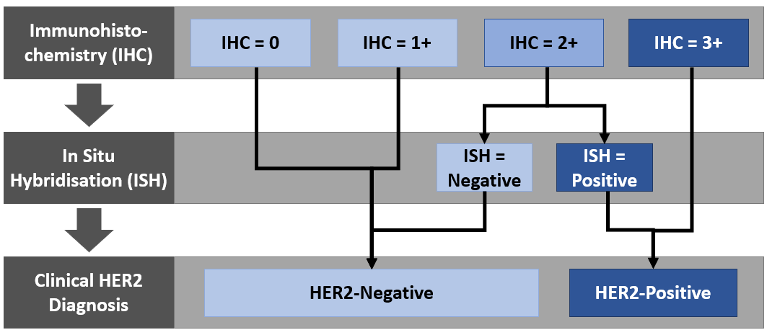

Abbreviations: HER2 = human epidermal growth factor receptor 2; IHC = immunohistochemistry; ISH = in situ hybridisation

The confirmation of HER2-positive status by ISH is currently used to identify patients who are eligible for PBS-funded trastuzumab. The recommended first-line treatment for advanced HER2-positive or metastatic gastric or GEJ adenocarcinoma is to combine trastuzumab, an anti-HER2 antibody, with standard first-line chemotherapy regimens. No other anti-HER2 treatments are currently approved for patients with metastatic gastric or GEJ cancer who have failed on trastuzumab.

Currently, the second and third-line treatment options are not stratified by HER2 status and typically involve challenging with an alternative chemotherapeutic agent that the patient has not yet been exposed to. As such, there is a significant unmet clinical need for effective treatments for patients with advanced gastric or GEJ cancer whose disease progressed on previous trastuzumab-containing regimens. (Figure 2).

Figure 2: Current treatment algorithm describing treatment options for newly diagnosed patients with metastatic GC/GEJ.

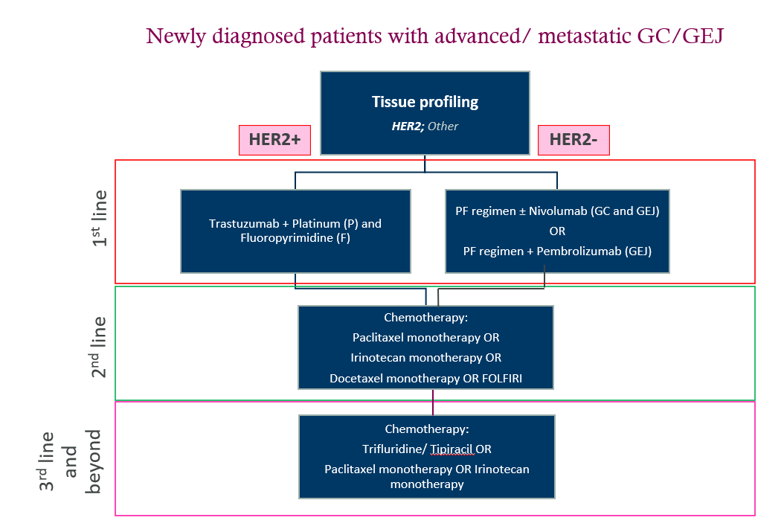Abbreviations: GC/GEJ, gastric carcinoma and gastro-oesophageal junction; GEJA, gastric and esophageal junction adenocarcinoma.

**Is there any expectation that the clinical management algorithm *before* the health technology is used will change due to the introduction of the proposed health technology?**

Yes

**Describe and explain any differences in the clinical management algorithm prior to the use of the proposed health technology vs. the comparator health technology:**

Currently, retesting for HER2 expression is not routinely performed beyond first-line treatment because there are no HER2-targeted therapies available for use in later lines. Consequently, current treatment guidelines do not include recommendations for HER2 retesting following progression on the first line treatment. (Lordick F 2022; NICE guideline 2020; Bartley AN 2016; Japanese GC guidelines 2021; NCCN guidelines 2022).

With the availability of trastuzumab deruxtecan on the PBS there may be an increase in HER2 testing post-trastuzumab where rebiopsying is faesible and deemed clinically necessary, prior to commencing trastuzumab deruxtecan (**Figure 3**). Regardless, the current testing process will remain unchanged as the diagnostic criteria required to identify patients with this disease phenotype is already well established and the current MBS items allow for retesting.

Figure 3: Proposed treatment algorithm describing treatment options for newly diagnosed patients with advanced/metastatic GC/GEJ.

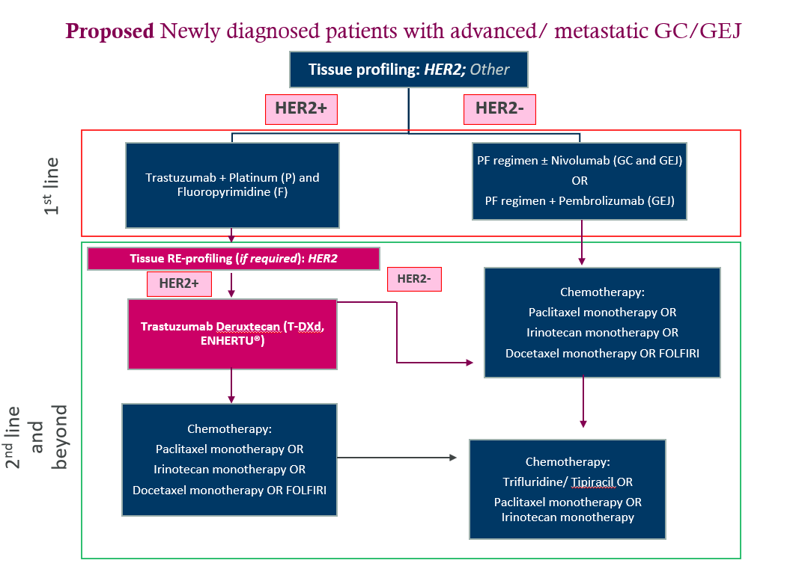

**Use of the health technology**

**Explain what other healthcare resources are used in conjunction with delivering the proposed health technology:**

A gastric or GEJ biopsy or biopsy from the metastatic site(s) (predominantly liver and lung) is required to perform HER2 testing. This is part of the standard diagnostic workup and is funded via the MBS. With the availability of HER2-targeted therapies beyond first-line, it is expected that the will be a small increase in the extent of biopsying and HER2 testing, with a minimal additional budget impact.

**Explain what other healthcare resources are used in conjunction with the comparator health technology:**

Currently, retesting for HER2 expression is not routinely performed beyond first-line treatment because there are no HER2 targeted therapies available for use in later lines.

**Describe and explain any differences in the healthcare resources used in conjunction with the proposed health technology vs. the comparator health technology:**

As previously mentioned, at diagnosis, metastatic gastric or GEJ cancer patients are routinely biopsied to obtain tissue samples and then HER2 tested: IHC (to detect over-expression of HER2 [item 72848] and ISH (for detection of HER2 gene amplification [item 73342]).

For patients failing trastuzumab there may be some retesting arising from the availability of PBS-funded trastuzumab deruxtecan however, since the number of patients currently treated with trastuzumab for gastric cancer is small (less than 200 patients per year) it follows that the number of patients receiving trastuzumab deruxtecan will be less than 200. Hence, the additional healthcare resources including costs to the MBS due to trastuzumab deruxtecan on the PBS will be minimal.

**Clinical management after the use of health technology**

**Define and summarise the clinical management algorithm, including any required tests or healthcare resources, *after* the use of the proposed health technology:**

Determining patients HER2 status via IHC and ISH has been standard of care practice in Australia following the introduction of HER2-targeted treatments, and the current HER2 testing paradigm remains appropriate for identifying patients with HER2+ gastric or GEJ cancer.

However, with the proposed reimbursement of trastuzumab deruxtecan for gastric or GEJ adenocarcinoma following trastuzumab, retesting for HER2 expression beyond first-line treatment (**Figure 3** may be appropriate for some patients.

**Define and summarise the clinical management algorithm, including any required tests or healthcare resources, *after* the use of the comparator health technology:**

Currently, retesting for HER2 expression is not routinely performed beyond first-line treatment because there are no HER2-targeted therapies available for second or third lines. The current practice after first-line progression is no re-testing + standard of care chemotherapy. (Please refere to Figure 3)

**Describe and explain any differences in the healthcare resources used *after* the proposed health technology vs. the comparator health technology:**

As previously mentioned, the current testing paradigm will remain unchanged as it already reports on the diagnostic criteria required to identify patients with advanced HER2-positive gastric or GEJ cancer whose disease progressed on previous trastuzumab-containing regimens. Retesting of HER2 status may be appropriate for some patients.

**Algorithms**

**Insert diagrams demonstrating the clinical management algorithm with and without the proposed health technology:**

The process for HER2 testing with the availability of trastuzumab deruxtecan on the PBS remains unchanged (refer Figure 1). Clinical management with and without trastuzumab deruxtecan on the PBS for use following trastuzumab is shown in Figure 2 and Figure 3, respectively.

**Claims**

**In terms of health outcomes (comparative benefits and harms), is the proposed technology claimed to be superior, non-inferior or inferior to the comparator(s)?** (please select your response)

Superior

Non-inferior

Inferior

**Please state what the overall claim is, and provide a rationale:**

Superiority vs. No testing + standard of care chemotherapy

**Why would the requestor seek to use the proposed investigative technology rather than the comparator(s)?**

Trastuzumab deruxtecan preceded or not by HER2 testing is associated with superior outcomes compared to "No HER2 testing and standard of care chemotherapy" in patients with unresectable or metastatic HER2+ gastric or GEJ cancer whose disease progressed on previous trastuzumab-containing regimens

**Identify how the proposed technology achieves the intended patient outcomes:**

The proposed technology intends to confirm HER2 status of patients previously known to be HER2 positive who have progressed on trastuzumab-containing regimens.

**For some people, compared with the comparator(s), does the test information result in:**

**A change in clinical management?** Yes

**A change in health outcome?** Yes

**Other benefits?** No

**Please provide a rationale, and information on other benefits if relevant:**

NA

**In terms of the immediate costs of the proposed technology (and immediate cost consequences, such as procedural costs, testing costs etc.), is the proposed technology claimed to be more costly, the same cost or less costly than the comparator?** (please select your response)

More costly

Same cost

Less costly

**Provide a brief rationale for the claim:**

The listing of trastuzumab deruxtecan on the PBS will not significantly impact the utilisation of biopsy, IHC and ISH procedures for HER2 retesting. The uptake estimates for trastuzumab deruxtecan (less than 200 patients per year) and the budget impact are expected to be low.

**Summary of Evidence**

**Provide one or more recent (published) high quality clinical studies that support use of the proposed health service/technology. At ‘Application Form lodgement’, please do not attach full text articles; just provide a summary (repeat columns as required).**

**Identify yet-to-be-published research that may have results available in the near future (that could be relevant to your application). Do not attach full text articles; this is just a summary (repeat columns as required).**

As stated previously, HER2 testing is already MBS listed therefore this will not change with the availability of trastuzumab deruxtecan. Table 8 provides a summary of the clinical evidence supporting the use of trastuzumab deruxtecan.

Table 8 Summary of clinical evidence for trastuzumab deruxtecan

| **Type of study design\*** | **Title of journal article or research project (including any trial identifier or study lead if relevant)** | **Short description of research (max 50 words)\*\*** | **Website link to journal article or research (if available)** | **Date of publication\*\*\*** |
| --- | --- | --- | --- | --- |
| Open-label, randomised, phase 2 trial of trastuzumab deruxtecan (T-DXd) compared to chemotherapy in patients with previously treated HER2-positive advanced gastric cancer | **DG-01:**  Shitara, K et al (2020). Trastuzumab Deruxtecan in Previously Treated HER2-Positive Gastric Cancer. N Engl J Med 382(25): 2419-2430.  DESTINY-Gastric-01 ClinicalTrials.gov number, NCT03329690. | Patients (N = 187) with HER2-positive gastric or GEJ adenocarcinoma that had progressed after at least two therapies, including trastuzumab (3L plus).  Treatment arms: Trastuzumab deruxtecan N = 125; Chemotherapy N = 62  Retesting for HER2 for eligibility to study was not mandatory. An exploratory analysis was conducted comparing patients who were retested vs not-retested and the results were comparable.  The primary outcome was objective response.  Key results:   |  |  |  | | --- | --- | --- | |  | **T-DXd** | **Chemotherapy** | | Objective response | 51% | 14% | | Overall survival (months) | 12.5 | 8.4 | | HR (95% CI) | 0.59 (0.38, 0.88), p = 0.01 | | | <https://clinicaltrials.gov/study/NCT05034887?cond=Gastric%20Adenocarcinoma&term=trastuzumab%20Deruxtecan&intr=trastuzumab%20Deruxtecan&rank=4> | June 18, 2020 |
| Open-label, phase 2, single-arm trial of T-DXd in HER2-positive, unresectable or metastatic gastric or GEJ adenocarcinoma in patients who have progressed on or after a trastuzumab-containing regimen | **DG-02:**  Van Cutsem E at al. Trastuzumab deruxtecan in patients in the USA and Europe with HER2-positive advanced gastric or gastroesophageal junction cancer with disease progression on or after a trastuzumab-containing regimen (DESTINY-Gastric02): primary and updated analyses from a single-arm, phase 2 study. Lancet Oncol 2023; 24: 744–56  DESTINY-Gastric-01 ClinicalTrials.gov, NCT04014075 | Single arm study in patients (N = 79) in patients who have progressed on trastuzumab (2L). Patients underwent a post-progression biopsy prior to commencing on T-DXd. The primary endpoint was confirmed objective response. Median follow up at time of first data cut-off was 5.9 months.   |  |  |  | | --- | --- | --- | |  | **Data cut-off** |  | |  | **Apr 21** | **Nov 21** | | Objective response, n (%, CI) | 30 (38%; 27·3–49·6) | 33 (42%; 30·8–53·4) | | Overall survival (months) | 12·1 (8·6–NE) | 12·1 (9·4–15·4) | | <https://clinicaltrials.gov/study/NCT04014075?cond=Gastric%20Adenocarcinoma&term=trastuzumab%20Deruxtecan&intr=trastuzumab%20Deruxtecan&rank=1> | July 2023 |
| Open-label, phase 3, multicentre, 2-Arm randomised study:  -DXd compared with ramucirumab and paclitaxel in participants with HER2-positive gastric or gastro-oesophageal junction (GEJ) adenocarcinoma who have progressed on or after a trastuzumab-containing regimen. | **DG-04:**  Trastuzumab Deruxtecan for Subjects With HER2-Positive Gastric Cancer or Gastro-Oesophageal Junction Adenocarcinoma After Progression on or After a Trastuzumab-Containing Regimen (DESTINY-Gastric04)  ClinicalTrials.gov ID NCT04704934 | This 2 arm randomised study will assess the efficacy and safety of T-DXd compared with Ram + PTX in participants with HER2-positive gastric or GEJ adenocarcinoma who have progressed on or after a trastuzumab-containing regimen and have not received any additional systemic therapy.  The primary objective will assess Overall Survival. Secondary objectives will further assess progression-free survival, objective response rate, duration of response, disease control rate, safety, pharmacokinetics, and immunogenicity of T-DXd. | <https://www.clinicaltrials.gov/study/NCT04704934?cond=Gastric%20Cancer&intr=Trastuzumab%20deruxtecan&rank=4> | TBC |

* Categorise study design, for example meta-analysis, randomised trials, non-randomised trial or observational study, study of diagnostic accuracy, etc.

**Provide high level information including population numbers and whether patients are being recruited or in post-recruitment, including providing the trial registration number to allow for tracking purposes. For yet to be published research, provide high level information including population numbers and whether patients are being recruited or in post-recruitment.

*** If the publication is a follow-up to an initial publication, please advise. For yet to be published research, include the date of when results will be made available (to the best of your knowledge).

# References

Abbas MN, Bright T, Price T et al. Patterns of care and outcomes for gastric and gastro-oesophageal junction cancer in an Australian population. ANZ J Surg. 2021 Dec;91(12):2675-2682. doi: 10.1111/ans.17249. Epub 2021 Oct 7. PMID: 34617383.

American Cancer Society. Targeted Therapies for Stomach Cancer. Available from: https://www.cancer.org/cancer/stomach-cancer/treating/targeted-therapies.html (Accessed 11 June 2020).

Australia Institute of Health and Welfare website (viewed in July 2023: https://www.aihw.gov.au/reports/cancer/cancer-data-in-australia/contents/cancer-summary-data-visualisation

Bang YJ, Van Cutsem E, Feyereislova A et al (ToGA Trial Investigators). Trastuzumab in combination with chemotherapy versus chemotherapy alone for treatment of HER2-positive advanced gastric or gastro-oesophageal junction cancer (ToGA): a phase 3, open-label, randomised controlled trial. Lancet. 2010 Aug 28;376(9742):687-97. doi: 10.1016/S0140-6736(10)61121-X. Epub 2010 Aug 19. Erratum in: Lancet. 2010 Oct 16;376(9749):1302. PMID: 20728210.

Bartley AN, Washington MK, Ventura CB et al. HER2 Testing and Clinical Decision Making in Gastroesophageal Adenocarcinoma: Guideline From the College of American Pathologists, American Society for Clinical Pathology, and American Society of Clinical Oncology. Arch Pathol Lab Med. 2016 Dec;140(12):1345-1363. doi: 10.5858/arpa.2016-0331-CP. Epub 2016 Nov 14. PMID: 27841667.

Cancer Australia website, viewed in July 2023: https://www.canceraustralia.gov.au/cancer-types/stomach-cancer/statistics

Davidson M, Cafferkey C, Goode EF et al. Survival in Advanced Esophagogastric Adenocarcinoma Improves With Use of Multiple Lines of Therapy: Results From an Analysis of More Than 500 Patients. Clin Colorectal Cancer. 2018 Sep;17(3):223-230. doi: 10.1016/j.clcc.2018.05.014. Epub 2018 Jun 8. PMID: 29980492.

Grieb BC and Agarwal R. HER2-Directed Therapy in Advanced Gastric and Gastroesophageal Adenocarcinoma: Triumphs and Troubles. Curr Treat Options Oncol. 2021 Aug 23;22(10):88. doi: 10.1007/s11864-021-00884-7. PMID: 34424404; PMCID: PMC8436174.

Iqbal N, Iqbal N. Human Epidermal Growth Factor Receptor 2 (HER2) in Cancers: Overexpression and Therapeutic Implications. Mol Biol Int. 2014;2014:852748. doi: 10.1155/2014/852748. Epub 2014 Sep 7. PMID: 25276427; PMCID: PMC4170925.

Kijima T, Arigami T, Uenosono Y et al. Comparison of HER2 Status Before and After Trastuzumab-based Chemotherapy in Patients With Advanced Gastric Cancer. Anticancer Res. 2020 Jan;40(1):75-80. doi: 10.21873/anticanres.13927. PMID: 31892554

Lordick F, Mariette C, Haustermans Ket al. ESMO Guidelines Committee. Oesophageal cancer: ESMO Clinical Practice Guidelines for diagnosis, treatment and follow-up. Ann Oncol. 2016 Sep;27(suppl 5):v50-v57. doi: 10.1093/annonc/mdw329. PMID: 27664261.Lordick F, Carneiro F, Cascinu S et al. Gastric cancer: ESMO Clinical Practice Guidelines for diagnosis, treatment and follow-up. Ann Oncol 2022

Japanese Gastric Cancer Association. Japanese Gastric Cancer Treatment Guidelines 2021 (6th edition). Gastric Cancer. 2023 Jan;26(1):1-25. doi: 10.1007/s10120-022-01331-8. Epub 2022 Nov 7. PMID: 36342574; PMCID: PMC9813208.Manabe N, Matsueda K, Haruma K. Epidemiological Review of Gastroesophageal Junction Adenocarcinoma in Asian Countries. Digestion 2021:1-8.

Modi S, Jacot W, Yamashita T et al. DESTINY-Breast04 Trial Investigators. Trastuzumab Deruxtecan in Previously Treated HER2-Low Advanced Breast Cancer. N Engl J Med. 2022 Jul 7;387(1):9-20. doi: 10.1056/NEJMoa2203690. Epub 2022 Jun 5. PMID: 35665782.

Nakada T, Sugihara K, Jikoh T et al. The Latest Research and Development into the Antibody-Drug Conjugate, [fam-] Trastuzumab Deruxtecan (DS-8201a), for HER2 Cancer Therapy. Chem Pharm Bull (Tokyo). 2019;67(3):173-185. doi: 10.1248/cpb.c18-00744. PMID: 30827997.

NCCN guidelines - gastric cancer. Version 2.2022 - January 11, 2022. Available from https://www.nccn.org/professionals/physician_gls/pdf/gastric.pdf (Accessed 31 August 2022).

NICE guideline. Oesophago-gastric cancer: assessment and management in adults. Available from: https://www.nice.org.uk/guidance/ng83 Accessed on 14 April 2020.

Ogitani Y, Aida T, Hagihara K, et al. DS-8201a, A Novel HER2-Targeting ADC with a Novel DNA Topoisomerase I Inhibitor, Demonstrates a Promising Antitumor Efficacy with Differentiation from T-DM1. Clin Cancer Res. 2016 Oct 15;22(20):5097-5108. doi: 10.1158/1078-0432.CCR-15-2822. Epub 2016 Mar 29. PMID: 27026201.

Park SR, Park YS, Ryu MH et al. Extra-gain of HER2-positive cases through HER2 reassessment in primary and metastatic sites in advanced gastric cancer with initially HER2-negative primary tumours: Results of GASTric cancer HER2 reassessment study 1 (GASTHER1). Eur J Cancer. 2016 Jan;53:42-50. doi: 10.1016/j.ejca.2015.09.018. Epub 2015 Dec 13. PMID: 26693898.

Pavlakis N, Tincknell G, Lim LE et al. European-Australasian consensus on the management of advanced gastric and gastro-oesophageal junction cancer: current practice and new directions. Ther Adv Med Oncol. 2022 Aug 24;14:17588359221118874. doi: 10.1177/17588359221118874. PMID: 36051471; PMCID: PMC9425884.

Pietrantonio F, Caporale M, Morano F et al. HER2 loss in HER2-positive gastric or gastroesophageal cancer after trastuzumab therapy: Implication for further clinical research. Int J Cancer. 2016 Dec 15;139(12):2859-2864. doi: 10.1002/ijc.30408. Epub 2016 Sep 16. PMID: 27578417.

Seo S, Ryu MH, Park YS et al. Loss of HER2 positivity after anti-HER2 chemotherapy in HER2-positive gastric cancer patients: results of the GASTric cancer HER2 reassessment study 3 (GASTHER3). Gastric Cancer. 2019 May;22(3):527-535. doi: 10.1007/s10120-018-0891-1. Epub 2018 Nov 1. PMID: 30386954.

Shu M, Yan H, Xu C et al. A novel anti-HER2 antibody GB235 reverses Trastuzumab resistance in HER2-expressing tumor cells in vitro and in vivo. Sci Rep. 2020 Feb 19;10(1):2986. doi: 10.1038/s41598-020-59818-2. PMID: 32076029; PMCID: PMC7031383.

Sung H, Ferlay J, Siegel RL et al. Global Cancer Statistics 2020: GLOBOCAN Estimates of Incidence and Mortality Worldwide for 36 Cancers in 185 Countries. CA Cancer J Clin. 2021 May;71(3):209-249. doi: 10.3322/caac.21660. Epub 2021 Feb 4. PMID: 33538338.

Van Cutsem E, di Bartolomeo M, Smyth E et al. Trastuzumab deruxtecan in patients in the USA and Europe with HER2-positive advanced gastric or gastroesophageal junction cancer with disease progression on or after a trastuzumab-containing regimen (DESTINY-Gastric02): primary and updated analyses from a single-arm, phase 2 study. Lancet Oncol. 2023 Jul;24(7):744-756. doi: 10.1016/S1470-2045(23)00215-2. Epub 2023 Jun 14. PMID: 37329891.

Zhang H, Wang Y, Wang Y et al. Intratumoral and intertumoral heterogeneity of HER2 immunohistochemical expression in gastric cancer. Pathol Res Pract. 2020 Nov;216(11):153229. doi: 10.1016/j.prp.2020.153229. Epub 2020 Sep 21. PMID: 33010699.

Zhao D, Klempner SJ, Chao J. Progress and challenges in HER2-positive gastroesophageal adenocarcinoma. J Hematol Oncol. 2019 May 17;12(1):50. doi: 10.1186/s13045-019-0737-2. PMID: 31101074; PMCID: PMC6525398.