**MSAC Application 1790**

**POLE genotyping for the molecular classification of endometrial cancer**

**PICO Set**

# **Population**

**Describe the population in which the proposed health technology is intended to be used:**

Uterine cancer is the most common gynaecological cancer diagnosed in Australian women, with 90-95% of these cancers being endometrial cancers, a malignancy arising from the inner epithelial lining of the uterus (Figure 1) (27, 28).

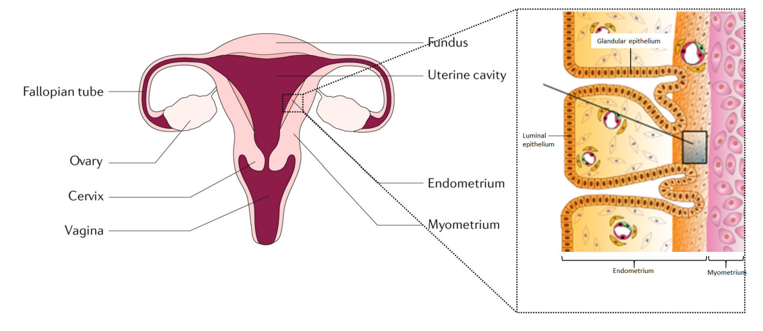

*Figure 1 Endometrial cancer arises from the endometrial glandular epithelium (28)*

Most patients diagnosed with endometrial cancer are postmenopausal with a median age at diagnosis of 60 years; however, rates of EC are steadily increasing over time, especially in younger, premenopausal women, which may be related to an increase in risk factors, including high and rising rates of obesity, and shifts in reproductive trends, including women having fewer children and delaying childbirth until later in life (29). In 2023, the estimated number of women diagnosed with EC in Australia would have been 2,986, equivalent to an age-standardised rate of 21.8 per 100,000 females. Rates of EC increase steadily in women aged >35 years, peaking in the 65–75-year age bracket (Figure 2). Rates of survival are generally extremely good in women with EC, with 84.4% of women surviving 5-years after being diagnosed with EC (95% CI [83.6, 85.2%]) (1, 2).

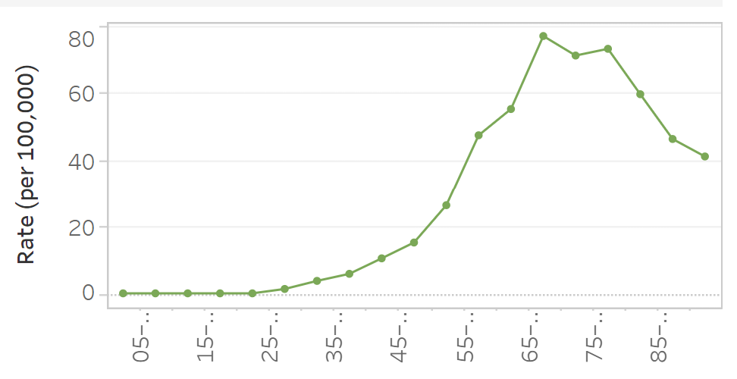

Age (years)

*Figure 2* *Endometrial cancer age-specific rates per 100,000 females (2)*

Traditionally, endometrial carcinomas are classified according to groups of histopathological subtypes (Type I and II) and tumour grade (I-III), with Type I (favourable prognosis) primarily composed of grade I or grade II endometrioid adenocarcinomas, and Type II (unfavourable prognosis) including grade III endometrioid adenocarcinomas, serous, clear cell, undifferentiated and carcinosarcomas (29, 30). Although histological classification is useful in determining further surgical and adjuvant therapy, decision-making can be complicated by an overlap between the subtype and grade of a tumour as well as interobserver variability in classification. Incorporating molecular classification into the standard histologic classification of EC will precisely define subtypes and guide therapeutic decision-making (29). A diagnostic algorithm may include the use of three immunohistochemical markers (p53, MSH6 and PMS2) as well as mutational analysis of the *POLE* gene (7). Approximately 7-10% of all ECs have a *POLE* mutation, characterised by a high tumour mutational burden (31).

Patients who are *POLEmut* have an excellent prognosis, with comparable recurrence-free and overall survival rates regardless of post-surgical adjuvant therapy (14). Therefore, de-escalation to no adjuvant treatment is recommended for patients with low-risk, stage I-II *POLE*mut endometrial carcinoma (5, 7, 8). POLE*mut* tumours are not able to be identified histologically, and it is recommended that all women with EC undergo risk stratification with *POLE* mutational analysis regardless of histological classification (11, 32).

**Specify any characteristics of patients with the medical condition, or suspected of, who are proposed to be eligible for the proposed health technology, describing how a patient would be investigated, managed and referred within the Australian health care system in the lead up to being considered eligible for the technology:**

Women presenting with symptoms such as post-menopausal bleeding would undergo clinical assessment for potential causes, including endometrial cancer. Although abnormal uterine bleeding is the most common symptom of EC and is present in approximately 90% of EC patients, it leads to an EC diagnosis in only 9% of cases. Other symptoms of EC can be similar to those of advanced ovarian cancer and may include pain and abdominal distension along with either constipation or diarrhoea (28).

Women presenting with these symptoms would undergo standard investigations such pelvic ultrasonography, endometrial biopsy or dilatation and curettage with or without hysteroscopy. In addition, transvaginal ultrasonography should be performed to measure endometrial thickness (28). Histological grade characterisation should be performed on any endometrial biopsy, and EC diagnosed only on the basis of morphology would be stratified into two subtypes that have overlapping clinical, pathological, and molecular features:

* Type I tumours are the most common subtype and tend to be low-grade, oestrogen-related, often clinically indolent, endometrioid carcinomas and are associated with a good prognosis; or
* Type II tumours are non-endometrioid, clinically aggressive carcinomas that are unrelated to oestrogen stimulation and include serous and clear cell carcinomas that are associated with a higher risk of metastasis and a poorer prognosis (3, 7, 28).

Histopathological classification of EC is challenging and often results in a lack of consensus, which may lead to over- or undertreatment. Guidelines now recommend molecular and histological classification of EC (28). Currently, standard testing for all endometrial carcinomas consists of immunohistochemistry (IHC) to detect the presence or absence of mismatch repair (MMR) proteins, p53 and oestrogen (ER), with appropriate treatment determined by the results of this molecular classification (e.g. brachytherapy, radiation therapy, adjuvant chemotherapy) (6).

**Provide a rationale for the specifics of the eligible population:**

The 2020 revision of the World Health Organization Classification of Female Genital Tumours recommends molecular classification of EC for all women after histological staging to characterise the diagnostic, prognostic, and therapeutic implications and to better stratify women into appropriate treatment groups (3, 4):

* Group 1 with pathogenic variants in the exonuclease domain of DNA polymerase epsilon (ε*POLE*mut), is associated with a good prognosis;
* Group 2 - microsatellite instability (MSI) hypermutated caused by defects in mismatch repair systems (MMR deficient – variants in *MSH6* and *PMS2* - MBS item number 73354) and, is associated with an intermediate prognosis;
* Group 3 with low–copy-number alterations, is also associated with an intermediate prognosis; and
* Group 4 tumours with high–copy-number alterations and p53 mutations are associated with a poor prognosis and increased intensive therapy may be of benefit (3, 5, 6).

Groups 1-3 have higher rates of progression-free survival and lower recurrence risk, whereas Group 4 are at high risk of recurrence (6). De-escalation or no adjuvant treatment is recommended for patients with low-risk, stage I-II *POLE*mut endometrial carcinoma (5, 7, 8).

**Are there any prerequisite tests?** (please highlight your response)

Yes: Women presenting with these symptoms would undergo standard investigations such pelvic ultrasonography, endometrial biopsy or dilatation and curettage with or without hysteroscopy. In addition, transvaginal ultrasonography should be performed to measure endometrial thickness (28).

**Are the prerequisite tests MBS funded?** (please highlight your response)

Yes

**Please provide details to fund the prerequisite tests:**

[55736](https://www9.health.gov.au/mbs/fullDisplay.cfm?type=item&q=55736&qt=item&criteria=endometrial%20ultrasound) **:** Pelvis, ultrasound scan of, in association with saline infusion of the endometrial cavity, by any or all approaches, if a previous transvaginal ultrasound has revealed an abnormality of the uterus or fallopian tube (R)

**Fee:** $142.40 **Benefit:** 75% = $106.80 85% = $121.05

[55739](https://www9.health.gov.au/mbs/fullDisplay.cfm?type=item&q=55739&qt=item&criteria=endometrial%20ultrasound): Pelvis, ultrasound scan of, in association with saline infusion of the endometrial cavity, by any or all approaches, if a previous transvaginal ultrasound has revealed an abnormality of the uterus or fallopian tube (NR)

**Fee:** $63.90 **Benefit:** 75% = $47.95 85% = $54.35

[35626](https://www9.health.gov.au/mbs/fullDisplay.cfm?type=item&q=35626&qt=item&criteria=hysteroscopy%20) Hysteroscopy for investigation of suspected intrauterine pathology, with or without local anaesthesia, including any associated endometrial biopsy, not being a service associated with a service to which item 35630 applies

**Fee:** $255.30 **Benefit:** 75% = $191.50 85% = $217.05

[35630](https://www9.health.gov.au/mbs/fullDisplay.cfm?type=item&q=35630&qt=item&criteria=hysteroscopy%20) Hysteroscopy for investigation of suspected intrauterine pathology if performed under general anaesthesia, including any associated endometrial biopsy, not being a service associated with a service to which item 35626 applies (H)

**Fee:** $208.50 **Benefit:** 75% = $156.40

[35620](https://www9.health.gov.au/mbs/fullDisplay.cfm?type=item&q=35620&qt=item&criteria=endometrial%20biopsy%20) Endometrial biopsy for pathological assessment in women with abnormal uterine bleeding or post-menopausal bleeding

**Fee:** $60.80 **Benefit:** 75% = $45.60 85% = $51.70

# **Intervention**

**Name of the proposed health technology:**

Polymerase ε exonuclease (POLE) genotyping for the molecular classification of endometrial cancer

Molecular characterisation of endometrial malignancies as per diagnostic criteria within the World Health Organization Classification of Female Genital Tumours in order to establish pathologic risk stratification that can be used to guide treatment decisions.

EC should only be classified as *POLE*mut, when pathogenic variants of *POLE* are identified in the exonuclease domain of the *POLE* gene. The technique used for the mutational analysis of *POLE* (exons 9, 11, 13, 14) described in the MBS item descriptor should remain agnostic as it is dependent on laboratory expertise and resources. Although Sanger sequencing, polymerase chain reaction (PCR) or next-generation approaches (6, 9) can be used, NGS would be the preferred (gold standard) technique based on sensitivity and lower limit of detection. Although NGS is more expensive, it is cost-effective compared to other methods and would future-proof the item to detect uncommon pathogenic POLE.

**Describe the key components and clinical steps involved in delivering the proposed health technology:**

Women with symptoms suggestive of EC will undergo standard clinical investigations, including imaging. If EC is suspected, endometrial sampling and biopsy will be taken, with histology performed to confirm the presence of EC. If there is insufficient tissue from this first specimen to conduct immunohistochemistry, it will be performed on the subsequent hysterectomy specimen. Testing on the paraffin-embedded biopsy includes MMR, p53, and ER immunohistochemistry followed by mutational analysis of the exonuclease domain of the *POLE* gene, specifically exons 9, 11, 13, and 14 of POLE, where the pathogenic mutations are located.

**Identify how the proposed technology achieves the intended patient outcomes:**

The 2020 revision of the World Health Organization Classification of Female Genital Tumours recommends molecular classification of EC for all women after histological staging to characterise the diagnostic, prognostic, and therapeutic implications and to better stratify women into appropriate treatment groups (3, 4):

* Group 1 with pathogenic variants in the exonuclease domain of DNA polymerase epsilon (ε*POLE*mut), is associated with a good prognosis;
* Group 2 - microsatellite instability (MSI) hypermutated caused by defects in mismatch repair systems (MMR deficient – variants in *MSH6* and *PMS2* - MBS item number 73354) and, is associated with an intermediate prognosis;
* Group 3 with low–copy-number alterations, is also associated with an intermediate prognosis; and
* Group 4 tumours with high–copy-number alterations and p53 mutations are associated with a poor prognosis and increased intensive therapy may be of benefit (3, 5, 6).

Groups 1-3 have higher rates of progression-free survival and lower recurrence risk, whereas Group 4 are at high risk of recurrence (6).

By identifying those women who are low-risk with stage I-II *POLE*mut endometrial carcinoma, de-escalation or no adjuvant treatment can be recommended (5, 7, 8).

**Does the proposed health technology include a registered trademark component with characteristics that distinguishes it from other similar health components?** (please highlight your response)

No

**Explain whether it is essential to have this trademark component or whether there would be other components that would be suitable:**

N/A

**Are there any proposed limitations on the provision of the proposed health technology delivered to the patient (For example: accessibility, dosage, quantity, duration or frequency):** (please highlight your response)

No

**Provide details and explain:**

Patients will only require this to be carried out once per lifetime. There is no benefit in cascade testing of relatives.

**If applicable, advise which health professionals will be needed to provide the proposed health technology:**

Testing would be requested by the treating clinician and provided by Approved Practising Pathologists in line with other tests on the MBS Pathology Table.

**If applicable, advise whether delivery of the proposed health technology can be delegated to another health professional:**

N/A

**If applicable, advise if there are any limitations on which health professionals might provide a referral for the proposed health technology:**

Patients should be referred by a gynaecological oncologist or consultant physician.

**Is there specific training or qualifications required to provide or deliver the proposed service, and/or any accreditation requirements to support delivery of the health technology?** (please highlight your response)

Yes

**Provide details and explain:**

Testing would be delivered only by Approved Practising Pathologists with appropriate scope of practice in NATA Accredited Pathology Laboratories (as defined in MBS Pathology table) by referral only by registered Medical Practitioners (non-pathologists) in line with other tests in the MBS Pathology Table.

**Indicate the proposed setting(s) in which the proposed health technology will be delivered:** (select all relevant settings)

Consulting rooms

Day surgery centre

Emergency Department

Inpatient private hospital

Inpatient public hospital

Laboratory

Outpatient clinic

Patient’s home

Point of care testing

Residential aged care facility

Other (please specify)

**Is the proposed health technology intended to be entirely rendered inside Australia?** (please highlight your response)

Yes

**Please provide additional details on the proposed health technology to be rendered outside of Australia:**

# **Comparator**

**Nominate the appropriate comparator(s) for the proposed medical service (i.e. how is the proposed population currently managed in the absence of the proposed medical service being available in the Australian health care system). This includes identifying health care resources that are needed to be delivered at the same time as the comparator service:**

The nominated comparator is no POLE mutational analysis. The endometrial cancer specimen (biopsy or hysterectomy) would undergo MMR, p53 and ER immunohistochemistry, but, in the absence of POLE mutational analysis, de-escalation or escalation of treatment according to mutational analysis would not occur. Patients would be treated on the basis of their histological findings alone, including observation, radiation, chemotherapy, or both, some of which may be unnecessary and have the potential for side effects.

**List any existing MBS item numbers that are relevant for the nominated comparators:**

N/A

**Please provide a rationale for why this is a comparator:**

**Pattern of substitution – Will the proposed health technology wholly replace the proposed comparator, partially replace the proposed comparator, displace the proposed comparator or be used in combination with the proposed comparator?** (please select your response)

None – used with the comparator

Displaced – comparator will likely be used following the proposed technology in some patients

Partial – in some cases, the proposed technology will replace the use of the comparator, but not in all cases

Full – subjects who receive the proposed intervention will not receive the comparator

**Please outline and explain the extent to which the current comparator is expected to be substituted:**

There is no comparator.

# **Outcomes**

**List the key health outcomes (major and minor – prioritising major key health outcomes first) that will need to be measured in assessing the clinical claim for the proposed medical service/technology (versus the comparator):** (please select your response)

Health benefits

Health harms

Resources

Value of knowing

**Outcome description – please include information about whether a change in patient management, or prognosis, occurs as a result of the test information:**

**Safety Outcomes**

* Adverse events (AEs) related to *POLE* testing
* AEs from change in patient management (adjuvant therapy verses no adjuvant therapy) A
* Es from treatment (if given)

**Clinical Effectiveness Outcomes**

* Direct evidence
* Change in patient health outcomes: mortality, morbidity, quality of life
* Clinical utility: change in patient management/treatment resulting in change in patient outcomes: mortality, morbidity, quality of life: comparing patients who *POLE* genotyping versus those who did not receive *POLE* genotyping
* Indirect evidence
* Clinical utility: change in patient management/treatment resulting in change in patient outcomes: mortality, morbidity, quality of life
* Clinical validity: prognostic value: assessment of diagnostic/test accuracy: sensitivity, specificity, number of false positives, number of false negatives, number of inconclusive results

**Cost-effectiveness outcomes**

* Cost per patient with a POLE variant identified
* Cost per patient avoiding adjuvant therapy
* Cost per quality-adjusted life year (QALY) gained

**Health system resources**

* Cost of molecular testing vs. saving costs of adjuvant therapy
* Total Australian Government healthcare costs

# **Proposed MBS items**

**How is the technology/service funded at present? (for example: research funding; State-based funding; self-funded by patients; no funding or payments):**

Self-funded, state-based funding (minimal) – no funding

**Please provide at least one proposed item with their descriptor and associated costs, for each population/Intervention:** (please copy the below questions and complete for each proposed item)

**Proposed item details**

**MBS item number** (where used as a template for the proposed item)

Category number

**Category 6**

**Category description**

***Group P7 Genetics***

**Proposed item descriptor**

Characterisation of variants in the exonuclease domain (targeting exons 9, 11 13 and 14 as a minimum) of the *POLE* gene, requested by a specialist or consultant physician in a patient diagnosed with endometrial carcinoma.

Applicable once per lifetime

**Proposed MBS fee**

Fee: $550 85% $467.50

**Indicate the overall cost per patient of providing the proposed health technology**

See below

**Please specify any anticipated out of pocket expenses**

Nil

**Provide any further details and explain**

POLE-mutational analysis has a 7-14-day turnaround time.

Costings will vary from laboratory to laboratory due to multiple variables in NGS testing, including the number of samples tested in each run; however, the cost of a small to medium NGS assay would typically be around $500 to $550, as per the example of one laboratory’s cost breakdown per sample below:

Anatomical pathology: H&E and unstained slides $18

DNA extraction/sample processing $30

Magnis SureSelect XT HS2 DNA (No Probe) (96 reactions) $102

SureSelect Custom Probes - Tier 1 (96 reactions) $65

Magnis Automation tips $1

Magnis Service cost $4.60

NextSeq P1 $150.48

NextSeq Service cost $6.38

Scientist time (MAGNIS / MiSeq) $6.67

Analysis, Curation & Validation Scientist/Clinician Time $88

Genomic analysis $25

Total $497.13

**Error of margin $550**

**Category 6**

**Pathology Services**

***Group P7 Genetics***

Characterisation of variants in the exonuclease domain (targeting exons 9, 11 13 and 14 as a minimum) of the POLE gene, requested by a specialist or consultant physician in a patient diagnosed with endometrial carcinoma.

Applicable once per lifetime

Fee: $550 85% $467.50

# **Algorithms**

**Preparation for using the health technology**

**Define and summarise the clinical management algorithm, including any required tests or healthcare resources, before patients would be eligible for the proposed health technology:**

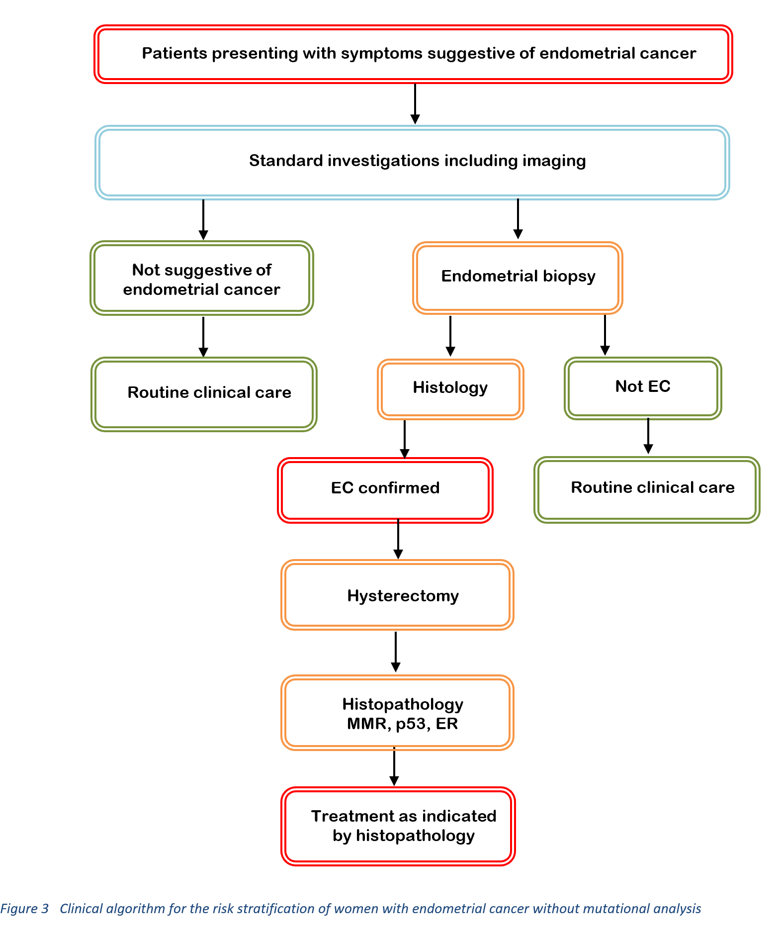

**Is there any expectation that the clinical management algorithm *before* the health technology is used will change due to the introduction of the proposed health technology?**

No

**Describe and explain any differences in the clinical management algorithm prior to the use of the proposed health technology vs. the comparator health technology:**

There is no difference in the clinical management of patients prior to testing with the proposed intervention as there is no comparator (the comparator is no genetic testing).

**Use of the health technology**

**Explain what other healthcare resources are used in conjunction with delivering the proposed health technology:**

Nil – the intervention is a genetic test. No other resources are required other than the test itself.

**Explain what other healthcare resources are used in conjunction with the comparator health technology:**

Nil – there is no comparator.

**Describe and explain any differences in the healthcare resources used in conjunction with the proposed health technology vs. the comparator health technology:**

No healthcare resources are used in conjunction with the proposed health technology vs. the comparator health technology.

**Clinical management after the use of health technology**

**Define and summarise the clinical management algorithm, including any required tests or healthcare resources, *after* the use of the proposed health technology:**

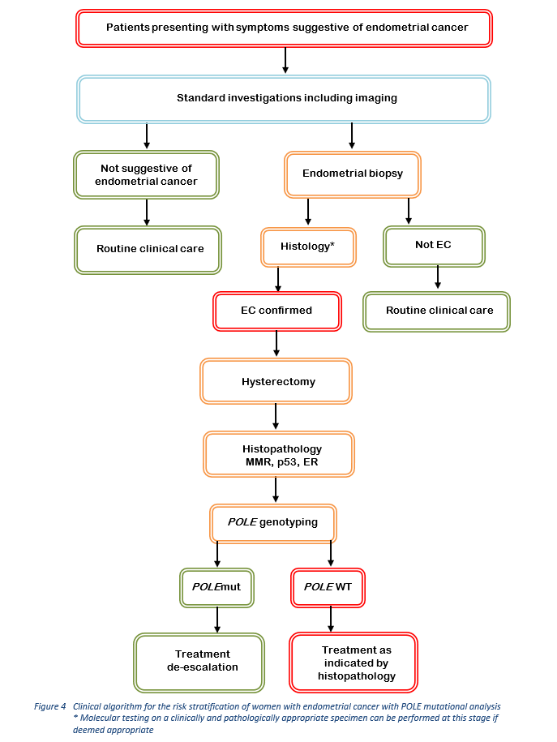

**Define and summarise the clinical management algorithm, including any required tests or healthcare resources, *after* the use of the comparator health technology:**

The comparator technology is no genetic testing.

**Describe and explain any differences in the healthcare resources used *after* the proposed health technology vs. the comparator health technology:**

As described in Figure 4, all women with a diagnosis of EC should undergo MMR, p53 and ER immunohistochemistry as well as *POLE* genotyping. According to international guidelines, treatment post-surgery depends on the risk as determined by molecular testing.

In women with *POLE*-mutated endometrial carcinoma, post-surgical treatment can be de-escalated. In those who do not have a *POLE*-mutated tumour, treatment may include adjuvant brachytherapy, chemotherapy, or external beam radiation therapy or a combination of those treatments.

**Algorithms**

**Insert diagrams demonstrating the clinical management algorithm with and without the proposed health technology:**

# **Claims**

**In terms of health outcomes (comparative benefits and harms), is the proposed technology claimed to be superior, non-inferior or inferior to the comparator(s)?** (please select your response)

Superior

Non-inferior

Inferior

**Please state what the overall claim is, and provide a rationale:**

Given that there is no current MBS item number that covers this testing, this testing is either currently being performed at cost to the referring pathology provider/patient or not being performed. Public funding of these genetic tests would align Australian clinical practice with the established clinical practice guidelines and diagnostic standard of care as stipulated by the revision of the WHO classification of female genital tumours. Access to genetic testing will allow more patients to have a more accurate assessment of the risk of recurrence and the need for adjuvant therapy, resulting in better patient management and improved outcomes.

At its August 2019 meeting, MSAC supported genetic tumour testing applications 1526, 1527 and 1528. The PSDs for these applications note that by virtue of their place in the WHO guidelines, the proposed genetic tests have documented clinical utility in these diseases. MSAC confirmed that it accepts the entry of each test into the WHO guidelines as a sufficient demonstration of its diagnostic performance, clinical validity (prognostic value), and clinical utility (resulting in changes to subsequent clinical management); therefore, the precedent has been established for MSAC accepting such claims based on WHO guidelines.

Recommendations of adjuvant therapy (chemotherapy or radiation therapy) are based on the individual patient's risk of disease recurrence using clinicopathologic factors such as age, stage, grade, lymphovascular invasion, and the presence of molecular variants in, amongst others, the *POLE* gene (21). By implementing *POLE* testing in routine diagnostics and omitting adjuvant therapy in EC patients with low-intermediate risk features, overtreatment of a substantial group of patients would be avoided, with a clear impact on the patient's quality of life (19).

**Why would the requestor seek to use the proposed investigative technology rather than the comparator(s)?**

There is no comparator. Without testing, patients will likely undergo unnecessary adjuvant chemotherapy, with its potential for harms and AEs.

**Identify how the proposed technology achieves the intended patient outcomes:**

By implementing POLE testing in routine diagnostics and omitting adjuvant therapy in EC patients with low-intermediate risk features, overtreatment of a substantial group of patients would be avoided, with a clear impact on the patient's quality of life (19).

**For some people, compared with the comparator(s), does the test information result in:** (please highlight your response)

**A change in clinical management?** Yes No

**A change in health outcome?** Yes No

**Other benefits?** Yes No

**Please provide a rationale, and information on other benefits if relevant:**

**In terms of the immediate costs of the proposed technology (and immediate cost consequences, such as procedural costs, testing costs etc.), is the proposed technology claimed to be more costly, the same cost or less costly than the comparator?** (please select your response)

More costly

Same cost

Less costly

As there is no comparator

# **Summary of Evidence**

**Provide one or more recent (published) high quality clinical studies that support use of the proposed health service/technology**

| Type of study design* | Title of journal article or research project | Short description of research (max 50 words)** | Website link to journal article or research |
| --- | --- | --- | --- |
| Guideline (4) | World Health Organization Classification of Female Genital Tumours | This series, known as the WHO Blue Books, is regarded as the gold standard for the diagnosis of tumours and comprises a synthesis of histopathological diagnosis with digital and molecular pathology, providing international standards for the care of patients with endometrial cancer. The 5th edition establishes a single coherent cancer classification, including histopathology, diagnostic molecular pathology, staging, and easy-to-read essential and desirable diagnostic criteria. | <https://publications.iarc.fr/Book-And-Report-Series/Who-Classification-Of-Tumours/Female-Genital-Tumours-2020> |
| Guideline (7) | ESGO/ESTRO/ESP Guidelines for the management of patients with endometrial carcinoma | Updated European Society of Gynaecological Oncology (ESGO), the European SocieTy for Radiotherapy & Oncology (ESTRO) and the European Society of Pathology (ESP) evidence-based guidelines. The guidelines are based on the best available evidence and expert consensus and reviewed by 191 independent international practitioners in cancer care delivery and patient representatives. The guidelines comprehensively cover endometrial carcinoma staging, definition of prognostic risk groups integrating molecular markers, pre- and intra-operative work-up, fertility preservation, management for early, advanced, metastatic, and recurrent disease and palliative treatment. | <https://pubmed.ncbi.nlm.nih.gov/33604759/> |
| Guideline, Germany (10) | Endometrial Cancer. Guideline of the DGGG, DKG and DKH. Part 1 with Recommendations on the Epidemiology, Screening, Diagnosis and Hereditary Factors of Endometrial Cancer, Geriatric Assessment and Supply Structures | Guideline review carried out at the request of German Cancer Aid as part of the Oncology Guidelines Program. Lead coordinators were the German Society for Gynecology and Obstetrics (DGGG), the Gynecology Oncology Working Group (AGO) of the German Cancer Society (DKG) and the German Cancer Aid (DKH).  Aim: The use of evidence-based risk-adapted therapies to treat women with endometrial cancer of low risk prevents unnecessarily radical surgery and avoids non-beneficial adjuvant radiation therapy and/or chemotherapy. A systematic search and assessment of the literature, with results used as a basis for developing recommendations and statements which were then modified during structured online consensus conferences and/or additionally amended online using the DELPHI process to achieve a consensus. | <https://pubmed.ncbi.nlm.nih.gov/37588260/> |
| Guideline (5) | Management of Patients Diagnosed with Endometrial Cancer: Comparison of Guidelines | Endometrial cancer is the most common gynaecological malignancy in Europe and its management involves a variety of health professionals. In recent years, big discoveries were made concerning the management of patients diagnosed with endometrial cancer, particularly in the field of molecular biology and minimally invasive surgery. This requires the continuous updating of guidelines and protocols over the years. In this paper, we aim to summarize and compare common points and disparities among protocols for management of patients diagnosed with endometrial cancer by leading international gynaecological oncological societies. We therefore systematically report the parallel among the guidelines based on the various steps patients with endometrial cancer usually undergo. The comparison between American and European protocols revealed some relevant disparities, in particular regarding surgical staging, molecular biology application as a prognostic tool and follow up regimens | <https://pubmed.ncbi.nlm.nih.gov/36831434/> |
| Guideline (11) | POLE testing in endometrial carcinoma | The British Association of Gynaecological Pathologists guideline. Molecular testing in endometrial carcinoma, including mutational analysis for POLE, is recommended by the World Health Organization wherever resources permit. POLE NGS is available for NHS patients via national genomics services within the UK. | <https://www.thebagp.org/wp-content/uploads/download-manager-files/BAGP-POLE-testing-in-Endometrial-cancer-v1.2-July-2022.pdf> |
| Guideline (3) | FIGO staging of endometrial cancer: 2023 | The updated 2023 staging of endometrial cancer includes the various histological types, tumour patterns, and molecular classification to better reflect the improved understanding of the complex nature of the several types of endometrial carcinoma and their underlying biologic behaviour. The changes incorporated in the 2023 staging system should provide a more evidence-based context for treatment recommendations and for the more refined future collection of outcome and survival data. | <https://pubmed.ncbi.nlm.nih.gov/37337978/> |
| Guideline, Poland (12) | The Polish Society of Gynecological Oncology Guidelines for the Diagnosis and Treatment of Endometrial Carcinoma | Based on current evidence, both the implementation of the molecular classification of endometrial cancer patients at the beginning of the treatment sequence and the extension of the final postoperative pathological report of additional biomarkers are needed to optimize and improve treatment results as well as to pave the route for future clinical trials on targeted therapies. | <https://pubmed.ncbi.nlm.nih.gov/36836017/> |
| Cost-effectiveness  USA (13) | Cost-effectiveness analysis of tumor molecular classification in high-risk early-stage endometrial cancer | Molecular analyses in EC includes 4 distinct subtypes: (1) POLE-mutated, (2) mismatch repair protein (MMR) deficient, (3) p53 mutant, and (4) no specific molecular profile. A Markov decision model was developed to compare tumour molecular classification (TMC) vs. no testing (NT). A healthcare payor's perspective and 5-year time horizon were used. Base case data were abstracted from PORTEC-3 and the molecular sub-analysis. When compared to NT, TMC was cost effective with an ICER of $25,578 per QALY gained; incremental cost was $1780 and incremental effectiveness was 0.070 QALYs. In one-way sensitivity analyses, results were most sensitive to the cost of POLE testing, but TMC remained cost-effective over all parameter ranges. | <https://pubmed.ncbi.nlm.nih.gov/34740462/> |
| RCT  The Netherlands (14) | Molecular Classification Predicts Response to Radiotherapy in the Randomized PORTEC-1 and PORTEC-2 Trials for Early-Stage Endometrioid Endometrial Cancer | 880 molecularly classified ECs (484 from PORTEC-1, 396 from PORTEC-2). Median follow-up was 11.3 years. No locoregional recurrences were observed in EC with POLEmut regardless of adjuvant radiotherapy. Omitting radiotherapy seems to be safe in POLEmut EC. | <https://pubmed.ncbi.nlm.nih.gov/37487144/> |
| Meta-analysis  Multi-centre (15) | Evaluation of treatment effects in patients with endometrial cancer and POLE mutations: an individual patient data meta-analysis. | Meta-Analysis of articles that provided individual patient data, adjuvant treatment, and survival. 359 women with POLE-mutated EC were identified; 294 (82%) had pathogenic mutations. Worse outcomes were demonstrated in patients with non-pathogenic POLE mutations (hazard ratio, 3.42, log-rank P < .01). Except for stage (P < .01), traditional prognosticators were not associated with progression/recurrence or death from disease. Adverse events were rare (11 progressions/recurrences and 3 disease-specific deaths). Salvage rates in patients who experienced recurrence were high and sustained, with 8 of 11 alive without evidence of disease (range, 5.5-14.2 years). Adjuvant treatment was not associated with outcome. Clinical outcomes for ECs with pathogenic POLE mutations are not associated with most traditional risk parameters, and patients do not appear to benefit from adjuvant therapy. | <https://pubmed.ncbi.nlm.nih.gov/33793971/> |
| Prognosis  Meta-analysis  China (16) | The clinicopathological characteristics of POLE‑mutated/ultramutated endometrial carcinoma and prognostic value of POLE status: a meta‑analysis based on 49 articles incorporating 12,120 patients | 12,120 EC patients from 49 studies were included. The pooled frequency of POLEmut was 7.95% in EC and 4.45% in non endometrioid endometrial carcinoma. A higher expression occurred in grade 3 (OR = 0.51, P = 0.0002), FIGO stage I-II (OR = 1.91, P = 0.0013), and myometrial invasion< 50% (OR = 0.66, P = 0.0025). Survival analyses revealed favourable OS (HR = 0.68, P = 0.0008), PFS (HR = 0.74, P = 0.0085), DSS (HR = 0.61, P = 0.0016), and RFS (HR = 0.47, P < 0.0001) for POLEmut ECs. Additionally, the clinical outcomes of POLEmut group were the best, but those of p53-abnormal/mutated (p53abn) group were the worst, while those of microsatellite-instable (MSI)/hypermutated group and p53-wild-type (p53wt) group were medium. | <https://pubmed.ncbi.nlm.nih.gov/36357827/> |
| Prognosis  Systematic review and meta-analysis  (17) | The clinicopathology and survival characteristics of patients with POLE proofreading mutations in endometrial carcinoma: A systematic review and meta-analysis | The meta-analysis included 11 cohort studies comprising 5,508 EC patients (442 POLE EDM tumours). Patients with POLE mutant EC were associated with improved disease specific survival (HR = 0.408) and progression-free survival (HR = 0.231). POLE-mutated tumours were mostly endometrioid histology (84.480%), although not significantly more than wild type tumours (OR = 1.386; p = 0.073). The POLE mutant tumours significantly present (p<0.001) at FIGO lower stages I-II (OR = 2.955, p<0.001) and highest grade III (OR = 1.717, P = 0.003). POLE mutations significantly protected against lymph node metastases (OR = 0.202, p = 0.001), and have no clear association with lymph-vascular space invasion (OR = 0.967, 95% 0.713-1.310, p = 0.826). The tumours are predominantly of low ESMO risk stratification distribution (40.356%). POLE mutations serve as an important biomarker of favourable prognosis in EC. The tumours are characteristically high grade, early stage, and remain localized in the endometrium with reduced likelihood of lymph node metastasis for improved survival prospects and the lowest risk classification. | <https://pubmed.ncbi.nlm.nih.gov/35139130/> |
| Prognosis  Systematic review  (18) | Clinicopathological characteristics and prognostic value of POLE mutations in endometrial cancer: A systematic review and meta-analysis | Six cohort studies assessing 179 EC patients with POLE EDMs were included. The results indicated a favourable progression-free survival in POLE-mutant patients (HR = 0.32). Overall survival was greatest in patients with POLE-mutant (HR = 0.68). A significantly higher incidence of POLE mutations with FIGO I group compared to FIGO II-IV group (pooled ORs: 0.34, P = .04). This meta-analysis confirms POLE EDMs may serve as a predictive biomarker of favourable prognosis but further studies are needed to explore the clinical utility of POLE EDMs in EC. | <https://pubmed.ncbi.nlm.nih.gov/32080141/> |
| Prognosis  RCT  Multicentre (19) | Molecular Classification of the PORTEC-3 Trial for High-Risk Endometrial Cancer: Impact on Prognosis and Benefit From Adjuvant Therapy | Randomized Adjuvant Chemoradiotherapy Versus Radiotherapy Alone in Women With High-Risk Endometrial Cancer (PORTEC-3) trial investigated the benefit of combined adjuvant chemotherapy and radiotherapy (CTRT) versus radiotherapy alone (RT) for 423 women with high-risk EC. Molecular analysis was successful in 410 high-risk EC (97%), identifying the 4 subgroups: p53abn EC (n = 93; 23%), POLEmut (n = 51; 12%), MMRd (n = 137; 33%), and NSMP (n = 129; 32%). Patients with POLEmut EC had an excellent RFS in both trial arms with 5-year RFS of 98% for POLEmut EC and the 5-year RFS with CTRT versus RT for patients with POLEmut EC was 100% versus 97% (p = .637). | <https://pubmed.ncbi.nlm.nih.gov/32749941/> |
| Prognosis  Retrospective cohort  Denmark, The Netherlands (20) | Prognostic relevance of the molecular classification in high-grade endometrial cancer for patients staged by lymphadenectomy and without adjuvant treatment | DNA-sequencing of pathogenic POLE-exonuclease domain mutations in 412 high-grade EC from the Danish Gynaecological Cancer Database (2005-2012). Molecular analysis was successful in 367 EC; 251 patients had undergone lymphadenectomy. Five-year recurrence rates in this subgroup of patients was 0.0% for POLEmut EC.  Among patients without adjuvant treatment (n = 264), none with POLEmut EC (n = 26) had a recurrence. The indolent behaviour of POLEmut EC is independent of adjuvant treatment. | <https://pubmed.ncbi.nlm.nih.gov/35078648/> |
| Prognosis  Cohort: long-term follow-up of 2 RCTs (PORTEC-1 and -2)  The Netherlands (21) | Improved Risk Assessment by Integrating Molecular and Clinicopathological Factors in Early stage Endometrial Cancer-Combined Analysis of the PORTEC Cohorts | Comprehensive genomic characterisation defined four subgroups: p53-mutant, microsatellite instability (MSI), POLE-mutant, and no specific molecular profile (NSMP). Analysis was undertaken on 947 available early-stage EC from the PORTEC-1 and -2 trials, mostly high-intermediate risk (n = 614). 834 samples were successfully analysed: p53-mutant (9%), MSI (26%), POLE-mutant (6%), and NSMP (59%). Integration of prognostic molecular alterations with established clinicopathologic factors resulted in a stronger model with improved risk prognostication. Approximately 15% of high-intermediate risk patients had unfavourable features, 50% favourable features (POLE-mutant, NSMP being microsatellite stable, and CTNNB1 wild-type), and 35% intermediate features (MSI or CTNNB1-mutant). Integrating clinicopathologic and molecular factors improves the risk assessment of patients with early-stage EC. | <https://pubmed.ncbi.nlm.nih.gov/27006490/> |
| Prognosis  Observational follow-up of PORTEC RCT  The United Kingdom and The Netherlands (22) | Adjuvant treatment for POLE proofreading domain-mutant cancers: Sensitivity to radiotherapy, chemotherapy, and nucleoside analogues | Recurrence-free survival of women with POLE-mutant and POLE–wild-type EC in the observation arm of the randomised PORTEC-1 EC trial (N = 245 patients with stage I EC for analysis). Women with POLE-mutant endometrial cancers (N = 16) had an improved recurrence-free survival (10-year recurrence-free survival 100% vs. 80.1% for POLE–wild-type; HR = 0.143; 95% CI [0.001–0.996], p = 0.049). These results support exploring minimization of adjuvant therapy for early-stage POLE-mutant cancers. | <https://pubmed.ncbi.nlm.nih.gov/29559562/> |
| Prognosis  Cohort  Thailand (23) | Molecular-based classification of endometrial carcinoma in Northern Thailand: impact on prognosis and potential for implementation in resource-limited settings. | 138 EC patients with hysterectomy specimens classified using immunohistochemistry for MMR proteins and p53, as well as POLE mutation testing. 52.9% in the NSMP subgroup, 28.2% were in the MMR-d, 13.8% in the p53-abn, and 5.1% in the POLE-mut. Patients with POLE-mut had the most favourable survival outcomes. When estimating the costs for post-operative management, the use of molecular classification resulted in a 10% increase over the conventional approach. However, the cost increased only by 1% if only *POLE* testing was used to identify patients for treatment omission. | <https://pubmed.ncbi.nlm.nih.gov/37964201/> |
| Prognosis  Cohort  Japan (24) | Clinical impact of endometrial cancer stratified by genetic mutational profiles, POLE mutation, and microsatellite instability | 138 EC patients underwent surgical resection with curative intent. Sanger sequencing was used to evaluate POLE mutations, which were found in 8.7% EC patients and were significantly associated with progression-free survival (P = 0.0129). | <https://pubmed.ncbi.nlm.nih.gov/29659608/> |
| Prognosis  Retrospective cohort  Canada (25) | Endometrial carcinomas with POLE exonuclease domain mutations have a favorable prognosis | 496 EC patients underwent targeted sequencing of the POLE exonuclease domain (406 evaluable tumours). Combined results from 8 studies in a meta-analysis. POLE EDMs were identified in 39 of 406 (9.6%) ECs. In univariable analysis, POLE-mutated EC had significantly improved outcomes compared with patients with no EDMs for progression-free survival, disease-specific survival and overall survival. The effect of adjuvant treatment on POLE-mutated cases could not be determined conclusively; however, both treated and untreated patients with POLE EDMs had good outcomes. Meta-analysis revealed an association between POLE EDMs and improved PFS and DSS with pooled HRs 0.34 and 0.35, respectively. | <https://pubmed.ncbi.nlm.nih.gov/26763250/> |

# **Identify yet-to-be-published research that may have results available in the near future (that could be relevant to your application)**

|  | Type of study design* | Title of research (including any trial identifier if relevant) | Short description of research (max 50 words)** | Website link to research (if available) | Date*** |
| --- | --- | --- | --- | --- | --- |
| 1. | RCT  The Netherlands (26) | PORTEC-4a: Randomised trial of standard or molecular profile-based recommendation for radiotherapy after surgery for women with early stage endometrial cancer | In the PORTEC-4a trial, the standard vaginal brachytherapy (standard treatment) will be compared to the use of the individual risk profile to determine adjuvant treatment (favourable: observation; intermediate: vaginal brachytherapy; unfavourable: external beam radiotherapy). The aim is to evaluate if the use of the individual risk profile saves many women unnecessary vaginal brachytherapy with similarly high recurrence-free survival and local control, and reduced health costs. | [ISRCTN11659025](https://www.isrctn.com/ISRCTN11659025) | Estimated date for first results expected in 2023 |
| 2. | Randomised trial, parallel assignment  Multicentre | Refining Adjuvant Treatment IN Endometrial Cancer Based On Molecular Features (RAINBO) | 1,615 women with histologically confirmed endometrial carcinoma assigned to one of four RAINBO trials based on the molecular profile of their cancer:   * p53 abnormal endometrial cancer patients to the p53abn-RED trial * mismatch repair deficient endometrial cancer patients to the MMRd-GREEN trial * no specific molecular profile endometrial cancer patients to NSMP-ORANGE trial * POLE mutant endometrial cancer patients to the POLEmut-BLUE trial   Comparing survival in no adjuvant vs adjuvant therapy | [NCT05255653](https://clinicaltrials.gov/study/NCT05255653?cond=Endometrial%20Cancer&term=POLE&intr=adjuvant%20therapy&rank=3) | Estimated Completion  01-01-2031 |
| 3. | Prospective, randomised trial  Multicentre  China | PROfiling Based Endometrial Cancer Adjuvant Therapy (PROBEAT) | 590 women with histologically confirmed endometrial carcinoma assigned to observation for POLE-mutated profile; vaginal brachytherapy for intermediate profile; chemo-radiotherapy for p53-abnormal profile, compared to radiotherapy | [NCT05179447](https://clinicaltrials.gov/study/NCT05179447?cond=Endometrial%20Cancer&term=POLE&intr=adjuvant%20therapy&rank=4) | Estimated Completion  01-01-2027 |
| 4. | Case series  British Columbia, Canada | Tailored Adjuvant Therapy in POLE-mutated and p53-wildtype Early Stage Endometrial Cancer | 42 women with histologically confirmed endometrial carcinoma with POLE-mutated or p53 wild type/NSMP early stage endometrial cancer who undergo surgery (hysterectomy, BSO, +/-LND)have a low risk (<5%) risk of pelvic (including vaginal) recurrence at 3 years with no or de-escalated adjuvant treatment. | [NCT04705649](https://clinicaltrials.gov/study/NCT04705649?cond=Endometrial%20Cancer&term=POLE&intr=adjuvant%20therapy&rank=2) | Estimated Completion  22-06-2023 |
| 5 | Non-Randomised, Parallel Assignment, Interventional  British Columbia, Canada  Netherlands | Adjuvant Therapy in POLE-Mutated and p53-Wildtype/NSMP Early Stage Endometrial Cancer RAINBO BLUE & TAPER | 325 women with histologically confirmed Stage I to III endometrial carcinoma (endometrioid, serous, clear cell, un/dedifferentiated, carcinosarcoma or mixed). This protocol tests de-escalated adjuvant treatment in patients with POLE-mutated or p53wt/NSMP (p53 wildtype/no specific molecular profile) early-stage endometrial cancer. Patients will be assigned to one of three treatment groups. (1) No adjuvant therapy (observation),(2) Radiation: Vaginal brachytherapy (3) Radiation: Adjuvant radiotherapy (EBRT +/- brachytherapy) | [NCT0564099930](https://clinicaltrials.gov/study/NCT05640999?cond=Endometrial%20Cancer&term=POLE&intr=adjuvant%20therapy&rank=1) | Estimated Completion  30-06-2029 |

# **References**

1. AIHW. Cancer in Australia 2021. Canberra: Australian Institute of Health and Welfare 2021.

2. AIHW. Cancer data in Australia Canberra: Australian Institute of Health and Welfare 2024 [Available from: <https://www.aihw.gov.au/reports/cancer/cancer-data-in-australia/contents/summary-dashboard>.

3. Berek JS, Matias-Guiu X, Creutzberg C, Fotopoulou C, Gaffney D, Kehoe S, et al. FIGO staging of endometrial cancer: 2023. J Gynecol Oncol. 2023;34(5):e85.

4. WHO. Female genital tumours Lyon, France: World Health Organization and International Agency for Research on Cancer; 2020 [cited 2024. Available from: <https://publications.iarc.fr/Book-And-Report-Series/Who-Classification-Of-Tumours/Female-Genital-Tumours-2020>.

5. Restaino S, Paglietti C, Arcieri M, Biasioli A, Della Martina M, Mariuzzi L, et al. Management of Patients Diagnosed with Endometrial Cancer: Comparison of Guidelines. Cancers (Basel). 2023;15(4).

6. Cuccu I, D'Oria O, Sgamba L, De Angelis E, Golia D'Augè T, Turetta C, et al. Role of Genomic and Molecular Biology in the Modulation of the Treatment of Endometrial Cancer: Narrative Review and Perspectives. Healthcare (Basel). 2023;11(4).

7. Concin N, Creutzberg CL, Vergote I, Cibula D, Mirza MR, Marnitz S, et al. ESGO/ESTRO/ESP Guidelines for the management of patients with endometrial carcinoma. Virchows Arch. 2021;478(2):153-90.

8. Arciuolo D, Travaglino A, Raffone A, Raimondo D, Santoro A, Russo D, et al. TCGA Molecular Prognostic Groups of Endometrial Carcinoma: Current Knowledge and Future Perspectives. Int J Mol Sci. 2022;23(19).

9. Bosse T, Nout RA, McAlpine JN, McConechy MK, Britton H, Hussein YR, et al. Molecular Classification of Grade 3 Endometrioid Endometrial Cancers Identifies Distinct Prognostic Subgroups. Am J Surg Pathol. 2018;42(5):561-8.

10. Emons G, Steiner E, Vordermark D, Uleer C, Paradies K, Tempfer C, et al. Endometrial Cancer. Guideline of the DGGG, DKG and DKH (S3-Level, AWMF Registry Number 032/034-OL, September 2022). Part 1 with Recommendations on the Epidemiology, Screening, Diagnosis and Hereditary Factors of Endometrial Cancer, Geriatric Assessment and Supply Structures. Geburtshilfe Frauenheilkd. 2023;83(8):919-62.

11. Singh N, Jamieson A, Morrison J, Taylor A, Ganesan R. POLE testing in endometrial carcinoma. London, United Kingdom: British Association of Gynaecological Pathologists (BAGP); 2022.

12. Sznurkowski JJ, Rys J, Kowalik A, Zolciak-Siwinska A, Bodnar L, Chudecka-Glaz A, et al. The Polish Society of Gynecological Oncology Guidelines for the Diagnosis and Treatment of Endometrial Carcinoma (2023). J Clin Med. 2023;12(4).

13. Orellana TJ, Kim H, Beriwal S, Bhargava R, Berger J, Buckanovich RJ, et al. Cost-effectiveness analysis of tumor molecular classification in high-risk early-stage endometrial cancer. Gynecol Oncol. 2022;164(1):129-35.

14. Horeweg N, Nout RA, Jürgenliemk-Schulz IM, Lutgens L, Jobsen JJ, Haverkort MAD, et al. Molecular Classification Predicts Response to Radiotherapy in the Randomized PORTEC-1 and PORTEC-2 Trials for Early-Stage Endometrioid Endometrial Cancer. J Clin Oncol. 2023;41(27):4369-80.

15. McAlpine JN, Chiu DS, Nout RA, Church DN, Schmidt P, Lam S, et al. Evaluation of treatment effects in patients with endometrial cancer and POLE mutations: An individual patient data meta-analysis. Cancer. 2021;127(14):2409-22.

16. Wu Q, Zhang N, Xie X. The clinicopathological characteristics of POLE-mutated/ultramutated endometrial carcinoma and prognostic value of POLE status: a meta-analysis based on 49 articles incorporating 12,120 patients. BMC Cancer. 2022;22(1):1157.

17. Jumaah AS, Al-Haddad HS, McAllister KA, Yasseen AA. The clinicopathology and survival characteristics of patients with POLE proofreading mutations in endometrial carcinoma: A systematic review and meta-analysis. PLoS One. 2022;17(2):e0263585.

18. He Y, Wang T, Li N, Yang B, Hu Y. Clinicopathological characteristics and prognostic value of POLE mutations in endometrial cancer: A systematic review and meta-analysis. Medicine (Baltimore). 2020;99(8):e19281.

19. León-Castillo A, de Boer SM, Powell ME, Mileshkin LR, Mackay HJ, Leary A, et al. Molecular Classification of the PORTEC-3 Trial for High-Risk Endometrial Cancer: Impact on Prognosis and Benefit From Adjuvant Therapy. J Clin Oncol. 2020;38(29):3388-97.

20. Leon-Castillo A, Horeweg N, Peters EEM, Rutten T, Ter Haar N, Smit V, et al. Prognostic relevance of the molecular classification in high-grade endometrial cancer for patients staged by lymphadenectomy and without adjuvant treatment. Gynecol Oncol. 2022;164(3):577-86.

21. Stelloo E, Nout RA, Osse EM, Jürgenliemk-Schulz IJ, Jobsen JJ, Lutgens LC, et al. Improved Risk Assessment by Integrating Molecular and Clinicopathological Factors in Early-stage Endometrial Cancer-Combined Analysis of the PORTEC Cohorts. Clin Cancer Res. 2016;22(16):4215-24.

22. Van Gool IC, Rayner E, Osse EM, Nout RA, Creutzberg CL, Tomlinson IPM, et al. Adjuvant Treatment for POLE Proofreading Domain-Mutant Cancers: Sensitivity to Radiotherapy, Chemotherapy, and Nucleoside Analogues. Clin Cancer Res. 2018;24(13):3197-203.

23. Dankai W, Pongsuvareeyakul T, Phinyo P, Tejamai C, Teerapakpinyo C, Cheewakriangkrai C, et al. Molecular-based classification of endometrial carcinoma in Northern Thailand: impact on prognosis and potential for implementation in resource-limited settings. BMC Womens Health. 2023;23(1):605.

24. Haruma T, Nagasaka T, Nakamura K, Haraga J, Nyuya A, Nishida T, et al. Clinical impact of endometrial cancer stratified by genetic mutational profiles, POLE mutation, and microsatellite instability. PLoS One. 2018;13(4):e0195655.

25. McConechy MK, Talhouk A, Leung S, Chiu D, Yang W, Senz J, et al. Endometrial Carcinomas with POLE Exonuclease Domain Mutations Have a Favorable Prognosis. Clin Cancer Res. 2016;22(12):2865-73.

26. van den Heerik A, Horeweg N, Nout RA, Lutgens L, van der Steen-Banasik EM, Westerveld GH, et al. PORTEC-4a: international randomized trial of molecular profile-based adjuvant treatment for women with high-intermediate risk endometrial cancer. Int J Gynecol Cancer. 2020;30(12):2002-7.

27. ANZGOG. The Rise of Endometrial Cancer Sydney, NSW: Australia New Zealand Gynaecological Oncology Group 2024 [Available from: <https://www.anzgog.org.au/the-rise-of-endometrial-cancer/>.

28. Makker V, MacKay H, Ray-Coquard I, Levine DA, Westin SN, Aoki D, et al. Endometrial cancer. Nat Rev Dis Primers. 2021;7(1):88.

29. Yen TT, Wang TL, Fader AN, Shih IM, Gaillard S. Molecular Classification and Emerging Targeted Therapy in Endometrial Cancer. Int J Gynecol Pathol. 2020;39(1):26-35.

30. Bell DW, Ellenson LH. Molecular Genetics of Endometrial Carcinoma. Annu Rev Pathol. 2019;14:339-67.

31. Corr B, Cosgrove C, Spinosa D, Guntupalli S. Endometrial cancer: molecular classification and future treatments. BMJ Med. 2022;1(1):e000152.

32. Colombo N, Creutzberg C, Amant F, Bosse T, González-Martín A, Ledermann J, et al. ESMO-ESGO-ESTRO Consensus Conference on Endometrial Cancer: Diagnosis, Treatment and Follow-up. Int J Gynecol Cancer. 2016;26(1):2-30.

33. Santoro A, Angelico G, Travaglino A, Inzani F, Arciuolo D, Valente M, et al. New Pathological and Clinical Insights in Endometrial Cancer in View of the Updated ESGO/ESTRO/ESP Guidelines. Cancers (Basel). 2021;13(11).