**MSAC Application 1792**

**Immunohistochemistry testing for FGFR2b expression in patients with unresectable locally advanced or metastatic gastric or gastro-oesophageal cancer, to determine eligibility for PBS subsidised bemarituzumab treatment**

**PICO Set**

# Introduction

This application is for immunohistochemistry (IHC) testing for fibroblast growth factor receptor 2b (FGFR2b) expression in patients with unresectable locally advanced or metastatic gastric or gastro-oesophageal junction cancers (G/GOJC), for the purpose of establishing access to bemarituzumab under the Pharmaceutical Benefits Scheme (PBS).

# Population

## Describe the population in which the proposed health technology is intended to be used:

The population in which the proposed health technology, FGFR2b IHC testing, is intended to be used is in adults (≥ 18 years of age) with unresectable locally advanced or metastatic G/GOJ adenocarcinoma. Of those tested, only those positive for FGFR2b overexpression (FGFR2b+), determined via IHC, and human epidermal growth factor receptor 2 negative (HER2-), determined via IHC (MBS item 72848) or in situ hybridization (MBS item 73342) test, would be eligible for access to bemarituzumab under the PBS.

*Gastric and gastro-oesophageal junction cancer*

G/GOJC comprise cancers that arise from the epithelial lining of the stomach and gastro-oesophageal junction (between the stomach and the oesophagus). Gastric cancer represents the fifth most common cancer worldwide with over 1 million new cases globally each year (Bray 2018), with highest incidences (>20 per 100,000 in men) seen in China, Japan, Latin America, and Eastern Europe, and lowest incidences (<10 per 100,000 in men) seen in North America, parts of Africa and Northern Europe (Sung 2021). An estimated 2,576 patients were diagnosed with gastric cancer in Australia in 2023 comprising 1.6% of new cancer cases, and there were 1,153 gastric cancer deaths comprising 2.2% of all cancer deaths (Cancer Australia 2024).

*Diagnosis and staging*

Diagnosis of G/GOJC is confirmed through biopsies obtained during endoscopy, endoscopic mucosal resection (EnMR), endoscopic submucosal dissection (ESD) or gastrectomy.

Gastric cancers are staged according to the 8th edition of the American Joint Committee on Cancer and the International Union Against Cancer (AJCC/UICC) staging manual (Lordick 2022). AJCC/UICC 8th edition TNM staging and stage grouping for gastric cancers are presented in Table 1 and Table 2 respectively.

Table 1 Gastric cancer TNM staging AJCC/UICC 8th edition

|  |  |  |
| --- | --- | --- |
| **Category** | | **Criteria** |
| **T category** | TX | Primary tumour cannot be assessed |
| T0 | No evidence of primary tumour |
| Tis | High grade dysplasia, defined as malignant cells confined by the basement membrane |
| T1 | Tumour invades the lamina propria, muscularis mucosae, or submucosa |
| *T1a* | *Tumour invades the lamina propria or muscularis mucosae* |
| *T1b* | *Tumour invades the submucosa* |
| T2 | Tumour invades the muscularis propria |
| T3 | Tumour invades adventitia |
| T4 | Tumour invades adjacent structures |
| *T4a* | *Tumour invades pleura, pericardium, azygous vein, diaphragm or peritoneum* |
| *T4b* | *Tumour invades other adjacent structures such as the aorta, vertebral body or trachea* |
| **N category** | NX | Regional lymph nodes cannot be assessed |
| N0 | No regional lymph node metastasis |
| N1 | Metastases in 1-2 regional lymph nodes |
| N2 | Metastases in 3-6 regional lymph nodes |
| N3 | Metastases in ≥7 regional lymph nodes |
| **M category** | M0 | No distant metastasis |
| M1 | Distant metastasis |

Adapted from Diaz 2020.

Abbreviations: AJCC, American Joint Committee on Cancer; GO, gastro-oesophageal.

Table 2 Anatomic stage/prognostic groups for gastric cancer according to the AJCC/UICC 8th Edition

|  |  |  |  |
| --- | --- | --- | --- |
| **Stage grouping** | **T stage** | **N stage** | **M stage** |
| Stage 0 | Tis | N0 | M0 |
| Stage IA | T1 | N0 | M0 |
| Stage IB | T2  T1 | N0  N1 | M0 |
| Stage IIA | T3  T2  T1 | N0  N1  N2 | M0 |
| Stage IIB | T4a  T3  T2  T1 | N0  N1  N2  N3a | M0 |
| Stage IIIA | T4b  T4a  T3  T2 | N0  N1-2  N2  N3a | M0 |
| Stage IIIB | T4b  T3-4a  T1-2 | N1-2  N3a  N3b | M0 |
| Stage IIIC | T4b  T3-T4a | N3a-N3b  N3b | M0 |
| Stage IV | Any T | Any N | M1 |

Source: Lordick 2022, Supplementary Table S3.

Abbreviations: AJCC, American Joint Committee on Cancer; GO, gastro-oesophageal.

Early stage G/GOJC is often asymptomatic, and the most common presenting symptoms for advanced stage G/GOJC are non-specific weight loss, persistent abdominal pain, dysphagia, hematemesis, anorexia, nausea, early satiety, and dyspepsia (Mukkamalla 2023). The non-specific nature of G/GOJC symptoms can lead some patients to delay medical attention, and healthcare practitioners may also not initially consider gastric cancer as a potential diagnosis due to the vague nature of the symptoms, causing further delays in referrals to specialists.

Challenges in identifying patients often results in a later diagnosis, with an estimated 20% of patients presenting with resectable disease (Petrillo 2019), leaving 80% of patients to be diagnosed with locally advanced unresectable or metastatic disease.

*Prognosis*

Despite improvements over the last 20 years, the prognosis for patients diagnosed with gastric cancer remains poor, with five-year survival rates increasing from 21% in 1990-1994 to 38% in 2015-2019 (Cancer Australia 2024). Poor prognosis is primarily a result of diagnosis commonly occurring at more advanced stages. Whilst G/GOJC is curable if diagnosed at an early stage, survival decreases significantly for those with more advanced disease, with 5-year survival rates of 75%, 35% and 7% for localised, regional and distant disease respectively (AMS 2024).

*Management of unresectable locally advanced or metastatic G/GOJC*

ESMO (Lordick 2022) and NCCN (Ajani 2022) guidelines recommend a platinum-fluoropyrimidine doublet as standard first-line chemotherapy for unresectable locally advanced or metastatic G/GOJC. In HER2+ tumours the addition of trastuzumab to chemotherapy is recommended, based on the Phase III ToGA study which demonstrated higher response rates and longer OS (HR 0.74; 95% CI 0.60-0.91; p = 0.0046) with trastuzumab plus chemotherapy compared with chemotherapy alone. In HER2- tumours the addition of nivolumab to chemotherapy is recommended, based on the Phase III Checkmate 649 trial which demonstrated improved OS (HR 0.71; 98.4% CI 0.59-0.86; p < 0.0001) and PFS (HR 0.68; 98% CI 0.56-0.81; p < 0.0001) for nivolumab plus chemotherapy compared with chemotherapy alone in patients with a PD-L1 CPS≥5 (minimum follow-up 12.1 months). Australian practice is generally aligned to these guidelines, with trastuzumab available on the PBS to HER2+ patients and nivolumab available to HER2- patients. The only slight deviation from guidelines is that nivolumab is available on the PBS for all HER2- patients irrespective of CPS score.

Second and later line therapies in unresectable locally advanced metastatic G/GOJC are generally limited to chemotherapy. International guidelines consider several other immunotherapies in this setting, including ramucirumab, pembrolizumab and dostarlimab (Lordick 2022; Ajani 2022); however, none of these drugs are listed on the PBS for use in G/GOJC.

*FGFR2b expression*

FGFR2 is a receptor tyrosine kinase primarily expressed on epithelial cells and involved in numerous cellular functions (Ishiwata 2018). FGFR2b overexpression is an emerging protein biomarker in G/GOJC, and is also expressed in other cancerous tumours, including oesophageal, lung, breast, pancreatic, colorectal, and gynaecological cancers. Studies have indicated FGFR2b protein overexpression may be associated with poor prognosis and is an important therapeutic target in gastric cancers (Schrumpf 2022; Kim 2019). FGFR2b overexpression is present in approximately 20-30% of advanced G/GOJC patients (Wainberg 2024).

## Specify any characteristics of patients with, or suspected of having, the medical condition, who are proposed to be eligible for the proposed health technology, describing how a patient would be investigated, managed and referred within the Australian healthcare system in the lead up to being considered eligible for the technology:

The proposed population for FGFR2b testing is in adult (≥ 18 years of age) patients with unresectable locally advanced or metastatic G/GOJC.

The proposed population for bemarituzumab is in adult (≥ 18 years of age) patients with unresectable locally advanced or metastatic G/GOJC who are negative for HER2 (HER2-) and positive for FGFR2b overexpression (FGFR2b+). HER2 status is determined via IHC (MBS item 72848) or in situ hybridization (MBS item 73342) testing, with expression thresholds based on current testing standards. FGFR2b status is determined via IHC testing, with positivity proposed to be defined by an IHC staining score of 2+ or 3+ in ≥10% of cells, consistent with the expected pivotal evidence for bemarituzumab (FORTITUDE-101).

The management of patients in the lead up to FGFR2b testing will not be impacted as a consequence of funding the co-dependent technologies of FGFR2b testing and bemarituzumab, i.e., a diagnosis of G/GOJC will be confirmed via biopsy, with the biopsied tumour tissue subsequently used for assessing biomarkers, including HER2 and FGFR2b testing.

## Provide a rationale for the specifics of the eligible population:

The rationale for conducting FGFR2b testing in G/GOJC is for establishing access to bemarituzumab under the PBS.

The rationale for bemarituzumab use in patients with unresectable locally advanced or metastatic G/GOJC who are HER2- and FGFR2b+ is based on the mechanism of action of bemarituzumab, the results of the Phase 2 FIGHT trial, and the inclusion criteria of the Phase 3 FORTITUDE-101 trial.

Bemarituzumab is a monoclonal antibody with two demonstrated mechanisms of actions; blocking fibroblast growth factors (FGFs) from binding and activating the FGFR2b protein, and eliciting tumour cell apoptosis via enhanced anti-body dependent cell-mediated cytotoxicity (Xiang 2021).

The FIGHT trial was a randomised, double-blind, placebo-controlled Phase 2 trial, comparing outcomes for bemarituzumab plus mFOLFOX6 (oxaliplatin, leucovorin, and 5-fluorouracil) versus placebo plus mFOLFOX6 in patients with HER2- advanced G/GOJC. In this trial, subgroup analyses were conducted based on FGFR2b expression, including:

* Overexpression by IHC irrespective of ctDNA
* Amplification by ctDNA irrespective of IHC
* Both overexpressed by IHC and amplified by ctDNA
* Tumour IHC staining score of 2+ or 3+ in ≥10% of cells versus <10% of cells
* Tumour IHC staining score of 2+ or 3+ in ≥5% of cells versus <10% of cells

Progression-free survival (PFS) and overall survival (OS) by tumour IHC staining scores of 2+ or 3+ in ≥10% of cells versus <10% of cells are presented in Table 3 and illustrated via Kaplan-Meier curves in Figure 1 and Figure 2. These results demonstrate the addition of bemarituzumab to chemotherapy is effective in patients with FGFR2b expression in ≥10% of cells, but not effective in patients with FGFR2b expression in <10% of cells, relative to chemotherapy alone.

Table 3 Progression-free survival and overall survival by FGFR2b expression in Phase 2 FIGHT trial

|  |  |  |  |  |
| --- | --- | --- | --- | --- |
|  | **Tumour** **IHC Staining Score of 2+ or 3+ in ≥10% of Cells** | | **Tumour IHC Staining Score of 2+ or 3+ in <10% of Cells** | |
| **Bemarituzumab + mFOLFOX6** | **Placebo + mFOLFOX6** | **Bemarituzumab + mFOLFOX6** | **Placebo + mFOLFOX6** |
| N | 46 | 52 | 30 | 26 |
| **Progression-free survival** |  |  |  |  |
| Events | 24 (52.2%) | 41 (78.8%) | 24 (80.0%) | 20 (76.9%) |
| Median survival (95% CI) | 14.0 (7.2, 19.0) | 7.3 (5.4, 8.2) | 8.8 (5.6, 12.9) | 7.9 (5.7, 12.1) |
| Hazard ratio (95% CI) | 0.43 (0.26, 0.73) | | 1.03 (0.57, 1.89) | |
| **Overall survival** |  |  |  |  |
| Events | 28 (60.9%) | 36 (69.2%) | 24 (80.0%) | 18 (69.2%) |
| Median survival (95% CI) | 24.7 (14.2, 30.1) | 11.1 (8.4, 13.8) | 15.1 (8.8, 22.3) | 17.2 (8.9, 29.4) |
| Hazard ratio (95% CI) | 0.52 (0.31, 0.85) | | 1.40 (0.76, 2.60) | |

Source: FIGHT CSR (Table 14.2.1.9; Table 14.2.2.7).

Abbreviations: CI, confidence interval.

Based on the results of this trial, a Phase 3 trial for bemarituzumab was developed that only included patients with FGFR2b ≥10% 2+/3+ tumour cell staining, FORTITUDE-101 trial. FORTITUDE-101 is a randomised, double-blind, placebo-controlled Phase 3 Study of bemarituzumab plus chemotherapy (BEMA+CTX) versus placebo plus chemotherapy (PBO+CTX) in subjects with previously untreated advanced G/GOJC who are HER2- and FGFR2b+. This trial is currently active, not recruiting, with an expected primary completion date of 18 August 2025 (NCT05052801[1]). It is expected to be the pivotal trial informing the effectiveness and safety of bemarituzumab in the forthcoming co-dependent submission.

Whilst access to bemarituzumab would be limited to HER2- patients (in line with FORTITUDE-101 and FIGHT), FGFR2b testing is **proposed to be conducted in parallel to HER2 testing,** in all patients with unresectable locally advanced or metastatic G/GOJC, determined via IHC (MBS item 72848) or in situ hybridization (MBS item 73342) test. Upfront testing would provide clinicians sufficient biomarker information to determine the optimal treatment pathway for each patient. Limiting FGFR2b testing to HER2- patients would only reduce testing costs by approximately 13.9%, as an estimated 86.1% of G/GOJC patients are HER2- (Kumarasinghe 2017).

Figure 1 FIGHT trial: Progression-free survival (left) IHC 2+ or 3+ Cells Proportion ≥10% (right) IHC 2+ or 3+ Cells Proportion <10%

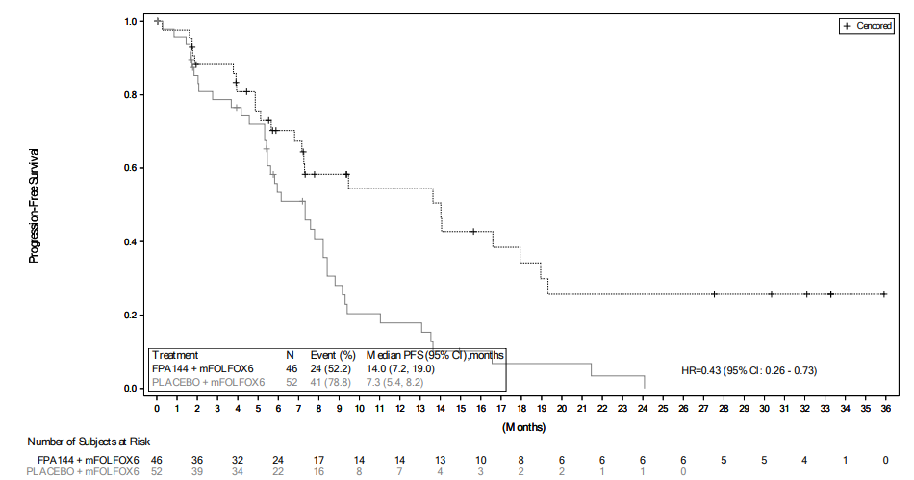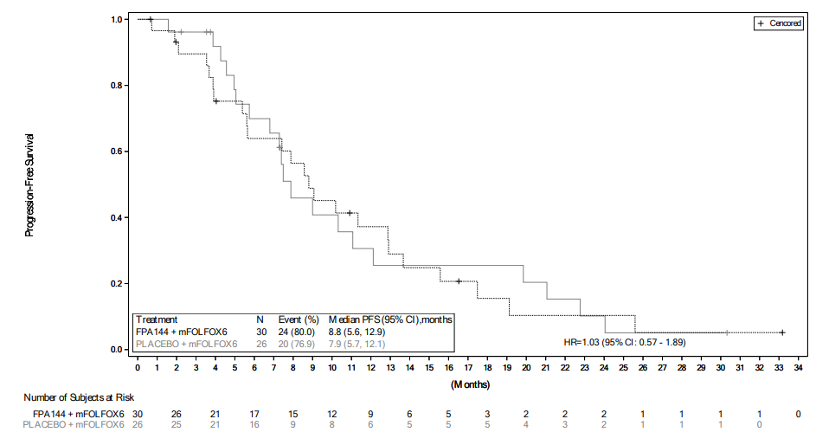

Abbreviations: CI, confidence interval; FPA144, bemarituzumab; HR, hazard ratio; PFS, progression-free survival.

Figure 2 FIGHT trial: Overall survival (left) IHC 2+ or 3+ Cells Proportion ≥10% (right) IHC 2+ or 3+ Cells Proportion <10%

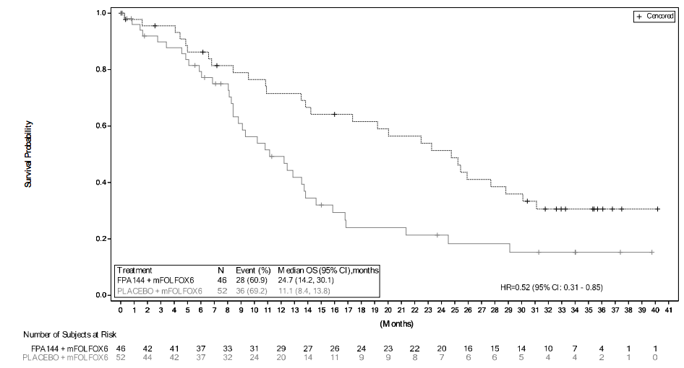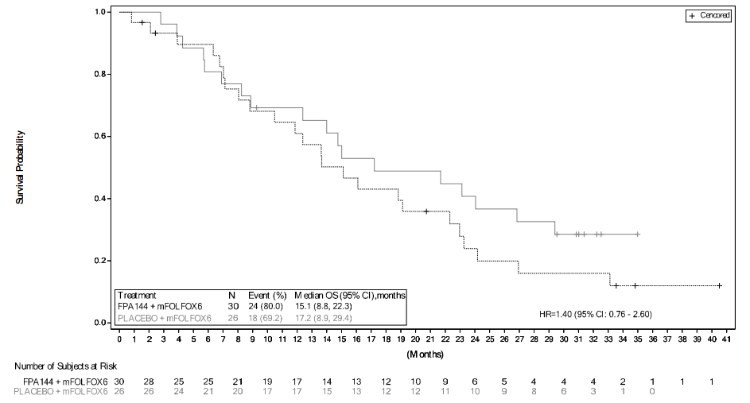

Abbreviations: CI, confidence interval; FPA144, bemarituzumab; HR, hazard ratio; OS, overall survival.

## Are there any prerequisite tests?

No.

It is proposed that FGFR2b testing be conducted in parallel with HER2 testing, therefore no prerequisite tests are required prior to FGFR2b testing.

## Are the prerequisite tests MBS funded?

N/A.

## Provide details to fund the prerequisite tests:

N/A

# Intervention

## Name of the proposed health technology:

*Test*: VENTANA FGFR2b (FPR2-D) RxDx Assay, developed and manufactured by Ventana Medical Systems, Inc. (Roche Tissue Diagnostics, 1910 E. Innovation Park Drive, Tucson, Arizona, 85755, USA).

*Treatment*: bemarituzumab, a humanized monoclonal antibody specific to the human FGFR2b receptor that blocks fibroblast growth factor (FGF) ligand binding to the receptor.

## Describe the key components and clinical steps involved in delivering the proposed health technology:

The VENTANA FGFR2b (FPR2-D) RxDx Assay is a diagnostic test that will be used to assess FGFR2b expression in patients with unresectable locally advanced or metastatic G/GOJC, to determine eligibility for treatment with PBS subsidised bemarituzumab.

The FGFR2b test involves taking a biopsy of the cancer tumour and performing an IHC assay to detect FGFR2b expression. The proposed threshold for a positive result for FGFR2b overexpression is an IHC staining score of 2+ (moderate to strong) or 3+ (strong) in ≥10% tumour cells. The testing would be done by a pathologist alongside other routine IHC or ISH tests (i.e., HER2), and it is proposed that the test is a pathologist determinable test.

Clinical utility standard

The key trials for bemarituzumab in G/GOJC (FIGHT and FORTITUDE-101) utilised the VENTANA FGFR2b (FPR2-D) RxDx Assay to assess FGFR2b expression. In the FIGHT trial, two thresholds for FGFR2b overexpression were considered; a tumour IHC staining score of 2+ or 3+ in ≥10% of cells, and a tumour IHC staining score of 2+ or 3+ in ≥5% of cells. Based on the results of the FIGHT trial, the FORTITUDE-101 trial included patients with FGFR2b overexpression based on a threshold of 2+ or 3+ staining in ≥10% of tumour cells. Therefore, the proposed diagnostic test for use in clinical practice is the same as the clinical utility standard.

## **Identify how the proposed technology achieves the intended patient outcomes**:

FGFR2b IHC testing will identify patients most likely to benefit from treatment with bemarituzumab (i.e., those positive for FGFR2b overexpression), ensuring appropriate treatment allocation and optimisation of patient outcomes in unresectable locally advanced or metastatic G/GOJC.

## Does the proposed health technology include a registered trademark component with characteristics that distinguishes it from other similar health components?

Yes

## Explain whether it is essential to have this trademark component or whether there would be other components that would be suitable:

The proposed health technology, VENTANA FGFR2b (FPR2-D) RxDx Assay is expected to be the only FGFR2b assay available in Australia. However, other in-house FGFR2b assays may be developed within laboratories in Australia. Any such in-house assays would need to meet the TGA’s regulatory requirements for in-house in vitro diagnostic medical devices (IVDs). Ideally, the MBS listing would be future proof to the availability of additional FGFR2b assays.

## Are there any proposed limitations on the provision of the proposed health technology delivered to the patient (For example: accessibility, dosage, quantity, duration or frequency):

Yes.

## Provide details and explain:

Accessibility

IHC staining is a common practice and can be conducted in any pathology laboratory holding the appropriate accreditation. The VENTANA FGFR2b (FPR2-D) RxDx Assay is used with the Ventana BenchMark system. Most Australian laboratories already have this platform; therefore the health system will be able to provide this technology without additional infrastructure. Therefore, accessibility should not limit the provision of FGFR2b testing.

Frequency

FGFR2b testing is proposed as a once per patient per lifetime service. This test is to be performed at diagnosis of unresectable locally advanced or metastatic G/GOJC. There are no other established roles for FGFR2b testing in managing or monitoring patients with G/GOJC.

Sample consideration

IHC testing does not require a large volume of tissue, therefore tissue availability shouldn’t limit access to FGFR2b testing.

## If applicable, advise which health professionals will be needed to provide the proposed health technology:

A certified pathologist would be responsible for conducting FGFR2b testing and reporting of results. It is proposed that FGFR2b testing be eligible to be carried out in any pathology laboratory holding the appropriate accreditation to claim pathology services through the MBS.

## If applicable, advise whether delivery of the proposed health technology can be delegated to another health professional:

It is not anticipated that any other professional, other than a certified pathologist would be able to conduct IHC testing for FGFR2b expression.

## If applicable, advise if there are any limitations on which health professionals might provide a referral for the proposed health technology:

The application recommends that ordering FGFR2b testing be restricted to gastroenterologists, gastric surgeons and oncologists, once a diagnosis of unresectable locally advanced or metastatic G/GOJC has been established.

## Is there specific training or qualifications required to provide or deliver the proposed service, and/or any accreditation requirements to support delivery of the health technology?

Yes

## Provide details and explain:

Consistent with introduction of diagnostic tests associated with access to other targeted therapies, pathologist training and quality assurance programs would be developed with respect to the delivery of diagnostic tests for access to treatments targeting the FGFR2b pathway on the PBS. This would address interpretation of the test results for FGFR2b positivity specific to the Ventana® FGFR2b assay.

Amgen is planning to facilitate peer-to-peer educational workshops for Australian pathologists, which will result in pathologists having greater experience in performing the test and applying the scoring methods.

## Indicate the proposed setting(s) in which the proposed health technology will be delivered:

Consulting rooms

Day surgery centre

Emergency Department

Inpatient private hospital

Inpatient public hospital

Laboratory

Outpatient clinic

Patient’s home

Point of care testing

Residential aged care facility

Other (please specify)

The test is run in a laboratory, but the biopsy sample can be taken, and bemarituzumab can be dispensed and administered, in multiple settings.

## Is the proposed health technology intended to be entirely rendered inside Australia?

Yes

## Provide additional details on the proposed health technology to be rendered outside of Australia:

N/A

# Comparator

## Nominate the appropriate comparator(s) for the proposed medical service (i.e., how is the proposed population currently managed in the absence of the proposed medical service being available in the Australian healthcare system). This includes identifying healthcare resources that are needed to be delivered at the same time as the comparator service:

*Test Comparator:*

No FGFR2b testing.

*Treatment Comparator*:

Nivolumab in combination with chemotherapy (e.g., FOLFOX; oxaliplatin + folinic acid + fluorouracil; or FOLFIRI; folinic acid, fluorouracil and irinotecan), or chemotherapy alone.

## List any existing MBS item numbers that are relevant for the nominated comparators:

As the proposed comparator is “no FGFR2b testing”, there are no eligible MBS items.

## Provide a rationale for why this is a comparator:

*Test Comparator*:

No FGFR2b testing reflects current standard practice, in which FGFR2b testing is not used in, or available to, patients with unresectable locally advanced or metastatic GC/GOJC.

*Treatment Comparator*:

The current standard of care for treatment naive patients with unresectable locally advanced or metastatic G/GOJC is nivolumab in combination with chemotherapy, FOLFOX or FOLFIRI as the currently listed treatment. Nivolumab was the first, and only, immunotherapy listed on the PBS for the treatment of patients with unresectable locally advanced or metastatic GC/GOJC; recommended by the PBAC in March 2022 and PBS listed in October 2022.

Nivolumab is also listed on PBS for the adjuvant treatment of stage II or III oesophageal cancer or gastro-oesophageal junction cancer. Patients receiving adjuvant nivolumab are not eligible for nivolumab in the unresectable locally advanced or metastatic setting. Therefore, chemotherapy alone remains the standard of care in patients with unresectable locally advanced or metastatic GC/GOJC who previously received adjuvant nivolumab.

## Pattern of substitution – Will the proposed health technology wholly replace the proposed comparator, partially replace the proposed comparator, displace the proposed comparator or be used in combination with the proposed comparator?

None (used with the comparator)

Displaced (comparator will likely be used following the proposed technology in some patients)

Partial (in some cases, the proposed technology will replace the use of the comparator, but not all)

Full (subjects who receive the proposed intervention will not receive the comparator)

‘None’ for the test, and ‘Full’ for the drug.

## Outline and explain the extent to which the current comparator is expected to be substituted:

The proposed medical service, FGFR2b testing, will determine eligibility for PBS funded treatment with bemarituzumab (in combination with chemotherapy) in patients with unresectable locally advanced or metastatic G/GOJC who are HER2- and FGFR2b+.

It is expected the addition of FGFR2b testing to current biomarker testing (i.e., HER2 testing) will be become standard practice, with the majority of (if not all) patients diagnosed with unresectable locally advanced or metastatic G/GOJC being tested.

It is expected that bemarituzumab plus chemotherapy (BEMA+CTX) will replace nivolumab plus chemotherapy (NIVO+CTX) in most FGFR2b+ patients. This is based on the proposed and current PBS restrictions for bemarituzumab and nivolumab respectively, and the anticipated clinical claims of superior effectiveness and different but non-inferior safety profiles for BEMA+CTX versus NIVO+CTX.

Both the current PBS restriction for nivolumab and the proposed restriction for bemarituzumab include a criteria limiting access to first-line drug treatment of advanced or metastatic G/GOJC. As a result, these drugs will not be eligible to be used sequentially, and any BEMA+CTX use will fully substitute existing NIVO+CTX use.

Clinical claims in a co-dependent (MSAC/PBAC) submission will be based on the indirect comparison of the active Phase 3 FORTITUDE-101 trial (BEMA+CTX vs PBO+CTX) and the Checkmate 649 trial (NIVO+CTX vs PBO+CTX). The expectation of superior effectiveness for BEMA+CTX versus NIVO+CTX is based on the naïve indirect comparison of outcomes from the FIGHT trial and the Checkmate 649 trial. As presented Table 4, a 57% reduction in PFS and 48% reduction in OS is observed for BEM+CTX vs CTX alone in the ‘Tumour IHC Staining Score of 2+ or 3+ in ≥10% of Cells’ subgroup of FIGHT, compared to 21% reduction in both PFS and OS for NIVO+CTX versus CTX alone in the ‘ITT’ cohort of Checkmate 649.

Table 4 Naïve indirect comparison of FIGHT (Tumor IHC Staining Score of 2+ or 3+ in ≥10% of Cells subgroup) and Checkmate 649 (ITT) trials

|  |  |  |  |  |
| --- | --- | --- | --- | --- |
|  | **FIGHT**  **(FGFR2b ≥10% a subgroup)** | | **Checkmate 649**  **(ITT)** | |
| **BEMA + mFOLFOX6** | **Placebo + mFOLFOX6** | **NIVO + Chemo** | **Chemo** |
| N | 46 | 52 | 789 | 792 |
| **Progression-free survival** |  |  |  |  |
| Events | 24 (52.2%) | 41 (78.8%) | NR | NR |
| Median survival (95% CI) | 14.0 (7.2, 19.0) | 7.3 (5.4, 8.2) | 7.7 (7.1, 8.6) | 6.9 (6.7, 7.2) |
| Hazard ratio (95% CI) | 0.43 (0.26, 0.73) | | 0.79 (0.71, 0.89) | |
| **Overall survival** |  |  |  |  |
| Events | 28 (60.9%) | 36 (69.2%) | NR | NR |
| Median survival (95% CI) | 24.7 (14.2, 30.1) | 11.1 (8.4, 13.8) | 13.7 (12.4, 14.5) | 11.6 (10.9, 12.5) |
| Hazard ratio (95% CI) | 0.52 (0.31, 0.85) | | 0.79 (0.71, 0.88) | |

Source: FIGHT CSR (Table 14.2.1.9; Table 14.2.2.7); Janjigian 2024.

Abbreviations: BEMA, bemarituzumab; CI, confidence interval; ITT, intention to treat; NIVO, nivolumab; NR, not reported.

a ‘Tumor IHC Staining Score of 2+ or 3+ in ≥10% of Cells’.

# Outcomes

## List the key health outcomes (major and minor – prioritising major key health outcomes first) that will need to be measured in assessing the clinical claim for the proposed medical service/technology (versus the comparator):

Health benefits

Health harms

Resources

Value of knowing

Test outcomes:

Sensitivity, specificity, positive predictive value (PPV), negative predictive value (NPV), test failure rate, test-retest reliability.

Treatment outcomes:

OS (primary outcome in FORTITUDE-101), PFS, ORR, DOR, DCR, PROs, safety.

Health care resources:

Cost of testing per patient (with associated re-biopsies), cost of treatment, cost of treating adverse events, financial implications (number of patients tested and treated).

## Outcome description – include information about whether a change in patient management, or prognosis, occurs as a result of the test information:

The test outcome of FGFR2b testing will impact the management of patients with unresectable locally advanced or metastatic G/GOJC, as FGFR2b expression is predictive of benefit with bemarituzumab. Under the proposed PBS listing, FGFR2b+ patients will be eligible for BEMA+CTX or NIVO+CTX, whereas FGFR2b-patients will continue to receive NIVO+CTX. Use of BEMA+CTX, as opposed to NIVO+CTX, in FGFR2b+ patients is expected to improve patient prognosis via improved survival outcomes (PFS and OS) and will impact health harms experienced by patients as a result of expected differences in their respective safety profiles.

# Proposed MBS items

## How is the technology/service funded at present? (e.g., research funding; State-based funding; self-funded by patients; no funding or payments):

FGFR2b testing is not currently funded in Australia.

## Provide at least one proposed item with their descriptor and associated costs, for each Population/Intervention:

|  |  |
| --- | --- |
| MBS item number  (where used as a template for the proposed item) | TBC |
| Category number | Category 6 |
| Category description | Pathology Services |
| Proposed item descriptor | Immunohistochemical examination of tumour tissue from a patient with locally advanced unresectable or metastatic gastric/gastro-oesophageal junction adenocarcinoma to determine eligibility relating to fibroblast growth factor receptor 2b (FGFR2b) expression for access to treatment with bemarituzumab under the Pharmaceutical Benefits Scheme (PBS). |
| Proposed MBS fee | $125 |
| Indicate the overall cost per patient of providing the proposed health technology | $125 |
| Please specify any anticipated out of pocket expenses | No gap |
| Provide any further details and explain | n/a |

# Algorithms

## PREPARATION FOR USING THE HEALTH TECHNOLOGY

## Define and summarise the clinical management algorithm, including any required tests or healthcare resources, before patients would be eligible for the proposed health technology:

The clinical management algorithm, including the proposed test, is displayed in Figure 4. The algorithm separates HER2- tumours into FGFR2b+ (≥10% of cells) and FGFR2b-, based on the results of the FGFR2b expression IHC test. To run the FGFR2b expression IHC test a biopsy of the cancer tumour is required. In the proposed setting, FGFR2b testing will be conducted parallel to HER2 testing, therefore a biopsy is the only healthcare resource use required prior to FGFR2b testing.

Is there any expectation that the clinical management algorithm before the health technology is used will change due to the introduction of the proposed health technology?

No

## Describe and explain any differences in the clinical management algorithm prior to the use of the proposed health technology vs. the comparator health technology:

Currently, patients receive HER2 testing and those determined to be HER2- become eligible for nivolumab (plus chemotherapy). The proposed co-dependent technologies (FGFR2b expression testing and bemarituzumab) would add FGFR2b testing to existing HER2 testing, with HER2- patients eligible for bemarituzumab (plus chemotherapy) if FGFR2b+, and eligible for nivolumab (plus chemotherapy) regardless of FGFR2b expression. HER2+ patients will continue to receive trastuzumab in line with current practice.

**USE OF THE HEALTH TECHNOLOGY**

## Explain what other healthcare resources are used in conjunction with delivering the proposed health technology:

Healthcare resources used in conjunction with FGFR2b IHC testing include tumour biopsy and HER2 testing. Tumour biopsies (MBS item30694) are initially used for confirming G/GOJC diagnoses and samples taken are subsequently used for biomarker testing. HER2 testing (MBS item 72848 and 72848), in combination with FGFR2b testing, will be used for treatment allocation in advanced or metastatic G/GOJC, with HER2+ patients eligible for trastuzumab, HER2-/FGFR2b- patients eligible for nivolumab, and HER2-/FGFR2b+ patients eligible for nivolumab or bemarituzumab. Note, both tumour biopsy and HER2 testing are a part of current standard practice for patients diagnosed with G/GOJC, and FGFR2b testing will not impact the delivery of these services.

The primary healthcare resource used in conjunction with bemarituzumab is a medical service for the parenteral administration of antineoplastic agents (MBS item 13950), as bemarituzumab is administered via intravenous infusion

*Tumour biopsy*

|  |
| --- |
| **MBS item 30694** |
| **Group**  T8 - Surgical Operations  **Subgroup**  1 - General |
| Endoscopic ultrasound (endoscopy with ultrasound imaging), with or without biopsy, with fine needle aspiration, for the diagnosis of 1 or more of pancreatic, biliary or gastric submucosal tumours, not in association with another item in this Subgroup (other than item 30484, 30485, 30491 or 30494) and other than a service associated with the routine monitoring of chronic pancreatitis. |

*HER2 testing*

|  |
| --- |
| **MBS item 72848** |
| **Group**  T5 - Tissue Pathology |
| Immunohistochemical examination of biopsy material by immunofluorescence, immunoperoxidase or other labelled antibody techniques with multiple antigenic specificities per specimen - 1 to 3 of the following antibodies - oestrogen, progesterone and c-erb-B2 (HER2). |
| **MBS item 73342** |
| **Group**  T7 - Genetics |
| An in situ hybridisation (ISH) test of tumour tissue from a patient with metastatic adenocarcinoma of the stomach or gastro-oesophageal junction, with documented evidence of human epidermal growth factor receptor 2 (HER2) overexpression by immunohistochemical (IHC) examination giving a staining intensity score of 2+ or 3+ on the same tumour tissue sample, requested by, or on the advice of, a specialist or consultant physician who manages the treatment of the patient to determine if the requirements relating to HER2 gene amplification for access to trastuzumab under the Pharmaceutical Benefits Scheme are fulfilled. |

*Intravenous infusions of bemarituzumab*

|  |
| --- |
| **MBS item 13950** |
| **Group**  T1 - Miscellaneous Therapeutic Procedures  **Subgroup**  11 - Chemotherapeutic Procedures |
| Parenteral administration of one or more antineoplastic agents, including agents used in cytotoxic chemotherapy or monoclonal antibody therapy but not agents used in anti-resorptive bone therapy or hormonal therapy, by or on behalf of a specialist or consultant physician—attendance for one or more episodes of administration |

## Explain what other healthcare resources are used in conjunction with the comparator health technology:

The same health care resources are used in conjunction with the test comparator (no FGFR2b testing), tumour biopsy and HER2 testing, and the treatment comparator (nivolumab), parenteral administration of antineoplastic agents, as with FBFR2b testing and bemarituzumab.

## Describe and explain any differences in the healthcare resources used in conjunction with the proposed health technology vs. the comparator health technology:

Utilisation of PBS subsidised bemarituzumab in conjunction with FGFR2b expression testing, as opposed to PBS subsidised nivolumab without FGFR2b expression testing. Both bemarituzumab and nivolumab are administered as 30-minute intravenous (IV) infusions, therefore the proposed co-dependent technologies are not expected to significantly impact resource use relating to the administration of IV infusions compared to current practice.

## CLINICAL MANAGEMENT AFTER THE USE OF HEALTH TECHNOLOGY

## Define and summarise the clinical management algorithm, including any required tests or healthcare resources, *after* the use of the proposed health technology:

Information from FGFR2b testing, in combination with information from HER2 testing, is intended to change treatment decisions; with patients identified as HER2- and FGFR2b+ to be eligible for bemarituzumab or nivolumab, those HER2- and FGFR2b- eligible for nivolumab, and those HER2+ (regardless of FGFR2b status) eligible for trastuzumab.

## Define and summarise the clinical management algorithm, including any required tests or healthcare resources, *after* the use of the comparator health technology:

In the absence of FGFR2b testing, HER2 testing alone is used for treatment allocation, with patients identified as HER2- eligible for nivolumab, and those HER2+ eligible for trastuzumab.

## Describe and explain any differences in the healthcare resources used *after* the proposed health technology vs. the comparator health technology:

The difference between the proposed health technologies and comparator health technologies is that with the addition of FGFR2b testing patients with unrespectable locally advanced or metastatic G/GOJC who are HER2- and FGFR2b+ will be eligible for bemarituzumab or nivolumab, as opposed to only nivolumab in current practice.

## Insert diagrams demonstrating the clinical management algorithm with and without the proposed health technology:

**Current algorithm (without FGFR2b testing and bemarituzumab):**

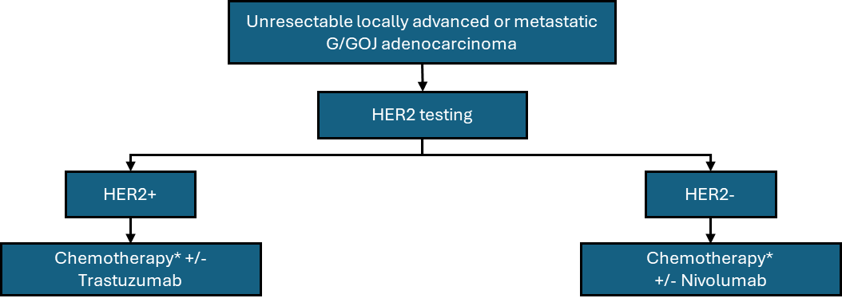

Figure 3 Current clinical management algorithm without FGFR2b testing

* Chemotherapy regimens containing at least a fluoropyrimidine drug and a platinum drug.

Abbreviations: G/GOJ, gastric or gastro-oesophageal; HER2, human epidermal growth factor receptor 2.

**Proposed algorithm (with FGFR2b testing and bemarituzumab):**

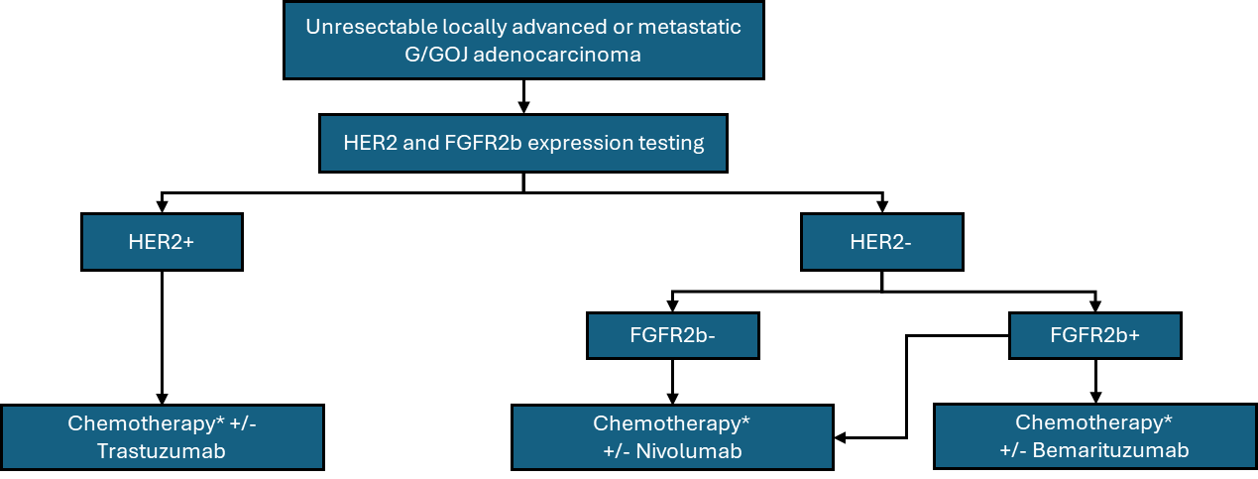

Figure 4 Proposed clinical management algorithm with FGFR2b expression testing

Note: the proposed definition of FGFR2b positivity for bemarituzumab is an IHC staining score of 2+ or 3+ in ≥10% of cells.

* Chemotherapy regimens containing at least a fluoropyrimidine drug and a platinum drug.

Abbreviations: FGFR2b, fibroblast growth factor receptor 2; G/GOJ, gastric or gastro-oesophageal; HER2, human epidermal growth factor receptor 2.

# Claims

## In terms of health outcomes (comparative benefits and harms), is the proposed technology claimed to be superior, non-inferior or inferior to the comparator(s)?

Superior

Non-inferior

Inferior

## Please state what the overall claim is, and provide a rationale:

FGFR2b testing alone will have no impact on health outcomes. However, in combination with bemarituzumab treatment in FGFR2b+ patients, these co-dependent technologies are expected to impact health outcomes in patients with HER2- unresectable locally advanced or metastatic G/GOJC.

In the forthcoming co-dependent (MSAC/PBAC) submission, clinical claims will be based on the indirect comparison of the active Phase 3 FORTITUTE-101 trial (BEMA+CTX vs PBO+CTX) and the Checkmate 649 trial (NIVO+CTX vs PBO+CTX). These clinicals claims are expected to be superior effectiveness and non-inferior safety for the co-dependent technologies of FGFR2b testing and treatment with bemarituzumab (plus chemotherapy) relative to no FGFR2b testing and treatment with nivolumab (plus chemotherapy).

The expectation of superior effectiveness for BEMA+CTX versus NIVO+CTX is based on the naïve indirect comparison of outcomes from the FIGHT trial and the Checkmate 649 trial, with a 57% reduction in PFS and 48% reduction in OS observed for BEM+CTX vs CTX alone in the ‘Tumour IHC Staining Score of 2+ or 3+ in ≥10% of Cells’ subgroup of FIGHT, compared to a 21% reduction in both PFS and OS for NIVO+CTX versus CTX alone in the ‘ITT’ cohort of Checkmate 649 (see Table 4 above).

## Why would the requestor seek to use the proposed investigative technology rather than the comparator(s)?

To access PBS subsidised bemarituzumab.

## Identify how the proposed technology achieves the intended patient outcomes:

Active testing will allow access to PBS listed bemarituzumab, which will improve clinical outcomes.

**For some people, compared with the comparator(s), does the test information result in:**

**A change in clinical management?** Yes

**A change in health outcome?** Yes

**Other benefits?**  No

## Please provide a rationale, and information on other benefits if relevant:

N/A

## In terms of the immediate costs of the proposed technology (and immediate cost consequences, such as procedural costs, testing costs etc.), is the proposed technology claimed to be more costly, the same cost or less costly than the comparator?

More costly

Same cost

Less costly

## Provide a brief rationale for the claim:

FGFR2b testing will be used in addition to standard practice (i.e., HER2 testing), and therefore will result in an additional cost to the MBS.

Bemarituzumab (plus chemotherapy) is expected to substitute nivolumab (plus chemotherapy) in FGFR2b+ patients. Assuming clinical claims of superior effectiveness and non-inferior safety, a cost-effectiveness analysis of BEM+CTX vs NIVO+CTX (to be conducted in the forthcoming co-dependent submission) would result in a higher cost per patient for bemarituzumab compared to nivolumab, resulting in an additional cost to the PBS.

# Summary of Evidence

## Provide one or more recent (published) high quality clinical studies that support use of the proposed health service/technology.

|  | **Type of study design** | **Title of journal article or research project** | **Short description of research** | **Website link to journal article or research** | **Date of publication** |
| --- | --- | --- | --- | --- | --- |
| 1 | Randomised, double-blind, phase 2 study. | FIGHT  (NCT03694522)  A Study of Bemarituzumab (FPA144) Combined With Modified FOLFOX6 (mFOLFOX6) in Gastric/Gastroesophageal Junction Cancer | The phase 2 FIGHT trial evaluated bemarituzumab combined with mFOLFOX6 in patients with FGFR2b-positive, HER-2 negative, advanced gastric or gastroesophageal junction adenocarcinoma. Out of 910 patients screened, 155 were randomised to receive bemarituzumab plus mFOLFOX6 (n=77) or placebo plus mFOLFOX6 (n=78). The primary endpoint was investigator-assessed PFS, and s endpoints included OS, ORR and safety. | <https://clinicaltrials.gov/study/NCT03694522>  <https://pubmed.ncbi.nlm.nih.gov/38308771/> | 28/02/2024  03/02/2024 |

Abbreviations: GC, Gastric Cancer; GEJ, gastric or gastroesophageal junction; HR; hazard ratio; ORR, objective response rate; OS, overall survival; PFS, progression free survival

Identify yet-to-be-published research that may have results available in the near future (that could be relevant to your application).

|  | **Type of study design** | **Title of journal article or research project** | **Short description of research** | **Website link to journal article or research** | **Date of publication** |
| --- | --- | --- | --- | --- | --- |
| 1. | Randomised, double-blind, phase 3 study. | FORTITUDE-101  (NCT05052801)  Bemarituzumab or Placebo Plus Chemotherapy in Gastric Cancers With Fibroblast Growth Factor Receptor 2b (FGFR2b) Overexpression | The FORTITUDE-101 study investigates treatment with bemarituzumab combined with oxaliplatin, leucovorin, and 5-fluorouracil (5-FU) (mFOLFOX6) compared to placebo plus mFOLFOX6 as assessed by overall survival (OS) in participants up to approximately 3.5 years with FGFR2b ≥10% 2+/3+ tumour cell staining (FGFR2b ≥10% 2+/3+TC) and previously untreated advanced gastric or gastroesophageal junction cancer. | <https://clinicaltrials.gov/study/NCT05052801> | Active not recruiting; primary completion date: 18/08/2025 |

1. <https://clinicaltrials.gov/study/NCT05052801>