**MSAC Application 1795**

**PET/CT Dopaminergic Imaging for Evaluating Parkinsonism**

**PICO Set 2**

**Dopaminergic PET imaging for the evaluation of Parkinsonism**

# **Population**

**Describe the population in which the proposed health technology is intended to be used:**

This examination is used to assess patients with Parkinsonism for a potential diagnosis of Parkinson Disease (PD). Patients presenting atypically, and are difficult to diagnose confidently with PD, would benefit significantly in order to confirm or exclude a PD diagnosis.

**Specify any characteristics of patients with the medical condition, or suspected of, who are proposed to be eligible for the proposed health technology, describing how a patient would be investigated, managed and referred within the Australian health care system in the lead up to being considered eligible for the technology:**

Approximately 19,000 people are diagnosed with Parkinson Disease each year in Australia, with complex cases typically referred to specialist movement disorder clinics. An estimated 15 -10% of the patient population sent to a movement disorder clinic would benefit significantly from dopaminergic PET investigation.

Parkinson disease can present with a wide range of motor and non motor symptoms. The motor symptoms include tremor, muscle stiffness and slowness of movement. There are also many non motor symptoms which may be present; including loss of smell, constipation, depression, dementia, REM sleep disorder, vision changes, and urinary incontinence.

The clinical diagnosis can be made with 73-80% accuracy.

There are some cases with PD that do not present with typical symptoms and clinical diagnosis is difficult.

There are conditions that mimic PD; including essential tremor, dementia with Lewy bodies and normal pressure hydrocephalus.

There are other pathologies that can result in symptoms of PD; including stroke, traumatic/ hypoxic brain injury, poisoning (carbon monoxide,mercury) and medications (for example; calcium channel blockers, antipsychotics, antiemetics, antidepressants).

Dopaminergic imaging would be ordered by the medical specialist after clinical evaluation fails to elicit a clear diagnosis of Parkinson’s disease.

**Provide a rationale for the specifics of the eligible population:**

Dopaminergic imaging is the most accurate imaging modality (93% accuracy) for confirming or excluding the diagnosis of Parkinson’s Disease. Dopaminergic imaging is included in the recommended diagnostic algorithm for patients with movement disorders in Europe and the USA and has been in use for over 20 years.

The creation of a new item for the use of 18F-DOPA PET for clinical evaluation in patients with Parkinsonism was previously recommended by the Medical Benefits Schedule Review Taskforce in the final report on the MBS items for Nuclear Medicine in 2018 (see below).

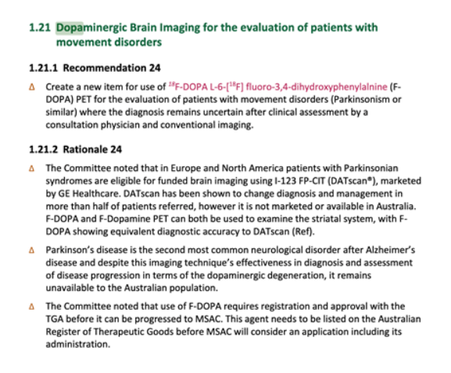

**Are there any prerequisite tests?** (please highlight your response)

Yes **No**

CT or MRI can be used as a screening test to exclude secondary causes of Parkinsonism such as cerebral infarction, space occupying lesion, demyelination, traumatic or toxic brain injury, hydrocephalus, or metal deposition. These are **not** prerequisite imaging modalities but are generally performed as part of the workup.

**Are the prerequisite tests MBS funded?** (please highlight your response)

Yes No

# **Intervention**

**Name of the proposed health technology:**

Diagnosis / sub-classification

**Describe the proposed health technology:**

Parkinson’s Disease is a condition characterised by progressive loss of dopaminergic neuronal function. Dopaminergic PET imaging identifies loss of dopaminergic neuronal activity in the basal ganglia.

Patients with Parkinson’s Disease generally do not present clinically until there has been approximately 60% loss of these neurons, so the test provides a clear indication as to the presence or absence of disease once patients present with symptoms.

**Describe the key components and clinical steps involved in delivering the proposed health technology:**

1. Patients with Parkinsonian symptoms are referred to a medical specialist, generally a neurologist, for appropriate diagnosis. In most cases of Parkinson’s Disease, the diagnosis can be made clinically, without any investigations required. However, referral for dopaminergic PET would be indicated if the patient’s history and testing are not clearly indicative of PD.
2. If a patient with presumed PD is commenced on appropriate medication but does not have a typical response to therapy a dopaminergic PET is also indicated.

**Identify how the proposed technology achieves the intended patient outcomes:**

The accuracy of clinical diagnosis of PD ranges between 73- 80%. Dopaminergic PET can differentiate clearly has between normal (non-PD) or abnormal (PD) appearance with an accuracy rating of 93%. This allows for diagnoses to be established earlier in the clinical management and with a higher level of accuracy.

The MAP-DOPA trial indicates 26% of patients referred had a change in diagnosis as a result of PET investigation; this included changes from PD to non-PD and non-PD to PD.

**Does the proposed health technology include a registered trademark component with characteristics that distinguishes it from other similar health components?** (please highlight your response)

Yes **No**

**Explain whether it is essential to have this trademark component or whether there would be other components that would be suitable:**

Dopamine transporter imaging using SPECT imaging has been available in USA and Europe for approximately 20 years. This is not available in Australia. Dopaminergic imaging with PET is at least of equivalent accuracy and has greater image resolution. The dopaminergic PET imaging agents are already manufactured and used in Australia.

There is no trademark component required. The imaging agents can be either those that assess pre- or post-synaptic dopaminergic function.

**Are there any proposed limitations on the provision of the proposed health technology delivered to the patient (For example: accessibility, dosage, quantity, duration or frequency):** (please highlight your response)

**Yes** No

**Provide details and explain:** Patients will generally require only a single scan to establish or discount the diagnosis of PD. In some cases, with equivocal results, a further scan may be necessary. This should not be performed within 12 months of the initial scan.

**If applicable, advise which health professionals will be needed to provide the proposed health technology:**

The PET scans will be reported by Nuclear Medicine specialists.

**If applicable, advise whether delivery of the proposed health technology can be delegated to another health professional:**

No other health professional will report the scans.

**If applicable, advise if there are any limitations on which health professionals might provide a referral for the proposed health technology:**

All referrals must be from medical specialists. It is anticipated that referrals will be received from neurologists, geriatricians, and general physicians with an interest in movement disorders.

**Is there specific training or qualifications required to provide or deliver the proposed service, and/or any accreditation requirements to support delivery of the health technology?** (please highlight your response)

Yes **No**

**Provide details and explain:**

Nuclear medicine specialist credentialling is all that is required.

**Indicate the proposed setting(s) in which the proposed health technology will be delivered:** (select all relevant settings)

Consulting rooms

Day surgery centre

Emergency Department

Inpatient private hospital

Inpatient public hospital

Laboratory

Outpatient clinic

Patient’s home

Point of care testing

Residential aged care facility

Other (please specify)

**Is the proposed health technology intended to be entirely rendered inside Australia?** (please highlight your response)

**Yes** No

**Please provide additional details on the proposed health technology to be rendered outside of Australia:**

Not applicable.

# **Comparator**

**Nominate the appropriate comparator(s) for the proposed medical service (i.e. how is the proposed population currently managed in the absence of the proposed medical service being available in the Australian health care system). This includes identifying health care resources that are needed to be delivered at the same time as the comparator service:**

No comparator. I123DAT SPECT is not available in Australia.

**List any existing MBS item numbers that are relevant for the nominated comparators:**

Not applicable.

**Please provide a rationale for why this is a comparator:**

Not applicable.

**Pattern of substitution – Will the proposed health technology wholly replace the proposed comparator, partially replace the proposed comparator, displace the proposed comparator or be used in combination with the proposed comparator?** (please select your response)

None – used with the comparator

Displaced – comparator will likely be used following the proposed technology in some patient.

Partial – in some cases, the proposed technology will replace the use of the comparator, but not in all cases

Full – subjects who receive the proposed intervention will not receive the comparator

**Please outline and explain the extent to which the current comparator is expected to be substituted:**

The dopaminergic PET scans will replace the absence of imaging in estimated 10% of cases that are referred to neurologists. These would represent a subset of all patients with Parkinsonism.

# **Outcomes**

**List the key health outcomes (major and minor – prioritising major key health outcomes first) that will need to be measured in assessing the clinical claim for the proposed medical service/technology (versus the comparator):** (please select your response)

Health benefits

Health harms

Resources

Value of knowing

**Outcome description – please include information about whether a change in patient management, or prognosis, occurs as a result of the test information:**

Health benefits/harms:

Patients will benefit significantly from receiving an accurate diagnosis earlier in their management. This would consequently allow patients with confirmed Parkinson’s Disease to access appropriate medication and allied health support earlier in their clinical pathway, resulting in an overall improved quality of life and long-term health outcomes.

Similarly, patients with an atypical outcome that excludes a diagnosis of Parkinson’s Disease would avoid unnecessary prescription of inappropriate medication. This would significantly minimise unpleasant and avoidable adverse effects following incorrect treatment, as well as reduce all superfluous costs the patient may have incurred.

Value of knowing:

Participants enrolled in the MAP-DOPA trial completed qualitative questionnaires preceding and following their 18F-DOPA PET scans. Participants commonly reported frustration with the lack of clarity in regard to their diagnosis, as well as with the amount of time spent trialling various treatments and interventions to exclude other diagnoses. Additional qualitative feedback from the referring clinicians has highlighted the value of providing access to the scan earlier in the clinical pathway to gain certainty on a patient’s subsequent management and minimise futile use of resources and time, as well improving long-term outcomes.

An increase in diagnostic certainty following implementation of the scan was reported by the treating neurologist in 90% of the enrolled cohort. Additionally, the trial identified a change in diagnosis in 21% of patients with Parkinsonian symptoms who have been referred for 18-F-DOPA from movement disorder outpatient specialist clinics. This means that patients who do not have PD are not subjected to trial of medication that is not clinically beneficial, can be potentially detrimental and incur expense. Patients with a scan indicating PD may be started on therapy earlier and have access to relatively invasive therapies, such as deep brain stimulation, earlier, Figure 1. Preliminary data from the MAP-DOPA trial demonstrating percentage change in clinical diagnostic confidence preceding and following 18F-DOPA PETsubsequently allowing for improved clinical outcomes and improved quality of life.

***Figure 1.*** *Preliminary data from the MAP-DOPA trial demonstrating percentage change in clinical diagnostic confidence preceding and following 18F-DOPA PET.*

# **Proposed MBS items**

**How is the technology/service funded at present? (for example: research funding; State-based funding; self-funded by patients; no funding or payments):**

1. State based at RBH (QLD), Austin Hospital (VIC).
2. Self-funded by patients.
3. Trials-SA, SAHMRI.

**Please provide at least one proposed item with their descriptor and associated costs, for each population/Intervention:** (please copy the below questions and complete for each proposed item)

**Proposed item details**

|  |  |
| --- | --- |
| MBS item number (where used as a template for the proposed item) | Dopaminergic PET imaging for the evaluation of Parkinsonism. |
| Category number | 5 |
| Category description | Group14- Nuclear Medicine subgroup 2- PET |
| Proposed item descriptor | Dopaminergic PET imaging of the brain for evaluation of Parkinsonism, if (a) clinical assessment by a specialist is inconclusive for a diagnosis of Parkinson’s disease or (b) if medical therapy for Parkinson’s disease does not result in expected clinical response or (c) there is rapid cognitive decline with suggestion of Lewy body dementia, with no prior diagnosis of PD. |
| Proposed MBS fee | $950 |
| Indicate the overall cost per patient of providing the proposed health technology | $950 |
| Please specify any anticipated out of pocket expenses | 0 |
| Provide any further details and explain | The number of tests is limited to 2 per lifetime. The repeat test should not be performed within 12 months. |

# **Algorithms**

**Preparation for using the health technology**

**Define and summarise the clinical management algorithm, including any required tests or healthcare resources, before patients would be eligible for the proposed health technology:**

1. Patient with Parkinsonian syndrome referred to specialist.
2. +/-Screening blood tests (if appropriate).
3. CT or MRI screening for secondary causes of symptoms.

Recently, MRI assessment of Nigrosome-1 has been used to assess for PD. This is not a comparator.

* This must be performed on 3T (or greater strength) MRI machines.
* This test is yet to be included in diagnostic recommendations in USA or Europe (unlike dopaminergic imaging).
* Image quality can vary and easily affect image quality and interpretation.
* This test is not as accurate as dopaminergic imaging. The MAP-DOPA trial showed 40% of patients with Nigrosome-1 present (non-PD identified) had 18F-DOPA scans positive for PD.
* If screening MRI reveals absent Nigrosome-1, then dopaminergic PET may not be required.
* If screening MRI is not performed on 3T MRI or if appropriate SWI sequences are not performed, a repeat MRI is not indicated with dopaminergic imaging availability.

Figure 2. Preliminary data from the MAP-DOPA trial illustrating differentiation between reporting outcomes for MRI in comparison to 18F-DOPA PET***Figure 2.*** *Preliminary data from the MAP-DOPA trial illustrating differentiation between reporting outcomes for MRI in comparison to 18F-DOPA PET.*

**Is there any expectation that the clinical management algorithm *before* the health technology is used will change due to the introduction of the proposed health technology?** (please highlight your response)

**Yes** No

**Describe and explain any differences in the clinical management algorithm prior to the use of the proposed health technology vs. the comparator health technology:**

**Use of the health technology**

See algorithm.

**Explain what other healthcare resources are used in conjunction with delivering the proposed health technology:**

Some practices may prescribe a single dose of carbidopa prior to the scan, obtained from pharmacy.

Nil other

**Explain what other healthcare resources are used in conjunction with the comparator health technology:**

No other health resources.

**Describe and explain any differences in the healthcare resources used in conjunction with the proposed health technology vs. the comparator health technology:**

PET/CT performed as outpatient.

**Clinical management after the use of health technology**

**Define and summarise the clinical management algorithm, including any required tests or healthcare resources, *after* the use of the proposed health technology:**

Follow up with referrer to discuss results and clinical management.

**Define and summarise the clinical management algorithm, including any required tests or healthcare resources, *after* the use of the comparator health technology:**

Follow up results with referrer.

**Describe and explain any differences in the healthcare resources used *after* the proposed health technology vs. the comparator health technology:**

Less medicationprescribed inappropriately for those without PD.

**Algorithms**

**Insert diagrams demonstrating the clinical management algorithm with and without the proposed health technology:**

1. **With PET imaging (*Figure 3).***

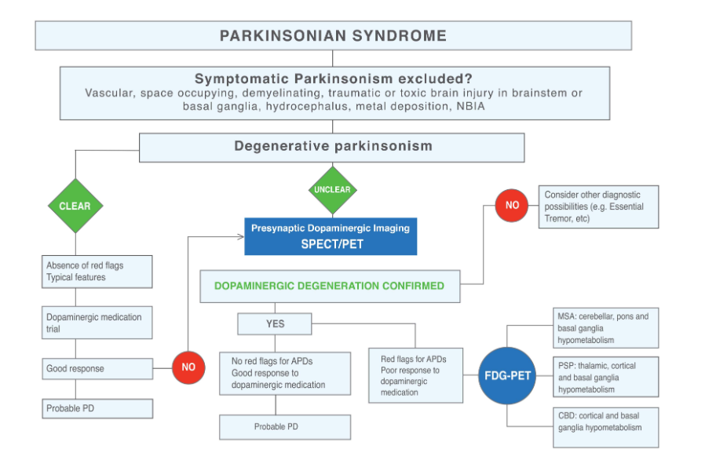

1. **Without dopaminergic PET imaging (*Figure 4).***

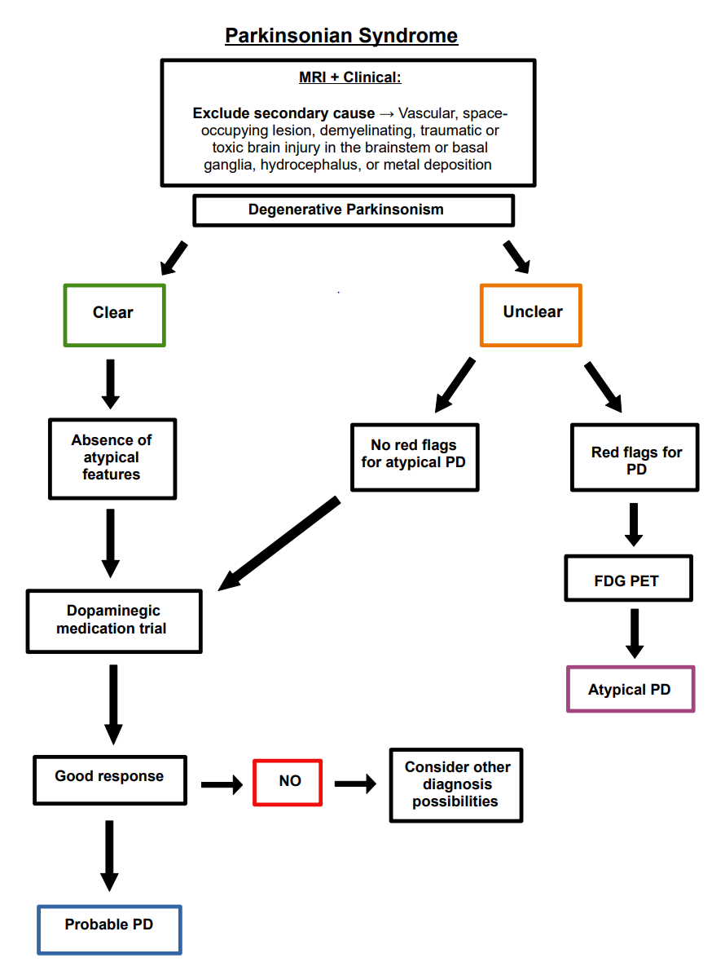

# **Claims**

**In terms of health outcomes (comparative benefits and harms), is the proposed technology claimed to be superior, non-inferior or inferior to the comparator(s)?** (please select your response)

Superior

Non-inferior

Inferior

**Please state what the overall claim is, and provide a rationale:**

The test will allow for diagnoses to be made with higher accuracy and earlier in the patient’s management in comparison to the absence of dopaminergic imaging.

**Why would the requestor seek to use the proposed investigative technology rather than the comparator(s)?**

To provide a diagnosis and to guide clinical management.

**Identify how the proposed technology achieves the intended patient outcomes:**

Dopaminergic PET allows for a more accurate diagnosis in those presenting with a movement disorder but without typical clinical features or expected response to medication.

**For some people, compared with the comparator(s), does the test information result in:** (please highlight your response)

**A change in clinical management?** **Yes**  No

**A change in health outcome?** **Yes** No

**Other benefits?** **Yes** No

**Please provide a rationale, and information on other benefits if relevant:**

The MAP-DOPA trial reveals a change in diagnosis in 26% of cases. This will allow for:

* Earlier access to appropriate treatment and support.
* Less patients prescribed inappropriate medication, so less risk of adverse effects.
* Satisfaction of patients knowing their diagnosis with higher confidence.

**In terms of the immediate costs of the proposed technology (and immediate cost consequences, such as procedural costs, testing costs etc.), is the proposed technology claimed to be more costly, the same cost or less costly than the comparator?** (please select your response)

More costly

Same cost

Less costly

**Provide a brief rationale for the claim:**

This is an additional test to the current work up of those with movement disorders without a clear clinical diagnosis.

# **Summary of Evidence**

**Provide one or more recent (published) high quality clinical studies that support use of the proposed health service/technology.**

| **Type of study design\*** | **Title of journal article or research project (including any trial identifier or study lead if relevant)** | **Short description of research (max 50 words)\*\*** | **Website link to journal article or research (if available)** | **Date of publication\*\*\*** |
| --- | --- | --- | --- | --- |
| Prospective cohort | Direct comparison of FP-CIT SPECT and F-DOPA PET in patients with Parkinson’s disease and healthy controls | 11 patients with early PD and 17 with advanced PD were enrolled. All underwent an FP-CIT SPECT and an F-DOPA PET. 10 FP-CIT SPECT scans or 10 F-DOPA PET scans were performed in 20 controls. FP-CIT SPECT and F-DOPA PET were able to diagnose presynaptic dopaminergic deficits sensitively and specifically. | <https://pubmed.ncbi.nlm.nih.gov/19037637/> | 2009 |
| Prospective cohort | Lateralisation of striatal function: evidence from 18F-DOPA PET in Parkinson’s Disease | 16 PD participants were evaluated with the Tower of London (TOL) spatial planning task, a verbal working memory task (VWMT) and (18)F-dopa PET. The findings supported a causative role of striatal dopaminergic depletion in the early impairment of executive functions seen in PD. | <https://pubmed.ncbi.nlm.nih.gov/16107352/> | 2005 |
| Prospective cohort | Extrastriatal monoamine neuron function in Parkinson’s disease: an 18F-DOPA PET study | 16 Controls and 41 patients underwent investigation. (18)F-dopa uptake was found to be decreased in cortical motor areas in early disease. Frontal association areas were also affected in later disease, but limbic areas were spared except for hypothalamus. The findings provided a basis for understanding the pathophysiology of PD. | <https://pubmed.ncbi.nlm.nih.gov/18226536/> | 2007 |
| Prospective cohort | Parkinson’s disease multimodal imaging: F-DOPA PET, neuromelanin-sensitive and quantitative iron-sensitive MRI | Measured dopaminergic function in pre- and post-commissural putamen by 18F-DOPA PET in 23 PD patients and 23 healthy controls. Dopaminergic function impairment was indicated to be progressing with iron accumulation and depigmentation in the SN. | <https://www.nature.com/articles/s41531-021-00199-2> | 2021 |
| Prospective cohort | Comparison of 18F-DOPA and 18F-DTBZ for PET/CT imaging of Idiopathic Parkinson Disease | 32 PD patients and 12 healthy controls were enrolled in this study. All subjects underwent both **18**F-DOPA and **18**F-DTBZ PET/CT, and the results were interpreted by visual analysis and semiquantitative analysis. **18**F-DTBZ and **18**F-DOPA reflected dopaminergic degeneration for early PD and had consistent visual analysis results. | <https://oce.ovid.com/article/00003072-202211000-00002/HTML> | 2022 |
| Prospective cohort | Relevance of 18F-DOPA visual and semi-quantitative PET metrics for the diagnostic of Parkinson disease in clinical practice: a machine learning based inference study | 110 patients (48 IPD, 62 controls) enrolled within 11 months of clinical follow up. The machine learning model k-NN provided final cv-ROC of 0.81. Visual expert analysis determined to be the most relevant parameter to predict IPD diagnosis. | <https://www.ncbi.nlm.nih.gov/pmc/articles/PMC9925664/> | 2023 |
| Prospective cohort | Molecular Algorithms of Parkinsonism: A prospective  cohort study to define criteria for the use of 18F-DOPA  PET/CT in a movement disorder clinic (MAP-DOPA) | Over 300 patients enrolled to date, with >200 having undergone 18F-DOPA PET imaging. Preliminary outcomes have highlighted the value of 18F-DOPA PET to improve diagnostic certainty and subsequent management and outcomes. Feedback from specialists and patients has further emphasised the importance of the 18F-DOPA PET clinically. |  | Ongoing research. |
| Prospective cohort | Regional metabolic changes in Parkinsonian patients with normal dopaminergic imaging. | 185 patients with clinically diagnosed IPD underwent 18F‐fluorodopa PET for diagnostic confirmation. 27 patients (14.6%) had normal scans. None of these developed clinical signs of classical PD or of atypical parkinsonian syndrome at a follow‐up visit 3 years after imaging. | <https://movementdisorders.onlinelibrary.wiley.com/doi/full/10.1002/mds.21185> | 2007 |
| Prospective cohort | Clinical implications of early caudate dysfunction in Parkinson’s Disease. | 18F-DOPA uptake in the putamen correlates with clinical severity of PD  as measured by Unified Parkinson’s Disease Rating Scale (UPDRS). Patients with early IPD (<2years  of diagnosis) with significant caudate dopaminergic dysfunction associated with relatively increased risk of developing cognitive impairment, depression, and gait problems over the next 4 years. | <https://www.proquest.com/docview/2290039883?_oafollow=false&accountid=8203&pq-origsite=primo&sourcetype=Scholarly%20Journals> | 2019 |
| MBS Taskforce Review | Medicare Benefits Schedule Review Taskforce: Final Report on the MBS Items for Nuclear Medicine | The MBS Review Taskforce recommended creation of a new item for 18F-DOPA PET for the evaluation of patients with movement disorders, particularly for Parkinsonism or similar, where the diagnosis remains uncertain following clinical evaluation. | <https://www.health.gov.au/sites/default/files/documents/2021/05/taskforce-final-report-mbs-items-for-nuclear-medicine-final-report-on-the-mbs-items-for-nuclear-medicine.pdf> | 2018 |