**MSAC Application 1796**

**ADAMTS13 testing for the diagnosis of thrombotic thrombocytopenic purpura (TTP)**

**PICO Set**

# Population

## Describe the population in which the proposed health technology is intended to be used:

Thrombotic microangiopathies (TMA) are a pathological process in which platelet aggregation and thrombus formation in small blood vessels cause luminal narrowing or occlusion, producing end-organ ischaemia and infarction. The most commonly affected organs are the kidneys, brain, heart, and gastrointestinal tract. TMA is characterised by: (i) thrombocytopenia; (ii) microangiopathic haemolytic anaemia with red cell fragments (schistocytes); and (iii) the clinical and laboratory abnormalities attributable to organ-specific dysfunction.4

Patients with thrombotic thrombocytopenic purpura (TTP), a rare and potentially fatal TMA, present with symptoms similar to other TMAs (Table 1). TTP is associated with severe ADAMTS13 deficiency and is defined by markedly reduced (<10%) ADAMTS13 activity. The primary function of ADAMTS13, a plasma protease, is cleavage of von Willebrand factor (VWF) anchored on the endothelial surface, in circulation, and at the sites of vascular injury (Figure 1). ADAMTS13 regulates the size of VWF multimers via proteolysis, and inhibits multimer formation, to reduce highly adhesive, potentially thrombogenic ultra-large VWF multimers to smaller multimers that do not spontaneously bind to platelets. When the ADAMTS13 activity is severely impaired, uncleaved VWF multimers accumulate in the microcirculation where they bind and activate platelets causing microvascular occlusion, resulting in TTP.4, 6, 7, 9, 23

Table 1 **Presenting clinical features and signs in acute TTP8**

|  |  |
| --- | --- |
| Thrombocytopenia | Epistaxis, bruising, petechiae, gingival bleeding, haematuria, menorrhagia, gastrointestinal bleeding, retinal haemorrhage and haemoptysis |
| Central neurological often fleeting and variable 70%–80% | Confusion, headache, paresis, seizures, aphasia, dysarthria, visual abnormalities, encephalopathy, coma (10%) |
| Fever (>37.5°C)  Non- specific symptoms  Jaundice  Renal impairment  Gastrointestinal tract  Cardiac | Pallor, jaundice, fatigue, arthralgia, myalgia  Unconjugated hyperbilirubinaemia, resulting from haemolysis  Proteinuria, microhaematuria  Abdominal pain, pancreatitis, gut ischaemia  Chest pain, heart failure, hypotension, myocardial infarction, acute cardiac arrest |

It is important to be able to differentiate TTP from other TMAs as, without appropriate treatment, TTP has a mortality rate of approximately 90% and an acute mortality of rate of 10% despite optimal care.4, 6, 24. The primary cause of death is often coronary thrombosis leading to an acute myocardial infarction, congestive heart failure, and sudden death.

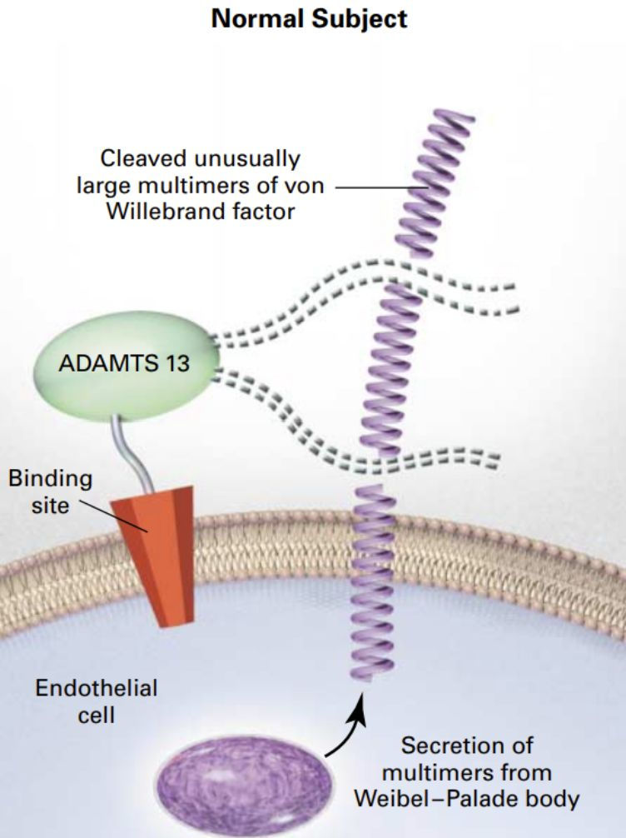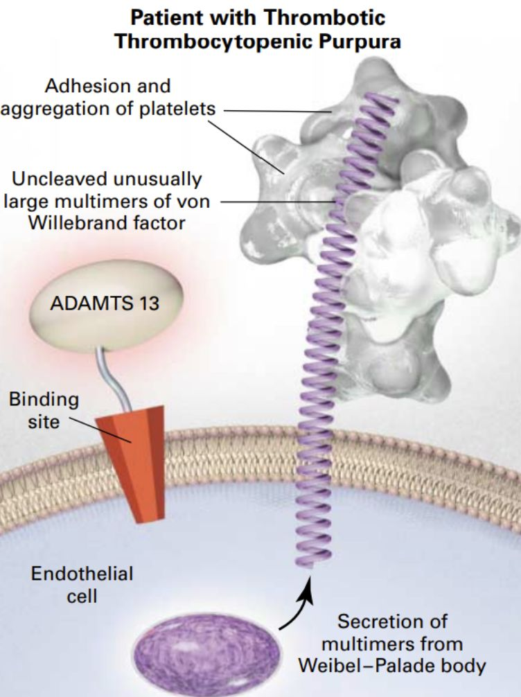

Figure 1 ADAMTS13 activity in normal and TTP patients 25

It is also important to differentiate between congenital (cTTP) and immune-mediated (iTTP - acquired) TTP, where patients develop an immune response against ADAMTS13. Congenital TTP, due to heterozygous or homozygous variants in the *ADAMTS13* gene, is rare, accounting for <5% of TTP cases. Onset can occur at any age and is often triggered by pregnancy/postpartum or infection, characterised often by renal failure or persistent severe deficiency (<10% or <10 IU/dL) in ADAMTS13 caused by biallelic recessive pathogenic mutations in the *ADAMTS13* gene. Immune-mediated TTP mediated by anti-ADAMTS13 autoantibodies usually occurs in adults, with women two to three times more likely to develop iTTP.1, 4

In addition, providing a rapid diagnosis that differentiates between TTP and other TMAs assists in the appropriate management and treatment of TMA patients, such as the administration of the high-cost drug eculuzimab to atypical haemolytic uremic syndrome (aHUS) patients.

## Specify any characteristics of patients with, or suspected of having, the medical condition, who are proposed to be eligible for the proposed health technology, describing how a patient would be investigated, managed and referred within the Australian healthcare system in the lead up to being considered eligible for the technology:

Clinically, TTP typically manifests as an abrupt-onset illness with patients presenting with symptoms such as those described in Table 1: thrombocytopenia, microangiopathic haemolytic anaemia and neurological symptoms ranging from headache to coma. Clinical symptoms and laboratory abnormalities seen in TTP are relatively non-specific; however, the potential for rapid clinical deterioration, and early mortality means that empiric treatment with therapeutic plasma is required before confirmation of diagnosis. Data from the Australian TMA registry describes a heterogenous approach to the diagnosis and management of TTP in Australia, highlighting the need for standardisation of practice, including comprehensive diagnostic testing and improved access to immediate PEX.26 Patients presenting with symptoms of TMA should undergo a number of routine tests to rule in/rule out TTP. Table 2 describes some of the laboratory features of patients presenting with suspected TMA; noting that some may be absent in early TMA.4, 8

Table 2  **Laboratory features of thrombotic microangiopathies4, 8**

|  |
| --- |
|  |
| Full blood count  Platelets <150 × 109/L or >25% fall from baseline  Haemoglobin <100 g/L  Peripheral blood film demonstrating red cell fragments (schistocytes)  Elevated reticulocyte (immature red blood cells) count  Elevated lactate dehydrogenase – raised due to haemolysis  Reduced haptoglobin  Urea and electrolytes checking for renal impairment  Troponin T/Troponin I checking for cardiac involvement  Elevated bilirubin  Direct antiglobulin (Coombs’)  Test negative (with a few exceptions)  Coagulation profile (APTT, INR, fibrinogen)   Normal except in disseminated intravascular coagulation, lupus anticoagulant, therapeutic anticoagulation  Glucose to exclude diabetes |

In the absence of ADAMTS13 activity testing, a PLASMIC score, which uses both clinical and basic laboratory results, has been demonstrated to have some efficacy in identifying patients with a likelihood of having a severe deficiency of plasma ADAMTS13 activity. The PLASMIC score is a clinical score based on seven clinical components with 1 point assigned to each variable:

1. platelet count of less than 30 x 109/L;
2. haemolysis variables (reticulocyte count > 2.5%, undetectable haptoglobin, or indirect bilirubin > 2 mg/dL);
3. no active cancer;
4. no history of solid or hematopoietic progenitor cell transplant;
5. mean corpuscular volume of less than 90 fL;
6. international normalized ratio of less than 1.5, and
7. creatinine level of less than 2 mg/dL.

If the score is 4 or less, the patient is *less* likely to have severe deficiency of ADAMTS13; however, a PLASMIC score does not have the sensitivity and/or specificity for diagnosing and distinguishing TTP from other TMAs.27

## Provide a rationale for the specifics of the eligible population:

Rapid identification of patients presenting with symptoms of TTP enables appropriate treatment to be administered. In the absence of any treatment, patients with undiagnosed TTP have a mortality rate of approximately 90%. Once appropriate (optimal) treatment is received, mortality rates will decrease to approximately 10%. On suspicion of TTP, patients should be administered daily PEX therapy to improve ADAMTS13 activity and decrease anti-ADAMTS13 antibodies. However, for those patients who have congenital TTP (no anti-ADAMTS13 antibodies), PEX therapy should be ceased, and they should receive only plasma infusions to improve ADAMTS13 activity

## Are there any prerequisite tests?

YES

## Are the prerequisite tests MBS funded?

YES

## Provide details to fund the prerequisite tests:

**65070 Group P1 - Haematology**

Erythrocyte count, haematocrit, haemoglobin, calculation or measurement of red cell index or indices, platelet count, leucocyte count and manual or instrument generated differential count - not being a service where haemoglobin only is requested - one or more instrument generated sets of results from a single sample; and (if performed)

(a) a morphological assessment of a blood film;

(b) any service in item 65060 or 65072

Fee: $16.95 Benefit: 75% = $12.75 85% = $14.45

**65072 Group P1 - Haematology**

Examination for reticulocytes including a reticulocyte count by any method - 1 or more tests

Fee: $10.20 Benefit: 75% = $7.65 85% = $8.70

**66500 Group P2 - Chemical**

Quantitation in serum, plasma, urine or other body fluid (except amniotic fluid), by any method except reagent tablet or reagent strip (with or without reflectance meter) of: acid phosphatase, alanine aminotransferase, albumin, alkaline phosphatase, ammonia, amylase, aspartate aminotransferase, bicarbonate, bilirubin (total), **bilirubin** (any fractions), C-reactive protein, calcium (total or corrected for albumin), chloride, creatine kinase, creatinine, gamma glutamyl transferase, globulin, **glucose, lactate dehydrogenase**, lipase, magnesium, phosphate, potassium, sodium, total protein, total cholesterol, triglycerides, urate or **urea** - 1 test

Fee: $9.70 Benefit: 75% = $7.30 85% = $8.25

**66518 Group P2 - Chemical**

Investigation of cardiac or skeletal muscle damage by quantitative measurement of creatine kinase isoenzymes, troponin or myoglobin in blood - testing on 1 specimen in a 24-hour period

Fee: $20.05 Benefit: 75% = $15.05 85% = $17.05

**65120 Group P1 - Haematology**

Prothrombin time (**including INR** where appropriate), activated partial thromboplastin time, thrombin time (including test for the presence of heparin), test for factor XIII deficiency (qualitative), Echis test, Stypven test, reptilase time, fibrinogen, or 1 of fibrinogen degradation products, fibrin monomer or D-dimer - 1 test

Fee: $13.70 Benefit: 75% = $10.30 85% = $11.65

# Intervention

## Name of the proposed health technology:

ADAMTS13 activity testing for the diagnosis of thrombotic thrombocytopenic purpura (TTP).

## Describe the key components and clinical steps involved in delivering the proposed health technology:

Patients presenting with symptoms of TMA (see Table 1) should undergo a number of routine tests to rule in/rule out TTP. Once TTP is suspected, venous blood should be collected into a citrated plasma collection tube and centrifuged at room temperature to ensure white cell and platelet depletion, and plasma removed. Plasma may be tested fresh or frozen (stable at -20°C for at least 14 days and for at least 6 months at -70°C). Note that serum or plasma can be used to assay anti- ADAMTS13 autoantibodies.7, 28

There are a variety of methods available to measure ADAMTS13 activity and to detect antibodies, with considerations of cost, turn-around time, accuracy, availability of analyser and reagent and other factors contributing. The main methods in use in Australian laboratories for measuring ADAMTS13 activity are ELISA–based detection of an epitope exposed after cleavage by ADAMTS13 , fluorescence resonance energy transfer assay (FRETS-VWF73) and chemiluminescence immunoassay (CLIA) which is a rapid test using a commercial kit requiring specific instrumentation (AcuStar).

An ADAMTS13 activity level below 10% as assessed by ELISA or FRETS-VWF73 has demonstrated 97% specificity and 100% sensitivity for TTP. For patients with low or moderate ADAMTS13 levels, ADAMTS13 antibodies should then be measured using either by a Bethesda-type activity-based assay that mixes equal volume of patient and control normal pooled plasma together, or by antibody capture ELISA methods using plate-bound ADAMTS13. Using these assays, 67% to 97% of patients with TTP have been shown to be positive for an ADAMTS13-inhibiting antibody. Taken together, these assays should confirm a TTP diagnosis.6

Other methods of testing ADAMTS13 activity are available, including chemiluminescence immunoassay (CLIA) a two-step immunoassay that quantifies plasma ADAMTS13 activity using magnetic particles as solid phase and a chemiluminescent detection system that requires specific instrumentation (AcuStar).29 Singh et al (2023) reported discrepancies between this assay and both the ELISA and FRET assays, meaning that a relatively high proportion of patients may have undergone unnecessary and invasive plasma exchange therapy.21 This issue has led to a TGA notification. However, it should be noted that the AcuStar test is currently used as a ‘triage’ test in some laboratories in Australia due to its rapid turnaround time, with subsequent confirmatory testing of low ADAMTS13 level samples by ELISA, and a rapid result showing normal levels able to be used to avoid initiating PEX and associated costs.

Although Favaloro et al (2023) reported that the CLIA assay took 35 minutes, Singh et al (2023) reported turnaround times of approximately 6 hours for the ELISA, 1.5 hours for the FRETS-VWF73 assay and 60 minutes for the CLIA on AcuStar.21

## **Identify how the proposed technology achieves the intended patient outcomes**:

Patients presenting with severe thrombocytopenia (typically <30x109/L), mechanical fragmentation of erythrocytes on the blood smear and elevated lactate dehydrogenase (LDH) values caused by a combination of haemolysis and tissue ischaemia should be immediately investigated for an acute episode of TTP. Measurement of ADAMTS13 activity by ELISA or FRETS-VWF73, with severe ADAMTS13 deficiency (activity <10%) supporting a diagnosis of TTP.4, 8, 23 Some laboratories in Australia currently use the AcuStar test due to its rapid turnaround time, with subsequent confirmatory testing of low ADAMTS13 level samples by ELISA. Testing for anti-ADAMTS13 autoantibodies should also be conducted either using an ELISA autoantibody assay or a Bethesda-type assay for detecting inhibitory antibodies to ADAMTS13.28 Negative ADAMTS13 autoantibody testing in a patient with ADAMTS13 activity below 10% suggests a diagnosis of cTTP, which would be confirmed with further genetic testing of the *ADAMTS13* gene (this would normally be included in a panel testing for other TMAs with a genetic origin).4, 8 Noting that infrequent testing of ADAMTS13 autoantibodies currently occurs in Australia (approximately 16% of patients).4

Although ADAMTS13 activity assays are essential in confirming the diagnosis of TTP, plasma exchange therapy (PEX) should commence immediately (within 4-8 hours of a suspected diagnosis) and not be delayed pending confirmatory results. Daily PEX with spun apheresis is preferred over plasma infusions as it restores ADAMTS13 enzyme at the same time as removing harmful autoantibodies. Daily PEX should continue until a normal platelet count (>150 × 109/L) is achieved (clinical remission).8 Other treatment recommendations include immunoglobulins, high-dose corticosteroid therapy, rituximab, antiplatelets and anticoagulants.17 Caplacizumab, a monoclonal antibody that inhibits interaction between VWF multimers and platelets, is also recommended for up to 30 days following completion of PEX.30 However, in July 2020 the PBAC did not recommend the listing of caplacizumab on the PBS due to uncertainties in the clinical pathway. It should be noted that whilst all patients with suspected TTP should be treated immediately with PEX, once results indicate that a patient has cTTP (due to the absence of autoantibodies), treatment with PEX should cease and plasma infusion alone, to replace deficient ADAMTS13 enzyme, should commence.4

Once patients have achieved clinical remission (platelet count >150 × 109/L), they should undergo repeat ADAMTS13 activity testing weekly for the first month, every 3-months for the first year, then every 3-6 months going forward to monitor for a potential relapse.2

## Does the proposed health technology include a registered trademark component with characteristics that distinguishes it from other similar health components?

NO

## Explain whether it is essential to have this trademark component or whether there would be other components that would be suitable:

N/A

## Are there any proposed limitations on the provision of the proposed health technology delivered to the patient (For example: accessibility, dosage, quantity, duration or frequency):

ADAMTS13 activity and anti-ADAMTS13 antibody testing should be applied when patients present with symptoms of acute and relapsing TTP, noting that the same ADAMTS13 assay should be used for the same patient to exclude variability amongst the different assays.25

Once patients have achieved clinical remission (platelet count >150 × 109/L), they should undergo repeat ADAMTS13 activity testing weekly for the first month, every 3 months for the first 3-years, and then every 6 months for the next 2-years to monitor for a potential relapse.25

## Provide details and explain:

N/A

## If applicable, advise which health professionals will be needed to provide the proposed health technology:

Testing would be requested by the treating clinician and provided by Approved Practising Pathologists in line with other tests on the MBS Pathology Table

## If applicable, advise whether delivery of the proposed health technology can be delegated to another health professional:

N/A

## If applicable, advise if there are any limitations on which health professionals might provide a referral for the proposed health technology:

Patients should be referred by a treating physician

## Is there specific training or qualifications required to provide or deliver the proposed service, and/or any accreditation requirements to support delivery of the health technology?

Testing would be delivered only by Approved Practising Pathologists with appropriate scope of practice in NATA Accredited Pathology Laboratories (as defined in MBS Pathology table) by referral only by registered Medical Practitioners (non-pathologists) in line with other tests in the MBS Pathology Table

## Provide details and explain:

Provide a response if you answered 'Yes' to the question above

## Indicate the proposed setting(s) in which the proposed health technology will be delivered:

*(Select all relevant settings)*

Consulting rooms

Day surgery centre

Emergency Department

Inpatient private hospital

Inpatient public hospital

Laboratory

Outpatient clinic

Patient’s home

Point of care testing

Residential aged care facility

Other (please specify)

## Is the proposed health technology intended to be entirely rendered inside Australia?

YES

## Provide additional details on the proposed health technology to be rendered outside of Australia:

N/A

# Comparator

## Nominate the appropriate comparator(s) for the proposed medical service (i.e., how is the proposed population currently managed in the absence of the proposed medical service being available in the Australian healthcare system). This includes identifying healthcare resources that are needed to be delivered at the same time as the comparator service:

There are many tests that should be conducted when a patient presents; however, many of these are necessary but not sufficient to provide a diagnosis of TTP but rather indicate that the patient may be experiencing a thrombotic microangiopathy.

|  |
| --- |
| **Table 2 Laboratory features of thrombotic microangiopathies4, 8** |
| Full blood count  Platelets <150 × 109/L or >25% fall from baseline  Haemoglobin <100 g/L  Peripheral blood film demonstrating red cell fragments (schistocytes)  Elevated reticulocyte (immature red blood cells) count  Elevated lactate dehydrogenase – raised due to haemolysis  Reduced haptoglobin  Urea and electrolytes checking for renal impairment  Troponin T/Troponin I checking for cardiac involvement  Elevated bilirubin  Direct antiglobulin (Coombs’)  Test negative (with a few exceptions)  Coagulation profile (APTT, INR, fibrinogen)   Normal except in disseminated intravascular coagulation, lupus anticoagulant, therapeutic anticoagulation  Glucose to exclude diabetes |

## List any existing MBS item numbers that are relevant for the nominated comparators:

Existing MBS item numbers may indicate that a patient is experiencing a TMA but they are not diagnostic of TTP, so therefore there is no true comparator

## Provide a rationale for why this is a comparator:

There are many tests that should be conducted when a patient presents; however, **many of these are necessary but not sufficient to provide a diagnosis of TTP but rather indicate that the patient may be experiencing a thrombotic microangiopathy**

## Pattern of substitution – Will the proposed health technology wholly replace the proposed comparator, partially replace the proposed comparator, displace the proposed comparator or be used in combination with the proposed comparator?

*(Please select your response)*

None (used with the comparator)

Displaced (comparator will likely be used following the proposed technology in some patients)

Partial (in some cases, the proposed technology will replace the use of the comparator, but not all)

Full (subjects who receive the proposed intervention will not receive the comparator)

## Outline and explain the extent to which the current comparator is expected to be substituted:

As above – the listed MBS items are necessary but not sufficient to provide a diagnosis of TTP

# Outcomes

*(Please copy the below questions and complete for each outcome)*

## List the key health outcomes (major and minor – prioritising major key health outcomes first) that will need to be measured in assessing the clinical claim for the proposed medical service/technology (versus the comparator):

*(Please select your response)*

Health benefits

Health harms

Resources

Value of knowing

## Outcome description – include information about whether a change in patient management, or prognosis, occurs as a result of the test information:

**Safety Outcomes:**

Adverse events (AEs) related to ADAMTS13 activity and ant-ADAMTS13 antibody testing

AEs from the change in patient management (appropriate treatment given/not given) – PEX (iTTP) vs plasma (cTTP)

AEs from treatment (if given) e.g. allergic reactions (anaphylaxis), citrate toxicity, transfusion-related acute lung injury, hypotension, arrhythmia, hypocalcaemia, hypokalaemia, vascular access complications (see Table 1 Complications of TPE for iTTP in Picod et al 2019 31)

**Clinical Effectiveness Outcomes:**

Direct evidence:

Change in patient health outcomes: mortality, morbidity, quality of life: Clinical utility: change in patient management/treatment resulting in change in patient outcomes: mortality, morbidity, quality of life: comparing patients who have ADAMTS13 levels tested and those who do not

Indirect evidence

Clinical utility: change in patient management/treatment resulting in change in patient outcomes: mortality, morbidity, quality of life

Clinical validity: prognostic value: assessment of diagnostic/test accuracy: sensitivity, specificity, number of false positives, number of false negatives, number of inconclusive results

**Cost-effectiveness outcomes**

Cost per patient diagnosed with TTP based on ADAMTS13activity levels

Cost per patient avoiding PEX

Cost per patient avoiding morbidity, mortality

Cost per quality-adjusted life year (QALY) gained.

**Health system resources:**

Cost of ADAMTS13 testing vs. treatment saving costs

Total Australian Government healthcare costs

# Proposed MBS items

## How is the technology/service funded at present? (e.g., research funding; State-based funding; self-funded by patients; no funding or payments):

For patients in the community, private ED/private hospital with a TMA that requires ADAMTS13 testing, the public hospital will currently bill them approximately $800 out of pocket expense for testing. For inpatients, health funds will not pay for any test that doesn’t have MBS item.

## Provide at least one proposed item with their descriptor and associated costs, for each Population/Intervention:

## *Noting CPG is set at $98.70*

|  |  |
| --- | --- |
| MBS item number  (where used as a template for the proposed item) | **AAAA** |
| Category number | **Category 6 – Pathology services** |
| Category description | **Group P1 Haematology** |
| Proposed item descriptor | ADAMTS13 activity testing in patients presenting with suspected thrombotic thrombocytopenic purpura (TTP) to be conducted concurrently with BBBB  Once per episode |
| Proposed MBS fee | $700 |
| Indicate the overall cost per patient of providing the proposed health technology | $601.30 |
| Please specify any anticipated out of pocket expenses | $98.70 |
| Provide any further details and explain |  |

|  |  |
| --- | --- |
| MBS item number  (where used as a template for the proposed item) | **BBBB** |
| Category number | **Category 6 – Pathology services** |
| Category description | **Group P1 Haematology** |
| Proposed item descriptor | Anti-ADAMTS13 antibody testing in patients presenting with suspected thrombotic thrombocytopenic purpura (TTP) to be conducted concurrently with AAAA  Once per episode |
| Proposed MBS fee | $1050 |
| Indicate the overall cost per patient of providing the proposed health technology | $951.30 |
| Please specify any anticipated out of pocket expenses | $98.70 |
| Provide any further details and explain |  |

|  |  |
| --- | --- |
| MBS item number  (where used as a template for the proposed item) | **CCCC** |
| Category number | **Category 6 – Pathology services** |
| Category description | **Group P7 Genetics** |
| Proposed item descriptor | Characterisation of variant(s) in the ADAMTS13 gene in a patient with symptoms suggestive of thrombotic thrombocytopenic purpura, where testing with AAAA has indicated reduced ADAMTS13 activity and testing with BBBB indicates an absence of anti-ADAMTS13 antibodies, requested by a specialist or consultant physician  Available once per lifetime |
| Proposed MBS fee | $1200 |
| Indicate the overall cost per patient of providing the proposed health technology | $1,101.30 |
| Please specify any anticipated out of pocket expenses | $98.70 |
| Provide any further details and explain |  |

|  |  |
| --- | --- |
| MBS item number  (where used as a template for the proposed item) | **CCCC** |
| Category number | **Category 6 – Pathology services** |
| Category description | **Group P7 Genetics** |
| Proposed item descriptor | Characterisation of variants in the *ADAMTS13* gene in a patient in a first-degree biological relative of a patient found to have a likely pathogenic variant(s) identified by item CCCC, requested by or on behalf of a specialist or consultant physician who manages the treatment of the patient  Available once per lifetime |
| Proposed MBS fee | $1200 |
| Indicate the overall cost per patient of providing the proposed health technology | $1,101.30 |
| Please specify any anticipated out of pocket expenses | $98.70 |
| Provide any further details and explain |  |

|  |  |
| --- | --- |
| MBS item number  (where used as a template for the proposed item) | **EEEE** |
| Category number | **Category 6 – Pathology services** |
| Category description | **Group P1 Haematology** |
| Proposed item descriptor | Monitoring ADAMTS13 activity levels in patients with confirmed acquired thrombotic thrombocytopenic purpura (TTP) by item AAAA and BBBB  Weekly for first month after diagnosis, every 3-months for next 12-months, every 3-6 months thereafter |
| Proposed MBS fee | $700 |
| Indicate the overall cost per patient of providing the proposed health technology | $601.30 |
| Please specify any anticipated out of pocket expenses | $98.70 |
| Provide any further details and explain |  |

# Algorithms

## PREPARATION FOR USING THE HEALTH TECHNOLOGY

## Define and summarise the clinical management algorithm, including any required tests or healthcare resources, before patients would be eligible for the proposed health technology:

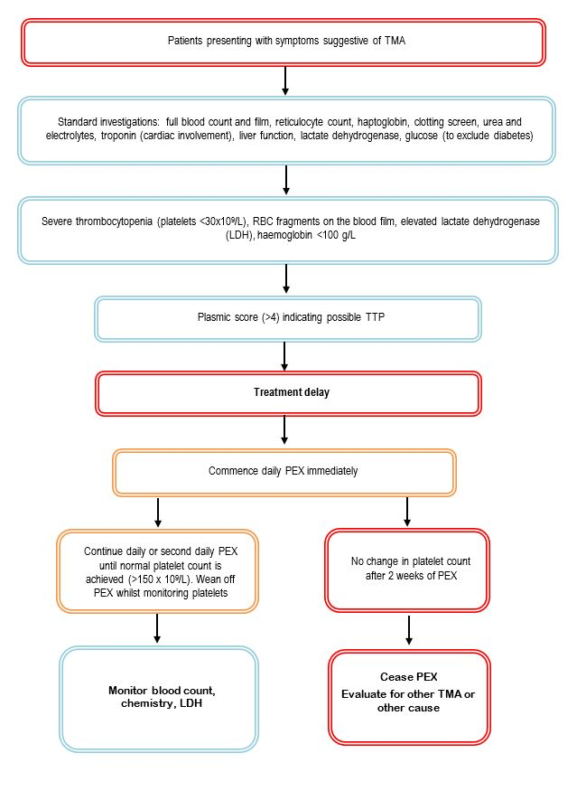

Is there any expectation that the clinical management algorithm before the health technology is used will change due to the introduction of the proposed health technology?

YES

## Describe and explain any differences in the clinical management algorithm prior to the use of the proposed health technology vs. the comparator health technology:

Patients presenting with severe thrombocytopenia (typically <30x109/L), mechanical fragmentation of erythrocytes on the blood smear and elevated lactate dehydrogenase (LDH) values caused by a combination of haemolysis and tissue ischaemia should be immediately investigated for an acute episode of TTP. Measurement of ADAMTS13 activity by ELISA or FRETS-VWF73, with severe ADAMTS13 deficiency (activity <10%) supporting a diagnosis of TTP.4, 8, 23 Some laboratories in Australia currently use the AcuStar test due to its rapid turnaround time, with subsequent confirmatory testing of low ADAMTS13 level samples by ELISA. Testing for anti-ADAMTS13 autoantibodies should also be conducted either using an ELISA autoantibody assay or a Bethesda-type assay for detecting inhibitory antibodies to ADAMTS13.28 Negative ADAMTS13 autoantibody testing in a patient with ADAMTS13 activity below 10% suggests a diagnosis of cTTP, which would be confirmed with further genetic testing of the *ADAMTS13* gene (this would normally be included in a panel testing for other TMAs with a genetic origin).4, 8 Noting that infrequent testing of ADAMTS13 autoantibodies currently occurs in Australia (approximately 16% of patients).4

Although ADAMTS13 activity assays are essential in confirming the diagnosis of TTP, plasma exchange therapy (PEX) should commence immediately (within 4-8 hours of a suspected diagnosis) and not be delayed pending confirmatory results. Daily PEX with spun apheresis is preferred over plasma infusions as it restores ADAMTS13 enzyme at the same time as removing harmful autoantibodies. Daily PEX should continue until a normal platelet count (>150 × 109/L) is achieved (clinical remission).8 Other treatment recommendations include immunoglobulins, high-dose corticosteroid therapy, rituximab, antiplatelets and anticoagulants.17 Caplacizumab, a monoclonal antibody that inhibits interaction between VWF multimers and platelets, is also recommended for up to 30 days following completion of PEX.30 However, in July 2020 the PBAC did not recommend the listing of caplacizumab on the PBS due to uncertainties in the clinical pathway. It should be noted that whilst all patients with suspected TTP should be treated immediately with PEX, once results indicate that a patient has cTTP (due to the absence of autoantibodies), treatment with PEX should cease and plasma infusion alone, to replace deficient ADAMTS13 enzyme, should commence.4

Once patients have achieved clinical remission (platelet count >150 × 109/L), they should undergo repeat ADAMTS13 activity testing weekly for the first month, every 3-months for the first year, then every 3-6 months going forward to monitor for a potential relapse.2

## USE OF THE HEALTH TECHNOLOGY

## Explain what other healthcare resources are used in conjunction with delivering the proposed health technology:

The same routine MBS funded tests need to be conducted with the ‘comparator’ and the intervention. Resources used only differ after the intervention when appropriate treatment decision-making can be made base don the ADAMTS-13 activity result.

## Explain what other healthcare resources are used in conjunction with the comparator health technology:

See above

## Describe and explain any differences in the healthcare resources used in conjunction with the proposed health technology vs. the comparator health technology:

See above. With the appropriate diagnosis, treatment with PEX (iTTP) may continue or be discontinued if cTTP or another TMA.

## CLINICAL MANAGEMENT AFTER THE USE OF HEALTH TECHNOLOGY

## Define and summarise the clinical management algorithm, including any required tests or healthcare resources, *after* the use of the proposed health technology:

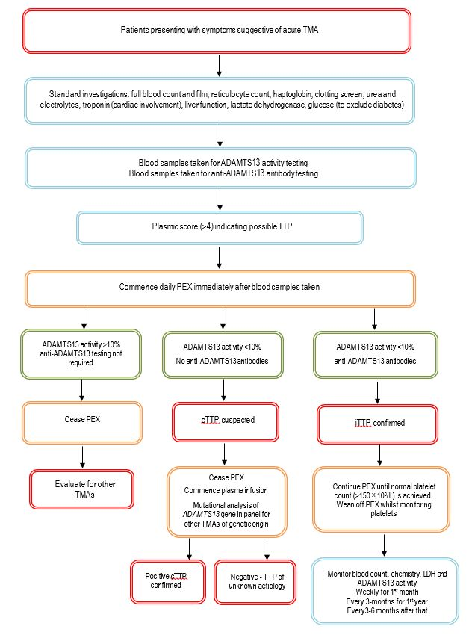

## Define and summarise the clinical management algorithm, including any required tests or healthcare resources, *after* the use of the comparator health technology:

Provide your response here

## Describe and explain any differences in the healthcare resources used *after* the proposed health technology vs. the comparator health technology:

Provide your response here

## Insert diagrams demonstrating the clinical management algorithm with and without the proposed health technology:

*(Please ensure that the diagrams provided do not contain information under copyright)*

See above

# Claims

## In terms of health outcomes (comparative benefits and harms), is the proposed technology claimed to be superior, non-inferior or inferior to the comparator(s)?

*(Please select your response)*

Superior

Non-inferior

Inferior

## Please state what the overall claim is, and provide a rationale:

Rapid identification of patients presenting with symptoms of TTP enables appropriate treatment to be administered. In the absence of any treatment, patients with undiagnosed TTP have a mortality rate of approximately 90%. Once appropriate (optimal) treatment is received, mortality rates will decrease to approximately 10%. On suspicion of TTP, patients should be administered daily PEX therapy to improve ADAMTS13 activity and decrease anti-ADAMTS13 antibodies. However, for those patients who have congenital TTP (no anti-ADAMTS13 antibodies), PEX therapy should be ceased, and they should receive only plasma infusions to improve ADAMTS13 activity.

## Why would the requestor seek to use the proposed investigative technology rather than the comparator(s)?

There are many tests that should be conducted when a patient presents; however, **many of these are necessary but not sufficient to provide a diagnosis of TTP but rather indicate that the patient may be experiencing a thrombotic microangiopathy**

## Identify how the proposed technology achieves the intended patient outcomes:

Provide your response here

## For some people, compared with the comparator(s), does the test information result in:

*(Please answer either Yes or No, deleting text as required)*

**A change in clinical management?** YES

**A change in health outcome?** Yes

**Other benefits?**  Yes

## Please provide a rationale, and information on other benefits if relevant:

Patient benefits – by identifying patients with iTTP appropriate treatment can be provided to both iTTP patients and those with other TMAs.

Health system savings - Rapid ADAMTS13 testing for patients yields significant per patient cost savings, achieved by reducing the costs associated with unnecessary therapeutic plasma exchange and other therapies in patients *without* iTTP.

## In terms of the immediate costs of the proposed technology (and immediate cost consequences, such as procedural costs, testing costs etc.), is the proposed technology claimed to be more costly, the same cost or less costly than the comparator?

*(Please select your response)*

More costly

Same cost

Less costly

## Provide a brief rationale for the claim:

As there is no true comparator, then costs of testing will be greater compared to no ADAMTS-13 testing. However, there are significant savings associatd with the appropriate treatment

* ceasing PEX treatment of non-iTTP patients
* reduced morbidity, mortality and hospitalisations associated with undiagnosed iTTP

**If your application is in relation to a specific radiopharmaceutical(s) or a set of radiopharmaceuticals, identify whether your clinical claim is dependent on the evidence base of the radiopharmaceutical(s) for which MBS funding is being requested. If your clinical claim is dependent on the evidence base of another radiopharmaceutical product(s), a claim of clinical noninferiority between the radiopharmaceutical products is also required.**

N/A

# Summary of Evidence

## Provide one or more recent (published) high quality clinical studies that support use of the proposed health service/technology.

| Type of study design* | Title of journal article or research project | Short description of research (max 50 words)** | Website link to journal article or research |
| --- | --- | --- | --- |
| Guideline  UK8 | A British Society for Haematology Guideline: Diagnosis and management of thrombotic thrombocytopenic purpura and thrombotic microangiopathies | To provide healthcare professionals with clear, up-to-date and practical guidance on the management of TTP and related TMAs, including complement-mediated haemolytic uraemic syndrome (CM HUS); these are defined by thrombocytopenia, microangiopathic haemolytic anaemia (MAHA) and small vessel thrombosis. Within England, all TTP cases should be managed within designated regional centres as per NHSE commissioning for highly specialised services. | <https://pubmed.ncbi.nlm.nih.gov/37586700/> |
| Guidelines  Australia and New Zealand4 | Consensus opinion on diagnosis and management of thrombotic microangiopathy in Australia and New Zealand | TMA should be considered in all patients with thrombocytopenia and anaemia, with an immediate request to the haematology laboratory to look for red cell fragments on a blood film. Although TMA of any aetiology generally demands prompt treatment, this is especially so in thrombotic thrombocytopenic purpura (TTP) and atypical haemolytic uraemic syndrome (aHUS), where organ failure may be precipitous, irreversible and fatal. In all adults, urgent, empirical plasma exchange (PE) should be started within 4-8 h of presentation for a possible diagnosis of TTP, pending a result for ADAMTS13 activity. A sodium citrate plasma sample should be collected for ADAMTS13 testing prior to any plasma therapy. | <https://pubmed.ncbi.nlm.nih.gov/29582550/> |
| Guidelines 3 | ISTH guidelines for the diagnosis of thrombotic thrombocytopenic purpura | In settings with a timely access to plasma ADAMTS13 activity testing and for patients with a high clinical suspicion (≥90% pre-test probability) of iTTP (eg based on clinical assessment or a formal clinical risk assessment method), the panel suggests the following diagnostic strategy. (A conditional recommendation in the context of low certainty evidence.)  Step 1: Acquire a plasma sample for ADAMTS13 testing (eg ADAMTS13 activity and inhibitors or anti-ADAMTS13 IgG) before an initiation of TPE or use of any blood product. | <https://pubmed.ncbi.nlm.nih.gov/32914582/> |
| Guideline  Japan 9 | Diagnostic and treatment guidelines for thrombotic thrombocytopenic purpura (TTP) in Japan 2023 | TTP has mainly been diagnosed by clinical findings such as thrombocytopenia and haemolytic anaemia. In addition to these clinical findings, however, reduced activity of a disintegrin-like and metalloprotease with thrombospondin type 1 motif 13 (ADAMTS13) below 10% has become internationally accepted as a diagnostic criterion for TTP. | <https://pubmed.ncbi.nlm.nih.gov/37689812/> |
| Endorsement of ISTH guidelines 10 | European Renal Best Practice endorsement of guidelines for diagnosis and therapy of thrombotic thrombocytopaenic purpura published by the International Society on Thrombosis and Haemostasis: A European Renal Best Practice (ERBP) endorsement of ISTH Guidelines for Treatment of Thrombotic Thrombocytopaenic Purpura (TTP) with some refinements for Europe | The ERBP working group endorsed the 2020 ISTH guidelines for the diagnosis and treatment of thrombotic thrombocytopenic purpura and urge establishing ADAMTS13 activity measurements in TTP centres across Europe to shorten the time to TTP diagnosis and to prevent a clinical relapse in the follow-up period. | <https://pubmed.ncbi.nlm.nih.gov/35195251/> |
| Cost-effectiveness  USA 11 | Cost-effectiveness of rapid vs in-house vs send-out ADAMTS13 testing for immune thrombotic thrombocytopenic purpura | While awaiting confirmatory results, empiric therapy for patients suspected to have iTTP provides benefits and also accrues risks and costs. Rapid assays for ADAMTS13 may be able to avoid the cost and risk exposure associated with empiric treatment. A cost-effectiveness evaluation of testing strategies with rapid vs traditional ADAMTS13 assays in patients with intermediate- to high-risk PLASMIC scores, with and without caplacizumab use was conducted. A Markov cohort simulation with 4 clinical base-case analyses: (1) intermediate-risk PLASMIC score with caplacizumab; (2) intermediate-risk PLASMIC score without caplacizumab; (3) high-risk PLASMIC score with caplacizumab; and (4) high-risk PLASMIC score without caplacizumab. Each of these evaluated 3 testing strategies: (1) rapid assay (<1-hour turnaround); (2) in-house FRET–based assay (24-hour turnaround); and (3) send-out FRET-based assay (72-hour turnaround). Primary outcome was the incremental net monetary benefit reported over a 3-day time horizon. While accruing the same amount of QALYs, the rapid assay strategy saved up to $46 820 per patient tested. No parameter variation changed the outcome. Sensitivity analyses favoured the rapid assay strategy in 100% across 100 000 Monte Carlo. Rapid ADAMTS13 testing for patients with intermediate or high-risk PLASMIC scores yields significant per patient cost savings, achieved by reducing the costs associated with unnecessary therapeutic plasma exchange and caplacizumab therapy in patients without iTTP. | <https://pubmed.ncbi.nlm.nih.gov/38502197/> |
| Cost-effectiveness  USA 12 | Potential impact of a delayed ADAMTS13 result in the treatment of thrombotic microangiopathy: an economic analysis | Pre-plasma exchange ADAMTS13 measurement differentiates TTP from other forms of thrombotic microangiopathy (TMA). An analysis investigating the potential impact of a delay in obtaining the results on the healthcare system was performed. An economic model was developed to estimate the impact of a delay in obtaining the pre-treatment ADAMTS13 results on patients admitted with. Incremental cost-effectiveness ratio (ICER) as a composite outcome was calculated from both cost and life days [LDs], an effectiveness surrogate marker. In patients with TMA, during the 6-day study period, the incremental cost to the healthcare system ranged from approximately $4,155 to $5,123 for every 1-day delay in obtaining the pre-exchange ADAMTS13 results with virtually no change in the effectiveness marker. The ICER composite outcome established the cost-effectiveness of having a fast TAT for pre-exchange ADAMTS13 results. Probabilistic sensitivity analyses also confirmed the robustness of the model. In patients with clinical presentations of TMAs, having a rapid TAT for pre-exchange ADAMTS13 measurement appeared to be cost-effective. If testing cannot be performed in-house, then our findings support the necessity of contracting with a reference laboratory that can reliably provide the result, preferably within 1 day of admission | <https://pubmed.ncbi.nlm.nih.gov/32227485/> |
| Economic impact  Multi-centre 13 | Economic impact of a rapid, on-demand ADAMTS-13 activity assay for the diagnosis of thrombotic thrombocytopenic purpura | Comparison of a rapid TAT scenario using an on-demand assay versus a standard TAT scenario in which it takes an average of 3 days to receive results. Model includes all adults hospitalized with TMA (due to TTP, aHUS, STEC-HUS, or other TMA diagnoses that would need differential diagnosis). Assumed that all patients with TMA would receive TPE until TTP was excluded based on the ADAMTS-13 assay result. On-demand, rapid ADAMTS-13 activity assay is used, would be cost-saving, saving US$10 788, £3497, and €4700 per patient with TMA in the United States, United Kingdom, and France. | <https://pubmed.ncbi.nlm.nih.gov/35599707/> |
| Cohort  USA 14 | Impact of severe ADAMTS13 deficiency on clinical presentation and outcomes in patients with thrombotic microangiopathies: the experience of the Harvard TMA Research Collaborative | 254 patients with symptoms suggestive of thrombotic microangiopathy underwent ADAMTS13 activity testing, 68 patients had an ADAMTS13 activity level <10% (severe deficiency) and 186 had a level >10%. Overall, 95.6% of patients with severe ADAMTS13 deficiency received TPE compared to 38.2% of patients with an ADAMTS13 level >10%. Both the median number of TPE treatments and units of plasma transfused were significantly higher in the group with severe ADAMTS13 deficiency compared to the group with an ADAMTS13 activity level of >10%: 11 versus 5 treatments and 125 versus 51 units, respectively. Patients with severe ADAMTS13 deficiency had significantly shorter hospitalization periods (9 d vs. 14 d) and more rapid platelet count recovery to (4 d vs. 6 d). Patients with severe deficiency were also more likely to be alive at both 90 and 360 d and had longer median overall survival compared to those without severe deficiency (1384 d vs. 126 d). | <https://pubmed.ncbi.nlm.nih.gov/26314936/> |
| Cohort  USA 15 | Role of ADAMTS13 in the management of thrombotic microangiopathies including thrombotic thrombocytopenic purpura (TTP) | 60 patients presenting with thrombotic microangiopathy were divided into two groups based on ADAMTS13 activity and clinical history. Patients with ADAMTS13 activity <10% were included in the TTP (n = 30) cohort while patients with activity >11% were classified as ‘other microangiopathies’. PLEX was only initiated in patients with a high likelihood of TTP and discontinued when the baseline ADAMTS13 activity was >11%. Patients with severe ADAMTS13 deficiency (TTP group) showed significant presenting differences: lower platelet counts, less renal dysfunction, higher presence of neurological abnormalities, and greater haemolysis markers as compared to non-deficient patients (TMA group). Most importantly, patients without severe ADAMTS13 deficiency were safely managed without increased mortality despite receiving no PLEX or discontinuing PLEX after a short course (upon availability of ADAMTS13 results). In conclusion, ADAMTS13 can be used to diagnose TTP and guide appropriate PLEX therapy. | <https://pubmed.ncbi.nlm.nih.gov/24111495/> |
| Case series  Canada 16 | Incidence of thrombotic microangiopathies in Quebec: insight from a laboratory centralizing ADAMTS-13 testing | 846 patients were evaluated for plasma ADAMTS-13 activity due to a suspicion of TMA. TTP was identified in 147 patients. The number of ADAMTS-13 tests performed and the number of patients with suspected TMA increased annually by 19% and 21% respectively. While the incidence of non-TTP TMA increased annually, that for TTP remained unchanged. The increase in ADAMTS-13 testing may be due to a growing awareness among physicians of the existence of TMAs and ADAMTS-13 testing. | <https://pubmed.ncbi.nlm.nih.gov/35927768/> |
| Retrospective case series  Canada 6 | Indicators Differentiating Thrombotic Thrombocytopenic Purpura From Other Thrombotic Microangiopathies in a Canadian Apheresis Referral Center | 100 patients presenting with a first episode of TMA. ADAMTS13 activity below 10% was identified in 35 of 100 cases, confirming a diagnosis of TTP. Clinical and laboratory parameters including PLASMIC scoring may lead to misdiagnosis in some cases of TMA. ADAMST13 activity testing provides definitive diagnosis of TTP, supporting the role of rapid turnaround ADAMTS13 testing for appropriate treatment of TMA. 12 patients received ADAMTS13 testing in the absence of TMA and were confirmed to have no TMA. | <https://pubmed.ncbi.nlm.nih.gov/34160013/> |
| Case series  Italy 17 | Lombardy diagnostic and therapeutic network of thrombotic microangiopathy | 44 consecutive patients presenting with symptoms of TMA, requiring plasma exchange therapy. Thirty-five patients (81%) had at presentation a severe deficiency of ADAMTS13 activity (< 10% of normal value), 8 (19%) had values = 10%. Overall, 30 of 44 were first acute TMA events (68%), 22 (63%) among patients with severe ADAMTS13 deficiency. PEX treatment was initiated in all patients, but discontinued in cases without severe ADAMTS13 deficiency. In this group, the mortality rate was higher and no episode exacerbations or relapses within 6 months occurred. | <https://pubmed.ncbi.nlm.nih.gov/35739601/> |
| Case series  USA 18 | Rapid ADAMTS13 Availability Impacts Treatment for Microangiopathic Hemolytic Anemia and Thrombocytopenia | The current and prior reference laboratories had an average TAT of 63 h (range 28–115 h, SD 27 h) and 123 h (range 83–158 h, SD 34 h) respectively. Of 14 patients, 4 had severe acquired ADAMTS13 deficiency (<10% activity) consistent with a diagnosis of TTP, one of whom died before the ADAMTS13 results returned. Remaining 3 patients completed a course of daily TPE until the platelet count was above 150 x109/L. The remaining 10 patients had an average ADAMTS13 activity of 67% (range 33–100%, SD 24.5%). In 7 patients, TPE treatment was either discontinued immediately after ADAMTS13 results became available (n=6) or after one additional procedure (n=1).  For the 7 patients with intermediate or normal ADAMTS13 activity for whom TPE was discontinued based on ADAMTS13 results, the quicker TAT resulted in a statistically significant reduction in the number of TPE procedures performed. | <https://pubmed.ncbi.nlm.nih.gov/26332753/> |
| Case series  USA 19 | Longitudinal assessments of plasma ADAMTS13 biomarkers predict recurrence of immune thrombotic thrombocytopenic purpura | 83 unique iTTP patients with 97 episodes. Plasma levels of ADAMTS13 activity, antigen, and anti-ADAMTS13 IgG on admission showed no significant value in predicting iTTP exacerbation or recurrence. However, persistently low plasma ADAMTS13 activity (<10 U/dL) or high anti-ADAMTS13 IgG (HR 3.1) 3 to 7 days after the initiation of therapeutic plasma exchange was associated with an increased risk for exacerbation or recurrence. Low plasma ADAMTS13 activity (<10 IU/dL) and low ADAMTS13 antigen (<25th percentile; HR 3.3) or high anti-ADAMTS13 IgG (>75th percentile; HR 2.6) at clinical response or remission was also predictive of exacerbation or recurrence. | <https://pubmed.ncbi.nlm.nih.gov/31856267/> |
| Retrospective case series  UK 20 | The utility of ADAMTS13 in differentiating TTP from other acute thrombotic microangiopathies: results from the UK TTP Registry | Over the 5-year period (2009–2013) there were a total of 810 samples referred for ADAMTS13 testing, which resulted in final diagnoses of 350 TTP cases and 460 non-TTP cases. Patients with TTP had a significantly lower median ADAMTS13 levels (5%, range 0–11) than patients with aHUS (66·5%, range 12–119, P < 0·0001), HUS (56%, range 11–82, P < 0·0001), or MAHA/TMA (51%, range 5–105, P < 0·0001). Patients with TTP had a median platelet count of 15 × 109/l (range 0–96), which was significantly lower than patients with aHUS (57 × 109/l; range 13–145, P < 0·0001) or HUS (35 × 109/l; range 14–106, P < 0·0001). | <https://pubmed.ncbi.nlm.nih.gov/26359646/> |
| Retrospective comparative  UK 21 | ADAMTS13 activity testing: evaluation of commercial platforms for diagnosis and monitoring of thrombotic thrombocytopenic purpura | 94 samples from patients with suspected TTP analysed by method:  FRETS-VWF73 vs. chemiluminescent assay (Acustar) n= 88, r = 0.84 FRETS-VWF73 vs. ELISA assay (Technozym) n= 68, r = 0.92 FRETS-VWF73 vs. FRETS assay (Ceveron) n= 48, r = 0.97  32 TMA presentation samples were tested, of which TTP was confirmed in 13 cases. All 4 platforms showed results <10 IU/dL for the TTP samples tested, suggesting comparable sensitivity. 5 of the 19 (26%) remaining TMA samples had discrepant results between AcuStar and FRETS-VWF73, suggesting TTP in the AcuStar assay. These cases were not confirmed as TTP, it suggests a somewhat lower specificity of the AcuStar assay. | <https://pubmed.ncbi.nlm.nih.gov/37063760/> |
| Retrospective case series  USA 22 | Use of the ADAMTS13 Activity Assay Improved the Accuracy and Efficiency of the Diagnosis and Treatment of Suspected Acquired Thrombotic Thrombocytopenic Purpura | A retrospective analysis was performed including 152 patients with clinically suspected TTP, screened using the ADAMTS13 activity assay. Results were correlated with potential PEX for all cases highly suspicious for TTP and evaluated for unnecessary patient morbidity and financial cost. ADAMTS13 activity assay had an overall sensitivity and specificity of 100% and 99%, respectively. PPV and NPV were 91% and 100%, respectively. In 95% of the studies ordered, TTP was ruled out, leading to decreased patient morbidity and avoidance of costs. | <https://pubmed.ncbi.nlm.nih.gov/24678685/> |

Identify yet-to-be-published research that may have results available in the near future (that could be relevant to your application).

| Type of study design* | Title of research (including any trial identifier if relevant) | Short description of research (max 50 words)** | Website link to research (if available) | Date*** |
| --- | --- | --- | --- | --- |
| Retrospective Comparative Multi-centre – Spain and Portugal | Improvement of Immunologic and Molecular Techniques for the Diagnosis and Follow-up of Patients With Thrombotic Thrombocytopenic Purpura | 500 frozen plasma samples analysed using fully automated HemosIL AcuStar ADAMTS13 Activity assay has been developed. - a 2-step chemiluminescent immunoassay (CLIA) with an analytical time of 33 minutes for the quantitative measurement of ADAMTS13 activity versus ELISA, DG-EIA ADAMTS13 Activity and FRETS-VWF73 for ADAMTS13 Activity Assay | [NCT05046717](https://clinicaltrials.gov/study/NCT05046717?cond=Thrombotic%20Thrombocytopenic%20Purpura&term=Thrombotic%20Microangiopathies&intr=ADAMTS13%20Activity%20Assays&rank=1) | Estimated completion data  30-06-2025- |

**REFERENCES:**

1. Sukumar, S., Lämmle, B.& Cataland, S. R. (2021). 'Thrombotic Thrombocytopenic Purpura: Pathophysiology, Diagnosis, and Management'. *J Clin Med*, 10 (3).

2. Masias, C.& Cataland, S. R. (2018). 'The role of ADAMTS13 testing in the diagnosis and management of thrombotic microangiopathies and thrombosis'. *Blood*, 132 (9), 903-10.

3. Zheng, X. L., Vesely, S. K. et al (2020). 'ISTH guidelines for the diagnosis of thrombotic thrombocytopenic purpura'. *J Thromb Haemost*, 18 (10), 2486-95.

4. Fox, L. C., Cohney, S. J. et al (2018). 'Consensus opinion on diagnosis and management of thrombotic microangiopathy in Australia and New Zealand'. *Nephrology (Carlton)*, 23 (6), 507-17.

5. Favaloro, E. J., Pasalic, L. et al (2021). 'Laboratory testing for ADAMTS13: Utility for TTP diagnosis/exclusion and beyond'. *Am J Hematol*, 96 (8), 1049-55.

6. Martin, S. D., McGinnis, E.& Smith, T. W. (2021). 'Indicators Differentiating Thrombotic Thrombocytopenic Purpura From Other Thrombotic Microangiopathies in a Canadian Apheresis Referral Center'. *Am J Clin Pathol*, 156 (6), 1103-12.

7. Moore, G. W., Griffiths, M.& Binder, N. B. (2023). 'ADAMTS13 Activity: Screening Test Protocol'. *Methods Mol Biol*, 2663, 523-31.

8. Scully, M., Rayment, R. et al (2023). 'A British Society for Haematology Guideline: Diagnosis and management of thrombotic thrombocytopenic purpura and thrombotic microangiopathies'. *Br J Haematol*, 203 (4), 546-63.

9. Matsumoto, M., Miyakawa, Y. et al (2023). 'Diagnostic and treatment guidelines for thrombotic thrombocytopenic purpura (TTP) in Japan 2023'. *Int J Hematol*, 118 (5), 529-46.

10. Eller, K., Knoebl, P. et al (2022). 'European Renal Best Practice endorsement of guidelines for diagnosis and therapy of thrombotic thrombocytopaenic purpura published by the International Society on Thrombosis and Haemostasis'. *Nephrol Dial Transplant*, 37 (7), 1229-34.

11. Allen, C., Ito, S. et al (2024). 'Cost-effectiveness of rapid vs in-house vs send-out ADAMTS13 testing for immune thrombotic thrombocytopenic purpura'. *Blood Adv*, 8 (9), 2279-89.

12. Kim, C. H., Simmons, S. C. et al (2020). 'Potential impact of a delayed ADAMTS13 result in the treatment of thrombotic microangiopathy: an economic analysis'. *Vox Sang*, 115 (5), 433-42.

13. White, A., Martin, R. et al (2022). 'Economic impact of a rapid, on-demand ADAMTS-13 activity assay for the diagnosis of thrombotic thrombocytopenic purpura'. *Res Pract Thromb Haemost*, 6 (4), e12711.

14. Bendapudi, P. K., Li, A. et al (2015). 'Impact of severe ADAMTS13 deficiency on clinical presentation and outcomes in patients with thrombotic microangiopathies: the experience of the Harvard TMA Research Collaborative'. *Br J Haematol*, 171 (5), 836-44.

15. Shah, N., Rutherford, C. et al (2013). 'Role of ADAMTS13 in the management of thrombotic microangiopathies including thrombotic thrombocytopenic purpura (TTP)'. *Br J Haematol*, 163 (4), 514-9.

16. Merlen, C., Pepin, E. et al (2022). 'Incidence of thrombotic microangiopathies in Quebec: insight from a laboratory centralizing ADAMTS-13 testing'. *Orphanet J Rare Dis*, 17 (1), 308.

17. Mancini, I., Agosti, P. et al (2022). 'Lombardy diagnostic and therapeutic network of thrombotic microangiopathy'. *Orphanet J Rare Dis*, 17 (1), 246.

18. Martin, I. W., Katus, M. C. et al (2016). 'Rapid ADAMTS13 availability impacts treatment for microangiopathic hemolytic anemia and thrombocytopenia'. *J Clin Apher*, 31 (5), 419-22.

19. Sui, J., Cao, W. et al (2019). 'Longitudinal assessments of plasma ADAMTS13 biomarkers predict recurrence of immune thrombotic thrombocytopenic purpura'. *Blood Adv*, 3 (24), 4177-86.

20. Hassan, S., Westwood, J. P. et al (2015). 'The utility of ADAMTS13 in differentiating TTP from other acute thrombotic microangiopathies: results from the UK TTP Registry'. *Br J Haematol*, 171 (5), 830-5.

21. Singh, D., Subhan, M. O. et al (2023). 'ADAMTS13 activity testing: evaluation of commercial platforms for diagnosis and monitoring of thrombotic thrombocytopenic purpura'. *Res Pract Thromb Haemost*, 7 (2), 100108.

22. Barrows, B. D.& Teruya, J. (2014). 'Use of the ADAMTS13 activity assay improved the accuracy and efficiency of the diagnosis and treatment of suspected acquired thrombotic thrombocytopenic purpura'. *Arch Pathol Lab Med*, 138 (4), 546-9.

23. Roose, E.& Joly, B. S. (2020). 'Current and Future Perspectives on ADAMTS13 and Thrombotic Thrombocytopenic Purpura'. *Hamostaseologie*, 40 (3), 322-36.

24. Tse, B., Buchholz, M.& Pavenski, K. (2023). 'Management of immune thrombotic thrombocytopenic purpura with caplacizumab: a Canadian, single-centre, real-world experience'. *Platelets*, 34 (1), 2157807.

25. Devreese, K. (2023). 'DIAGNOSIS OF ACQUIRED THROMBOTIC THROMBOCYTOPENIC PURPURA'.Conference Proceeding: INTERNATIONAL JOURNAL OF LABORATORY HEMATOLOGY; In *DIAGNOSIS OF ACQUIRED THROMBOTIC THROMBOCYTOPENIC PURPURA*, 45, 32-, <https://www.bjh.be/diagnosis-of-acquired-thrombotic-thrombocytopenic-purpura/>.

26. Blombery, P., Kivivali, L. et al (2016). 'Diagnosis and management of thrombotic thrombocytopenic purpura (TTP) in Australia: findings from the first 5 years of the Australian TTP/thrombotic microangiopathy registry'. *Intern Med J*, 46 (1), 71-9.

27. Kim, C. H., Simmons, S. C. et al (2017). 'ADAMTS13 test and/or PLASMIC clinical score in management of acquired thrombotic thrombocytopenic purpura: a cost-effective analysis'. *Transfusion*, 57 (11), 2609-18.

28. Moore, G. W., Vetr, H.& Binder, N. B. (2023). 'ADAMTS13 Antibody and Inhibitor Assays'. *Methods Mol Biol*, 2663, 549-65.

29. Favaloro, E. J., Chapman, K. et al (2023). 'Automated and Rapid ADAMTS13 Testing Using Chemiluminescence: Utility for Identification or Exclusion of TTP and Beyond'. *Methods Mol Biol*, 2663, 487-504.

30. Gavriilaki, E., Nikolousis, E. et al (2023). 'Caplacizumab for immune thrombotic thrombocytopenic purpura: real-world multicenter data'. *Front Med (Lausanne)*, 10, 1226114.

31. Picod, A., Provot, F.& Coppo, P. (2019). 'Therapeutic plasma exchange in thrombotic thrombocytopenic purpura'. *Presse Med*, 48 (11 Pt 2), 319-27.