**MSAC Application 1800**

**IncobotulinumtoxinA (XEOMIN) injection code for chronic sialorrhea treatment**

**PICO Set**

# Population

## Describe the population in which the proposed health technology is intended to be used:

Children and adolescents aged 2-17 years with chronic sialorrhea due to neurological or neurodevelopmental disorders, and adults (≥18 years) with chronic sialorrhea due to neurological disorders.

## Specify any characteristics of patients with, or suspected of having, the medical condition, who are proposed to be eligible for the proposed health technology, describing how a patient would be investigated, managed and referred within the Australian healthcare system in the lead up to being considered eligible for the technology:

Sialorrhea (excessive drooling) is an excess spillage of saliva over the lip margin. Sialorrhea is generally diagnosed by clinical assessment on the basis of the experience of the patients and parents/caregivers as well as the observations by healthcare professionals. However, the most commonly used quantitative measure to describe the severity of sialorrhea is the Drooling Severity and Frequency Scale (DSFS).

A combined score of 6 or more indicates on the DSFS is required to initiate treatment with incobotulinumtoxinA.

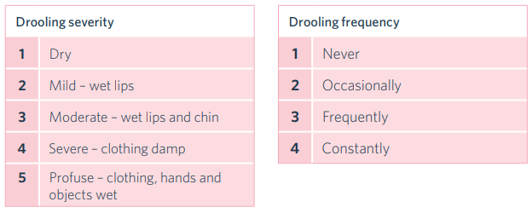

Figure 1.1.1. Drooling Severity and Frequency Scale (DSFS)

Sialorrhea may be due to excessive saliva production or excessive pooling of saliva in the anterior oral cavity secondary to poor swallowing and is usually caused by neuromuscular dysfunction (e.g., Parkinson’s disease, stroke, cerebral palsy), hypersecretion (e.g., medication side effects, gastroesophageal reflux disease), or anatomic abnormalities (e.g., macroglossia, oral incompetence, dental malocclusion). Paediatric sialorrhea can be associated with general physical disability such as infantile cerebral palsy, with other neurodevelopmental disorders or intellectual disability, metabolic diseases, and neurodegenerative diseases.

The target population have sialorrhea as a result of neurological and neurodevelopment disorders, rather than temporary hypersecretion or anatomic abnormalities.

## Provide a rationale for the specifics of the eligible population:

Patients with severe chronic sialorrhea can suffer from quality-of-life issues (such as social isolation) and unintelligible speech to facial skin maceration and even increased morbidity and mortality due to dehydration, choking, aspiration, and pneumonia [1-5].

The evidence base for the safety and efficacy of incobotulinumtoxinA has been established in adult and paediatric populations with neurological conditions, rather than those with other conditions which may lead to excessive drooling.

## Are there any prerequisite tests?

No.

## Are the prerequisite tests MBS funded?

N/A

## Provide details to fund the prerequisite tests:

N/A

# Intervention

## Name of the proposed health technology:

IncobotulinumtoxinA (brand name: Xeomin®)

## Describe the key components and clinical steps involved in delivering the proposed health technology:

Xeomin consists of a white to off-white powder for solution for injection. Each vial of Xeomin powder for solution for injection contains 50 or 100 units of incobotulinumtoxinA. Xeomin is reconstituted prior to use with sodium chloride 9 mg/mL (0.9%) solution for injection. A suitable sterile needle should be used for administration. Reconstituted Xeomin is injected intraglandularly using a suitable sterile needle (e.g. 27-30 gauge/0.30-0.40 mm diameter/12.5  mm length).

For adults, a reconstituted solution at a concentration of 5 units/0.1 mL should be used. Xeomin is injected into the parotid and submandibular glands on both sides (four injections per treatment in total). The injection site should be close to the centre of the gland. In adults, anatomic landmarks or ultrasound guidance are both possible for the localisation of the involved salivary glands.

The recommended and total maximum dose per treatment session is 100 units. The dose is divided with a ratio of 3:2 between the parotid and submandibular glands as indicated in Table 1.

Table 1 Dosing by gland for treatment of chronic sialorrhea (adults)

|  |  |  |
| --- | --- | --- |
| **Glands** | **Units** | **Volume** |
| Parotid glands | 30 per side | 0.6 ml per injection |
| Submandibular glands | 20 per side | 0.4 ml per injection |

For children and adolescents ages 2 to 17 years, a reconstituted solution at a concentration of 2.5 units/0.1 mL should be used. The same number of injections should be administered in the same way they are for adults and described above.

In children and adolescents, ultrasound guidance should be used for the localisation of the involved salivary glands. Local anaesthesia (such as local anaesthetic cream), sedation, or anaesthesia in combination with sedation may be offered to children prior to injection after a careful benefit-risk evaluation and per local site practice.

Dosing for children and adolescents, however, should be administered by body weight class and the total dose should not exceed 75 units per treatment session as detailed in Table 2. For children weighing less than 12kg no data are available and therefore no dosing recommendations can be made for children weighing less than 12kg.

Table 2 Dosing by Body Weight and Gland for Treatment of Chronic Sialorrhea (children/adolescents)

|  |  |  |  |  |  |
| --- | --- | --- | --- | --- | --- |
| **Body weight** | **Parotid gland, each side** | | **Submandibular gland each side** | | **Total dose, both glands, both sides** |
| **Dose per gland** | **Volume per injection** | **Dose per gland** | **Volume per injection** |
| [kg] | [Units] | [ml] | [Units] | [ml] | [Units] |
| ≥ 12 and < 15 | 6 | 0.24 | 4 | 0.16 | 20 |
| ≥ 15 and < 19 | 9 | 0.36 | 6 | 0.24 | 30 |
| ≥ 19 and < 23 | 12 | 0.48 | 8 | 0.32 | 40 |
| ≥ 23 and < 27 | 15 | 0.60 | 10 | 0.40 | 50 |
| ≥ 27 and < 30 | 18 | 0.72 | 12 | 0.48 | 60 |
| ≥ 30 | 22.5 | 0.90 | 15 | 0.60 | 75 |

## **Identify how the proposed technology achieves the intended patient outcomes**:

Xeomin blocks cholinergic transmission at the neuromuscular junction by inhibiting the release of acetylcholine from peripheral cholinergic nerve terminals. This inhibition occurs according to the following sequence:

* heavy chain of toxin binding to cholinergic nerve terminals
* internalization of the toxin within vesicles into the nerve terminal
* translocation of the light-chain of the toxin molecule into the cytosol of the nerve terminal
* enzymatic cleavage of SNAP25, the presynaptic target protein essential for the release of acetylcholine.

Complete recovery of endplate function/impulse transmission after intramuscular injection normally occurs within 3-4 months as nerve terminals sprout and reconnect with the muscle endplate and the presynaptic neurotransmitter release mechanism becomes functional again.

## Does the proposed health technology include a registered trademark component with characteristics that distinguishes it from other similar health components?

Yes.

## Explain whether it is essential to have this trademark component or whether there would be other components that would be suitable:

IncobotulinumtoxinA (Xeomin®) is the only botulinum toxin preparation that is TGA-indicated for the treatment of chronic sialorrhea.

## Are there any proposed limitations on the provision of the proposed health technology delivered to the patient (For example: accessibility, dosage, quantity, duration or frequency):

Yes – the service can only be delivered once every 16 weeks.

## Provide details and explain:

Provide a response if you answered 'No' to the question above

## If applicable, advise which health professionals will be needed to provide the proposed health technology:

Neurologists, rehabilitation specialists, ENT surgeons, and plastic surgeons can provide the service to both adult and paediatric populations, in addition to geriatricians in the adult population, and paediatricians in the paediatric population.

## If applicable, advise whether delivery of the proposed health technology can be delegated to another health professional:

N/A.

## If applicable, advise if there are any limitations on which health professionals might provide a referral for the proposed health technology:

The service providers will be the service referrers.

## Is there specific training or qualifications required to provide or deliver the proposed service, and/or any accreditation requirements to support delivery of the health technology?

Yes

## Provide details and explain:

Merz Australia provide training workshops throughout the year in injections and ultrasound use with the aid of a sonographer. Workshops are provided for a range of existing indications which incobotulinumtoxinA treats and will be provided for use in the chronic sialorrhea population also.

## Indicate the proposed setting(s) in which the proposed health technology will be delivered:

Consulting rooms

Day surgery centre

Emergency Department

Inpatient private hospital

Inpatient public hospital

Laboratory

Outpatient clinic

Patient’s home

Point of care testing

Residential aged care facility

Other (please specify)

## Is the proposed health technology intended to be entirely rendered inside Australia?

Yes

## Provide additional details on the proposed health technology to be rendered outside of Australia:

N/A

# Comparator

## Nominate the appropriate comparator(s) for the proposed medical service (i.e., how is the proposed population currently managed in the absence of the proposed medical service being available in the Australian healthcare system). This includes identifying healthcare resources that are needed to be delivered at the same time as the comparator service:

In both adults and paediatric patients, there is no standard comparator for a proposed incobotulinumtoxinA (Xeomin) listing. There are currently no PBS listed items for chronic sialorrhea, nor specific MBS services.

The comparator then is supportive care via current clinical management.

## List any existing MBS item numbers that are relevant for the nominated comparators:

N/A

## Provide a rationale for why this is a comparator:

*Adults with neurological disorders*

As part of the PBAC submission, the sponsor conducted a survey of Australian clinicians to determine the place of Xeomin in treatment for sialorrhea. Based on responses, the percentage of adult patients with chronic sialorrhea who receive conservative treatment, such as behavioural or physical therapy, is around 7% and treatment with oral devices is only used in approximately 1%. Anticholinergics are prescribed in around 37% of patients and botulinum toxin injections are given to around 31%. Clinicians indicated that surgical removal/relocation of salivary glands or radiation of salivary glands is only performed in approximately 2% of patients for either. Clinicians also advised that 20% of patients would receive no treatment.

Currently there are no official, detailed guidelines for managing sialorrhea in adults with neurological disorders in Australia. According to the Australian Therapeutic Guidelines[1], patients who present with sialorrhea as a complication of Parkinson’s disease should be referred for *“expert advice”*. The guidelines state that first-line treatment for sialorrhea in these patients is considered to be botulinum toxin type A injections in the salivary glands.

Based on the survey responses, and with the limited information in the Australian therapeutic guidelines, it can be reasonably assumed that following conservative treatment measures, the majority of adult patients with chronic sialorrhea would be prescribed either anticholinergic medications or botulinum toxin injections.

*Children and adolescents with neurological/neurodevelopmental disorders*

According to the Australian Therapeutic Guidelines, management of sialorrhea includes addressing underlying issues and interventions to improve saliva control. These include behaviour modification (e.g., encouraging swallowing more frequently), biofeedback and oral motor therapy (e.g., providing exercises to assist mouth closure), and referral to a specialist saliva control clinic, speech pathologist and rehabilitation physician.

The guidelines note that *“evidence for pharmacological therapy to manage excessive saliva is limited; anticholinergic drugs (eg trihexyphenidyl [benzhexol], benzatropine, glycopyrronium bromide [glycopyrrolate]) may be helpful in drying secretions in cerebral palsy, but adverse effects can be significant.”* The guidelines also listinjection of Botulinum toxin A into salivary glands*,* removal of salivary glands or redirection of salivary ducts as other potential treatment options. Clinicians are advised to use the Royal Children’s Hospital guide on saliva control in children[2] for further details on strategies to manage sialorrhea.

The guide on saliva control published by the Royal Children Hospital describes five strategies to manage saliva in children, these include:

1. Conservative management – including, occupational or physiotherapy, behavioural modification, improving oral health and eating skills, and using exercises and games to improve oral motor function and control.
2. Oral appliances – such as, intraoral prostheses to improve lip, tongue and jaw position and strength.
3. Medication (anticholinergics) – including, oral medications, oral drops and dermal patches
4. Botulinum toxin injections
5. Surgical management – including, the denervation or removal of salivary glands or ligation or relocation of salivary ducts.

The guide states that anticholinergic medications are most useful in young children where maturation of oral function may still occur, in older children and adults with relatively milder saliva control problems and as an alternative to surgery for those who prefer a non-surgical approach.

The guide states that a surgical approach may be taken if drooling is so severe that conservative measures are unlikely to achieve a satisfactory outcome, compliance with conservative measures is unlikely due to severe intellectual or physical disability, or if the child is older than 6 years and conservative management is failing.

Based on the responses in the sponsor survey of Australian clinicians, the percentage of paediatric patients with chronic sialorrhea who receive conservative treatment, such as behavioural or physical therapy, is around 5% and treatment with oral devices is only used in approximately 3%. Anticholinergics are prescribed in around 57% of patients and botulinum toxin injections are given to around 29%. Clinicians indicated that surgical removal/relocation of salivary glands is only performed in approximately 2%. Clinicians also advised that 3% of patients would receive no treatment and zero would undergo radiation of salivary glands.

It can be reasonably assumed that following conservative treatment measures, the majority of paediatric patients with chronic sialorrhea would be prescribed either anticholinergic medications or botulinum toxin injections. For those with very severe symptoms or after failure to gain control via other measures, surgery would be the next option.

## Pattern of substitution – Will the proposed health technology wholly replace the proposed comparator, partially replace the proposed comparator, displace the proposed comparator or be used in combination with the proposed comparator?

None (used with the comparator)

Displaced (comparator will likely be used following the proposed technology in some patients)

Partial (in some cases, the proposed technology will replace the use of the comparator, but not all)

Full (subjects who receive the proposed intervention will not receive the comparator)

## Outline and explain the extent to which the current comparator is expected to be substituted:

As the comparator to incobotulinumtoxinA (Xeomin) is supportive care, Xeomin is unlikely to fully replace all aspects of the comparator in patients who are treated with it. Additionally, as toxin injections are already being used off-label according to the results of the clinician survey, there likely will not be a large addition of new injections. Also, as toxin injectors are a limited class of specialists, uptake of Xeomin is likely to be low in the initial years following a PBS/MBS listing.

# Outcomes

## List the key health outcomes (major and minor – prioritising major key health outcomes first) that will need to be measured in assessing the clinical claim for the proposed medical service/technology (versus the comparator):

Health benefits

Health harms

Resources

Value of knowing

## Outcome description – include information about whether a change in patient management, or prognosis, occurs as a result of the test information:

Treatment of chronic sialorrhea with incobotulinumtoxinA (Xeomin) results in superior health outcomes to standard care, with a tolerable safety profile.

The health benefits evaluated in the clinical trial evidence for sialorrhea include:

* Quantitative measurement of salivary control via uSFR (unstimulated salivary flow rate).
* Qualitative measurement of salivary control using scales such as DSFS.
* Global impression of change scale.
* Quality of life improvements via EQ-5D-3L.

Health harms are evaluated via incidence of adverse events, evidence of toxin spread, dental/oral examination, and monitoring of suicidality.

# Proposed MBS items

## How is the technology/service funded at present? (e.g., research funding; State-based funding; self-funded by patients; no funding or payments):

Self-funded by patients.

## Provide at least one proposed item with their descriptor and associated costs, for each Population/Intervention:

|  |  |
| --- | --- |
| MBS item number  (where used as a template for the proposed item) | MBS item XXXX1 |
| Category number | Category 3 |
| Category description | Therapeutic procedures |
| Proposed item descriptor | IncobotulinumtoxinA (Xeomin), injection of, for the treatment of chronic sialorrhea including all such injections on any one day, if:   1. The patient is at least 18 years of age; and 2. The chronic sialorrhea is due to a neurological disorder |
| Proposed MBS fee | Fee: $142.25 Benefit: 75% = $106.70 85% = $120.95 |
| Indicate the overall cost per patient of providing the proposed health technology | MBS fee: $142.25  PBS fee:   * Ex-manufacturer price: $356.25 * DPMQ: $379.17   **Total: $498.50 (ex-man); or $521.42 (DPMQ)** |
| Please specify any anticipated out of pocket expenses | N/A |
| Provide any further details and explain | Fee presented is identical to fee for MBS Item 18374 – for treatment of bilateral blepharospasm with incobotulinumtoxinA. Reasoning is that the injection process is similar, consisting of multiple injections into both sides of the face. |
| MBS item number  (where used as a template for the proposed item) | MBS item XXXX2 |
| Category number | Category 3 |
| Category description | Therapeutic procedures |
| Proposed item descriptor | IncobotulinumtoxinA (Xeomin), injection of, for the treatment of chronic sialorrhea including all such injections on any one day. if:   1. The patient is between 2 and 17 years of age; and 2. The chronic sialorrhea is due to a neurological or neurodevelopmental disorder. |
| Proposed MBS fee | Fee: $142.25 Benefit: 75% = $106.70 85% = $120.95 |
| Indicate the overall cost per patient of providing the proposed health technology | MBS fee/s:   * Injection service: $142.25 * Ultrasound service: $153.20   PBS fee:   * Ex-manufacturer price: $356.25 * DPMQ: $379.17   **Total: $651.70 (ex-man); or $674.62 (DPMQ)** |
| Please specify any anticipated out of pocket expenses | N/A |
| Provide any further details and explain | *Injection service fee is described as above.*  Inclusion of MBS ultrasound service fee (item number 55848) as it is necessary to locate salivary glands in a paediatric population, whereas anatomical markers can be used in an adult population. |

# Algorithms

## PREPARATION FOR USING THE HEALTH TECHNOLOGY

## Define and summarise the clinical management algorithm, including any required tests or healthcare resources, before patients would be eligible for the proposed health technology:

There is no defined algorithm for treating chronic sialorrhea in either adults or children and adolescents. Currently, a patient’s sialorrhea is most often assessed via a clinical evaluation as shown in the sponsor’s clinician survey, and best supportive care is utilised. Details of this care can be seen in the comparator section of this application.

Is there any expectation that the clinical management algorithm before the health technology is used will change due to the introduction of the proposed health technology?

No.

## Describe and explain any differences in the clinical management algorithm prior to the use of the proposed health technology vs. the comparator health technology:

A PBS listing should not result in changes to the clinical management algorithm as has been described by Australian specialists who were surveyed. A significant proportion are using botulinum toxin preparations off-label (mean 31.3%, median 20.0%) – it is the second most used treatment currently. The use of toxin may increase with the listing of Xeomin, given a TGA-indication, and PBS funding will extend access to those who cannot afford a private script. However, the overall treatment pathways will remain unchanged.

## USE OF THE HEALTH TECHNOLOGY

## Explain what other healthcare resources are used in conjunction with delivering the proposed health technology:

Ultrasound guidance (item number 55848) is used for paediatric patients to locate salivary glands (in adults, anatomic markers can be used).

## Explain what other healthcare resources are used in conjunction with the comparator health technology:

N/A

## Describe and explain any differences in the healthcare resources used in conjunction with the proposed health technology vs. the comparator health technology:

Use of ultrasound in paediatric patients will be used in all paediatric patients and may be used to adult patients with chronic sialorrhea. However, considering a significant proportion of patients are already being treated with botulinum toxin off-label, this is not expected to be a new utilisation of healthcare resources.

## CLINICAL MANAGEMENT AFTER THE USE OF HEALTH TECHNOLOGY

## Define and summarise the clinical management algorithm, including any required tests or healthcare resources, *after* the use of the proposed health technology:

The clinical management algorithm for the treatment of sialorrhea in adults and children with neurological disorders is detailed in Figure 1.2.1. In lieu of an official, published treatment algorithm, the one presented here is based on information in the Australian Therapeutic Guidelines, the guide on Saliva Control published by the Royal Children’s Hospital in Melbourne, and the sponsor-conducted survey of Australian clinicians.

Following PBS listing, Xeomin would be placed as second-line treatment following conservative measures and anticholinergics. A DSFS score of 6 or more is proposed as a cut-off to determine access to treatment for both adult and paediatric patients. The DSFS is the criteria used in the pivotal trial SIAXI and is the measure most used by Australian clinicians, alongside a general clinical assessment, in clinical practice.

Improvement on Xeomin is defined as a responder receiving 1 point or greater improvement in their DSFS score as defined by the treating doctor. If a patient fails to improve by 1 or greater point DSFS, Xeomin treatment is ceased, and further clinical measures such as surgery can be sought.

## Define and summarise the clinical management algorithm, including any required tests or healthcare resources, *after* the use of the comparator health technology:

As the comparator is supportive care via standard medical management which consists of no specific treatment for sialorrhea, it is expected that in every case where it is appropriate, the use of incobotulinumtoxinA would partially replace standard care.

## Describe and explain any differences in the healthcare resources used *after* the proposed health technology vs. the comparator health technology:

As above.

## Insert diagrams demonstrating the clinical management algorithm with and without the proposed health technology:

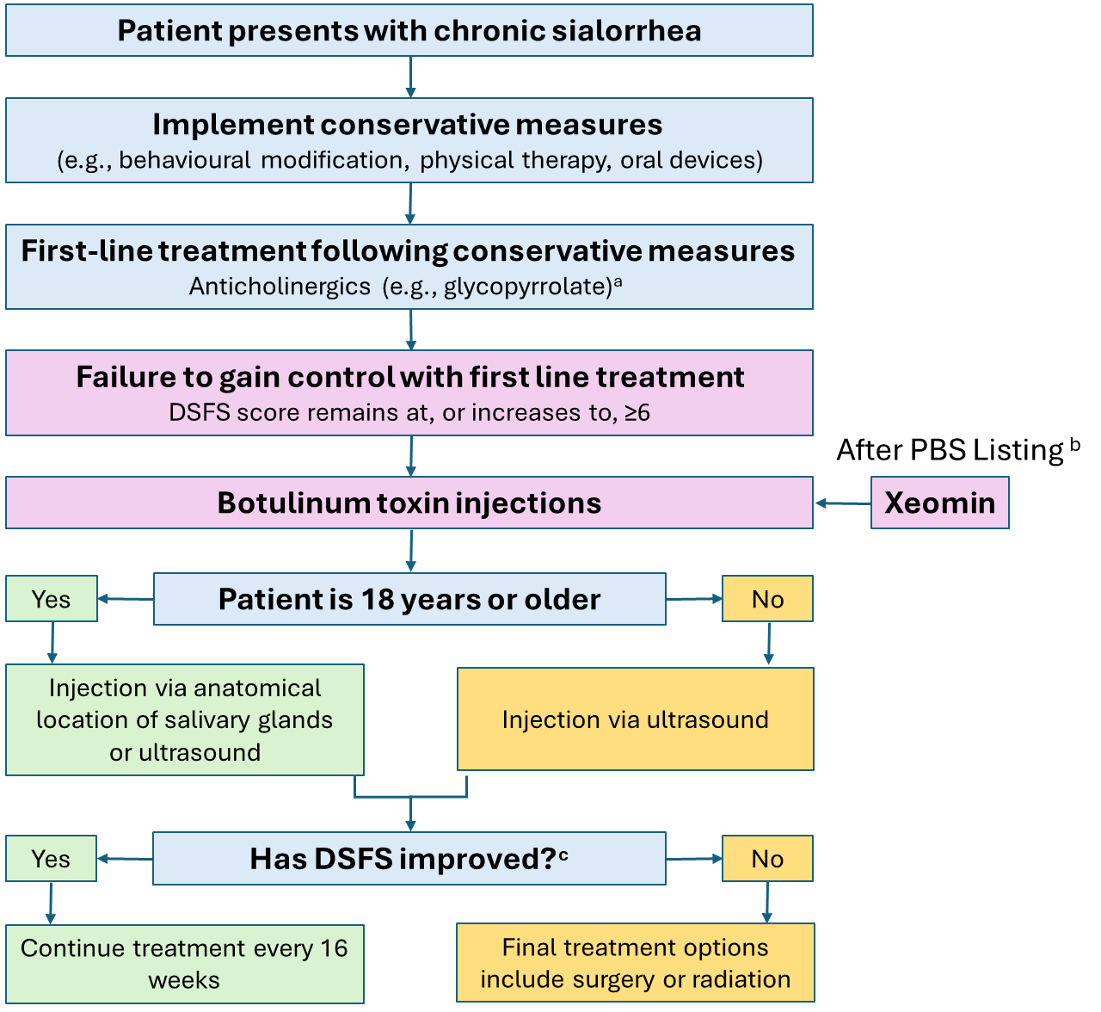

a) Whilst anticholinergics are not TGA indicated for the treatment of sialorrhea and are therefore not the exclusive comparator for this submission, they are included in the treatment algorithm to reflect advice from Australian clinicians that they are used in clinical practice to manage sialorrhea in patients with neurological disorders. b) Although other forms of toxin are used off-label on a private script, Xeomin would likely be preferred in case of PBS listing. C) Defined as an improvement in DSFS score of 1 point or greater.

Figure 1.2.1. Clinical management algorithm for sialorrhea in adults and children with neurological disorders with the addition of Xeomin.

# Claims

## In terms of health outcomes (comparative benefits and harms), is the proposed technology claimed to be superior, non-inferior or inferior to the comparator(s)?

Superior

Non-inferior

Inferior

## Please state what the overall claim is, and provide a rationale:

Treatment of chronic sialorrhea with incobotulinumtoxinA (Xeomin) is superior to standard care with regards to efficacy, and non-inferior with regards to safety, in both adult and children/adolescent populations. This was demonstrated in two randomised controlled trials – SIAXI and SIPEXI, tabulated in the Summary of Evidence.

## Why would the requestor seek to use the proposed investigative technology rather than the comparator(s)?

IncobotulinumtoxinA (Xeomin) is the only toxin with efficacy and safety data in a population with chronic sialorrhea. Although toxins are being used off label currently, following PBS and MBS listing, requestors and patients will have access to a reimbursed toxin with a TGA-approved body of evidence in support of its use.

## Identify how the proposed technology achieves the intended patient outcomes:

Xeomin blocks cholinergic transmission at the neuromuscular junction by inhibiting the release of acetylcholine from peripheral cholinergic nerve terminals. This inhibition occurs according to the following sequence:

* heavy chain of toxin binding to cholinergic nerve terminals
* internalization of the toxin within vesicles into the nerve terminal
* translocation of the light-chain of the toxin molecule into the cytosol of the nerve terminal
* enzymatic cleavage of SNAP25, the presynaptic target protein essential for the release of acetylcholine.

Complete recovery of endplate function/impulse transmission after intramuscular injection normally occurs within 3-4 months as nerve terminals sprout and reconnect with the muscle endplate and the presynaptic neurotransmitter release mechanism becomes functional again.

## For some people, compared with the comparator(s), does the test information result in:

**A change in clinical management?** Yes

**A change in health outcome?** Yes

**Other benefits?**  No

## In terms of the immediate costs of the proposed technology (and immediate cost consequences, such as procedural costs, testing costs etc.), is the proposed technology claimed to be more costly, the same cost or less costly than the comparator?

More costly

Same cost

Less costly

## Provide a brief rationale for the claim:

As the current method of treating sialorrhea is standard care consisting of no reimbursed therapies, a listing of any service would be more costly to the Commonwealth in terms of immediate costs.

**If your application is in relation to a specific radiopharmaceutical(s) or a set of radiopharmaceuticals, identify whether your clinical claim is dependent on the evidence base of the radiopharmaceutical(s) for which MBS funding is being requested. If your clinical claim is dependent on the evidence base of another radiopharmaceutical product(s), a claim of clinical noninferiority between the radiopharmaceutical products is also required.**

N/A

**References**

1. Hockstein, N.G., et al., *Sialorrhea: a management challenge.* Am Fam Physician, 2004. **69**(11): p. 2628-34.

2. Kalf, J.G., et al., *Impact of drooling in Parkinson's disease.* J Neurol, 2007. **254**(9): p. 1227-32.

3. Rodrigues, B., et al., *Silent saliva aspiration in Parkinson's disease.* Mov Disord, 2011. **26**(1): p. 138-41.

4. Scully, C., et al., *Drooling.* Journal of Oral Pathology & Medicine, 2009. **38**(4): p. 321-327.

5. Akbar, U., et al., *Incidence and mortality trends of aspiration pneumonia in Parkinson's disease in the United States, 1979-2010.* Parkinsonism Relat Disord, 2015. **21**(9): p. 1082-6.

6. Jost, W.H., et al., *SIAXI: Placebo-controlled, randomized, double-blind study of incobotulinumtoxinA for sialorrhea.* Neurology, 2019. **92**(17): p. e1982-e1991.

7. Berweck, S., et al., *Placebo-controlled clinical trial of incobotulinumtoxinA for sialorrhea in children: SIPEXI.* Neurology, 2021. **97**(14): p. e1425-e1436.

# Summary of Evidence

## Provide one or more recent (published) high quality clinical studies that support use of the proposed health service/technology.

|  | **Type of study design** | **Title of journal article or research project** | **Short description of research** | **Website link to journal article or research** | **Date of publication** |
| --- | --- | --- | --- | --- | --- |
| 1. | Phase III randomised double-blind placebo-controlled trial | SIAXI (Sialorrhea in Adults Xeomin Investigation)  [6] | Adults (n=184) with chronic sialorrhea due to Parkinson’s disease, stroke, and traumatic brain injury randomised to Xeomin or placebo treatment arms.  Health outcomes, safety, and quality of life evaluated. | **[3]** | April 2019 |
| 2. | Phase III randomised double-blind placebo-controlled trial | SIPEXI (Sialorrhea Paediatric Xeomin Investigation)  [7] | Children and adolescents (n=220) with chronic sialorrhea due to cerebral palsy, traumatic brain injury, or other congenital neurodevelopmental disorders, randomised to Xeomin or placebo treatment arms.  Health outcomes, safety, and quality of life evaluated. | [4] | October 2021 |

1. Australian Therapeutic Guidelines. Melbourne: Therapeutic Guidelines Limited; accessed February 2024. <https://www.tg.org.au>
2. The Royal Children’s Hospital Melbourne: Saliva Control in Children; accessed February 2024. https://www.rch.org.au/neurodevelopment-and-disability/saliva/
3. <https://pubmed.ncbi.nlm.nih.gov/30918101/>
4. <https://pubmed.ncbi.nlm.nih.gov/34341153/>